**Blogs**

1. **Be Creative, think different.**

Who among us does not dream of being an influence on the world around him? Who among us does not dream of being the creator of this era who is developing his life and the lives of those around him?

But what is creativity? How can the retailer change his life and the whole world? Creativity is the ability of the individual to see something from a different side from what others see, and the creative person is considered a unique and distinct person from the rest of the individuals, as he thinks and works in a way that distinguishes him from the people around him and finds innovative solutions to the problems around him.

That is why we can prove the correctness of the positive relationship between creativity and difference, being almost the same thing. The greater the difference in the way of thinking "in the right side", the greater one's ability to be creative and produce impressive results.

History has given many examples of innovators in various fields over time.

Painters such as the artist Leonardo Da Vinci, scholars such as the scientist Isaac Newton, writers Shakespeare, and many other people who have influenced the world in various fields. And it is certain that their way of thinking was unique and greatly different and unique, as each of them was able to see aspects that no one had seen, and they proved that the difference when directed to meaningful and useful aspects achieves impressive results that change the world.

And now many strive to achieve this difference and become the creators of this era, and there is no stopping you to be one of them as well, so get up and change the way you see things, change your thinking!

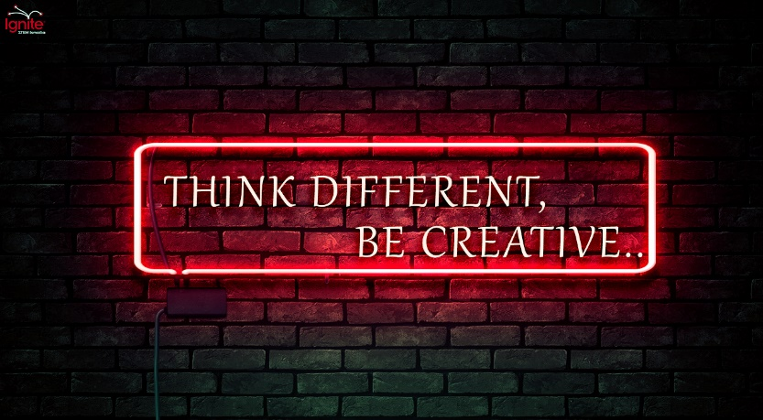

1. **How to be successful?**

"Successful people do what unsuccessful people are not willing to do. Don't wish it were easier; wish you were better."

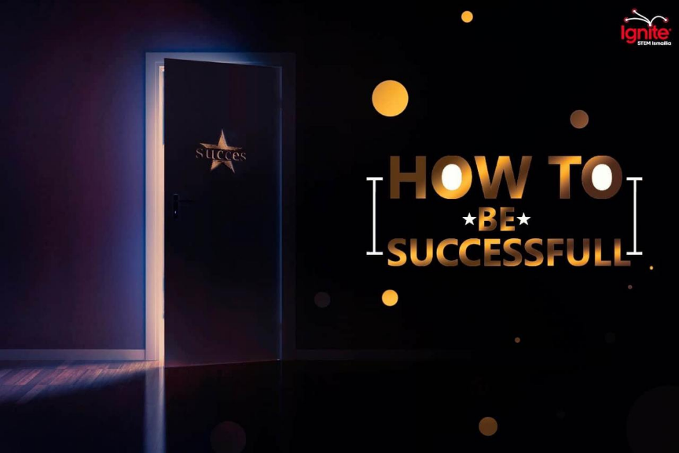

       Success doesn’t come by luck or wishing but it comes as a result of a lot and a lot of hard-working combined with failures. As the road to success and the road to failure are almost the same. Success means attaining a certain social status in life or fame.

Here you are some tips success: -

1. Focus on commitment, not motivation. To do that you have to seek knowledge, not results. As focusing on the excitement of discovery will make you motivated. Contrast focusing on the results will make your motivation can die easily.
2. Make it for fun and don’t do it just because it is your duty.
3. Get rid of stagnating thoughts. Always try to filter your thought as many of them will affect your emotions.
4. Get rid of distractions: Learn to focus on what is most important and leave all meaningless things to go.
5. Don’t rely on others: You should never expect others to do it for you, as all are busy with their own needs.

      The last thing and the main reason for any success is time management. You need always to benefit from every second. You can do that by many things like [Creating a time audit – set a deadline for every task - Plan ahead and otherwise]. Always put in your mind that lost time is never found again. So, think differently and make a metanoia to achieve your success.

1. **Changing Careers.**
2. **Ignite talk (Changing Careers)**

"On my 50th birthday, I felt like I was in the middle of a game of my life

I kept looking at the previous half and the remaining half, and suddenly, I realized that I was hanging at this point. I asked myself, will I complete my life working in marketing that I have been working with for 30 years, but I do not want to do that?

For a moment, I told myself that if I did not work in this field, what would I do?

My mind panic that a solution must be found because it cannot be the first half of the game like the last.

To give my mind and heart a chance to think, I wanted to control them, I wanted to close my eyes to the past and not be obsessed with the future and only think about the present, so I did meditation

Meditation gave me time to think and ideas to work on like improvisation classes and acting classes, and much more. Now I am speaking to you from the year 52. Although I am not working in a specific job, I am happier than before.

Finally, there is no exact recipe or limited age, but I think you know now how to get out of your mind and into the moment. And you should just do what makes you happy even it is hard"

That was Amanda Falconer's story, and her message was (getting unstuck).

1. **Ignite talk (Changing Careers)**

How many people has gone through a huge career change, where they just forgot everything they have done before and started something new?

Many of us have experienced loss of passion or faced a failure in their work or discovered after a while that this is not what he seeks, not his goal in life. He decides to change the course of his life and begins to search for this goal with all that he has, and then he has to face these 3 steps.

Firstly, learn it, know it, forget it. It means learn the job and know about it, have its experience and knowledge then leave it and go learn something new. You're able to learn this so, you'll be able to learn another, and know that everything you've learned will benefit you later.

****Secondly, share and share alike. Share everything you learnt because that's what connects you to the other people. It'll leave you with good relationships and help you in your search. The more you help people the more you learn and know new things from their experience.

Finally, be in the moment. If you spend all the time worrying about failure and thinking about, you'll not find your way, you'll not catch the moment. Live the moment and believe in yourself. Set yourself a specific rule about learning, exploring, and pushing your technical.

Your goal won't come to you, but you have to work to find it, so work as hard as you can.