Big Data Project Proposal
Cairo University — Faculty of Engineering
CMP4011 — Big Data and Cloud Computing — Spring 2026
Name | ID
Seif Mohamed Ahmed Abdelbaky | 9220386
Nour Khaled | 9220921
Zeyad Alaa El-Din | 9220327
Kareem Wael Abo Samra | 9220602

1. Idea
Analyze historical football match data to uncover key performance indicators influencing match outcomes by evaluating and interpreting results under different match conditions, as well as make predictions for future match outcomes (FTResult: Home win, Draw, or Away win).

2. Dataset
Football Matches Dataset — a large historical dataset containing match statistics across multiple leagues and seasons with 48 features per match record.

3. Planned Approach

3.1 Data Preprocessing & Cleaning
The dataset is processed using Apache Spark (PySpark) in pseudo-distributed mode. A train/test split (80/20) is performed first; all cleaning statistics are derived exclusively from the training set and then applied to both splits to prevent data leakage.

Remaining columns after preprocessing:
Division, MatchDate, HomeTeam, AwayTeam, HomeElo, AwayElo, Form3Home, Form5Home, Form3Away, Form5Away, FTHome, FTAway, FTResult (target), HTHome, HTAway, HTResult, HomeYellow, AwayYellow, HomeRed, AwayRed, OddHome, OddDraw, OddAway, MaxHome, MaxDraw, MaxAway, Over25, Under25, MaxOver25, MaxUnder25, HandiSize, HandiHome, HandiAway

Cleaning pipeline steps:

# | Step | Description
1 | Remove Duplicates | Drop exact duplicate rows from the dataset.
2 | Drop High-Null Columns | Remove columns where more than 50% of values are missing.
3 | Drop High-Null Rows | Drop rows where any column with <5% nulls (low-null columns) is missing.
4 | Fill Normal-Distribution Columns with Mean | HomeElo, AwayElo — assumed normally distributed, filled with training mean.
5 | Fill Remaining Numeric Columns with Median | Form3Home, Form5Home, Form3Away,Form5Away,FTHome, FTAway, HTHome, HTAway, Yellow/Red cards, Odds, Handicap fields — filled with training median to resist skew/outliers.
6 | Fill Categorical Columns with 'Unknown' | Division, MatchDate, MatchTime, HomeTeam, AwayTeam, FTResult, HTResult — missing string values replaced with 'Unknown'.
7 | Validate FTResult Values | Retain only rows where FTResult ∈ {H, D, A}; drop rows with unexpected labels (the prediction target).
8 | Validate Elo Columns | HomeElo and AwayElo must be positive. Non-positive values are replaced with the training mean.
9 | Validate Form Columns | Form3Home, Form5Home, Form3Away, Form5Away must be non-negative. Negative values are replaced with the training mean.
10 | Validate same team in homa and away | HomeTeam must be different from Away Team

Outcome: 181,049 training rows and 44,987 test rows — all columns fully populated with zero nulls remaining.

3.2 Exploratory Data Analysis (EDA)

3.2.1 Feature Distributions
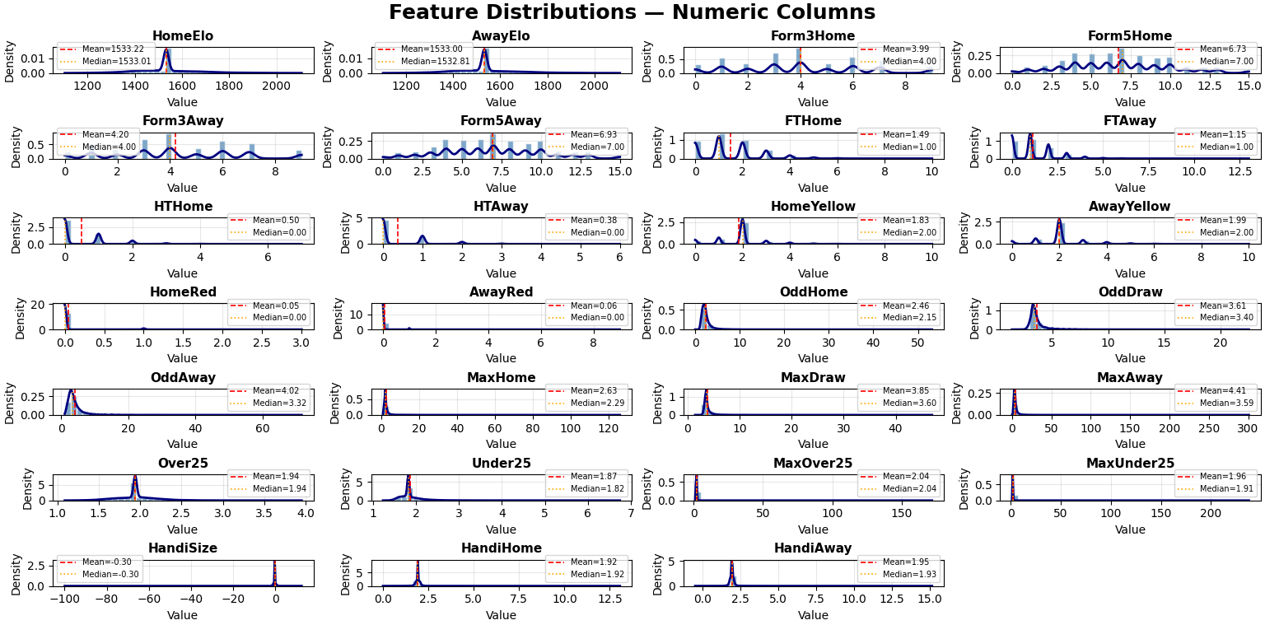
Most distributions are strongly right-skewed with long tails and concentration near lower values.
Only HomeElo and AwayElo appear roughly symmetric, while the rest deviate clearly from normality.

3.2.2 Data Introduction
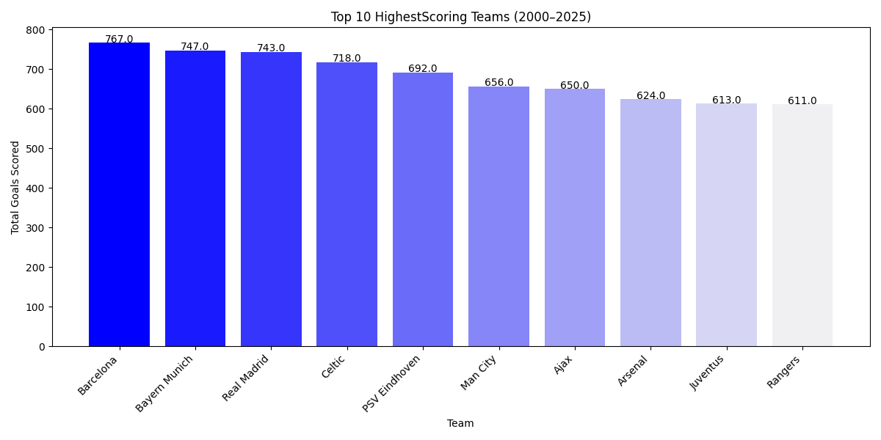
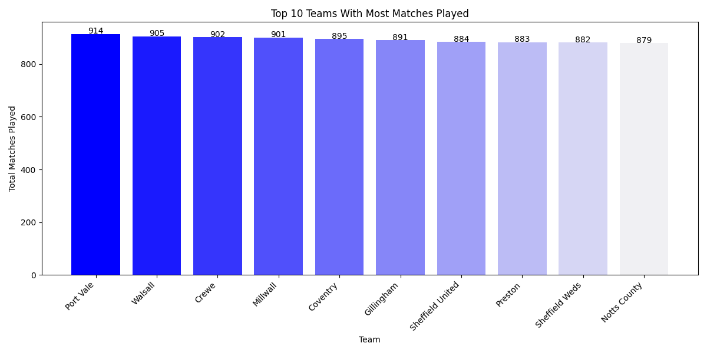
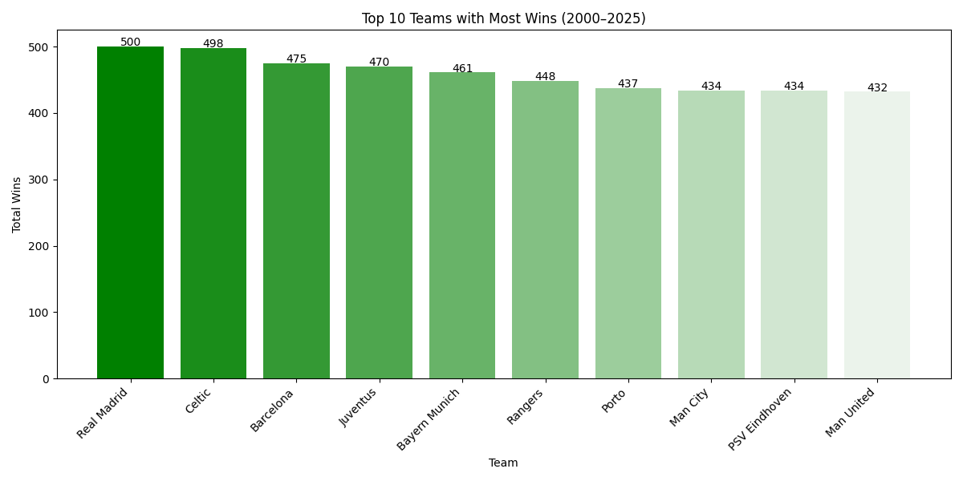
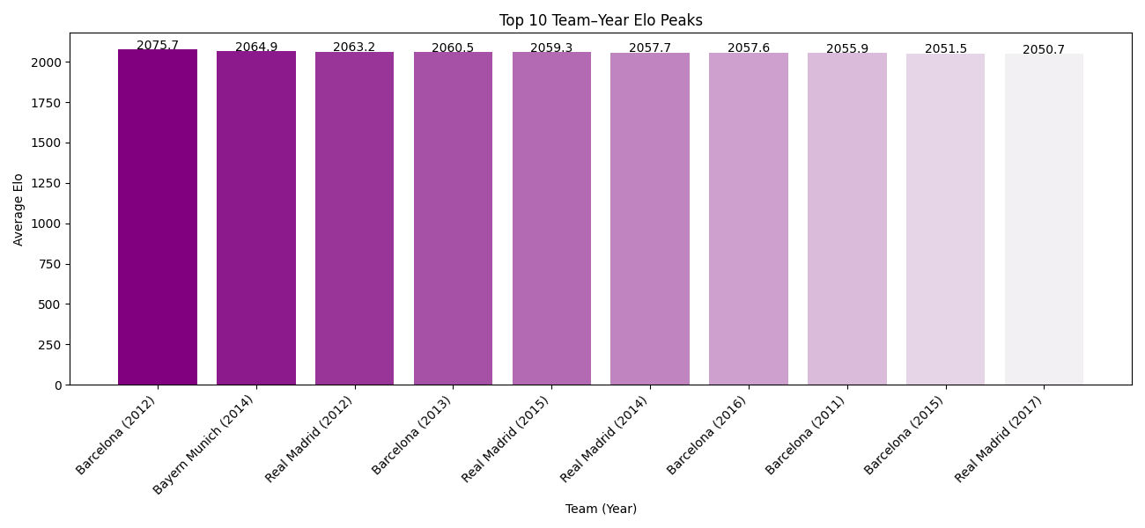
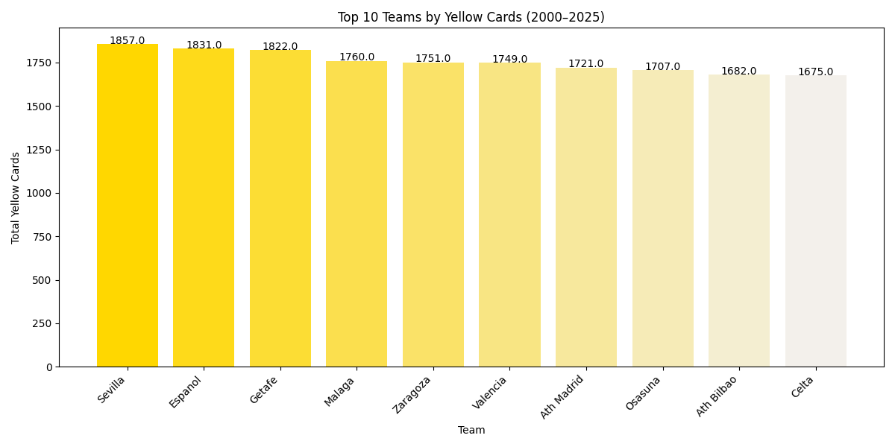

3.2.3 Class Distribution
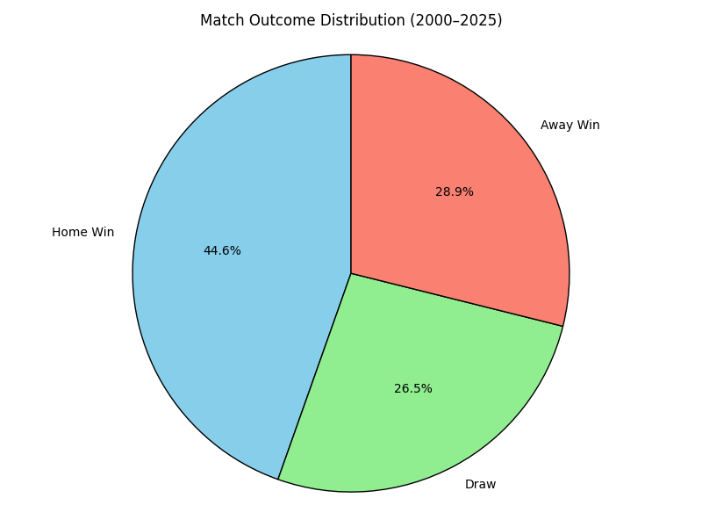
I observed that the class distribution is slightly imbalanced, with Home Win (44.6%), Draw (26.5%), and Away Win (28.9%).

3.2.4 Feature Relationships with Match Outcome
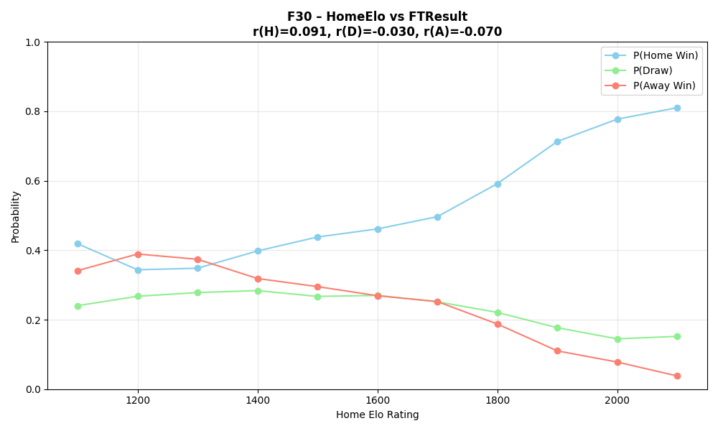
Home win probability rises steadily with HomeElo while away win probability falls, and draw probability remains relatively flat throughout. The overall Spearman correlations appear weak (r ≈ 0.09) because the vast majority of matches cluster in the 1400–1700 Elo range where probabilities are nearly equal — the strong separation only emerges at the extremes (below 1200 or above 1800), which represent a small fraction of the data.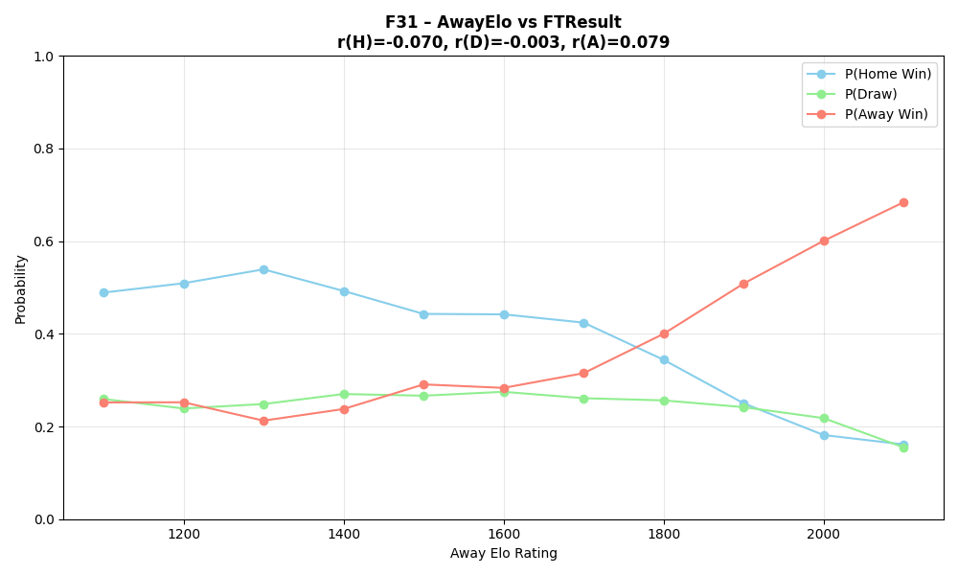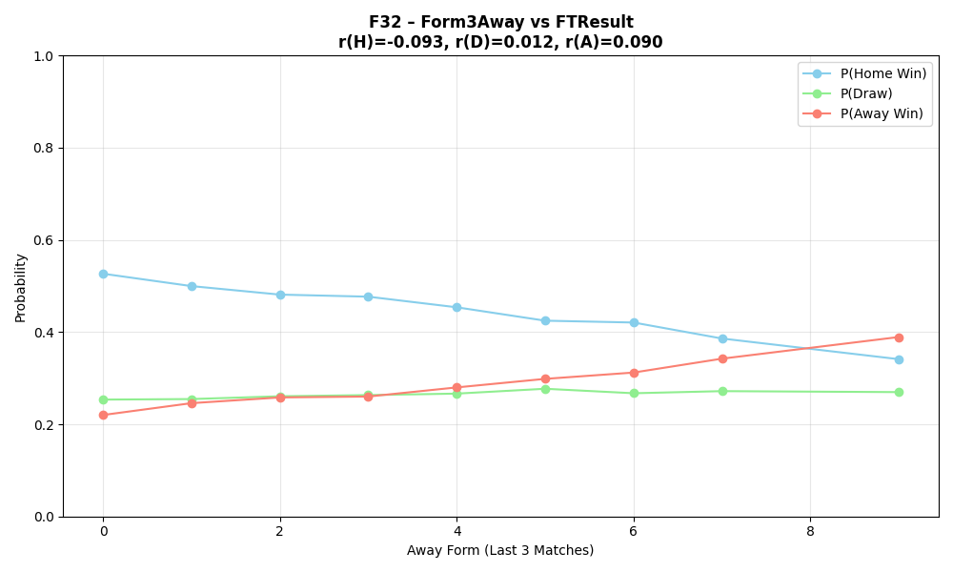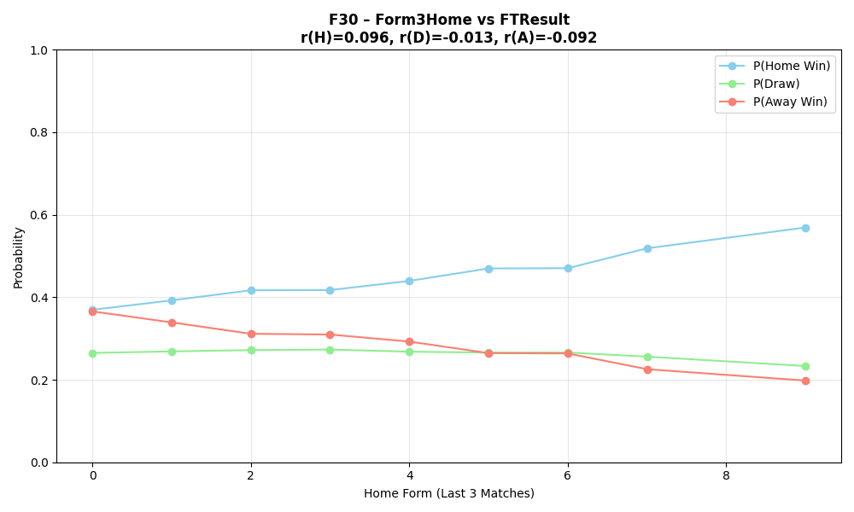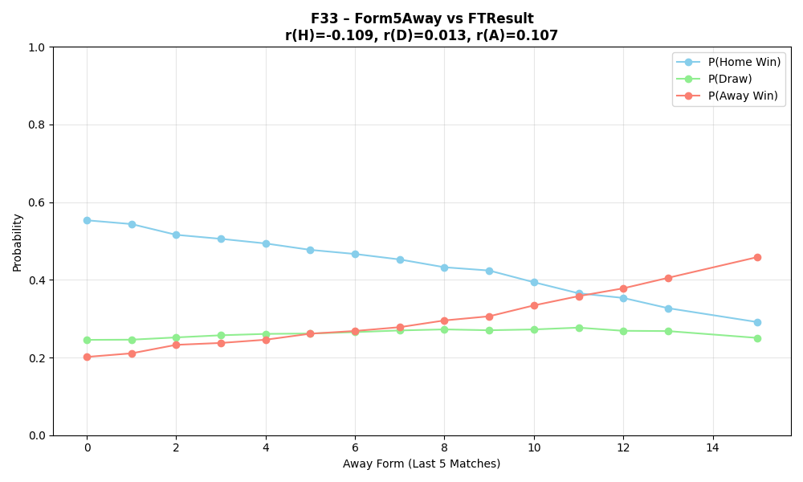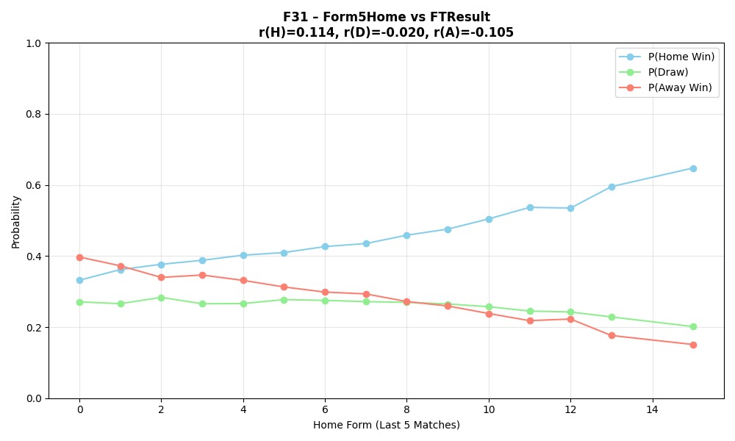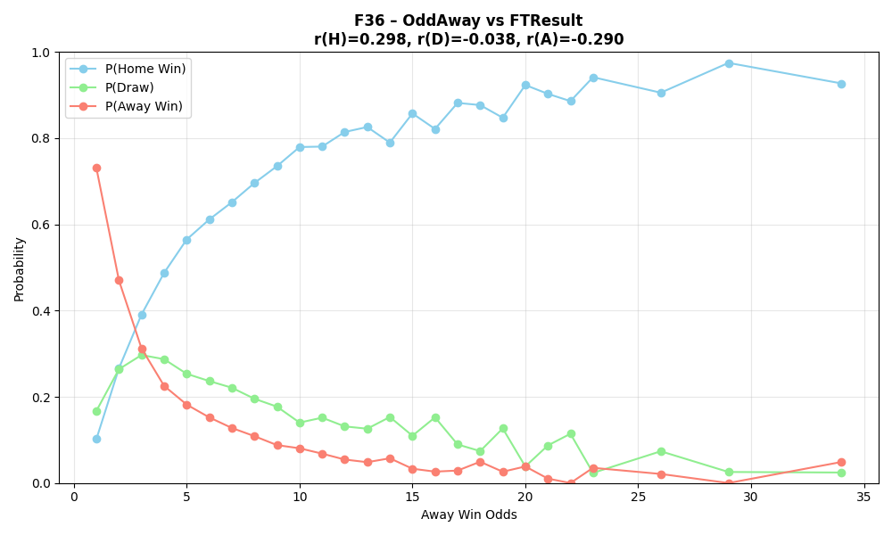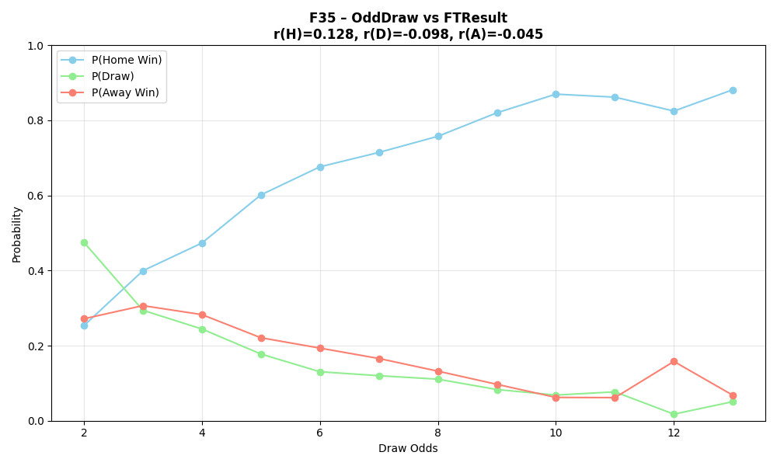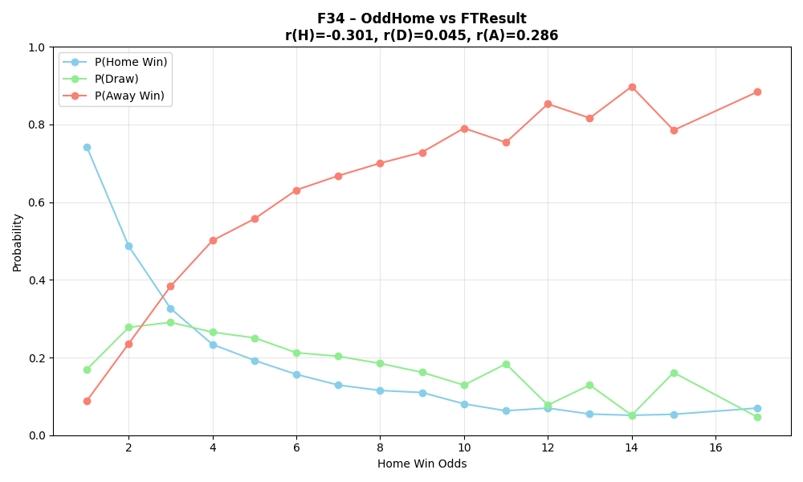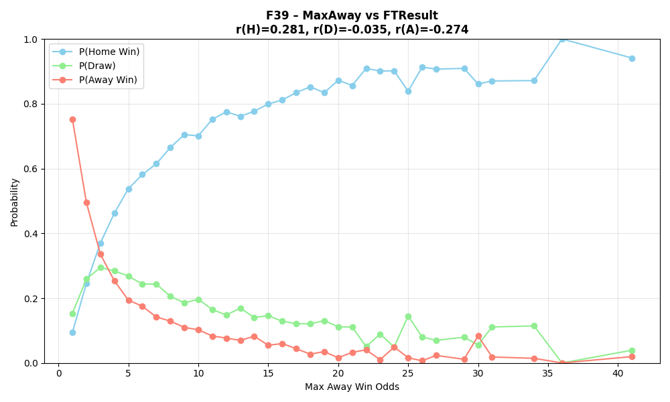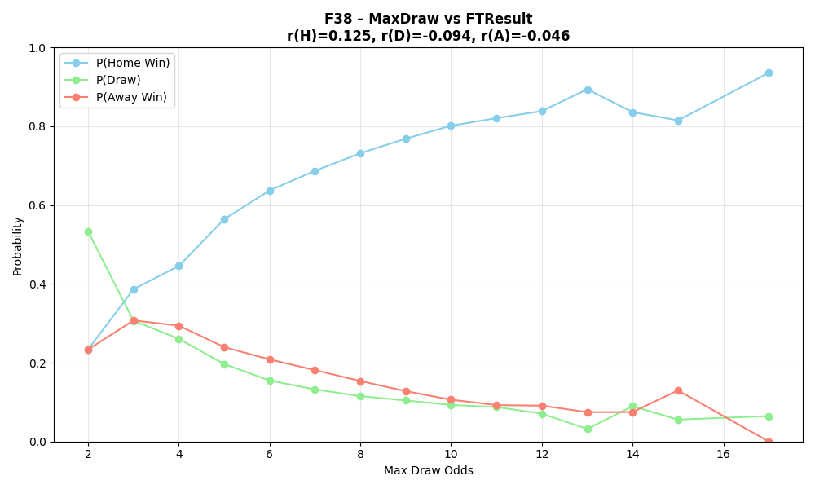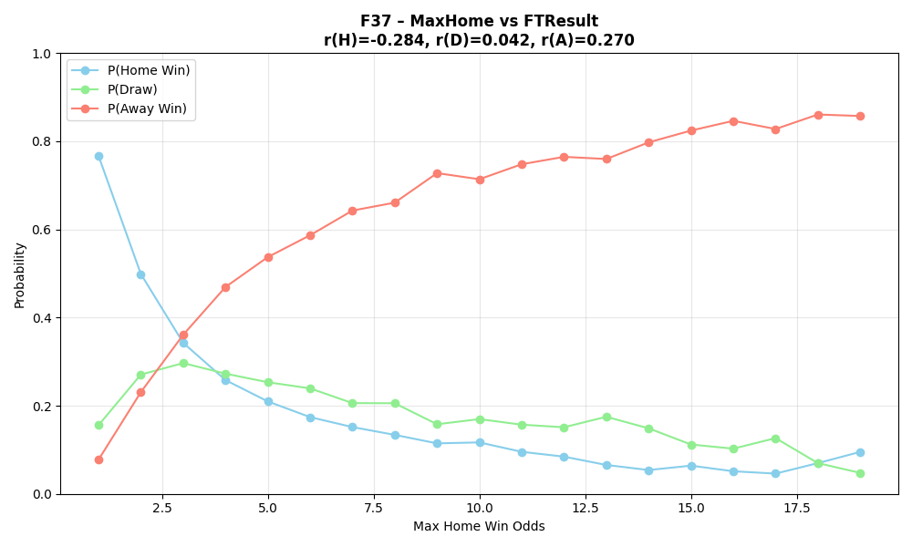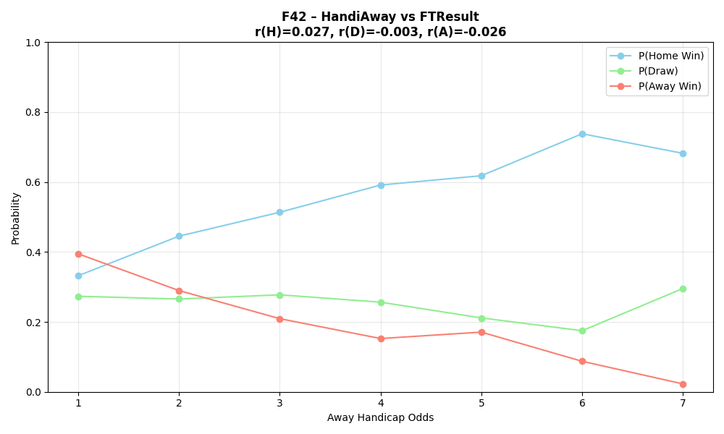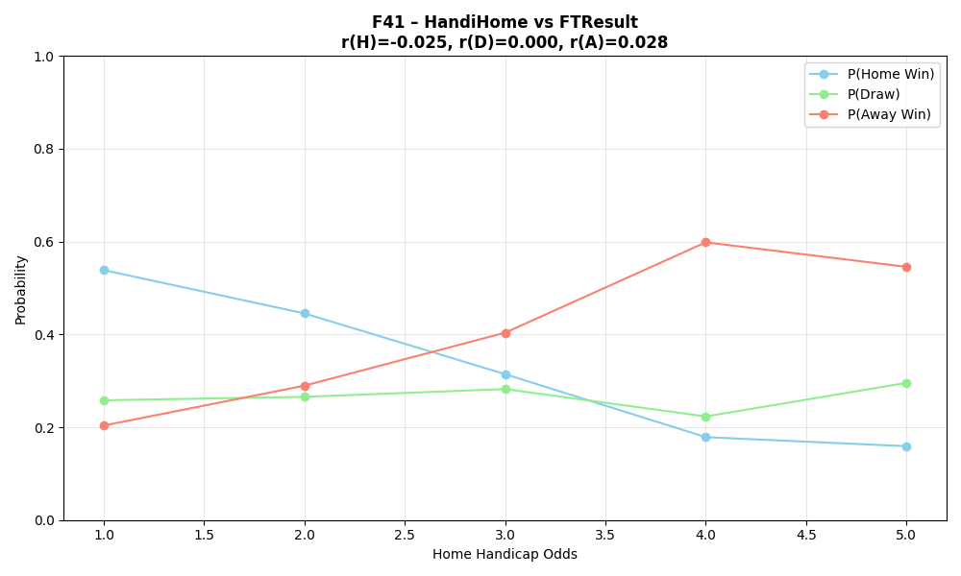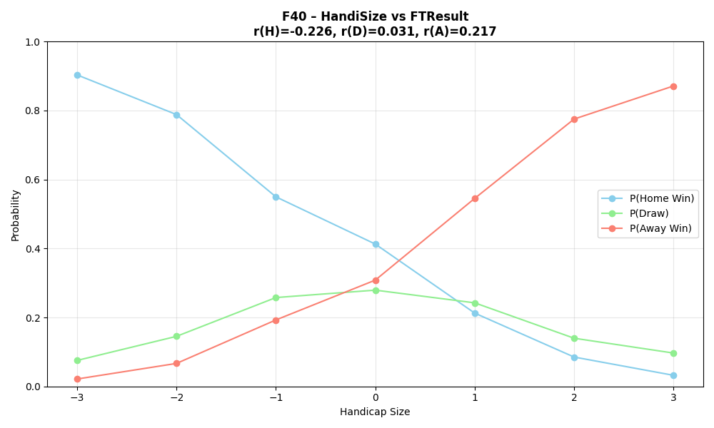
The correlations between individual features and FTResult are consistently low, with the strongest being r ≈ −0.30 for OddHome and most others near zero.This means no single feature alone can predict the outcome, and the real signal comes from combining them together.

3.2.5 Feature Engineering
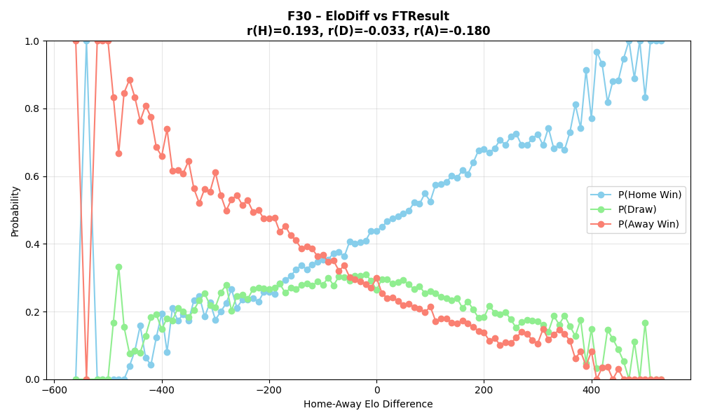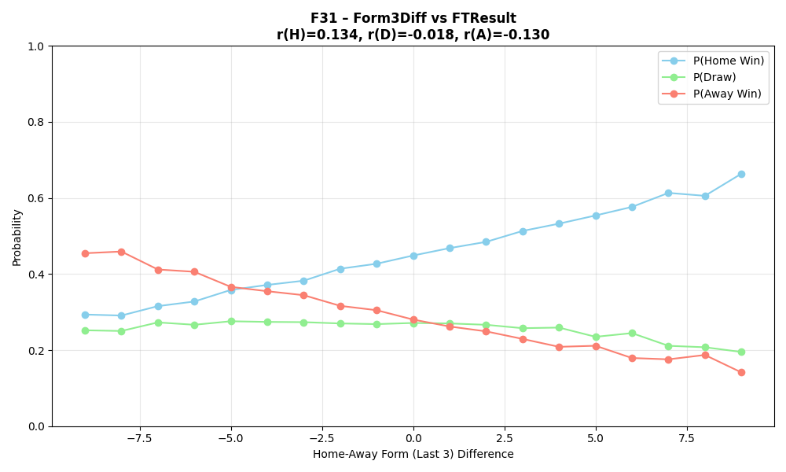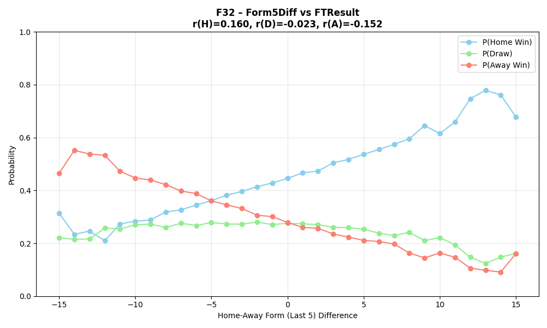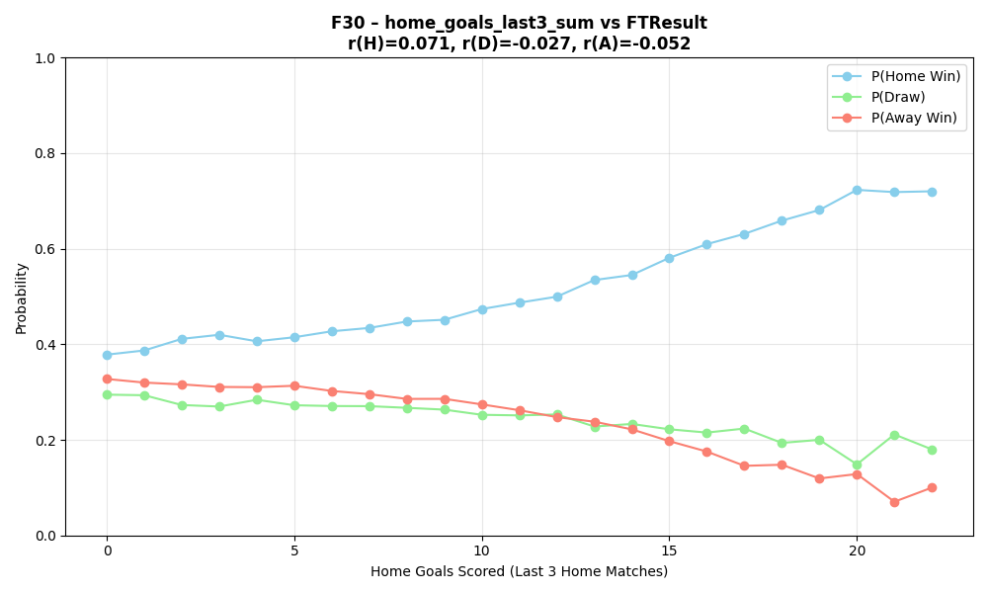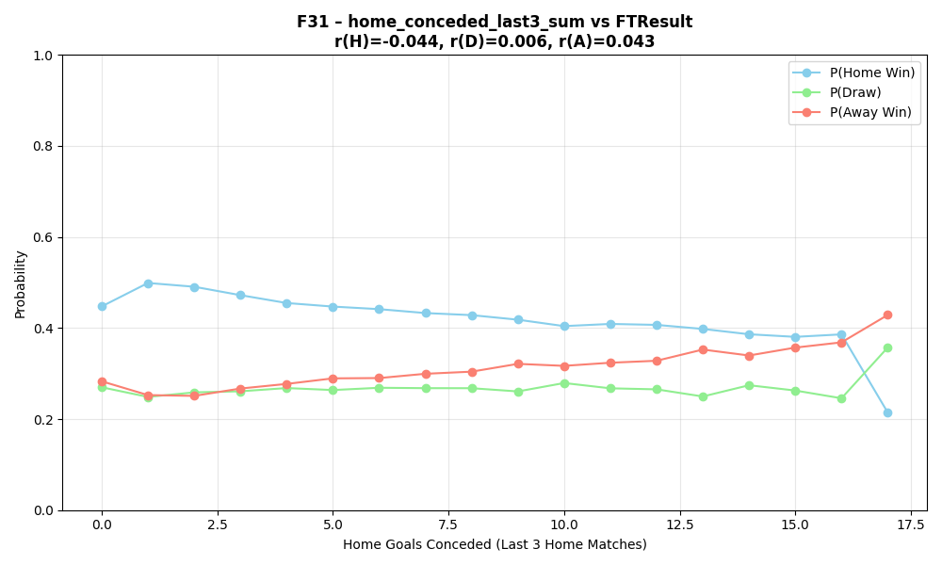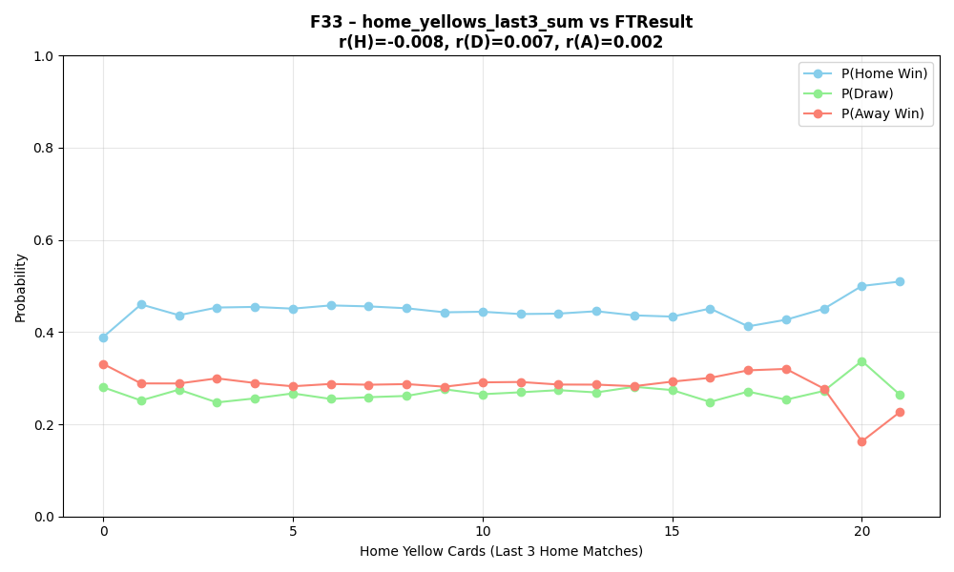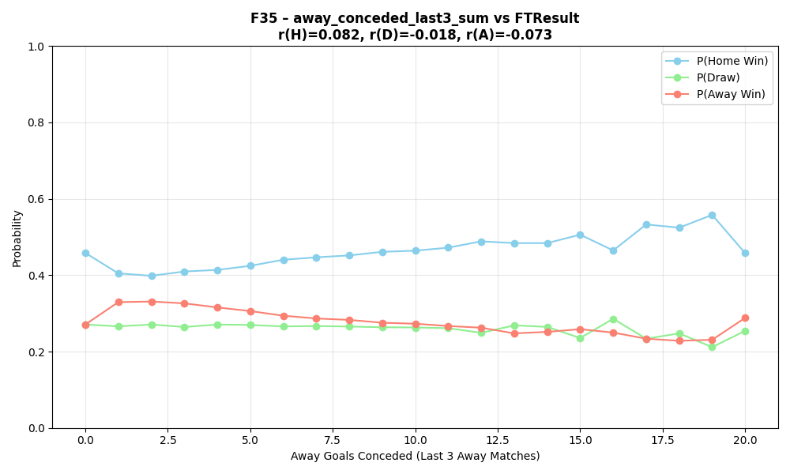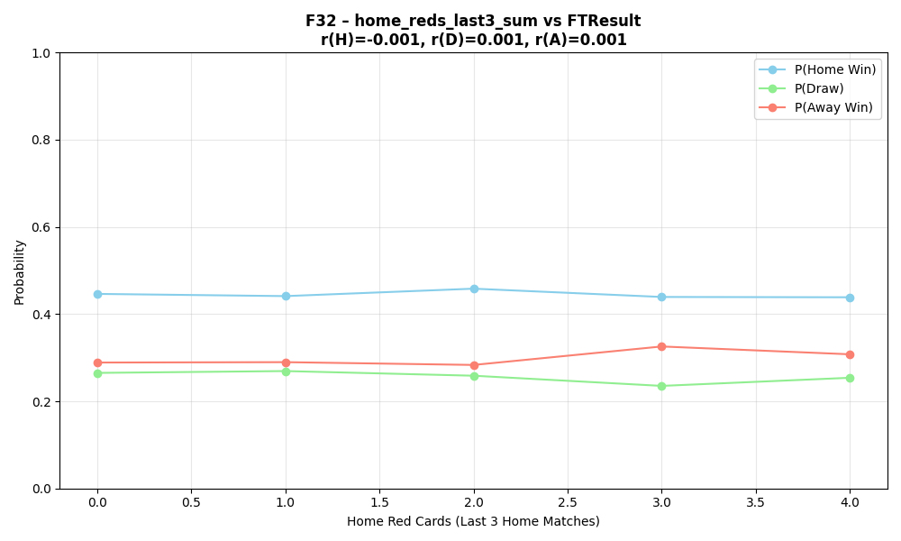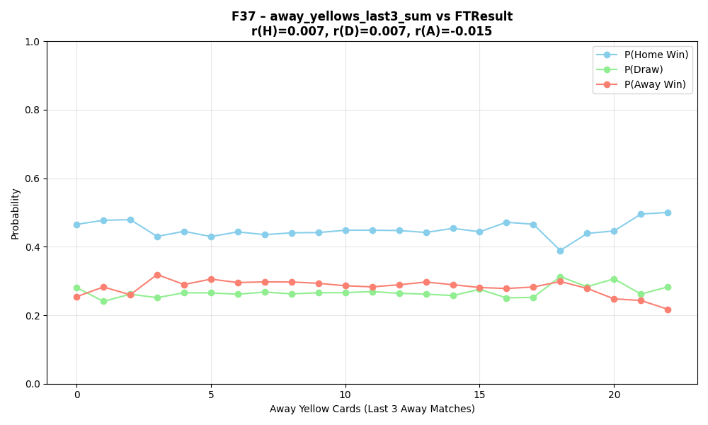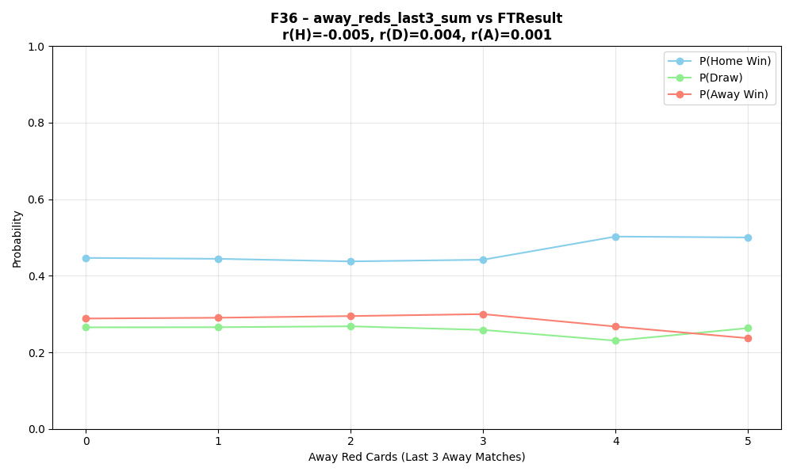
The correlations between the newly engineered features and FTResult remain low, with the strongest being EloDiff at r ≈ 0.193 and most others falling below r ≈ 0.13. Card-based features show near-zero correlations, confirming they carry almost no individual predictive signal. As with the raw features, no single engineered feature alone is sufficient to predict the outcome.

3.3 Descriptive Analysis — Clustering
I implemented Kmeans using a MapReduce approach.

3.3.1 Mapper
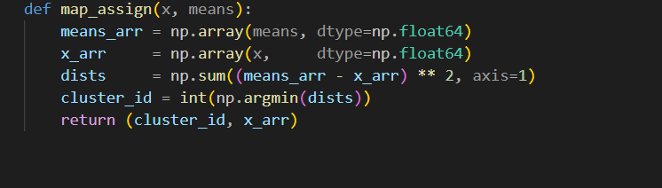

3.3.2 Combiner
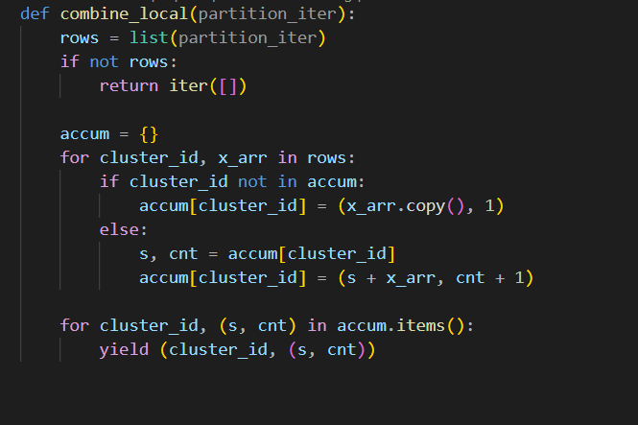

3.3.3 Reducer
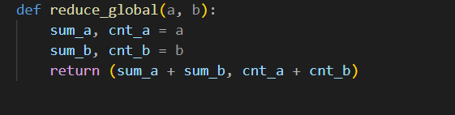

3.3.4 Results
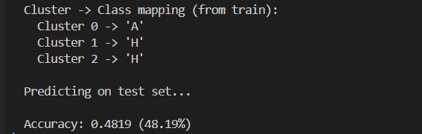

3.4 Predictive Analysis

3.4.1 Random Forest
The Random Forest classifier achieved an overall accuracy of 48.98% on the pre-match feature set, with notably poor performance on draw prediction (F1 = 0.13), likely due to class imbalance favoring home wins. 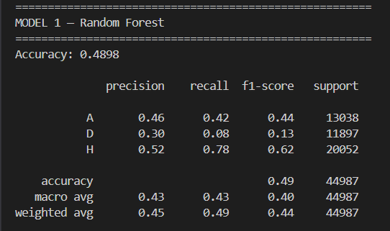

3.4.2 KNN
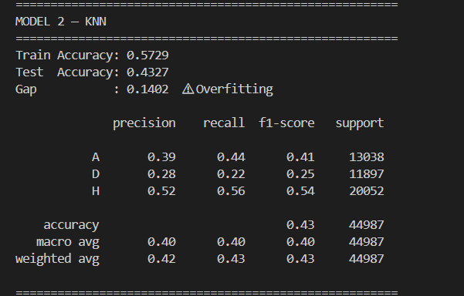

3.4.3 XGBoost
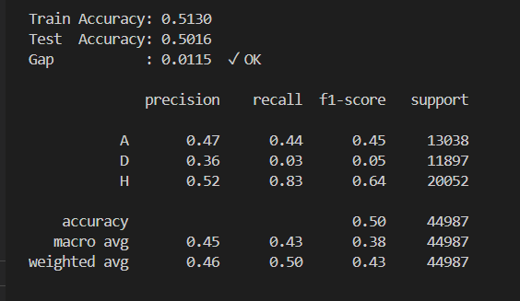

3.4.4 Neural Network
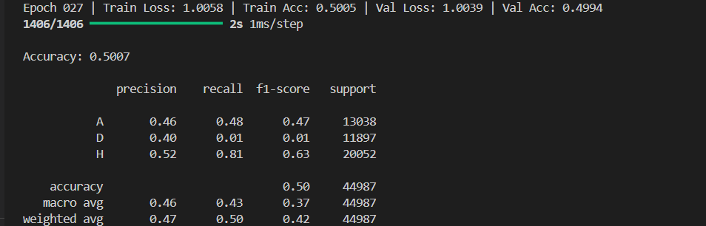
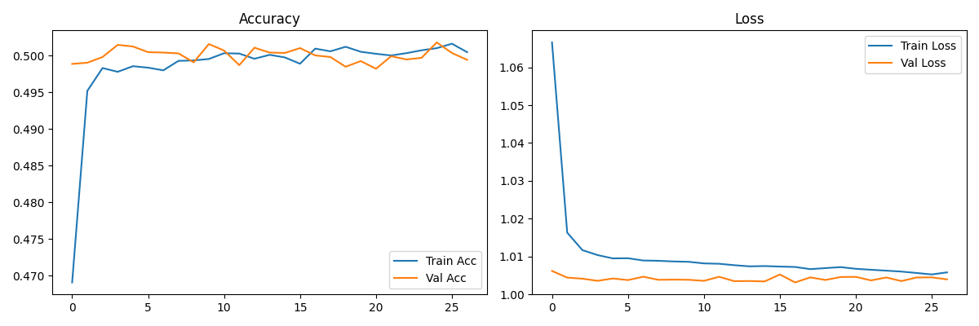

3.4.5 Weighted Random Forest
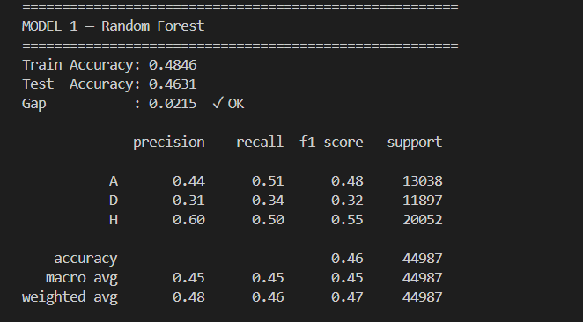
Weighting reduced bias toward H, so overall accuracy dropped slightly (0.49 → 0.46) since the model no longer over-predicts the majority class. In return, D recall improved significantly (0.08 → 0.34) and macro F1 increased (0.40 → 0.45), making the model more balanced and honest across all three outcomes.

3.4.6 Weighted XGBoost
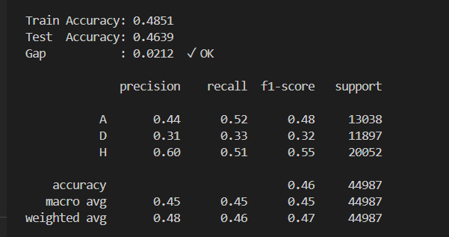

3.4.7 Weighted NN
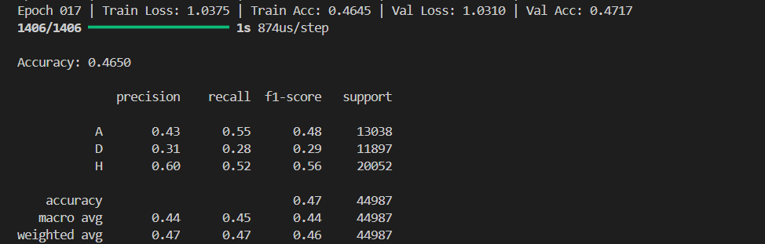

3.5 MapReduce Implementation
I implemented KNN using a MapReduce approach.

3.5.1 Mapper
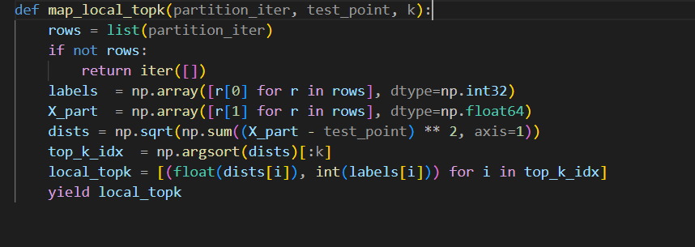

3.5.2 Reducer
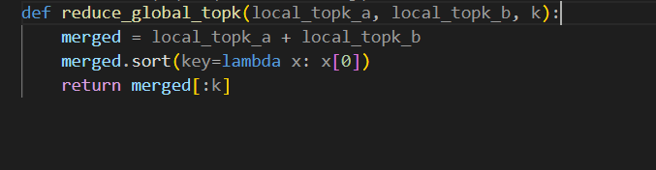

3.5.3 Prediction
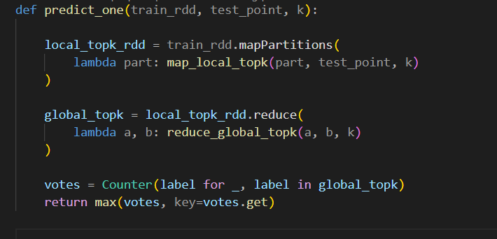

3.5.4 Results

