Benha University
Faculty of Engineering in Shoubra
Department of Communication and Computer Engineering
★ Electronics Project Report ★
555 Timer Astable Oscillator
Flashing LED Indicator Circuit

Student Name | Zeyad Bilal Gamal
Bench Number | 26
Section | 2
Academic Year | Second Year (2025)
Course | Electronics
Submission Date | 22 June 2026

1. Introduction

The 555 timer IC is one of the most versatile and widely used integrated circuits in electronics. Introduced by Signetics in 1972, it has remained a fundamental building block for timing, oscillation, and pulse-generation circuits for over five decades.
In this project, the 555 timer is configured in its Astable (free-running) mode to generate a continuous square-wave output. This output is used to alternately flash two LEDs (LED1 and LED2), producing a visible oscillation that demonstrates the principles of RC charging networks and timer operation.
The project was designed, simulated, and documented as part of the Electronics course at the Faculty of Engineering in Shoubra, Benha University.

2. Project Objectives

- Understand the internal operation of the NE555 timer IC.
- Design an astable oscillator circuit using R1, R2, and C1.
- Calculate the oscillation frequency and duty cycle from component values.
- Observe the flashing behavior of LEDs driven by the 555 output.
- Correlate theoretical calculations with practical circuit observations.

3. Theoretical Background

3.1 The 555 Timer IC – Internal Structure
The NE555 timer consists of two voltage comparators, a bistable SR flip-flop, a discharge transistor, a resistive voltage divider (three equal 5 kΩ resistors), and an output buffer stage. The internal voltage divider sets the upper comparator threshold at 2/3 VCC and the lower comparator threshold (trigger level) at 1/3 VCC.

3.2 Astable Operation
In astable mode, no stable state exists. The capacitor C1 charges through R1 and R2, and discharges through R2 only (via Pin 7 – the discharge pin). When the capacitor voltage reaches 2/3 VCC the output goes LOW; when it falls to 1/3 VCC the output goes HIGH. This cycle repeats indefinitely, producing a square-wave oscillation.

3.3 Timing Equations
Using the component values in this circuit (R1 = 1 kΩ, R2 = 10 kΩ, C1 = 100 µF):
Parameter | Formula | Calculated Value
High Time (t_H) | 0.693 × (R1 + R2) × C1 | ≈ 0.762 s
Low Time (t_L) | 0.693 × R2 × C1 | ≈ 0.693 s
Total Period (T) | t_H + t_L | ≈ 1.455 s
Frequency (f) | 1 / T | ≈ 0.687 Hz
Duty Cycle (D) | t_H / T × 100% | ≈ 52.4%

4. Circuit Diagram & Description

The circuit diagram below shows the complete astable oscillator with the LED output network. Annotations in green indicate suggested corrections to resistor values in the LED branches.
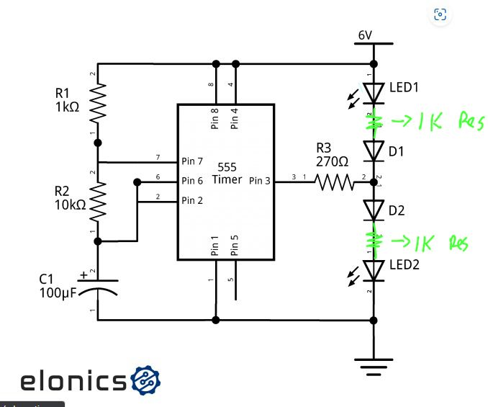
Figure 1 – 555 Timer Astable Oscillator Circuit (6 V supply, annotated)

4.1 Pin Connections
The 555 timer IC is connected as follows in this circuit:
- Pin 1 (GND) – Connected to the negative supply rail (0 V).
- Pin 2 (Trigger) & Pin 6 (Threshold) – Tied together and connected to the top of C1, allowing the capacitor voltage to control both comparators simultaneously.
- Pin 3 (Output) – Drives the LED network through current-limiting resistor R3 (270 Ω).
- Pin 4 (Reset) & Pin 8 (VCC) – Both connected to the positive supply (6 V). Tying Reset HIGH keeps the timer active.
- Pin 5 (Control Voltage) – Connected to ground through a 0.01 µF decoupling capacitor (not shown) to filter noise on the internal 2/3 VCC reference.
- Pin 7 (Discharge) – Connected to the junction of R1 and R2, allowing C1 to discharge through R2 when the internal transistor turns ON.

5. Components List

# | Reference | Value / Part | Function
1 | IC1 | NE555 Timer | Astable oscillator core
2 | R1 | 1 kΩ | Charge resistor (sets t_H with R2)
3 | R2 | 10 kΩ | Charge & discharge resistor
4 | R3 | 270 Ω | Current limiter for LED network
5 | R4 (LED1) | 1 kΩ (annotated) | Series resistor for LED1
6 | R5 (LED2) | 1 kΩ (annotated) | Series resistor for LED2
7 | C1 | 100 µF | Timing capacitor
8 | LED1 | Red LED | Indicator – ON during HIGH output
9 | LED2 | Red LED | Indicator – ON during LOW output (via D1/D2)
10 | D1, D2 | 1N4148 / signal diode | Steering diodes for alternate LED drive

6. Circuit Operation

When the 6 V power supply is connected, C1 begins to charge through R1 and R2 toward VCC. During this charging phase Pin 3 output is HIGH, forward-biasing LED1 (through R3) and causing it to illuminate. LED2 remains OFF because the diode steering network is reverse-biased.
Once the voltage across C1 reaches 2/3 × 6 V = 4 V, the upper comparator inside the 555 trips, the SR flip-flop resets, and Pin 3 switches LOW. The internal discharge transistor at Pin 7 turns ON, providing a discharge path for C1 through R2 to GND. During this phase LED1 turns OFF and LED2 illuminates.
When C1 discharges to 1/3 × 6 V = 2 V, the lower comparator trips, the flip-flop sets, Pin 3 returns HIGH, and the cycle restarts. The resulting flashing frequency is approximately 0.687 Hz, meaning each LED flashes roughly once every 1.5 seconds — clearly visible to the human eye.
The annotation " →1K Res" written in green on the schematic indicates that the original schematic showed short-circuit or missing series resistors for LED1 and LED2. Adding a 1 kΩ resistor in series with each LED limits the LED current to a safe level and protects both the LEDs and the 555 output stage.

7. Results & Discussion

Based on the component values and theoretical calculations, the following results were obtained:
- Oscillation frequency: ≈ 0.687 Hz (period ≈ 1.455 s)
- High-state duration: ≈ 0.762 s — LED1 illuminated
- Low-state duration: ≈ 0.693 s — LED2 illuminated
- Duty cycle: ≈ 52.4% (slightly above 50% because R1 contributes to charging but not discharging)
- Supply current: low (555 quiescent current ≈ 6–15 mA at 6 V plus LED currents)
The duty cycle is greater than 50% due to the asymmetric charge/discharge path: charging occurs through R1 + R2 while discharging occurs through R2 only. To achieve a near-50% duty cycle, R1 should be made very small relative to R2 (or a bypass diode placed across R2 during charging).

8. Conclusion

This project successfully demonstrated the operation of the NE555 timer in astable mode to generate a low-frequency square wave. The flashing LED circuit provides clear visual evidence of the oscillation and confirms the theoretical timing equations derived from the RC network.
Key engineering insights from this project include the relationship between timing component values and oscillation frequency, the role of the internal voltage divider in setting trigger thresholds, and the practical importance of current-limiting resistors when driving LEDs from CMOS/TTL compatible outputs.
The 555 timer remains an indispensable tool in the electronics engineer's toolkit, and its astable configuration forms the basis for countless practical applications including clock generation, PWM control, tone generation, and light effects.

9. References

[1] Texas Instruments, "NE555 Precision Timers," Datasheet SLFS022I, 2014.
[2] R. L. Boylestad & L. Nashelsky, Electronic Devices and Circuit Theory, 12th ed., Pearson, 2015.
[3] A. S. Sedra & K. C. Smith, Microelectronic Circuits, 7th ed., Oxford University Press, 2014.
[4] Circuit Diagram – elonics (annotated by student), Academic Year 2025.

