HELWAN NATIONAL UNIVERSITY
Faculty of Engineering — Mechatronics Engineering Program
Electric Drives — Third Year Project
ELEVATOR BRAKING
CONTROL SYSTEM
Advanced Motor Control with Precision Braking
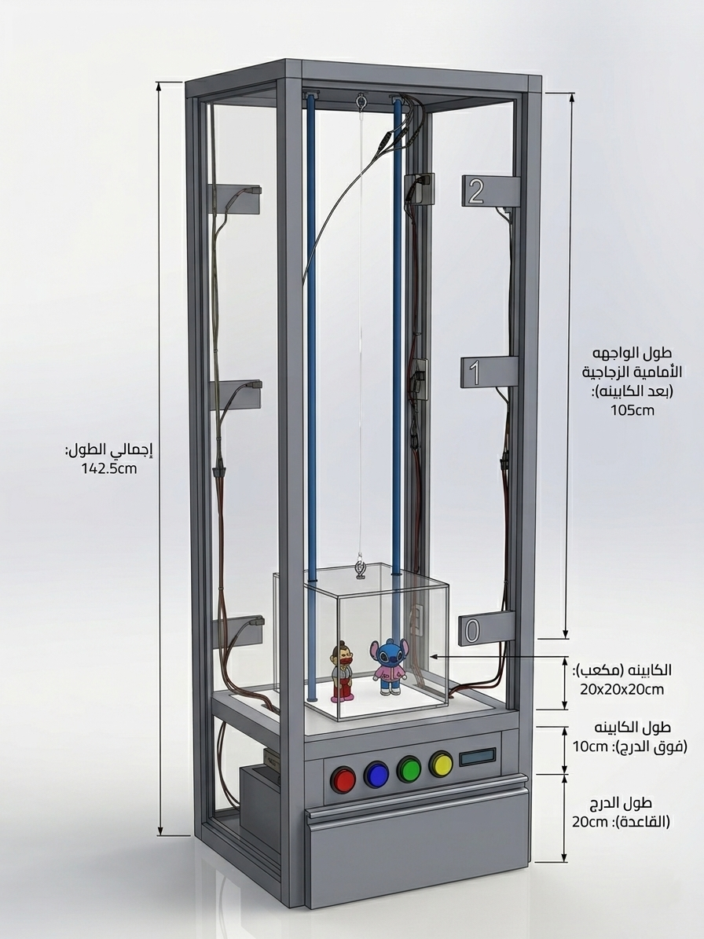
Figure 0 — CAD model of the elevator test rig with labeled dimensions
Technical Documentation Report
Project Components
ESP32 Microcontroller | L298N Motor Driver | Hall Effect Sensors
4x4 Matrix Keypad | 16x2 I2C LCD Display | Push Button Controls

Table of Contents

1. Executive Summary
This report presents a comprehensive technical analysis of an advanced elevator control system featuring precision braking technology. The system implements smooth acceleration and deceleration profiles to ensure passenger comfort and safety while maintaining operational efficiency.
The project demonstrates sophisticated motor control algorithms using an ESP32 microcontroller, integrating multiple control interfaces (keypad and buttons), real-time position sensing, and an emergency stop system. The braking control algorithm is the cornerstone of this system, featuring ramping acceleration, full-speed operation, and multi-stage deceleration with precise timing control.

Key Features
- Smooth acceleration and deceleration with customizable timing parameters
- Dual control modes: Keypad (with confirmation) and Direct Button control
- Three-floor operation with Hall effect position sensing
- Emergency stop system with intelligent recovery options
- Real-time LCD feedback for user interaction
- Debounced sensor and button inputs for reliable operation

2. System Architecture
The elevator control system follows a modular architecture built around a state machine design pattern. The system integrates hardware components through well-defined interfaces and implements control logic through distinct operational states. The ESP32 microcontroller sits at the core of the design, coordinating all inputs (keypad, buttons, sensors) and outputs (motor driver, LCD).
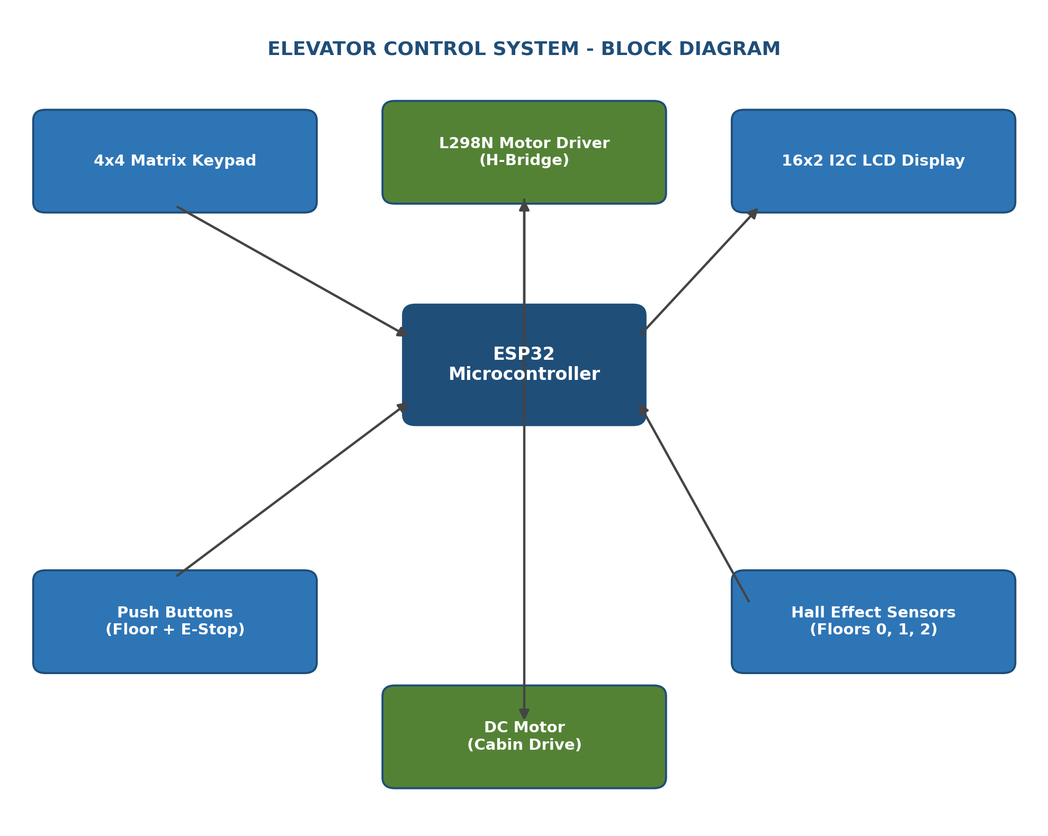
Figure 1 — System block diagram showing signal flow between the ESP32 and peripheral modules

3. Hardware Components

3.1 Motor Control System
The motor control system utilizes an L298N H-bridge driver connected to the ESP32 via three control pins:
- ENA (GPIO 23): PWM speed control signal
- IN1 (GPIO 18): Direction control line 1
- IN2 (GPIO 19): Direction control line 2
The motor direction is controlled by the logic states of IN1 and IN2, while speed is regulated through an 8-bit PWM signal (0–255) on the ENA pin. The system uses PWM channel 0 at 1 kHz frequency for smooth motor operation.

3.2 Position Sensing System
Three Hall effect sensors provide precise floor position detection. All sensors are configured with internal pull-up resistors and trigger LOW when activated. A debounce period of 80 ms is implemented to filter electrical noise, particularly important for long cable runs.

3.3 User Interface Components
- 4x4 Matrix Keypad: Provides floor selection (keys 0, 1, 2), confirmation (#), cancellation (*), and emergency stop (D). Scanned continuously using the Keypad library.
- Push Buttons: Four momentary push buttons provide direct control with hardware debouncing (50 ms) implemented in software — three floor-selection buttons and one emergency-stop button.
- LCD Display: A 16x2 character LCD with I2C interface (address 0x27) provides real-time feedback, displaying system status, floor position, and operational messages.
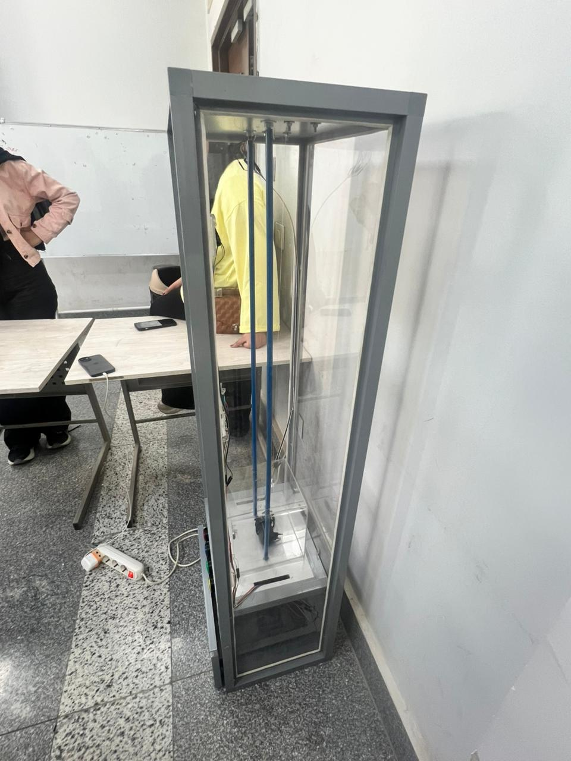
Figure 2 — Assembled elevator rig: cabin, dual guide rails, and wiring harness

4. Software Architecture

4.1 State Machine Design
The control system implements a finite state machine with eight distinct operational states, covering idle, floor selection, confirmation, ramping, full-speed travel, braking, stopped, and emergency stop.
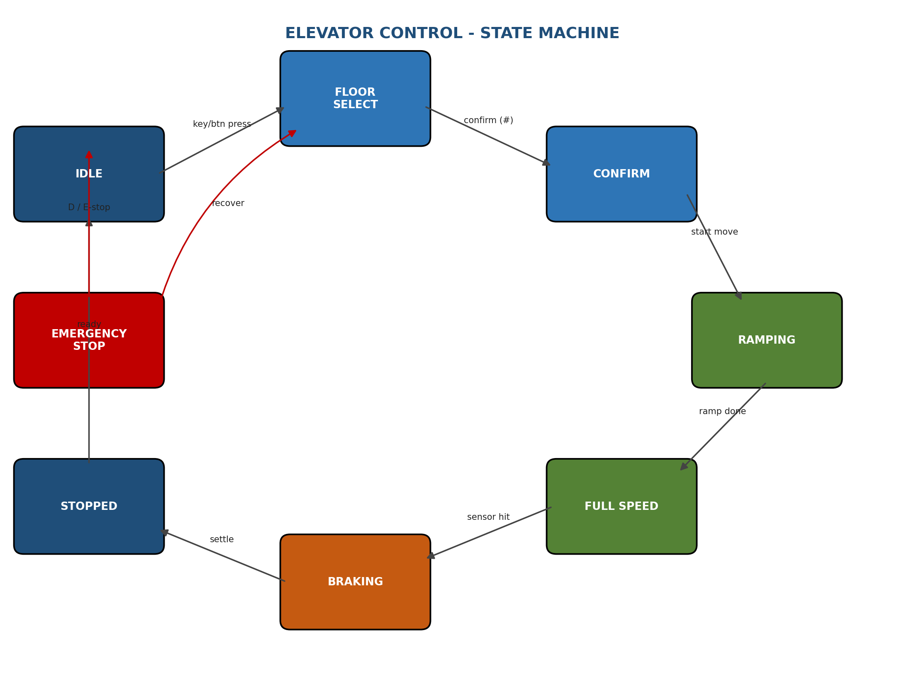
Figure 3 — Elevator control state machine and transition triggers

4.2 Control Modes
The system provides two distinct user interface modes.
Keypad Mode (Confirmation-Based)
- Press floor number (0, 1, or 2)
- System displays confirmation prompt
- Press # to confirm and initiate movement
- Press * to cancel selection
This mode provides a safety mechanism by requiring explicit confirmation before elevator movement begins.
Button Mode (Direct Control)
- Press floor button (B0, B1, or B2)
- Elevator immediately begins movement to selected floor
- No confirmation required
This mode provides rapid response for scenarios where immediate elevator dispatch is preferred.
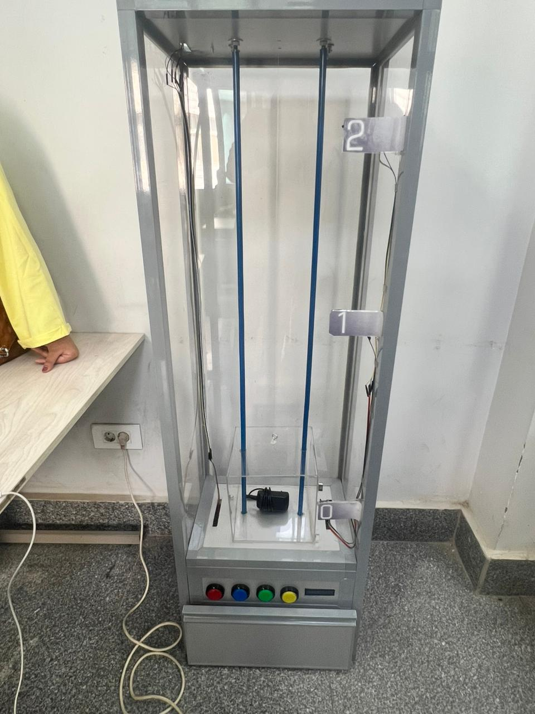
Figure 4 — Control panel with floor buttons, emergency stop, and floor indicators

5. Advanced Braking Control Algorithm
The braking control system represents the core innovation of this project, implementing a multi-stage motion profile that ensures smooth, comfortable, and precise elevator operation. The complete motion cycle consists of five sequential phases, with a total deceleration time from sensor detection to full stop of 1000 ms (1 second).
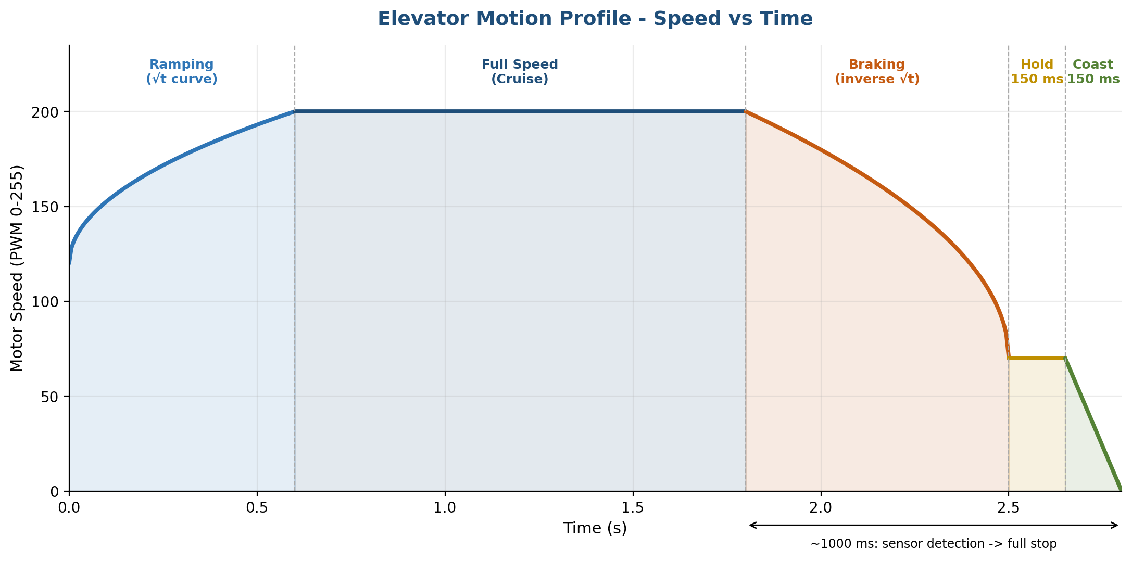
Figure 5 — Motor speed vs. time across all five motion-profile phases

5.1 Acceleration Phase (RAMPING)
The acceleration phase uses a square-root curve to provide smooth initial acceleration:
progress = t / rampTime (t = elapsed time)
curve = √(progress)
speed = rampMinSpeed + (maxSpeed − rampMinSpeed) × curve
speed = 120 + (200 − 120) × √(progress)

5.2 Deceleration Phase (BRAKING)
The braking phase uses an inverse square-root curve for controlled deceleration:
progress = t / brakeTime (t = elapsed time)
curve = 1 − √(1 − progress)
speed = maxSpeed − (maxSpeed − brakeEndSpeed) × curve
speed = 200 − (200 − 70) × [1 − √(1 − progress)]

5.3 Precision Stopping Mechanism
The final stopping phase implements a two-stage approach:
- Hold Phase (150 ms): Maintains constant low speed (PWM 70) to ensure precise positioning
- Coast Phase (150 ms): Linear reduction from PWM 70 to 0 for an ultra-smooth final stop
This dual-stage approach prevents abrupt stops that could cause passenger discomfort or mechanical stress.

6. Safety Systems

6.1 Emergency Stop System
The emergency stop can be triggered via keypad (D key) or a dedicated button. When activated during motion:
- Motor immediately stops all power
- System records origin floor and destination floor
- Current position marked as unknown
- LCD displays emergency status and recovery options
- User selects new floor to resume operation
- System intelligently determines travel direction based on last known position

6.2 Sensor and Button Debouncing
Hall effect sensors implement an 80 ms debounce period to filter electrical noise. The sensor must remain active (LOW) continuously for the full debounce period before triggering the braking sequence — preventing false triggers from electromagnetic interference, long cable runs, and momentary signal fluctuations.
Push buttons use 50 ms software debouncing to prevent bounce-induced false triggers. The debounce algorithm tracks both press and release events, ensuring clean edge detection.

6.3 Position Validation
On system startup, the elevator automatically detects its initial position by checking all three floor sensors. If no sensor is active, the system defaults to ground floor (floor 0) for safety.

7. Technical Specifications

7.1 Pin Configuration
Function | Pin | Notes
Motor PWM (ENA) | GPIO 23 | 1 kHz, 8-bit PWM, channel 0
Motor Direction (IN1) | GPIO 18 | H-bridge direction line 1
Motor Direction (IN2) | GPIO 19 | H-bridge direction line 2
Hall Sensors | 3x GPIO (pull-up) | Active LOW, 80 ms debounce
LCD (I2C) | SDA / SCL | Address 0x27, 16x2 characters
Keypad | 4x4 matrix | Floors 0–2, #, *, D (E-stop)
Push Buttons | 4x GPIO | 3 floor + 1 emergency stop, 50 ms debounce

7.2 Library Dependencies
- Wire.h — I2C communication library for LCD interface
- LiquidCrystal_I2C.h — LCD display driver with I2C backend
- Keypad.h — Matrix keypad scanning library

7.3 Key Functions
Function | Description
motorUp(int spd) | Rotates motor clockwise (upward direction) at specified PWM speed
motorDown(int spd) | Rotates motor counterclockwise (downward direction) at specified PWM speed
motorStop() | Applies active braking by setting both IN1 and IN2 HIGH
motorRun(int dir, int spd) | Unified motor control: dir = 1 for up, dir = -1 for down
goToFloor(int floor) | Initiates movement to specified floor; handles same-floor and emergency-recovery cases
checkSensors() | Monitors floor sensors during motion; debounces and triggers braking sequence
readButton(...) | Debounced button reading; returns true on valid press after debounce period
lcdSet(line1, line2) | Updates LCD only when content changes, reducing I2C traffic and flicker
showTempMsg(...) | Displays a temporary message for 2 s, then transitions to the next screen

8. Conclusion
This elevator braking control system demonstrates advanced embedded systems design principles through the integration of precise motor control, sophisticated motion algorithms, and robust safety mechanisms. The multi-stage braking algorithm ensures a smooth passenger experience while maintaining operational safety.

Key Achievements
- Implementation of mathematically derived acceleration and deceleration curves
- Precision timing control with millisecond-level accuracy
- Dual-mode user interface accommodating different use cases
- Comprehensive emergency stop system with intelligent recovery
- Robust sensor and button debouncing for reliable operation
- State machine architecture enabling clear operational flow

Future Enhancement Opportunities
- Integration of load sensors for dynamic speed adjustment
- Wireless remote control capability via Bluetooth or Wi-Fi
- Data logging for performance analysis and maintenance prediction
- Multi-elevator coordination for building-wide optimization
- Voice announcement system for accessibility
- Adaptive learning algorithms to optimize motion profiles based on usage patterns
The system demonstrates that careful attention to control algorithms, timing precision, and safety mechanisms can produce professional-grade elevator control suitable for real-world deployment.

