**CSE212 Web Programming, Fall semester 24/25**

**Assignment #1: Websites conceptual design and mock up**

**222100680 – Zeyad Walaa Eisa**

**2.3.1. Part 1: Research**

**Q.1**

**Web 2 characteristics:**User-Generated Content: Users contribute to content creation, such as posts, comments, reviews, videos, and more.With Web 2.0 platforms like Myspace, Facebook, YouTube and twitter made it easy for anyone to create and share content, regardless of technical skills. Social media democratized publishing, allowing people of all backgrounds to have a voice, share opinions, showcase talents, and reach large audiences. This shift was revolutionary because it allowed individuals to influence public opinion, promote causes, and even start movements.  
This empowerment of users to create content transformed the internet into a space of free expression.

Rich User Experiences: The concept of Rich User Experiences in Web 2.0 transformed websites into interactive, responsive environments that felt more like apps than static pages. The addition of dynamic content, real-time updates, and responsive designs created a seamless, engaging experience for users. Web 2.0 laid the foundation for the modern, app-like experiences we expect from websites today. This shift towards rich user experiences marked a pivotal point in web design and development, setting standards that continue to shape the web.

Social Media Platforms and Community Building: Web 2.0 emphasizes community, allowing users to connect, share, and interact. Social media networks, such as Facebook, Twitter, and LinkedIn, offered spaces for users to connect, communicate, and share aspects of their lives. This was a major evolution into the interactive profiles.

These platforms allowed users to create personal profiles, share updates, comment on others' posts, and build online communities around shared interests.

Interactivity and Collaboration: Users can interact with content and collaborate with others in real-time (e.g., wikis, Facebook). interactivity and collaboration create a dynamic, community-driven experience. In a wiki, one user can write an article, another user can edit it for clarity, and a third might add citations or images.

Centralization and Data Ownership: Major platforms like Google, Facebook, and Twitter store vast amounts of user data.  
In Web 2.0, users often rely on a few key platforms for daily activities (socializing, shopping, watching videos, etc.), making them dependent on these centralized services.

Users need individual accounts for each platform, leading to fragmented experiences. This dependency also makes it challenging for users to leave one platform without losing data or connections. Since data is stored centrally, breaches in a single platform can expose millions of users to privacy risks. Facebook’s data breaches, for example, have affected hundreds of millions of users.

**Web 4 characteristics:**

Intelligent Automation:

The integration of advanced AI and machine learning to provide personalized experiences and automate complex processes.

Systems will be able to learn from user interactions and adjust functionalities accordingly.

Emotional and Contextual Understanding:

Web 4.0 aims to understand user emotions and context, can deal with how quickly we can speak, allowing to having interactions and responses from the web.

This could involve analysing user sentiment through natural language processing or visual data.

Human-Computer Collaboration:

A focus on collaborative interactions between humans and machines, where AI acts as a partner rather than just a tool.

This interaction between human and machine intelligence is not just about efficiency but also about unlocking new creative possibilities.

**Q.2**

Social Media Buttons (Share, Like, Comment): These buttons are main features that let users engage directly with content by sharing or reacting to it, thereby supporting the characteristics of user participation and social networking.

APIs (Application Programming Interfaces): APIs are features that allow different software applications to communicate. They enable web applications combining multiple data sources and are essential for integrating social media or map services into websites. APIs support characteristics of collaboration by allowing different platforms to work together.

Tagging Systems and Folksonomies: Tags allow users to categorize content, creating a user-generated system of organization known as a "folksonomy." This feature supports the characteristic of personalized, user-driven content discovery by enabling users to organize content in ways that make sense to them.

**Q.3**

Data Ownership and Privacy: Web 3.0 empowers users to own their data through decentralized storage and blockchain technology and cryptocurrencies conducting peer-to-peer transactions. Decentralized Internet platform that offers consumers increased value and security.

Artificial Intelligence and Machine Learning: Web 3.0 leverages AI and machine learning algorithms to process and analyse massive amounts of data, enabling the web to learn, adapt, and make decisions. These algorithms can perform tasks like recognizing patterns in data, understanding natural language, and generating predictions.

Edge computing: Is a critical technology that processes data closer to the source of data generation, rather than relying on centralized data centres. This localized approach to data processing improves speed, reduces latency, and enables more efficient and secure interactions.

Blockchain and Smart Contracts: Blockchain technology underpins Web 3.0, allowing for transparent, fixed records of transactions and interactions. Smart contracts, which are self-executing contracts with the terms of the agreement directly written into code, automate transactions in a decentralized way.

Web 3.0 enables meaningful data connections through decentralized, trust-based networks and advanced AI-driven insights. It promotes user-centric data control, cross-platform knowledge integration, and personalized experiences, fostering a more intelligent, connected, and user-driven internet.

**Q.4**

Virtual and Augmented Reality (VR/AR): Web 4.0 is expected to integrate VR/AR into everyday online experiences, enabling users to interact with digital environments in a more immersive and intuitive way. This could lead to the development of a pervasive metaverse where the digital and physical worlds blend seamlessly.

Artificial Intelligence and Machine Learning Integration: Web 4.0 envisions advanced AI that can proactively assist users by anticipating their needs, based on context, history, and preferences. These digital assistants will be capable of autonomous decision-making, operating on behalf of the user.

Semantic and Contextual Understanding: Building on the semantic capabilities of Web 3.0, Web 4.0 aims to further understand and interpret complex human language. This includes not only understanding meaning but also context, and intent. Also, NLP (natural language processing) advancements will enable machines to understand and communicate in multiple languages more accurately.

Enhanced Security, Privacy, and Trust Mechanisms: Web 4.0 will aim for built-in privacy mechanisms where users can control and limit data sharing. Privacy-focused features will be embedded into digital products and services as default. Building on blockchain technology, Web 4.0 will rely heavily on trust less transactions and fixed smart contracts, allowing individuals and organizations to transact with minimal risk and without intermediaries.

Web 4.0 represents a transformative leap forward in how we interact with the digital world, characterized by a symbiotic relationship between humans and technology. Through the integration of AI, BCIs, IoT, and immersive technologies, Web 4.0 will enable more intuitive, personalized, and secure experiences, reshaping our engagement online with each other.

**Q.5**

Collective intelligence, social networking, social media, and social bookmarking are interconnected concepts that play significant roles in how information is shared, created, and utilized.

Collective Intelligence: Enhanced Problem Solving by gathering diverse expertise to tackle complex issues. Enhance innovation and new ideas through collaboration. Allows for real-time feedback, enabling rapid adaptation. Democratizes knowledge, giving a platform to various voices allowing inclusivity.

Social Networking: Connection Building by facilitating relationships and community engagement globally. Enables quick sharing of news and ideas, raising awareness. Supports professional networking for job growth and collaborations. It also provides a space for direct audience engagement.

Social media: Breaks geographical barriers, fostering cultural exchange. User-Generated content empowers individuals to create and share diverse media. Businesses can build brands and engage customers directly. Mobilizes support for social causes and raises issue awareness. Social Bookmarking: Helps users find high-quality information through community recommendations. Organizes online resources for easier retrieval. Enhances Collaboration by Enabling shared resources among groups with common interests.

These elements enhance communication, collaboration, and knowledge sharing enhancing innovation and promoting social engagement.

**Q.6**

Collective intelligence, social networking, social media, and social bookmarking significantly empower current and future business plans by enhancing innovation and creativity through diverse perspectives, enabling informed decision-making with crowd-sourced insights, and enhancing agility to adapt to market changes. Social networking expands connections with potential clients, partners, and influencers while facilitating direct communication that builds customer loyalty. Social media promotes brand awareness and effective marketing campaigns, allowing for real-time interaction and providing valuable analytics on consumer behaviour that refines strategies. Meanwhile, social bookmarking enhances authority in the industry, improves collaboration through efficient resource management. Together, these technologies enhance innovation, engagement, collaboration, and marketing effectiveness, positioning businesses for success in a digital landscape and enabling adaptation to evolving market demands.

**Q.7**

I would use the latest technologies to create responsive, interactive, and secured websites that deliver top-tier user experiences. AI-driven tools to enable adaptive designs and personalized content. Integrating AR/VR brings immersive elements, especially valuable in e-commerce, while blockchain provides added security for decentralized applications. Accessibility features, progressive web apps, and 3D graphics ensure sites are inclusive, mobile-friendly, and visually dynamic. Finally, no-code tools and automation streamline the design process, allowing for faster prototyping and improved client collaboration. This approach aligns with modern web standards and positions clients to stand out in a digital-first world.

**2.3.2. Part 2: Website planning**

**Q.1**

This website is a platform for selling curated perfumes. The goal is to offer an elegant and enjoyable shopping experience for people seeking high-quality perfumes, allowing users to explore a wide range of fragrances and easily purchase them online.

**Q.2**

Generate sales by providing a well-designed online store.

Establish brand trust by offering detailed product information and a secure checkout experience.

Build a loyal customer base by offering unique fragrances and providing a memorable online shopping experience.

**Q.3**

Individuals aged 18-50 who enjoy perfumes or are shopping for them as gifts. This group may include people interested in high-quality or luxury products and those who value a curated selection of scents.

**Q.4**

Opportunities:

* Allows customers to shop for high-quality perfumes from the comfort of their homes.
* Provides a platform for lesser-known brands that may not have physical storefronts.
* Helps users discover new fragrances through recommendations or scent profiles.

Problems Addressed:

* Customers often feel overwhelmed when shopping for perfumes in stores and may not find the time for an in-person experience.
* Finding a personalized fragrance is challenging; the website could use filtering options to help users narrow down choices.

Issues:

* Trust in Online Purchasing: Ensuring a safe, user-friendly, and transparent experience to encourage users to make a purchase without physically smelling the products.

**Q.5**

* Product Pages: Detailed pages with descriptions of each perfume, images, fragrance notes, sizes, and prices.
* Customer Reviews: User-generated content to help potential customers make informed decisions.
* FAQs: Covering shipping policies, return policies, and other common questions.
* About Us Page: Information about the brand, values, and unique selling points (e.g., sustainable sourcing or exclusive brands).
* Contact Information: Phone number, email, and chat options for customer service.
* Special Offers or Newsletter: Sign-up section for updates, promotions, and product launches.

**Q.6**

UX: Easy to navigate-where, within minutes, one would search, locate, and buy the product.

Tailor-made recommendations: filters and search options provide the chance to find perfumes suitable to a taste.

The trust will be built because detailed descriptions of the product will help clients who are not very comfortable buying online get confidence in fragrance sales.

**Q.7**

Easy Navigation and Search: A well-organized menu structure and search filters based on fragrance family, brand, or price.

Quick and Secure Checkout: Minimal steps in the checkout process with trusted payment options.

Clear Call to Action (CTA) Buttons: Prominent “Add to Cart” and “Buy Now” buttons to guide users toward completing purchases.

Wish List Feature: Let users save perfumes they’re interested in and may want to purchase later.

Cross-Selling Suggestions: Display related perfumes or products on product pages to encourage exploration and increase sales.

**Q.8**

Intuitive Design:

* Navigation Bar: A simple, top-level navigation menu with categories like “Shop All,” “New Arrivals,” “Best Sellers,” and “Gift Sets.”
* Search Bar: A visible search bar where users can type in keywords (e.g., “floral perfume” or “vanilla scent”).
* Filters on Product Pages: Filters for fragrance type, brand, and price range make it easy to find specific perfumes.

Clear Visual Cues: Icons and buttons with labels like “Add to Cart,” “View Details,” and “Check Out” to simplify actions.

Mobile-Responsive Design: The website should work seamlessly on mobile devices, allowing users to shop on the go.

Help Options: Chat or help options accessible from every page so users can easily ask questions if they need guidance.

**Q.9**

Confirmation and Notifications: Once users make a purchase, they should receive an order confirmation on the website immediately after checkout, followed by an email or SMS confirmation.

User Feedback: If users are using a filtering or search function, the website should instantly display matching products or results, giving users immediate feedback on their actions.

Real-Time Updates: If any product is out of stock or unavailable, users should see this in real time to avoid disappointment at checkout.

**Q.10**

User Orders: For each purchase, user data, product details, and shipping information will be securely stored in the database. This data will be used to process the order, generate shipping labels, and prepare for delivery.

User Accounts and Preferences: If users create accounts or save items to a wish list, this data can be stored and later used to provide personalized recommendations or exclusive promotions.

Newsletter and Marketing: Users who sign up for the newsletter can be added to an email list, allowing the business to send marketing emails, updates, and exclusive offers.

**Q.11**

Order Processing: Orders will be processed by the backend system, which will communicate with a fulfilment team or service to pack and ship the items.

Customer Support: Any support requests or feedback will be monitored and addressed by the customer service team, creating a continuous improvement cycle for the website’s user experience.

**Q.12**

Order Updates and Tracking: These are emails or text messages regarding dispatch details of products ordered by a customer.

Post-Purchase Engagement: Follow-up emails after users receive their products will help ask for reviews, offer feedback, or even suggest products based on previous purchases.

Customer Retention: It can be retained either by follow-up emails, offering exclusive discount, or even enrolling customers through a loyalty program.

Feedback Collection: Periodically, it reaches out to customers through satisfaction surveys or reviews that help in the improvement of the website, its products, and services based on real customers' experiences.

**Q.13**

Sephora ([www.sephora.com](http://www.sephora.com)): Known for its user-friendly and professional design, which makes browsing easy.

Offers advanced filters, enabling users to find perfumes based on fragrance type, brand, and price, which simplifies decision-making.

Features customer reviews and personalized recommendations that build trust and encourage additional purchases.

Fragrantica ([www.fragrantica.com](http://www.fragrantica.com)): Specializes in perfumes, providing in-depth fragrance details, brand history, and scent compositions, making it a trusted resource for fragrance enthusiasts.

Encourages community engagement through user reviews and discussions, creating a loyal, interactive user base.

Helps users discover new fragrances with educational tools and scent categorization, making it easier to choose perfumes online.

**Q.14**

**a. Website Goal**

The goal of this website is to provide an elegant and user-friendly platform for selling curated perfumes. It aims to:

* Offer an enjoyable and informative shopping experience.
* Educate users on selecting fragrances.
* Build trust and customer loyalty through detailed product descriptions, reviews, and secure purchasing.
* Drive sales by making the buying process seamless and engaging.

**b. Working Title of Website Pages (Excluding Home Page)**

1. All Perfumes
2. Wishlist
3. About Us
4. FAQs
5. Contact Us
6. My Account
7. Shopping Cart

**c. Page Content Descriptions**

Home Page: Engaging visuals showcasing featured perfumes and seasonal promotions. Links to main categories like “All Perfumes” and “Wishlist” are prominent. It also includes a call-to-action for creating an account.

All Perfumes: Displays all available perfumes in a grid or list view. Includes filtering options (e.g., by price, scent family, brand). Each perfume has an image, short description, price, and an “Add to Cart” or “Add to Wishlist” button.

Wishlist: A page where logged-in users can save perfumes for future reference. Each item has an “Add to Cart” option and can be removed from the list. Ideal for users comparing scents or saving items for a future purchase.

About Us: Information on the brand's history, values, and mission. May include team photos, a brief video introduction, or a section on sustainable practices. Helps build trust with customers by sharing the story behind the store.

FAQs: Answers to common questions about product quality, returns, shipping, and payment. This page reduces user hesitation by addressing concerns upfront, improving the user experience.

Contact Us: A simple contact form (with fields like name, email, and message) and direct contact details, including email and phone. Social media links and a physical address (if applicable) can also be added. Provides a way for users to reach out with any questions or concerns.

My Account: User dashboard for account settings, order history, and saved addresses. Users can view past orders, track current orders, and update personal information. This page allows users to manage their account details easily.

Shopping Cart: A summary of selected items, including item names, prices, and quantities. Users can adjust quantities or remove items. Displays a total price with options to proceed to checkout, apply discount codes, and estimate shipping fees.

**d. Forms for Information Collection**

* Contact Form: Located on the “Contact Us” page, where users can submit inquiries. Includes fields for name, email, and message.
* Wishlist: Requires users to create an account or log in to save perfumes. By creating an account, the system can track their saved items for future access.
* Account Registration/Login Form: Allows users to create an account on the “My Account” page, with fields for name, email, and password.
* Product Reviews: Users can submit reviews (possibly under each product in “All Perfumes”) with a simple form that includes fields for rating, comments, and possibly an image upload.

**e.**

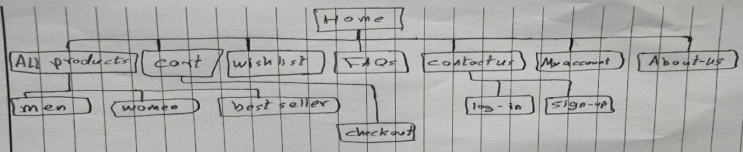**f. Wireframes for Each Page**

1. Logo: Placed in the top-centre , linking back to the Home Page.
2. Navigation Menu: Horizontal menu with links to main pages (All Perfumes, Wishlist, About Us, FAQs, Contact Us, My Account).
3. Content Region: The primary content area will differ for each page:
   * Home Page: Visual banner, featured products, and links to categories.

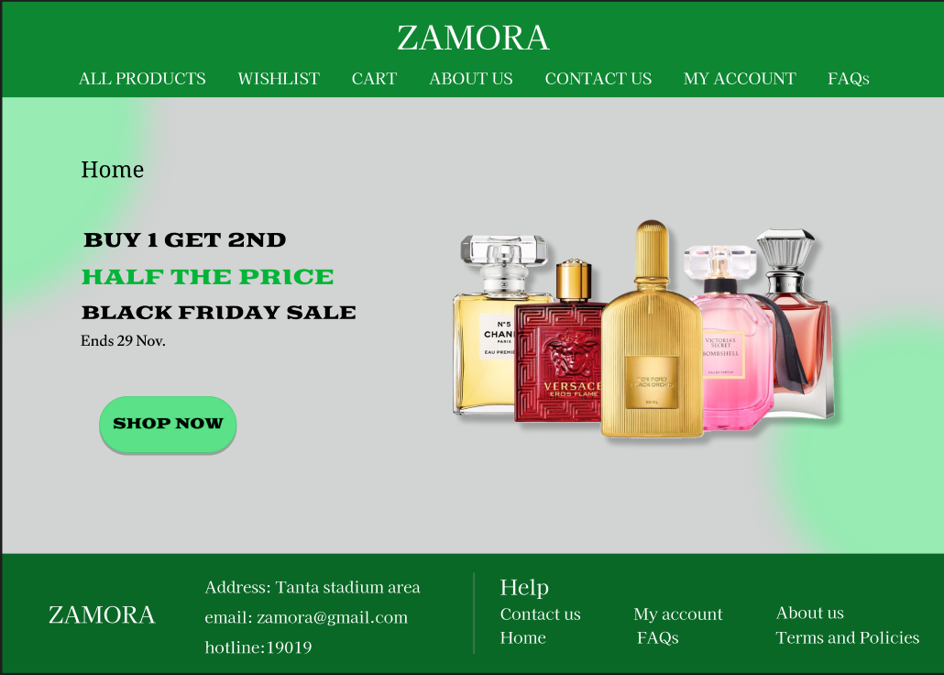

* + All Products: Grid of product listings with filter options.

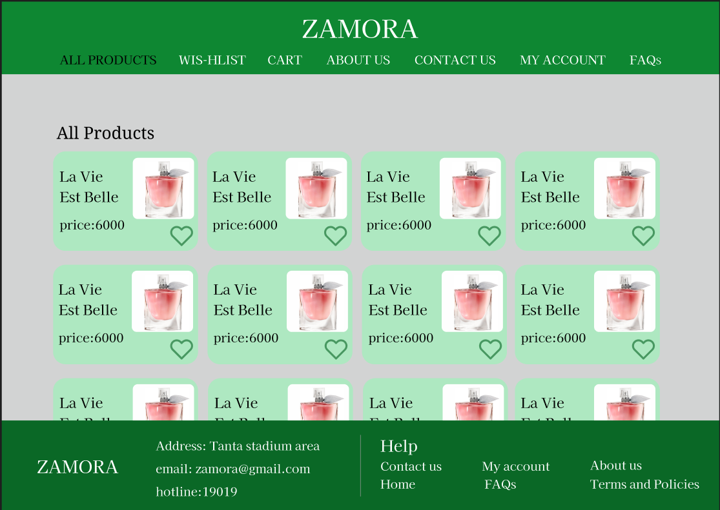

* + Wishlist: Grid of saved items for logged-in users.

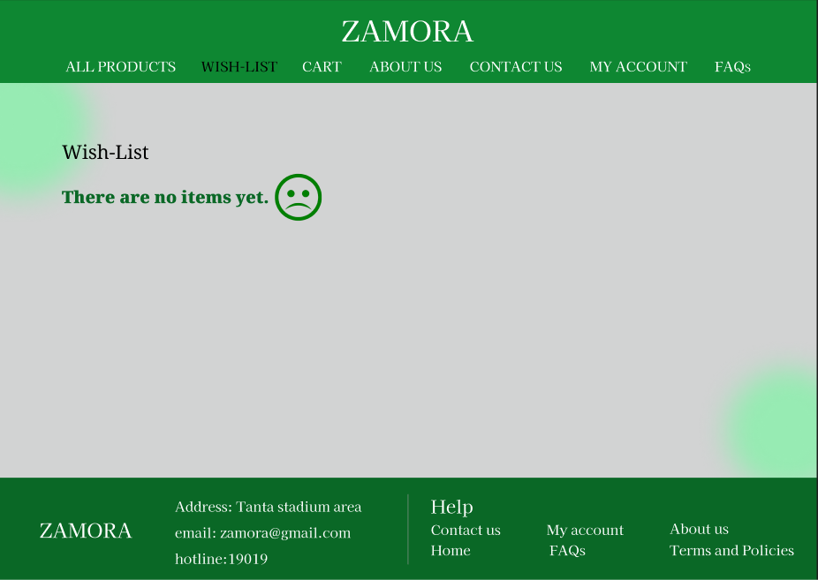

* + About Us: Text and images about the brand’s story.

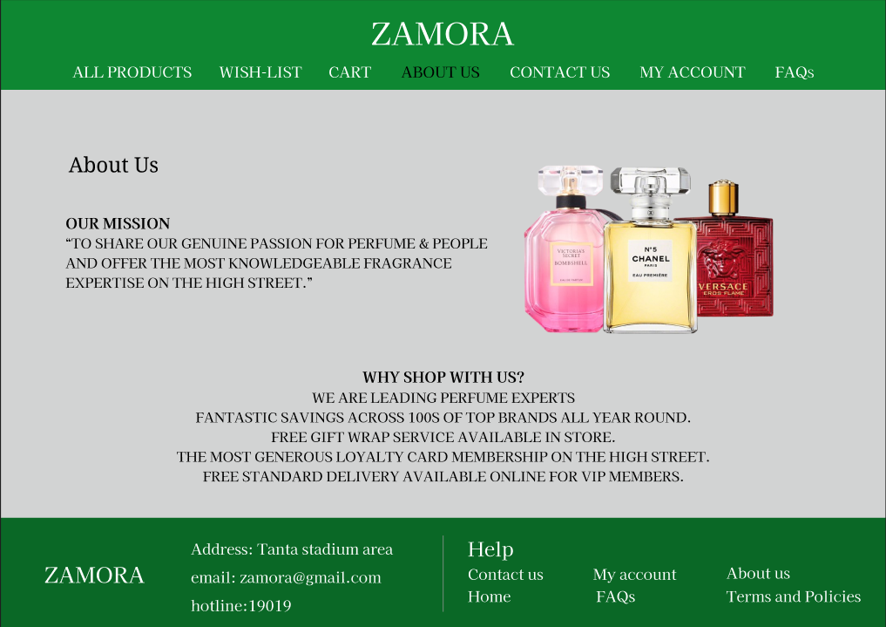

* + FAQs: List of common questions with expandable answers.

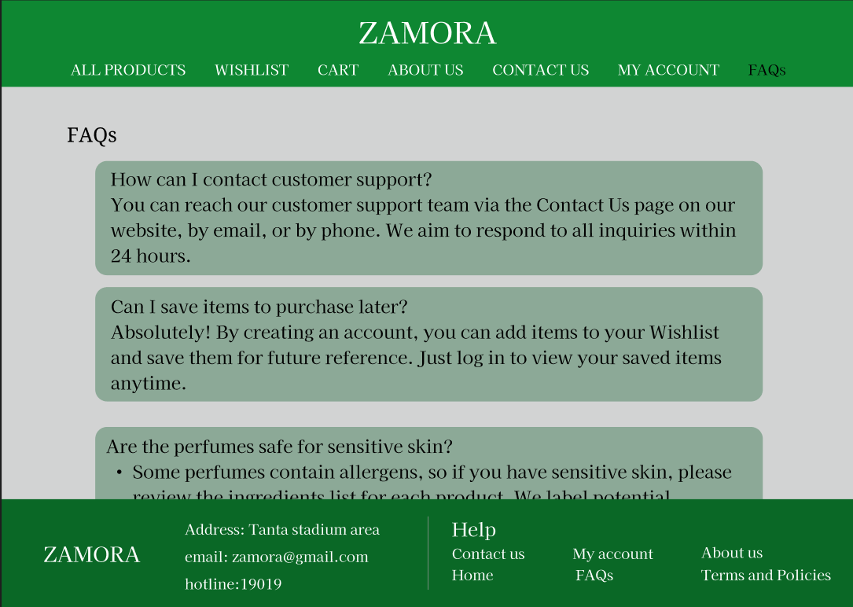

* + Contact Us: Contact form and company contact information.

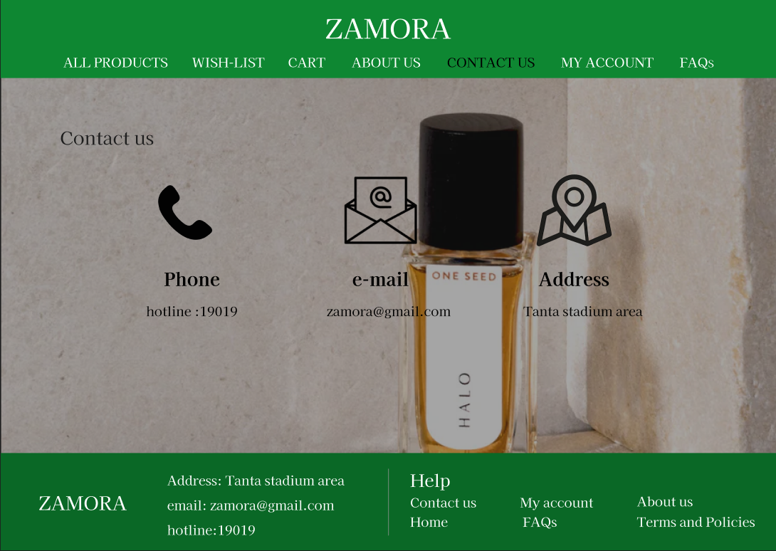

* + My Account: User account dashboard showing order history and settings.

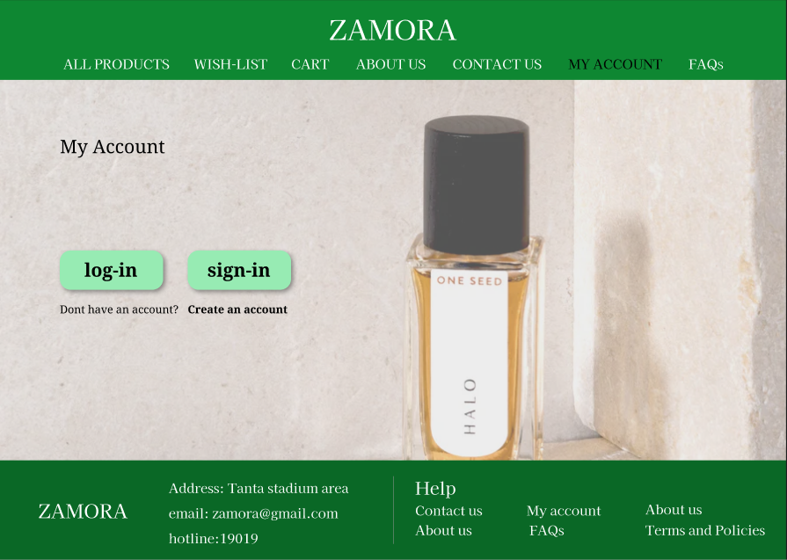

* + Shopping Cart: Summary of selected items with total price and checkout button.

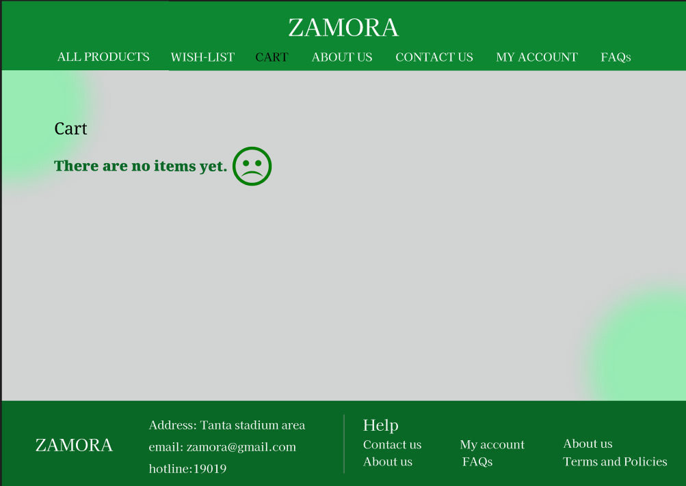

1. Footer: Consistent across all pages with links to FAQs, Contact Us, About Us, social media, and newsletter signup.

**2.2.3. Part 2: Website design**

**[A]**

**Q.1**

Employ neat and minimalistic design to make it not only functional but also nice looking. Therefore, the product pages and other navigation elements within the website should become simple, straightforward, and enable users to focus on products - perfumes.  
**Q.2**

Arrange images and content of products to let intuitive relationships between items immediately emerge visually and put across a cohesive experience. For instance, products with similar scents or categories place the product family together for the customer.

**Q.3**

Create a balanced, grid-based layout for product listings and content sections. This gives the site a polished, orderly look that’s easy to follow, making it pleasant for users to browse.

**Q.4**

Use contrasting colours or shadows to make product images and essential buttons (like “Add to Cart”) stand out from the background, helping users focus on the main elements.

**Q.5**

Apply consistent colours and fonts across the website, especially for elements like buttons or product titles. This creates a unified feel, linking sections like “All Products” and “My Account” as parts of a cohesive experience.

**Q.6**

Employ borders, frames, or background colours to visually group together merchandise or information of similar nature. For example, new arrivals or bestsellers can be highlighted within a bordered section.  
**Q.7**

Place related information, such as product descriptions, prices, and ratings, close to each perfume image. This ensures users easily understand the relationship between details without searching around. (e.g., best seller, men, women)

**Q.8**

Guide the user's eye naturally across the page through the use of aligned elements or breadcrumb navigation. This could help users seamlessly go from browsing items to adding them in their cart.

**Q.9**

Present promotional items or collections (e.g., seasonal fragrances) in a way that groups them visually, creating a sense of unity and emphasizing a shared theme.

**Q.10**

Align text, images, and product sections in parallel rows or columns. This reinforces order and structure, making it easy for users to scan through products.

**Q.11**

Keep similar design elements, like icons, colours, and fonts, across related pages (e.g., Wishlist, Cart, and My Account) to maintain visual coherence.

**Q.12**

Use familiar icons and navigation cues, such as a shopping cart icon or a search bar, to make the site intuitive for users who have experience with other online stores.

**[B]**

**Q.1**

1440x1024

**Q.2**



**Q.3**

4.5:1

**Q.4**

HTML because it is the backbone of any website, CSS to control website formatting and layout, JavaScript to enable interactive element on the website.

**Q.5**  
Shopify, Wix, and Squarespace are ideal, offering easy setup, customizable themes, and built-in e-commerce tools. WordPress with WooCommerce and Magento are more powerful, providing advanced customization options for those with technical skills. Each CMS allows you to showcase products, manage inventory, and handle payments, making it easy to launch and grow your online store.

**Q.6**

PHP for developing web pages and web applications, Laravel to provide a built-in user interface, flexibility, creativity.

**Q.7**

I am going to use benchmark to measure website performance.

**Q.8**

<!DOCTYPE html>

<html>

    <body>

        <h1>Zamora</h1>

        <ul>

            <li><nav><a href="about.html">About Us</a></nav></li>

            <li><nav><a href="contact.html">Contact Us</a></nav></li>

            <li><nav><a href="allprod.html">All Product</a></nav></li>

            <li><nav><a href="cart.html">Cart</a></nav></li>

            <li><nav><a href="wishlist.html">Wish-list</a></nav></li>

            <li><nav><a href="myacc.html">My Account</a></nav></li>

            <li><nav><a href="faqs.html">FAQs</a></nav></li>

        </ul>

        <h3>Welcome to Zamora</h3>

        <p>Welcome to Zamora,We specialize in luxurious perfume </p>

        <h3>Latest sales</h3>

    </body>

 </html>

**Reference:**

<https://www.figma.com/design/x5z0026GdqCyBNJBZBMFXk/Assignment1?node-id=0-1&t=oXbWyqPdRpPc1zo4-1>