HyperInvest — Systematic Funds, News Sentiment, and a Learning-by-Doing Practice Area
FINS3645 Project B · z5538441 · 2026
Evidence, not advice.

1. The funds and the backtest design
HyperInvest is an investment app, which offers 12 systematically managed funds and one sentiment-tilted variant designed for the fusion analysis in Section 4. Investors open the app, compare the out-of-sample historical performance of each fund, read the fund fact sheets, and then decide how to allocate their capital. The funds are the product, and since the products are marketed based on evidence, every performance figure in this report and in the app is out-of-sample. None of them are in-sample fits packaged as results.
HyperInvest offers a complete matrix of funds: three asset families crossed with construction methods. The asset families are the mixed portfolio (50 U.S. large capital stocks spanning ten industries and 10 cryptocurrencies, for a total of 60 assets); the pure stock portfolio; and the pure cryptocurrency portfolio. The methods are equal-weight, minimum-variance, maximum-Sharpe, and risk parity. The coverage of each asset class by each method is intentional: the matrix allows users to separate two key issues: what the method changes and what the asset class changes. Each combination of asset class and method represents an independent, investable fund, as these are the units users purchase and that are described on the fact sheet.
The 12 funds apply four construction rules, which are listed below, and the sentiment tilt is separated from the thirteenth variant and is not part of the matrix.
- Equal-Weight: Each asset holds the same weight, reset monthly. No predictions are made; this serves as a simple benchmark for evaluating other methods.
- Minimum-Variance: Selecting the weight combination with the lowest total variance within the estimation window.
- Maximum-Sharpe: Selects the portfolio with the highest return per unit of volatility within the estimation window.
- Risk Parity: Ensures that each asset contributes equally to the portfolio’s total risk; assets with lower volatility are given higher weights, while those with higher volatility are underweighted.
- Equity + Sentiment Tilt: Uses the Equity Max-Sharpe weights as a baseline and adjusts based on the tone of industry news. This strategy was the subject of the fusion experiment in Section 4 and was evaluated separately from the 12 main funds.
In the app page, reading the matrix vertically reveals changes in methodology and horizontally reveals changes in the asset pool. The fund name represents the rule of construction rather than a randomly assigned label.
Each fund in HyperInvest is evaluated using the same rolling out-of-sample walk-forward backtest. Weights are rebalanced on the last trading day of each month, using only returns from the past 252 trading days. The estimated slices exclude returns from the rebalancing date itself, ensuring that information from that day and beyond does not influence the weights. Between rebalancing events, holdings drift with market prices, just as they would in a real fund; the out-of-sample period begins only after the first complete estimation window ends: for the fund on the equity calendar, this spans from 1 February 2021 to 29 December 2023, totaling 734 trading days.
Calendar handling is a common trap in hybrid stock-crypto products. There are approximately 252 trading days per year for stocks and about 365 days for cryptocurrencies. In HyperInvest, returns are first calculated based on their respective calendars, then the cryptocurrency return is left-merged onto equity trading date. The weekend cryptocurrency price movements were excluded because funds that rebalance on stock trading days cannot act on weekends anyway. Annualized figures are also calculated separately: funds that include stocks use 252 days, while pure crypto funds use 365 days. The pure cryptocurrency funds follow their own daily calendar, so their out-of-sample period begins earlier, starting on 1 October 2020 for a total of 1,187 valuation dates. If the crypto funds were also annualized with 252 days, the annualized volatility would be off by about 20%, so the two calendar systems are never mixed.
There are three designs for HyperInvest. First, all funds are long-only, with weights summing to 1. Since this product is aimed at beginners, short selling is difficult to explain and unnecessary. Second, the Sharpe ratio uses a zero risk-free rate, and the backtest assumes zero transaction costs; these two simplifications will be discussed in a later section. Third, the maximum-Sharpe portfolio is not computed by optimizing the ratio directly; instead, it was calculated using an equivalent convex optimization form, with covariance estimates subject to shrinkage. The method was changed because direct optimization had silently stalled on every equity estimation window without reporting an error. The issue was discovered during a cross-method weight comparison: two funds that should have been different produced identical weights; this check now runs with every build. The framework follows standard practice. The switch to a convex optimization form and the covariance shrinkage are two added modifications to ensure numerical stability.
The backtest is based on a dataset covering 2020 through 2023, comprising 50,300 rows of stock data and 14,620 rows of cryptocurrency data. The completeness audit found no missing trading days or duplicate prices. Approximately 2,850 rows of completely duplicate news headlines were removed before counting. All extreme returns were retained and recorded. For example, on 9 March 2020, an energy stock fell 52% in a single day; removing actual market crashes would make all risk metrics look better, but that would be misleading. The early data preparation stage also mapped each news headline to its corresponding trading date and retained the original wording, which serves as the input for the sentiment model in Section 3.

2. Out-of-sample results and fund fact sheets
Fund | Ann. return | Ann. volatility | Sharpe | Max drawdown
Combined Equal-Weight | 14.8% | 21.1% | 0.76 | -28.7%
Combined Min-Variance | 6.7% | 12.7% | 0.57 | -15.6%
Combined Max-Sharpe | 17.2% | 22.2% | 0.83 | -27.3%
Combined Risk-Parity | 14.1% | 15.9% | 0.91 | -19.9%
Equity Equal-Weight | 13.3% | 16.2% | 0.86 | -20.3%
Equity Min-Variance | 6.0% | 12.7% | 0.52 | -15.5%
Equity Max-Sharpe | 9.8% | 17.9% | 0.61 | -27.6%
Equity Risk-Parity | 10.6% | 14.6% | 0.76 | -18.6%
Crypto Equal-Weight | 51.9% | 81.0% | 0.93 | -81.6%
Crypto Min-Variance | 86.9% | 66.3% | 1.28 | -71.1%
Crypto Max-Sharpe | 14.0% | 77.2% | 0.56 | -85.9%
Crypto Risk-Parity | 57.5% | 78.8% | 0.97 | -79.7%
Equity+Sentiment Tilt | 9.2% | 18.1% | 0.58 | -26.9%
Table 1 — Out-of-sample performance by fund: annualized return and volatility, Sharpe ratio (risk-free rate 0) and maximum drawdown. Equity-calendar funds Feb 2021 – Dec 2023 (734 days); pure-crypto funds from Oct 2020 (1,187 days) on their own calendar. Zero transaction costs
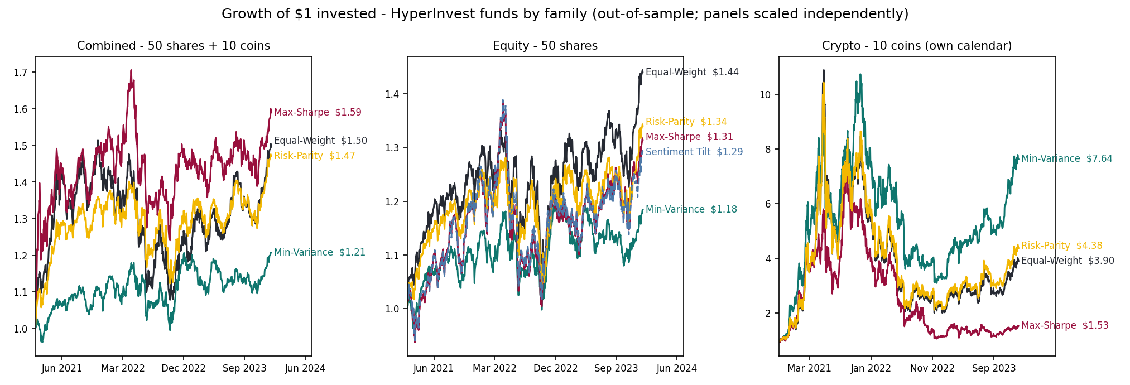
Figure 2 — Growth of $1, one panel per asset family (thirteen funds incl. the tilt variant); method colors are shared across panels, line ends carry terminal values, panels scaled independently (Feb 2021 – Dec 2023; pure crypto funds from Oct 2020).
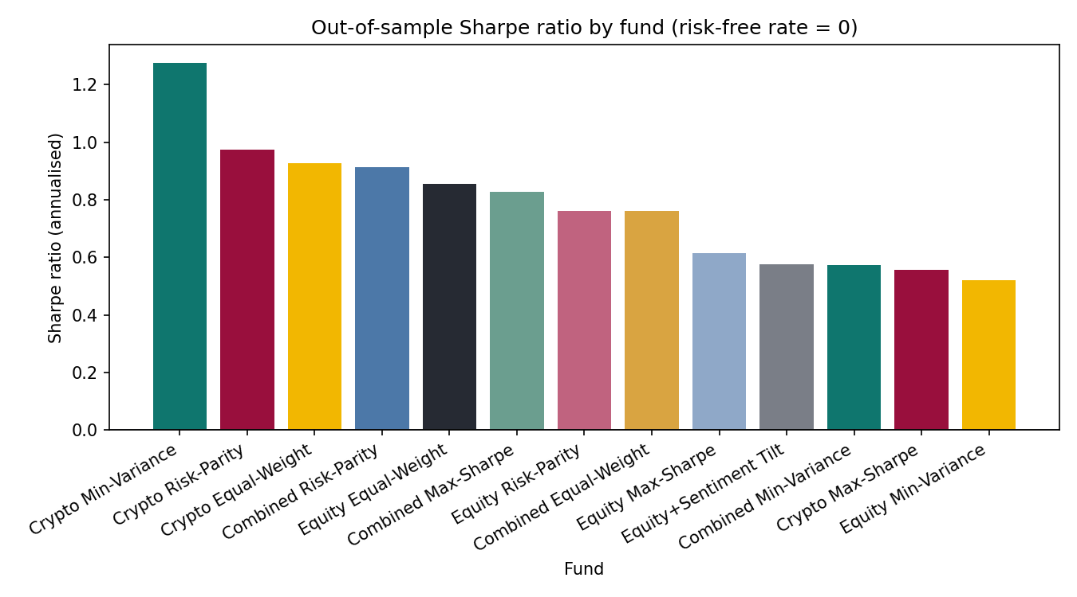
Figure 3 — Out-of-sample Sharpe ratio by fund (risk-free rate 0), same periods as Exhibit 1.
In this section, Table 1, Figure 2 and 3 summarize the out-of-sample performance of all funds over a three-year period. The conclusion is that asset classes determine the extremes, while investment strategies determine the shape of the performance curve. The highest Sharpe ratio across the entire portfolio came from the Crypto Min-Variance fund at 1.28, driven by an annualized return of 86.9% against a volatility of 66.3%. However, the deepest drawdown was also found in the crypto category, with the same fund experiencing a maximum decline of 71.1%. Looking at the hybrid category, the Combined Risk-Parity had the highest Sharpe Ratio at 0.91, with a return of 14.1% and volatility of 15.9%. Combined Max-Sharpe ratio delivered the highest return at 17.2%, but also experienced the deepest drawdown of -27.3%, which occurred on 30 September 2022. Combined Min-Variance was the most stable fund across the entire portfolio, with the volatility of only 12.7% and a maximum drawdown of -15.6%, though at the cost of the lowest return in the combined family at 6.7%.
The Growth of $1 plot illustrates the same numbers in more direct terms. The $1 of Combined Max-Sharpe reaches $1.59, Combined Min-Variance grows to $1.21, and Crypto Min-Variance rises dramatically to $7.64. However, the peak and bottom points of cryptocurrency are both far beyond those of other families. The maximum drawdown in Table 1 shows that Crypto Max-Sharpe experienced its largest drawdown of 85.9% from the previous peak. By looking at the return rate individually, users would not recognize that holding those funds requires accepting a drawdown of around 70% to 86%.
The matrix also explained the question of whether adding cryptocurrency to the stock pool would make the performance of the fund better or not. Using the same method to measure the Sharpe ratio of equity-only and combined funds together, the result shows that all three optimized methods improved. The Maximum-Sharpe increased from 0.61 to 0.83, the minimum variance saw a slight increase from 0.52 to 0.57, and the risk parity rose from 0.76 to 0.91. However, the performance of the Equal-Weight fund worsened, dropping from 0.86 to 0.76. The reason is that no matter what the risk is, the Equal-Weight fund always places one-sixth of the portfolio in cryptocurrency, whereas the optimization methods can determine the allocation on their own. Therefore, the conclusion is conditional: whether including cryptocurrency improves performance depends on whether there is a rule to determine its allocation.
Appendix A2 shows the monthly target weight of the Combined Max-Sharp; first, the portfolio is highly concentrated, and there are some months when one asset holds more than half of the portfolio. Second, the holding is unstable; the colored bands in the plot change almost every month. Additionally, in Appendix A2b, the situation for Crypto Max-Sharpe is more extreme; there are months when the plot only shows a single color, which indicates the portfolio only has a single coin, and the next month it switches entirely to another one. The turnover of these two funds is relatively high; the performance in the sample is achieved by frequent rebalancing. The actual switching has real costs, which will be discussed in detail in Section 6.
Each fund in the app has a page of fact sheet, which converts the evidence into a form users can read. The fact sheet has four core metrics, a $1 growth chart and a drawdown chart, target weights for each rebalancing, and the current portfolio holding. For those funds with virtually unchanged weightings, the app omits the weight chart and provides an accurate, simple explanation instead. The fact sheet also includes a construction section that answers the potential question or concern from users: is the fund simply a name, or is there a clear set of rules behind it? The professional mode shows the mathematical formula for those experienced investors, while Plain English mode illustrates the rules by using the fund’s own latest figures. For example, a Combined Equal-Weight fund states that each asset accounts for 100% divided by 60, which is 1.67%. Equity Max-Sharpe states that it currently holds only 7 out of 50 stocks. The sidebar also features a fixed section explaining how every fund is built, which introduces the construction process common to all funds. Each paragraph concludes with a reminder, which is included to prevent misunderstanding: This describes how the fund is constructed; it is not a promise of future results.
Figure 3 sorts the 13 funds by Sharpe ratio from highest to lowest; the top three are all crypto funds. Specific values are in Table 1. This ranking should be read together with Figure 2: the rebound of crypto funds in 2023 pushed their Sharpe ratios to the top. This is the result for this sample; the rankings might be different in another time period. This is also why each comparison table in the app always has a sentence indicating that the sorting only changes the order, not the quality of funds.
Three conclusions could be drawn from these charts together. First, the extreme values are all concentrated in the crypto family, such as the highest returns, and within each group, the risk profiles of the four methods vary significantly. Second, adding cryptocurrencies helps all optimization methods but harms the Equal-Weight fund. Third, no single metric can rank all funds. The Crypto Min-Variance, with the highest Sharpe ratio, also has a maximum drawdown of -71.1%, while the most stable fund in the mixed group, Combined Min-Variance, has the lowest return within its group, at only 6.7%. Which fund to choose depends on the investor, and the numbers provide supporting evidence to help investors make their own decisions.

3. The news-sentiment index
In addition to funds, HyperInvest also uses news data to create an independent analysis tool, the daily sector sentiment index for each of the ten stock industries. The raw material is 149,683 news headlines for 50 stocks from 2020 to 2023. Note that there are only headlines and no article text, so this index reads the wording of the title, not the substance of the news. Before modeling, a two-step cleaning process was performed. The first step is to remove duplicates and delete duplicate rows with the same ticker, date, and title, a total of 2,847 rows. The second step is to map each title to its trading day. If the day is a trading day, it will be counted as that day. Otherwise, it will be counted as the next trading day. The 6 titles after the last trading day could not be mapped to the next trading day and can only be discarded. After two steps, 146,836 headlines were left to enter the model.
The model uses VADER, which is a rule-based sentiment scoring tool, and there is also an extra financial dictionary in HyperInvest, totaling 115 words. The reason is that the original VADER vocabulary comes from social media, and it doesn’t include many financial terms; there were 4,000 headlines, and 48.5% scored zero in the original VADER. A zero score does not mean the news article lacks information. For example, words like “beat” and “downgrade” have clear meaning in financial news, but they do not get a score in a general dictionary. The dictionary in HyperInvest assigns these words scores according to VADER’s conventions, ranging from -4 to +4, with the sign indicating the direction and the absolute value indicating intensity. Every word in the dictionary was manually checked because AI-suggested dictionaries can make mistakes, such as marking neutral terms like “liability” and “debt” as negative. When scoring, the headlines are left as is, without cleaning for capitalization or punctuation; negation words are also part of VADER’s rules: cleaning them would lose information.
The process from headline score to industry index involves five steps.
- First, the headline scores for the same stock on the same day are averaged to obtain a daily score for each stock.
- Second, a 5-day exponential moving average (EMA) is applied to the daily scores to suppress spikes caused by individual headlines.
- Third, the scores of all stocks within the same industry are equally weighted to obtain the industry index. The reason for using an industry rather than individual stocks is that a single stock has news only on about 70% of trading days; combining five stocks in an industry significantly reduces gaps in news coverage.
- Fourth, on days without news, the previous day’s score is used, up to a maximum of 10 trading days; after that, the score reverts to zero.
- Fifth, the entire index is lagged by one trading day; the value displayed on day t only uses information available up to t-1, so no future sentiment leaks into the current day's reading.
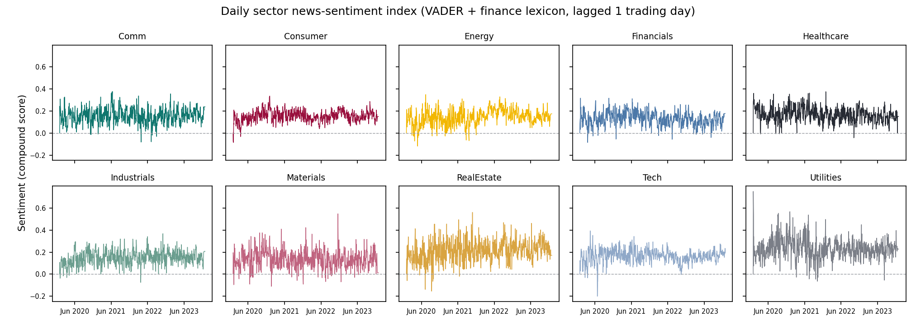
Figure 4 — Sector news-sentiment index over time, one panel per sector on a shared scale (VADER + finance dictionary, lagged one trading day), 2020–2023.
Figure 4 above shows the index for ten sectors; the ten industry lines are mostly above zero, which means that headline wording in this data is positive most of the time; zero is not a neutral reference point. Therefore, the application also includes a standardized view, comparing each industry with its own historical average and fluctuation range. Standardization allows those truly panicked days to emerge from the mild and positive underlying noise.
This index is validated; the same batch of headlines was re-scored using the finVADER benchmark provided in the course. This uses VADER plus two ready-made financial dictionaries, the SentiBigNomics lexicon and Henry’s financial word list, independent of the custom dictionary in HyperInvest. The two indices follow the exact same pipeline, so the differences only come from the dictionaries. Appendix A3 presents results indicating that both indices are positively correlated in each industry, with the lowest correlation coefficient of 0.48 for RealEstate and the highest of 0.69 for Energy. The fact that two independent dictionaries calculate indices in the same direction indicates that the index tracks real signals. Meanwhile, the correlation is only moderate, indicating that the specific magnitude will vary depending on the dictionary, and downstream users should expect this level of noise.
The validation also revealed two weaknesses in the model:
- First, the handling of negation in concession clauses is flawed. Specifically, in headlines like “Despite weak prices, a company is still expanding”, the negative information following despite is reversed by the rule engine.
- Second, words like “buy” and “dividend” in promotional headlines can inflate the score, even though these headlines are essentially marketing, not news.
Therefore, the index’s purpose needs to be clearly stated: it’s useful, validated, but contains noise. Every sentiment page in the application consistently displays the same sentence to tell users that it describes a news tone, not a buy or sell signal.
There are explanations for two parameters because they are choices, not defaults. 5-day smoothing corresponds to a work week; spikes caused by single headlines subside within a few days, and averaging on a weekly scale preserves the true news cycle while suppressing daily noise. Days without news reuse the previous reading,
The carry-forward limit is set at 10 trading days based on the assumption that information becomes outdated: readings from two weeks ago might still describe the news environment of an industry, but beyond that they go stale. Therefore, readings older than two weeks without news are treated as neutral, avoiding the use of outdated readings.
The industry differences in Figure 4 are also reasonable. Defensive industries like utilities and real estate have the highest overall line position; cyclical industries like Finance and Materials are at the bottom. Industries with less news have noticeably noisier lines, which reflects the reality of data coverage, not a model flaw.

4. Extensions and innovations
This section focuses on five extensions beyond the baseline design. The most important one is the practice area, which is an investment time machine. Users choose a starting date, an amount, and a set of funds, and then cross the three-year out-of-sample interval. It has two modes. In the Replay mode, the entire timeline is visible. The user drags the slider to move the time forward. It usually goes by month, and when it enters the turbulent period, it will automatically slow down to the day. The Blind walk mode hides the future, and the picture only draws to the current date. Users decide to move forward step by step, but the progress will automatically stop at the beginning of the next turbulent period, so users can skip a calm year, but the actual huge fluctuation events can not be avoided. On any date, users can adjust the combination, add money, or withdraw money, and the position is tracked in US dollars, just like the real holding.
There is also deliberate design in the time machine; it states but does not evaluate. When the user experiences a drawdown, the interface will tell the user what happened and why, using the user’s real numbers but not saying whether their decision is correct or not. Trading apps face the criticism of gamifying trading, a specific case is Robinhood removed its its confetti animation in 2021 after such criticism (CNBC, 2021). This design is to reward users with understanding rather than activity.
The second extension is to fold the sentiment index into the equity fund, and the result is negative. The result is reported as it is; the method is very direct and simple: at every monthly rebalancing, multiply the base weight of Equity Max-Sharpe by a factor, and the factor increases or decreases with the z-score of the industry sentiment, and then the calculated negative weight is truncated to zero and re-normalized. The effect is that industries with a positive news tone automatically get more weight.
The results are shown in Figure 5 and Table 2: the tilt fund underperforms the base fund. Sharpe ratio: 0.575 against the base fund’s 0.614; annualized return: 9.2% against 9.8%, also on 734 evaluation days. The strength or signal was not adjusted. The report was the result of the first run.
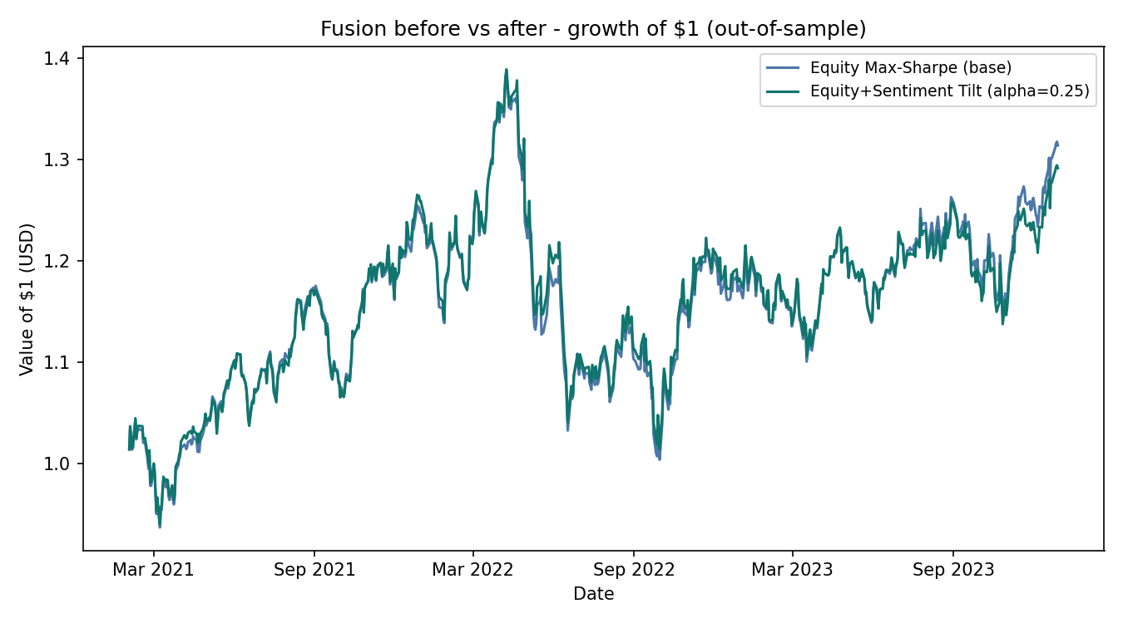
Figure 5— Fusion before vs after: growth of $1, base Equity Max-Sharpe vs sentiment-tilted, same 734 evaluated days.
Metric | Base: Equity Max-Sharpe | Equity+Sentiment Tilt | Difference
Annualised return | 9.8% | 9.2% | -0.6 pp
Annualised volatility | 17.9% | 18.1% | +0.2 pp
Sharpe ratio | 0.614 | 0.575 | -0.038
Maximum drawdown | -27.6% | -26.9% | +0.6 pp
Evaluated days | 734 | 734 | 0
Table 2 — Fusion before vs after, in table form: the base equity max-Sharpe fund against its sentiment-tilted variant on the same 734 evaluated days (pp = percentage points).
The explanation goes back to Section 3; the headline tone is a real but noisy signal. The noisy signal is directly folded into the weight, which shows that it is an unnecessary adjustment, not an advantage. This negative result itself is a baseline, and any better integration method in the future must first prove that it can surpass it.
The third item is the custom financial dictionary mentioned previously in Section 3, which is built from scratch; each entry has been manually reviewed and passed the external verification of the finVADER benchmark. The fourth is the product's design system, which is a set of its own color, font, and chart style consistent throughout the whole app. A further illustration is in Section 5. The fifth item is the fixed language-switching function which allows the same set of numbers to be switched between plain English and technical terms at any time to allow non-professional users understand evidence.
In five extensions, the time machine is the innovation at the product level, the dictionary is the innovation at the tool level, the fusion experiment is the attempt at the method level, and the design system is the work at the expression level. They are independent but serve the same purpose: to help non-professional investor understand the evidence and make their own decisions.

5. The app and the investor journey
HyperInvest is a Streamlit application deployed from the public GitHub repository. The deployed version only reads the pre-calculated and submitted result file and does not recalculate the backtest at runtime, so it also allows users to access it quickly on the free tier.
There are four steps in the journey of investors:
- First - Compare: the shelf table lists 13 funds on four core indicators, with the note that sorting changes the order instead of the quality of the fund.
- Second - Inspect: The fact sheet of each fund shows growth of $1, drawdown, target weights and current holdings.
- Third - Allocate: The user enters a dollar amount and allocates it to each fund, and the historical performance of the portfolio will be given together with all assumptions.
- Fourth - Explore: The sentiment page provides a multiple-choice comparison and standardized view of the industry index. The permanent sentence is that it describes the tone of news and does not represent a trading signal.
The saved combination will enter My Portfolio and can be sent back to the practice area for a time machine walkthrough at any time. Keep the same line for the whole journey that HyperInvest is an evidence layer rather than an advice layer, and the app itself does not recommend any fund; no mixed is scored, and it is always decided to leave it to users,
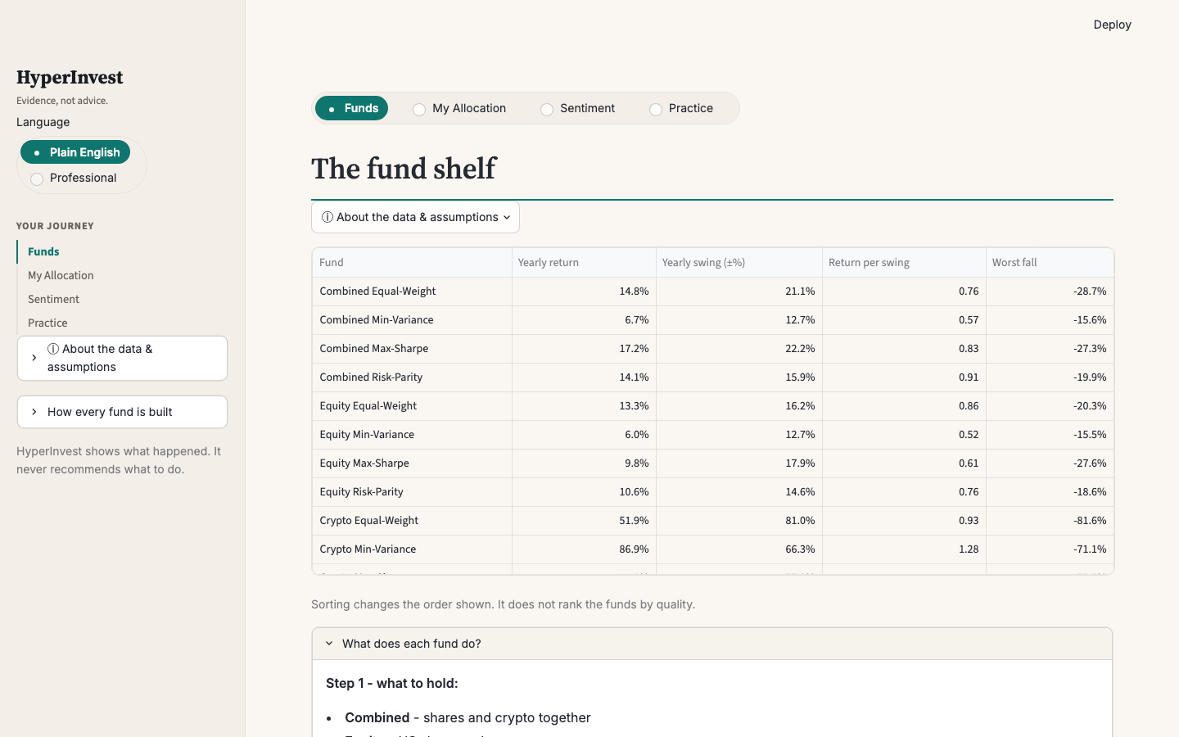
Product view 1 — The fund shelf: all thirteen funds compared on the four core measures (plain-English mode), with the standing note that sorting changes order, not merit.
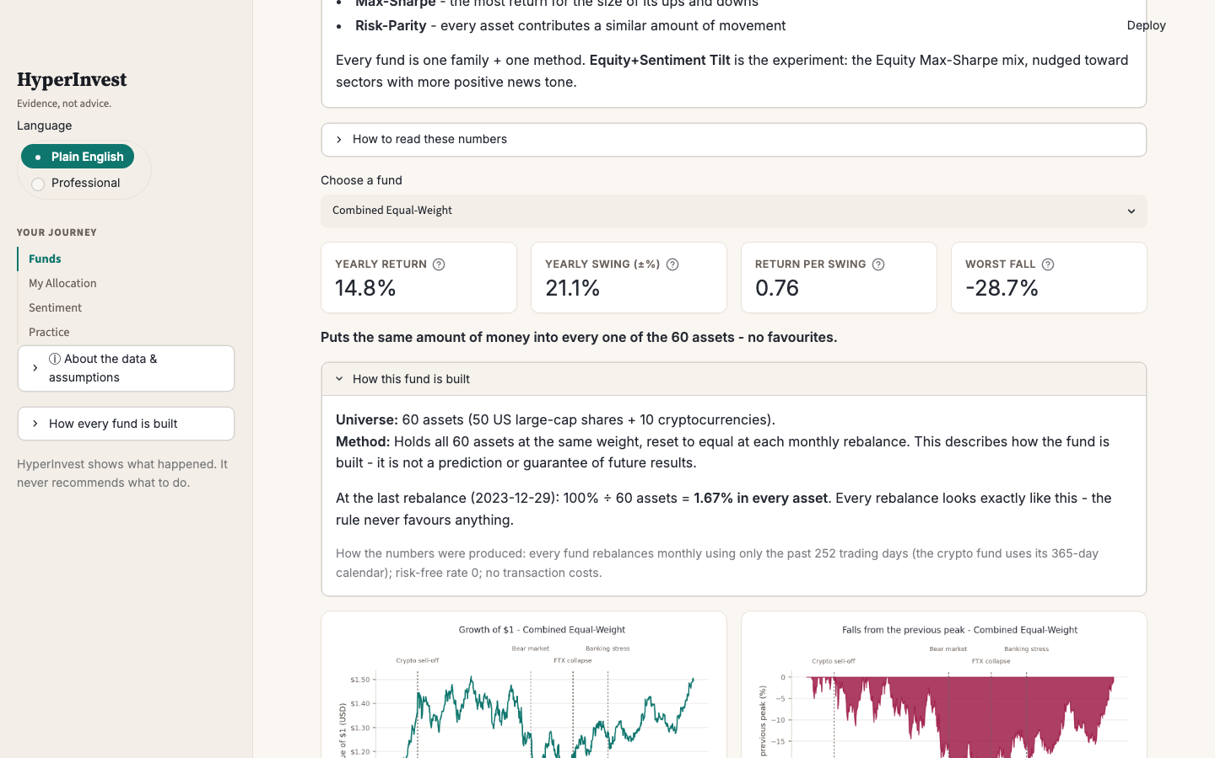
Product view 2 — A fund fact sheet: headline measures with reading instructions, the one-line method description, and the construction block showing the rule applied to the fund's own latest numbers.
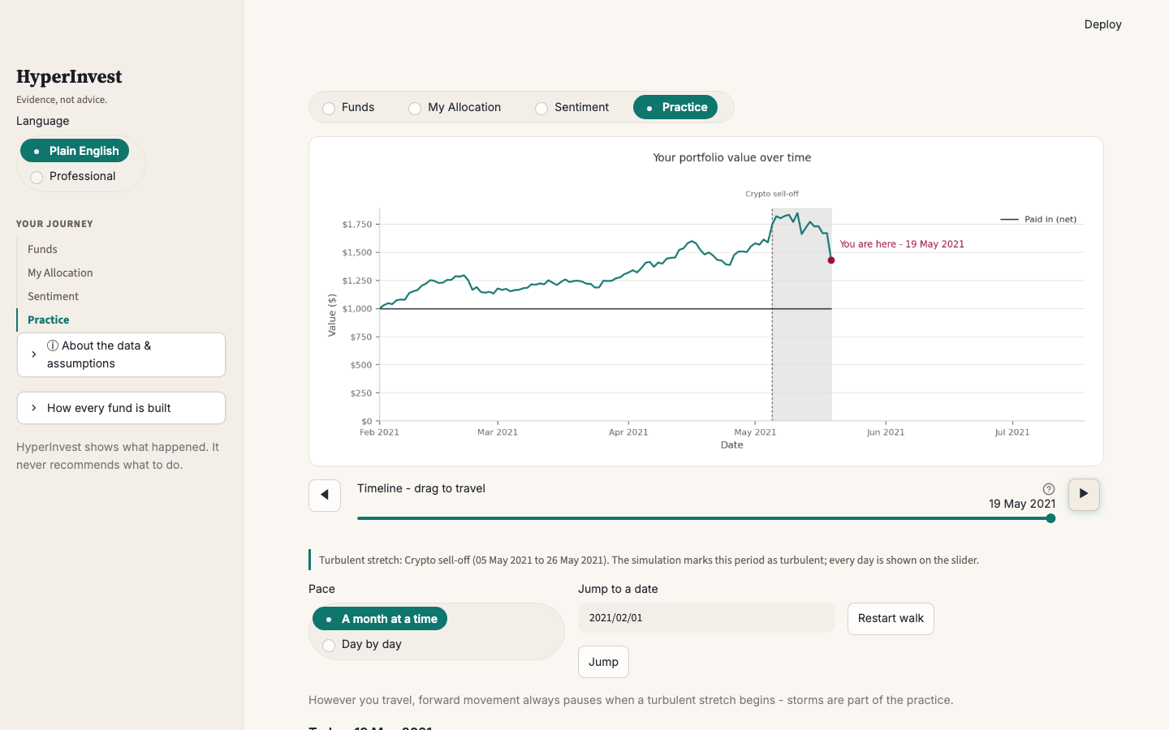
Product view 3 — The Practice time machine in Blind walk: the future is hidden, a turbulent stretch (the May 2021 crypto sell-off) slows travel to daily steps, and forward movement pauses at window starts.
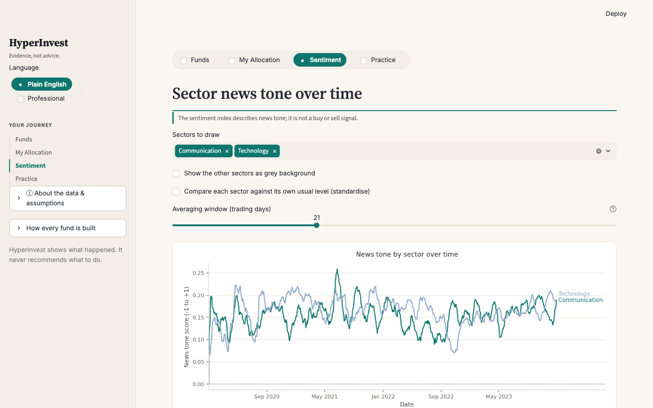
Product view 4 — The sentiment tab: sector news tone with multi-select comparison and the standardised view, under the permanent not-a-signal disclaimer.

6. Critical reflection and recommendations
After reviewing the whole project, the most effective thing is not a certain result, but discipline. The weight is only formed by past data, the sentiment signals is forced to lag one trading day, and the output of the solver is compared across methods every time it is constructed. These checks detected mistakes. The solver’s silent stalling and the look-ahead in the sentiment signal were caught in this way. Another valid judgment is that neutrality and usefulness can coexist; the plain language teaches how to read and understand the evidence, not choose for users.
The unsuccessful part also has a lot of information. Sentiment tilt reduces value, and post-analysis is more useful than the result itself. The signal is real but noisy, and the noise is directly folded into the weight, which shows that it is an unnecessary position adjustment, not an advantage. The three explicit simplifications qualify all the conclusions: zero transaction costs, zero risk-free interest rates, and the sample ends on 29 December 2023, so this product does not have a word to describe today’s market.
In addition, there is another function in the practice area that only has the design idea but is not implemented in the app, which is the settlement page. Now, after the journey, users can only see the contrast between their own path and doing nothing. The settlement page will clearly calculate how much profit and loss each adjustment brings, so that users can see which decisions are useful and which are not. This is the first function to be done in the future of HyperInvest.
There are three specific suggestions based on evidence. First, before believing in the advantage of any optimization fund, add the transaction-cost and turnover model. Appendix A2 and A2b show that some funds replace the whole portfolio in a single rebalance. Even if only a few basis points are collected for each transaction, the ranking given in this report may be rearranged. Second, if the product goes live instead of a prototype, refresh the data nightly and re-run the pipeline, so the evidence stays current to the day before. The architecture supports running every day, and the boundary does not need to be moved; the application will not show nothing beyond the sample. Third, add an optimization method that considers tail risk, such as conditional value at risk (mean-CVaR). The deep drawdown in 2022 is the tail event that is easily underestimated by the variance target. The method of tail loss pricing can be used to test whether the current drawdown ranking can stand under a stricter risk definition.
The lesson worth mentioning in the process is that the verification check should be written first, and the model should be built later. Every check in this project immediately caught errors. The earlier the inspection exists, the cheaper the errors it catches.

AI workflow statement
The code, backtest, mood index, and application of this project are completed by a single AI agent, Kimi Code CLI, under my command. Every substantive change is approved or rejected by me, and the product and modeling decisions are made by me. I review the results by executing code to make sure the result is correct. This report was first generated as a draft sample by AI, and then I rewrote the whole report in my own words. In the process of writing, Grammarly was used for basic editing assistance, such as fixing typos and misspellings. AI was also used to check logic and numbers. The complete prompt record can be found in ai/prompt_log.md, and the proxy instruction file AGENT.md is written by me. The analysis and interpretation of this report are my own.

Appendix — supporting exhibits
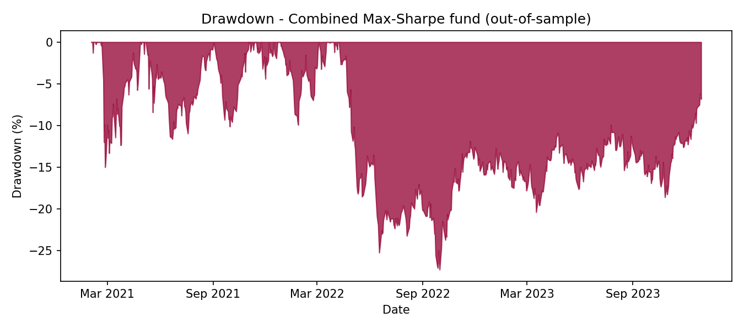
A1 — Drawdown from peak, Combined Max-Sharpe, out-of-sample period (Feb 2021 – Dec 2023).
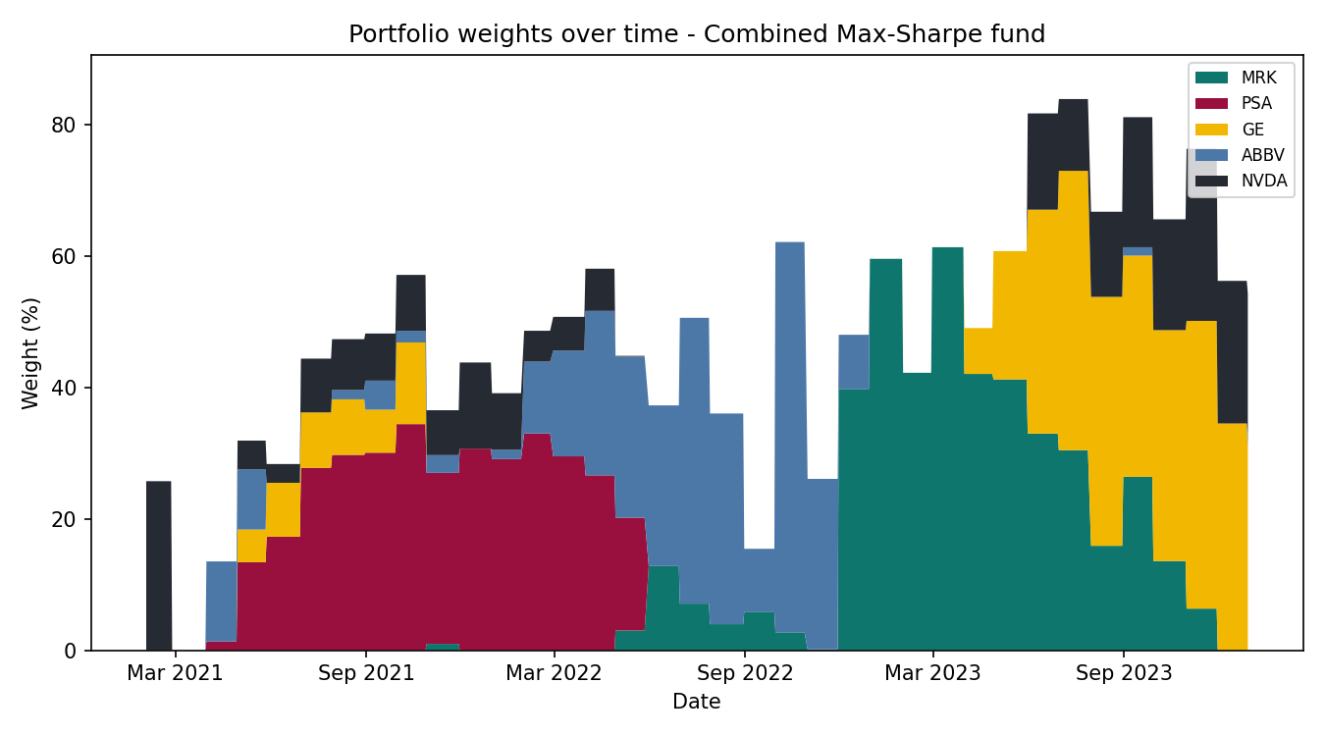
A2 — Target weights per monthly rebalance, Combined Max-Sharpe (top 5 holdings; the remainder is spread across all other assets).
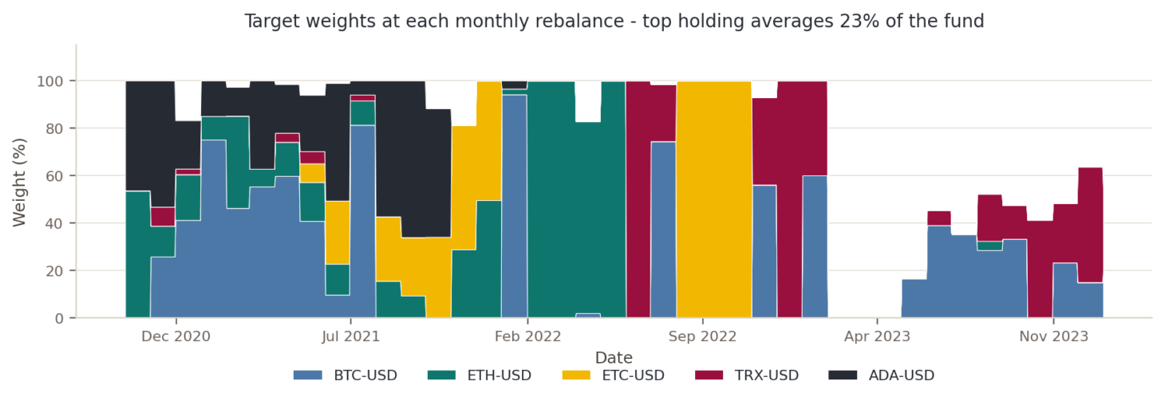
A2b — Target weights per monthly rebalance, Crypto Max-Sharpe, out-of-sample period (Oct 2020 – Dec 2023). Top 5 holdings shown.
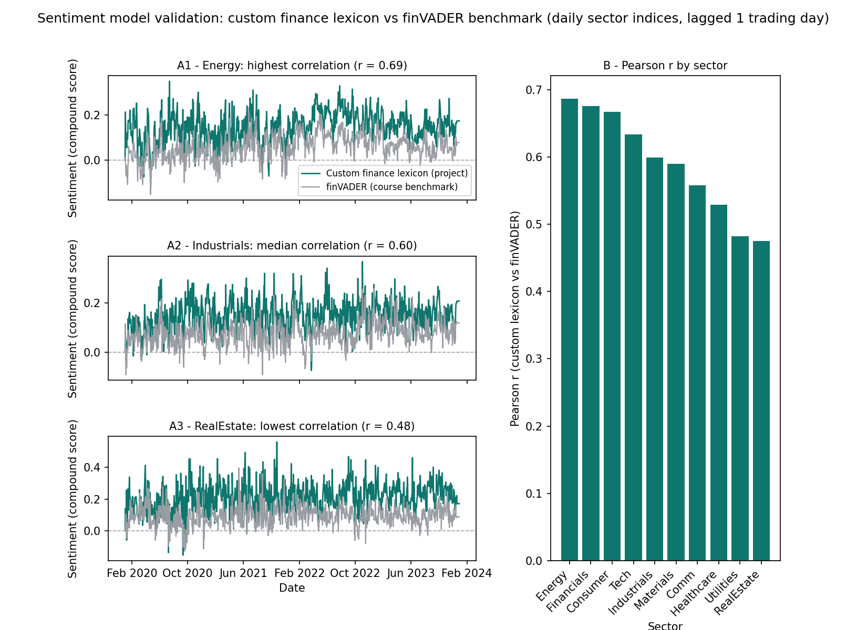
A3 — Custom dictionary vs finVADER benchmark: per-sector correlation and representative sectors, 2020–2023.
[EVIDENCE — verified numbers] Also reference as tables: results/tables/performance_metrics.csv, fusion_comparison.csv, sentiment_model_comparison.csv, sentiment_disagreement_examples.csv, weights_sanity_check.csv.

References
[VERIFY EACH REFERENCE YOURSELF before submission — context/verify_ai_output.md: every citation must be one you have opened. Candidate list:] Course data bundle (equity prices, crypto prices, news headlines, 2020–2023). Hutto, C.J. & Gilbert, E. (2014), VADER: A Parsimonious Rule-based Model for Sentiment Analysis of Social Media Text, ICWSM. Henry, E. (2008), Are Investors Influenced by How Earnings Press Releases are Written?, Journal of Business Communication (Henry's finance word list). SentiBigNomics lexicon (as distributed with the finvader package). Course weekly materials, weeks 1–9 [cite the specific weeks you use].

