Classification

Features: can be any type of Data

Label: It can be **categorical data** or **district numerical data**.

We have two types of classification:

1. Binary classification:

* Label column will have two unique values(yes/no, 0/1, spam/ham)

1. Multi – class classification

* Label column will have more than two unique values.

Classification algorithms:

1. Logistic Regression
2. K-Nearest Neighbor
3. SVC
4. Decision Tree Classifier
5. Random Forest Classifier
6. XGB Classifier
7. XGBR Classifier

Logistic Regression algorithm

* Classification algorithm
* Applying sigmoid function on a line function Fn(y= b0 + b1x1)
* sigmoid function 🡺 y=1/(1+e^(-xy))
* if y in Sigmoid on Linear Regression 🡺 Logistic Regression = 1/(1+e^(-(b0+b1x))
* 𝜆= 1 ( 𝜆 is lambda)
* In binary Classification, Any number between 0 – 0.05 consider as 0 and Any number between 0.05 – 1 consider as 1.
* Default output of Logistic Regression is probability Values. Because Logistic Regression is a classification, we prefer to see categories as an output rather that probability Values as an output.

Classification Dataset:

* Balanced Dataset.

Numbers of records for each unique label must be same. For example: number of (Spam) = number of (Ham)

* UnBalanced Dataset

Numbers of records for each unique label are different. For example: number of (Spam) =! number of (Ham)

Evaluation Metrics

Evaluating Classification Models:

* Accuracy
* Precision
* Recall
* F1-Score

When to use which metrics?

* Balanced Dataset 🡺 Accuracy
* Unbalanced Dataset 🡺 Precision-Recall Pair, F1-Score

Rules for Classification (From Sklearn)

1. Data must be complete

2. Data must be strictly numeric

3. Features must be in the form of 2d numpy array

4. Label must be in the form of 1d numpy array(In Regression,label should be 2d numpy array)

Issue in terms of Achieving CL

* Play with Random State[Playing with Sampling method]
* Change the ration of train test split[80:20, 75:25, 90:10]
* Change algorithm
* Tune Hyperparameters
* Ask for more Data

**Use-case for Logistic Regression:**

**An Online Shopping Mall has provided this dataset. Your job is to create a model that can predict whether the customer will shop or not based on customer's age and estimated salary**

|  |  |  |
| --- | --- | --- |
|  |  | data = pd.read_csv('Social_Network_Ads.csv') |
|  |  | data.info()  <class 'pandas.core.frame.DataFrame'>  RangeIndex: 400 entries, 0 to 399  Data columns (total 5 columns):  # Column Non-Null Count Dtype  --- ------ -------------- -----  0 User ID 400 non-null int64  1 Gender 400 non-null object  2 Age 400 non-null int64  3 EstimatedSalary 400 non-null int64  4 Purchased 400 non-null int64  dtypes: int64(4), object(1)  memory usage: 15.8+ KB |
|  |  | data.head() |
|  | Assumption is: Data Preprocesssing is DONE  Check whether the dataset is a balanced dataset or not  # 0 --- bad customer (no purchase)  # 1 --- good customer (purchase) | data.Purchased.value_counts()  0 257  1 143  Name: Purchased, dtype: int64 |
|  | Here the dataset is Unbalanced |  |
|  | Features and Label | features = data.iloc[:,[2,3]].values  label = data.iloc[:,4].values |
|  | Create Good Model  Finding a Generalized Model | from sklearn.model_selection import train_test_split  from sklearn.linear_model import LogisticRegression  for i in range(1,401):  X_train,X_test,y_train,y_test = train_test_split(features,label,test_size=0.2,random_state=i)  model = LogisticRegression()  model.fit(X_train,y_train)    train_score = model.score(X_train,y_train)  test_score = model.score(X_test,y_test)    if test_score > train_score:  print("Test {} Train {} RS {}".format(test_score,train_score,i))  Test 0.6875 Train 0.63125 RS 3  Test 0.7375 Train 0.61875 RS 4  Test 0.6625 Train 0.6375 RS 5  Test 0.65 Train 0.640625 RS 6  Test 0.675 Train 0.634375 RS 7  Test 0.675 Train 0.634375 RS 8  Test 0.65 Train 0.640625 RS 10  Test 0.6625 Train 0.6375 RS 11  Test 0.7125 Train 0.625 RS 13  Test 0.675 Train 0.634375 RS 16  Test 0.7 Train 0.628125 RS 17  Test 0.7 Train 0.628125 RS 21  Test 0.65 Train 0.640625 RS 24  Test 0.6625 Train 0.6375 RS 25  Test 0.75 Train 0.615625 RS 26  Test 0.675 Train 0.634375 RS 27  Test 0.7 Train 0.628125 RS 28  Test 0.6875 Train 0.63125 RS 29  Test 0.6875 Train 0.63125 RS 31  Test 0.6625 Train 0.6375 RS 37  Test 0.7 Train 0.628125 RS 39  Test 0.7 Train 0.628125 RS 40  Test 0.65 Train 0.640625 RS 42  Test 0.725 Train 0.621875 RS 46  Test 0.65 Train 0.640625 RS 48  ...  Test 0.6625 Train 0.6375 RS 393  Test 0.675 Train 0.634375 RS 396  Test 0.7 Train 0.628125 RS 397  Test 0.7125 Train 0.625 RS 400 |
|  |  | X_train,X_test,y_train,y_test = train_test_split(features,label,test_size=0.2,random_state=199)  finalModel = LogisticRegression()  finalModel.fit(X_train,y_train)  LogisticRegression(C=1.0, class_weight=None, dual=False, fit_intercept=True,  intercept_scaling=1, l1_ratio=None, max_iter=100,  multi_class='auto', n_jobs=None, penalty='l2',  random_state=None, solver='lbfgs', tol=0.0001, verbose=0,  warm_start=False) |
|  |  | print(finalModel.score(X_train,y_train))  print(finalModel.score(X_test,y_test))  0.8375  0.8875 |
|  | Check whether to Accept or Reject the Model  Since the dataset is Unbalanced You need to Check for Non-Tolerable Areas  0 ---> Bad Customer  1 ---> Good Customer  GC 1 ----> BC 0(Non-Tolerable)  BC ----> GC ()  Precision()  Recall () | from sklearn.metrics import confusion_matrix  #confusion_matrix(actualLabel, predictedLabel)  confusion_matrix(label,finalModel.predict(features))  array([[237, 20],  [ 41, 102]]) |
|  |  | from sklearn.metrics import classification_report  print(classification_report(label,finalModel.predict(features)))  precision recall f1-score support  0 0.85 0.92 0.89 257  1 0.84 0.71 0.77 143  accuracy 0.85 400  macro avg 0.84 0.82 0.83 400  weighted avg 0.85 0.85 0.84 400 |
|  |  | 0.78 >= CL ---- approve model else reject model |

**K nearest neighbor algorithm(KNN):**

* Don’t use knn for huge datasets.
* Knn is applicable for both, regression(averaging) and classification(voting)

Training algorithm:

Copy the entire training data in an object.

Prediction algorithm:

1. Calculate the distance between the unknown point and all known points with:

-Euclidean Distance Formula 🡺 Default Formula

-Manhattan Distance Formula

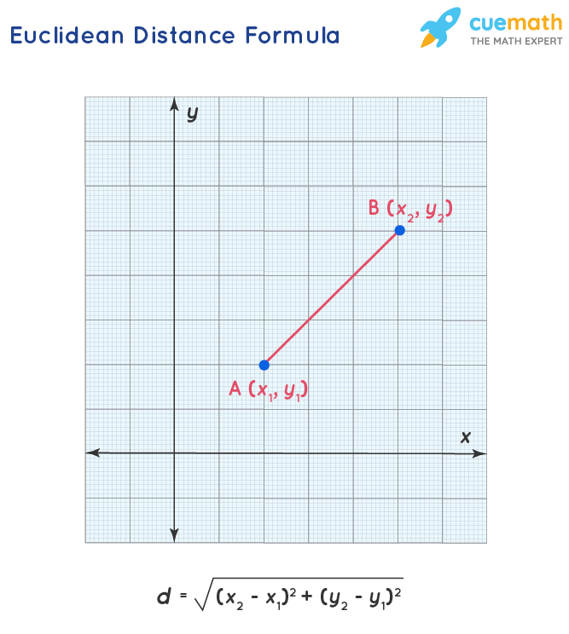

1. Arrange the data in ascending order based on distance
2. Take first ‘k’ values and performing voting.

**Use-case:**

**An Online Shopping Mall has provided this dataset. Your job is to create a model that can predict whether the customer will shop or not based on customer's age and estimated salary.**

The process is the same like above with extra code for knn part

|  |  |  |
| --- | --- | --- |
|  | # KNN Algorithm | from sklearn.neighbors import KNeighborsClassifier  modelKNN = KNeighborsClassifier(n_neighbors=7)  modelKNN.fit(X_train,y_train) |
|  |  | modelKNN.score(X_train,y_train)  0.86875 |
|  | It is an overfitted model bcz  Test score < train score | modelKNN.score(X_test,y_test)  0.7875 |
|  |  |  |