

IE 306 Reinforcement Learning and Dynamic Optimization

Term Project
Reinforcement Learning for City-Scale Drone Delivery

Davut Berk KARA
Engin ÖZKAN
Zeynebi Kübra GÜZEL

Department of Industrial Engineering
Gebze Technical University
2026
- INTRODUCTION
This project aims to optimize real-time operational decisions using a previously developed city-scale drone delivery simulator. The simulator includes realistic parts like delivery orders, battery levels, charging stations, no-fly zones, and delivery time limits. The main goal of the project is to improve delivery performance and reduce the cost per order. To do this, we develop reinforcement learning-based policies as an alternative to the current classic heuristic methods.
- ROLE A- VALUE BASED METHODS
In this section, DQN, Double DQN, and Dueling DQN algorithms are developed, trained, and their performances are compared with baseline methods.
2.1. Environment Structure
To develop the model, we first examined the observation space from the simulator. The observation space has four main parts:
- Drones Vector: An (8 × 10) matrix containing the drones’ position, battery, and status information.
- Orders Vector: An (20 × 5) matrix containing information about active orders.
- Grid Layout: A (20 × 20) matrix representing the city map.
- Time Variable: A one-dimensional variable containing the system’s current time information.
To enable the neural network to process this data, all components were combined to form a single 581-dimensional state vector. This made the current state of the environment directly usable by the network. Also, the action space has 169 discrete actions in total. These actions represent different drone-order matches. Finally, we used an action mask mechanism to stop the network from choosing invalid actions.
  - DQN Implementation
First, the basic DQN algorithm was implemented. In this step, the state vector from the environment was given to the neural network, and the network produced a Q-value for each action. The network takes 581-dimensional state information as input and generates 169 action values. The epsilon-greedy decision mechanism was used to enable the agent to interact with the environment. This way, the agent can explore new actions in some cases, while choosing the best action it learned in other cases.
During the learning process, we used a Replay Buffer structure. The experiences of the agent (state, action, reward, next state, done) were stored in the buffer and used as random mini-batches during training. When the buffer size reached 10,000, the oldest steps were deleted to focus on current data. Also, we added a Target Network to make the learning process more stable.
2.3 Double DQN and Dueling DQN
After the basic DQN model was developed, the Double DQN and Dueling DQN methods were applied to improve its performance.
In the Double DQN algorithm, action selection and action evaluation are performed using separate networks. This approach aims to reduce the overestimation problem seen in standard DQN.
In the Dueling DQN algorithm, the network architecture is divided into two separate streams. The first stream learns state values, while the second stream learns action advantages. This way, we aimed to help the agent evaluate states more effectively.
2.4 Experimental Setup
The same simulation environment was used in all experiments. To make the results reproducible, we added a seed system and performed the experiments with three different random seed values (0, 1, and 2). The model parameters were kept in YAML files instead of being hardcoded into the code.
DQN, Double DQN, and Dueling DQN models were trained with different episode and epsilon parameters, and their results were compared. At the end of each training, model weights (.pt), training logs (.csv), and learning curve data were saved. Also, we made a comparison with Random Policy, Greedy Nearest, and MILP Rolling methods.
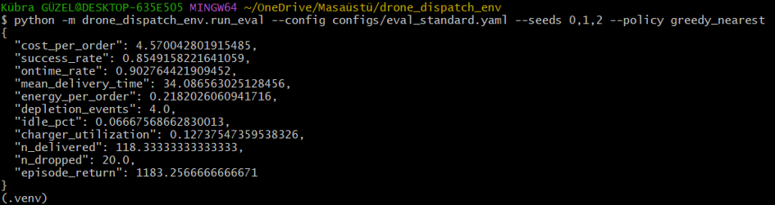
The baseline results for the Greedy Nearest method are as follows:
- Cost per Order: 4.57
- Success Rate: %85.5
- On-Time Rate: %90.3
- Depletion Events: 4
2.5 Ablation Study
In this project, we did an ablation study to see the specific effect of the Target Network component. To do this, we removed the Target Network from the standard DQN model (DQN No Target) and ran a training cycle. When we examined the logs, we saw that without the Target Network, the target Q-values constantly shifted, and there were sharp fluctuations in the reward values. The model could not develop a stable policy and performed worse than the standard DQN. Therefore, we chose the standard structure with the Target Network for the final experiments.
2.6 Results and Evaluation
In the first experiments, 10 episodes and $\varepsilon = 0.02$ parameters were used. The learning curve graph shows that the models could not display a stable learning behavior because the training time was too short. We observed a high variability among the results of the three different seeds. This situation shows that the models have not collected enough experience yet.
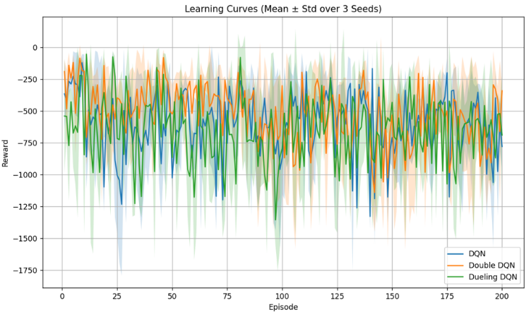
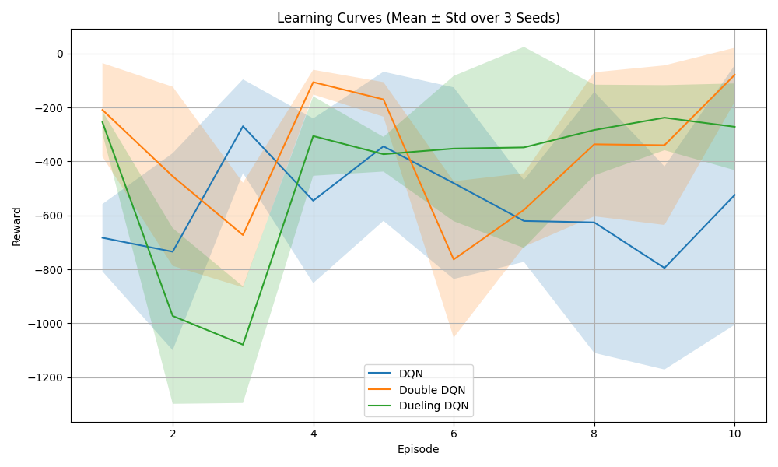
Senaryo 1: 10 Episode, $ϵ$= 0.05 Senaryo 2: 200 Episode, $ϵ$= 0.05

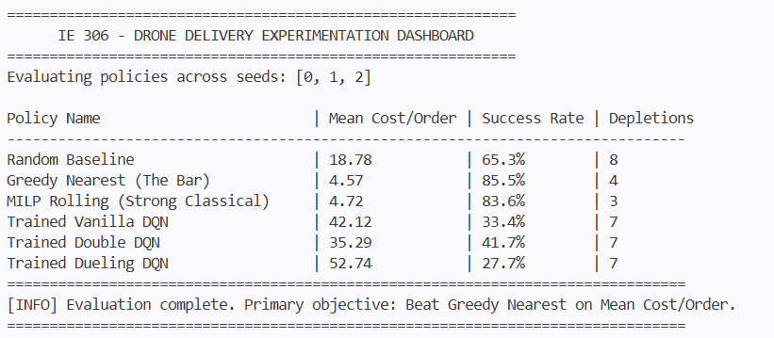
Later, the training time was increased to 200 episodes, and the models were trained again. When we examine the learning curve graph, we can see that the models interacted with the environment for a longer time and collected more experience. However, there are still important fluctuations in the reward values. This situation might be caused by the complex structure of the problem and the fact that the learning process has not fully converged yet.
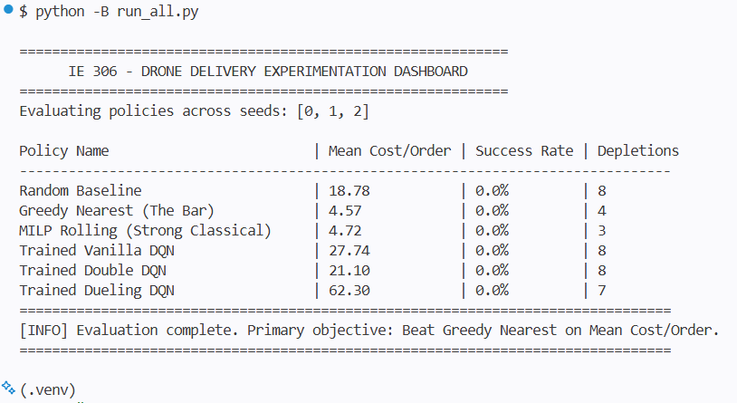
In the performance evaluation, the Greedy Nearest method was used as the main baseline. The DQN-based methods could not pass this baseline performance. However, we could observe different behaviors of the algorithms. While the Double DQN method produced more stable results in some experiments compared to standard DQN, Dueling DQN showed variable performance with different training parameters.
These results show that the RL models learned in the environment, but they could not reach the performance of the classic Greedy Nearest approach with the current training time and hyperparameters. Nevertheless, the required learning curves, experiments with three different seeds, baseline comparisons, and performance analyses within the project were successfully obtained.
In conclusion, the developed DQN, Double DQN, and Dueling DQN models are working and have been successfully integrated into the simulator environment. The results show that the performance can be improved in the future by using longer training times, different reward functions, and advanced hyperparameter settings.

