

IE 306 Reinforcement Learning and Dynamic Optimization

Term Project
Reinforcement Learning for City-Scale Drone Delivery

Davut Berk KARA
Engin ÖZKAN
Zeynebi Kübra GÜZEL

Department of Industrial Engineering
Gebze Technical University
2026
- INTRODUCTION
This project aims to optimize real-time operational decisions using a previously developed city-scale drone delivery simulator. The simulator includes realistic parts like delivery orders, battery levels, charging stations, no-fly zones, and delivery time limits. The main goal of the project is to improve delivery performance and reduce the cost per order. To do this, we develop reinforcement learning-based policies as an alternative to the current classic heuristic methods.
- ROLE A- VALUE BASED METHODS
In this section, DQN, Double DQN, and Dueling DQN algorithms are developed, trained, and their performances are compared with baseline methods.
2.1. Environment Structure
To develop the model, we first examined the observation space from the simulator. The observation space has four main parts:
- Drones Vector: An (8 × 10) matrix containing the drones’ position, battery, and status information.
- Orders Vector: An (20 × 5) matrix containing information about active orders.
- Grid Layout: A (20 × 20) matrix representing the city map.
- Time Variable: A one-dimensional variable containing the system’s current time information.
To enable the neural network to process this data, all components were combined to form a single 581-dimensional state vector. This made the current state of the environment directly usable by the network. Also, the action space has 169 discrete actions in total. These actions represent different drone-order matches. Finally, we used an action mask mechanism to stop the network from choosing invalid actions.
  - DQN Implementation
First, the basic DQN algorithm was implemented. In this step, the state vector from the environment was given to the neural network, and the network produced a Q-value for each action. The network takes 581-dimensional state information as input and generates 169 action values. The epsilon-greedy decision mechanism was used to enable the agent to interact with the environment. This way, the agent can explore new actions in some cases, while choosing the best action it learned in other cases.
During the learning process, we used a Replay Buffer structure. The experiences of the agent (state, action, reward, next state, done) were stored in the buffer and used as random mini-batches during training. When the buffer size reached 10,000, the oldest steps were deleted to focus on current data. Also, we added a Target Network to make the learning process more stable.
2.3 Double DQN and Dueling DQN
After the basic DQN model was developed, the Double DQN and Dueling DQN methods were applied to improve its performance.
In the Double DQN algorithm, action selection and action evaluation are performed using separate networks. This approach aims to reduce the overestimation problem seen in standard DQN.
In the Dueling DQN algorithm, the network architecture is divided into two separate streams. The first stream learns state values, while the second stream learns action advantages. This way, we aimed to help the agent evaluate states more effectively.
2.4 Experimental Setup
The same simulation environment was used in all experiments. To make the results reproducible, we added a seed system and performed the experiments with three different random seed values (0, 1, and 2). The model parameters were kept in YAML files instead of being hardcoded into the code.
DQN, Double DQN, and Dueling DQN models were trained with different episode and epsilon parameters, and their results were compared. At the end of each training, model weights (.pt), training logs (.csv), and learning curve data were saved. Also, we made a comparison with Random Policy, Greedy Nearest, and MILP Rolling methods.
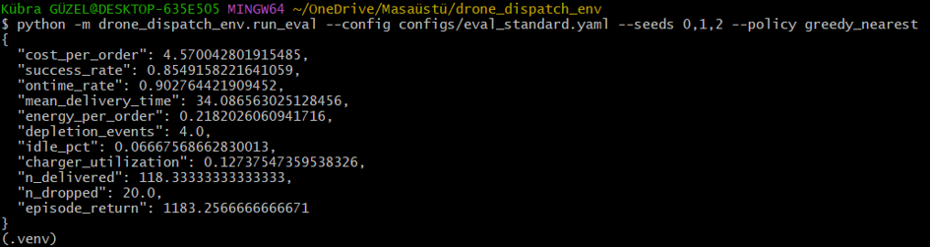
The baseline results for the Greedy Nearest method are as follows:
- Cost per Order: 4.57
- Success Rate: %85.5
- On-Time Rate: %90.3
- Depletion Events: 4
2.5 Ablation Study
In this project, we did an ablation study to see the specific effect of the Target Network component. To do this, we removed the Target Network from the standard DQN model (DQN No Target) and ran a training cycle. When we examined the logs, we saw that without the Target Network, the target Q-values constantly shifted, and there were sharp fluctuations in the reward values. The model could not develop a stable policy and performed worse than the standard DQN. Therefore, we chose the standard structure with the Target Network for the final experiments.
2.6 Results and Evaluation
In the first experiments, 10 episodes and $\varepsilon = 0.02$ parameters were used. The learning curve graph shows that the models could not display a stable learning behavior because the training time was too short. We observed a high variability among the results of the three different seeds. This situation shows that the models have not collected enough experience yet.
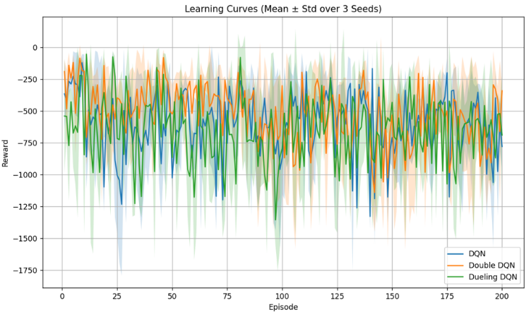
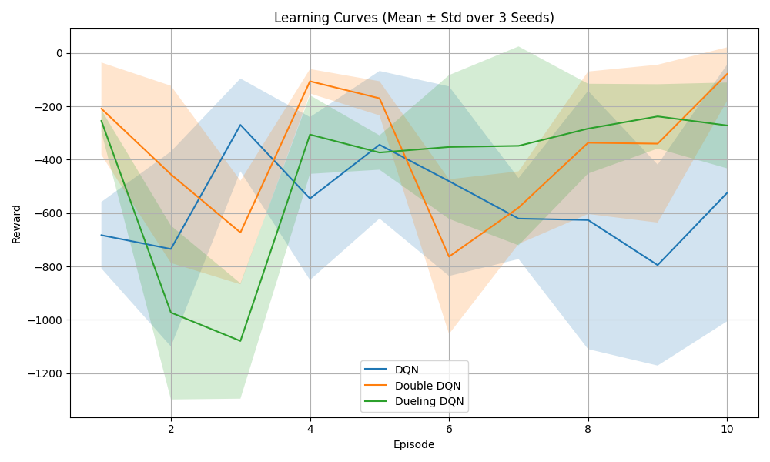
Senaryo 1: 10 Episode, $ϵ$= 0.05 Senaryo 2: 200 Episode, $ϵ$= 0.05

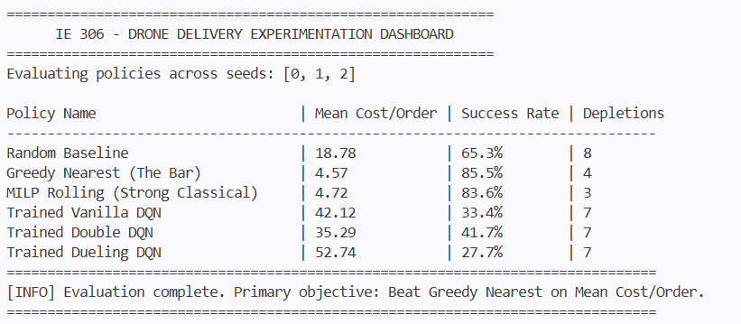
Later, the training time was increased to 200 episodes, and the models were trained again. When we examine the learning curve graph, we can see that the models interacted with the environment for a longer time and collected more experience. However, there are still important fluctuations in the reward values. This situation might be caused by the complex structure of the problem and the fact that the learning process has not fully converged yet.
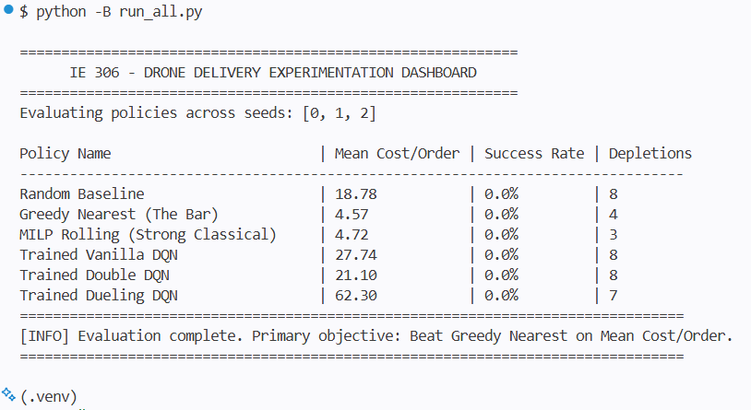
In the performance evaluation, the Greedy Nearest method was used as the main baseline. The DQN-based methods could not pass this baseline performance. However, we could observe different behaviors of the algorithms. While the Double DQN method produced more stable results in some experiments compared to standard DQN, Dueling DQN showed variable performance with different training parameters.
These results show that the RL models learned in the environment, but they could not reach the performance of the classic Greedy Nearest approach with the current training time and hyperparameters. Nevertheless, the required learning curves, experiments with three different seeds, baseline comparisons, and performance analyses within the project were successfully obtained.
In conclusion, the developed DQN, Double DQN, and Dueling DQN models are working and have been successfully integrated into the simulator environment. The results show that the performance can be improved in the future by using longer training times, different reward functions, and advanced hyperparameter settings.

3. ROLE B- POLICY BASED METHODS
In this section, policy-based reinforcement learning and actor-critic methods are developed and tested on the DroneDispatch-v0 environment. The main method used in this role is Advantage Actor-Critic (A2C). In addition to the standard A2C implementation, behavior cloning from the Greedy Nearest policy and a behavior cloning warm-start experiment were also tested. Finally, an ablation study was performed by removing advantage normalization.
3.1 Environment Structure
For Role B, the same DroneDispatch-v0 environment was used. The environment has 8 drones and a maximum visible order window of 20 orders. The action space has 169 discrete actions in total. These actions include assigning a drone to an order, sending an idle drone to a charger, or choosing a no-op action.
The observation space is given as a dictionary. In our implementation, the drone vector, order vector, and time variable were flattened and combined into a single 181-dimensional state vector. The grid layout was not included in the first model in order to keep the policy network simple. Also, the action mask was used during training and evaluation. This prevented the policy from selecting invalid actions.
3.2 A2C Implementation
The main policy-based model was implemented using an Actor-Critic network. The network has a shared multilayer structure and two separate output heads. The actor head produces action logits for the 169 discrete actions. The critic head estimates the state value.
During training, the agent collects rollout steps from the environment. Then, Generalized Advantage Estimation (GAE) is used to calculate the advantage values. These advantage values are used in the policy loss. The critic is trained with mean squared error between the predicted value and the return target. An entropy term is also added to encourage exploration.
The total loss consists of three parts: Policy loss + Value loss - Entropy bonus.
In the main A2C experiment, advantage normalization was used to make the learning process more stable. Because of package installation problems on the local computer, a small manual Adam optimizer was implemented instead of using torch.optim.Adam. This did not change the learning logic, but it made the code runnable in the available environment.
3.3 Experimental Setup
All Role B experiments were run with the standard evaluation configuration and seeds 0, 1, and 2. The model parameters were stored in YAML configuration files. At the end of each training, model weights (.pt), logs (.csv), and evaluation results (.json) were saved.
The following methods were tested: Vanilla A2C, Behavior Cloning from Greedy Nearest, Behavior Cloning Warm-Start + A2C Fine-Tuning, and A2C without Advantage Normalization.
The baseline methods used for comparison were Random Policy, Greedy Nearest, and MILP Rolling.
The baseline results are as follows: Random Policy Cost per Order: 18.780, Greedy Nearest Cost per Order: 4.570, and MILP Rolling Cost per Order: 4.722.
According to the main metric, Greedy Nearest was the strongest baseline. Therefore, it was used as the main comparison point for Role B.
3.4 Behavior Cloning Warm-Start
After the vanilla A2C experiment, behavior cloning was tested as a warm-start method. In this method, the actor network was first trained to imitate the Greedy Nearest policy. The idea was to start the policy from a more meaningful dispatching behavior instead of a random policy.
The behavior cloning model was trained using expert state-action pairs collected from the Greedy Nearest policy. After 8 epochs, the imitation accuracy reached approximately 0.337. This means that the model learned some expert-like behavior, but it could not reliably copy the Greedy Nearest policy.
Then, this behavior cloning model was used as the initial model for A2C fine-tuning. The aim was to improve the cloned policy with reinforcement learning.
3.5 Ablation Study
For the ablation study, the effect of advantage normalization was tested. In the main A2C model, advantage normalization was used. In the ablation experiment, the same A2C structure was trained again, but advantage normalization was turned off.
This comparison showed that removing advantage normalization made the results worse. With advantage normalization, vanilla A2C achieved a cost per order of 24.371. Without advantage normalization, the cost per order increased to 35.832. Therefore, advantage normalization helped stabilize the A2C training, even though it was not enough to reach the Greedy Nearest baseline.
3.6 Results and Evaluation
The Role B results are summarized in the table below.
Method | Cost per Order | Success Rate | On-Time Rate | Delivered Orders | Dropped Orders | Episode Return
Random Policy | 18.780 | 0.653 | 0.890 | 39.67 | 21.67 | -168.33
Greedy Nearest | 4.570 | 0.855 | 0.903 | 118.33 | 20.00 | 1183.26
MILP Rolling | 4.722 | 0.836 | 0.911 | 118.00 | 23.00 | 1173.00
Vanilla A2C | 24.371 | 0.618 | 0.948 | 27.67 | 17.67 | -267.35
Behavior Cloning | 30.031 | 0.453 | 0.937 | 62.67 | 73.33 | -446.05
BC Warm-Start + A2C | 26.713 | 0.409 | 0.807 | 55.33 | 80.00 | -700.71
A2C without Advantage Normalization | 35.832 | 0.438 | 0.948 | 25.00 | 32.33 | -527.42

The vanilla A2C model was trained for 50,000 steps. The training and evaluation pipeline worked correctly. The model interacted with the environment, used the action mask, saved weights, and produced evaluation metrics. However, the final performance was not competitive. The vanilla A2C model achieved a cost per order of 24.371, which was worse than both Random Policy and Greedy Nearest.
This result shows that learning a good dispatching policy from scratch is difficult in this environment. The action space is large, the rewards are delayed, and the agent must learn order assignment, battery management, charging behavior, and delivery deadlines at the same time. On the other hand, Greedy Nearest is already a strong hand-designed rule for this problem.
The behavior cloning model also could not reach the performance of Greedy Nearest. Although it imitated some expert actions, its accuracy was not high enough. Small mistakes in action selection caused many dropped orders. The BC warm-start + A2C fine-tuning experiment improved the direct behavior cloning cost from 30.031 to 26.713, but it was still not better than vanilla A2C.
In conclusion, the Role B models were successfully integrated into the simulator and evaluated with saved logs and weights. The learned policies did not pass the Greedy Nearest baseline. However, the experiments clearly showed why policy-gradient learning is difficult in this dispatching environment. The results also showed that advantage normalization is useful for stabilizing A2C, while behavior cloning warm-start needs stronger imitation accuracy to become effective.
3.7 Implementation and Debugging Process
During Role B development, the implementation was completed step by step instead of directly writing the final model. First, the DroneDispatch-v0 environment was examined to understand the observation dictionary, discrete action space, and action mask structure. This was important because the policy network should not select invalid actions during training or evaluation.
After understanding the environment, a simple observation flattening function was created. In the first version, drone information, order information, and time information were combined into a single state vector. The grid information was not included in this first implementation in order to keep the model simple and easier to debug.
Then, the Actor-Critic network was implemented. The actor part produced action logits, and the critic part estimated the state value. Invalid actions were masked before sampling an action. This step was necessary because the dispatching environment contains many actions that are not valid at every decision step.
During implementation, a local dependency problem occurred with the PyTorch optimizer module. Since torch.optim.Adam could not be used reliably in the available environment, a small ManualAdam optimizer was implemented. This allowed the A2C training script to run without changing the main learning logic.
After the vanilla A2C pipeline was working, the model was trained and evaluated. The first results showed that the policy was technically working, but its performance was not competitive with the Greedy Nearest baseline. Because of this, behavior cloning from the Greedy Nearest policy was added as a warm-start strategy. The goal was to initialize the actor with more meaningful dispatching behavior before reinforcement learning fine-tuning.
Finally, an ablation experiment was added by removing advantage normalization. This was done to understand whether advantage normalization had a stabilizing effect on A2C training. The results showed that removing advantage normalization increased the cost per order, so this component was useful for learning stability.

3.8 Visual Analysis
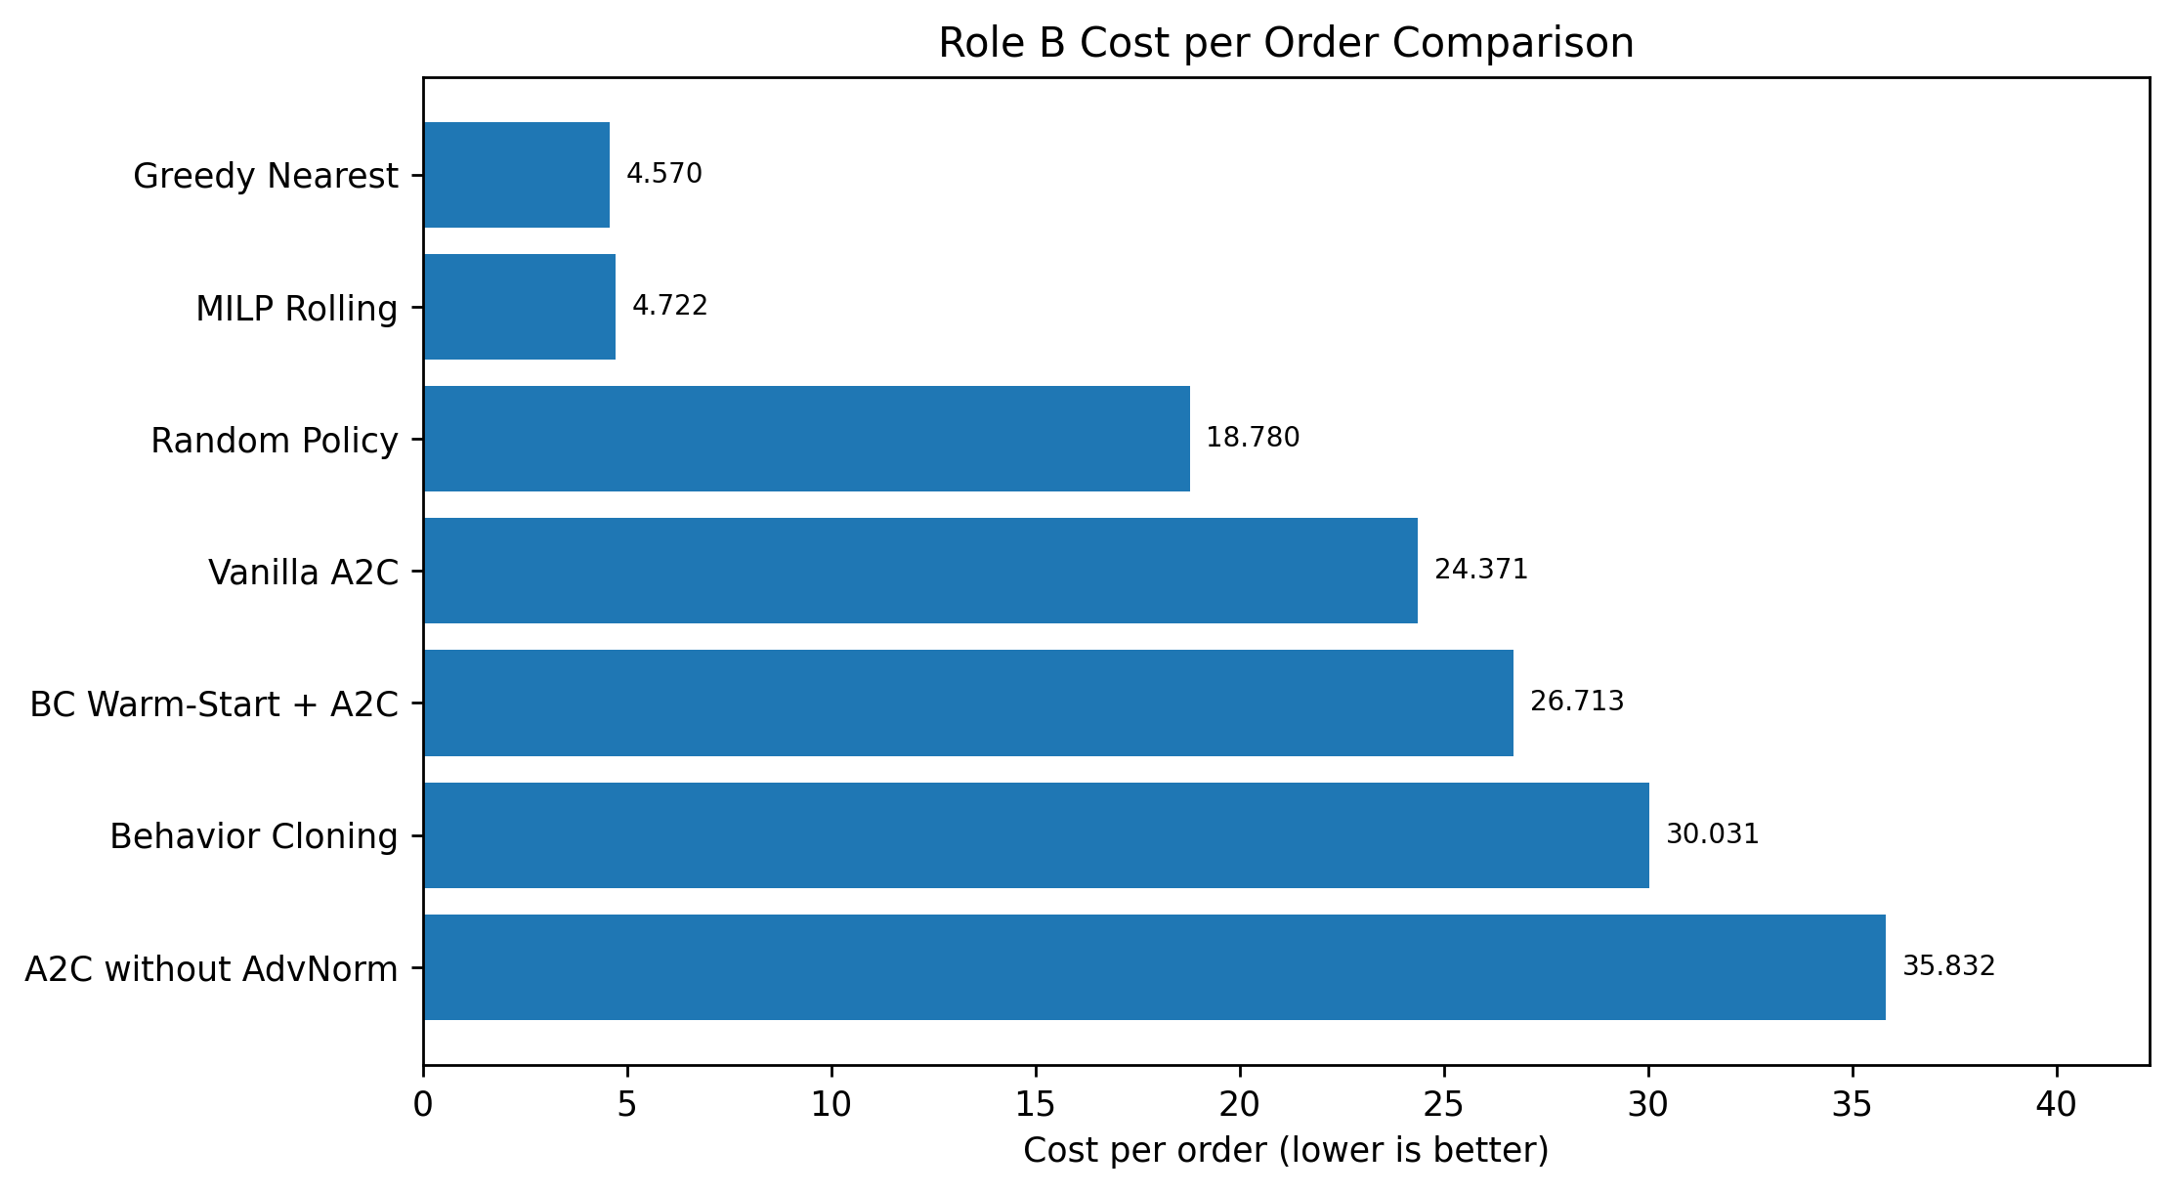
Figure B.1. Cost per order comparison for Role B methods and baselines. Lower values are better.

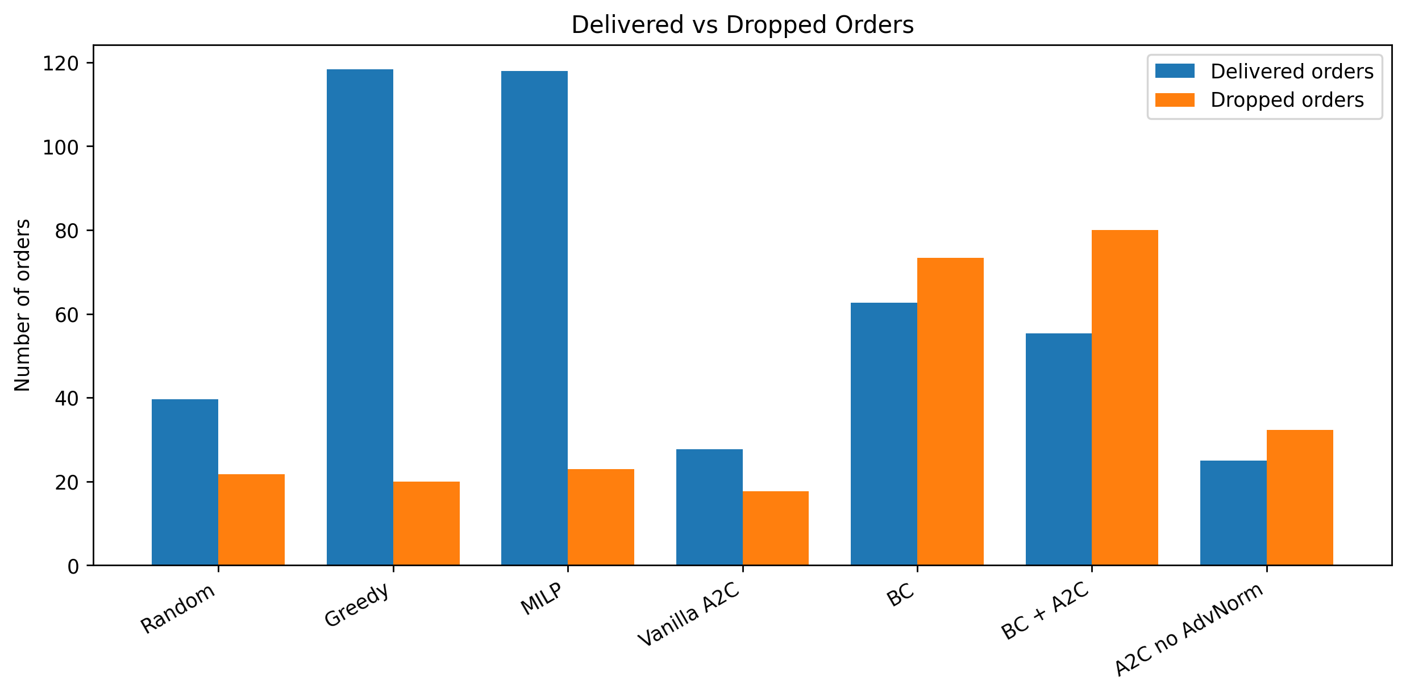
Figure B.2. Delivered and dropped orders for Role B methods and baselines.

- ROLE C - PLANNING BASED METHODS
In this section, a planning-based reinforcement learning method was developed for the DroneDispatch-v0 environment. The main objective of Role C was to improve real-time dispatching decisions by using Dyna-Q based planning. The final method was developed through three main stages. First, a direct Priority Dyna-Q method was tested. Then, a greedy-based rollout and battery safety correction mechanism was developed. Finally, the method was redesigned as a Priority Meta Dyna-Q V2 Battery-Reassignment Planner.
The final version uses Greedy Nearest as a strong base policy and applies learned planning corrections only when a better battery-aware decision is possible. This design makes the policy both safe and effective, because the planner does not need to learn the whole dispatching problem from scratch.
4.1 Environment Structure
Role C used the DroneDispatch-v0 environment and the standard evaluation configuration. The environment contains 8 drones, a maximum visible order window of 20 orders, charging stations, no-fly zones, delivery deadlines, and battery constraints. The action space contains 169 discrete actions. These actions include assigning a drone to an order, sending a drone to a charger, or selecting a no-op action.
The observation dictionary includes drone information, active order information, the grid layout, the current time, and the valid action mask. The action mask was used in all Role C methods to prevent invalid actions. Greedy Nearest was used as the main baseline because it provides a strong heuristic policy for the dispatching problem.
4.2 Stage 1: Direct Priority Dyna-Q
The first Role C approach was a direct tabular Priority Dyna-Q method. In this version, the agent tried to learn Q-values directly over the original 169 environment actions. The method included a tabular Q-table, model memory, and a prioritized planning queue. After each real environment transition, the model performed additional planning updates using previously stored transitions.
The idea was to combine real experience and simulated planning updates. Transitions with larger temporal-difference errors were assigned higher priority, so the planning process could focus on more important updates.
However, this direct approach had important limitations. The environment state includes drone locations, battery levels, active orders, order ages, and time. Because of this, the same exact state was rarely observed again. Also, learning directly among 169 actions made the tabular learning problem very sparse. As a result, the direct Priority Dyna-Q method did not produce stable enough improvements.
This first stage showed that Dyna-Q planning was useful in structure, but the original action space was too large for direct tabular planning.
4.3 Stage 2: Greedy-Based Rollout and Battery Safety Correction
After the direct Priority Dyna-Q approach, the method was redesigned around Greedy Nearest. Instead of replacing the baseline policy completely, Greedy Nearest was used as the default action generator. Then, a one-step rollout and battery safety correction mechanism was added on top of it.
The motivation was that Greedy Nearest usually produces reasonable assignments, but some assignments may create battery-related risks. Therefore, the second-stage method checked whether the greedy assignment was risky. If the selected drone had a low battery margin, the planner searched for another feasible drone that could serve the same order with a safer battery condition.
This rollout-based safety correction improved the standard Greedy Nearest result. In the standard evaluation seeds, it reduced the cost per order from 4.570 to approximately 4.437. It also reduced depletion events. However, this version was still mostly based on rule-based safety logic. The Dyna-Q component was not active enough during evaluation.
This stage was important because it showed that battery-aware reassignment was a valuable correction strategy. However, the final method still needed a stronger learned planning component.
4.4 Stage 3: Priority Meta Dyna-Q Planner
To make Dyna-Q more effective, the problem was reformulated as a meta-decision problem. Instead of learning directly over all 169 environment actions, the agent learned among three high-level meta-actions:
- Keep Greedy: use the action proposed by Greedy Nearest.
- Safe Swap: assign the same order to another feasible drone with a safer battery condition.
- Charge Risky Drone: send the risky drone to a charging station when the battery condition is critical.
This reduced the learning problem from 169 actions to 3 meta-actions. This design made the Q-table more practical and also made the learned policy safer. Greedy Nearest remained the default action unless the planner detected a useful correction opportunity.
The first Meta Dyna-Q version improved over the baseline, but it was still very conservative. In many evaluation steps, it selected Keep Greedy. Therefore, a stronger V2 version was developed.
4.5 Final Method: Priority Meta Dyna-Q V2 Battery-Reassignment Planner
The final version was called Priority Meta Dyna-Q V2 Battery-Reassignment Planner. This version improved the previous meta-controller in four main ways.
First, the meta-state representation was made coarser. Instead of using very detailed state buckets, the V2 encoder grouped similar states together. This increased the chance that a state seen during evaluation would match a state learned during training.
Second, the intervention zone was widened. The planner was allowed to consider corrections not only in clearly risky battery situations, but also in near-risk situations. This gave Dyna-Q more opportunities to learn useful Safe Swap and Charge Risky Drone decisions.
Third, prioritized sweeping was strengthened for intervention actions. Safe Swap and Charge Risky Drone transitions were given higher priority in the planning queue. As a result, the planning updates focused more on important battery-risk correction decisions.
Fourth, training-only reward shaping was updated. Depletion events were strongly penalized. Keeping the greedy action in risky states was penalized, while Safe Swap and Charge Risky Drone were rewarded when they were used in appropriate risk situations. Evaluation was still performed using the original environment metrics.
4.6 Meta-State Representation
The V2 planner used a compact meta-state representation. The main features were:
- Number of active orders
- Number of low-battery drones
- Number of very-low-battery drones
- Type of the greedy action
- Whether the greedy action is an assignment
- Battery risk flag of the selected drone
- State-of-charge bucket
- Estimated trip distance bucket
- Order age bucket
- Battery risk margin bucket
- Availability of a safe swap action
- Availability of a charge action
- Time bucket
This representation focuses on the information needed for planning and battery-risk correction. Since the features are discretized into coarse buckets, the tabular Dyna-Q model can generalize better across similar dispatching situations.
4.7 Experimental Setup
The final V2 model was trained for 200 episodes using the standard evaluation configuration. The final selected model used 60 planning updates per real environment step. In the ablation study, 0 and 30 planning-step settings were also tested to analyze the effect of Dyna planning updates. The model parameters were stored in a YAML configuration file, and the trained weights were saved as a compressed model file.
The final trained model was evaluated on three different seed groups:
- Seeds 0, 1, and 2
- Seeds 3, 4, and 5
- Seeds 6, 7, and 8
This was done to test whether the model could generalize to different random scenarios.
4.8 Results and Evaluation
The final Priority Meta Dyna-Q V2 planner outperformed Greedy Nearest on all tested seed groups.
For seeds 0, 1, and 2, the results were:
Method | Cost per Order | Success Rate | On-Time Rate | Delivered Orders | Dropped Orders | Depletion Events | Episode Return
Random Policy | 18,780 | 0,653 | 0,890 | 39,670 | 21,670 | 8,000 | -168,330
Greedy Nearest | 4,570 | 0,855 | 0,903 | 118,330 | 20,000 | 4,000 | 1.183,260
MILP Rolling | 4,722 | 0,836 | 0,911 | 118,000 | 23,000 | 3,330 | 1.173,000
Priority Meta Dyna-Q V2 | 2,374 | 0,920 | 0,926 | 130,330 | 11,330 | 2,000 | 1.599,420
For seeds 3, 4, and 5, the results were:
Method | Cost per Order | Success Rate | On-Time Rate | Delivered Orders | Dropped Orders | Depletion Events | Episode Return
Greedy Nearest | 3,911 | 0,866 | 0,913 | 117,670 | 18,330 | 3,000 | 1.252,590
MILP Rolling | 4,288 | 0,859 | 0,889 | 116,330 | 18,670 | 3,330 | 1.201,110
Priority Meta Dyna-Q V2 | 3,104 | 0,899 | 0,929 | 121,330 | 14,000 | 2,670 | 1.397,640
For seeds 6, 7, and 8, the results were:
Method | Cost per Order | Success Rate | On-Time Rate | Delivered Orders | Dropped Orders | Depletion Events | Episode Return
Greedy Nearest | 3,097 | 0,894 | 0,944 | 127,670 | 15,000 | 2,670 | 1.488,650
MILP Rolling | 2,075 | 0,921 | 0,945 | 131,000 | 11,330 | 1,330 | 1.659,380
Priority Meta Dyna-Q V2 | 2,235 | 0,933 | 0,944 | 133,000 | 9,670 | 2,330 | 1.661,850

Across the three seed groups, the approximate average cost per order was 2.571 for Priority Meta Dyna-Q V2 and 3.859 for Greedy Nearest. This means that the final Role C planner consistently improved the main project metric.
Figure C.4. Cost per order comparison between Priority Meta Dyna-Q V2 and Greedy Nearest across different evaluation seed groups.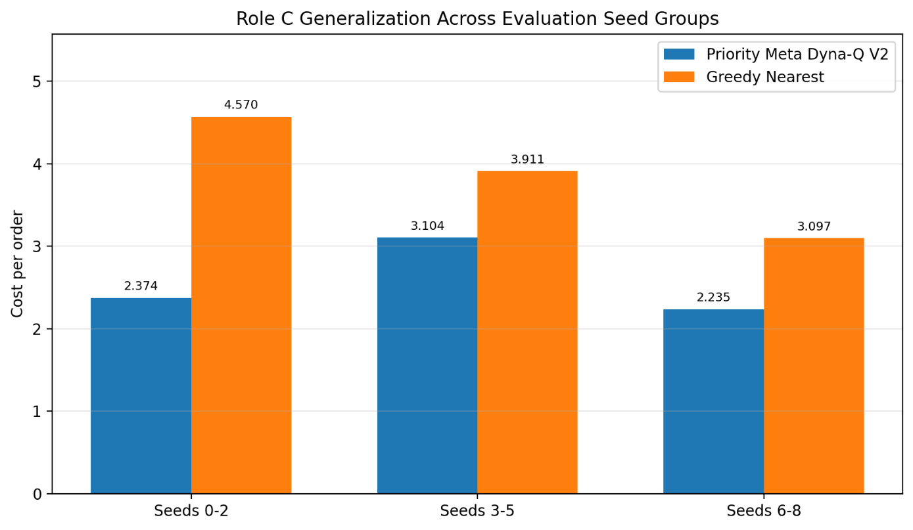
The debug counters also showed that the learned planner was active during evaluation. The policy mostly kept the greedy action, which is expected because Greedy Nearest is already a strong default decision rule. However, the planner also applied Safe Swap and Charge Risky Drone interventions in selected risk situations. These rare but useful interventions reduced dropped orders, reduced depletion events, and increased delivered orders.
Figure C.1. Cost per order comparison for Role C final policy and baselines. Lower values are better.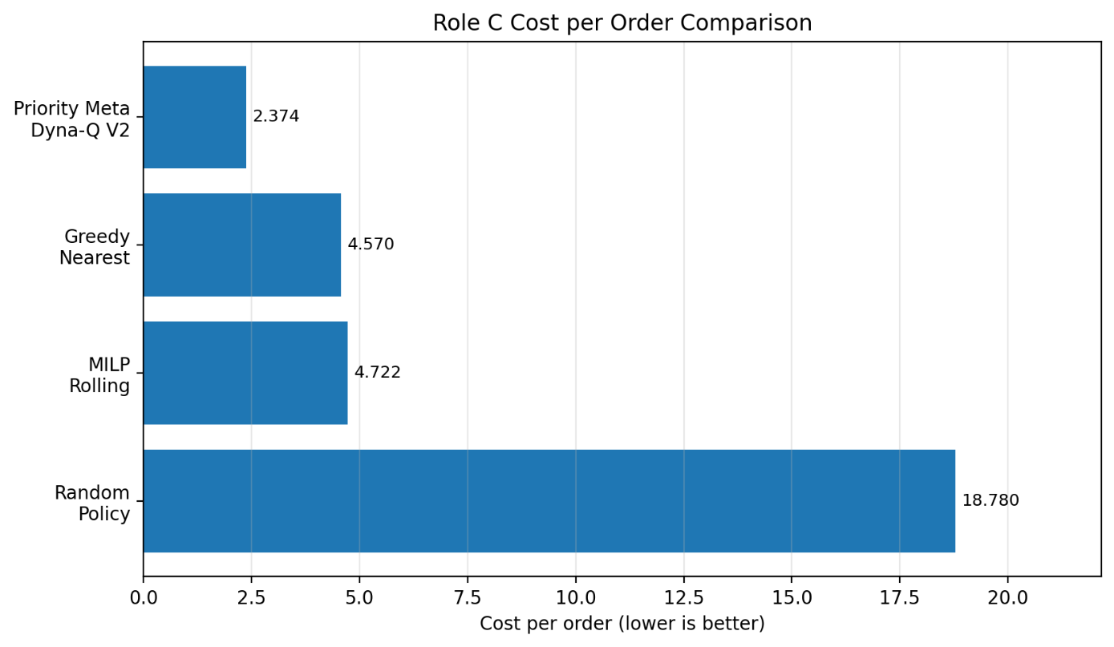
Figure C.2. Delivered and dropped orders for Role C final policy and baselines.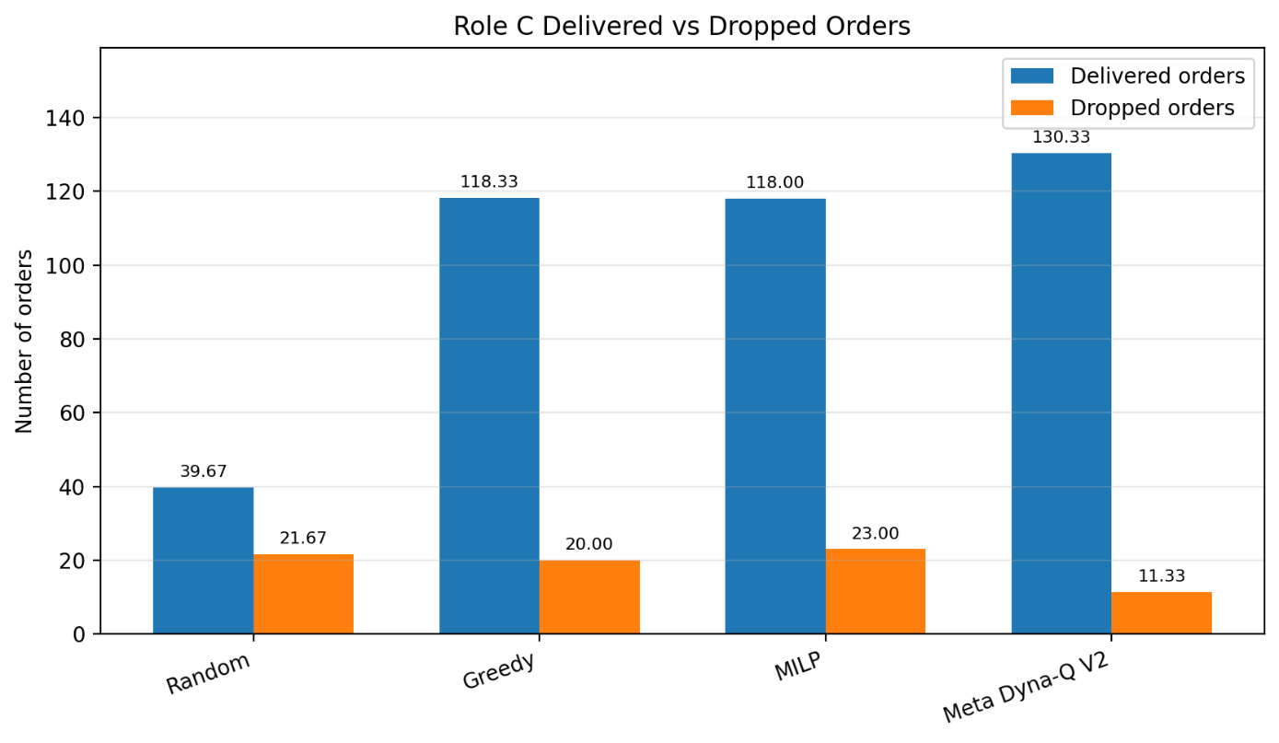
4.9 Ablation Study: Effect of Dyna Planning Steps
For the Role C ablation study, the number of Dyna planning updates was changed while keeping the same Priority Meta Dyna-Q V2 structure. The purpose of this experiment was to observe the effect of model-based planning updates on the final policy performance.
Three settings were tested: 0 planning steps, 30 planning steps, and 60 planning steps. All models were trained for 200 episodes and evaluated on the standard evaluation configuration using seeds 0, 1, and 2.
Planning Steps | Cost per Order | Success Rate | On-Time Rate | Delivered Orders | Dropped Orders | Depletion Events | Episode Return
0 | 2,321 | 0,917 | 0,931 | 129,67 | 11,67 | 1,67 | 1603,37
30 | 2,374 | 0,92 | 0,926 | 130,33 | 11,33 | 2 | 1599,42
60 | 2,374 | 0,92 | 0,926 | 130,33 | 11,33 | 2 | 1599,42
Greedy Nearest | 4,57 | 0,855 | 0,903 | 118,33 | 20 | 4 | 1183,26

The ablation results show that all Priority Meta Dyna-Q V2 variants clearly outperformed the Greedy Nearest baseline. The 0-step version achieved the lowest cost per order on seeds 0, 1, and 2. However, the 30-step and 60-step versions produced almost identical results and also achieved strong performance.
This result suggests that after reformulating the problem into a small meta-action space, the agent can learn useful battery-aware correction behavior even from real environment experience alone. Additional Dyna planning updates did not create a large extra improvement in this specific seed group. This can be interpreted as a diminishing-return effect. Once the action space is reduced to three meta-actions, the meta-state representation and battery-risk reward shaping become the most important parts of the method.
Even though the 0-step version achieved a slightly lower cost on seeds 0, 1, and 2, the 60-step version was kept as the final planning-based model because it represents the full Priority Meta Dyna-Q approach. Also, the 60-step final model was evaluated on additional seed groups and consistently outperformed Greedy Nearest. Therefore, the final selected Role C method remained the Priority Meta Dyna-Q V2 planner with 60 planning updates.
Figure C.3. Ablation study showing the effect of Dyna planning steps on cost per order.
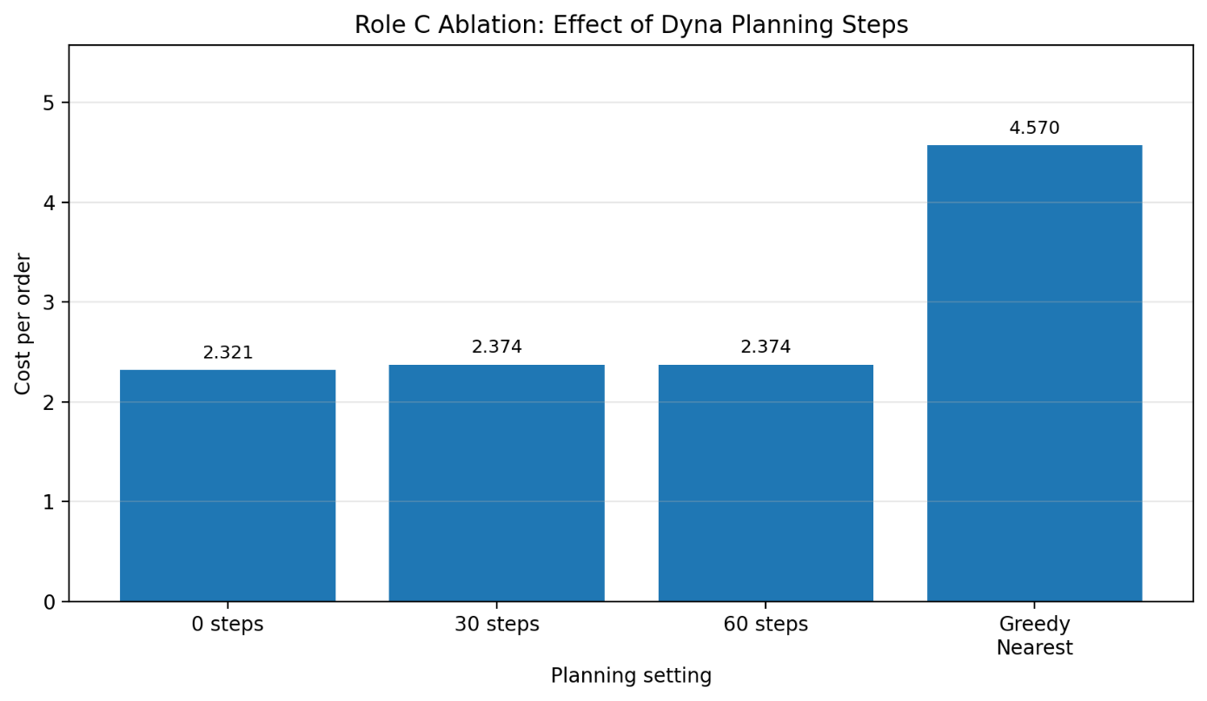
4.10 Development Summary
The development process of Role C shows a gradual improvement from a direct planning method to a more structured hybrid planner.
The direct Priority Dyna-Q method was limited by the large 169-action space and sparse tabular state representation. The rollout-based safety correction method improved the baseline, but it was mostly rule-based. The final Priority Meta Dyna-Q V2 method combined the strengths of both approaches. It kept Greedy Nearest as a strong default policy, but used learned Dyna-Q planning to decide when battery-risk corrections should be applied.
This final design made the learning problem smaller, safer, and more generalizable.
4.11 Conclusion for Role C
In conclusion, the Role C planning-based method successfully improved drone dispatching performance. The final Priority Meta Dyna-Q V2 Battery-Reassignment Planner achieved better results than Greedy Nearest on all tested seed groups. It also improved delivered orders, dropped orders, depletion events, and episode return.
These results show that combining a strong heuristic baseline with learned Dyna-Q planning corrections is an effective approach for this drone delivery dispatching problem.

- JOINT COMPONENT 1 - OFFLINE REINFORCEMENT LEARNING
In addition to the online reinforcement learning methods, an offline reinforcement learning component was implemented as a shared part of the project. The goal of this component was to train policies from previously collected logged trajectories without additional online environment interaction.
5.1 Offline Dataset Collection
A mixed-quality offline dataset was collected from different policy sources. The dataset included classical baseline policies, learned policies from Role A and Role B, and the final planning-based Role C policy. This created a realistic offline learning setting because the dataset contained both successful and unsuccessful behavior.
The final offline dataset contained 3572 transitions. The policy sources were Random Policy, Greedy Nearest, MILP Rolling, Role A DQN, Role A Double DQN, Role B A2C, Role B Behavior Cloning, and Role C Priority Meta Dyna-Q V2.
The contribution of the three project roles to the full offline dataset was also analyzed. Role A contributed 1230 transitions, Role B contributed 691 transitions, and Role C contributed 500 transitions. In the full dataset, this corresponds to approximately 34.4% from Role A, 19.3% from Role B, and 14.0% from Role C. The remaining 32.2% came from baseline policies. If only the three learned role-based sources are considered, the proportions become approximately 50.8% Role A, 28.5% Role B, and 20.7% Role C.
This means that all three roles contributed logged trajectories to the shared offline learning dataset. The purpose of using this mixed dataset was to test whether offline learning could extract useful behavior from imperfect logged data.
5.2 Behavior Cloning Baseline
As the first offline learning baseline, a Behavior Cloning model was trained on the collected dataset. This model learned to imitate the logged actions directly using supervised learning. Behavior Cloning reached high training accuracy, but its environment performance was weak. It achieved a cost per order of 33.226 and delivered only 37.67 orders on average.
This result shows that simply copying actions from a mixed-quality dataset is not enough. Since the dataset contains both strong and weak behavior, direct imitation can also copy poor decisions.
5.3 Naive Offline DQN
After Behavior Cloning, a naive offline DQN model was trained directly on the static dataset. The model used Bellman updates without collecting new online experience. This experiment showed a typical offline reinforcement learning problem. During training, the OOD gap increased from 0.451 to 3.797. This means that the model started assigning much higher Q-values to selected actions than to the actions observed in the dataset. This is an indication of out-of-distribution action overestimation.
When evaluated in the environment, the naive offline DQN achieved a cost per order of 19.562. This was better than Behavior Cloning, but still much worse than Greedy Nearest. Therefore, naive offline Q-learning was not reliable enough for deployment.
5.4 Conservative and Advantage-Weighted Offline Learning
A CQL-lite model was also tested to reduce overestimation by adding a conservative penalty. The conservative penalty reduced the overestimation diagnostic compared to naive offline DQN, but it did not improve the final deployment performance. Because of this, an IQL-lite approach was implemented as the final offline RL fix.
The IQL-lite model was trained using advantage-weighted behavior cloning. Instead of giving equal importance to all transitions, it assigned larger weights to transitions from higher-return trajectories. For the final IQL-lite training stage, a higher-return subset was selected from Greedy Nearest, MILP Rolling, and Role C Priority Meta Dyna-Q V2. This subset contained 1406 transitions: 456 from Greedy Nearest, 450 from MILP Rolling, and 500 from Role C. Their proportions were approximately 32.4%, 32.0%, and 35.6%, respectively.
The full offline dataset still included trajectories from all three roles. However, for the final advantage-weighted training stage, the model focused on higher-quality logged behavior. This helped the offline policy avoid copying weak actions from the mixed dataset while still using the shared dataset collection process.
5.5 Offline RL Results
Method | Cost per Order | Success Rate | On-Time Rate | Delivered Orders | Dropped Orders | Depletion Events | Episode Return
Behavior Cloning | 33,226 | 0,451 | 0,91 | 37,67 | 56,33 | 7,67 | -698,56
Naive Offline DQN | 19,562 | 0,742 | 0,951 | 30,67 | 12,67 | 8 | -150,58
IQL-lite | 2,251 | 0,934 | 0,927 | 131,67 | 9,33 | 2,33 | 1631,38
Random Policy | 18,78 | 0,653 | 0,89 | 39,67 | 21,67 | 8 | -168,33

The results show that Behavior Cloning was not enough to learn a strong dispatching policy from the mixed dataset. Naive Offline DQN improved over Behavior Cloning, but it suffered from out-of-distribution Q-value overestimation and still performed poorly compared to Greedy Nearest.
The IQL-lite model achieved the best offline RL result. It reduced the cost per order to 2.251 and achieved a success rate of 0.934. It also delivered more orders and dropped fewer orders than Greedy Nearest. These results show that advantage-weighted offline learning was effective for this dataset because it emphasized high-quality trajectories from stronger policies.
5.6 Offline RL Conclusion
The offline RL experiments showed that directly applying naive Q-learning to a fixed dataset can lead to overestimation and poor deployment performance. Behavior Cloning also performed poorly because it imitated both good and bad decisions from the mixed dataset. Conservative learning reduced the overestimation diagnostic, but the strongest practical result was obtained with IQL-lite advantage-weighted behavior cloning.
Overall, the offline RL component successfully used logged trajectories collected from all three project roles and baseline policies. The final IQL-lite policy outperformed Behavior Cloning, naive Offline DQN, Random Policy, Greedy Nearest, and MILP Rolling on the standard evaluation seeds.

- JOINT COMPONENT 2 - MULTI-AGENT DISPATCHING
A multi-agent dispatching component was implemented as the second shared part of the project. The aim of this component was to test a decentralized decision structure where each drone is treated as an independent agent. Instead of using one centralized controller that directly selects one of the 169 environment actions, each drone produces its own local action proposal.
6.1 Parameter-Shared IDQN-lite Structure
The implemented method was a parameter-shared Independent DQN-lite model. In this structure, all drones use the same neural network parameters, but each drone receives its own local observation. The local observation includes the selected drone’s own features, visible order information, the current time, and a normalized drone ID feature.
Each drone can propose one of the following local actions:
- assign itself to a visible order slot,
- go to a charging station,
- or select no-op.
Since the original environment expects a single centralized action, a conflict resolver was added after the local decisions. The conflict resolver collected the action proposals from all drone agents and selected the proposal with the highest Q-value among valid actions. This made it possible to run decentralized per-drone agents inside the original centralized simulation environment.
6.2 Initial IDQN-lite Experiment
First, the parameter-shared IDQN-lite model was trained from scratch for 80 episodes. This version was able to run end-to-end, but its performance was weak. The scratch IDQN-lite model achieved a cost per order of 55.346. This showed that learning decentralized dispatching behavior from scratch is difficult in this environment.
The main reasons were the large coordination requirement between drones, sparse rewards, shared environment dynamics, and the non-stationarity problem created by independent agents learning at the same time.
6.3 Behavior Cloning Warm-Start for Multi-Agent Learning
To improve the decentralized model, a behavior cloning warm-start was added. Expert trajectories were collected from Greedy Nearest, MILP Rolling, and the final Role C Priority Meta Dyna-Q V2 planner. These centralized expert actions were converted into local per-drone labels.
For example, if the centralized expert assigned a specific drone to an order, that drone received the corresponding local assignment label, while the other drones received no-op labels. This created a local supervised dataset for training the parameter-shared drone policy.
The multi-agent behavior cloning dataset contained 11248 local samples. After training, the model reached high imitation accuracy. The final training accuracy was approximately 0.973, and the weighted accuracy was approximately 0.968. This warm-start helped the decentralized policy learn more meaningful dispatching behavior before evaluation.
6.4 Multi-Agent Results
Policy | Cost per Order | Success Rate | On-Time Rate | Delivered Orders | Dropped Orders | Depletion Events | Episode Return
Parameter-shared IDQN-lite with BC warm-start | 16,585 | 0,62 | 0,923 | 62,33 | 36,67 | 7,67 | -42,41
Random Policy | 18,78 | 0,653 | 0,89 | 39,67 | 21,67 | 8 | -168,33
Greedy Nearest | 4,57 | 0,855 | 0,903 | 118,33 | 20 | 4 | 1183,26
MILP Rolling | 4,722 | 0,836 | 0,911 | 118 | 23 | 3,33 | 1173
The behavior cloning warm-start significantly improved the multi-agent policy compared with the scratch IDQN-lite model. The cost per order decreased from 55.346 to 16.585. The episode return also improved from -1035.30 to -42.41.
The warm-started multi-agent model also achieved a lower cost per order than Random Policy. However, it was still not competitive with Greedy Nearest or MILP Rolling. This shows that the decentralized policy learned useful behavior, but it still could not match centralized decision-making methods.
6.5 Discussion: Why Multi-Agent Learning Was Difficult
The multi-agent model had weaker performance than centralized policies for several reasons.
First, each drone agent used only local information. This made it difficult for an individual drone to understand the full fleet-level effect of its decision.
Second, the agents acted in the same shared environment. When one drone changes its behavior, the effective environment seen by the other drones also changes. This creates a non-stationarity problem.
Third, multiple drones may prefer similar orders or charging actions. Because the simulator accepts only one centralized action at each decision step, a conflict resolver was needed. Although the conflict resolver made the decentralized system executable, it also introduced a gap between local drone proposals and the final environment action.
Fourth, the reward signal is shared at the environment level. This makes credit assignment difficult because it is not always clear which drone’s local proposal caused the final positive or negative reward.
6.6 Multi-Agent Conclusion
The multi-agent component successfully implemented an end-to-end decentralized per-drone learning structure with parameter sharing. The first scratch IDQN-lite version performed poorly, but the behavior cloning warm-start improved the result substantially.
The final warm-started IDQN-lite model outperformed Random Policy in terms of cost per order and episode return, but it did not reach the performance of centralized methods such as Greedy Nearest and MILP Rolling. This result shows that decentralized dispatching is possible, but coordination and credit assignment remain challenging.
Future improvements could include centralized training with decentralized execution, communication between drone agents, stronger global state features, or a learned conflict-resolution mechanism.

- METHOD ORIGIN NOTE AND ENGINEERING LOG
7.1 Method-Origin Note
DQN was introduced by Mnih et al. (2015) for learning action-value functions with deep neural networks in discrete action spaces. We used it as the main value-based baseline because the simulator has a discrete dispatcher action space. Double DQN was proposed by van Hasselt et al. (2016) to reduce Q-value overestimation, which is important in this project because the action space is large and poor actions can be overvalued. Dueling DQN was introduced by Wang et al. (2016) to separate state-value and action-advantage estimation; we tested it because some drone states may be generally good or bad regardless of the exact action.
For policy-based learning, A2C was used as a synchronous actor-critic method based on the A3C work of Mnih et al. (2016). It was chosen because it directly learns a stochastic dispatching policy. GAE, introduced by Schulman et al. (2016), was used to stabilize advantage estimation and reduce variance in policy-gradient updates.
For planning, Dyna-Q was introduced by Sutton (1990) as a method combining learning, acting, and planning. We selected it for Role C because the drone problem benefits from correcting greedy decisions using remembered experience and planning updates. For offline RL, CQL by Kumar et al. (2020) was tested to reduce out-of-distribution Q-value overestimation. However, the final offline fix used an IQL-lite idea inspired by Kostrikov et al. (2021), because advantage-weighted behavior cloning performed better on our logged trajectories.
For the multi-agent part, we implemented parameter-shared Independent DQN, inspired by independent Q-learning approaches for multi-agent systems. It was selected as a simple decentralized per-drone baseline that could run end-to-end inside the original simulator.
7.2 Engineering Log
The main difficulty was that the simulator has a large discrete action space and sparse delayed rewards. Early DQN and Dyna-Q versions struggled to connect assignment decisions with final delivery outcomes. Battery depletion was another major issue, so the final Role C planner focused on battery-risk interventions over greedy assignments.
In offline RL, naive Offline DQN showed out-of-distribution overestimation: its OOD gap increased during training and deployment performance remained poor. CQL-lite reduced the diagnostic overestimation but did not improve final performance enough. IQL-lite with advantage-weighted behavior cloning solved this better by emphasizing higher-return logged trajectories.
In the multi-agent part, the first scratch IDQN-lite model performed poorly because independent drone agents created non-stationarity and coordination problems. Adding behavior cloning warm-start from Greedy Nearest, MILP Rolling, and Role C improved the cost per order from 55.346 to 16.585, but centralized methods still performed better.

