**CME 4432 APPLICATIONS OF DECISION SUPPORT SYSTEMS ASSIGNMENT I**

**2014510056 - ZEYNEP KÖSE**

Implement a desktop application by using WEKA library (C# application for WEKA.dll or Java for WEKA.jar) to obtain the suitable dataset content for each classification algorithm.

* For Naïve Bayes algorithm, the dataset must have only nominal data,
* For Logistic Regression algorithm, the dataset must have only numeric data,
* For K-Nearest Neighbour algorithm (named as IBk in WEKA), the dataset must be numeric.
* For Decision Tree algorithms (named as J48, Random Forest and Random Trees in WEKA), the data type is not important. (Don’t change anything in the dataset)
* For Artificial Neural Network algorithm (named as Multilayer Perceptron in WEKA), the dataset must be numeric
* For Support Vector Machine algorithm (named as SVM in WEKA), the dataset must be numeric

Implement the application for these algorithms.

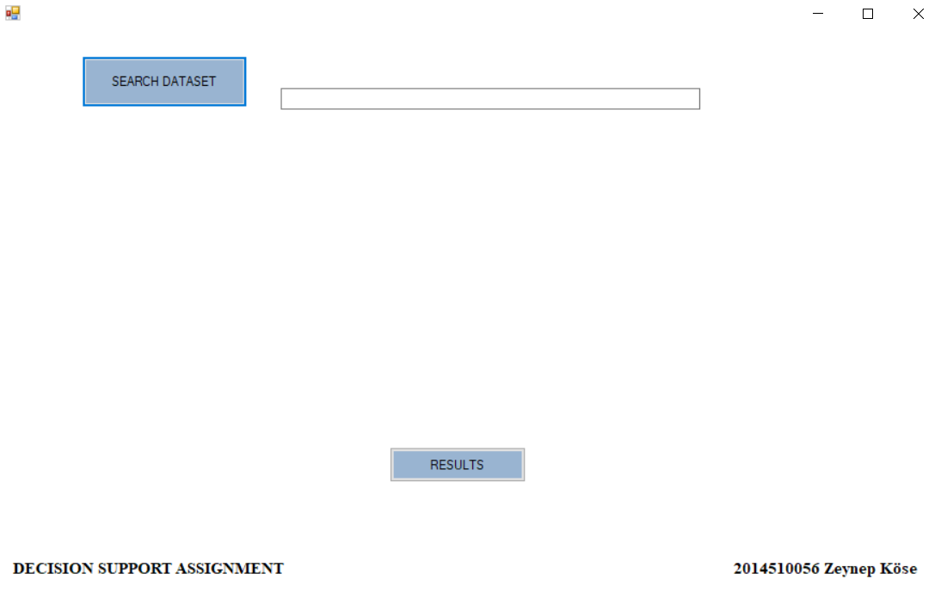

Figure 1. Application UI

1. **DATASET CAR TEST**

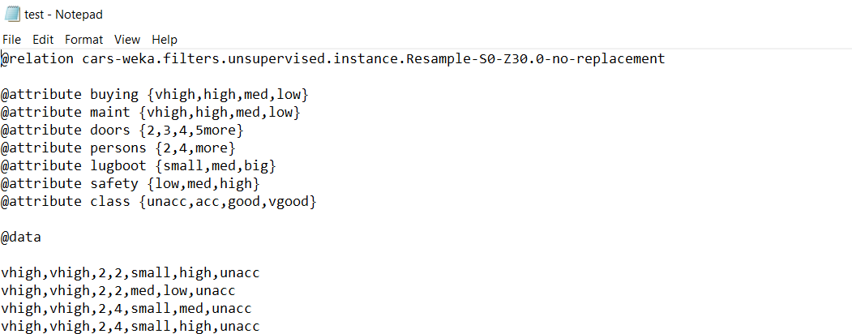

Figure 2. Dataset car test

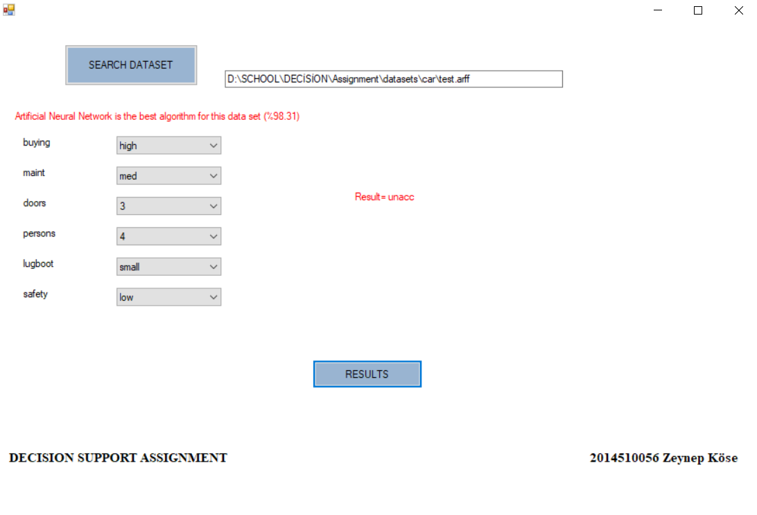

Figure 3. Result of Dataset car test

1. **DATASET IRIS**

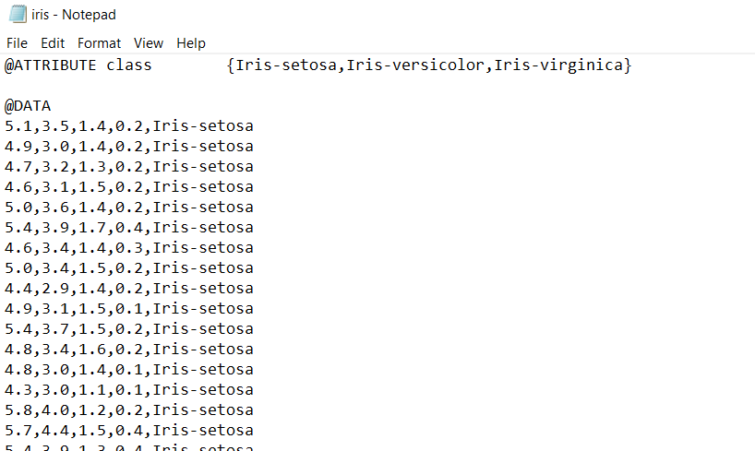

Figure 4. Dataset iris

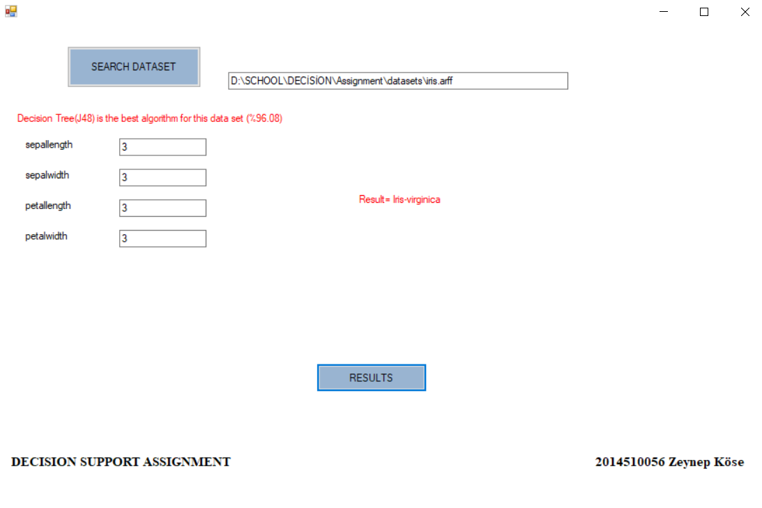

Figure 5. Result of Dataset car test

1. **DATASET WEATHER.NOMINAL**

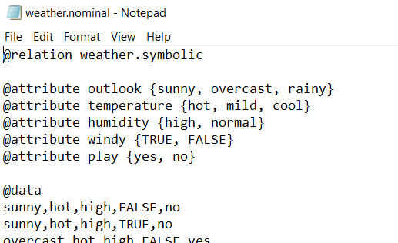

Figure 6. Dataset weather.nominal

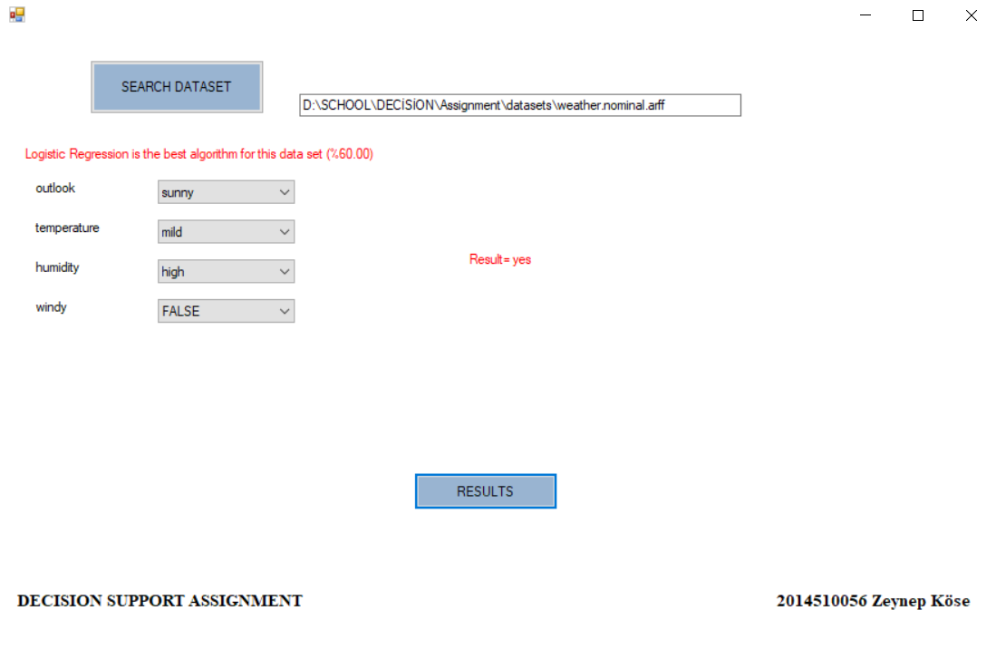

Figure 7. Result of Dataset weather.nominal