**CME 4432 APPLICATIONS OF DECISION SUPPORT SYSTEMS ASSIGNMENT 2 REPORT**

**Zeynep Köse 2014510056**

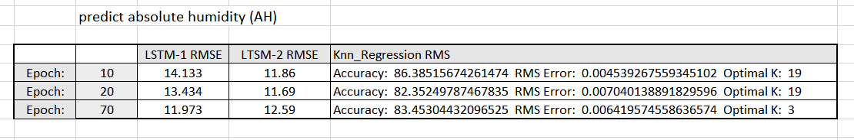



**LSTM-1**

UCI air quality data obtained from https://archive.ics.uci.edu/ml/datasets/Air+Quality . It contains one year data of parameters like NOx,CO,PT08,NMHC,Temp etc with time interval of one hour.

The object is to predict absolute humidity (AH) based on LSTM using multivariate time-series concept( [t-1] -> [t] ).All codes are in LSTM-1 notebook. As discrete data to be predicted we check only RMSE which shows up to be around 12 with 70 epochs and rmsprop optimizer.

Epoch 70:

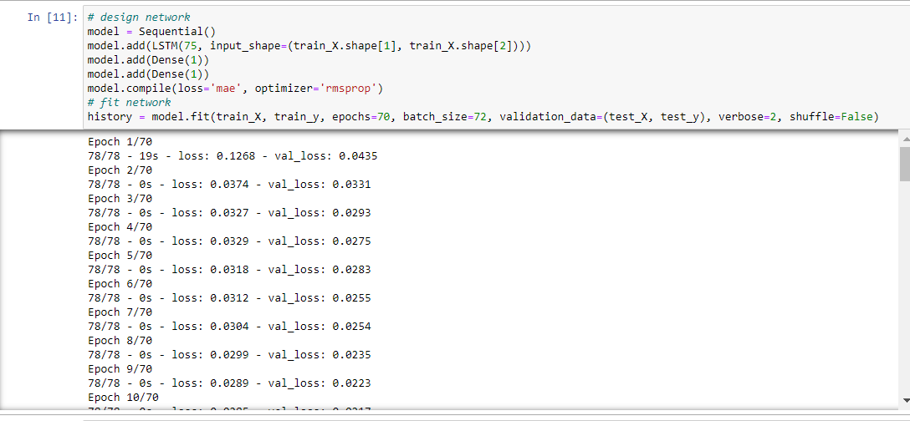

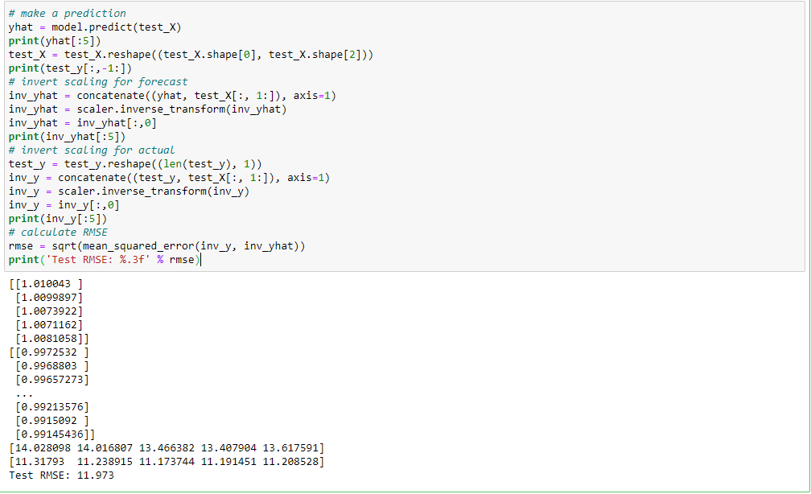

Epoch 10:

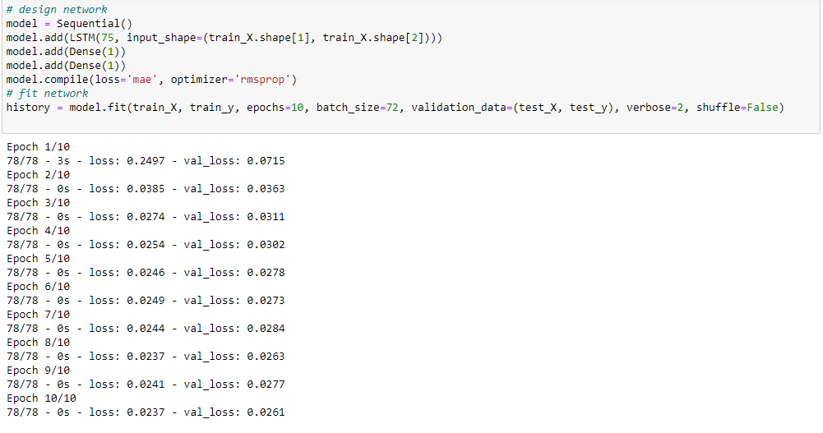

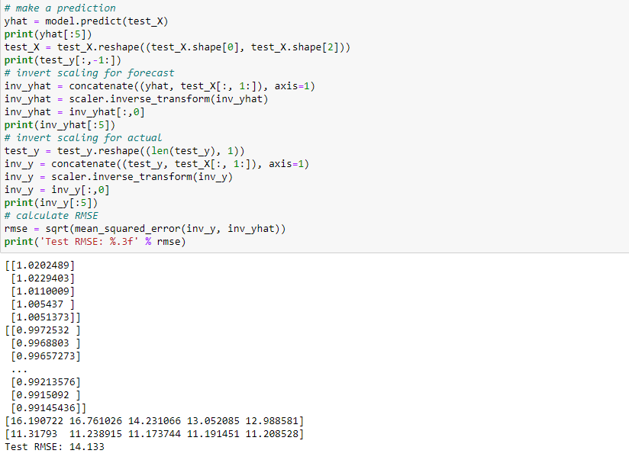

Epoch 20:

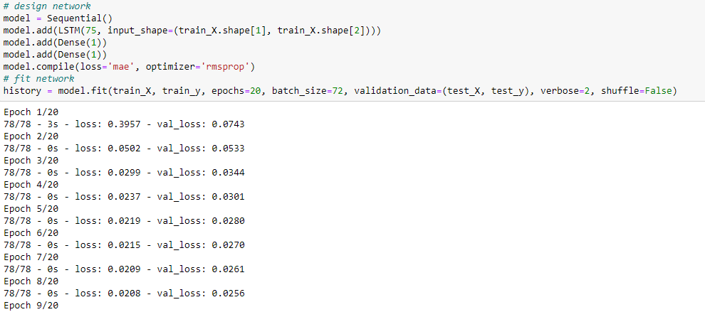

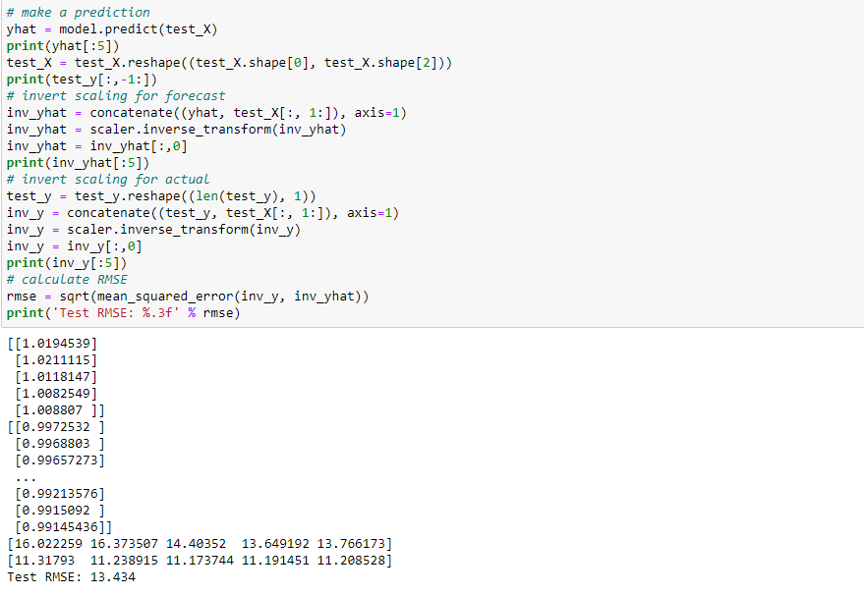

**LSTM-2**

Epoch:10

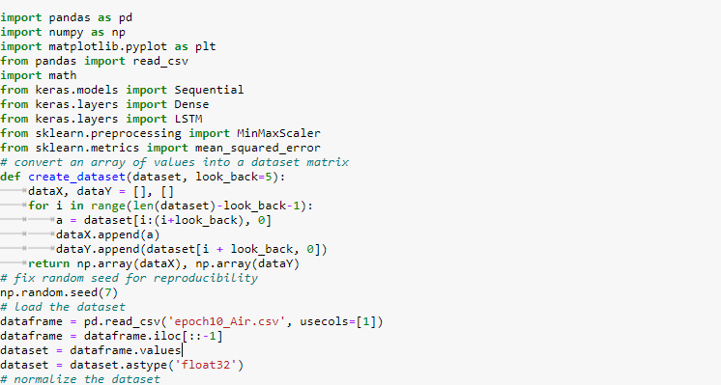

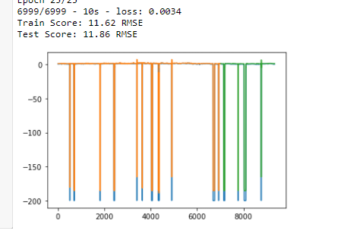

Epoch:20

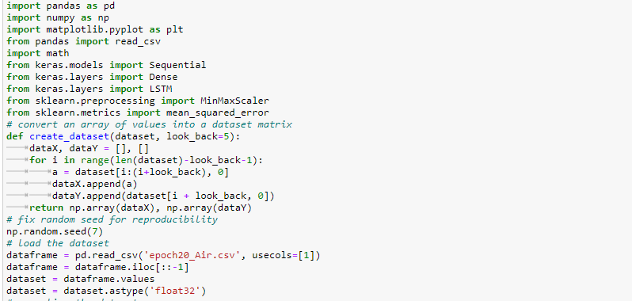

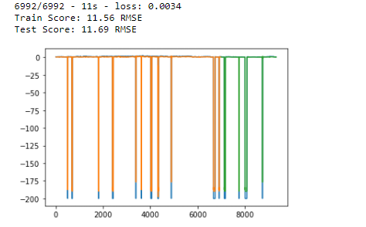

Epoch:70

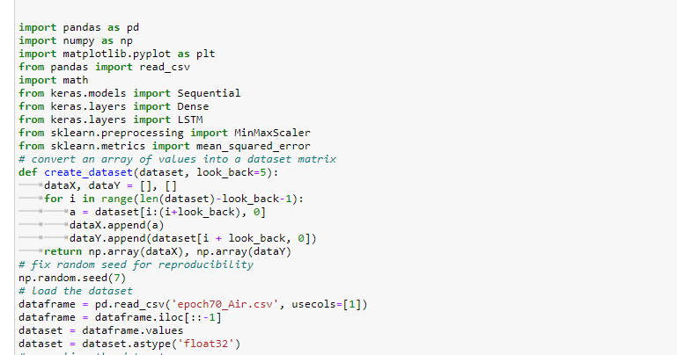

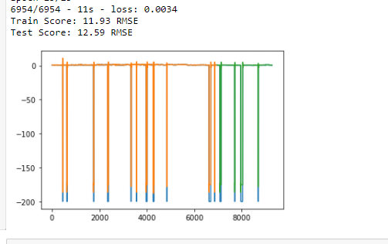

KNN-Regression

Epoch:10

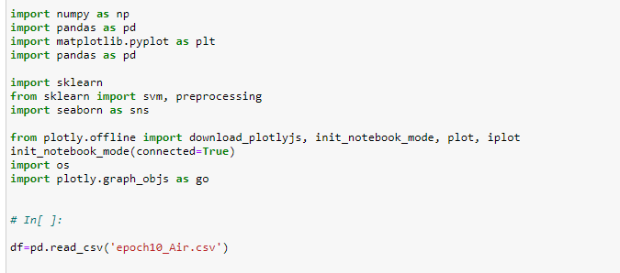

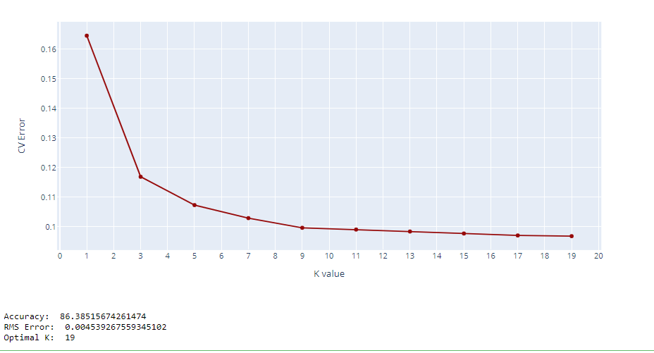

Epoch:20

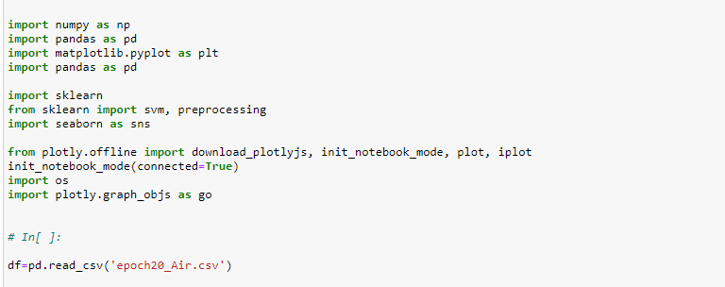

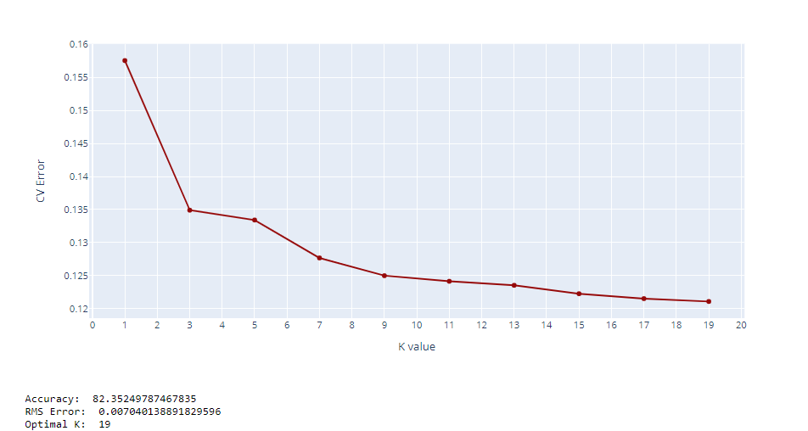

Epoch:70

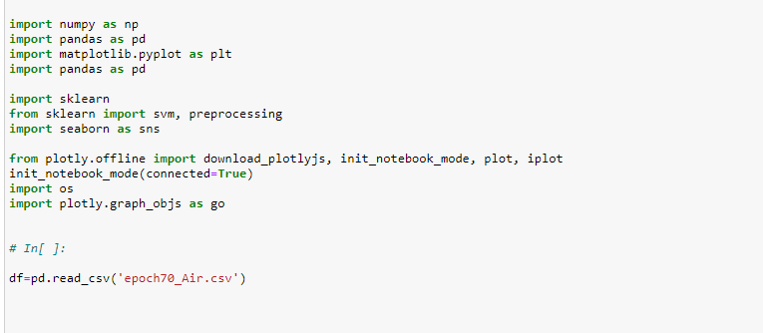

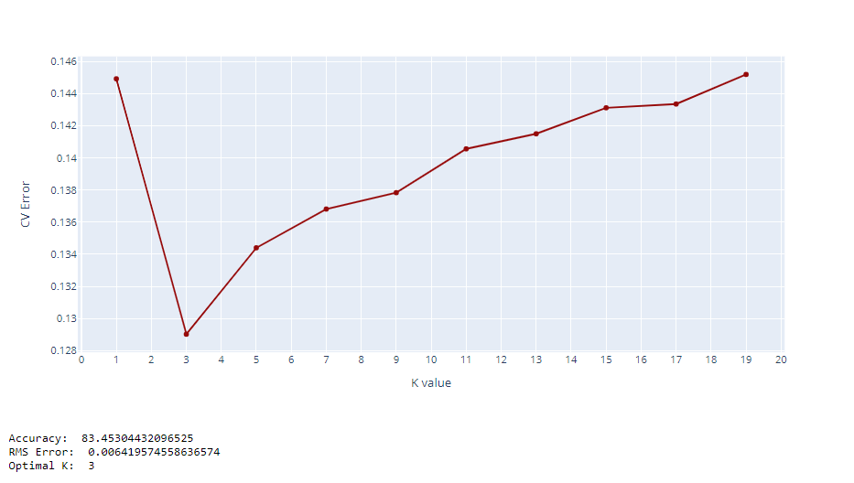

REGRESSION

Objective

Perform a multiple regression on a new dataset and evaluate the model with R² and RMSE.

Data

The data for this portion of the lab was obtained from the UCI machine learning repo. Here, the air quality data set was extracted and the CSV was edited in notepad to convert the european style decimal points to periods and the semicolons to commas to allow for easier reading by python. The headings were also adjusted into unique, easy to parse versions of the originals.

