**DOKUZ EYLUL UNIVERSITY**

**ENGINEERING FACULTY**

**DEPARTMENT OF COMPUTER ENGINEERING**

**METROPOLITAN AREA NETWORK**

**SIMULATION PROJECT**

**by**

**2014510056 Zeynep Köse**

**11.06.2021**

**İZMİR**

**CHAPTER ONE**

**INTRODUCTION**

**1.1. Project Definition and Problem Formulation**

A metropolitan area network (MAN) is a network that interconnects users with computer resources in a geographic area or region larger than that covered by even a large local area network (LAN) but smaller than the area covered by a wide area network (WAN). The term is applied to the interconnection of networks in a city into a single larger network. It is also used to mean the interconnection of several local area networks by bridging them with backbone lines.

**1.2. The Purpose and Motivation of the Project**

MAN allows sending and receiving of local emails in a cheaper and more quicker manner.Due to its use of fiber optics, users can transfer databases and files quickly, as the speed of the network has the capacity of reaching 1000Mbps. This is why telephone companies across the world utilize the structure of MAN and use fiber optics to transfer data in an unprecedented speed.MAN has the feature of allowing network administrators to manage the entire network centrally leading to much more effective and efficient network management. Speaking of effective network management, it is always highly recommended to essential network training beforehand.A MAN is also considered a more secure network in comparison to a WAN[2].

**1.3.**​**Term Definitions**

**Network :** ​This general term refers to all the components involved in getting computers andother types of hardware to talk to each other.

**Server :**​Also called "file server" and "network server" this term refers to the "nerve center" ofyour network. It typically needs to be much more high-powered than a regular desktop workstation. The server is home to hardware that is networked (allows more than one person to use it simultaneously). All of your data will typically be stored on this machine.

**Workstation :**​This refers to each person's computer. Your front and back office staffcomputers and the machines in the examination room will be workstations on the network. **Wireless :**​This refers to a type of network that broadcasts an access signal to the workstations.This allows for transporting laptops and tablet PCs from room to room while maintaining a network connection continuously. A wireless network also presents some additional security requirements.

**Ethernet :** This is the backbone of our network. It consists of the cabling and is typically able totransfer data at a rate of 100mb/s. What is not shown here are the hubs and switches that are used to connect computers and other devices together.

**Router :** This is your network's "air traffic controller." It routes all the data on your network towhere it is supposed to go. It also assigns unique network addresses to all the computers (IP addresses). Routers can also hide the computer and devices that connect to it from the outside world. To people on the Internet, your entire network looks like one computer (one IP address). This adds another layer of protection to the computers on your network. A router may contain a VPN server and/or a firewall. Read more about hubs, switches and routers.

**Architecture:** Network architecture is the design of a computer network. It can also be definedas the physical and logical design of the software, hardware, protocols, and media of the transmission of data.

**Switch:** Switch is a high-speed device that receives incoming data packets and redirects them totheir destination.

**Server:**​Servers manage access to a centralized resource or service in a network.

**Packet:**​Packet is a formatted unit of data carried by a packet-switched network.

**Channel:** Channel refers either to a physical transmission medium such as a wire or to a logicalconnection over a multiplexed medium such as a radio channel.

**Protocol:**​Protocols define rules of communication between network devices.

**DNS :** DNS stands for domain name system. It is an application layer protocol used to provide ahuman-friendly naming mechanism for internet resources. It is what ties a domain name to an IP address and allows you to access sites by name in your browser.

**IP :** The IP protocol is one of the fundamental protocols that allow the internet to work. IPaddresses are unique on each network and they allow machines to address each other across a network. It is implemented on the internet layer in the IP/TCP model[3].

**CHAPTER TWO**

**METHOD AND SIMULATION**

**2.1.**​**Simulation and Modelling Concepts**

The network requirements, physical and logical needs were calculated. The alternate approach, known as bottom-up, is more commonly employed, but is far from optimal. They have a tendency to begin the design process at this level, leaving applications and services as an afterthought to be considered later. In most cases, taking a bottom-up approach tends to require a less thorough initial analysis, and is easier to implement as a quick fix.

The main approach to the modelling is building workstations (some facilities include the wireless workstation users and to provide a successful connection wireless router were used and their configurations were adjusted) as needed for facilities and connections between each of them. Furthermore, we could call it this method as divide and conquer. It makes the process much easier than the thought.

After building workstations, the IP`s are assigned for each workstation. In deeply, first branch is located on network. Network devices connections between workstations and network devices are analysed. In addition to analyse process, facilities have more than one network devices and they must be connected logically and physically to workstations. Network devices were configured.

In order to connect workstations to the each other to provide essential connection, the physical cable is chosen as automatically by the packet tracer simulation software. In this case, workstations are connected with straight copper cable to the switches.

A facilities which are located in the same branches are connected each other with a main switch over a fast ethernet port. Router has been used for two different networks which are commonly used same network channel rules/bases. The other significant responsibility of the router is managing the packages; if one of the workstation wants to send something (message/mail or etc.) to another workstation at different network, router ensure the package goes to the other network with the help of static routing.(In packet tracer simulation, router has a option for redirecting the incoming network requests named as static routing configuration).

Finally, to achieve the main requested services; such as sending/receiving mail, browsing the web, sending/receiving files, VoIP Services (sending voice data over an IP between dedicated users/workstations) and lastly database management the servers are essential and needful. Servers are located in first branch, third facility. Servers were configured and connected to the main switch of server farm. This server farm switch is connected to the other switch of second facility.

To sum up, we did not want to mention the structure deeply. All network connections are ended and connected successfully to ensure the achievable accomplished network connection between two distinct branches.

**2.2.**​**Simulation Environment**

The simulations done in the project Cisco Packet Tracer was used. Packet Tracer offers a unique combination of realistic simulation and visualization experiences, complex assessment and activity authoring capabilities and opportunities for multi-user collaboration. Cisco Packet Tracer makes learning and teaching significantly easier by supporting multi-user collaboration and by providing a realistic simulation environment for exploration and experimentation.

**2.3. Network Design Requirements**

Server/client architecture was used as the architecture of the network. MAIL, DNS, HTTP 2, HTTP 1, FTP 1, FTP 2 and DHCP protocols were used for the communication between devices. LANs contained in the MAN use the star topology so in general our topology can be considered to be a hybrid topology. Logical and physical topology of the network is presented below with the configurations for the servers.

**2.4. Requirement Analysis**

All workstations at all sites of the second branch and at the first and second sites of the first branch can access the web servers located at the third site of the first branch. The mail server can be accessed from the first facility of the first branch and the first and third facility of the second branch. These stations were authorized to use mail applications.

**2.5. Definitions of the System/Model**

Shape of The System

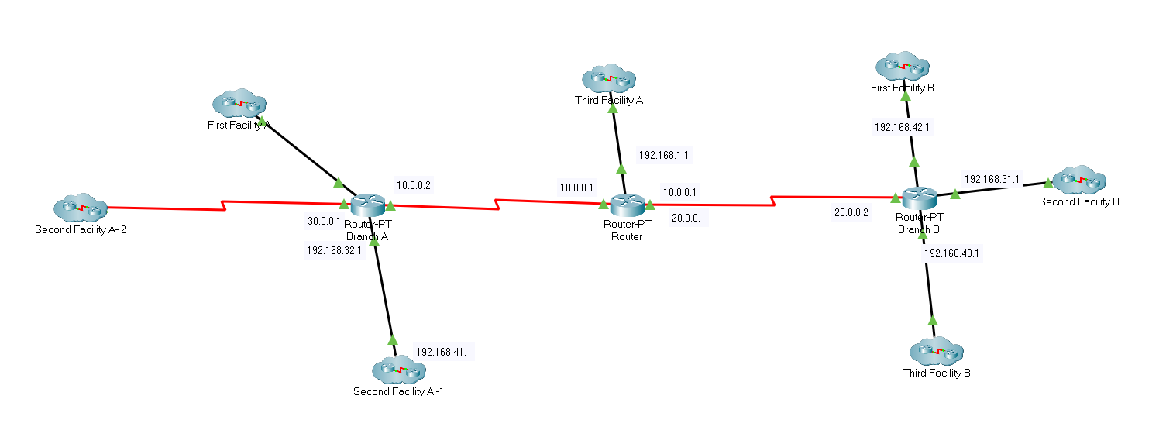

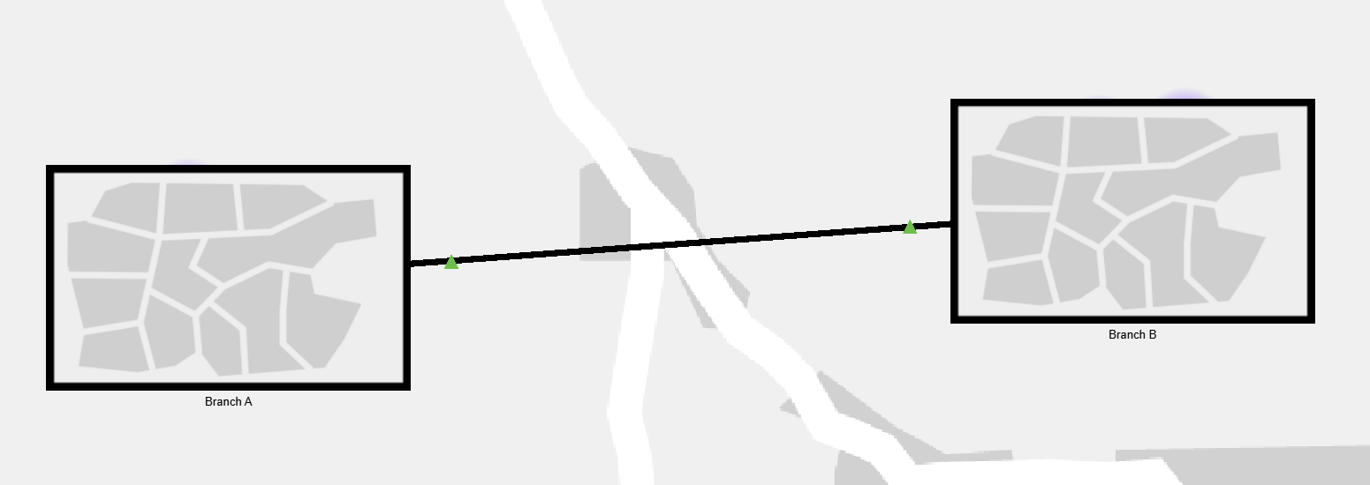

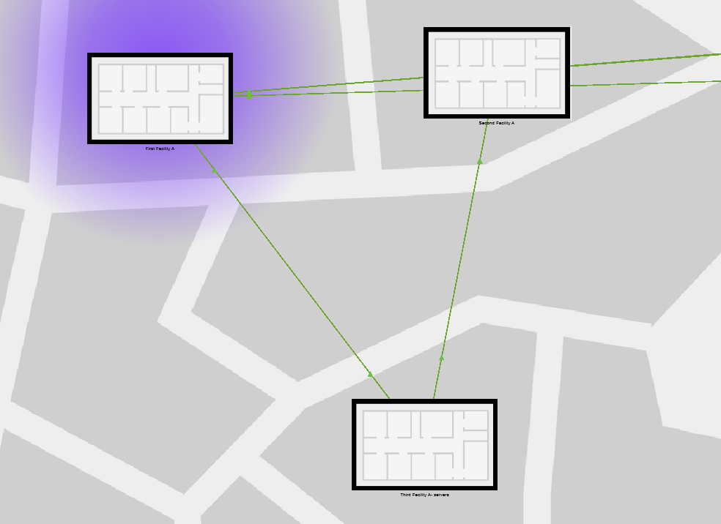

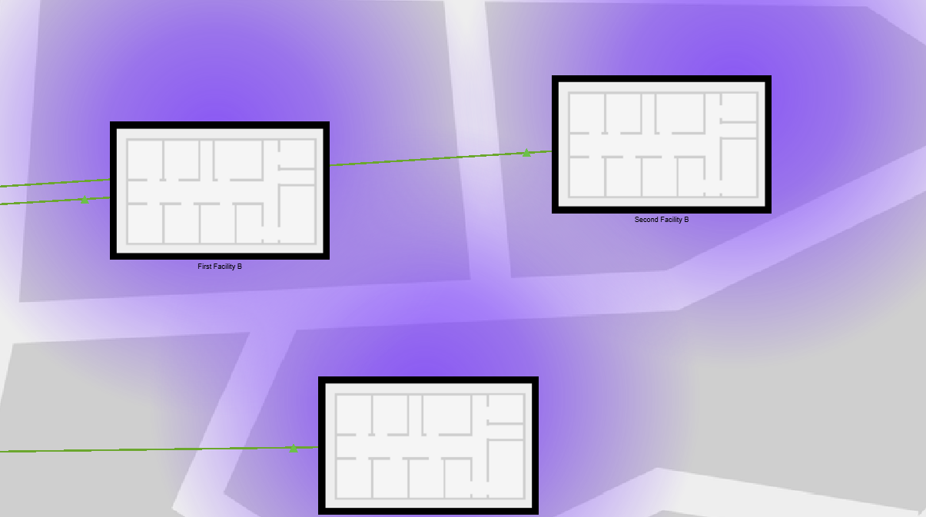

Branch A First Facility

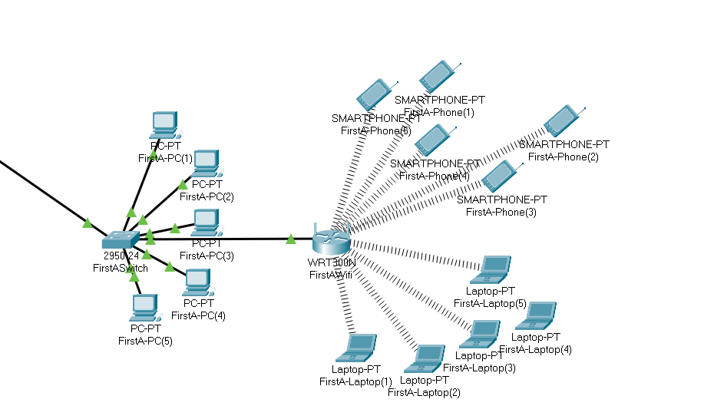

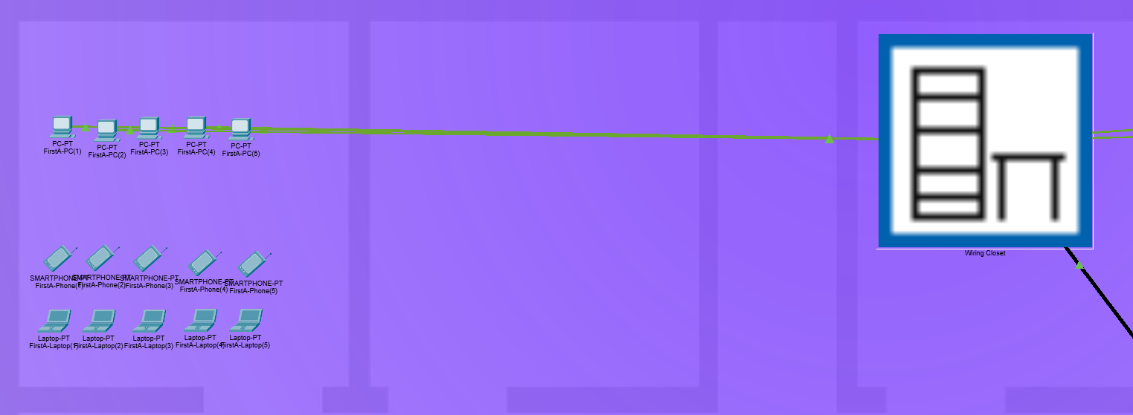

Branch A Second Facility

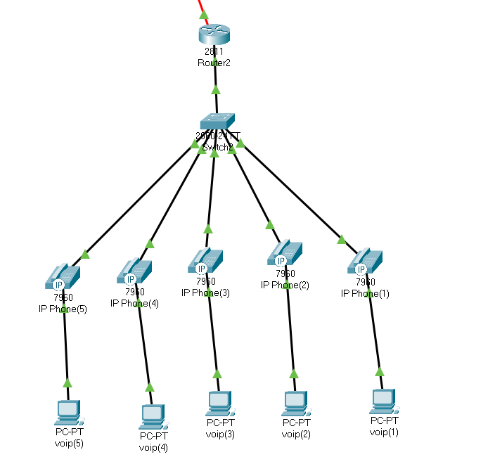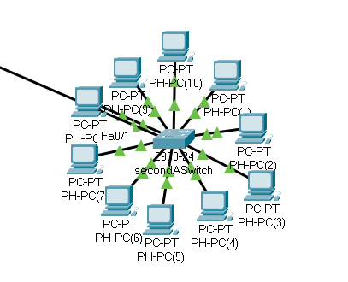

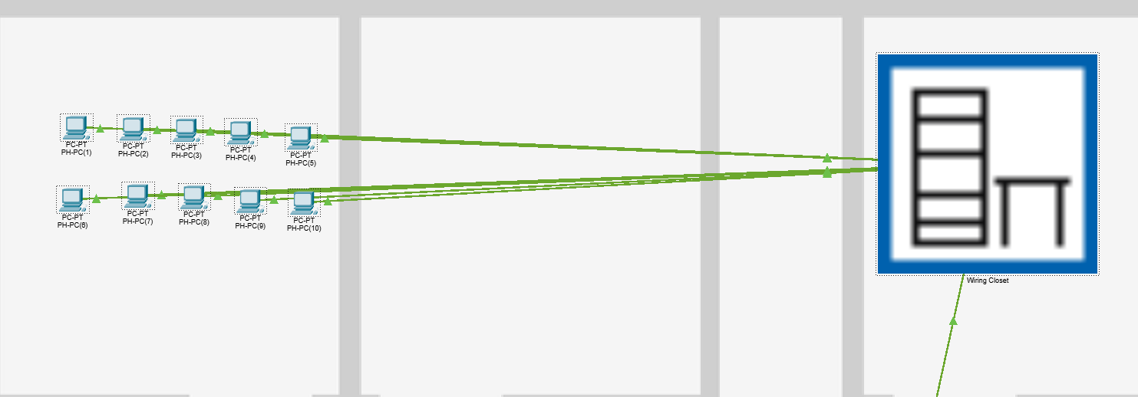

Branch A Third Facility

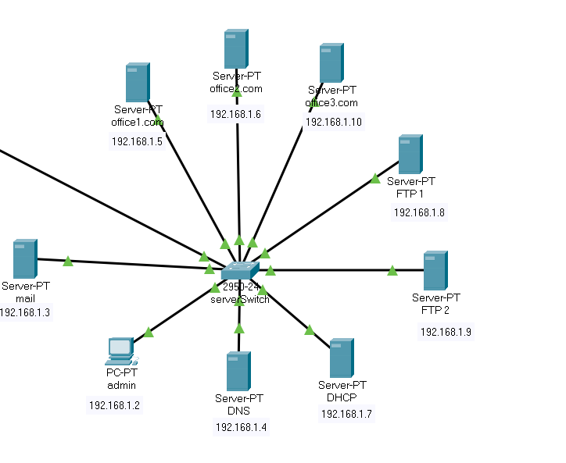

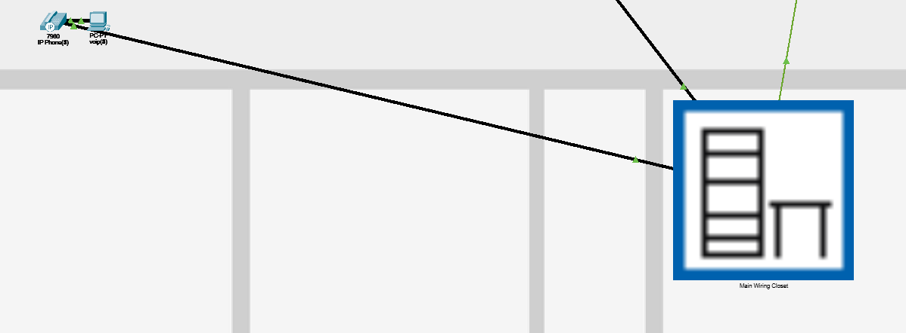

Branch B First Facility

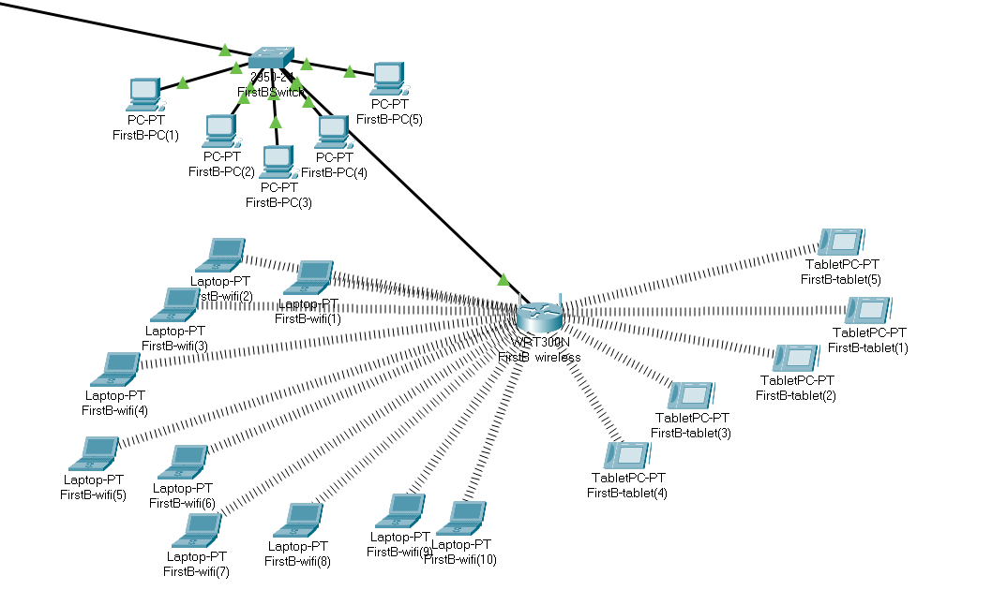

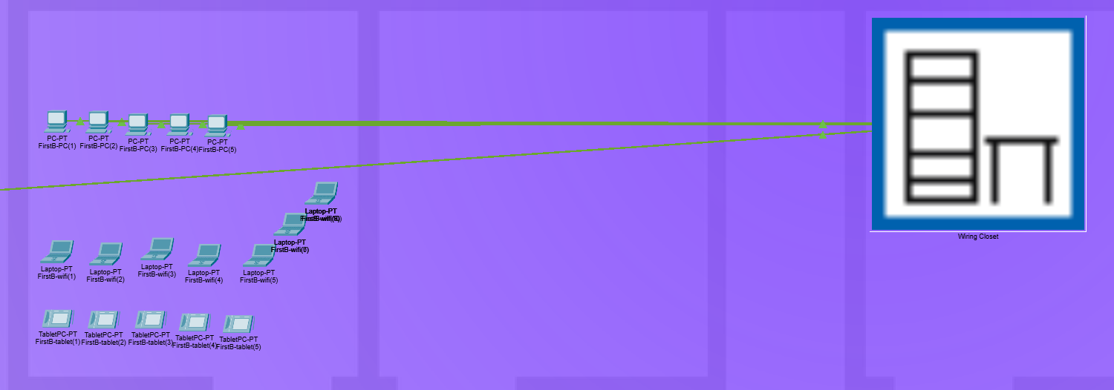

Branch B Second Facility

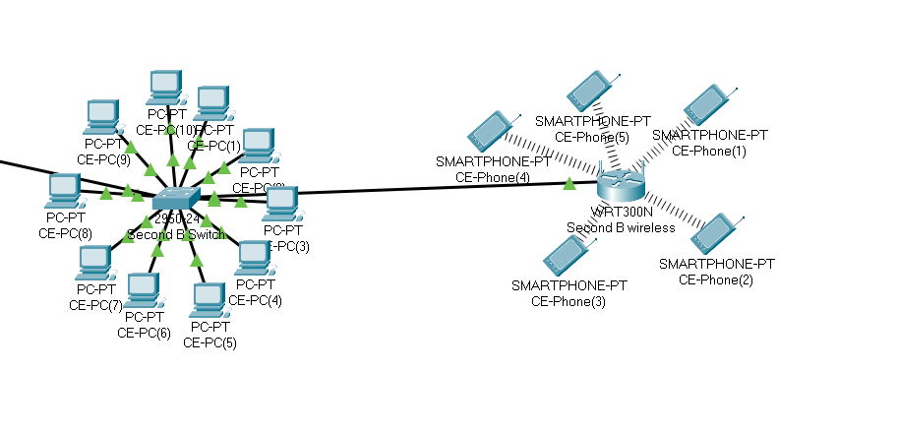

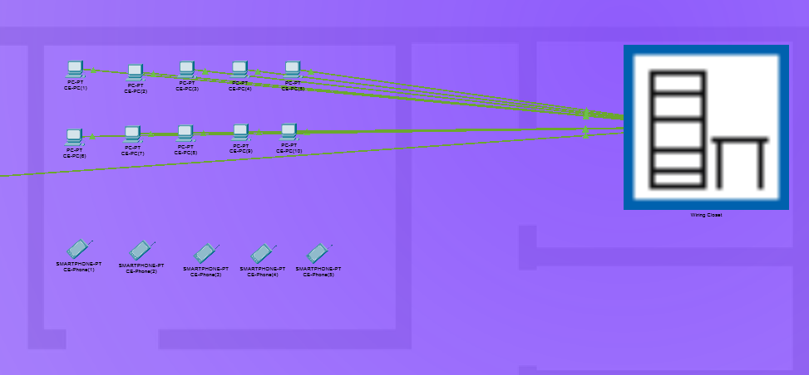

Branch B Third Facility

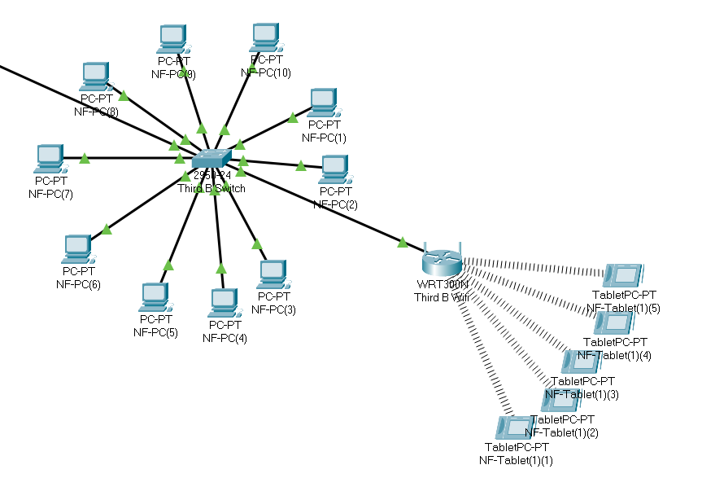

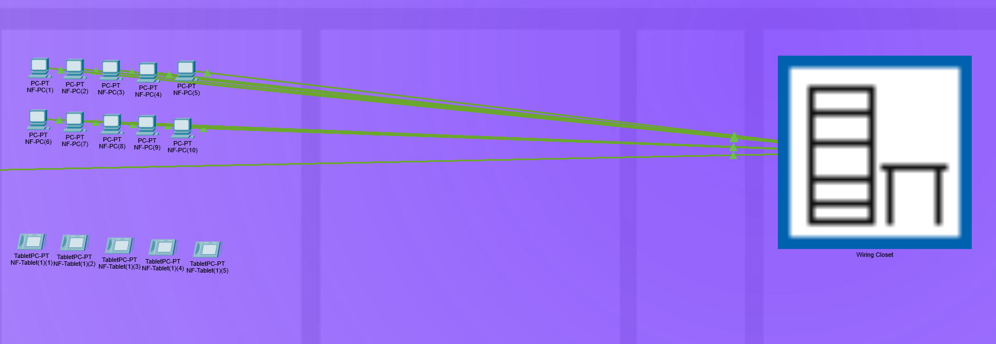

**2.6. Simulation Elements**

**Web Servers:**

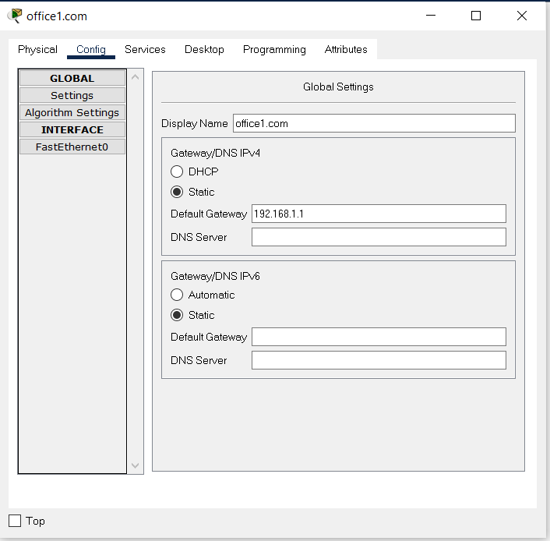

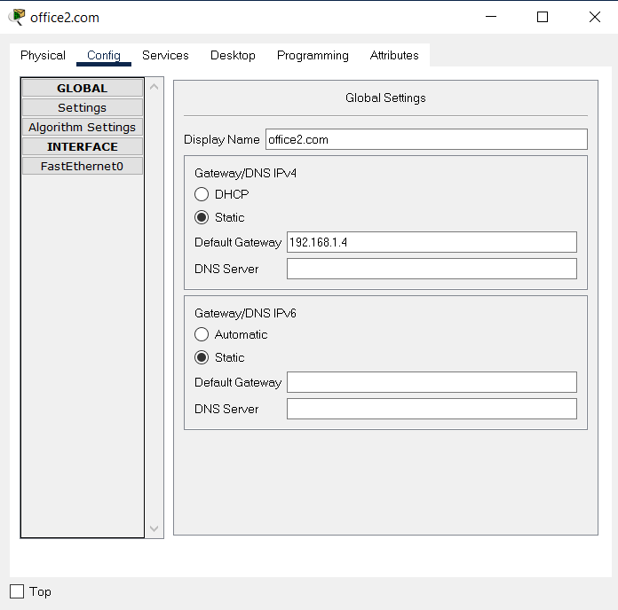

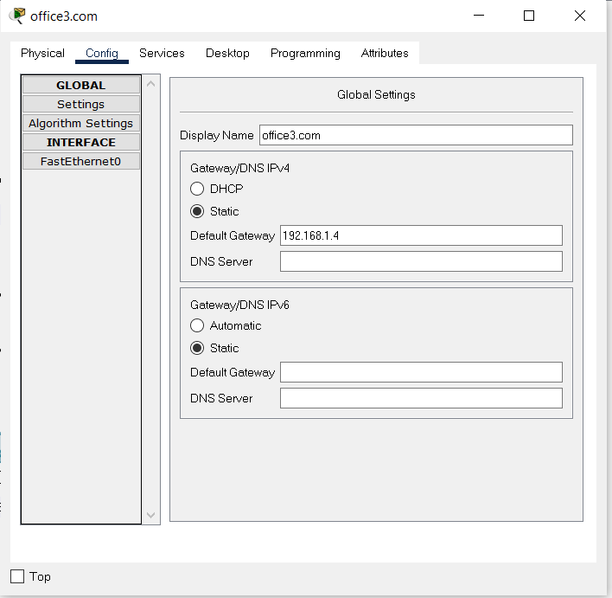

**FTP Servers:**

FTP1 Server Config

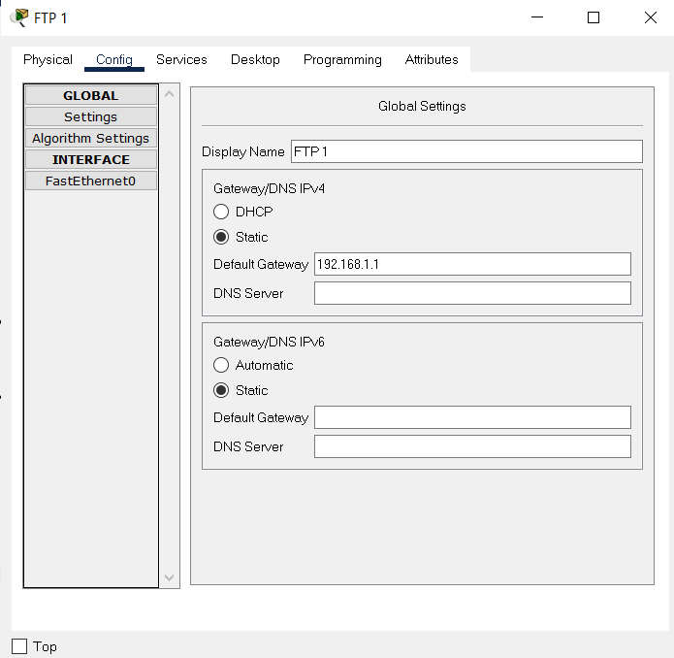

FTP1 Server Service

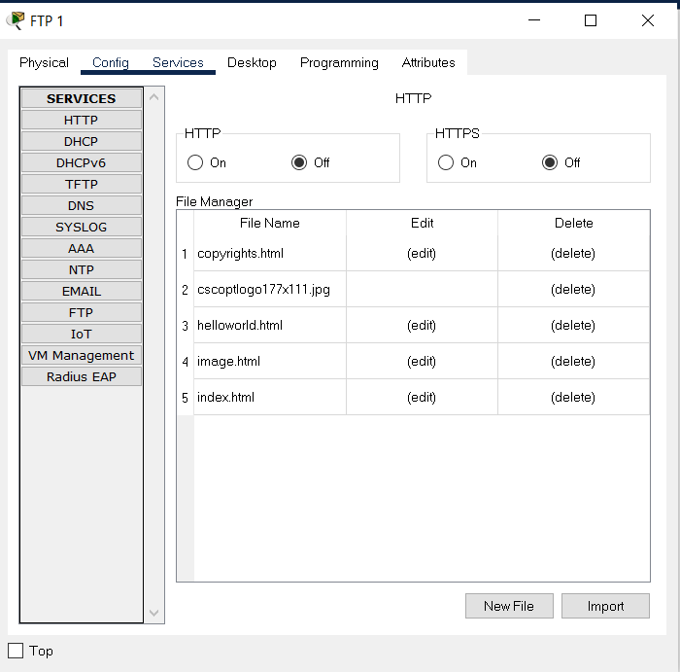

FTP2 Server Config

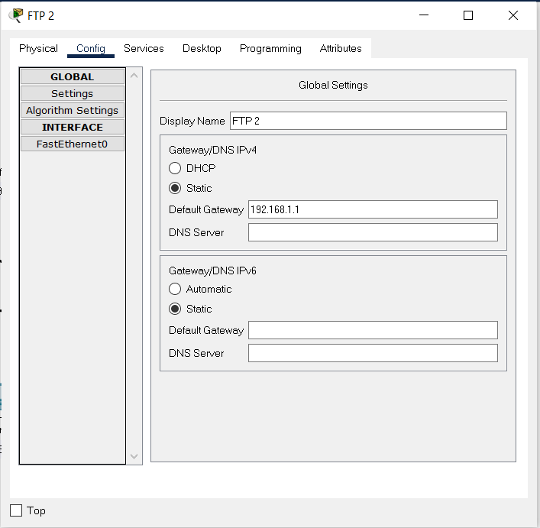

FTP2 Server Service

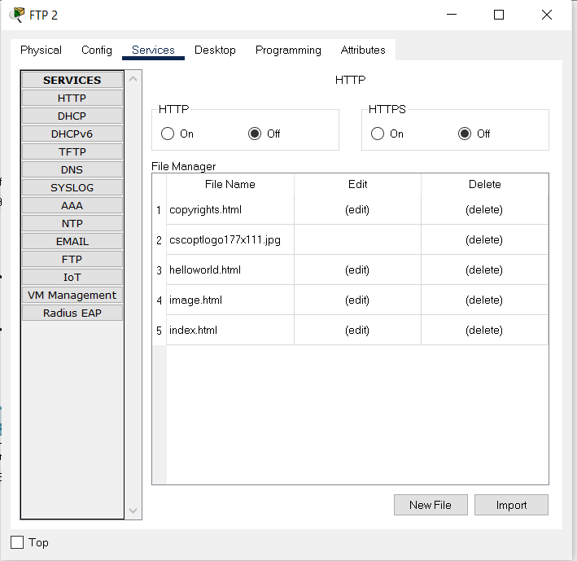

DHCP Server Config

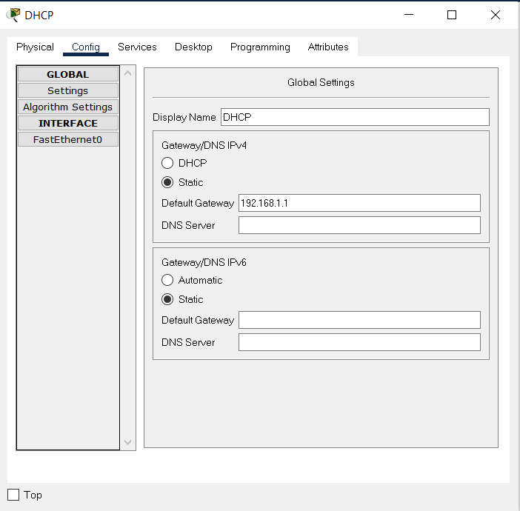

DHCP Server Service

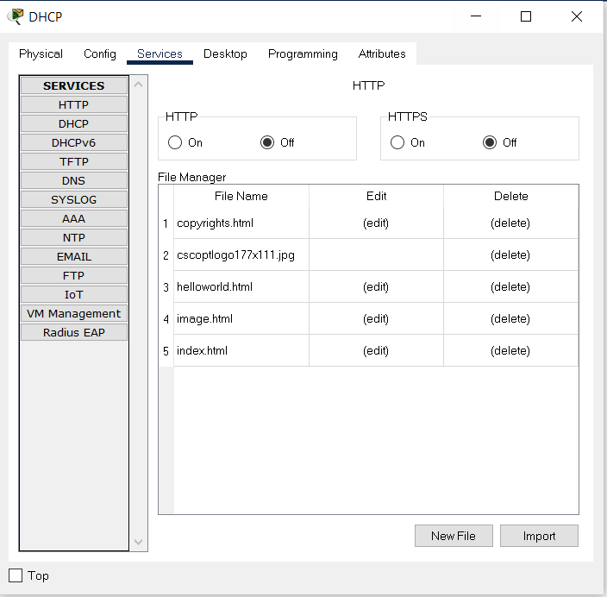

DNS Server Config

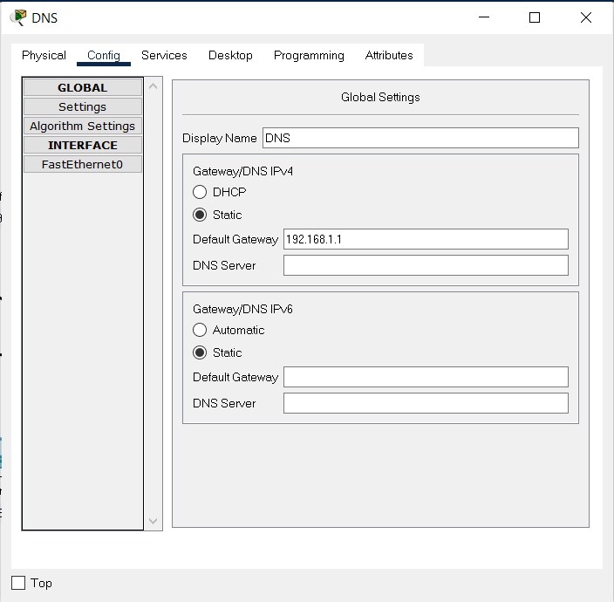

DNS Server Service

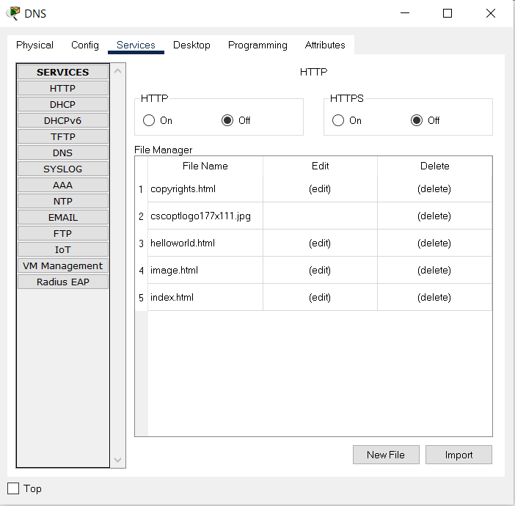

MAIL Server Config

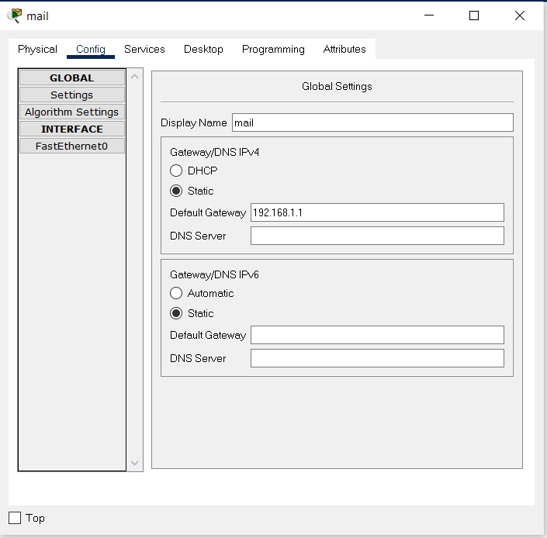

MAIL Server Service

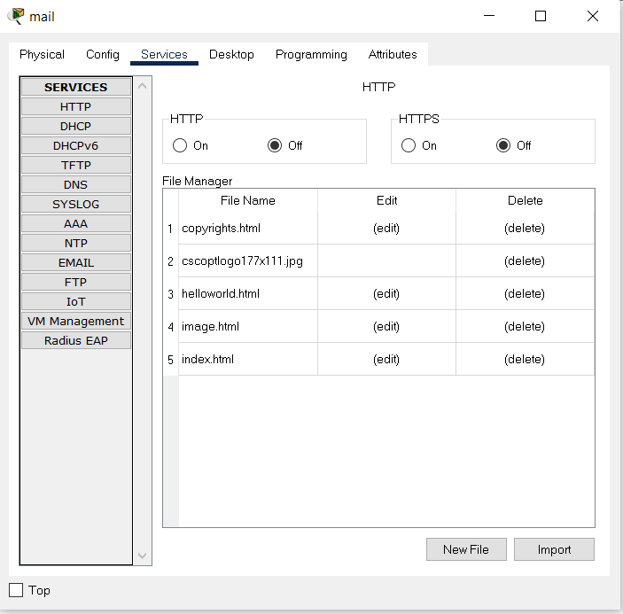

**CHAPTER THREE**

**TRAFFIC ANALYSIS & SIMULATION RESULTS**

**Scenarios**

1. A wireless user from first facility of second branch wants to read emails and browse Web.

Browse Web:

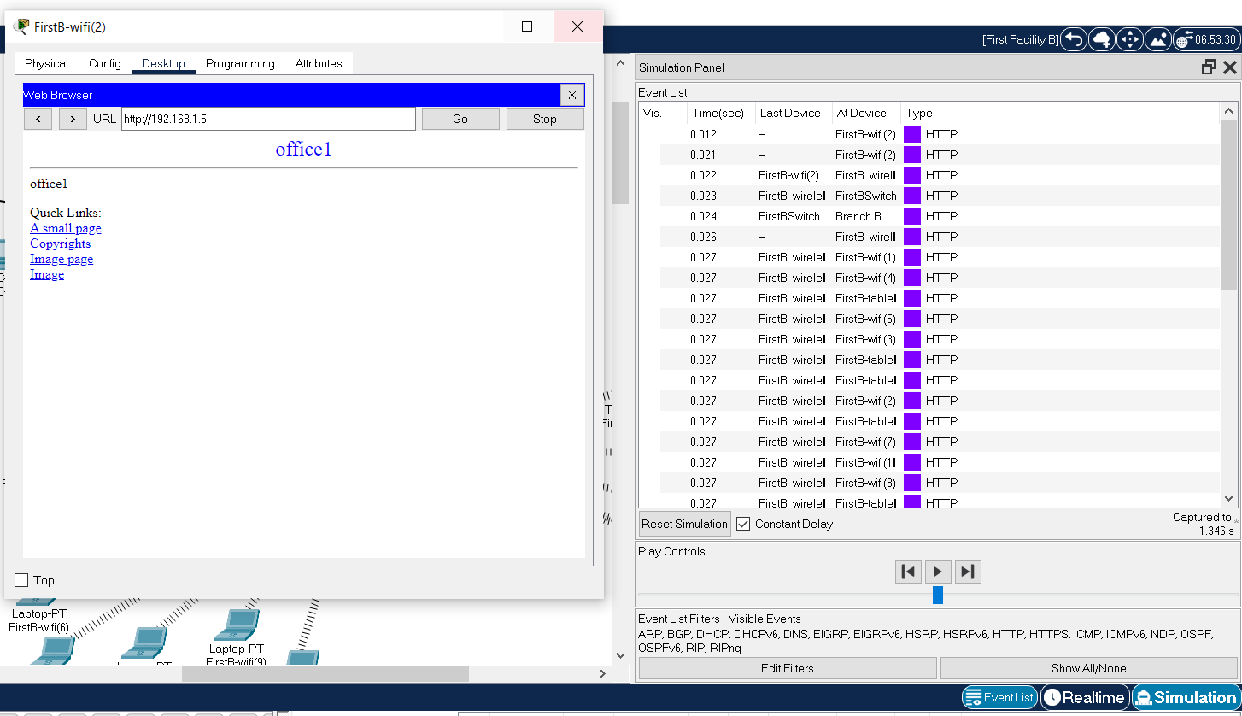

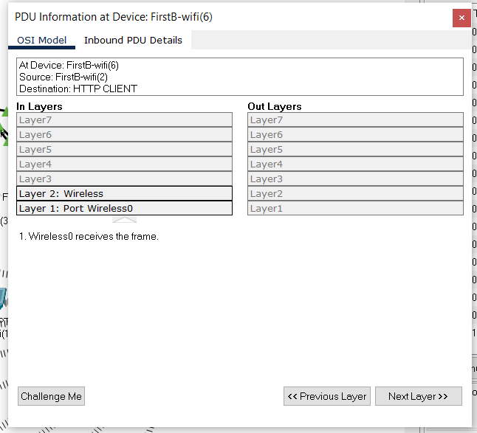

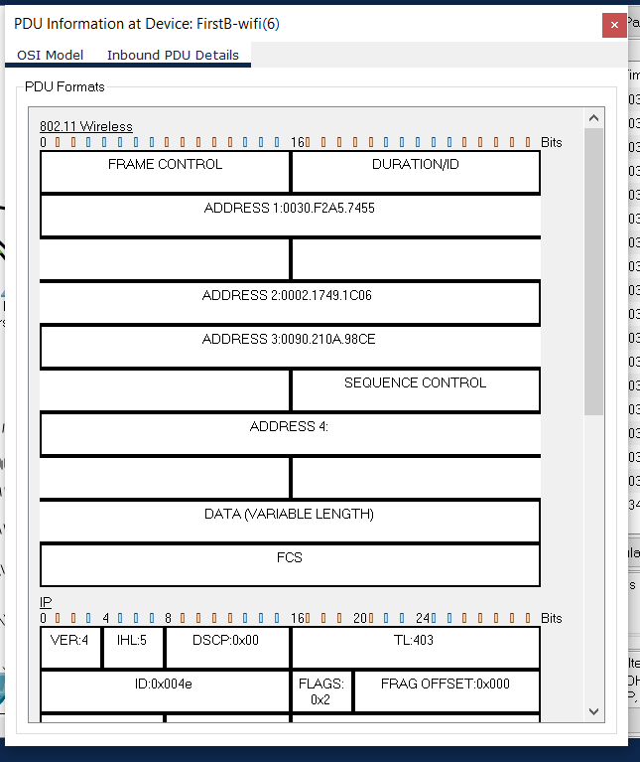

Read Emails:

1—sending mail

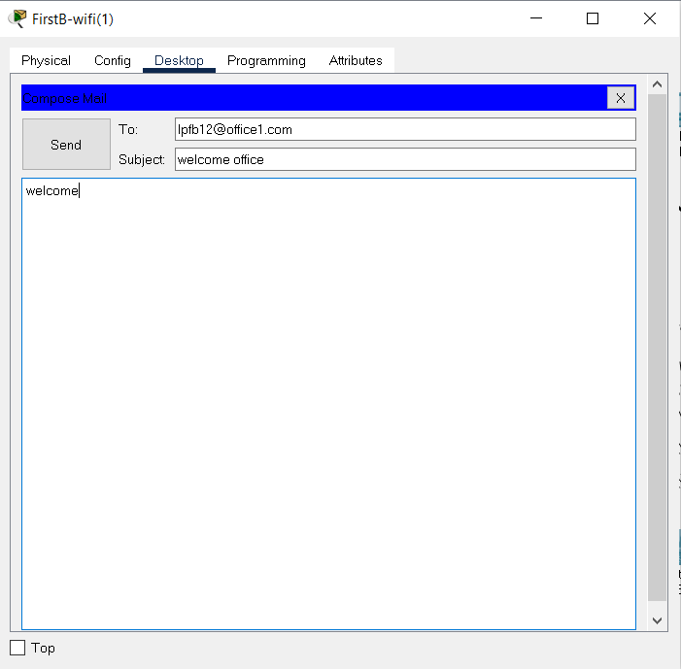

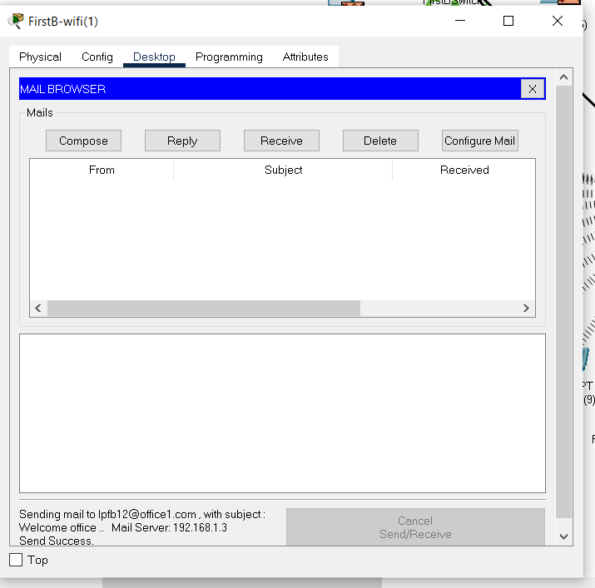

Read Email:

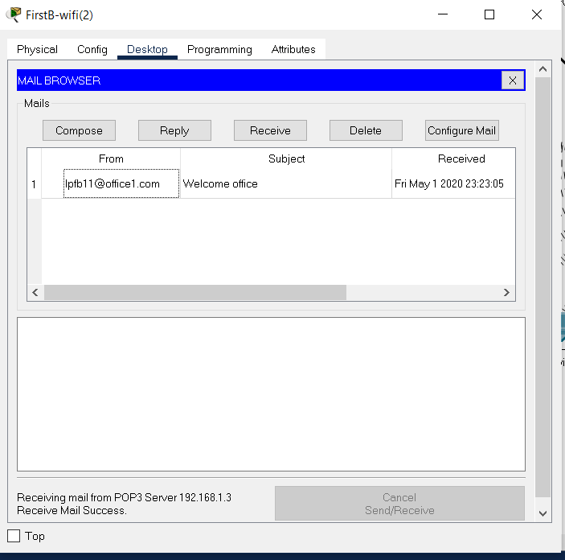

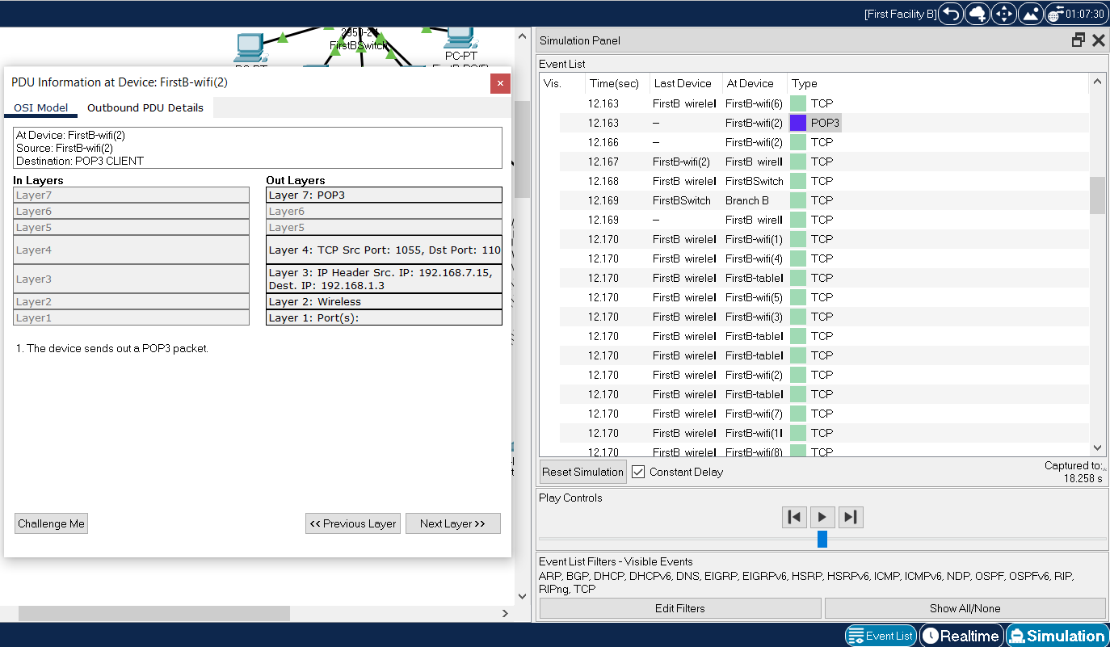

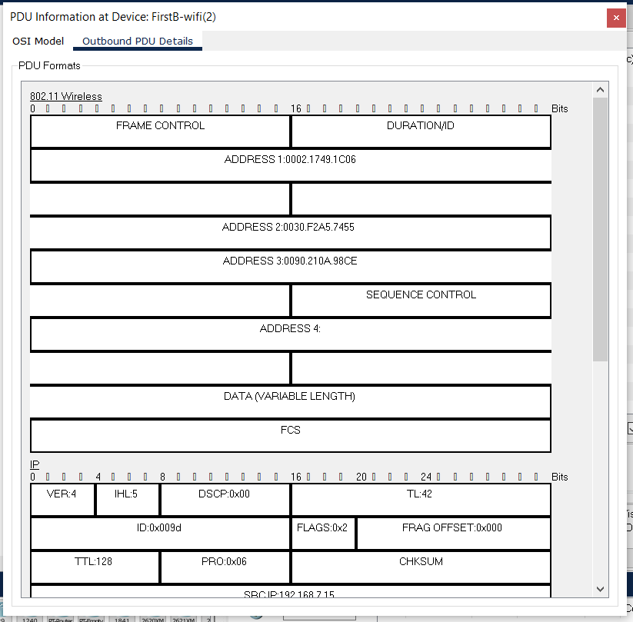

1. A computer engineer from second facility of second branch developed a web application and wants to send her code files to FTP server in the third facility of first branch.

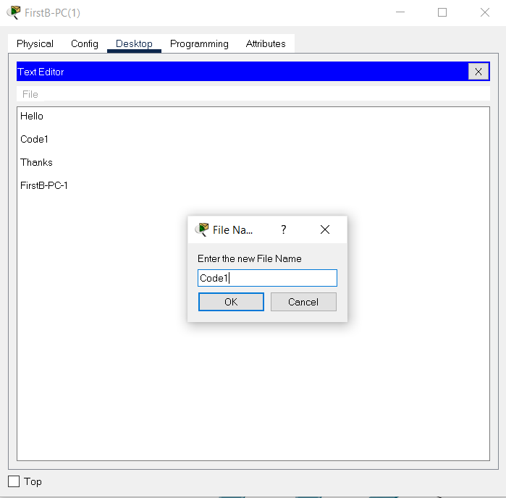

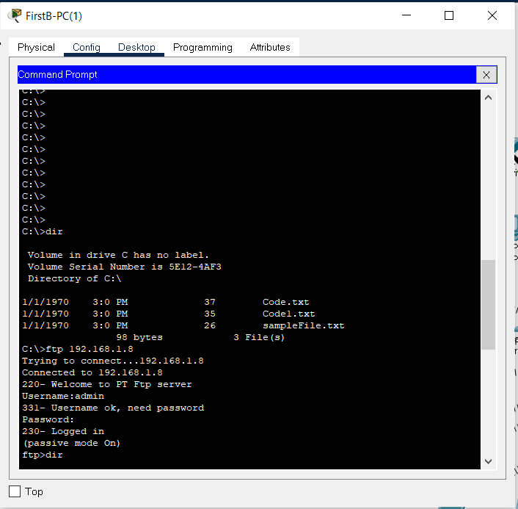

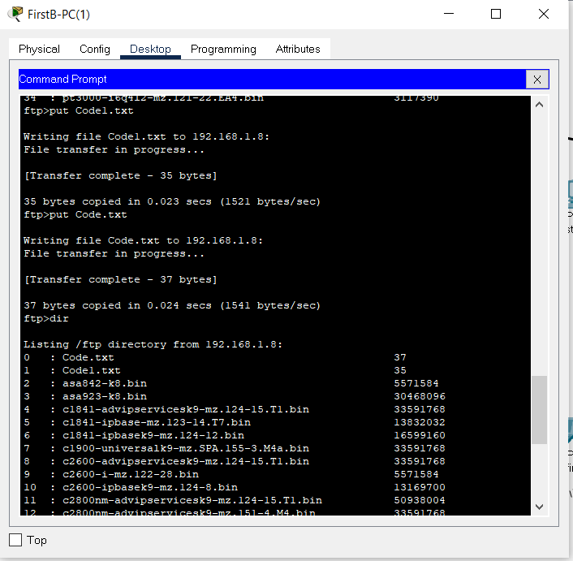

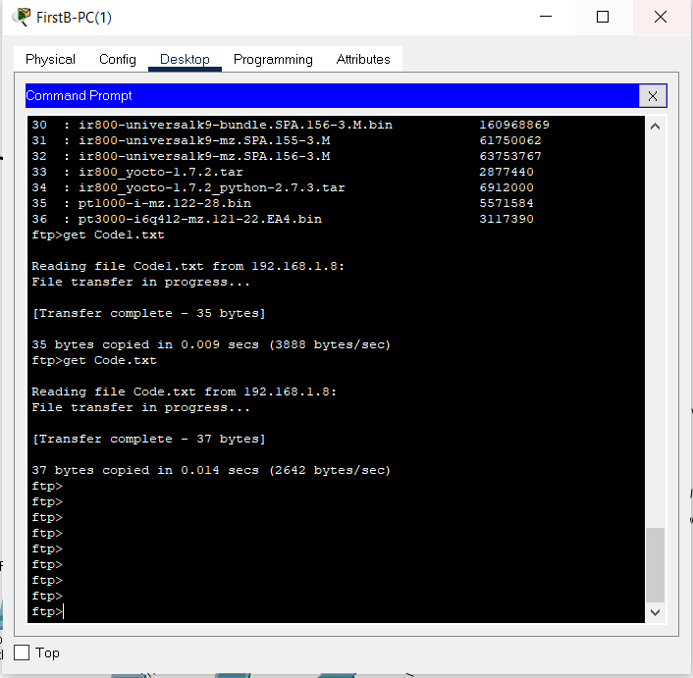

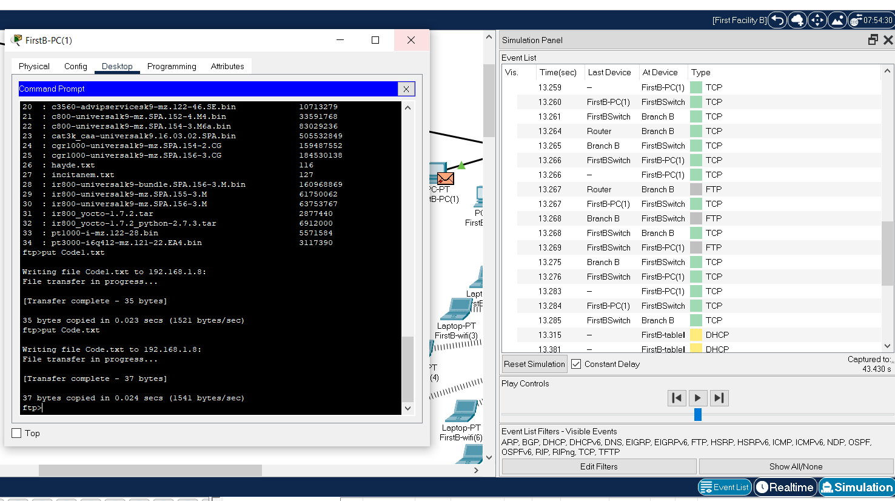

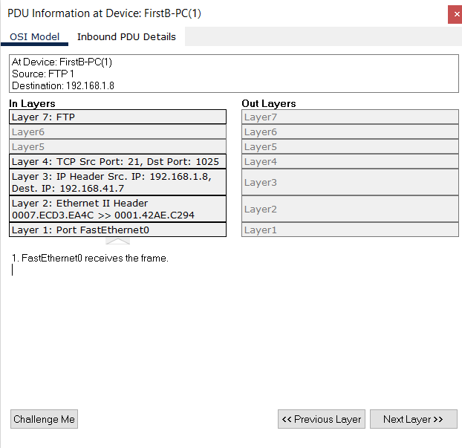

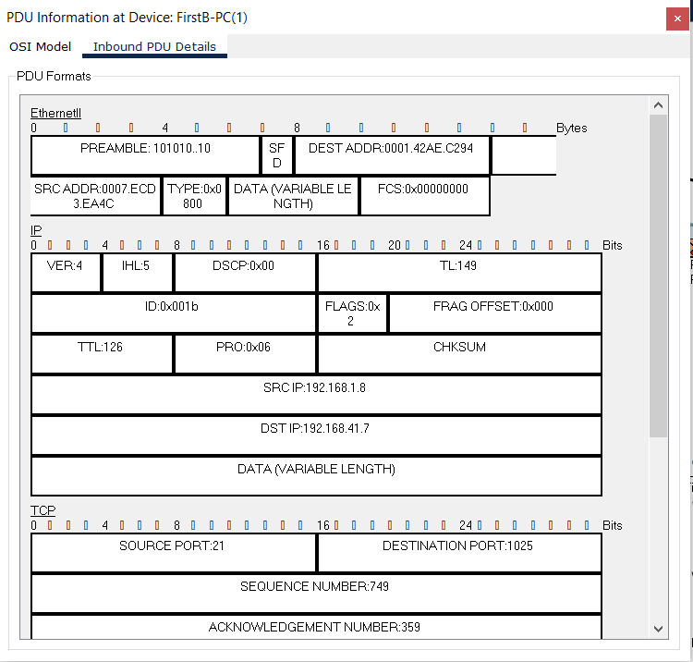

1. Two users from second facility of first branch want to talk via VoIP.

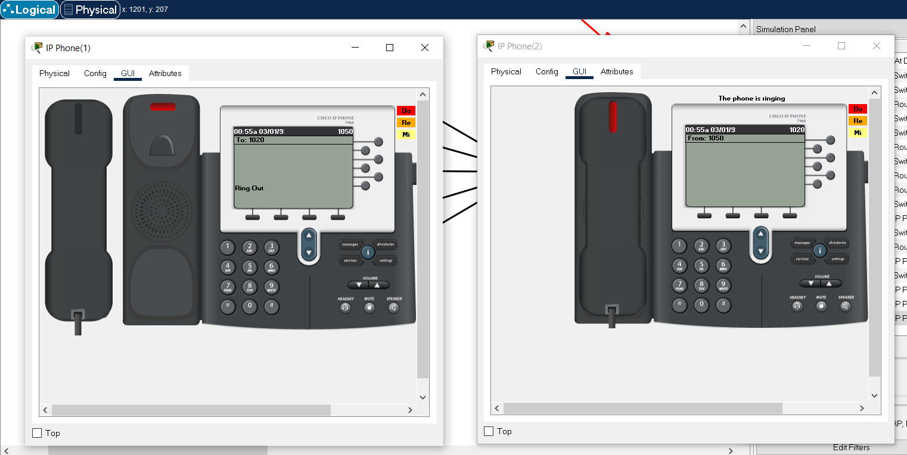

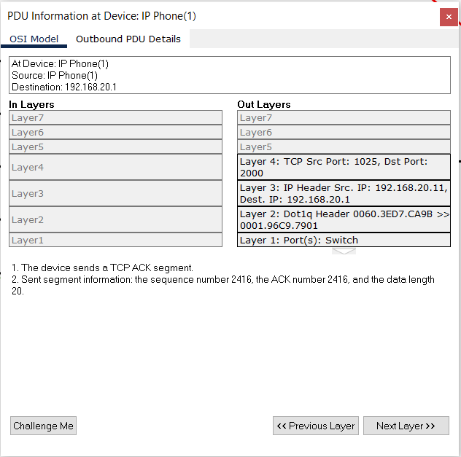

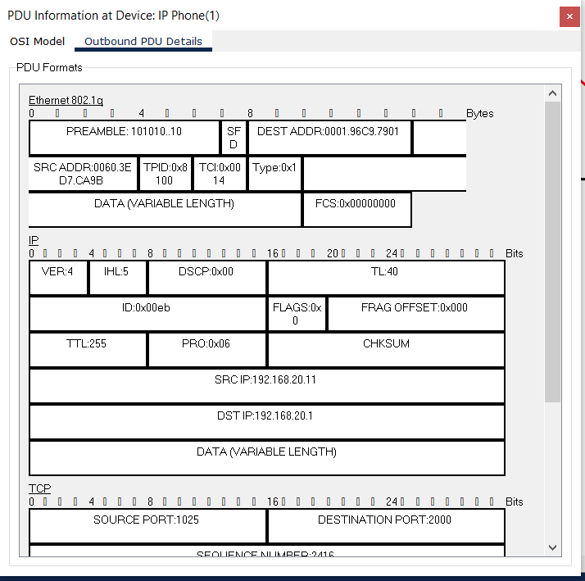

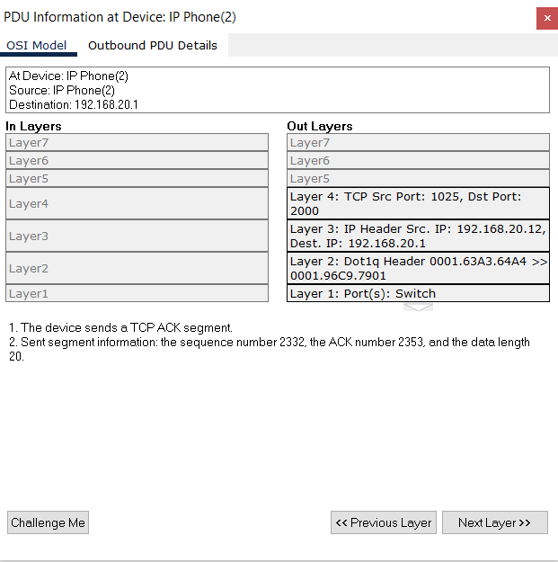

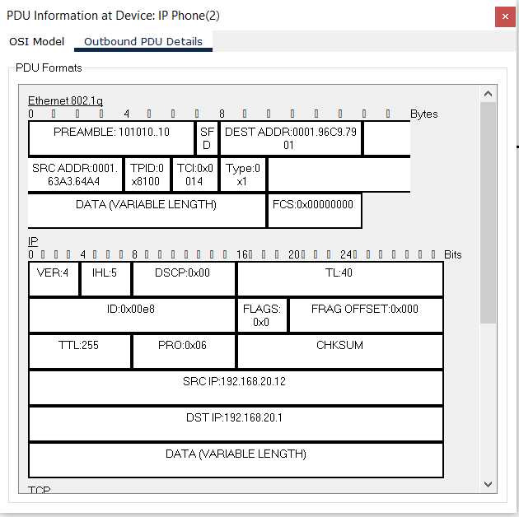

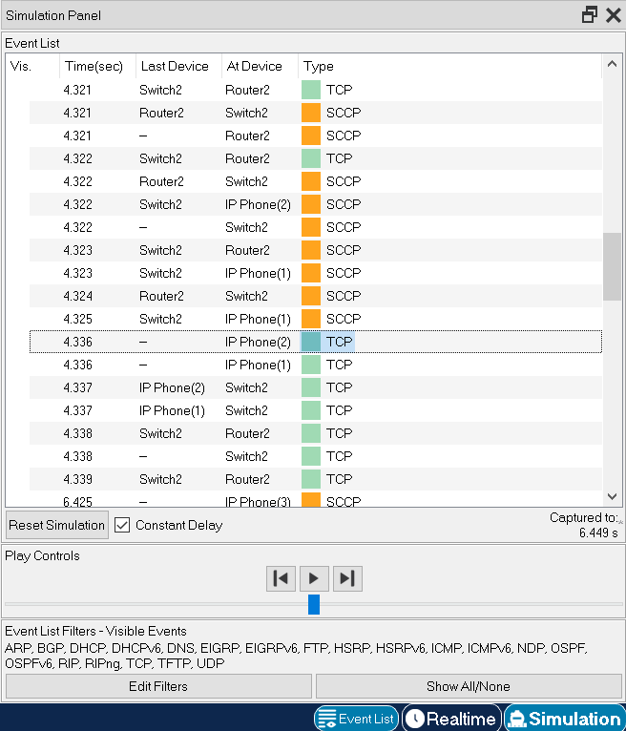

1. A user in the second facility of first branch wants to send an email message to his friend in the second facility of second branch.

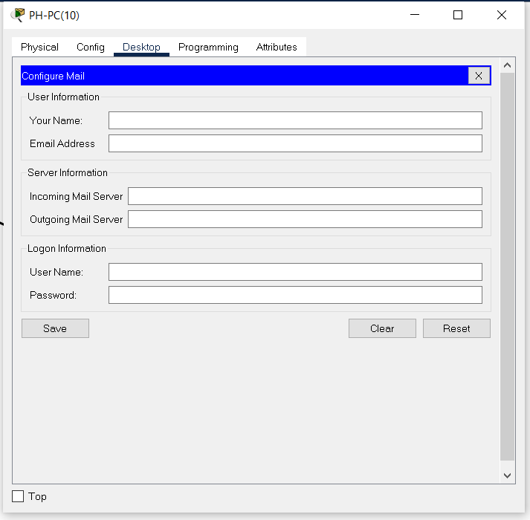

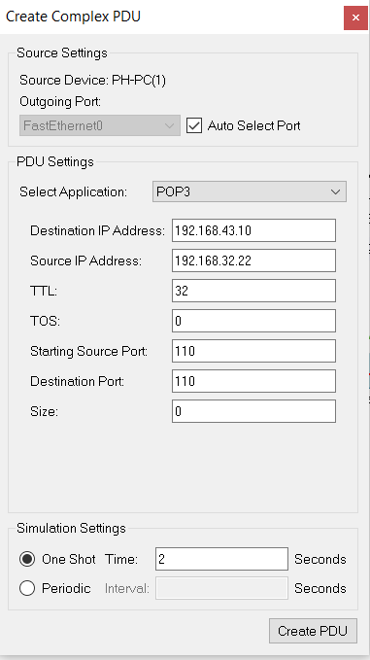

POP3 is the most current version of the Post Office Protocol. Allows e-mail applications to retrieve e-mail messages from e-mail servers. This means you can access your e-mail wherever you access a web-based e-mail service.

POP3 is one of the few standard email receiving protocols, supported by most email applications and web services. POP3 gives you access to your emails so you can read them online or save them offline. However, your messages are deleted as soon as you view them. It can be secured using an encrypted connection with POP3, STLS, TLS, or SSL.

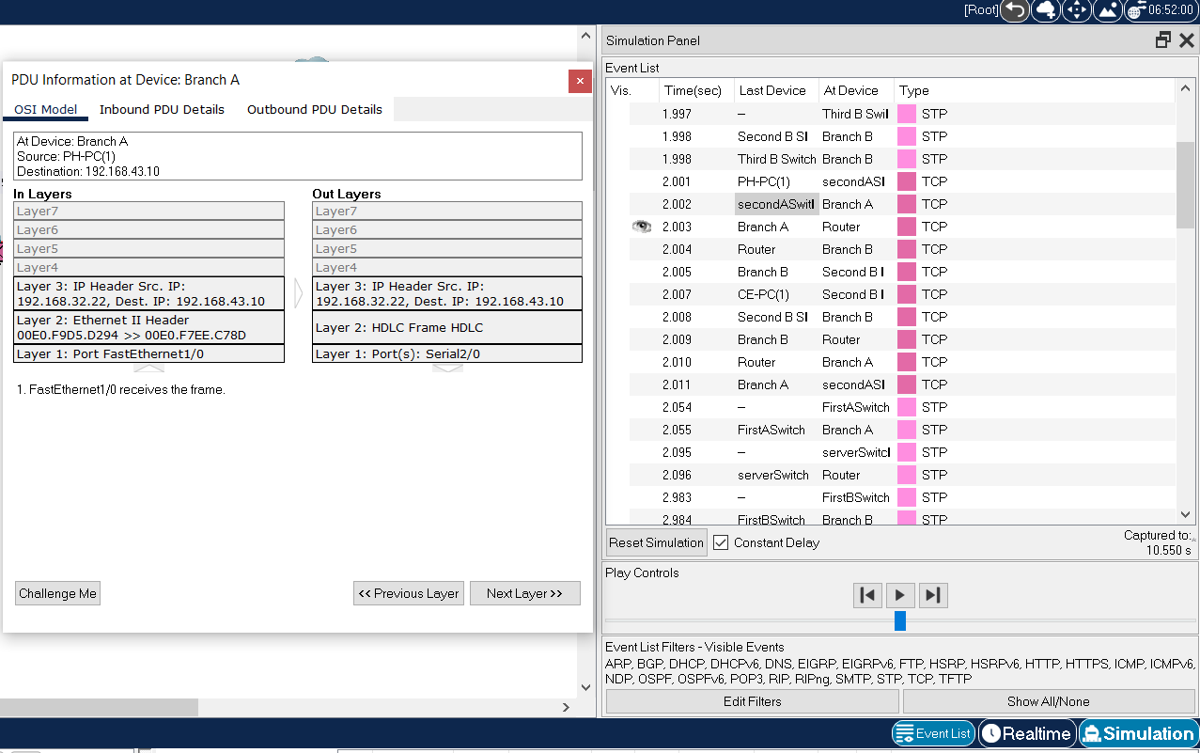

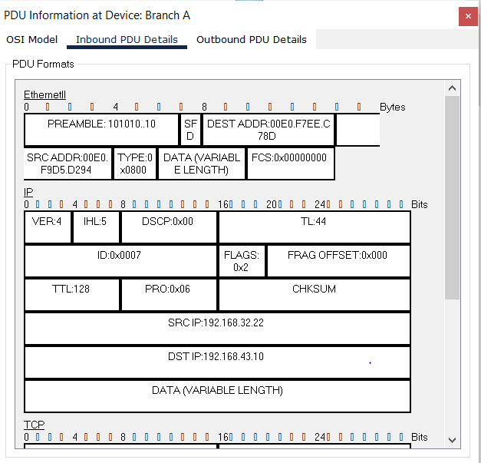 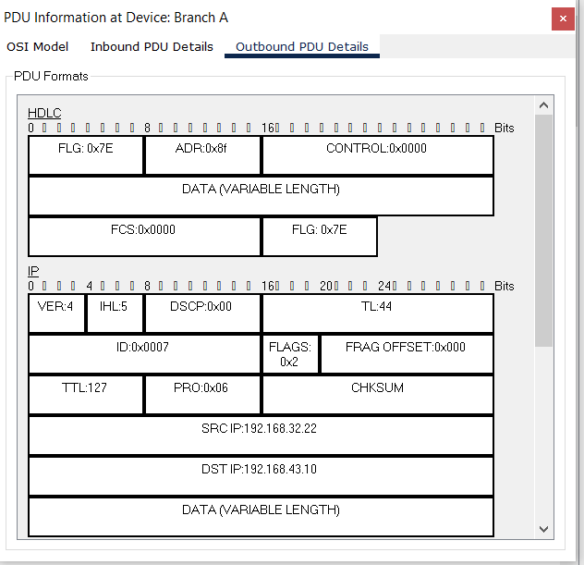

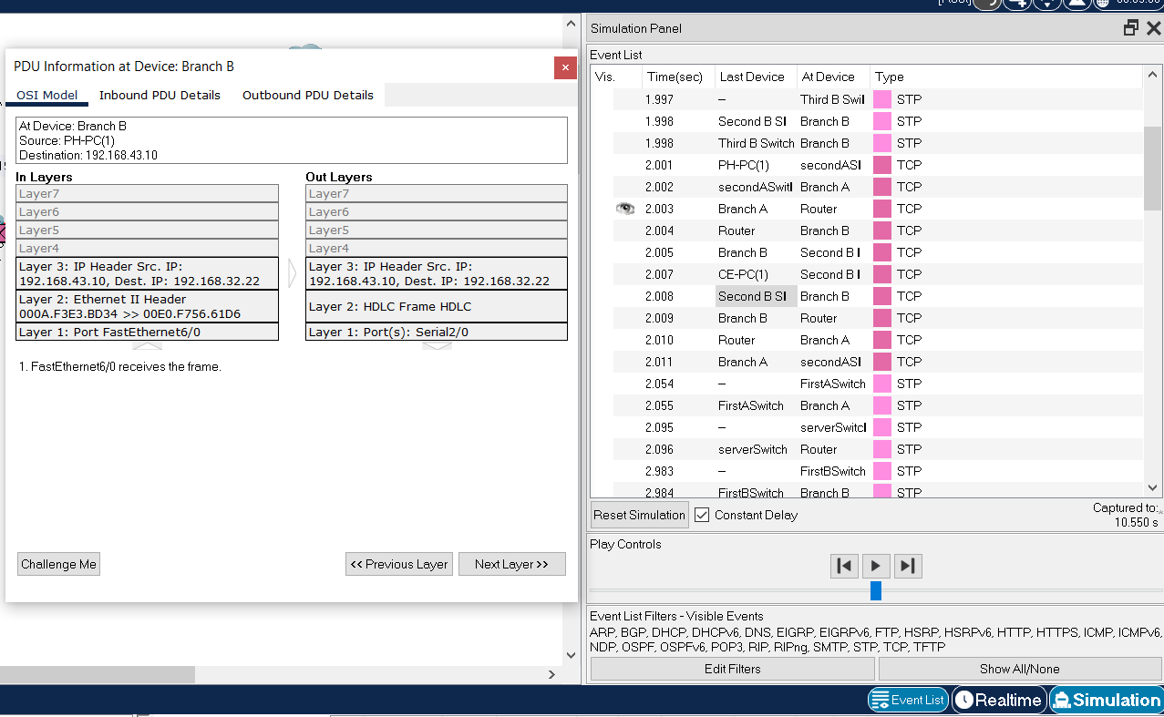

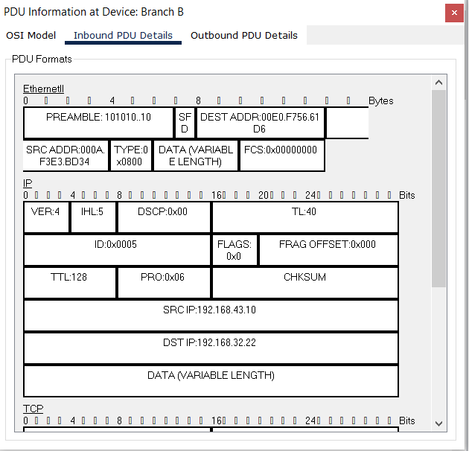 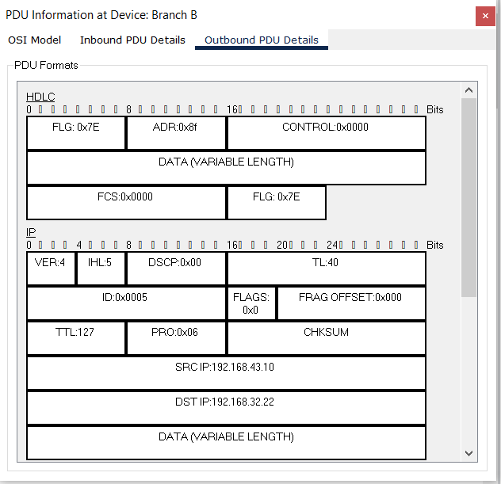

1. A user from first facility of second branch pings Web server of second facility of first branch.

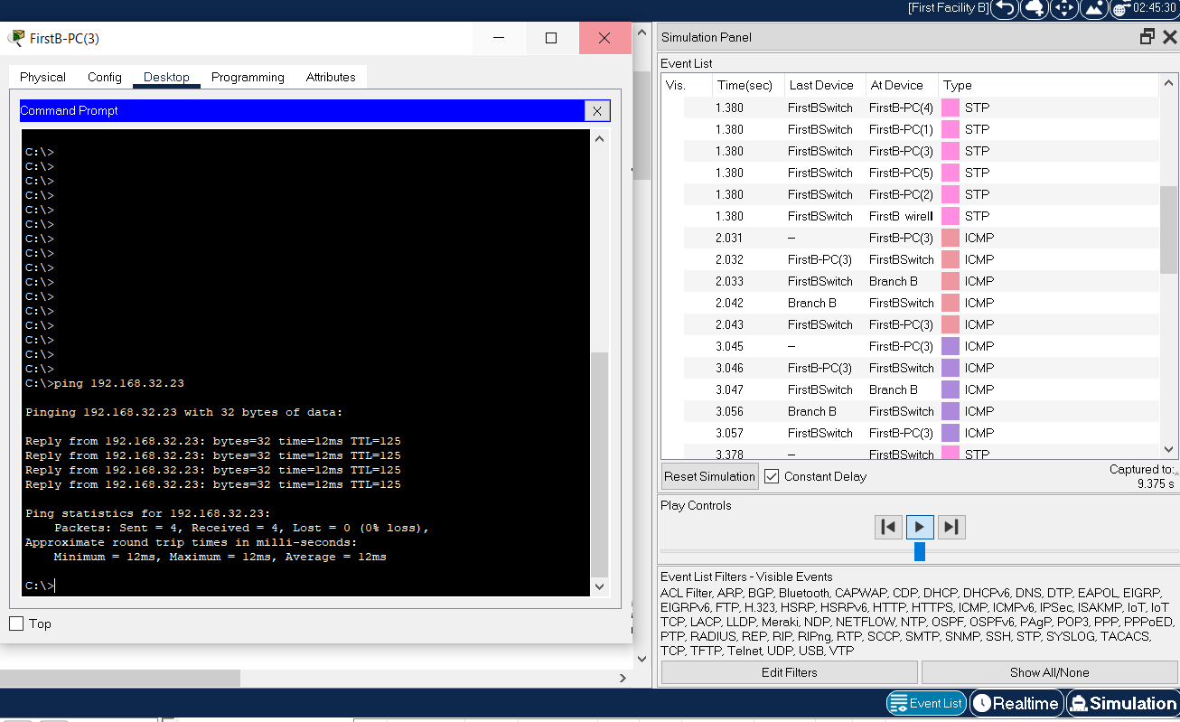

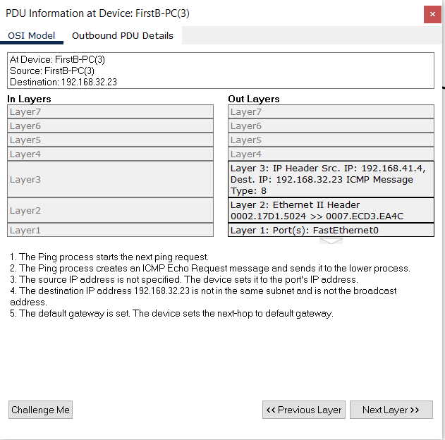

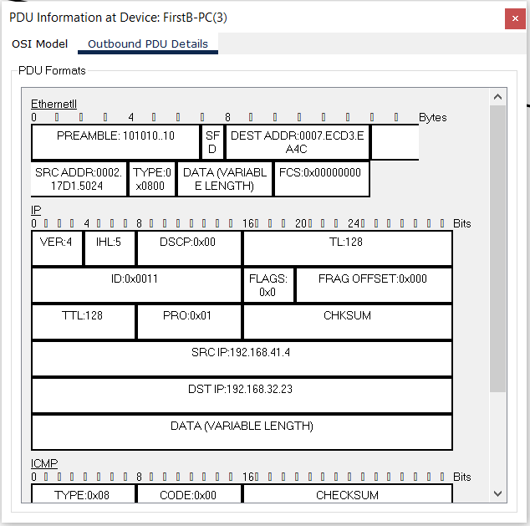

1. A laptop user from first facility of first branch office wants to send email to her friend in the first facility of second branch office.

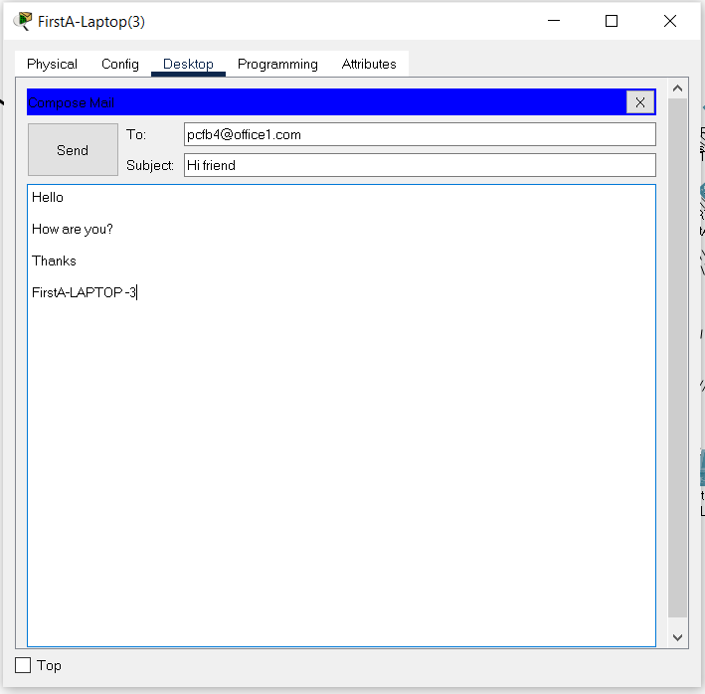

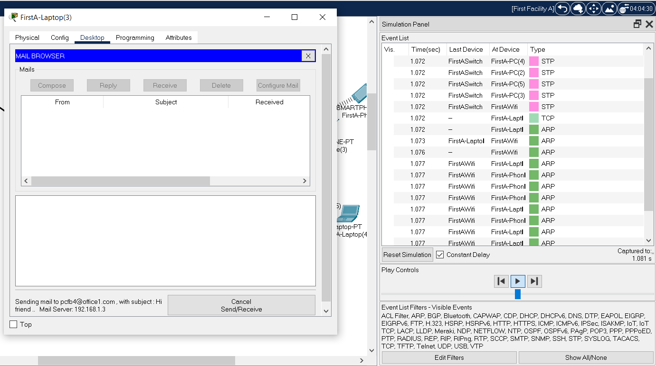

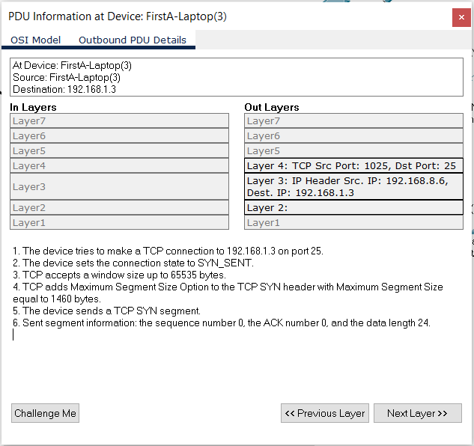

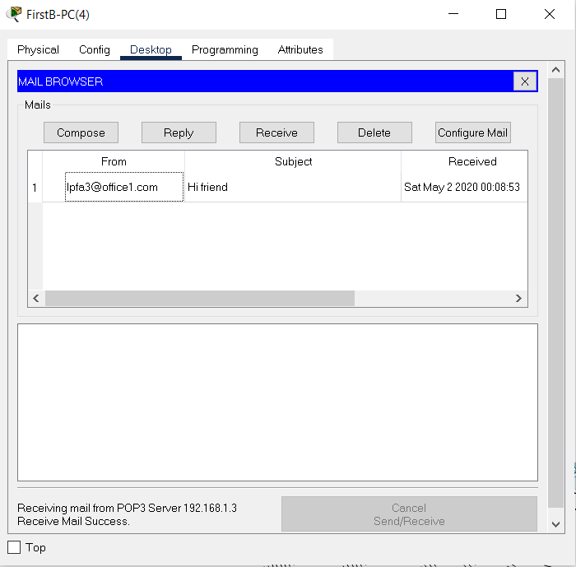

1. A smartphone user from third facility of second branch office wants to use ssh to connect to a Web server in the third facility of first branch office.

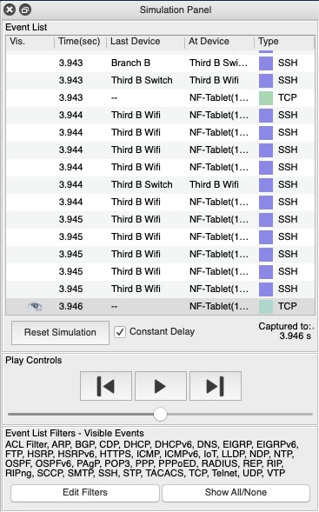

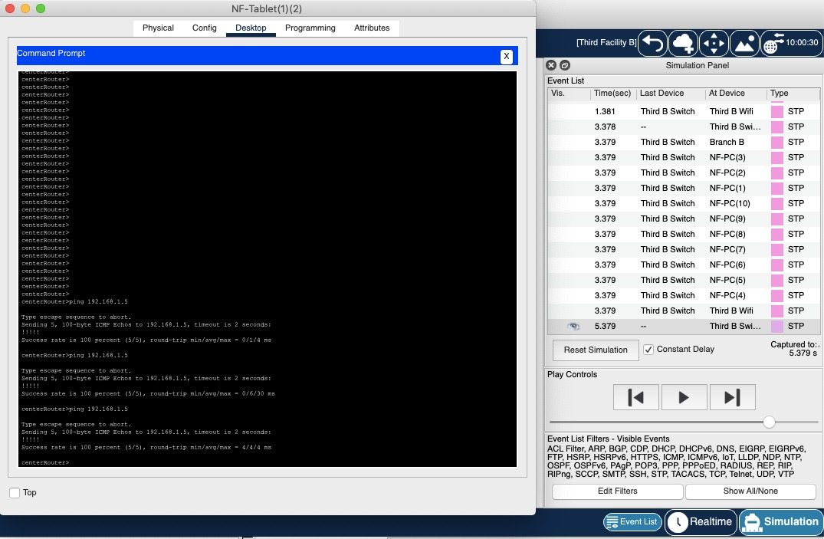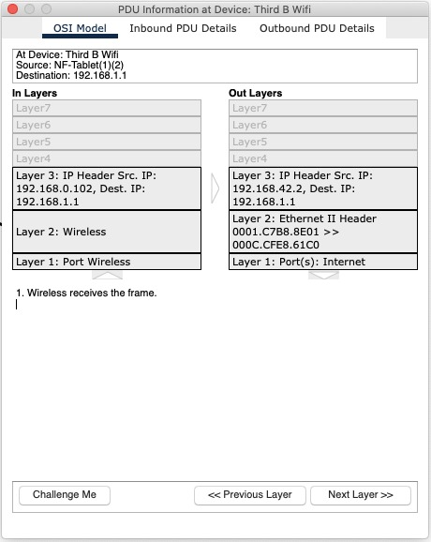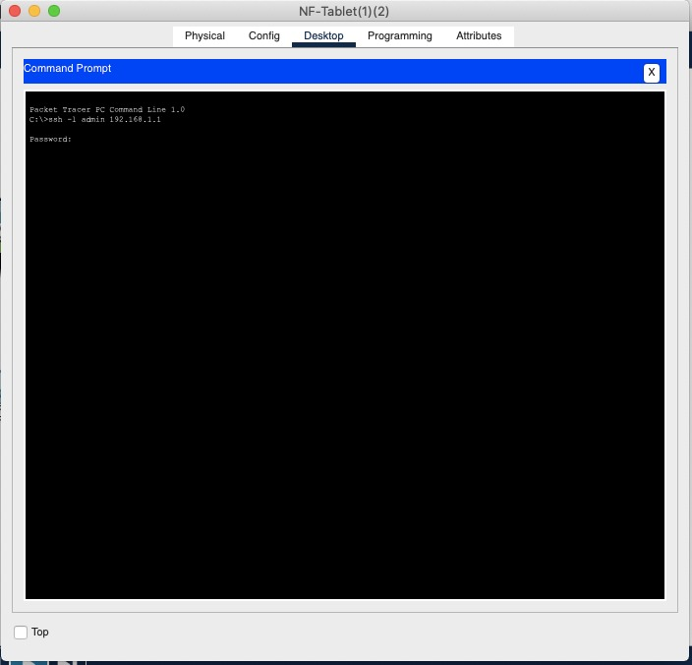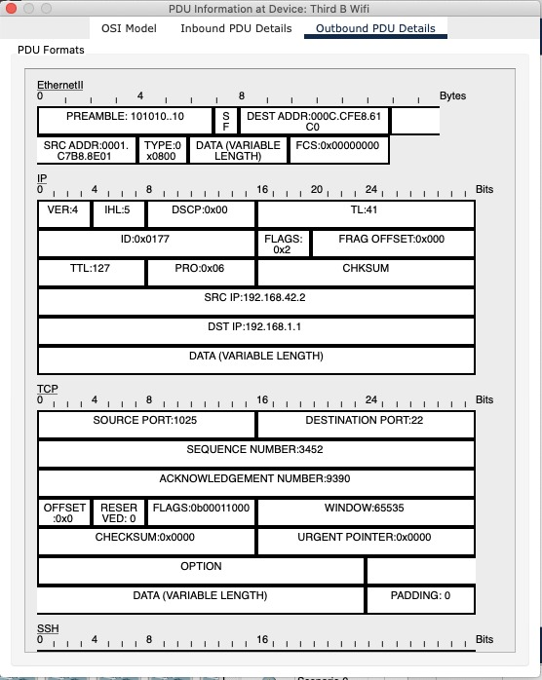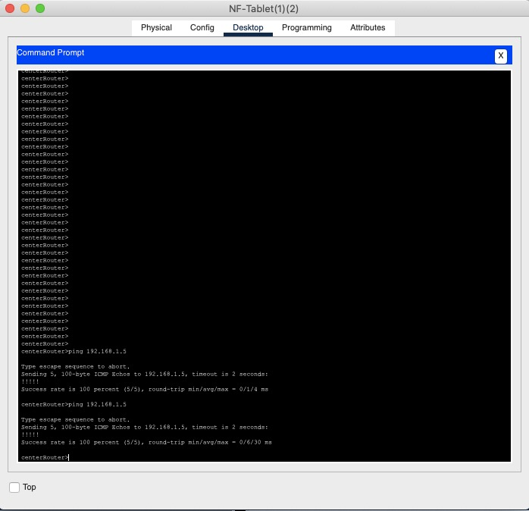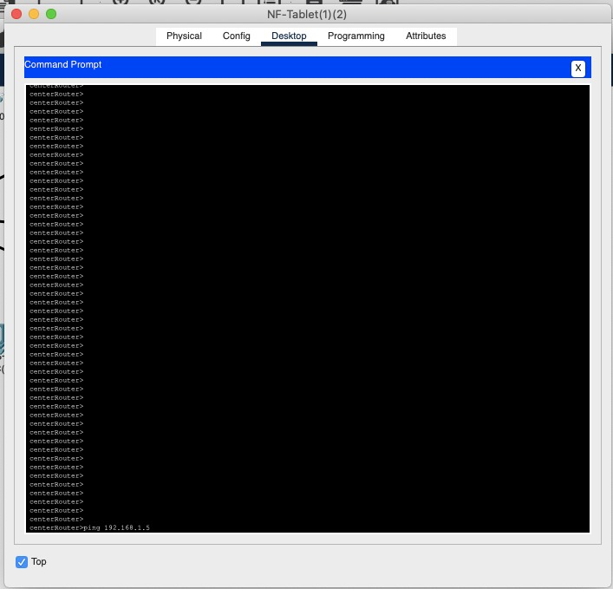

8-Ping the first facility of the first branch, the second facility of the branch

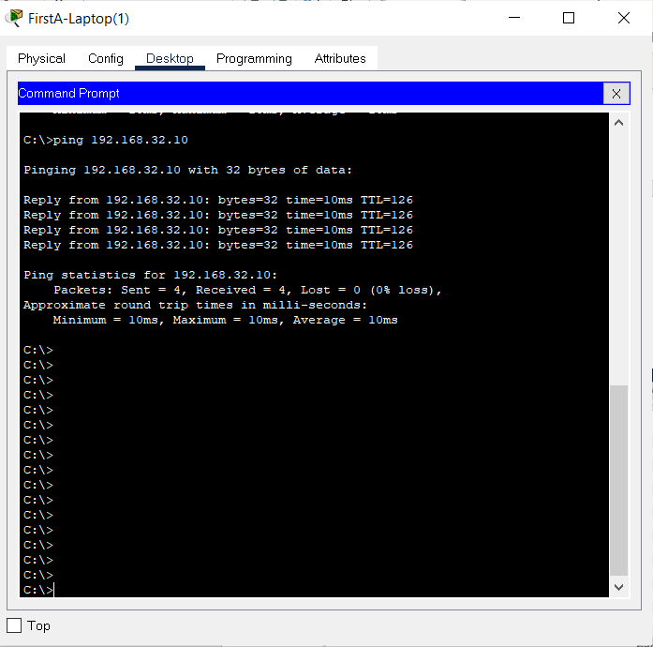

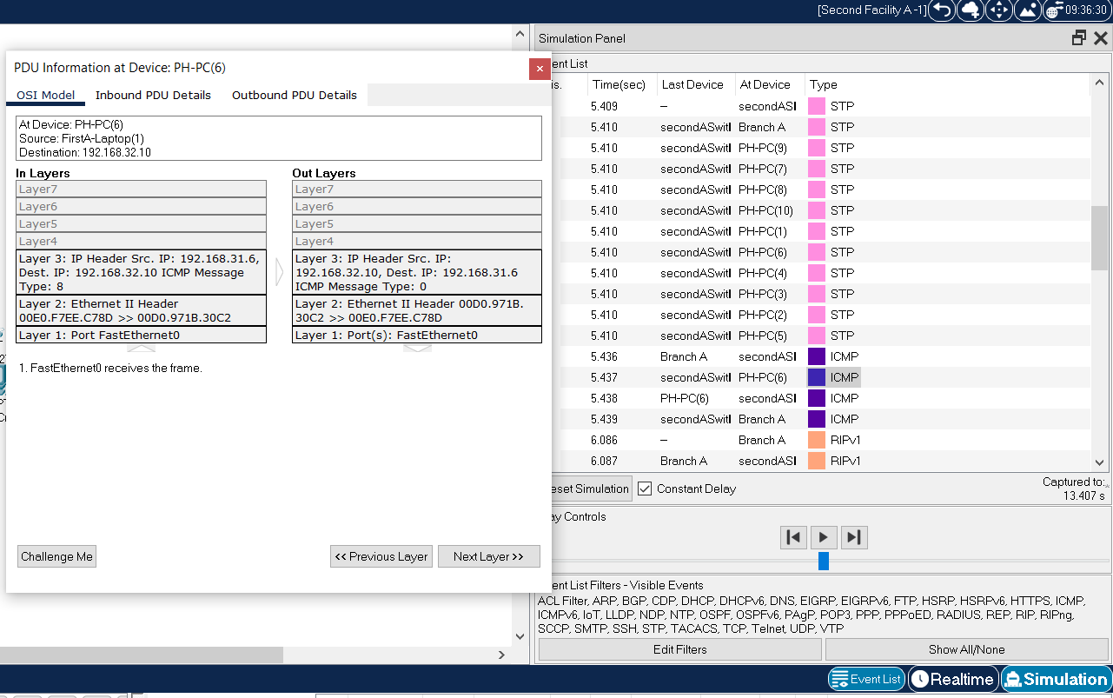

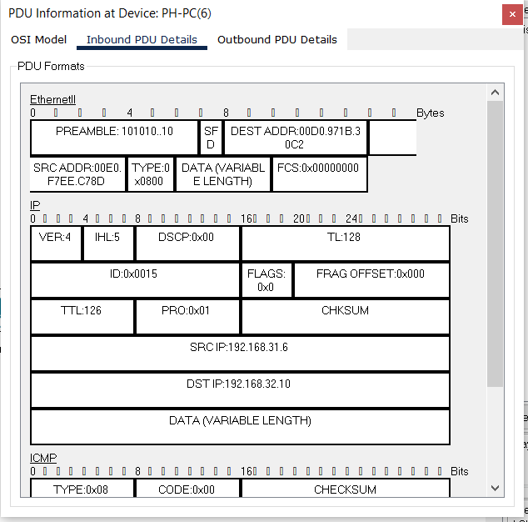

1. A tablet user from third facility of second branch office wants to send email to her friend in the third facility of second branch office.

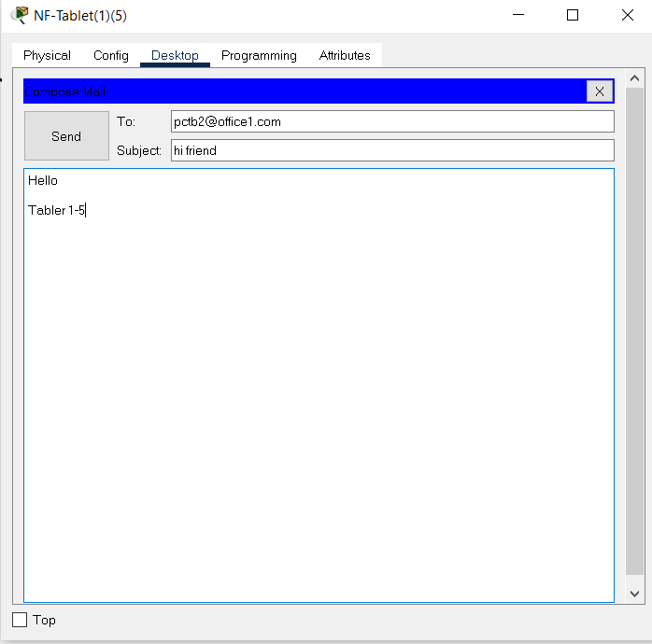

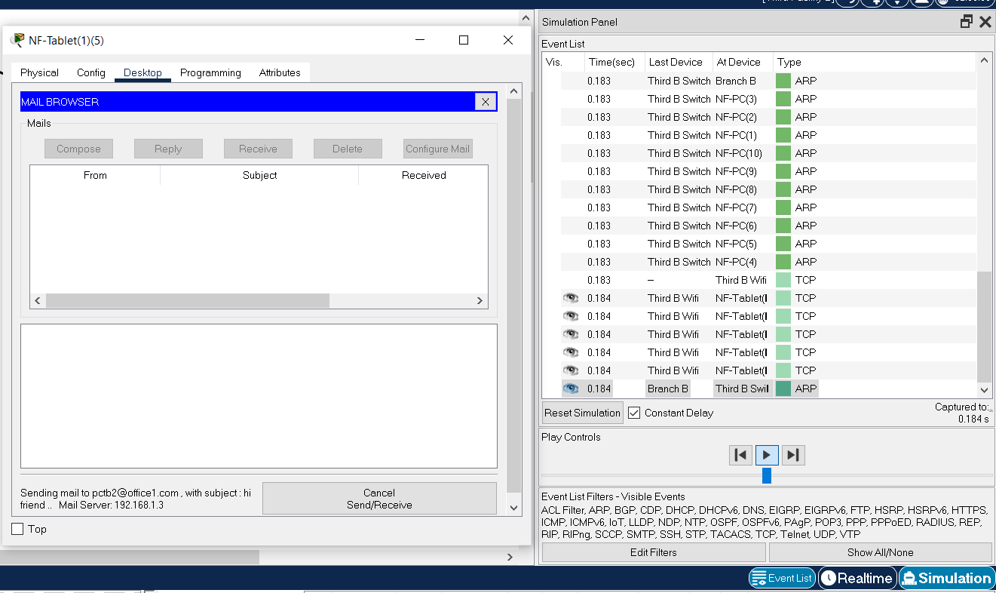

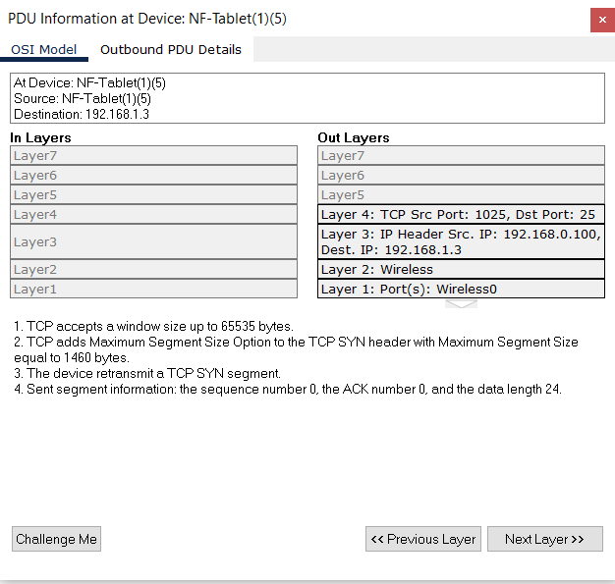

1. A pc user from third facility of second branch wants to read emails.

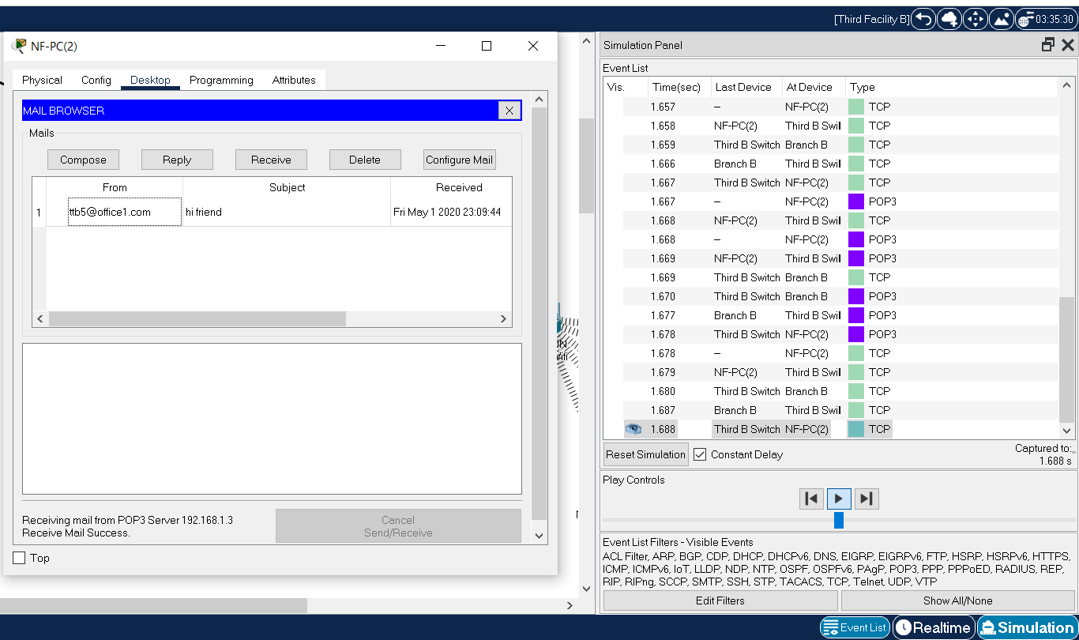

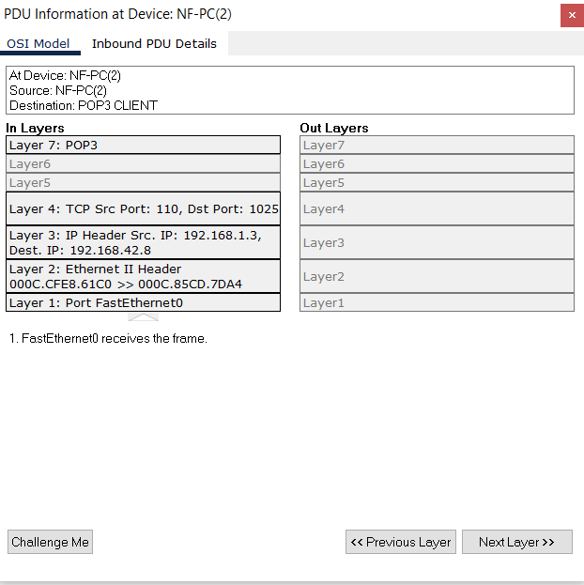

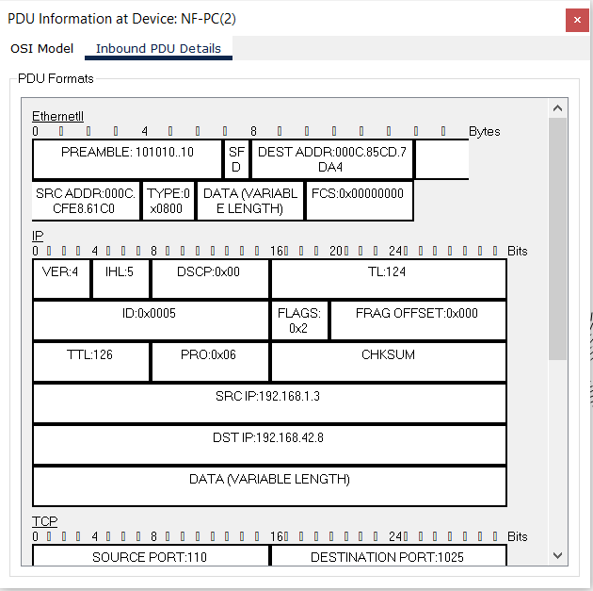

**CHAPTER FOUR**

**CONCLUSION**

Analysis and tests on simulation show that topology and architecture selection is done correctly according to requirements. Using the metropolitan area network instead of the wide area network provided the desired security and speed. The network was successful in providing the desired services using the protocols specified in the report. As a result, networks created between the two branches of the city and within the branches themselves were successful. The project team has gained insights into the network design and the challenges it brings.

**CHAPTER FIVE**

**REFERENCES**

[1]​<https://computernetworking747640215.wordpress.com/2018/07/05/configuring-a-mail-server-in-packet-tracer/>

[2]​<https://www.youtube.com/watch?v=m8_IP74PEm8>

[3]​<https://uzmanposta.com/blog/e-posta-protokolleri/>

[4]​<https://en.wikipedia.org/wiki/Metropolitan_area_network>

[5]​[https://www.digitalocean.com/community/tutorials/an-introduction-to-networking-terminolog](https://www.digitalocean.com/community/tutorials/an-introduction-to-networking-terminology-interfaces-and-protocols)

[y-interfaces-and-protocols](https://www.digitalocean.com/community/tutorials/an-introduction-to-networking-terminology-interfaces-and-protocols)