**DOKUZ EYLUL UNIVERSITY**

**ENGINEERING FACULTY**

**DEPARTMENT OF COMPUTER ENGINEERING**

**CME4408**

**INTRODUCTION TO NATURAL LANGUAGE PROCESSING**

**ASSIGNMENT-2**

**By**

**2014510056 Zeynep Köse**

**1. Part One**

**1.1 Definition of Algorithm**

Within the scope of this assignment, it uses data from a source named “sozluk.txt” for an input from the user. A MED algorithm will be implemented with a user interface that takes the input as 'word' and lists the first 5 alternative correct words (list the 5 closest words) using the supplied dictionary. Two functions named " medFunction " and "minValue" have been developed to perform these operations.

**minValue:** The minimum function is used to compare the neighboring indexes of the current location while navigating the two-dimensional matrix and to select the smallest value to write to that index.

**medFunction:** This function performs the appropriate minimum edit distance operation by traversing the two-dimensional array it receives and based on the minimum values.

**Runtime:** The "runtime" output value is performed in this function until the sentence is scanned from the entered input and the result is obtained.

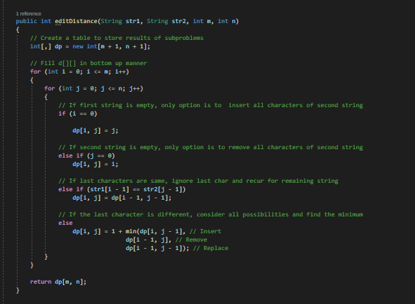

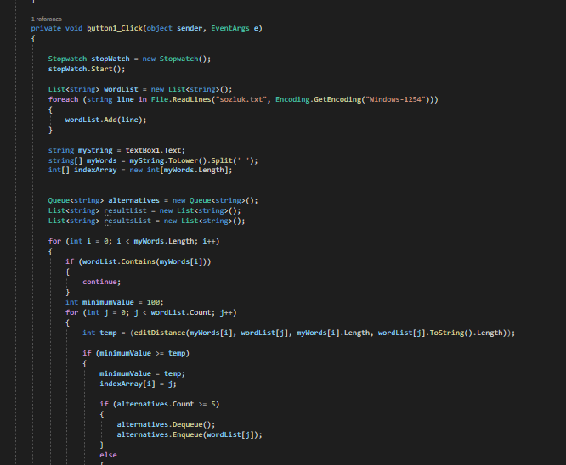

**1.2 Test Results**

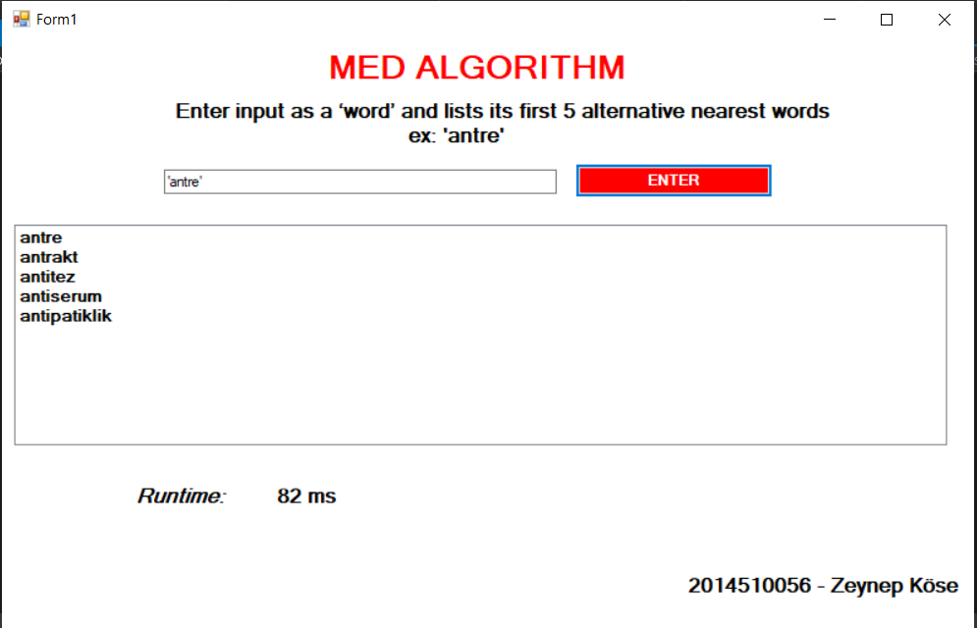

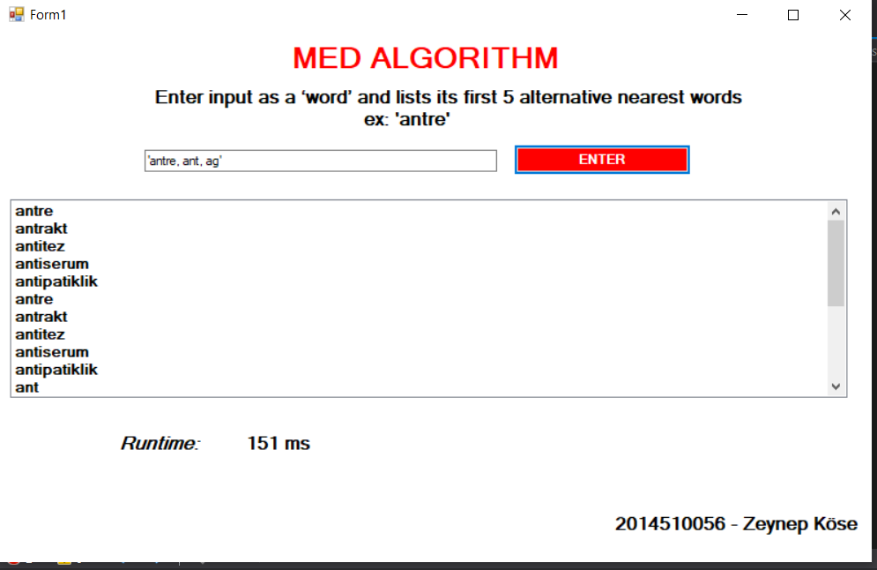

The results containing the nearest 3 values ​​ ​​in the text "implemented med algorithm with user interface which takes input text" are listed and the total runtime value is as shown above.

**2. Part Two**

**2.1 Definition of Algorithm**

Within the scope of this section, we are asked to calculate the MED value of two words received by the user, show the steps in a table and write the names of the operations required to convert.

For this part, I am creating another project in JAVA. This project has no interface, I can see the result from the command window. It is a one page project.

It contains two functions apart from the main function. A function with “medFunction” creates MED matrix, MED value, add, remove, replace values. The other function with "min" helps to edit the Distance function for adding, removing, changing values and finding a min value of the matrix, calculating and updating. The main function calculates the runtime, takes two input words from the user, and calls the med function.

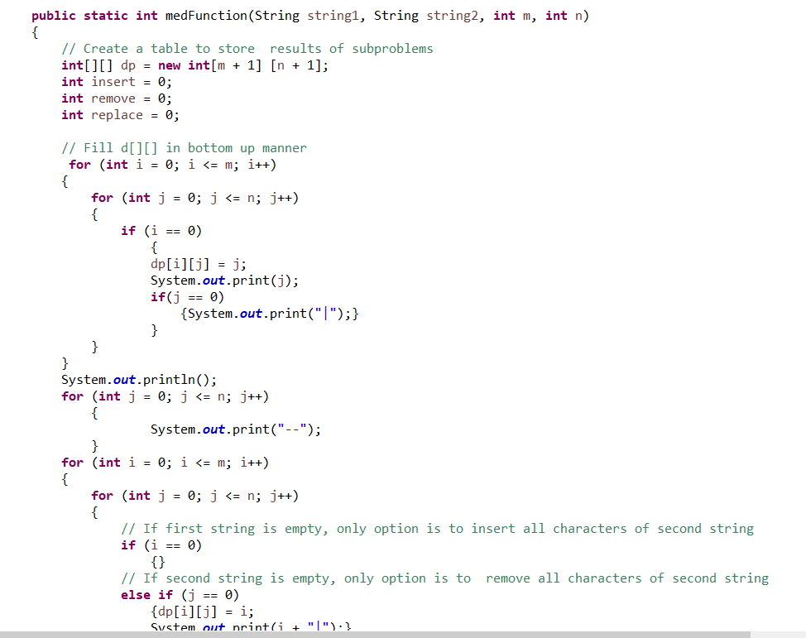

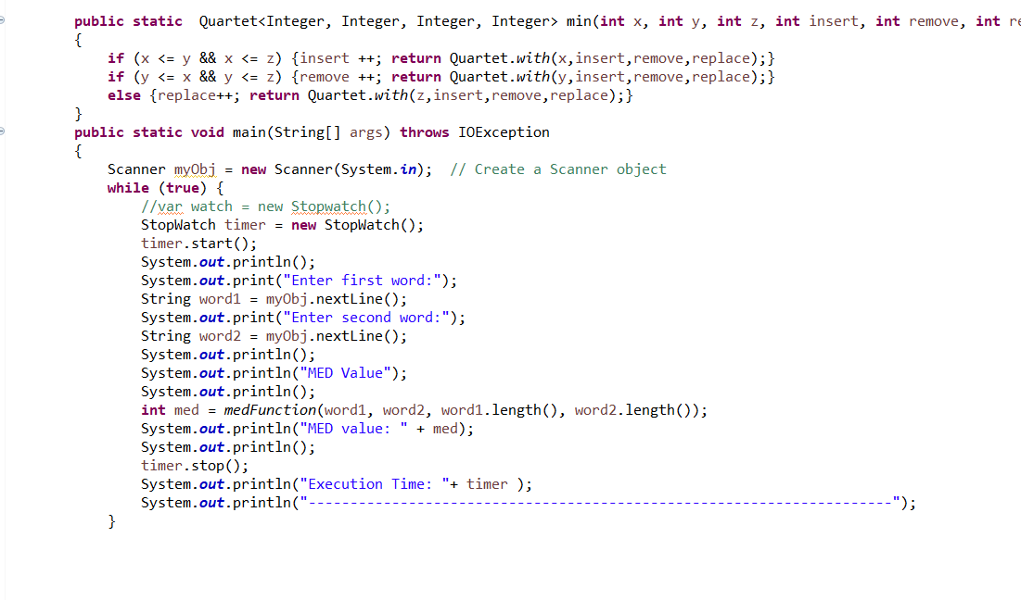

**2.2 Test Results**

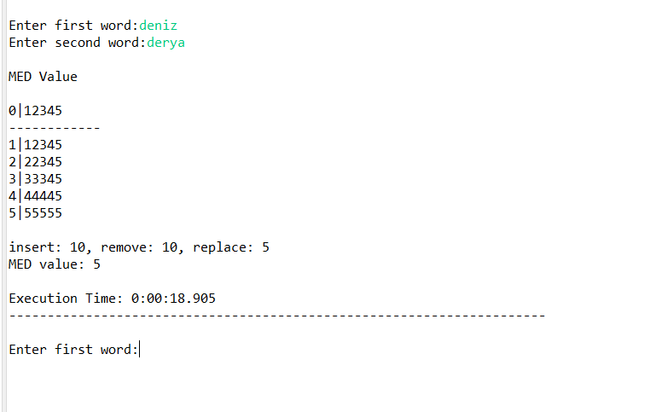

Like it is shown in left, program takes two word from user, than show MED calculation matrix, number of insert, remove, replace values, MED value and total running time.