Zeynep Akçil
22102833
Section 2 | 19.04.2023
Lab 3: Combinational Logic Circuit
Purpose
In this lab, a combinational logic circuit will be designed on breadboard. To implement the circuit, an integrated circuit which is 74HC163 and some other logic gates will be used.
Usage of these components properly requires basic reading skills of their datasheets, therefore, datasheets will be visited.

Design Specifications
2-to-1 multiplexer will be designed in this lab which is inspired by the design in the second lab. In second lab, 6-to-1 multiplexer consisting of 5 2-to-1 multiplexers was designed but since this circuit will be based on breadboard, not a compact electronic board, it is hard to implement and observe results from such a circuit.
Multiplexer is the component that is used to select data inputs by using selection signals. In this design there are two inputs (i0 and i1), one selection input (s) and one output signal (out). Sum of products (SOP) expression is $\overline{s}i_{0}+si_{1}$. This logic design is given in Figure 1. This expression uses AND and OR gates; however, in real life implementation, NAND and NOR gates are more practical. Therefore, it is wiser to update the circuit and use only NAND or NOR gates. However, since this is lab aiming to learn how to use and connect components, first design will be used in order to study with varying components instead of most practical design.

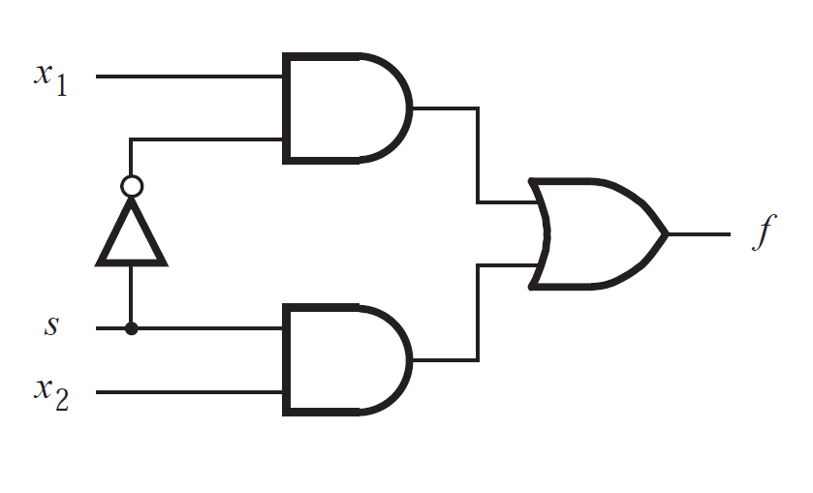
Figure 1: 2-to-1 multiplexer logic design
out
i₁
S
i₀

During experiment, 3 components will be used: 4-bit counter (74HC163), quad 2-input AND gate (74HC08) and hex inverter (74HC04). OR gate in the Figure 1 will be implemented with AND gate and inverter by using DeMorgan’s Theorem. Signal generator connected to the clock (CP) port of the counter generates the signals. VCC port is connected to power supply and 5V is given. Additionally, GND port is connected to ground node of the breadboard. Q₀, Q_{1,} Q₂ and Q₃ are the output ports of the counter used as the inputs (s, i₀, i₁) of the design and since there are three inputs in this design, Q₀, Q₁ and Q₂ are used. As shown in the truth table, Q2 is selection bit and Q₀ and Q₁ are input data i₀ and i₁, respectively.

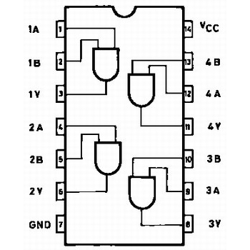
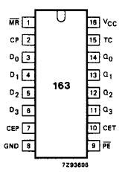
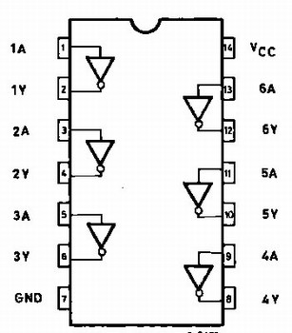
Figure 3: Pin configuration of 74HC08
Figure 4: Pin configuration of 74HC163
Figure 2: Pin configuration of 74HC04
Q2 (S) | Q1 (i1) | Q0 (i0) | out
0 | 0 | 0 | 0
0 | 0 | 1 | 1
0 | 1 | 0 | 0
0 | 1 | 1 | 1
1 | 0 | 0 | 0
1 | 0 | 1 | 0
1 | 1 | 0 | 1
1 | 1 | 1 | 1

Table 1: Truth table of 2-to-1 multiplexer

Methodology
There are two main parts in this experiment. In the first part, displaying waveform in the oscilloscope is required. In order to do this, the counter and logic gates are connected as specified onto the breadboard. Also the ground pins of the power supply and signal generator are connected to ground level of the breadboard which allows connection between these devices and the circuit. Additionally, on counter, CEP and $\overline{MR}$ are connected to positive rail of the breadboard. These are the special port of the 74HC163. Signal generator is set to 5 Vpp, 1 Hz and square wave, power supply is set to 5 V. After ensuring power supply and signal generator is appropriately connected and active, oscilloscope probe is connected to the out pin and waveform is displayed on the oscilloscope screen. This waveform can be found in the results part.
In the second part, since there are three inputs of the circuit, 3 resistors and 3 LED’s are used. Each LED is connected to the used outputs of the counter, Q₀, Q_{1,} Q₂, in series with a 4.7 KΩ resistor so that LED’s are protected against high current. By doing this, high-low states of the outputs of the counter is displayed. After that, one more LED and resistor connection is made in series with the out pin in order to see the out state according to the current states of Q₀, Q_{1,} Q₂. All of the eight combinations on the truth table are observed and their photos can be found in the appendices part. The order of the LED’s in the photos given in the appendices are S, i0, i1 from left to right.

Results
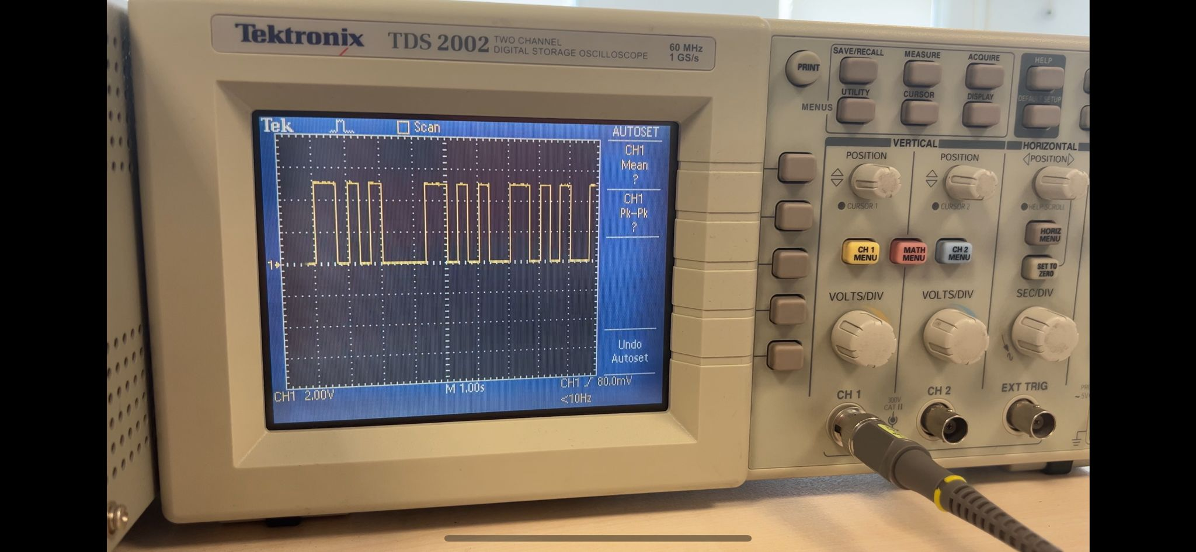
In the first part of the experiment, waveform graph is used by using oscilloscope. The graph can be seen on the Figure 5 below. The graph matches with the truth table as it is expected.
Figure 5: Waveform graph of the 2-to-1 multiplexer

In addition, LED states are also in harmony with the truth table. LED connected to the out pin is emitting light when input pin selected by selection bit is high. Examples are given in the appendices with experiment photos.

Conclusion
In this experiment, it was aimed to design a logic circuit and use it in real world. Instead of designing these on paper or writing code and run it on the FPGA board, this lab was consisting of breadboard, logic gate components and basic electronic circuit components such as LEDs, resistors, jumpers etc. Furthermore, the waveform graph is displayed by using oscilloscope and verified with LED implementation on component outputs. Since logic circuits are more complicated than analog electronic circuits, they require many connections, namely, wires. In the circuit, jumper wires are used and this caused the circuit to be too complicated. It was the biggest problem during the experiment because tracking connections and making sure they are connected properly to the proper pin. Second difficulty experienced was the first counter used was not working properly. A lot of things are tried but in each time, counter was not creating ordered outputs specified in the truth table, but instead, they were arbitrarily changing. I acquired the working circuit by changing counter to different brand. After that the circuit worked perfectly as expected. The order of the outputs of counter became correct. Additionally, during the experiment datasheet reading and obtaining required information is visited and studied.

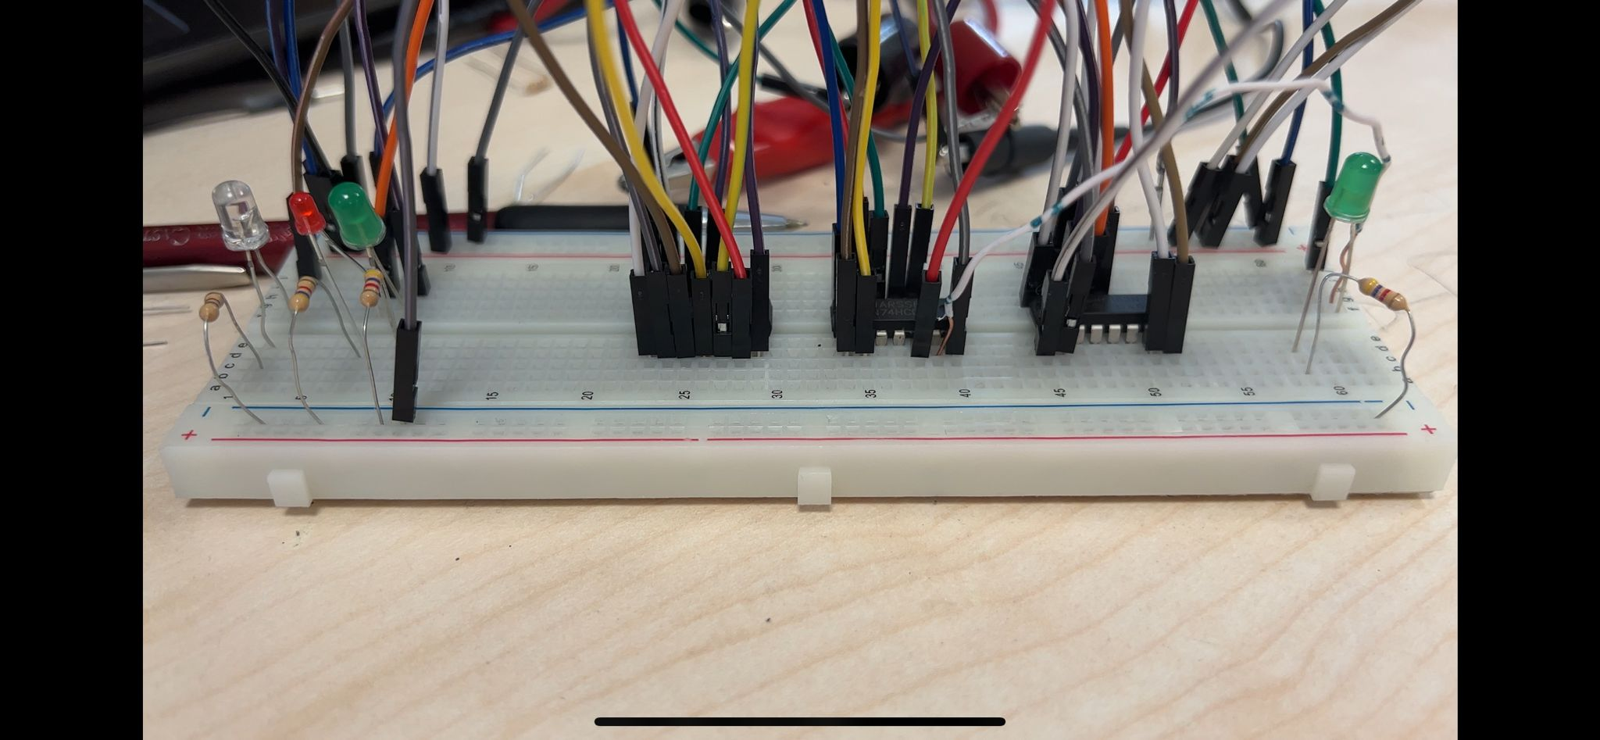
Appendices
Figure 6: Case 1. S, i0, i1 are low and out is low

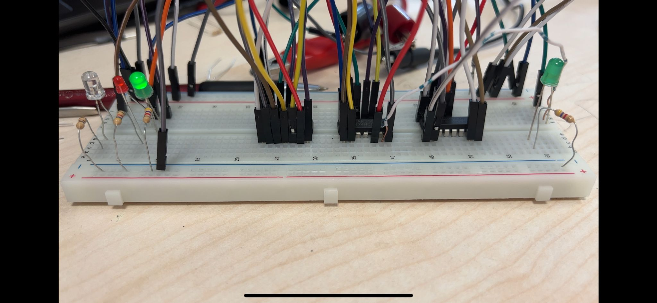
Figure 7: Case 2. S and i0 are low, i1 is high and out is low

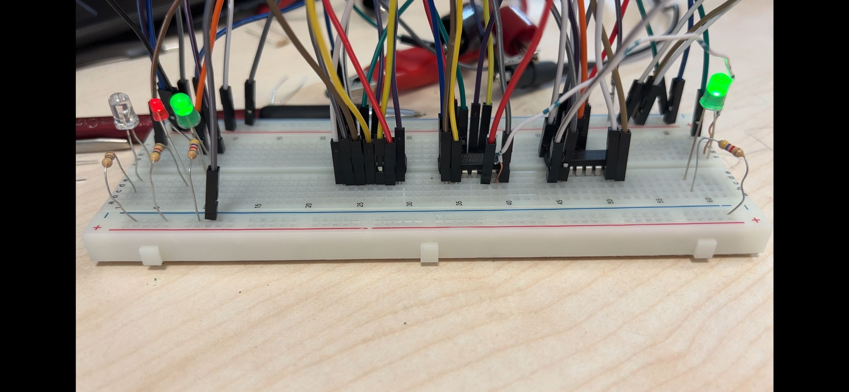
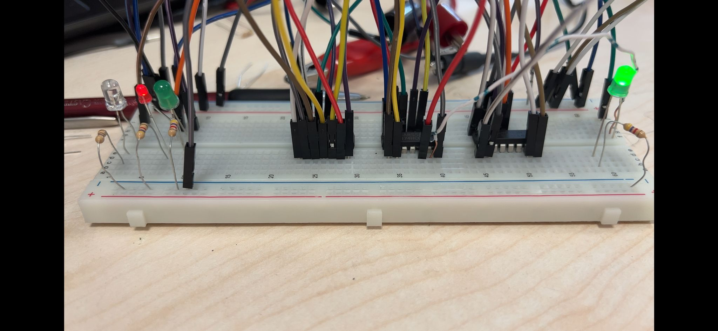
Figure 9: Case 4. S is low, i1 and i0 are high and out is high
Figure 8: Case 3. S and i1 are low, i0 is high and out is high
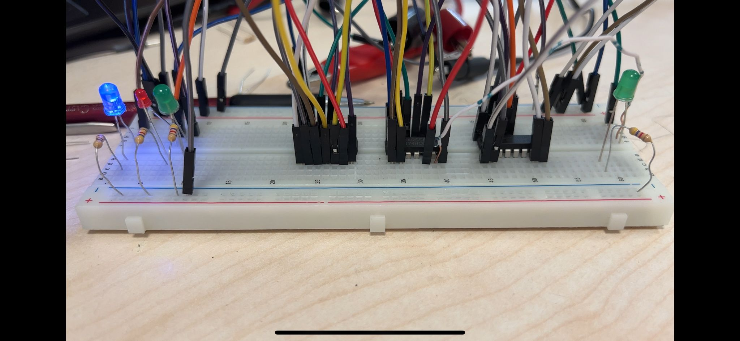
Figure 10: Case 5. S is high, i1 and i0 are low and out is low

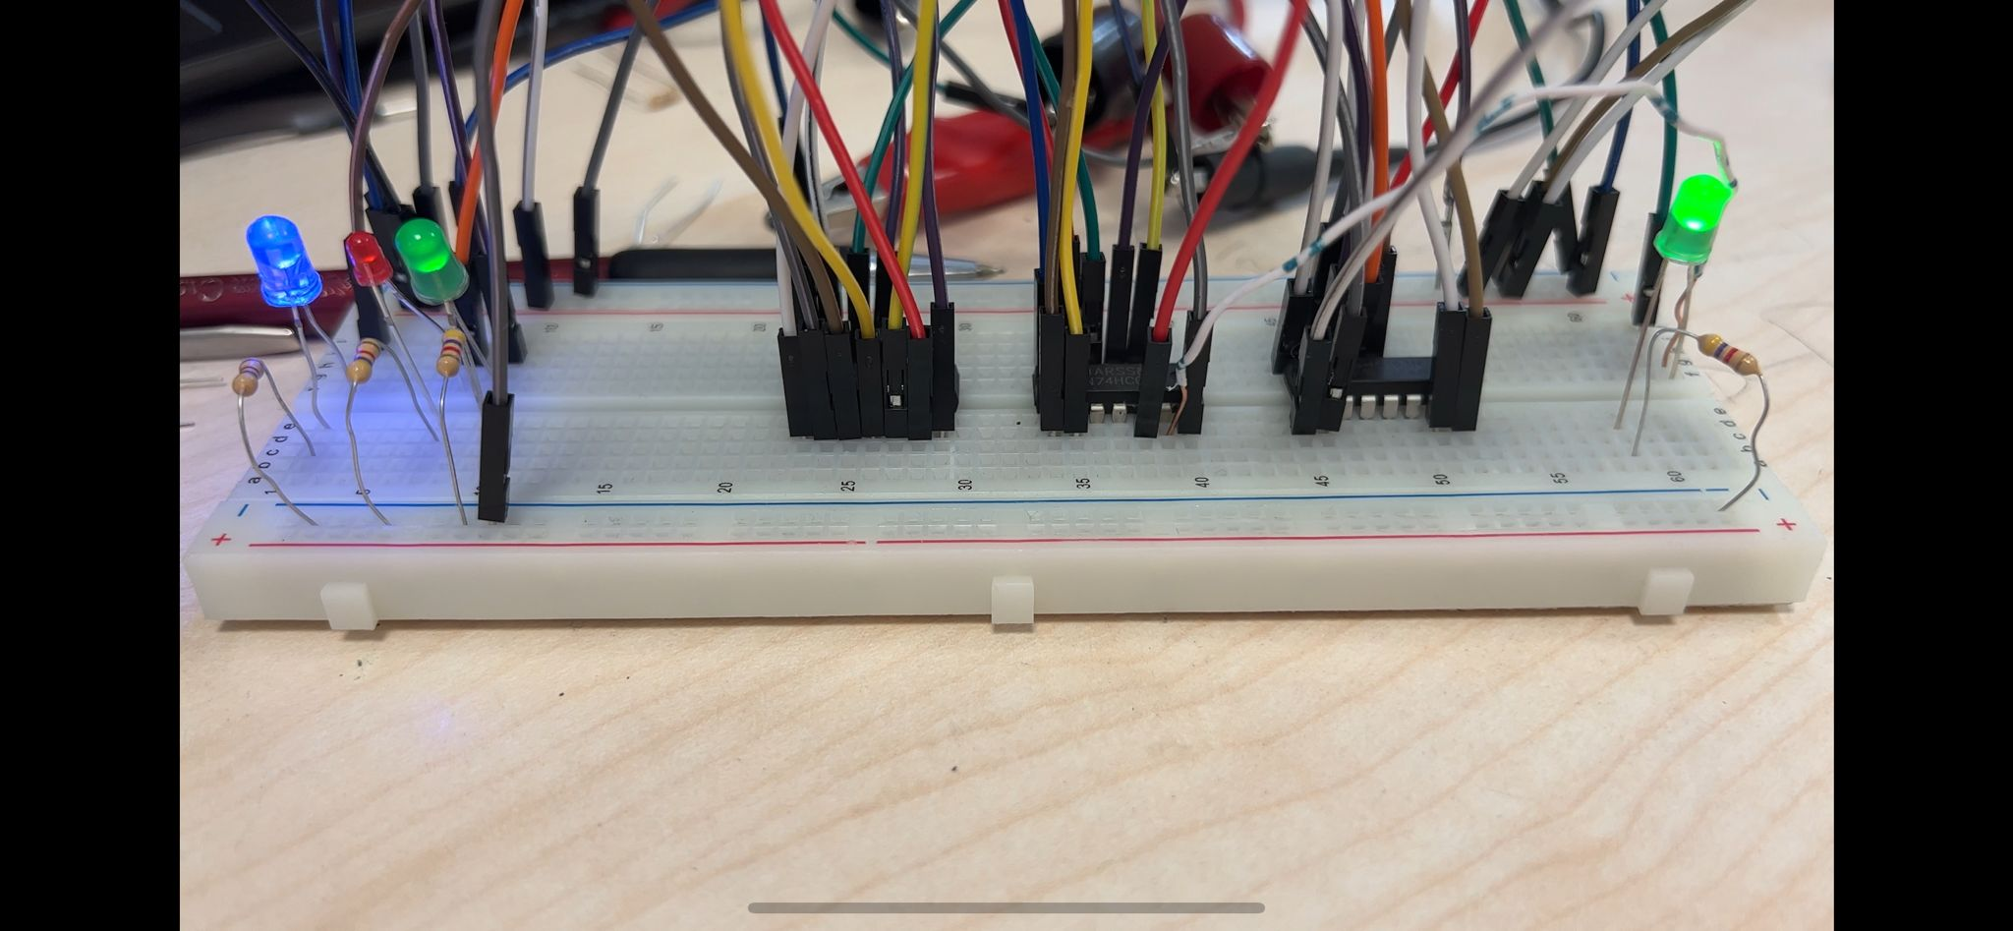
Figure 11: Case 6. S and i1 are high, i0 is low and out is high
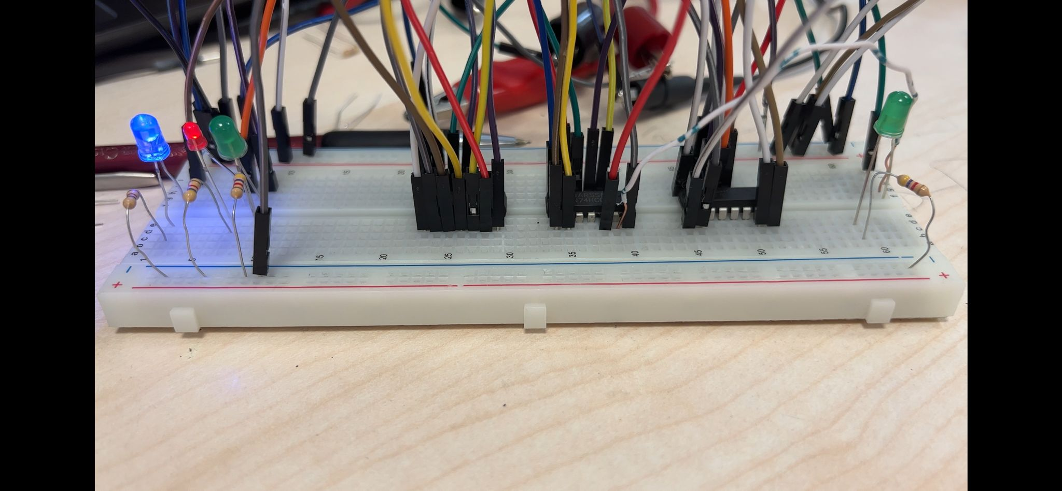
Figure 12: Case 7. S and i0 are high, i1 is low and out is low
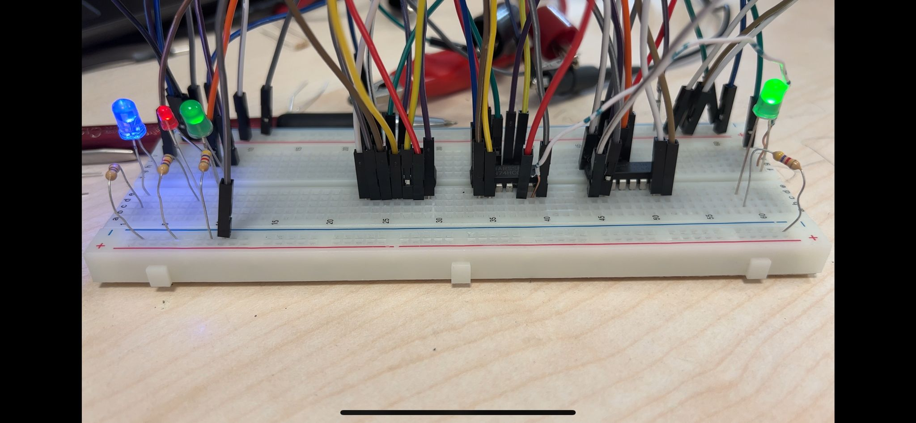
Figure 13: Case 8. S, i0, i1 are high and out is high
References
“74HC04 Hex Inverters.” Technorobots. Accessed on April 19, 2023. https://www.technobotsonline.com/74hc04-hex-inverters.html
“74HC08 Quad 2-Input Positive And Gate.” Technorobots. Accessed on April 19, 2023. https://www.technobotsonline.com/74hc08-quad-2-input-positive-and-gate.html
“74HC32 Quad 2-Input Or Gate.” Technorobots. Accessed on April 19, 2023. https://www.technobotsonline.com/74hc32-quad-2-input-or-gate.html

