Zeynep Akçil
22102833
Section 2 | 05.05.2023
Lab 5: Seven-Segment Display
Purpose
The purpose of this lab is to use multiple seven-segment displays on BASYS 3 board and display numbers simultaneously.
Questions
- What is the internal clock frequency of Basys 3?
Internal clock of the BASYS 3 is 100 MHz. In the design, this clock will be used and adjusted according to the needs.
- How can you create a slower clock signal from this one?
Clock divider is a useful way to adjust clock frequency. To illustrate, while using BASYS 3 whose internal clock is 100 MHz, value can be toggled in every 2 falling/rising edges of the clock. Therefore, one can obtain a clock having a 50 MHz which is the half of the base clock.

- Can you create a clock with any arbitrary frequency lower than that of the internal clock? If not, which frequencies can you create?
Since the methodology is taking action during specific behavior of the internal clock, the possible divided clock frequencies are limited, they cannot be generated arbitrarily. Only integer values who are the divisors of the base clock can be created by using clock division method.

Design Specifications
Each seven-segment display consists of 7 distinct light emitting diodes (LED). These are together allow to display numbers from 0 to 9. They have two inputs: anode and cathode. one is anode and the other is cathode. The BASYS 3 board contains a four-digit common anode seven-segment LED display.
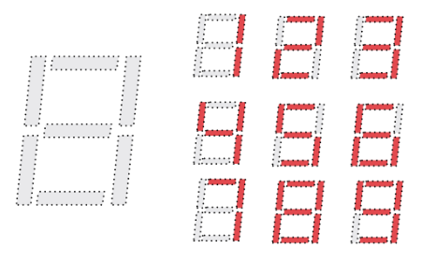
Figure 1: Representation of numbers in seven-segment display
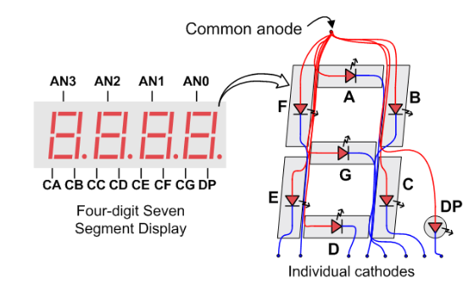
Figure 2: Seven-segment display connections

There are 4 segments in BASYS 3; however, they cannot be high at the same time. Segments are becoming high and low at a remarkably high speed. Human eye cannot catch the changes in high and low values. Therefore, it is likely to seem as more than one segment is emitting light at the same time. This is called as “persistence of vision”. This can be proven by the photos in the appendices. On the photos, some of the segments are low, but they do not seem so. Additionally, in photos there are examples that including more than one segment is high, this is so because, during capture time, there are many transitions made from high to low or low to high. Since capture time is much longer compared to time that a segment is active, it is indeterminate that which segments will be captured as low or high. The numbers are too small so in the photos different number of segments can be captured as high.
For the implementation of the seven-segment display a main module named as “main.vhd” will be written. It will have 2 inputs, clk and reset, and 2 outputs, anode and cathode. Clk is the internal clock of the BASYS 3 having 100MHz frequency and reset will be controlled by users externally, therefore, it will be assigned to the rightmost switch V17. Anode and cathode are not controlled by users, they are internal structures and will be assigned U2, U4, V4, W4 and W7, W6, U8, V8, U5, V5 and U7, respectively.
To avoid complexity, modular fashion will be used and therefore, 2 distinct modules will be used. These will be called as “clockController.vhd” and “segmentController.vhd”

Methodology
In this lab, a hexadecimal counter will be implemented and displayed on the seven-segment display component on BASYS3. The counter starts from 0 and by incrementing displayed number 1, it goes up. As long as the program works steady the counter keeps counting upwards. However, when the reset switch is turned high, count becomes 0 and when it is low again, counter starts counting again from 0.

In the module “clockController”, clock is adjusted. And, in the module “segmentController”, segments are activated in the first process. This is done by checking the signal “converter” which is a 2-bit binary number and coming from the main module. In the second process, the LED’s will be turned on are declared according to the hexadecimal value of the binary signal names as “binaryNumber”. Lastly, in the main module, signals are declared and two modules are used.
Constraint file consists of internal structures which is different than previous labs. Instead of switches and LEDs, internal clock signal and internal anode/cathode assignments are made. Clock is assigned to internal port W5. Anode is assigned to U2, U4, V4, W4 for its range 0 to 3, respectively. Likewise, cathode is assigned to U7, V5, U5, V8, U8, W6, W7 for its range 0 to 6. In this design, only thing controlled externally is reset and it is assigned to the rightmost switch V17.
Test bench file includes the main module as component and two processes, clock process and stimulus. By using this, the waveform graph given in the results part.

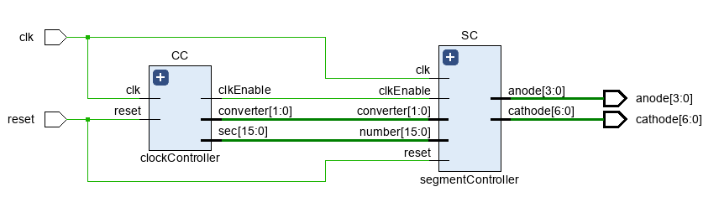
Results
Figure 3: Schematic of the main module of the seven-segment display
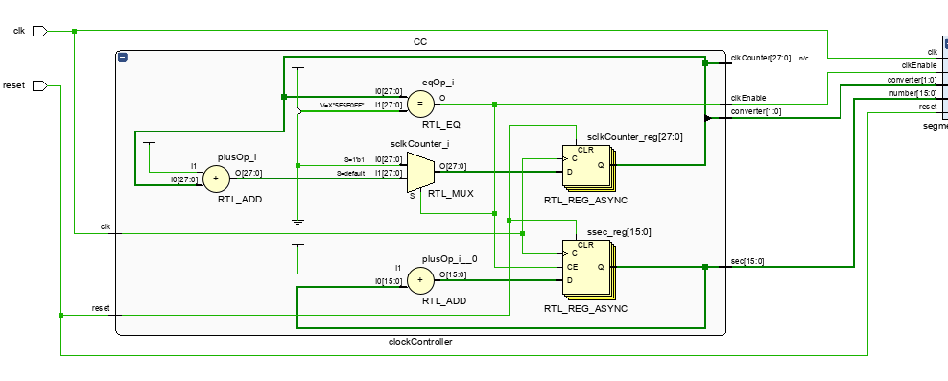
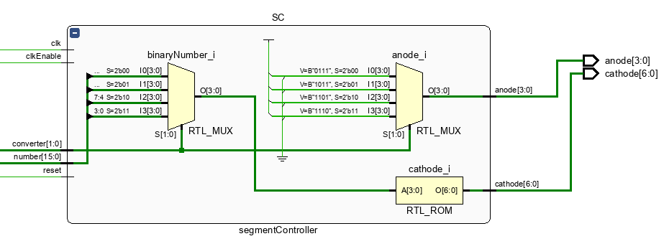
Figure 4: Schematic of the clockController module
Figure 5: Schematic of the segmentController module
To test the code before running it on the BASYS 3 board, test bench is written. Waveform graph shows the transitions in clock and therefore in anode and cathode. It matches with the expectations. The example photos are given in the appendices.
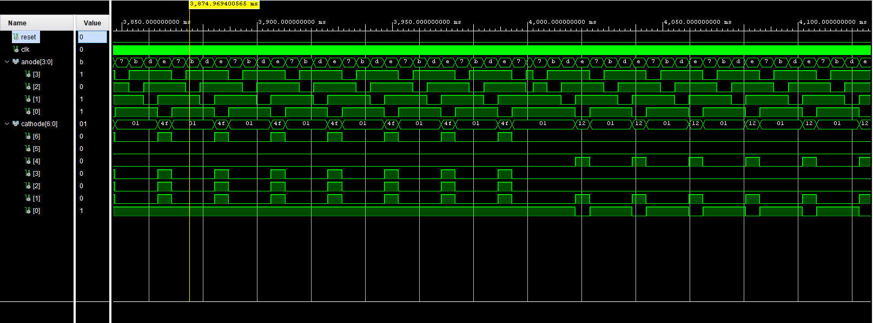
Figure 6: Waveform graph of seven-segment display

Conclusion
The aim of this lab was to implement a hexadecimal counter using the seven-segment display of BASYS 3. One main module and two sub modules are used for this design. It uses the internal clock of BASYS 3 and the internal seven-segment display structure. Since they are different than controlling the program with switches and observing the outputs with LEDs, it can be hard to track and detect problems encountered. Another issue faced was that test bench was not working properly. The clock and reset signals were changing correctly; however, anode and cathode values were fixed at a specific value and not changing. Later, I realized that the default simulation time was not adequate and it is needed to be continued for a couple of microseconds more. When it simulates for 5 µs, transitions on anode and cathode were observable.
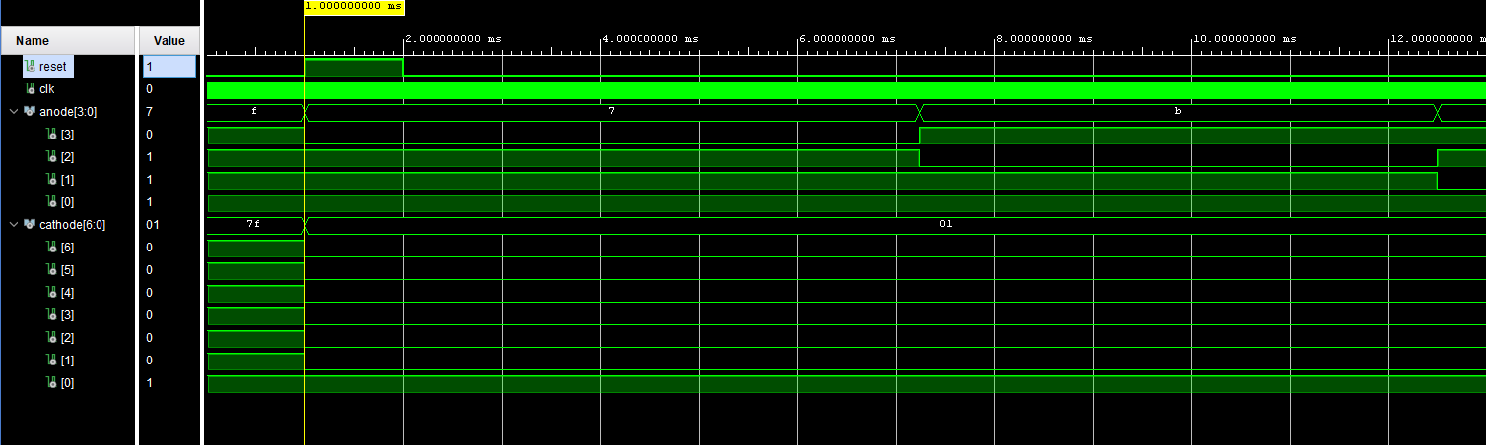
Appendices
Figure 7: Waveform graph showing the transitions when and after turning reset on
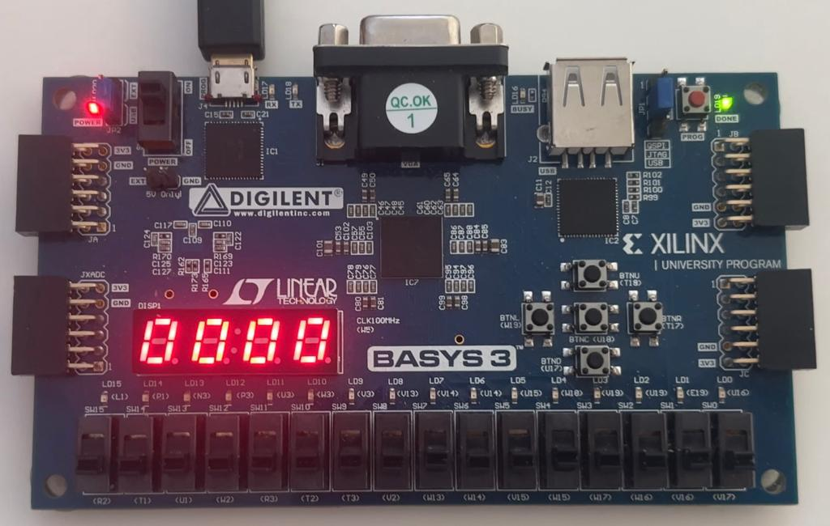
Figure 8: Initial display right after BASYS 3 is programmed
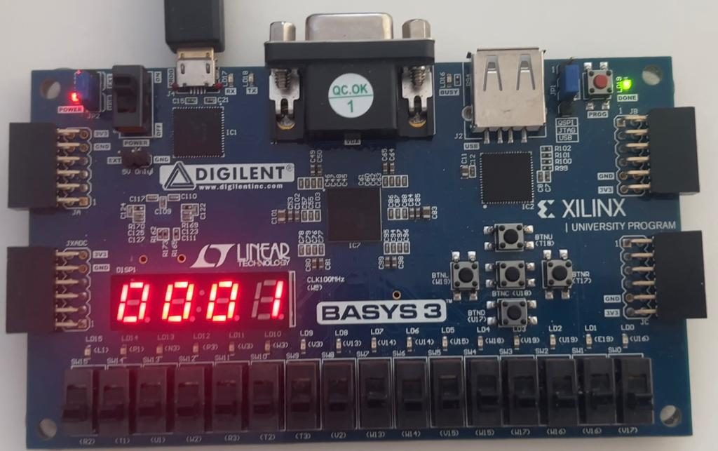
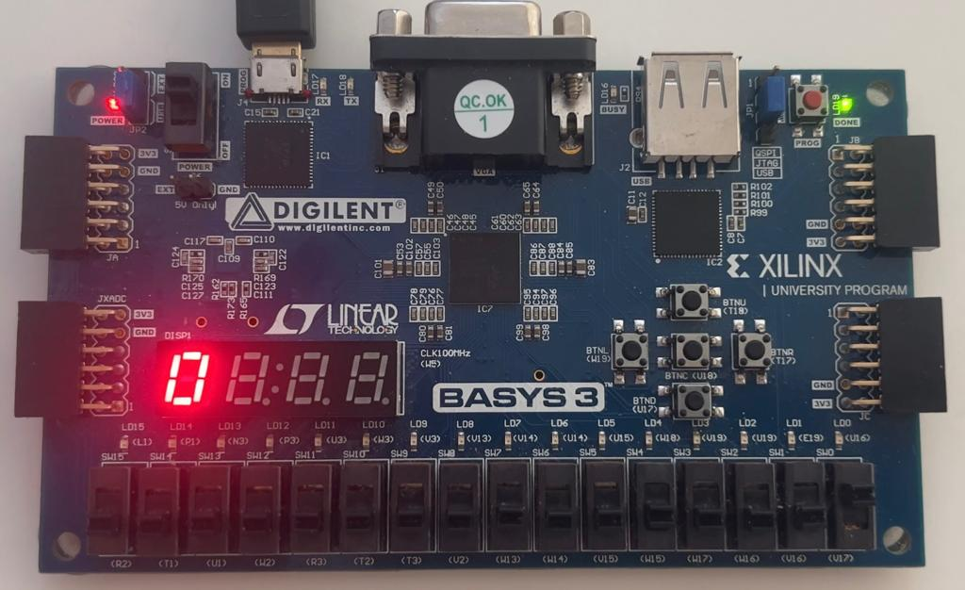
Figure 10: Seven-segment display at second 1
Figure 9: Seven-segment display when reset switch is high
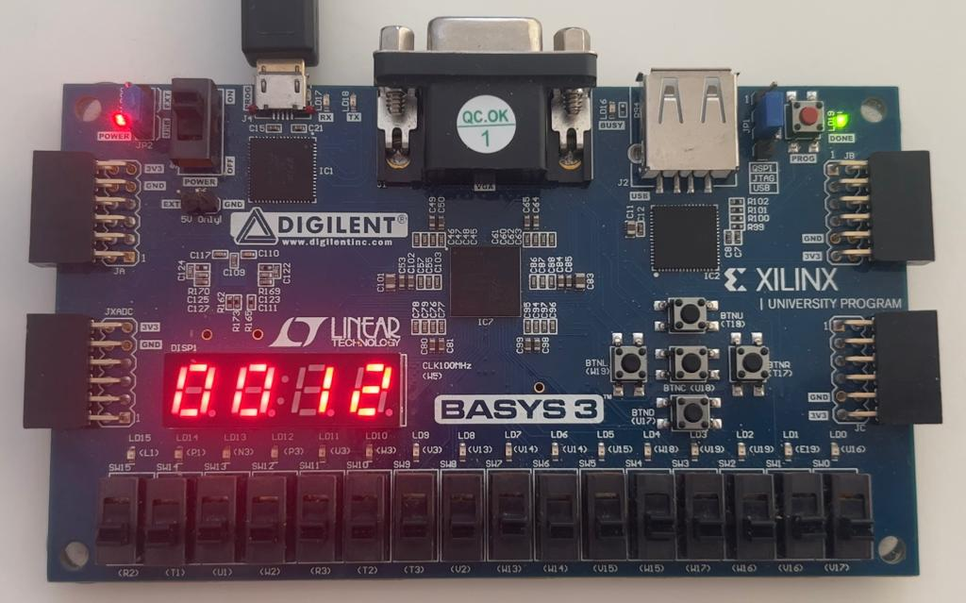
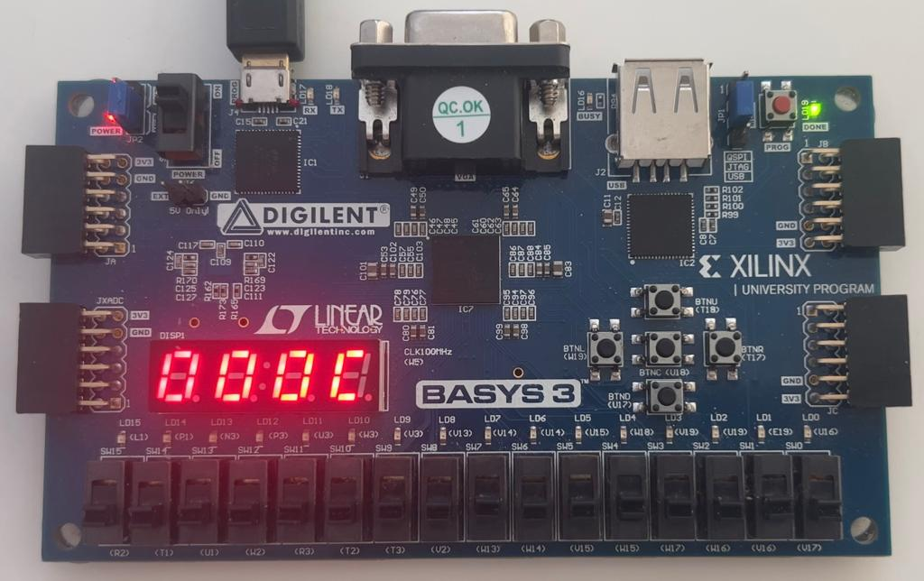
Figure 12: Seven-segment display at second 18
Figure 11: Seven-segment display at second 12, 12’s hexadecimal value C is displayed
library IEEE;
use IEEE.NUMERIC_STD;
use IEEE.STD_LOGIC_1164.ALL;
use IEEE.STD_LOGIC_UNSIGNED.ALL;

entity main is
Port (clk : in std_logic;
reset : in std_logic;
anode : out std_logic_vector(3 downto 0);
cathode : out std_logic_vector(6 downto 0));
end main;

architecture Behavioral of main is

signal clkEnable : std_logic;
signal converter : std_logic_vector(1 downto 0);
signal number : std_logic_vector(15 downto 0);

component clockController is
Port (clk : in std_logic;
reset : in std_logic;
clkEnable : out std_logic;
converter : out std_logic_vector(1 downto 0);
sec : out std_logic_vector(15 downto 0);
clkCounter : out std_logic_vector(27 downto 0));
end component;

component segmentController is
Port (clk : in std_logic;
reset : in std_logic;
clkEnable : in std_logic;
converter : in std_logic_vector(1 downto 0);
number : in std_logic_vector(15 downto 0);
anode : out std_logic_vector(3 downto 0);
cathode : out std_logic_vector(6 downto 0));
end component;

begin

CC: clockController port map(clk => clk, reset => reset, clkEnable => clkEnable, converter => converter, sec => number);
SC: segmentController port map(clk => clk, reset => reset, clkEnable => clkEnable, converter => converter, number => number, anode => anode, cathode => cathode);

end Behavioral;
Code 1: Main module

library IEEE;
use IEEE.NUMERIC_STD;
use IEEE.STD_LOGIC_1164.ALL;
use IEEE.STD_LOGIC_UNSIGNED.ALL;

entity clockController is
Port (clk : in std_logic;
reset : in std_logic;
clkEnable : out std_logic;
converter : out std_logic_vector(1 downto 0);
sec : out std_logic_vector(15 downto 0);
clkCounter : out std_logic_vector(27 downto 0));
end clockController;

architecture Behavioral of clockController is

signal ssec : std_logic_vector(15 downto 0) := (others => '0');
signal sclkCounter : std_logic_vector(27 downto 0);

begin
process(clk) begin
if(reset = '1') then
sclkCounter <= (others => '0');
ssec <= (others => '0');
else
if rising_edge(CLK) then
sclkCounter <= sclkCounter + '1';

if sclkCounter =x"5F5E0FF" then
ssec <= ssec + '1';
sclkCounter <= (others => '0');

end if;
end if;
end if;
end process;

clkEnable <= '1' when sclkCounter = x"5F5E0FF" else '0';
converter <= sclkCounter(19 downto 18);
clkCounter <= sclkCounter;
sec <= ssec;
end Behavioral;
Code 2: clockController module

library IEEE;
use IEEE.NUMERIC_STD;
use IEEE.STD_LOGIC_1164.ALL;
use IEEE.STD_LOGIC_UNSIGNED.ALL;

entity segmentController is
Port (clk : in std_logic;
reset : in std_logic;
clkEnable : in std_logic;
converter : in std_logic_vector(1 downto 0);
number : in std_logic_vector(15 downto 0);
anode : out std_logic_vector(3 downto 0);
cathode : out std_logic_vector(6 downto 0));
end segmentController;

architecture Behavioral of segmentController is
signal binaryNumber : std_logic_vector(3 downto 0);
begin

process(converter) begin
case converter is
when "00" => anode <= "0111"; -- activates first segment
binaryNumber <= number(15 downto 12);
when "01" => anode <= "1011"; -- activates second segment
binaryNumber <= number(11 downto 8);
when "10" => anode <= "1101"; -- activates third segment
binaryNumber <= number(7 downto 4);
when "11" => anode <= "1110"; -- activates fourth segment
binaryNumber <= number(3 downto 0);
when others => anode <= "1111";
end case;
end process;

process(binaryNumber) begin
case binaryNumber is
when "0000" => cathode <= "0000001"; -- 0
when "0001" => cathode <= "1001111"; -- 1
when "0010" => cathode <= "0010010"; -- 2
when "0011" => cathode <= "0000110"; -- 3
when "0100" => cathode <= "1001100"; -- 4
when "0101" => cathode <= "0100100"; -- 5
when "0110" => cathode <= "0100000"; -- 6
when "0111" => cathode <= "0001111"; -- 7
when "1000" => cathode <= "0000000"; -- 8
when "1001" => cathode <= "0000100"; -- 9
when "1010" => cathode <= "0000010"; -- a
when "1011" => cathode <= "1100000"; -- b
when "1100" => cathode <= "0110001"; -- c
when "1101" => cathode <= "1000010"; -- d
when "1110" => cathode <= "0110000"; -- e
when "1111" => cathode <= "0111000"; -- f
when others => cathode <= "1111111";
end case;
end process;
end Behavioral;
Code 3: segmentController module

# Clock signal
set_property PACKAGE_PIN W5 [get_ports clk]
set_property IOSTANDARD LVCMOS33 [get_ports clk]
create_clock -add -name sys_clk_pin -period 10.00 -waveform {0 5} [get_ports clk]

#seven-segment LED display
set_property PACKAGE_PIN V17 [get_ports {reset}]
set_property IOSTANDARD LVCMOS33 [get_ports {reset}]
set_property PACKAGE_PIN W7 [get_ports {cathode[6]}]
set_property IOSTANDARD LVCMOS33 [get_ports {cathode[6]}]
set_property PACKAGE_PIN W6 [get_ports {cathode[5]}]
set_property IOSTANDARD LVCMOS33 [get_ports {cathode[5]}]
set_property PACKAGE_PIN U8 [get_ports {cathode[4]}]
set_property IOSTANDARD LVCMOS33 [get_ports {cathode[4]}]
set_property PACKAGE_PIN V8 [get_ports {cathode[3]}]
set_property IOSTANDARD LVCMOS33 [get_ports {cathode[3]}]
set_property PACKAGE_PIN U5 [get_ports {cathode[2]}]
set_property IOSTANDARD LVCMOS33 [get_ports {cathode[2]}]
set_property PACKAGE_PIN V5 [get_ports {cathode[1]}]
set_property IOSTANDARD LVCMOS33 [get_ports {cathode[1]}]
set_property PACKAGE_PIN U7 [get_ports {cathode[0]}]
set_property IOSTANDARD LVCMOS33 [get_ports {cathode[0]}]
set_property PACKAGE_PIN U2 [get_ports {anode[0]}]
set_property IOSTANDARD LVCMOS33 [get_ports {anode[0]}]
set_property PACKAGE_PIN U4 [get_ports {anode[1]}]
set_property IOSTANDARD LVCMOS33 [get_ports {anode[1]}]
set_property PACKAGE_PIN V4 [get_ports {anode[2]}]
set_property IOSTANDARD LVCMOS33 [get_ports {anode[2]}]
set_property PACKAGE_PIN W4 [get_ports {anode[3]}]
set_property IOSTANDARD LVCMOS33 [get_ports {anode[3]}]
Code 4: Constraint file

library IEEE;
use IEEE.STD_LOGIC_1164.ALL;

entity testBench is
-- Port ( );
end testBench;

architecture Behavioral of testBench is

signal reset : std_logic;
signal clk : std_logic;
signal anode : std_logic_vector(3 downto 0);
signal cathode : std_logic_vector(6 downto 0);

component main is
Port (clk : in std_logic;
reset : in std_logic;
anode : out std_logic_vector(3 downto 0);
cathode : out std_logic_vector(6 downto 0));
end component;

begin
uut: main port map(clk => clk, reset => reset, anode => anode, cathode => cathode);

clockProcess: process begin
clk <= '0';
wait for 10 ns;
clk <= '1';
wait for 10 ns;
end process;

stimulusProcess: process begin
reset <= '0';
wait for 1 ms;
reset <= '1';
wait for 1 ms;
reset <= '0';
wait;
end process;

end Behavioral;

Code 5: Test bench
References
https://digilent.com/reference/programmable-logic/basys-3/reference-manual

