Zeynep Akçil
22102833
Section 2 | 19.05.2023
Lab 7: Finite State Machine
Purpose
The purpose of this lab is to build a Finite State Machine (FSM) on the breadboard. In the process, using integrated circuits as digital gates to construct the circuit is aimed.

Methodology
In this lab, it is expected to create a finite state machine. It could be done either as a Moore machine or a Mealy machine. The chosen algorithm is Moore machine. In this design, 2 outputs and 2 inputs are used and 2 states are available. To be able to build the circuit, first state diagram is drawn, then state assignment table, state transition table, karnaugh maps are created. Finally the logical circuit is illustrated. Once the circuit is visualized, it is carried onto the breadboard using jumpers, resistors and logic gates.
Design Specifications
The aim was to recreate a basic algorithm for a heater. It is inspired by thermometer and a heater. When temperature drops a certain level, the sensor transmits data and heater turns on. On the contrary, when the temperature becomes more than specified value while heater is on, sensor sends a data again and the heater turns off. This is such a practical way to make savings.
It has two inputs: clock and incoming data named as “w”. Clock is supplied by signal generator. It is set to 3Vpp and 1 Hz. “w” is connected to a rail of a breadboard. Assuming that coming data is 1, it is connected to the positive rail, while it is connected to ground otherwise. Positive rail is connected to power supply set to 5 V. Reset and preset inputs are connected to this rail.
For signal assignments, one hot encoding methodology is used. The states and and their assignments are as following:
- StateA : Heater is ON, Output = 1
- StateB: Heater is OFF, Output = 0
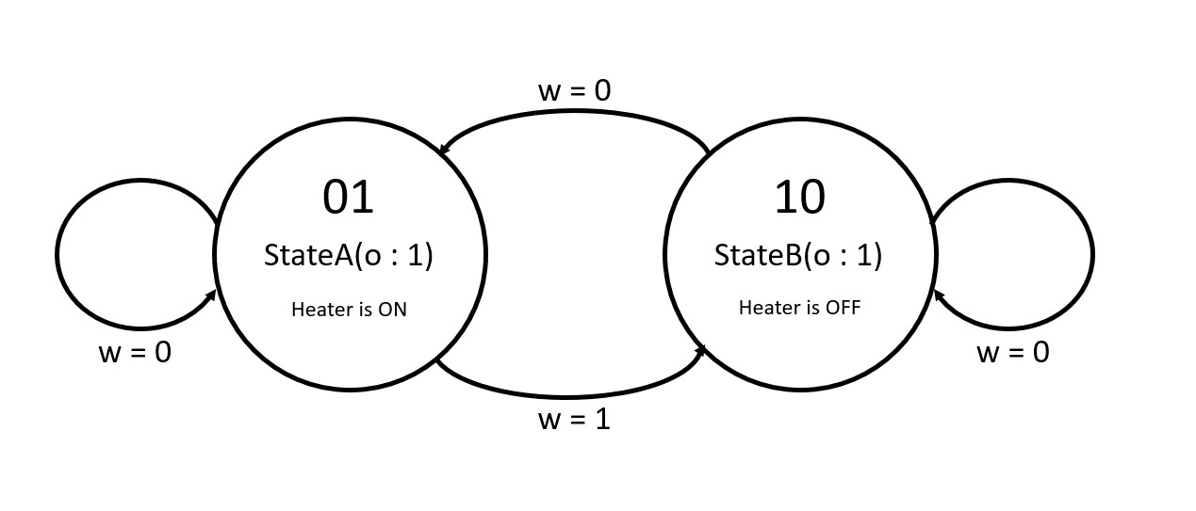
Figure 1: State diagram
Present State | Next State |  | Output
 | w = 0 | w = 1
"01" | "01" | "10" | 1
"10" | "01" | "10" | 0

Table 2: State transition table
Next state variables are defined as Y₂ and Y₁. Y₂ is the most significant bit while Y₁ is the least significant bit.
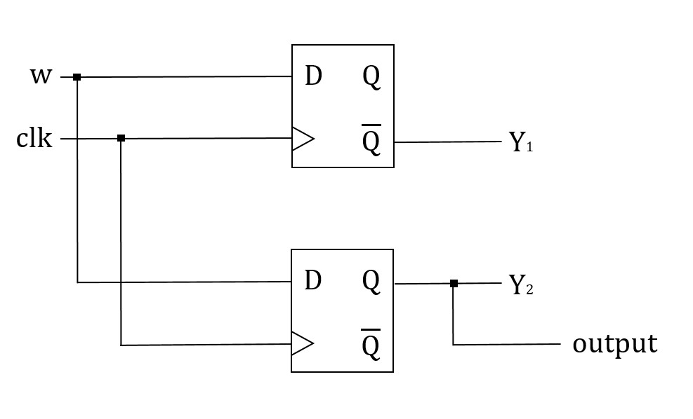
Figure 3: Logic Circuit
This design consists of 2 D Flip-Flops (74HC74). Their outputs are connected to next state logic. These are connected to LED’s to observe the states.

Results
Finite state machine is created onto breadboard as follows:
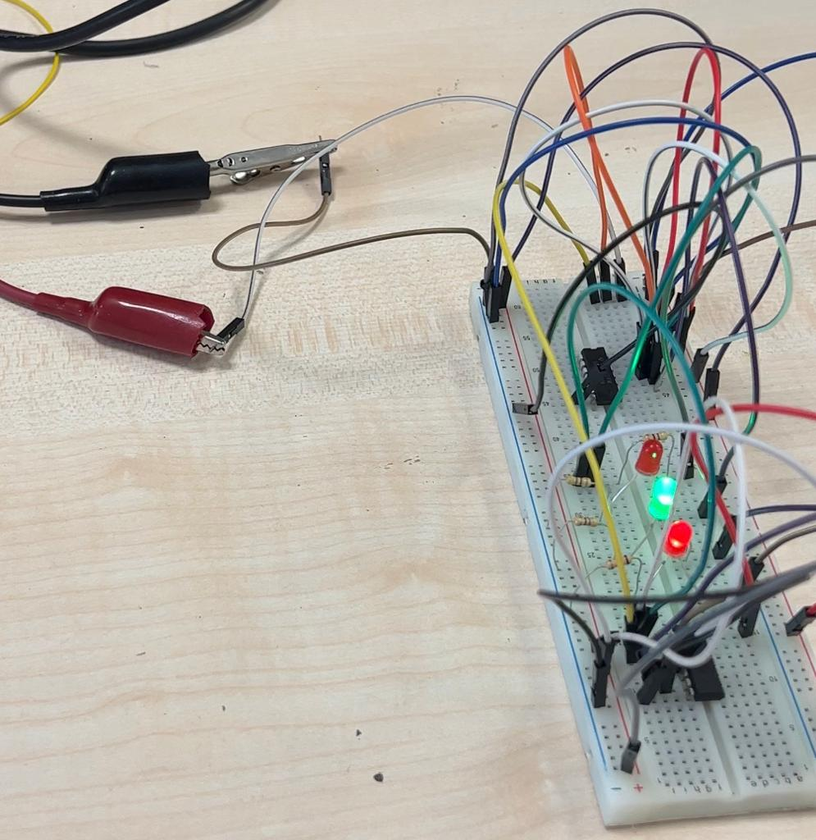
Figure 4: Connections on the breadboard, shown cables are coming from signal generator

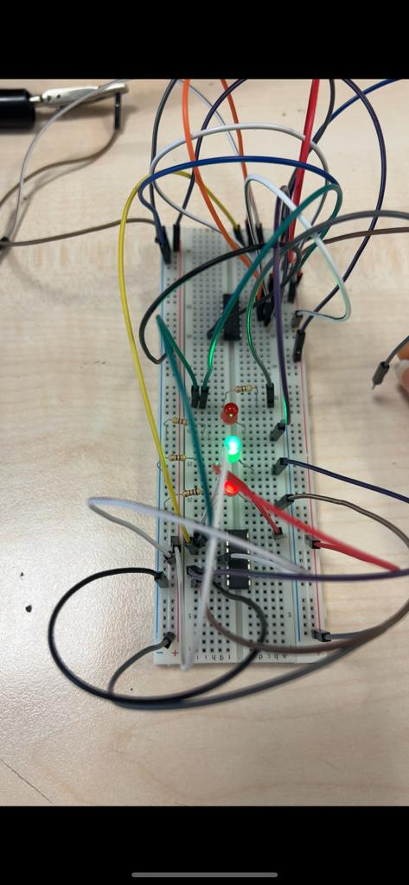
The first case is StateA which happens when “w = 0”. This indicates that heat is low, and therefore the heater goes high. In this case output is ‘1’.
Figure 5: StateA, output is 1

The upper red LED shown in the picture is connected to next state variable Y₂, namely, the most significant bit. This equals to $Q$ of the first flip-flop and this equals to w, the input data. When “w = 0” is applied, it is OFF. The middle LED is the Y₁, the least significant bit. It is connected to $\overline{Q}$ output of the second flip-flop, namely, equal to $\overline{w}$. And the LED at the down is output signal and it equal to Y_{1,} namely $\overline{w}$. Therefore, in this case output logic control LED and next state logic variable Y₁ is high while next state logic variable Y₂ is low.
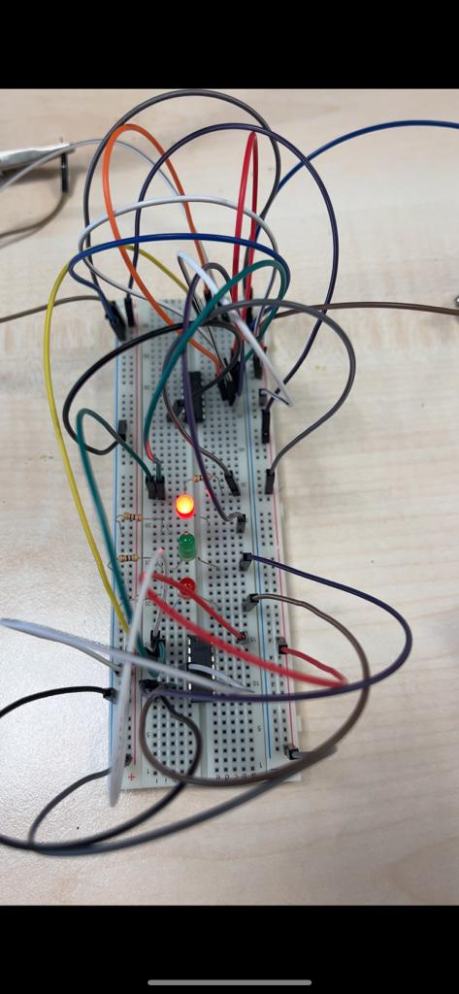
Figure 6: StateB, output = 0

In this case w = 1. On the contrary to previous case, Y₂ is now ‘1’ while Y₁ and output is low.

Conclusion
In this lab, it is aimed to design a finite state machine using logic gate components on breadboard. A simple heater control design is made. This need not to be done by using finite state machine because it is not a complex circuit; however, since this circuit had to be implemented on the breadboard, I had to keep it simple. At first, the circuit I designed was consisting of two bit control bit carrying two different data each is hold by one bit. However, this circuit became so complex to be implemented on the breadboard. This was not practical and applicable. Therefore, I chose to simplify the circuit so that I can observe, understand and present better. This is why I go with a simple circuit. The cases and expected results are arisen as expected.

References
https://www.mouser.com/datasheet/2/308/74HC74-108792.pdf

