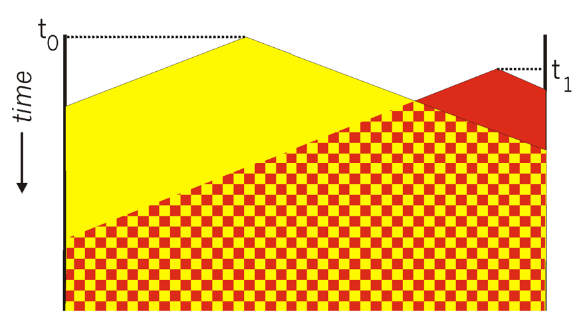

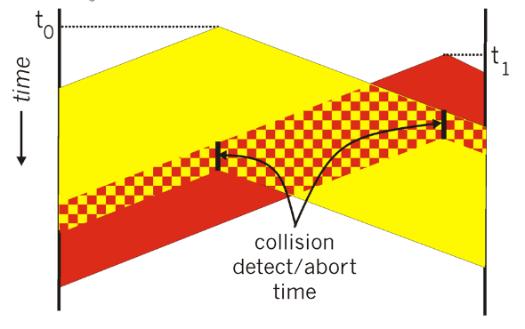

~~Scaffold-DbContext "Data Source=LAPTOP-C0LH22JG\AS2000004907;Initial Catalog=InternshipDB;Integrated Security=True;Connect Timeout=30;Encrypt=False;Trust Server Certificate=False;Application Intent=ReadWrite;Multi Subnet Failover=False" Microsoft.EntityFrameworkCore.SqlServer -OutputDir AppDbContext~~

Scaffold-DbContext "Data Source=LAPTOP-C0LH22JG\AS2000004907;Initial Catalog=InternshipDB;Integrated Security=True;Connect Timeout=30;Encrypt=False;Trust Server Certificate=False;Application Intent=ReadWrite;Multi Subnet Failover=False" Microsoft.EntityFrameworkCore.SqlServer -OutputDir AppDbContext

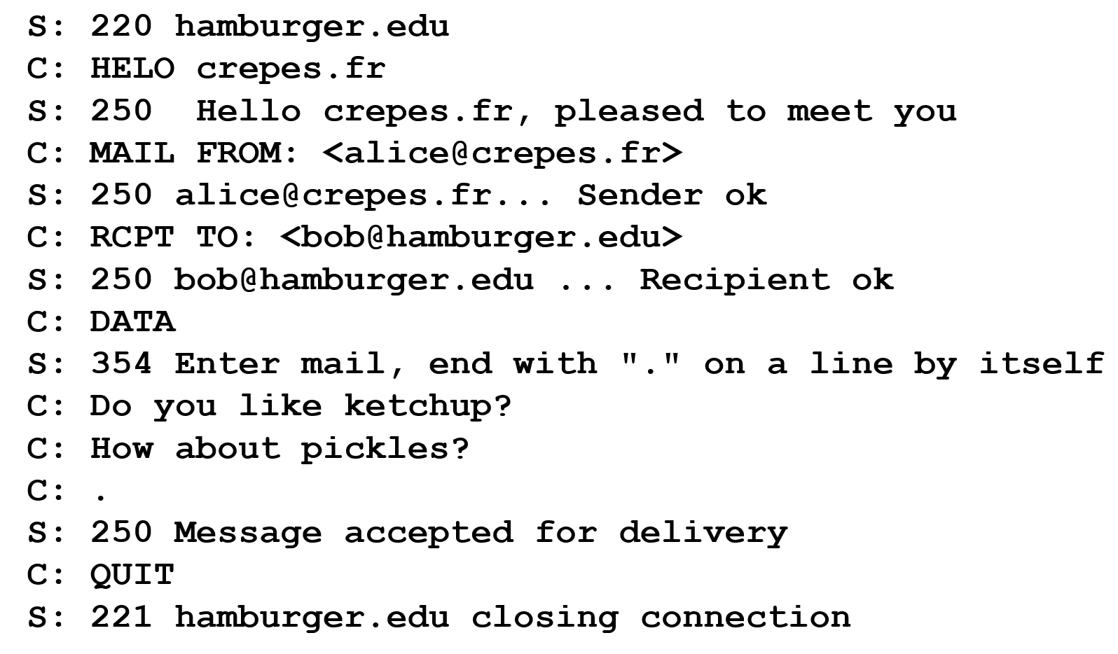

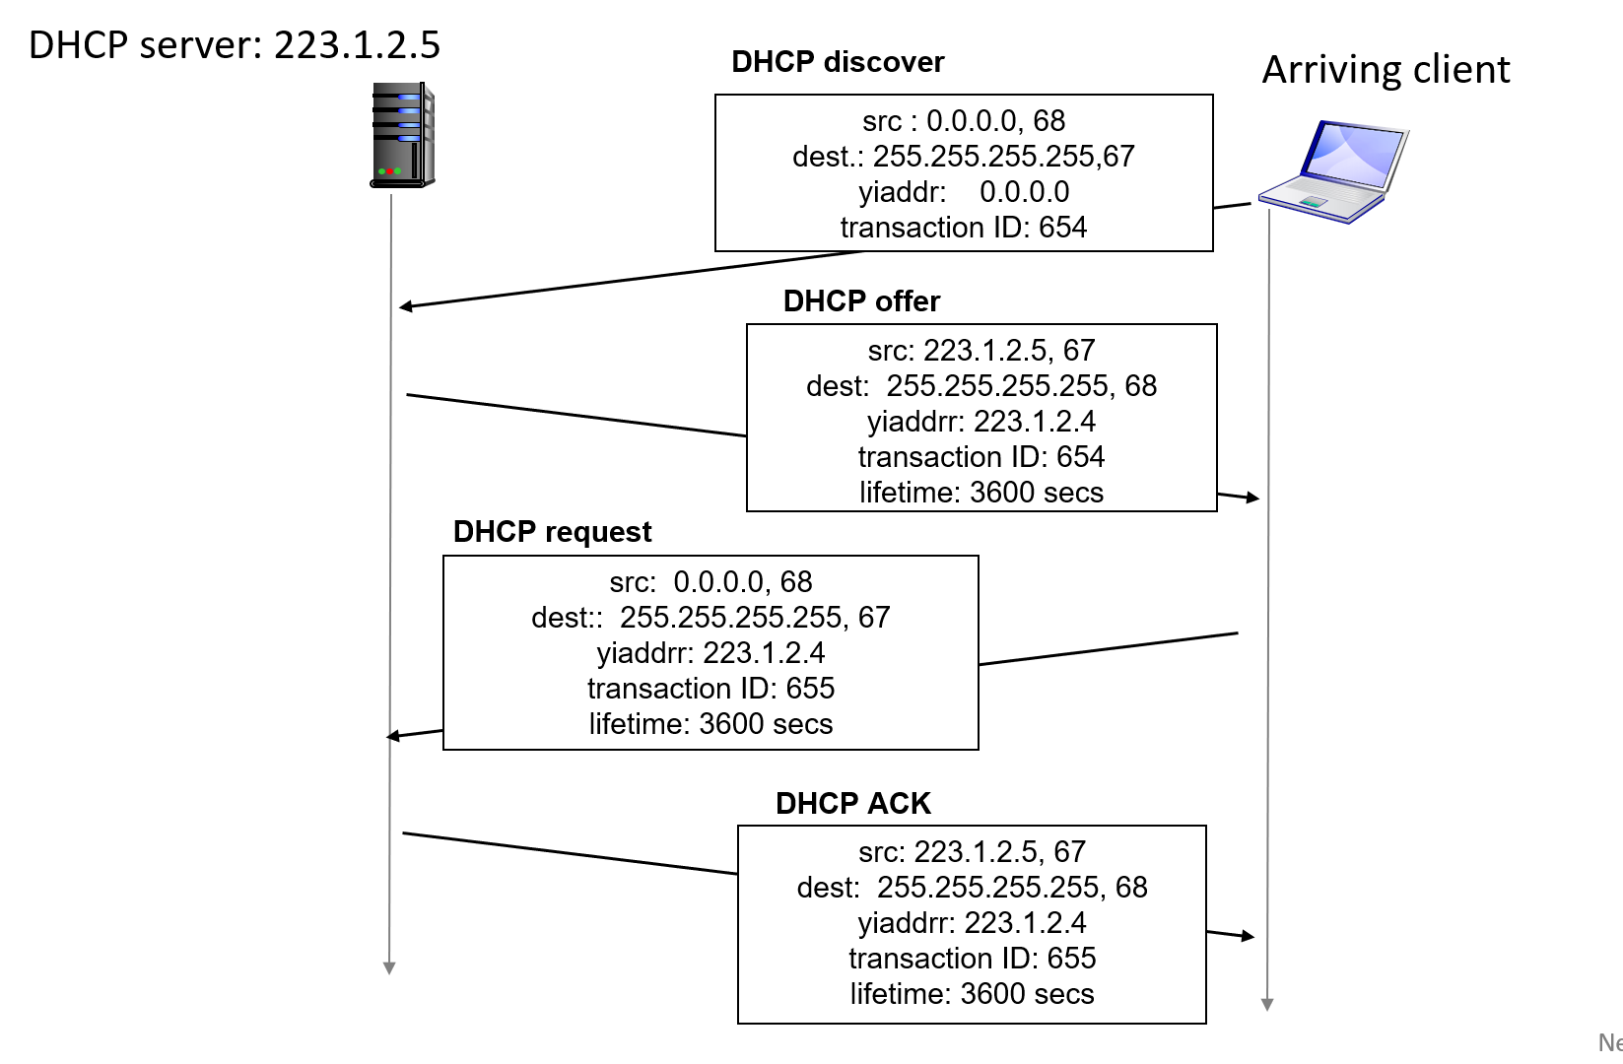

Scaffold-DbContext "Server=AYSENUR;Database=IntershipDB;uid=sa;pwd=12;Trusted_Connection=True" Microsoft.EntityFrameworkCore.SqlServer -o Models