**Internship Application**

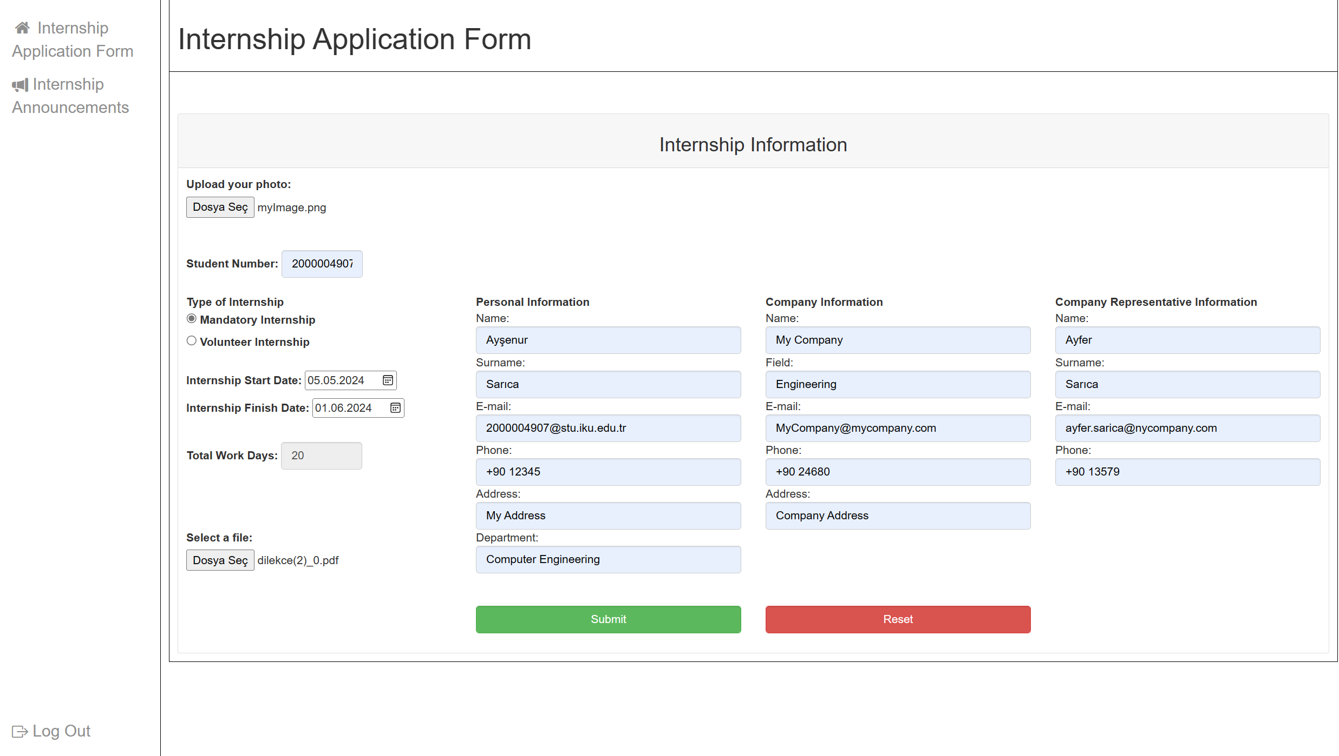

If total work days for mandatory internship is 20 days, system won’t give an error and student can submit the form.

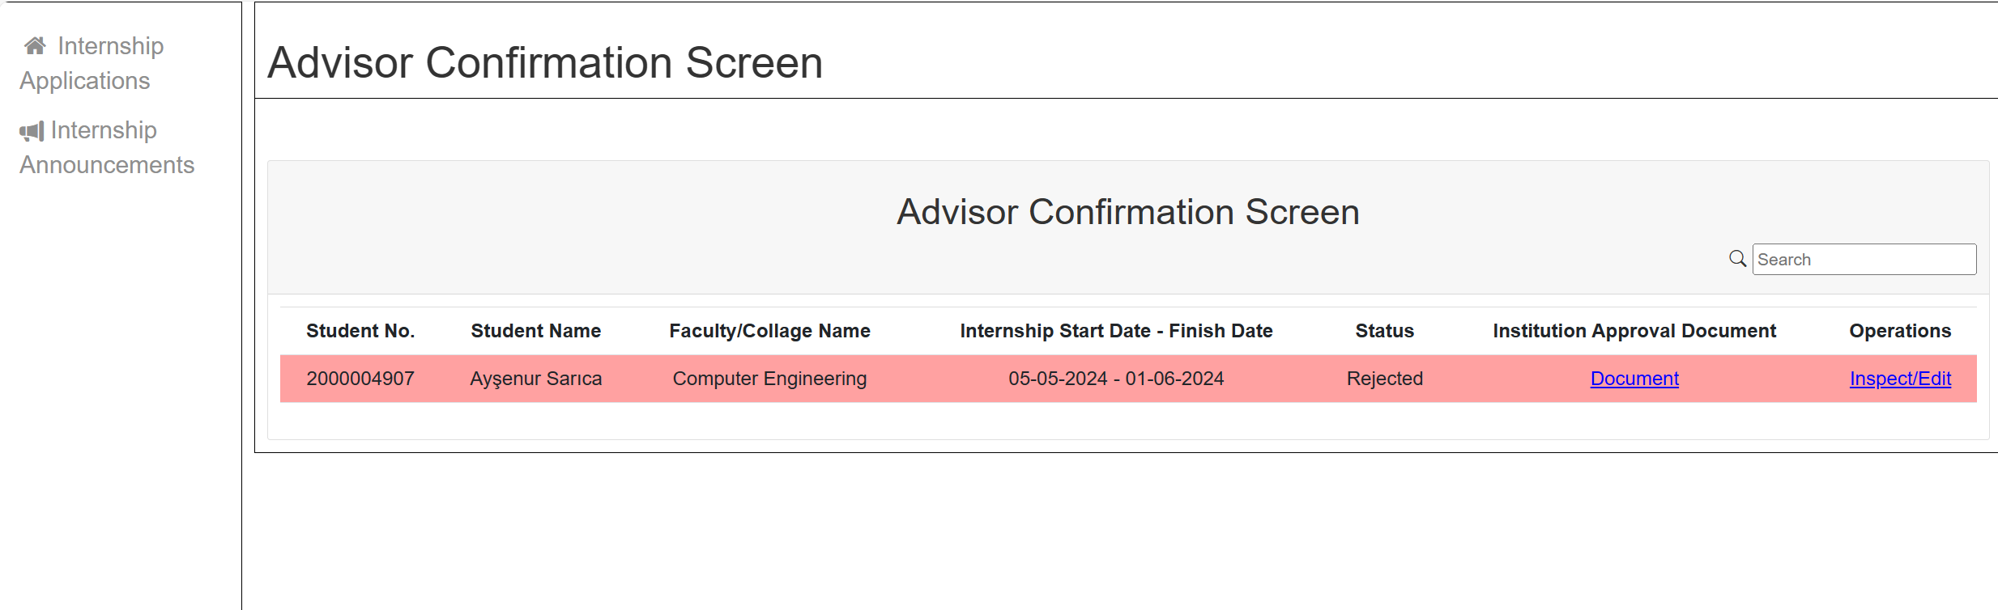

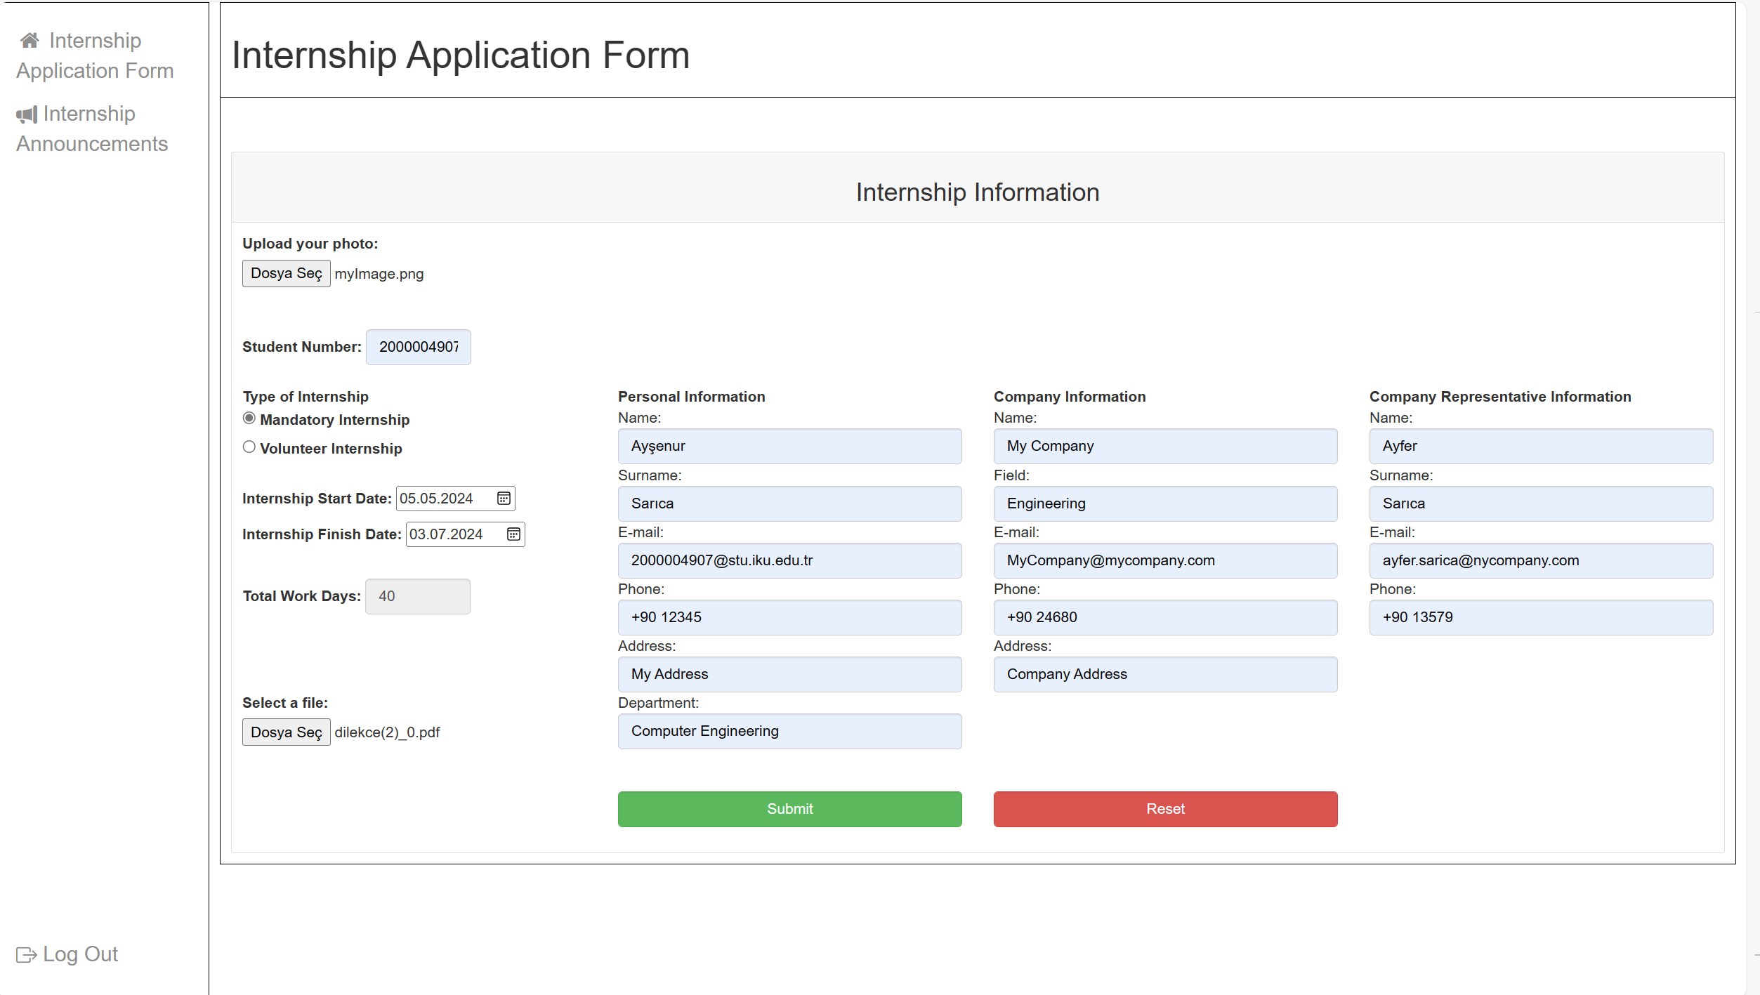

If total work days for mandatory internship is 40 days, system won’t give an error and student can submit the form.

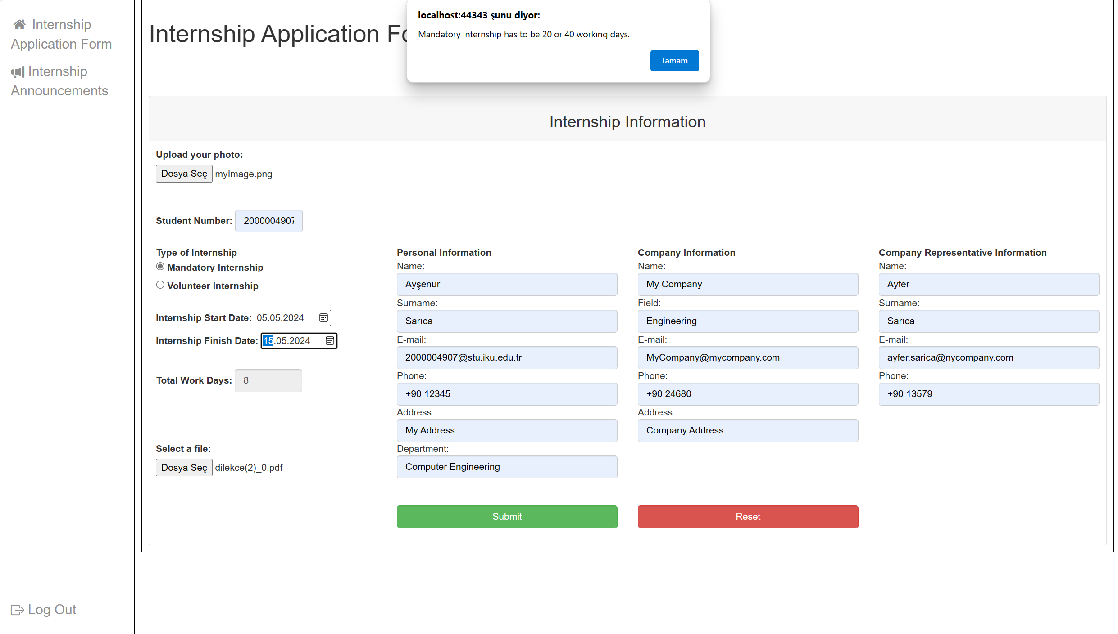

If total work days for mandatory internship is not equal to 20 or 40 days system will give an error ‘Mandatory internship has to be 20 or 40 working days.’. After that the start and finish date values will be cleared.

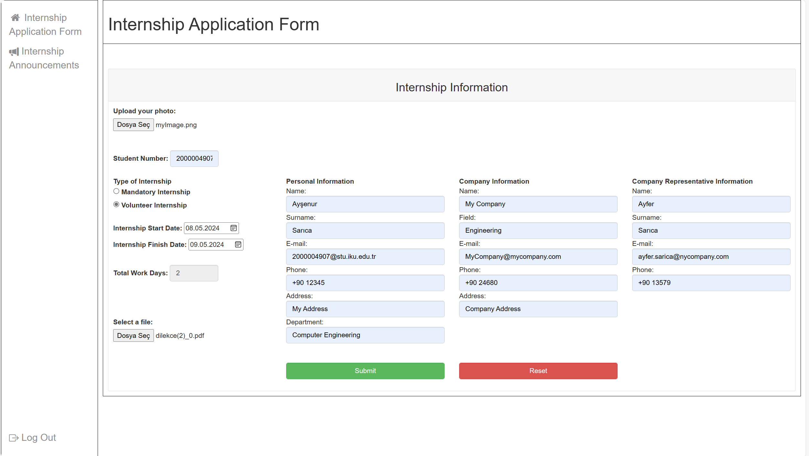

There is no restriction on total working days for volunteer internship.

**Student/AddInternship.cshtml:**

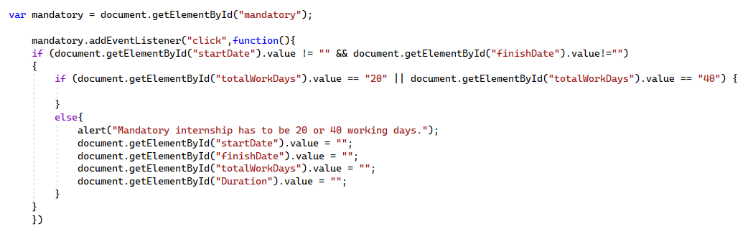

If student first selects start and finish date and then selects type of internship, this code works.

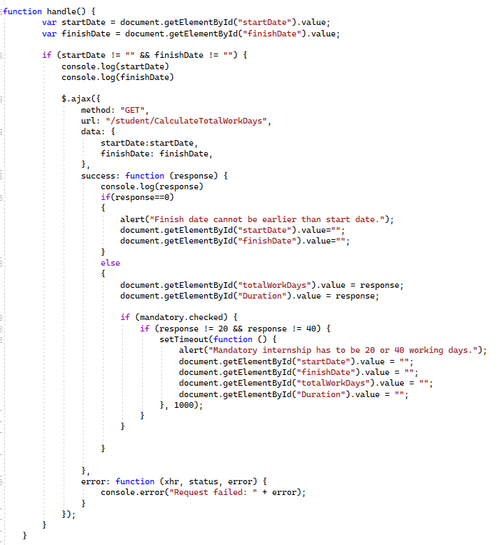

If student first selects mandatory internship and then selects start and finish date, this code works.