Paper Title* (use style: paper title)
Subtitle as needed (paper subtitle)

Authors Name/s per 1st Affiliation (Author)
line 1 (of Affiliation): dept. name of organization
line 2-name of organization, acronyms acceptable
line 3-City, Country
line 4-e-mail address if desired
Authors Name/s per 2nd Affiliation (Author)
line 1 (of Affiliation): dept. name of organization
line 2-name of organization, acronyms acceptable
line 3-City, Country
line 4-e-mail address if desired

Abstract—Ecoli data set was trained and 7 data mining techniques were applied. 5%, 10% and 15% cross-validation was used. These machine learning techniques were trained on PCA on and off. Then, performance comparison was made for these 7 data mining techniques using classification accuracy, precision, recall (sensitivity) and F-measure (F-score).
Keywords— Escherichia coli; diarrhea; mutant; EHEC

Introduction
Escherichia coli (E.coli) is a member of the Enterobacteriaceae family and is a bacterium that lives in the large intestine of mammals. E.coli is rod-shaped and a gram-negative bacteria. E. coli is approximately 2.0 μm long and 0.5 μm in diameter. E.coli bacteria coexist in the human body without any adverse effects. However, some E.coli bacteria can cause disease in creatures with eroded intestinal barriers and/or immunocompromised individuals. In particular, some E. coli cause various intestinal and extraintestinal diseases in humans and animals around the world.

Related Work

Acid Tolerance of Enterohemorrhagic Escherichia coli
Its importance has increased due to epidemics and occasional cases of diarrhea caused by Enterohemorrhagic E. coli (EHEC) in hemorrhagic diarrhea. This bacterium also causes life-threatening hemorrhagic colitis and hemerotic-uremic syndrome. EHEC infections are usually transmitted through contaminated water or food. However, it can also be transmitted by people coming into contact with each other[1].
Stomach acid plays an important role in preventing food-borne infections. Bacteria must not be affected by stomach acid before reaching the intestine. For this reason, stomach acid is the first defense mechanism in case of foodborne contamination. Studies have been conducted to compare the survival rates of bacteria in various degrees of acidic environments and at various temperatures[1].
To investigate the acid sensitivity of bacteria, bacterial cultures were grown in broth at 37ºC and pH value 7.3. Fresh bacterial cultures were diluted 1:1000 in broth and sterilized using a filter overnight. Bacteria started to grow at 37ºC with gentle shaking. Some experiments were performed in gelled broth at various temperatures and pH values. It was observed that 50% to 100% of the produced bacteria survived in high acid tolerance, 10% to 50% survived in medium acid tolerance, and less than 10% survived in mild acid tolerance[1].
In experiments conducted to understand the mechanism behind high acid levels, it was observed that weak acids suppress the bacteria produced for a longer time because they can enter the bacterial cell more easily, while strong acids are not effective because they cannot enter the bacterial cell[1].
In the experiment conducted by decreasing the pH value from 7.6 to 7.3 overnight, it was observed that the acid tolerance of the bacteria produced increased[1].
It has been determined that food also affects the growth of bacteria. Although apple cider and mayonnaise are acidic foods, it was observed that they did not reduce the acid tolerance of the bacteria and diarrhea cases increased[1].
Bacteria produced at various pH values and 37ºC temperature were tested by keeping them for 5 hours. It has been observed that the higher the pH value, the lower the acid tolerance of the bacteria. The opposite is also true, but the effects vary. Test conditions were simulated to the human stomach environment[1].
As a result, it has been determined that the pH value is of great importance in the change in the acid tolerance level of the bacteria and its growth rate[1].

Giant Cells of Escherichia Coli
In many recent reports, the characteristics of the "lon" locus of E. coli K-12 have been described. If the “Lon” mutant is exposed to radiation, cell growth occurs. This phenomenon was previously studied in rod-shaped cells, and it was observed that such cells increased only in length, not width.
All organisms are derived from E. coli K-12.
The P678-7 mutant produced is the radiation-resistant mutant of the P678 mutant. A series of experiments were performed on this mutant.
As a result of these experiments, the introduction of the lon allele into the cells enabled the production of non-rod-shaped giant cells. Although rod-shaped cells grew along the long axis, P678-7 cells grew in all directions. It was possible to stop cytoplasm division while ensuring cell growth in organisms carrying this mutation.
Giant cells are interesting from a cellular perspective. Cellular and chemical studies showed that they were multinucleated, like rod-shaped cells.
It was observed that the growth rate of giant cells during the growth period was not higher than the volumetric growth of E. coli cells during the microcolony formation period.

Nonchemotactic Mutants of Escherichia Coli
In the late 19th century, microbiologists discovered chemotaxis in bacteria. It is unknown how bacteria detect chemicals and how they turn into action once detected. In this paper, motile but non-chemotactic E. coli mutants are reported.
AW330 and AW405 coli bacteria used in the chemotaxis experiment were produced and grown in the medium prepared for the experiment. Some experiments were conducted on these bacteria.
At the end of these experiments, it was concluded that E. coli bacteria showed chemotaxis to energy sources used without oxygen, such as oxygen, glucose and serine (amino acid).
Mutant M353, however, failed to respond chemotactically. The mutant and its parent consumed approximately the same amount of oxygen in a capillary tube. The mutant consumed oxygen by moving forward, but it was observed that it did not form a band, while the parent consumed oxygen by migrating by forming a band.
In the experiments, it was observed that E. coli showed chemotaxis to glucose, serine (amino acid), aspartic acid (amino acid) and threonine (amino acid). Mutant M353, unlike its parent, could not form a ring. In fact, mutant bacteria are mobile and do not remain where they accumulate. M353 has been found to effectively deplete serine (amino acid) despite its refusal to respond chemotactically.
Microscopic examinations showed that the mutants were fully mobile and that they swam better than their parents, that is they did not change their direction frequently. When the sensitivity of M353 was examined, it was observed that the mutant bacteria swam randomly.
Although the flagella of the mutants were not analyzed chemically, they all appeared to have wild-type flagella.
When the growth rates of M353 and AW330 were examined, it was seen that the mutant had no defects that would affect the growth rate. It has been observed that the failure to achieve chemotaxis cannot be attributed to the growth requirement.
As a result, it is not known which biochemical functions affect the mutation, but studies show that more than one gene plays a role. The mutants reported here are generally not chemotactic. Attempts to isolate non-chemotactic mutants are ongoing.

Conjugation in Escherichia Coli
Bacteria transferring genetic material to each other occurs in a few genera, but most of the experiments have been conducted on E. coli K-12 and various species of salmonella bacteria. The establishment of sexuality in these organisms is provided by the E. coli sex factor F1. This report concerns the transfer of the E. coli K-12 sex factor (F1) to E. E. coli B/r and the sexual characteristics of Hfr derivatives.
E. coli B/r and its derivatives described herein will be referred to as E. coli B. E. coli K-12 and B were produced and some experiments on mating were performed on them.
Conjugation experiments have been performed for various bacterial species. These are not limited to E. coli. Conjugation experiments in Salmonella and Shigella bacterial species are also very comprehensive. The fertility of these bacteria depends on the sexual characteristics brought by the E. coli K-12 sex factor. The sexual characteristics of the male derivatives of these bacteria are very similar to each other.
It is interesting that the sex factor varies depending on the gene and chromosome in which it is located. One or two types of Hfr derivatives are bacteria (isolates) that come from the F+ population and have not been produced under laboratory conditions. The K-12F+ bacteria produced for use in these experiments exemplifies this.
The data obtained from the experiments show that the F1 sex factor is integrated in different regions in each of the produced coli K-12 and B bacteria and salmonella bacteria. There are two possibilities for the reason for this. The first is that the qualities of the integration regions of the located genes and chromosomes (genome) are different from each other. Second, the sites are identical, but the genomes are located in different regions of the bacteria used in the experiments.

Aging of Escherichia Coli
A lot of research has been done on aging in recent years. Sorokin defined aging as “a process that leads to a decrease in the survival capacity of the individual organism”. Since there is no natural death in single-celled organisms, Sorokin presented evidence that aging occurs in microbial cells and that aging occurs at the cellular level.
Aging was evaluated as increasing time. Cells were collected from the culture medium and suspended in a deprived environment. It has been observed that as the cells age, their cellular content changes and they cannot maintain cellular activity. In this study, changes in the C14 cell content were first examined.
Bacteria were grown on gelled salt solution and tested on the salt solution. Some experiments have been done on aging. The cells were fed with glucose and a loss of nitrogen was observed in the cells. Decreases in cellular carbohydrates have been noted, especially in the first 1-2 hours of aging.
To conduct further research on substances lost from cells as we age, the K-12A mutant was obtained. Some experiments have been done on this bacterium. It has been shown that the results obtained in the experiments will be the same as the K-12 bacteria produced. Subsequent experiments were continued with K-12. The results of the experiments also support the concept of maintenance energy. Results regarding the effects of nutrition on growth and viability were obtained. Population and viability were determined when glucose was administered to E. coli.
In feeding experiments, a yellowish green color appeared in suspensions fed with glucose. As the age and amount of suspension increased, the color also increased. In suspensions fed with basal salts or glucose, absorbance increased with the age of the suspension. It was observed that ammonia was produced in cells fed with glucose.
Most of the enzymatic activities of bacteria decrease as the age of the cells increases. Death of cells is due to inactivation, enzyme loss, coenzyme loss and other changes. Enzyme inactivation is not a significant factor in bacterial death.
Respiratory activities also decrease with aging. The percentage reduction in oxygen consumption or live counts was greater than the reductions noted for population (turbidity) with aging time of the cell. It was observed that the decrease in respiratory activities after 24-48 hours paralleled the decrease in live count.
It has been observed that it is possible to slightly stimulate respiration by administering glucose to cells aged more than 48 hours. Percentage values in the experiments show that feeding the cells maintains living populations at higher levels than starved suspensions and that the fed cells perform a high level of metabolic activity.
Studies by Marr, Nilson and Clark, and Malette have demonstrated maintenance energy for E. E. coli. It has been observed that glucose begins to accumulate if the supply is above the optimum amount required for maintenance energy. The results show that energy is required to maintain all cells.
In periodic experiments conducted with glucose-fed cells, it has been observed that cells tend to decrease with aging. It was observed that the increase in respiration rate continued when senescent cells were fed with glucose. It was observed that death was postponed when an external energy source was available, but due to the current unstable conditions, one or more of the life functions of the cells were destroyed.

Autolysis of Escherichia coli
Conditions that cause autolysis of E. coli cells have been investigated. When looking for factors that trigger autolysis, growth conditions, osmotic environment and pH have been found to be important. It is generally assumed that peptidoglycan plays a key role in the osmotic protection of bacteria by imparting mechanical resistance to the cell membrane and that one of the main steps of autolysis is its degradation by specific endogenous substances. Experimental conditions that promote autolysis in E. coli cells and, in particular, the effects of sudden changes in osmotic environments have been studied in detail.
Most experiments were performed with E. coli K-12 HfrH. Different strains of E. coli K-12 were also used in some experiments. The bacteria used in the experiments were grown in a nutrient-rich environment. Then, experiments were carried out by applying certain procedures to these bacteria.
Induction of autolysis in coli cells by different osmotic shocks was investigated. Autolysis occurred at salt concentrations of 0.3 to 0.8 M. Shock treatments containing high concentrations of sodium acetate suppressed autolysis.
In the experiments, upshock and downshock treatments were applied to the bacteria. Performing both shock treatments together increased the speed and extent of autolysis.
Experiments showed that pH, buffer concentration and growth conditions also affected autolysis. It has been observed that the initial rate of autolysis depends on the pH value of the sodium acetate concentration applied to the bacteria. Intensity of sodium acetate concentration also increased the cell lysis rate.
Temperature has also been observed to have an effect on autolysis. It has been observed that autolysis is faster at high temperatures, and the autolysis rate decreases significantly at low temperatures.
In experiments, the effectiveness of potassium, calcium and magnesium acetate in stimulating the autolysis of water-shocked cells was compared with that of sodium acetate, and it was observed that different ions and chelating agents had an effect on autolysis.
In the experiments, it was seen that the radiation of paptidoglycan had an effect on the relationship between autolysis and degradation.
In this article, different osmotic shocks that promote autolysis of E. coli cells are examined. Factors that accelerate the breakdown of E. coli cells are factors such as pH, temperature and buffer concentration. Adherence to autolysis is not irreversible. It was observed that live counts remained constant for at least 2 hours when divalent cations were added.
A close relationship has been observed between peptidoglycan degradation and autolysis. Both events were triggered by the same shock treatment, with similar kinetics observed, being effectively blocked by the addition of divalent cations.

Energy of Maintenance in Escherichia coli
To investigate the use of extracellular glucose for maintenance without growth, several experiments were performed using E. coli B populations. In these experiments, it was observed that when glucose was added to bacteria grown at 37ºC for a long time, the population did not change or increased. During monitoring for 10 days, it was determined that the viability of unfed bacteria decreased rapidly. This led to the conclusion that E. coli uses extracellular glucose for maintenance.
Rahn (1932) suggested that internal nutrition causes the metabolism to wear out, and the situation is reversed with external nutrition. The energy obtained through external nutrition is called maintenance energy.
Some researchers theoretically assume the existence of maintenance energy. Kandler (1955) showed that not all of the energy coming from external materials is used for growth and that such maintenance energy is possible. Windisch and Nordheim (1957) also emphasized that starvation prevents the growth of cells.
If energy is used for maintenance, low amounts of external materials will not enable the cell to grow. If the cell does not grow, the energy provided from outside corresponds to maintenance energy.
Monod and Tessier (1936) found in their study that there was no detectable maintenance energy. Monod (1942) made a more comprehensive investigation using bacillus E. coli and bacillus subtilis and concluded that zero energy was required for maintenance.
Monod found that the population decreased in different experiments by increasing the temperature.
Battley (1960) found a linear relationship between final population value and limiting energy sources for saccharomyces (Saccharomyces) cerevisiae.
Data from experiments conducted at the Department of Bacteriology at Pennsylvania State University show that maintenance energy exists for E. coli B. Experiments showed that bacteria died of starvation, but bacterial cells grew by adding glucose. Addition of glucose more than once a day increased the population, and it was observed that the population remained stable with the addition of half as much glucose. It was determined that when glucose was added to the tubes with a high population, there was no cell growth and viability increased. Glucose below growth-promoting levels was used as maintenance energy.
The above findings showed that a small amount of glucose does not stimulate growth, while multiple additions of glucose over a long period of time preserve the population, at least partially preserve the viability, which shows that the concept of maintenance energy is justified.

Lysine Suppressor in Escherichia coli
E. coli bacteria with amber suppressor mutants were used to grow the amber mutant of phage T4. It has been determined that it produces high levels of suppression and the added amino acid is lysine.
E. coli CA273 culture infected with H36 was grown and purified for use in experiments. Later, some procedures were applied to these bacteria.
Some experiments were carried out on these bacteria and the results of the experiments were examined. It has been observed that when lysine is added to the amber region of the protein peptide PhT12, no amino acid other than lysine gives chemical and electrophoretic properties.
As a result of the experiments, it was seen that the suppression effect of E. coli sup-273 bacteria was around 8%.

rRNA Transcription Rate in Escherichia coli
Gene expression is caused by the transcription of DNA into RNA and is also affected by the elongation speed of RNA chains. To investigate this issue, electron microscopy was performed.
E. coli W3110 bacterium grown for the experiments was prepared for electron microscopy by undergoing some processes. Milar dispersion technique was used to prepare bacteria for electron microscopy.
In order to examine the elongation rate of the rRNA chain in E. coli, the initiation of transcription was prevented by using rifampin. Later, RNA polymerases were observed.
Information about the transcription rate was obtained by observing the positions of RNA polymerases.

Proline Metabolism in Escherichia coli
It was observed that a proline-requiring mutant of the E. coli bacterium could not grow much when grown in glucose salt containing L-proline.
E. coli B strain and E. coli B4 strain were preserved by growing in salt solution.
Subcultures of wild type and mutant species were created for use in experiments. These cultures were given concentration containing L-proline. Growth rates were estimated from population measurements. The growth of the produced E. coli B4 bacteria was supported by giving L-proline. Bacteria were subjected to various processes and washed for the experiment.
It was observed that the rate of proline oxidation in both mutant and wild type washed bacteria produced depended on the growth medium. It was observed that the activity of the proline oxidation system in the mutant type bacteria produced was much less than that of the wild type bacteria in glucose-containing environments. It was observed that there was a very low difference in different environments. With this result, it was determined that mutant type coli bacteria were exposed to glucose pressure. It has been observed that this pressure decreases in prototrophic bacteria.
If the proline oxidation system works effectively, it determines the amount of porlin. The activity of the proline oxidation system is thought to depend on bacterial concentration and not on proline concentration.

Phosphoproteins in Escherichia coli
It has been observed that phosphate binds to protein residues in various bacteria. Research has provided evidence that there are phosphoamino acids in the soluble proteins of E. coli bacteria.
Some chemical substances were prepared in the laboratory and experiments were carried out on coli bacteria produced under laboratory conditions using these chemicals.
To examine the transformation of phosphate in protein during the experiments, after the bacteria were grown in phosphate, 200 times more phosphate was added to half of the bacterial culture. The bacteria were then allowed to grow for a while longer. In the measurements made between the two samples, it was seen that the total protein amount of the second sample was twice as much as the total protein amount of the first sample. This result indicates that protein phosphate does not convert into non-protein phosphate during bacterial growth.
In previous experiments, it was determined that the protein phosphate content remained constant during the growth of the bacteria. When the growth of bacteria came to a halt, it was observed that the amount of protein phosphate decreased due to loss of protein phosphate.
It has been determined that there are enzymes that make protein phosphate acid soluble during protein divisions of E. coli.
As a result of the studies, it is thought that phosphoproteins have a special role in the metabolism of bacteria and not only have a function of storing nutrients.

Immunity to Enterotoxigenic Escherichia coli
Enterotoxigenic coli (ETEC) has a short incubation period. Along with the travelers, this bacteria also travels and is carried to different places. This bacterium is one of the causes of diarrhea in children. The use of prophylactic antibiotics makes it easier to prevent contamination. However, it should be used daily without interruption during the travel period. This may cause side effects. It may cause antibiotic resistance of antibiotic-resistant bacteria to increase.
Many enterotoxigenic coli bacteria contain heat-stable enterotoxin (LT) as well as heat-stable enterotoxin (ST). coli bacteria that produce only ST or LT are lethal to humans.
The studies described here were conducted to determine whether diarrheal infection caused by coli bacteria that produce both LT and ST produces immunity against subsequent infection with the same bacteria.
Healthy volunteers between the ages of 18 and 41, with an average age of 25, were used for the studies. The studies were carried out at the vaccine development center. The necessary health screenings of the volunteers were carried out.
E. coli bacteria produced for the studies were transformed into vaccines by going through some processes. This vaccine was then given orally to the volunteers. Volunteers started to be examined daily 2 to 3 days before vaccination and continued to be examined daily. Their temperatures were measured regularly every 6 hours. All vomit and feces of those with high fever were collected within 5 minutes, examined and their volumes were measured. Volunteers were treated with antibiotics for 5 days to prevent the spread of bacteria through feces before discharge.
Some analyzes were made on E. coli bacteria taken from feces.
Diarrhea rates were determined in volunteers given bacteria, and the symptoms of the disease were observed to be similar to traveler's diarrhea. Before the studies, none of the volunteers had E. coli bacteria. Volunteers were found to have bacteria in their stool 24 to 48 hours after they were given bacteria. The volunteers were not given antibiotics until the eighth day after the bacteria were administered.
Studies have examined the rates of diarrhea and how resistant the immune system has become to this bacterium.
Four of the volunteers agreed to come back after 10 days. E. coli bacteria were given to the returning volunteers again and it was examined whether their immune systems developed.
The studies conducted here show that ETEC infections can be prevented by immunological methods.

Gluconate Metabolism in Escherichia coli
Gluconate instead of glucose can also be induced in some bacteria. It is metabolized via the Entner-Doudoroff (ED) pathway.
Our findings showed that the ED system constitutes the primary pathway of gluconate metabolism in E. coli ML30. For this reason, the E. coli system and gluconate mechanism had to be re-evaluated. This resource describes the results of studies conducted on E. coli and other bacterial species.
Bacterial cultures used in the experiments were kept on Trypticase Soy Agar (BBL) slants and transferred to the same medium every 2 months. Except for Pseudomonas bacterial cultures grown at 25oC, all bacterial cultures were grown under aerobic conditions at 37oC and underwent a series of processes during the experiments.
To investigate the nature of gluconate dissimilation in the bacterium E. coli ML30, some experiments on the oxidation of glucose and gluconate were carried out. As a result of these experiments, it was seen that bacteria grown with glucose could not oxidize gluconate at a sufficient level. However, bacteria grown with gluconate have been found to oxidize both glucose and gluconate.
As a result of a series of experiments, it was observed that the gluconate mechanism in E. coli contains an inducible Entner-Doudoroff (ED). Additional evidence in this direction was obtained with some enzyme experiments.
Various experiments have been carried out on the presence of a number of ED pathway enzymes with E. coli M30 bacteria grown on glucose and gluconate. E. coli ML30 bacteria grown with glucose and some different substances do not contain any notable ED pathway enzymes, but the ED mechanism is inducible in cells grown with gluconate. has been made.
At this stage of the experiments, it was investigated whether there was ED pathway enzyme activity in other coli bacteria produced.
E. coli bacteria grown on glucose were compared with different bacterial species such as Pseudomonas, which have dehydrase and aldolase activities. In some experiments, it was observed that these enzymes were found in E. coli B derivatives grown with gluconate. It has also been observed that these enzymes are present in cultures grown aerobically or anaerobically. The dehydrase enzyme was present in cells grown on glucose and gluconate but not in cells grown on casein hydrolyzate alone.

T1 Bacteriophage Production in Escherichia Coli
After UV irradiation, phages T1, T3, and T7 were presented to have lower survival rates in strain B. Experiments were run to test both possibilities.
Cultures of bacteria are cultivated and tested. Dilutions of the stock phage are prepared. Phage stock is added to a cell suspension for capacity testing.
T1 is absorbed by strain Bs-1. Strain B was used to see if Bs-1 adsorbs phage particles. The results of the experiments are repeatable.
99% of phage particles which survived irradiation were adsorbed to Bs-1. Desorption of phage is also known to have occurred.
Colony-forming ability suggests E. coli strains present marked differences, with strains B and Bs-1 being sensitive in particular.
When survival of the host cell was measured, phages T1, T3, T7, and P22 were particularly less sensitive to UV than T2, T4, and T5.

Calcification by Escherichia coli
Escherichia coli K-12 has been studied to determine its effect on the hardening of tissue. Biological apatite, a component of bone and teeth, is virtually indistinguishable from the calcium phosphate produced by the more commonly studied corynebacterium matruchotii, or simply B. matruchotii. It is due to this that K-12 would be more valuable in an experiment, as the other is not as represented.
With the temperature at 37 C, K-12 was cultivated in a liquid used to assist with calcification. With the rightful conditions, a growth was withdrawn at various intervals and then dried. Methodology remains akin to those used when working with B. matruchotii.
After 3 days, calcification occurred with some cultures. The crystallization was of a lesser size than of dentin. The crystals were needle-like and in clumps. Decay was shown, so coordination between calcification and organelles was not possible. Calcification had occurred later than apoptosis.

Methodology

Methods
We have used the Ecoli dataset where we evaluated different machine learning algorithms using cross validation methods. Our dataset cannot have holdout so we have split our dataset into training and testing by only using cross validation techniques at different levels (5%,10%,15%)
Approach:
We have used two different approaches which are PCA and Non PCA.
- PCA: As the dataset is high-dimensional so in this approach the data can be easily visualized. It transform original dataset into a lower dimensional space while returning most of the variance in the data
- Non PCA: It uses the original feature without dimensionality reduction for our model training
Algorithms:
We have used 7 different algorithms to train our model here is the brief description of these algorithms
- Linear SVM: This is used for classification tasks and regression tasks. I our dataset it is used to predict the presence of specific stains and conditions based on the features. We have preprocessed the data properly and tune the model's hyperparameters to optimize its performance for the specific task and dataset.
- Subspace Discriminant: It is also mainly used for classification as well. It works by finding a subspace by maximizing the class separability. It first examines the discriminant power of each input feature and then uses probabilistic projections of features to yield 1D subspaces.
- Quadratic SVM: Quadratic SVM is a variant of SVM which uses a quadratic kernel to moderate the value. This is effective for non-linear data set and high dimensional feature space. As our dataset has diverse features it gives us flexibility. Just by doing proper tuning of parameters we can achieve results.
- Medium KNN: Medium KNN refers to the K-nearest neighbor algorithm and medium refers to the specific parameter setting or configuration. KNN suitable for classification tasks where decision boundary is irregular and classes are distributed in clusters. In our model training we had to choose the K value and calculate the euclidean distance between test data and all training points.
- Cubic KNN: Cubic KNN algorithm utilizes a cubic kernel function for distance weighting. It can capture high order interaction between features and classes. Proper parameter tuning is important to have correct accuracy. In our dataset the contribution of each neighbor to the decision is weighted based on the cubic distance.
- SVM Kernel: We have used this algorithm to handle both linear and no linear relationships between features and classes. SVM with kernel function is a powerful algorithm capable of giving us higher accuracy.
- Medium Gaussian SVM: This algorithm is mostly used for non linear data sets. This refers to a specific parameter setting of the gaussian kernel. We have chosen this configuration based on empirical testing and cross-validation to achieve a balance between model complexity and performance.

Data Description
Ecoli Data set:
- # of records: 336
- Feature names: mcg, gvh, lip, chg, aac, alm1, alm2
- Feature value types: continuous, continuous, binary, binary, continuous, continuous, continuous
- Feature value ranges: 0.89, 0.84, 0.52, 0.50, 0.88, 0.97, 0.99
- # of missing values: 0

Evaluation Metrics
Accuracy is the closeness of measurements, such as observations, to their true values. It is a measure of observational error.
For multiclass classification formula:
Accuracy = Correct classifications
All classsifications
Precision means positive prediction and is the ratio of the samples taken to the corresponding samples included. The closer the measurements are to each other, the higher the precision value. It is a measure of observational error.
Presicion = True Positives
True Positives + False Positives
Recall also means sensitivity and is the proportion of relevant samples retrieved. Recall is equal to the number of actual positive results.
Recall = True Positives
True Positives + False Negatives
F-score (F-measure) is a measure of performance by prediction. It is calculated from the precision and recall of the test.
F-score = 2 * True Positives
2 * True Positives + True Positives + False Negatives

Experimental Results

The computer System Configuration:
- Operating system: Windows 11
- CPU: 12th Gen Intel(R) Core(TM) i7-12700H
- RAM: 16GB
- Used program: MATLAB R2023a

Comparing the Performance of Data Mining Techniques

Table I. 5-FOLD CROSS VALIDATION / NON PCA
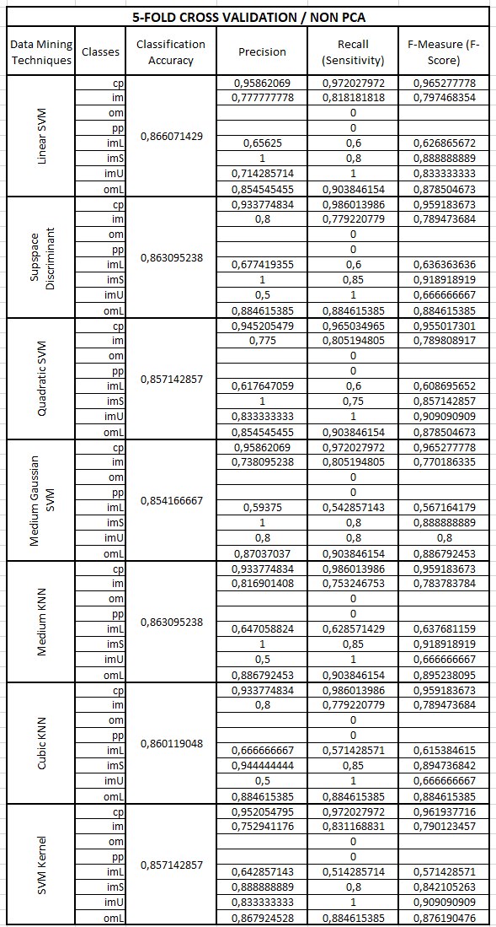
Table 1. 10-FOLD CROSS VALIDATION / NON PCA
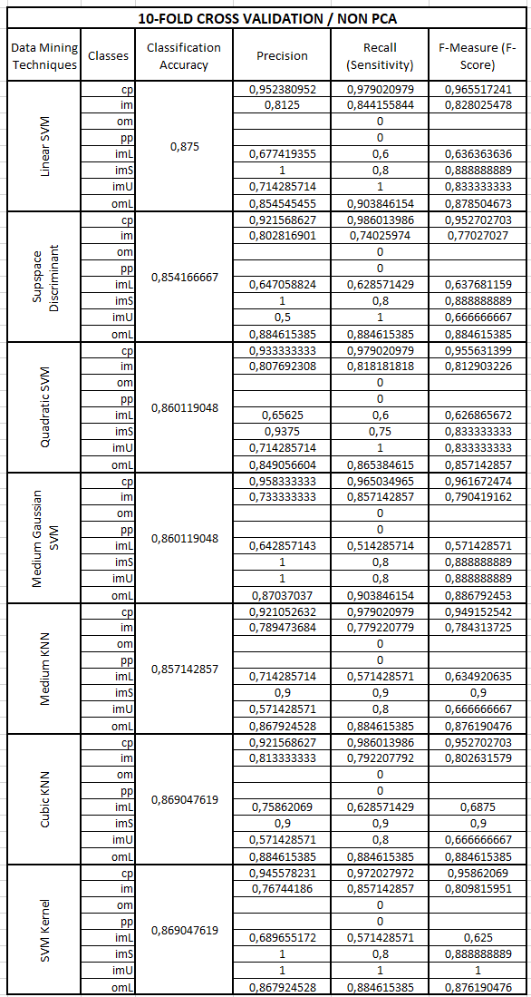
Table 2. 15-FOLD CROSS VALIDATION / NON PCA
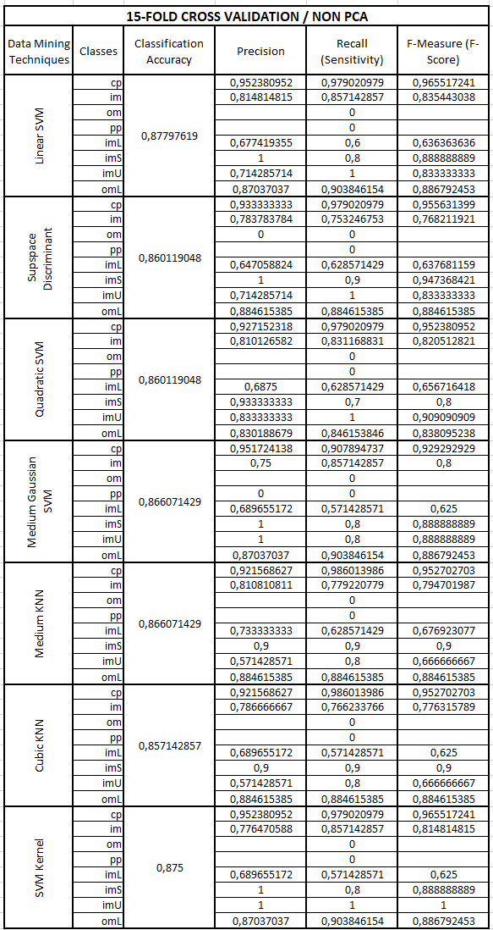
Table 3. 5-FOLD CROSS VALIDATION / USING PCA
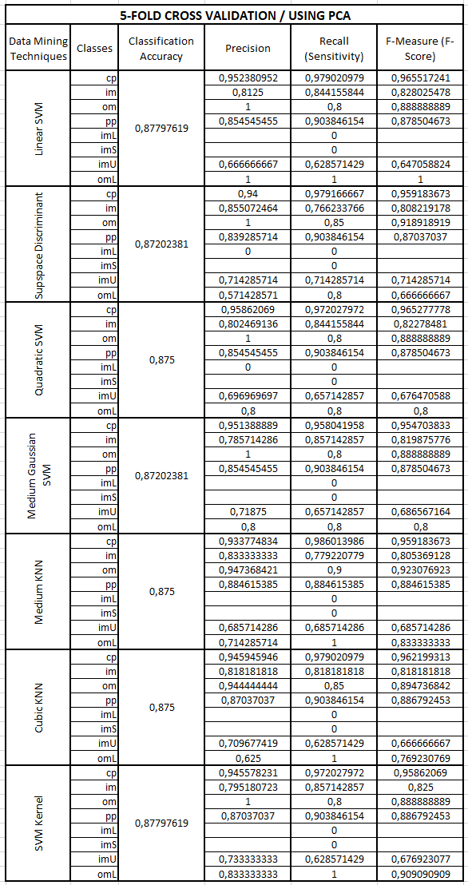
Table 4. 10-FOLD CROSS VALIDATION / USING PCA
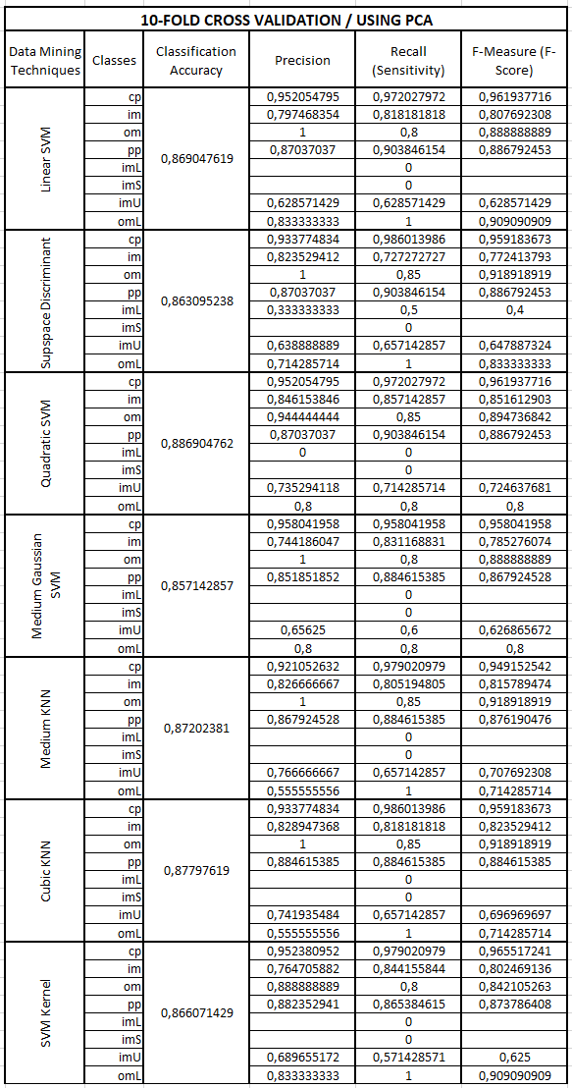
Table 5. 15-FOLD CROSS VALIDATION / USING PCA
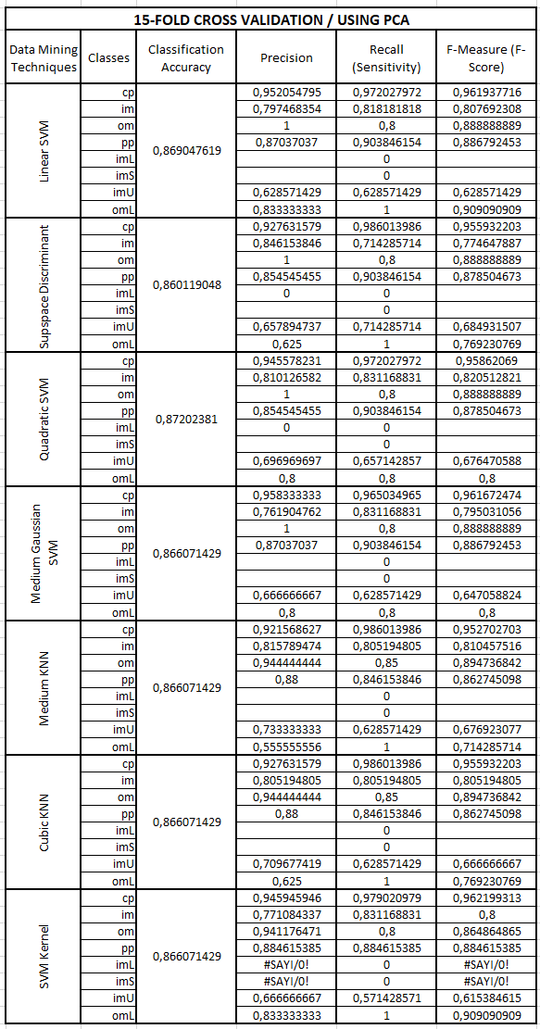
- Table Styles
Table Head | Table Column Head
Table Head | Table column subhead | Subhead | Subhead
copy | More table copyª
- Sample of a Table footnote. (Table footnote)

- Example of a figure caption. (figure caption)
Figure Labels: Use 8 point Times New Roman for Figure labels. Use words rather than symbols or abbreviations when writing Figure axis labels to avoid confusing the reader. As an example, write the quantity “Magnetization,” or “Magnetization, M,” not just “M.” If including units in the label, present them within parentheses. Do not label axes only with units. In the example, write “Magnetization (A/m)” or “Magnetization (A ( m(1),” not just “A/m.” Do not label axes with a ratio of quantities and units. For example, write “Temperature (K),” not “Temperature/K.”

CONCLUSIONS AND FUTURE WORK
Xxxxxxx xxxxxx

References
The template will number citations consecutively within brackets [1]. The sentence punctuation follows the bracket [2]. Refer simply to the reference number, as in [3]—do not use “Ref. [3]” or “reference [3]” except at the beginning of a sentence: “Reference [3] was the first ...”
Number footnotes separately in superscripts. Place the actual footnote at the bottom of the column in which it was cited. Do not put footnotes in the reference list. Use letters for table footnotes.
Unless there are six authors or more give all authors’ names; do not use “et al.”. Papers that have not been published, even if they have been submitted for publication, should be cited as “unpublished” [4]. Papers that have been accepted for publication should be cited as “in press” [5]. Capitalize only the first word in a paper title, except for proper nouns and element symbols.
For papers published in translation journals, please give the English citation first, followed by the original foreign-language citation [6].

- G. Eason, B. Noble, and I.N. Sneddon, “On certain integrals of Lipschitz-Hankel type involving products of Bessel functions,” Phil. Trans. Roy. Soc. London, vol. A247, pp. 529-551, April 1955. (references)
We suggest that you use a text box to insert a graphic (which is ideally a 300 dpi resolution TIFF or EPS file with all fonts embedded) because this method is somewhat more stable than directly inserting a picture.
To have non-visible rules on your frame, use the MSWord “Format” pull-down menu, select Text Box > Colors and Lines to choose No Fill and No Line.
- J. Clerk Maxwell, A Treatise on Electricity and Magnetism, 3rd ed., vol. 2. Oxford: Clarendon, 1892, pp.68-73.
- I.S. Jacobs and C.P. Bean, “Fine particles, thin films and exchange anisotropy,” in Magnetism, vol. III, G.T. Rado and H. Suhl, Eds. New York: Academic, 1963, pp. 271-350.
- K. Elissa, “Title of paper if known,” unpublished.
- R. Nicole, “Title of paper with only first word capitalized,” J. Name Stand. Abbrev., in press.
- Y. Yorozu, M. Hirano, K. Oka, and Y. Tagawa, “Electron spectroscopy studies on magneto-optical media and plastic substrate interface,” IEEE Transl. J. Magn. Japan, vol. 2, pp. 740-741, August 1987 [Digests 9th Annual Conf. Magnetics Japan, p. 301, 1982].
- M. Young, The Technical Writer’s Handbook. Mill Valley, CA: University Science, 1989.

