Factors Influencing Career Choices Among METU Students



FINAL PROJECT REPORT

STAT 365

DEPARTMENT OF STATISTICS

MIDDLE EAST TECHNICAL UNIVERSITY

BY

Başak Uğurlu 2561546
Berfin Akdemir 2614410
Damla Başarmış 2510048
Zeynep Fenercioğlu 2561264

January 2025

Table of Contents
- Introduction
  - Data Description
- Aims and Objectives
  - Research Questions
- Methodology
  - Research Design and Sampling
  - Measurement
  - Data Analysis Technique
- Analysis
  - Exploratory Data Analysis
  - Confirmatory Data Analysis
    - Faculty Differences in Career Influencing Factors
    - Gender Differences in Career Influencing Factors
    - Correlation Between External Pressure, Personal Fulfillment, Confidence, and Career Change Likelihood
- Results and Discussion
- Conclusion
- References
- Appendices

- Introduction

A career plays a significant and influential role in an individual’s life, not only by determining their income level but also by shaping their personality and worldview. Career choices impact a person’s life, work, and achievements throughout their lifetime (Napompech, 2011). Decision-making is an unavoidable process and a fundamental aspect of real life. Among the most critical decisions that everyone must make is the selection of a career (DeSimone et al., 2002).
Although career choice holds both individual and societal significance, it is a well-known fact that in Turkey, career decisions are often influenced by chance (Yılmaz et al., 1996). Many young people experience indecision upon completing their primary or secondary education and face challenges in choosing a field of work that could define their entire lives (Kuzgun, 1988).
Ginzberg refers to the career decision-making period between the ages of 20-25 as the "realistic period," while Super identifies the ages of 18-21 as a time for exploring and testing the validity of choices and the ages of 22-24 as a phase where decisions are made with a stronger focus on reality (Kıyak, 2006). Considering this, it becomes clear that the perspectives and thoughts of individuals in this age group are highly significant when evaluating the factors influencing career choices.
Considering the target audience, this report explores the factors influencing career choices among students at Middle East Technical University (METU). The primary focus of the study was to investigate which factors influence METU students’ career choices, the role of different faculties, gender differences, students’ success definition, and the relationship between external pressures, personal fulfillment, confidence, and the likelihood of career changes. By examining these elements, the report aims to provide insights into the key drivers of career decisions among METU students and identify significant trends and patterns that may inform educational strategies and career counseling services.

  - Data Description
The survey involved 295 participants from various faculties at METU, exploring key factors influencing students’ career choices. The data collected included demographic variables such as faculty and gender, along with responses related to career confidence, external pressures, personal fulfillment, and openness to career changes. Each response was measured on a 1 to 5 scale, allowing for quantitative analysis of these factors. The use of convenience sampling facilitated efficient data collection despite logistical challenges, though it may affect the generalizability of the findings. The dataset provides a diverse and informative foundation for investigating trends and patterns in career decision-making across different student groups. Further explanation of the 13 variables given below:

- Birth Year: The year of birth of the participant, providing demographic context for age analysis.
- Gender: The self-identified gender of the participant, categorized as Female, Male, or Prefer not to say/Other.
- Faculty: The academic faculty in which the participant is enrolled (e.g., Engineering, Arts & Sciences).
- Grade: The participant’s current academic year (e.g., freshman, sophomore).
- Enrollment History: A record indicating any breaks or interruptions in the participant's academic enrollment.
- Personal Fulfillment: A measure on a 1 to 5 scale assessing the importance of personal satisfaction in the participant's career decisions.
- Career Fields: The industries or professional areas the participant is considering or pursuing for a future career.
- Career Influences: Factors that participants consider important when making career choices, such as family, financial stability, or passion for the field.
- External Pressure: A measure on a 1 to 5 scale evaluating the influence of societal, family, or peer expectations on career decisions.
- Career Decision Influences: The specific motivators or considerations affecting participants' career choices (e.g., job market trends, skill fit).
- Career Success Meaning: The participant's personal definition of career success, such as financial security, job satisfaction, or work-life balance.
- Career Confidence: A measure on a 1 to 5 scale indicating how confident the participant feels about their career decisions.
- Career Change Likelihood: A measure on a 1 to 5 scale assessing the participant's likelihood of changing their career path in the future.

- Aims and Objectives
The primary aim of this project is to explore and analyze key trends and factors influencing the data set provided, leveraging statistical methods and data science techniques. Objectives include performing comprehensive data cleaning and preprocessing, identifying patterns and correlations within the data, and employing visualization tools to present findings effectively. Through statistical modeling and hypothesis testing, the project seeks to draw meaningful insights that inform decision-making and highlight potential areas for further investigation. Ultimately, the objective is to deliver an accurate, insightful, and actionable analysis aligned with the project's goals.

Research questions :
Q.1.Which faculties have significant differences in their choices of career-influencing factors?
Q.2.Which factors influencing career decisions have significant differences between female and male students?
Q.3.Is there a correlation between external pressure, personal fulfillment, confidence, and career change likelihood?

- Methodology

  - Research Design and Sampling
In this study, a quantitative research approach was used to measure the relationship between family influence, financial stability, flexible working hours, job market demand, online research, opportunities abroad, personal interest, promotion opportunities, remote opportunities, social media, social recognition, university prestige, work-life balance, workplace environment, gender, faculties, and career choice. This study focused on Middle East Technical University’s undergraduate students' career choices as they were a group of people who would make their own career choices based on the factors chosen for this study Convenience sampling was employed due to its practical efficiency given the logistical constraints of reaching diverse groups across campus. Conducting the survey posed several challenges that impacted data collection and overall participant engagement. The sprawling METU campus and its geographically dispersed faculties made it physically demanding to reach a diverse group of students. Navigating between various parts of the campus required significant time and effort, which limited the number of students we could approach each day. Many students exhibited reluctance to engage with the survey until reassurances were given regarding the minimal time commitment and the anonymity of their responses. Emphasizing these factors proved instrumental in gaining their cooperation and ensuring a sufficient sample size for meaningful analysis.
  - Measurement
In this study, questionnaires were utilized for data collection and analysis in two sections. In the first section, separate questions were directed regarding the respondents' demographic profiles; birth year, faculty, grade, and gender. The second part consists of 9 questions regarding the factors that are influencing students’ career choices. 5 of them are multiple choice questions while other questions are scaled from 1 to 5.

  - Data Analysis Technique
Python was used for data analysis. We also conducted non-parametric tests to analyze demographic factors and factors that are influencing career choices. The chi-square test and Kruskal-Wallis Test are conducted.

- Analysis
4.1. Exploratory Data Analysis
Frequency tables of each variable are conducted by Google Forms, therefore we did not need to plot additional graphs. You can find these along with the survey questions in the appendix.

Statistic | Birth Year | External Pressure | Personal Fulfillment | Career Confidence | Career Change Likelihood
Count | 295 | 295 | 295 | 295 | 295
Mean | 2002.88 | 2.49 | 4.31 | 3.51 | 3.48
Std | 1.83 | 1.26 | 0.85 | 1.00 | 1.10
Min | 1997 | 1.00 | 1.00 | 1.00 | 1.00
25% | 2002 | 1.00 | 4.00 | 3.00 | 3.00
50% (Median) | 2003 | 2.00 | 5.00 | 4.00 | 4.00
75% | 2004 | 3.00 | 5.00 | 4.00 | 4.00
Max | 2007 | 5.00 | 5.00 | 5.00 | 5.00
Table 1: Descriptive Statistics for Quantitative Variables (Likert Data and Birth Year)

4.2. Confirmatory Data Analysis (statistical test like t-test, ANOVA)

Q.1.Which faculties have significant differences in their choices of career-influencing factors?

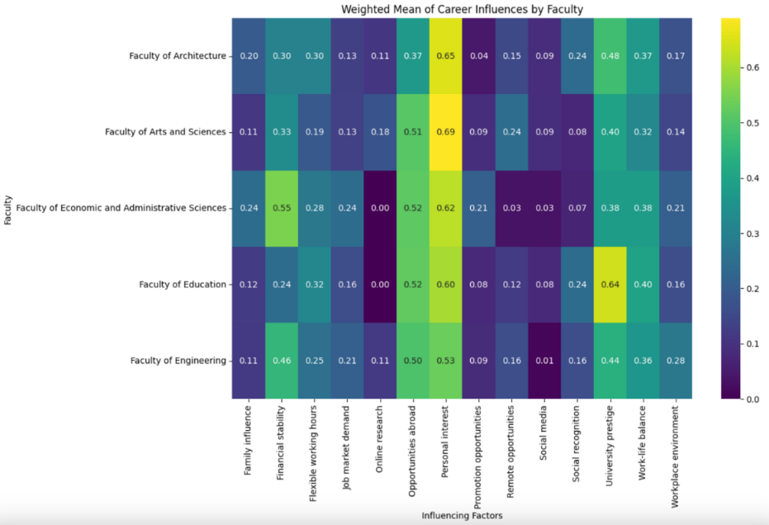
Figure 1: Weighted Means Of Faculties by Their Choices of Influencing Factors
We see that there are some differences visible so we conduct pairwise chi-square tests for faculties to see which pairs have significant differences. We see that the Faculty of Economic and Administrative Sciences and the Faculty of Education have the highest difference of weighted means with 0.55 and 0.24 respectively for Financial Stability so we checked the significance for each pair for Financial Stability.
Faculty Pair | Chi-Square Statistic | P-Value | Significant
(Faculty of Arts and Sciences, Faculty of Engineering) | 2.6009 | 0.1068 | False
(Faculty of Arts and Sciences, Faculty of Education) | 0.4180 | 0.5180 | False
(Faculty of Arts and Sciences, Faculty of Architecture) | 0.0219 | 0.8822 | False
(Faculty of Arts and Sciences, Faculty of Economics) | 3.5385 | 0.0600 | Weak, <0.1
(Faculty of Engineering, Faculty of Education) | 3.0774 | 0.0794 | Weak, <0.1
(Faculty of Engineering, Faculty of Architecture) | 2.4867 | 0.1148 | False
(Faculty of Engineering, Faculty of Economics) | 0.4798 | 0.4885 | False
(Faculty of Education, Faculty of Architecture) | 0.0897 | 0.7645 | False
(Faculty of Education, Faculty of Economics) | 4.1898 | 0.0407 | True,<0.05
(Faculty of Architecture, Faculty of Economics) | 3.5631 | 0.0591 | Weak, <0.1
Table 2: Chi-Square Test Results for Faculty Pairs for Financial Stability
Significant Result:
Faculty of Education vs. Faculty of Economics:
The Chi-Square Statistic is 4.1898. The P-value is 0.0407. There is a significance if p<0.05. There is a statistically considerable difference in the proportion of students from the Faculty of Economics who consider financial stability important compared to those from the Faculty of Education. Specifically, students from the Faculty of Economics are more likely to prioritize financial stability when determining their career choices.
Faculty of Architecture vs. Faculty of Economics:
The Chi-Square Statistic is 3.5631. The P-value is 0.0591. The significance is weak because of p<0.1. There is weak evidence suggesting a difference between the Faculty of Architecture and the Faculty of Economics regarding the importance of financial stability. Students from the Faculty of Economics are slightly more inclined to value financial stability as a career factor compared to those from the Faculty of Architecture.
Faculty of Arts and Sciences vs. Faculty of Economics:
The Chi-Square Statistic is 3.5385. The P-value is 0.0600. The significance is weak because of p<0.1. There is weak evidence indicating a potential difference in how students from the Faculty of Economics and the Faculty of Arts and Sciences perceive financial stability. Faculty of Economics students show a higher tendency to consider financial stability important.
Faculty of Engineering vs. Faculty of Education:
The Chi-Square Statistic is 3.0774. The P-value is 0.0794. There is a weak significance because of p<0.1. There is weak evidence to suggest that students from the Faculty of Engineering are more likely to emphasize financial stability compared to students from the Faculty of Education.
Non-Significant Results
Faculty of Arts and Sciences vs. Faculty of Engineering, Faculty of Arts and Sciences vs. Faculty of Education, Faculty of Arts and Sciences vs. Faculty of Architecture, Faculty of Engineering vs. Faculty of Architecture, Faculty of Engineering vs. Faculty of Economics, Faculty of Education vs. Faculty of Architecture. In these faculty pairs, the P-value>1, indicates no differences in the importance placed on financial stability between these groups.
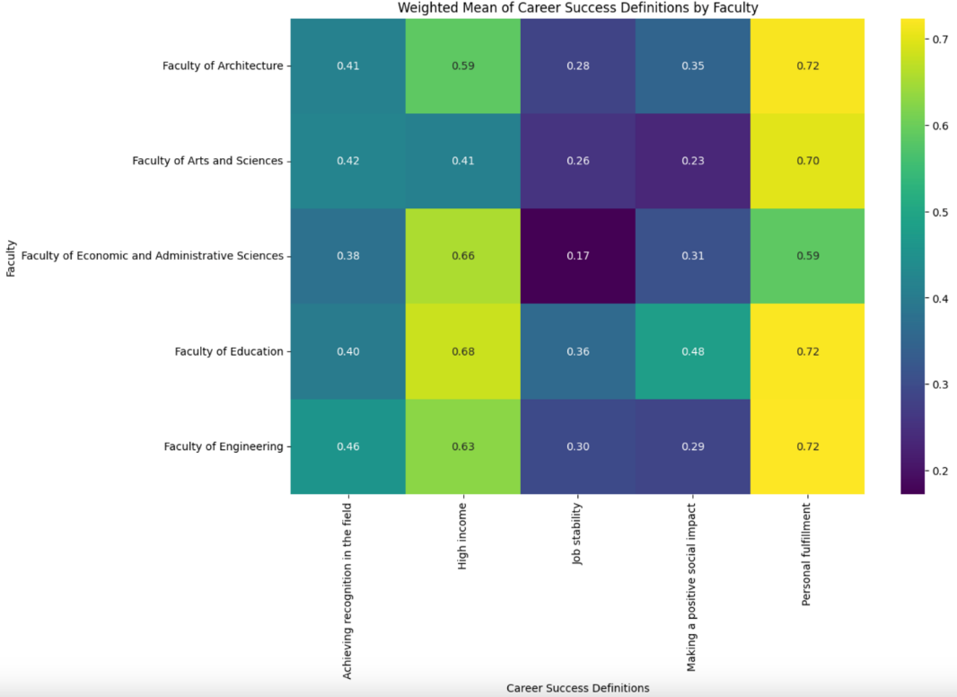
Figure 2: Weighted Means Of Career Success Definitions by Faculty

Test | Statistic | P-Value | Conclusion
ANOVA | F = 0.3526 | 0.8392 | No statistically significant difference in career success definitions.
Chi-Square Test | χ² = 0.1757 | ~1.0000 | No statistically significant difference in career success definitions.
Kruskal-Wallis Test | H = 1.9422 | 0.7464 | No statistically significant difference in career success definitions.
Table 3: Statistical Test Results for Career Success Definitions Across Faculties
We conducted ANOVA, chi-square, and Kruskal-Wallis tests to see if there is a statistically significant difference but there is no significant difference between faculties and career success definitions.

Q.2.Which factors influencing career decisions have significant differences between female and male students?
Variable | F-Statistic | p-Value
Personal Fulfillment by Faculty | 0.7246 | 0.5757
External Pressure by Faculty | 1.3161 | 0.2640
Career Confidence by Faculty | 1.5144 | 0.1980
Career Change Likelihood by Faculty | 0.3314 | 0.8567
Personal Fulfillment by Gender | 0.0610 | 0.9409
External Pressure by Gender | 5.8745 | 0.0032
Career Confidence by Gender | 10.0838 | 0.00005825
Career Change Likelihood by Gender | 0.1255 | 0.8821
Table 4: ANOVA Test Results for Factors Influencing Career Decisions
We conducted an ANOVA test to test the significance of quantitative factors. We found that Career Confidence and External Pressure had significant differences by Gender. We analyzed the relationship further.
Gender | Count | Mean | Std Dev | Min | 25% | 50% (Median) | 75% | Max
Female | 172.0 | 3.4128 | 0.9103 | 1.0 | 3.0 | 3.0 | 4.00 | 5.0
Male | 110.0 | 3.7636 | 1.0220 | 1.0 | 3.0 | 4.0 | 4.75 | 5.0
Prefer not to say / Other | 13.0 | 2.6154 | 1.3253 | 1.0 | 1.0 | 3.0 | 4.00 | 4.0
Table 5: Descriptive Statistics for Career Confidence by Gender
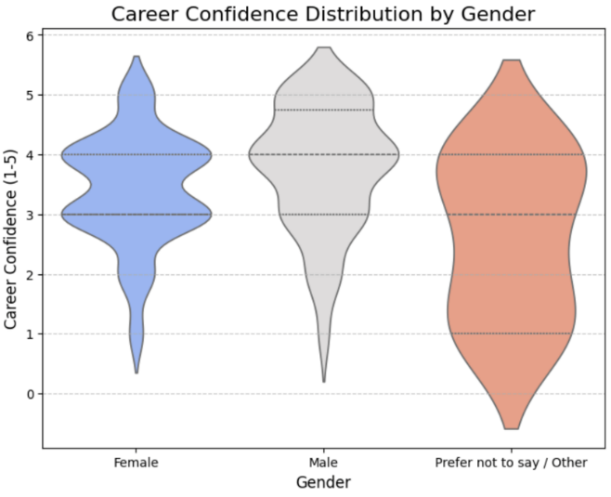
Figure 3: Career Confidence Distributions by Gender
We see that females have significantly lower Career Confidence than males with a mean of 3.41 whereas males have 3.76.
Gender | Count | Mean | Std Dev | Min | 25% | 50% (Median) | 75% | Max
Female | 172.0 | 2.6919 | 1.2299 | 1.0 | 2.0 | 3.0 | 3.25 | 5.0
Male | 110.0 | 2.1727 | 1.2478 | 1.0 | 1.0 | 2.0 | 3.00 | 5.0
Prefer not to say / Other | 13.0 | 2.4615 | 1.3301 | 1.0 | 1.0 | 3.0 | 3.00 | 5.0
Table 6 : Descriptive Statistics For External Pressure by Gender

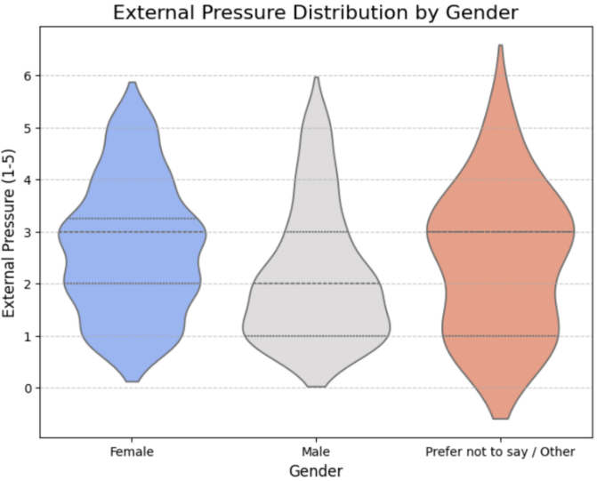
Figure 4: External Pressure Distributions by Gender

We see that females have significantly higher External Pressure than males with a mean of 2.70 whereas males have 2.17.
The analysis revealed significant gender differences in career confidence and perceived external pressure among METU students. ANOVA results showed that male students reported higher career confidence (mean = 3.76) compared to female students (mean = 3.41), with a statistically significant difference (F = 10.0838, p < 0.001). Conversely, female students reported greater external pressure (mean = 2.70) than males (mean = 2.17), also yielding a significant difference (F = 5.8745, p = 0.0032). These findings suggest that while male students exhibit greater self-assurance in their career decisions, female students experience heightened societal or familial pressures during their decision-making process. Although there were variations between faculties regarding factors like personal fulfillment and career change likelihood, none were statistically significant, indicating that faculty membership does not strongly differentiate career-influencing factors. Moderate correlations (~0.22) between personal fulfillment and both career confidence and openness to career changes suggest that intrinsic motivations play a more critical role than external pressures in shaping students' career trajectories.

Q.3.Is there a correlation between external pressure, personal fulfillment, confidence, and career change likelihood?
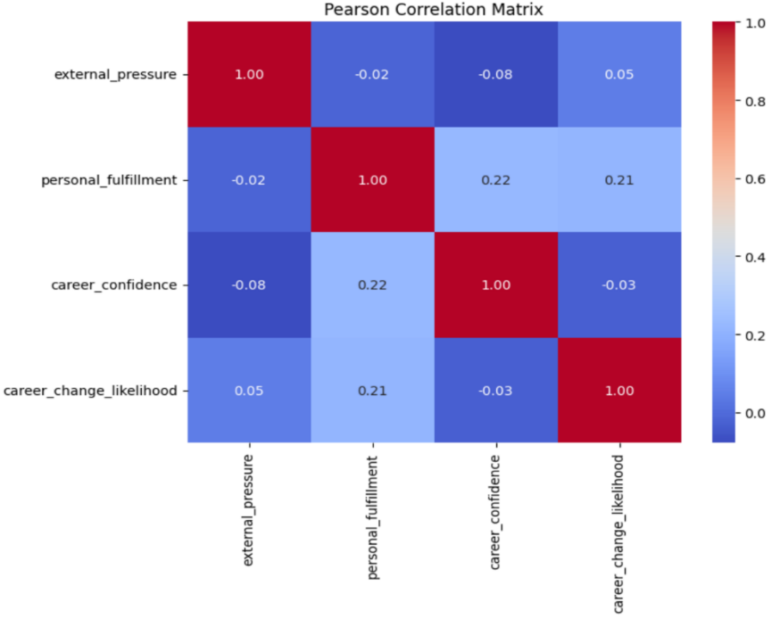
Figure 5: Pearson Correlation Matrix

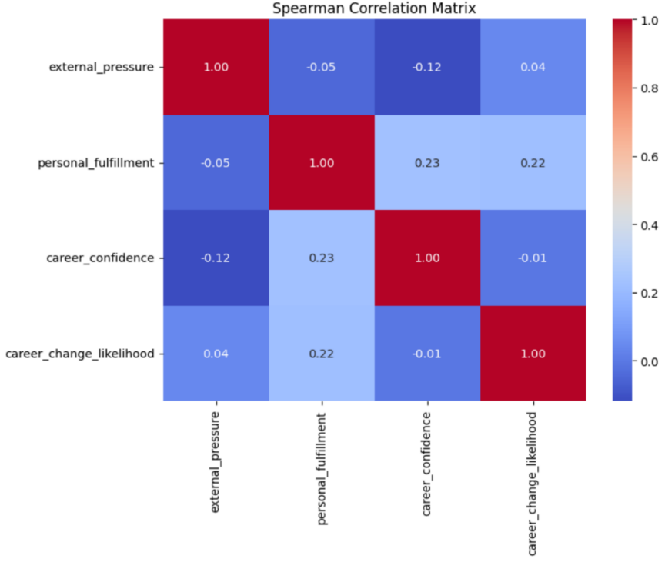
Figure 6: Spearman Correlation Matrix
A moderate positive correlation (~0.22 for both Pearson and Spearman) suggests that individuals valuing personal fulfillment are more confident about their career alignment. A positive correlation (~0.21 for Pearson, ~0.22 for Spearman) indicates that individuals prioritizing personal fulfillment are more likely to change their careers if misaligned. Weak correlations with other variables suggest external pressure has minimal influence on personal fulfillment, confidence, or likelihood of career change. Almost no correlation suggests confidence in career alignment doesn't predict the likelihood of a career change.

- Results and Discussion
The analysis revealed noteworthy distinctions between faculties regarding the factors influencing career choices. A chi-square test demonstrated significant differences between the Faculty of Economics and Administrative Sciences and the Faculty of Education concerning the prioritization of financial stability (p < 0.05). Students in the Faculty of Economics exhibited a higher tendency to value financial stability as a critical factor, suggesting a more pragmatic approach to career decision-making compared to their peers in education-related fields. Although weak differences were observed between some other faculty pairs, no statistically significant variations were found concerning other factors like career success definitions. This indicates that beyond financial stability, faculties may exhibit relatively homogeneous preferences for career-influencing factors. Gender analysis through ANOVA highlighted significant disparities in external pressure and career confidence. Male students demonstrated significantly higher career confidence (mean = 3.76) compared to female students (mean = 3.41), with a p-value < 0.001. Conversely, female students reported experiencing greater external pressure (mean = 2.70) than male students (mean = 2.17), with a p-value < 0.01. These findings suggest that gender influences both self-assurance in career decisions and perceived external expectations. The contrast underscores the need for gender-sensitive interventions that bolster career confidence among female students while mitigating societal or familial pressures. Moderate positive correlations were identified between personal fulfillment and both confidence in career alignment and the likelihood of career changes (~0.22 for both Pearson and Spearman correlations). These results indicate that students who prioritize personal fulfillment are more inclined to have confidence in their career decisions and are open to change if their careers no longer align with their values. In contrast, external pressure exhibited weak or negligible correlations with other variables, suggesting that while societal or familial expectations may be present, they do not significantly determine students' career confidence or their likelihood to change careers. This finding reinforces the prominence of intrinsic motivations over external pressures in shaping career trajectories for METU students.
- Conclusion
This study underscores the diverse factors influencing METU students' career choices, highlighting significant differences between faculties and gender groups. Financial stability emerges as a more prominent concern for students in economics-related faculties, while gender disparities point to differing experiences of career confidence and external pressure. The challenges encountered during the survey process reflect broader obstacles in understanding student perspectives comprehensively. Despite these difficulties, the data gathered provides valuable insights into student motivations and barriers in career decision-making. Key recommendations include tailoring faculty-specific career guidance programs to address students' unique priorities, implementing initiatives to enhance female students' career confidence, and fostering environments that encourage students to pursue careers aligned with their values. These efforts aim to foster informed and confident career decision-making among METU students, contributing to their long-term professional satisfaction and success.

- References
ABDO, A.A.M. & MAJID, A. & AUF, M.A.A. & AMAN, ABDULRAZAK. (2016). Factors affecting career choice among undergraduate students in Universitas Indonesia. International Journal of Economic Perspectives. 10. 630-644.
DESIMONE, R. L., WERNER, J. M., & HARRIS, D. M. (2002). Human resource development. Thomson Learning. Inc., USA.
KUZGUN, Y. (1988). Kendini Değerlendirme Envanterinin Geçerlik ve Güvenirliğine İlişkin Çalışmalar. V. Ulusal Psikoloji Kongresi, İzmir.
KIYAK, S. (2006). Genel Lise Öğrencilerinin Meslek Seçimi Yaparken Temel Aldığı Kriterler. (Yayınlanmamış Yüksek Lisans Tezi), Yeditepe Üniversitesi Sosyal Bilimler Enstitüsü, İstanbul.
PEKKAYA, M. ÇOLAK, N. (2013). Üniversite Öğrencilerinin Meslek Seçimini Etkileyen Faktörlerin Önem Derecelerinin Ahp İle Belirlenmesi.The Journal of Academic Social Science Studies, İstanbul
NAPOMPECH, K. (2011). What Factors Influence High School Students in Choosing Cram School in Thailand? Paper presented at the International Conference on Business and Economics Research, Singapore.
YILMAZ, H., Ö. ÜRE ve A. SÜRÜCÜ (1996); Rehberlik Ders Notları, Konya.

- Appendices
