Airline Customer Satisfaction

Berfin Akdemir
Middle East Technical University
Ankara, Turkey
e261441@metu.edu.tr
Damla Başarmış
Middle East Technical University
Ankara, Turkey
e251004@metu.edu.tr
Zeynep Fenercioğlu
Middle East Technical University
Ankara, Turkey
e256126@metu.edu.tr

Abstract: In the aviation sector, passenger satisfaction is how passengers rate the quality of service and performance. Our project, "Airline Customer Satisfaction," investigates airline customer satisfaction and employs statistical analyses for this purpose. These analyses utilize data cleaning, missing value assignment, confirmatory statistical analysis, feature engineering, and dimensionality reduction methods. The data consists of a total of 129,880 rows and 24 columns. 19 of the columns are numerical values. The dataset contains 6.89% missing values. To address significant class imbalance, SMOTE (Synthetic Minority Oversampling Technique) was used in conjunction with various Logistic Regression models employing L1 (Lasso) and L2 (Ridge) methods. The Elastic Net + SMOTE model showed the best performance with an F1 macro score of 0.5564. However, the Lasso Logistics model offered superior interpretability, revealing that Personal Travel Intention (OR = 2.62), Online Boarding efficiency, and In-Flight WiFi quality positively influenced passenger feelings and were the most critical determinants. Furthermore, applied statistical tests confirmed significant relationships between satisfaction and key variables, including travel class, service ratings, and demographic factors.
Keywords—Airline Satisfaction, Logistic Regression, Elastic Net, SMOTE, Imbalanced Classification, Statistical Data Mining, Regularization, Feature Importance.

Introduction
In this project, passenger satisfaction with airline flights is studied. Since every passenger has a different experience, they all end their journey with a certain level of satisfaction. The dataset includes several variables such as the passenger’s age, travel class, and the quality of the Wi-Fi service on the plane. It also considers factors like seat comfort and whether the check-in and boarding processes were fast or slow.
The survey participants were grouped into two categories: Satisfied and Neutral/Dissatisfied. Firstly, an exploratory data analysis was conducted to understand the dataset. Before conducting analyses, missing values and incomplete information were detected and handled accordingly.
After the cleaning, different statistical models were created to predict passenger satisfaction. To evaluate the models' performance, measures such as sensitivity, F1 score, and accuracy were used. The main purpose of this project is not only to predict satisfaction, but also to see which factors affect passenger satisfaction the most. This can help airlines understand which parts of their service need more attention in order to improve overall customer satisfaction.

lıterature review
There are many studies about customer satisfaction in service-related businesses.
Among machine learning methods used for such cases, logistic regression appears to be the most suitable approach. The reason behind this is that this model is easier to understand while achieving meaningful results. Logistic regression works well even when the data set is messy. In addition, some studies focus specifically on airline passengers. These studies show that factors such as service quality, reliability, and having good digital services play an important role in passenger satisfaction since they attribute the most to the passenger satisfaction.

methodology

A) Dataset
The dataset contains airline passenger satisfaction survey responses. The original data includes 129,880 observations and 24 variables. The variables are as follows:
- ID: Passenger identifier - Continuous variable
- Gender: Gender of passenger - Categoric Variable
- Age: Age of passenger - Continuous Variable
- Customer Type: First-time or returning customer - Categoric Variable
- Type of Travel: Purpose of travel (Business/Personal) - Categoric Variable
- Class: Travel class - Categoric Variable
- Flight Distance: Distance traveled in miles - Continuous Variable
- Departure Delay: Delay at departure in minutes - Continuous Variable
- Arrival Delay: Delay at arrival in minutes - Continuous Variable
- Departure and Arrival Time Convenience: Rating 0-5 - Continuous Variable
- Ease of Online Booking: Rating 0-5 - Continuous Variable
- Check-in Service: Rating 0-5 - Continuous Variable
- Online Boarding: Rating 0-5 - Continuous Variable
- Gate Location: Rating 0-5 - Continuous Variable
- On-board Service: Rating 0-5 - Continuous Variable
- Seat Comfort: Rating 0-5 - Continuous Variable
- Leg Room Service: Rating 0-5 - Continuous Variable
- Cleanliness: Rating 0-5 - Continuous Variable
- Food and Drink: Rating 0-5 - Continuous Variable
- In-flight Service: Rating 0-5 - Continuous Variable
- In-flight Wifi Service: Rating 0-5 - Continuous Variable
- In-flight Entertainment: Rating 0-5 - Continuous Variable
- Baggage Handling: Rating 0-5 - Continuous Variable
- Satisfaction: Satisfaction level - Categoric Variable (Dependent Variable)

Satisfaction is defined as the dependent variable, representing the overall level of passenger satisfaction.

B) Data Cleaning & Preprocessing

B1. Descriptive statistics

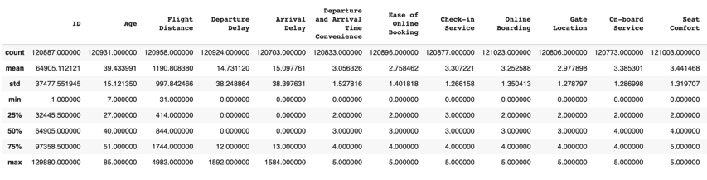
Table 1 Descriptive Summary of Variables

As shown in Table 1, the mean age of the passengers is around 39 years. The lowest age is 7 and the highest age is 85 years. Fifty percent of the passengers are aged above or below 40 years. Conversely, the mean range is 1191 miles. Minimum distance of flight is 31 miles and maximum flight distance is 4983 miles. The difference between the maximum values and 3 rd quartile of delays is quite high, which implies that there are some outliers. The response variable includes 68,464 passengers that are neutral or dissatisfied and 52,642 satisfied passengers. This indicates disparity in information.

B2. Missingness

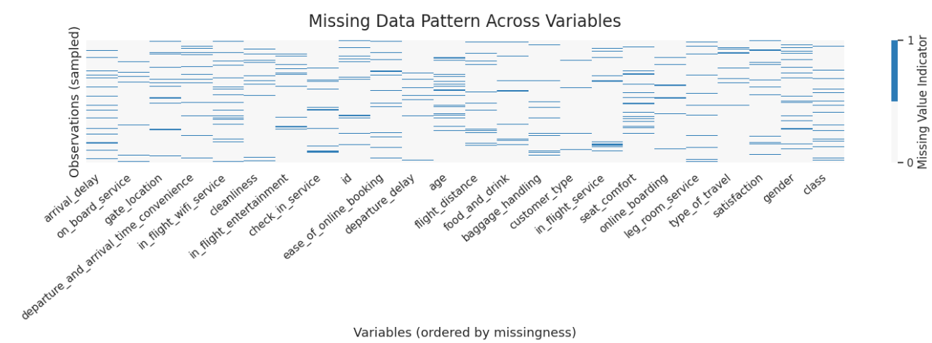

There is an intermediate amount of missing data in the dataset with a general rate of around 5.25 percent missing data over 129880 observations after cleaning of the data and no duplicates were detected. The missing values are predominantly focussed on service-related and delay variables (approximately 67 per cent), but the target variable (Satisfaction) and major categorical variables do not have any missing values. missingness The data set has a considerable number of missing data. The rate of missingness was identified to be 5.25% following data cleaning and none of the records were duplicated. The service related and delay variables of the data contain most of the missing values with a rate of missing ranging at 6-7 percent. There are no missing values in the target variable and the key categorical variables.
The missingness heatmap indicates that the missing data does not take any recognizable pattern. Besides, statistical tests also indicate that missingness does not have any significant relationship with variables. According to the outcome of these tests, the mechanism of missing is assumed to be either Missing Completely at Random (MCAR) or Missing at Random (MAR).
Based on the mechanism of missingness identified, iterative imputation was used. This method was employed because it does not interfere with the relationships of variables and does not lose any information as would happen when list-wise deletion was employed.

C) Exploratory Data Analysis
This part of the data analysis defined four research questions which were answered. These research questions made the data easier to comprehend.
What is the relationship between age and satisfaction?
An independent t-test was done to determine whether the mean age and levels of satisfaction were statistically different. The findings here are that, the older passengers are likely to have varying profiles of satisfaction than the younger passengers.

Figure 1 Box-plot Age vs Satisfaction 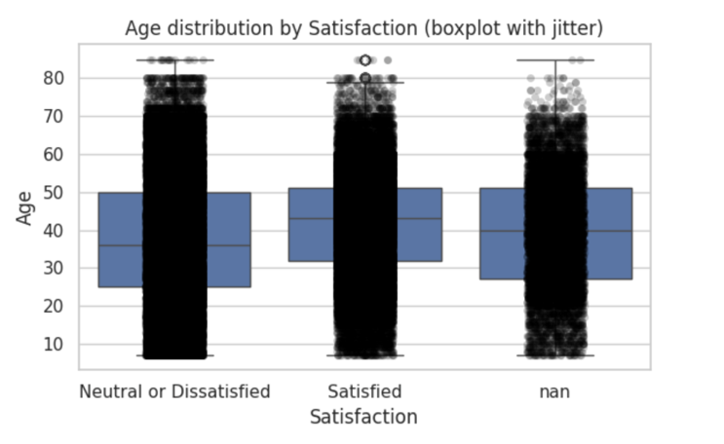
Does Type of Travel have a relationship with Satisfaction?
To test the relationship between type of travel and satisfaction, a Chi- Square test of independence was utilized to check the relationship. The results of the test revealed that the p-value was lower than 0.001, which shows that there is a statistically significant difference. Business travelers had significantly different levels of satisfaction than the personal travelers.
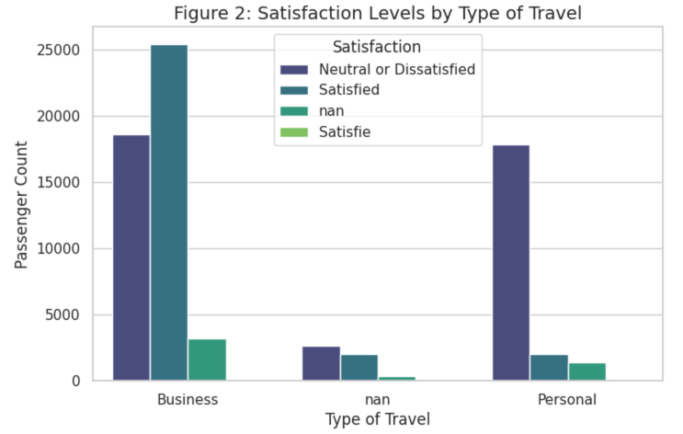Figure 2 Satisfaction Levels by Type
Figure 2 demonstrates that the level of satisfaction with Business travelers is different significantly as compared to that of Personal travelers. The chart suggests that most Personal travelers are either "Neutral or Dissatisfied" indicating that leisure travelers might be experiencing different services or have different expectations as compared to business passengers.
Does Travel Class correlate with Satisfaction?
A Chi-Square test indicated strong relationship between Class (Business, Eco, Eco Plus) and level of satisfaction and the resultant p-value is below 0.001.
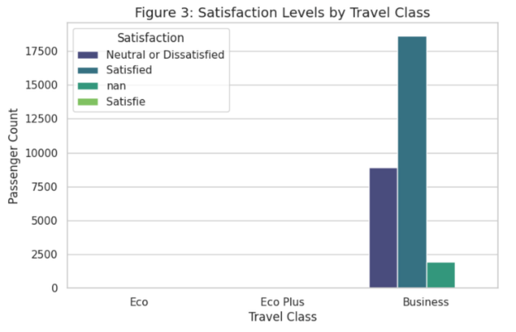
Figure 3 Satisfaction Levels by Travel Class
As seen in figure 3, the difference in the level of satisfaction between the different cabin classes. Business class mainly satisfies the passengers, whereas passengers in the Eco and Eco Plus classes are far more neutral or unhappy. This implies that the high-end service aspects that are attached to Business class are the key factors influencing the positive passenger sentiment.
What is the dependence of departure and arrival delay?
Correlation analysis was done to ensure the absence of multicollinearity. The findings indicated a positive relationship between Departure Delay and Arrival Delay, which is strong thus indicating that the two redundant information are captured by these two delays.

Figure 4 Heatmap of Numeric Variables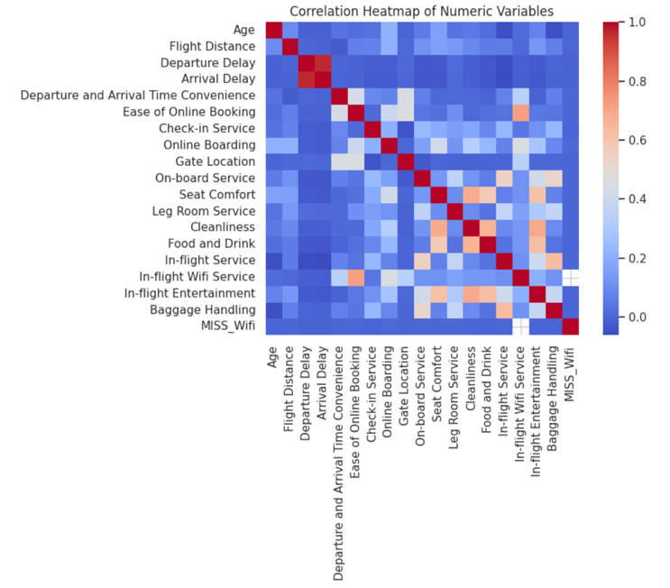
As it can be seen in the heatmap in Figure 4, Departure Delay and Arrival Delay have a strong positive correlation (r > 0.7). The dark colouring of the respective cell proves that these variables represent redundant data; a late flight is almost guaranteed to be late. Therefore, there can be only a single delay variable to be used in modeling in order to prevent multicollinearity.
D) Confirmatory Data Analysis
The confirmatory data analysis is parallel to the exploratory data analysis. Normality tests showed that age is not normally distributed across the satisfaction groups, so non-parametric methods were preferred. The results from the Mann-Whitney U test suggest that there is a statistically significant difference in age between satisfied and not satisfied passengers, since the p-value is less than 0.0001.
In-flight service ratings were also compared across different passenger classes. Both the one-way ANOVA and the Kruskal-Wallis test resulted in p-values being less than 0.001. The results suggest that passenger class has a statistically significant effect on how service quality is rated. The Chi-square test also showed a significant relationship between passenger class and satisfaction, since p-value is less than 0.001, meaning that satisfaction levels change depending on the travel class.
Lastly, the Spearman correlation analysis showed a strong positive relationship between departure delays and arrival delays since r is 0.73 and p-value is less than 0.001. The results indicate that when a flight is delayed at departure, it is likely to be delayed at arrival as well. These results from the tests conducted are parallel with the exploratory data analysis and show that the selected variables are relevant for the next modeling stage.

E. Feature Engineering Dimension Reduction

E1. Feature Selection Methods

Mutual Information (MI) and L1-regularized logistic regression were used for feature selection in this study. First, Mutual Information was conducted to inspect the relationship between each feature and the target variable separately. After that, L1-regularized logistic regression was used, since this method automatically removes less important features by pushing their coefficients towards zero. Wrapper-based feature selection methods were not applied since they would increase the number of features, making the model inefficient and computationally expensive.

E2. Dimension Reduction Techniques

PCA is used to plot the high-dimensional data.
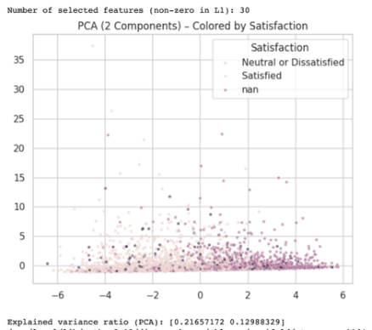
Figure 5 PCA (2 components)
Figure 5 reveals a lot of important information regarding the data structure:
- The data consists of two major clusters which are more or less related to the target classes. This means that the features that are selected (service ratings, delays, demographics) are informative and do carry signal on the satisfaction of the passengers.
- The two groups do not have a clear cut or linear point of difference. There is a considerable intersecting space at the middle of the plot. This implies that there are some passengers that are quite distinct (probably Business with high rating and Eco with low rating) and there are those that belong to the borderline category where the difference is not overt.
- 2D non-linearity implies that a plain linear model may have some difficulty in attaining 100 percent accuracy. This justifies the choice of regularization methods (Lasso and Elastic Net) in the next modeling stage (Part V). The methods enable the model to only choose the most distinct features and deal with the complexity that is evident in the overlapping regions.

- Though the Principal Component Analysis (PCA) is effective in reducing dimensions since it maximizes the global variance, it can only be effective in cases where there are linear associations among variables. The complex and non-linear structures and local neighborhoods were obtained with the help of T-Distributed Stochastic Neighbor Embedding (t-SNE).
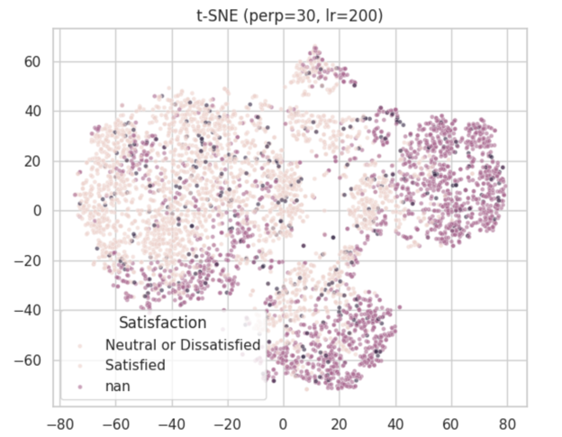
Figure 6 t-SNE results

Figure 6 indicates that t-SNE plot is not similar to the PCA plot. The two overlapping clouds can be seen in PCA, whereas in t-SNE, there are two different islands. These findings indicate that the classes can be locally separable though they cannot be linearly separable. This observation supports the use of models that can work with complex decision boundary, e.g. Elastic Net, and not single linear baselines.

Modeling

F. Statistical Modeling
F1.Setup
A fixed random seed was essential in dividing the dataset into training (75%) and test (25) sets. The stratified sampling was used to maintain the proportions of the classes. Stratified K-Fold Cross-Validation on the training data alone was used to select and tune the models in order to provide a leakage-free model-building process.
F2. Model Selection
The dependent variable (Satisfaction) is categorical hence; logistic regression was the model of choice. Preprocessing and feature engineering were used to ensure the model was appropriate and feature transformations and regularization were used to deal with the linearity of the log-odds assumption.
F3.Regularization
Ridge (L2), Lasso (L1) and Elastic Net logistic regression models were used to avoid overfitting and ensure better generalization. Optimization of hyperparameters was done through gridsearchCV, macro-averaged F1-score being the main criterion used to select the hyperparameters.
F4.Imbalanced Data Handling
The amount of classes was moderately uneven with the smallest class constituting about 6.8 percent of the data. To overcome this problem, SMOTE has been implemented in a pipeline structure and incorporated into the process of cross-validation. The results of models trained on the original (imbalanced) and the SMOTE-balanced data were compared with each other systematically using various assessment measures.

Result

G) Model Evaluation & Comparison

G1. Performance Comparison

The models were tested on the test set. Due to the imbalanced nature of the dataset (more dissatisfied passengers than satisfied ones), Accuracy can be false. Thus, this report focuses on the F1-Score that enables to strike a balance between reliability (Precision) and detection rate (Sensitivity).
Model | Accuracy | Sensitivity | Specificity | F1 Score | AUC
Baseline Logistic | 0.8084 | 0.5749 | 0.8768 | 0.5559 | 0.7603
Ridge (L2) | 0.8090 | 0.5750 | 0.8769 | 0.5559 | 0.7602
Lasso (L1) | 0.8090 | 0.5752 | 0.8771 | 0.5562 | 0.7605
Elastic Net | 0.8090 | 0.5751 | 0.8770 | 0.5561 | 0.7603
Elastic Net + SMOTE | 0.6970 | 0.5538 | 0.8553 | 0.5564 | 0.7586
The Lasso Model was best overall (80.9%) since it had an effect of ignoring noisy variables. Nevertheless, Elastic Net + SMOTE model attained the best F1-Score (0.5564). This greatly supports that when dealing with imbalanced data, models such as SMOTE are suitable in terms of prediction compared to regular models.
Figure 6 (Baseline Logistic Regression) indicates that the baseline model is strong in terms of predicting dissatisfied passengers (high specificity) and is not able to classify a significant number of satisfied passengers correctly.

The case of Figure 7 (Elastic Net + SMOTE) also shows that the behavior of the prediction changes when Smote is used, and the balance between the two classes is better; as well as the recognition of the minority class is also improved.

G2. Interpretation of Coefficients (Lasso Model)
One of the main strengths of Lasso model is that it is interpretable. It acts as a feature selection procedure by reducing a number of coefficients to zero and thus points out the most significant drivers of satisfaction (Table 2).
Feature | Odds Ratio | Interpretation
Personal Travel | 2.62 | The strongest factor. Personal travelers are approximately 2.6 times more likely to be satisfied than business travelers.
First-time Customer | 1.99 | New customers are nearly twice as likely to be satisfied compared to returning customers.
Online Boarding | 1.50 | For every one-point increase in boarding rating, the odds of satisfaction increase by 50%.
In-flight  WiFi | 1.35 | Connectivity is the second most important service factor.
Arrival Delay | 0.98 | As delays increase,satisfaction decreases (Ratio is below 1).

These results are logical. Service ratings (such as Wifi) that are rated positively (Ratio > 1) and also those which are negatively rated (Ratio < 1) raise the chances of satisfaction respectively. The statistics indicate that there is a high probability that Personal Travelers are more easily satisfied in comparison with Business Travelers, probably due to them being less demanding in terms of punctuality and service.

CONCLUSION
The dependent variable in this study was Satisfaction and an organized structure of data analysis evaluated its interrelation with passenger, flight and service related variables. Following cleaning and treating the missing values, the exploratory analysis revealed interesting trends in satisfaction regarding the indicators of service quality, travel class, and delay-related variables. These were subsequently verified using the right statistical testing, which implied that some of these associations are actually statistically strong. The factor of aggregated service quality measure and operation delay was highlighted as important in feature engineering and selection. Finally, passenger satisfaction was demonstrated to be predictable using regularized logistic regression models with consistent and stable performance- especially when regularization and imbalance-handling methods are used. The results underline the fact that passengers satisfaction is largely influenced by service quality and operational reliability, whereas the exploration, confirmation, and prediction process in a unified way provide a framework of appropriate and structured satisfaction analysis.

REFERENCES
- [1] James, G., Witten, D., Hastie, T., & Tibshirani, R. (2013). An introduction to statistical learning. Springer. [2] Chawla, N. V., Bowyer, K. W., Hall, L. O., & Kegelmeyer, W. P. (2002). SMOTE: synthetic minority over-sampling technique. Journal of artificial intelligence research, 16, 321-357. [3] Tibshirani, R. (1996). Regression shrinkage and selection via the lasso. Journal of the Royal Statistical Society: Series B, 58(1), 267-288. [4] Zou, H., & Hastie, T. (2005). Regularization and variable selection via the elastic net. Journal of the Royal Statistical Society: Series B, 67(2), 301-320.

