|  |  |
| --- | --- |
| **Topic** | Apache Kafka |
| **Document Name** | KAFKA-EX-03 |
|  |  |

|  |  |  |  |
| --- | --- | --- | --- |
| **Document Difficulty Level** | | | |
| **Beginner** | **Junior** | **Senior** | **Expert** |
| □ | ■ | □ | □ |

# Document History

|  |  |  |  |
| --- | --- | --- | --- |
| Date | Author | Ver | Comments |
| 05.03.2025 | Mennan Tekbir | 1.0 | Initial Draft |
| 05.03.2025 | Mehmet Erdem Önal | 1.1 | Revisions |

# Apache Kafka

## Exercise KAFKA-EX-03:

**Definiton:** Create 2 sample java programs; one for Producer one for Consumer. Publish java objects ( you can use following class ) from Producer app. Read those objects from Consumer app and print them to the console.

**Java Classes & Objects:** <https://www.geeksforgeeks.org/classes-objects-java>

**Java Program For Class Example:**

class Student {

  // data member (also instance variable)

  int id;

  // data member (also instance variable)

  String name;

  public static void main(String args[])

  {

    // creating an object of

    // Student

    Student s1 = new Student();

    System.out.println(s1.id);

    System.out.println(s1.name);

 }

}

**Sample Kafka Producer code:** <https://github.com/chrissearle/kafka-java-to-scala/blob/master/java-starter/producer/src/main/java/net/chrissearle/kafka/BasicProducer.java>

**Sample Kafka Consumer code:** <https://github.com/chrissearle/kafka-java-to-scala/blob/master/java-starter/consumer/src/main/java/net/chrissearle/kafka/BasicConsumer.java>

Please provide screenshots to show your work.

## KAFKA-EX-03 Solution:

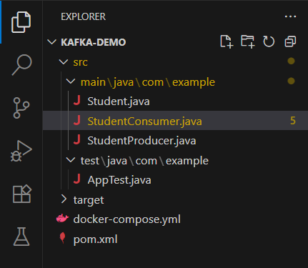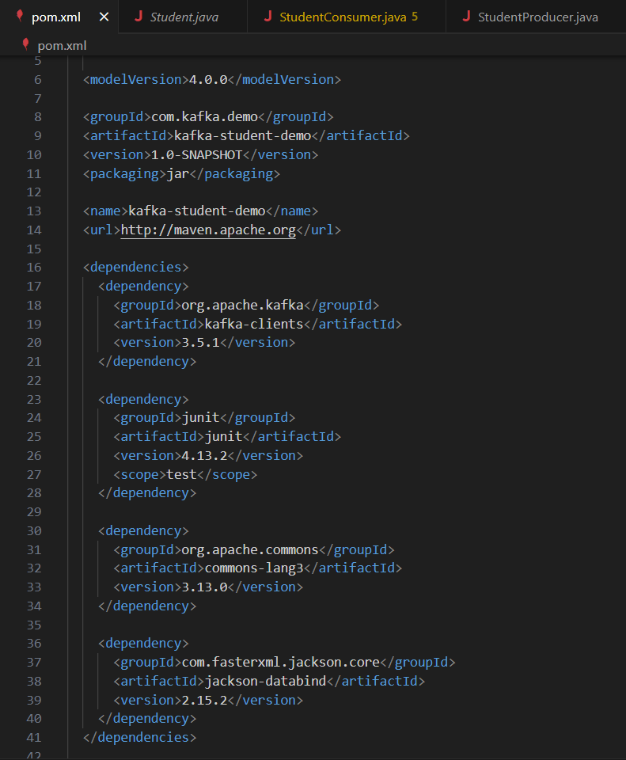**Your Answer:**

You may provide screenshots here to show your work…

