|  |  |
| --- | --- |
| **Topic** | SQL Language Fundamentals I |
| **Document Name** | PLSQL01-EX-08 |
|  |  |

|  |  |  |  |
| --- | --- | --- | --- |
| **Document Difficulty Level** | | | |
| **Beginner** | **Junior** | **Senior** | **Expert** |
| □ | ■ | □ | □ |

# Document History

|  |  |  |  |
| --- | --- | --- | --- |
| Date | Author | Ver | Comments |
| 20.09.2013  03.10.2013 | Onur Bayram  Erman İbrişim | 1.0  1.1 | Initial Draft  Sample Outputs and Rules Added |

# SQL Language Fundamentals I

## Exercise PLSQL01-EX-08:

**Definiton :** Write a PL/SQL program that prints out string in xml format.

Input String : “acbbcadefghkkhgfed”

Input String: “abbcddfggfca”

**Rules:** -Maximum string length is 30.

-No duplicate characters in string like ‘abbcddfaafca’ or ‘defgddgfed’.

-String can’t have space character or any numeric characters.

**Sample Output :**

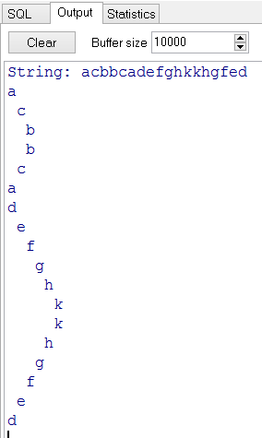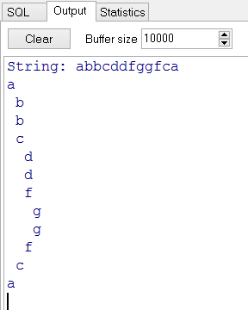

**Objectives** : To learn SQL string functions and conditional claueses(IF THEN ELSE), loops(FOR, WHILE)

## Solution of PLSQL01-EX-08:

For solution of example, please send your answer to your supervisor.