|  |  |
| --- | --- |
| **Topic** | Volt Active Data |
| **Document Name** | VOLTDB-EX-02 |
|  |  |

|  |  |  |  |
| --- | --- | --- | --- |
| **Document Difficulty Level** | | | |
| **Beginner** | **Junior** | **Senior** | **Expert** |
| □ | ■ | □ | □ |

# Document History

|  |  |  |  |
| --- | --- | --- | --- |
| Date | Author | Ver | Comments |
| 05.03.2025 | Mennan Tekbir | 1.0 | Initial Draft |
| 05.03.2025 | Mehmet Erdem Önal | 1.1 | Revisions |

# Volt Active Data

## Exercise VOLTDB -EX-02:

**Definiton:** pull & run voltdb container from docker hub in your GCP or AWS cloud machine. (You can use voltdb community [docker- repo](https://hub.docker.com/r/voltdb/voltdb-community) ). For being more practical, you can run in your local machine first, and then, you can switch to cloud machine.

**Note:** If you did not get a cloud machine previously, you may simply run it on your local machine.

**Commands for Running VoltDB:**

docker pull voltdb/voltdb-community

docker run -P -e BUSY_COUNT=1 -e HOSTS=node1 --name=node1 --network=voltLocalCluster voltdb/voltdb-community:latest

**Hint:** [Voltdb Quick Start](https://www.youtube.com/watch?v=1EkWP6Gu3VY)

Please provide screenshots to show your work.

## VOLTDB-EX-02 Solution:

**Your Answer:**

You may provide screenshots here to show your work…

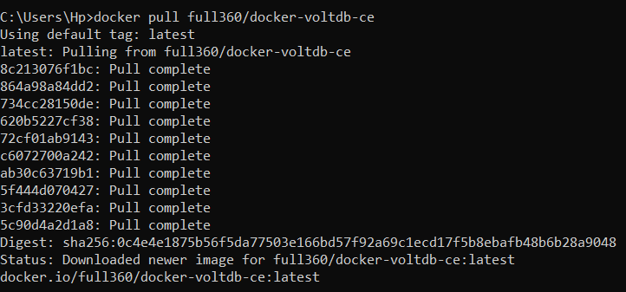

C:\Users\Hp\Desktop\VOLTDB-EX-02\docker network create.png

C:\Users\Hp\Desktop\VOLTDB-EX-02\docker run.png



