Attack Detection in Connected Vehicles
Zeynep Gürler, Serra Uysal, and Ahmet Yemliha Öner
Abstract—This project focused on the usage of multiple machine learning techniques on credit card fraud detection. Credit card frauds are getting more and more common with the improvements in technology. In contrary, with the developments in the state-of-the-art techniques of machine learning, there are many countermeasures which can be available. In this work, we are going to use random forest regression to make predictions about the probability of transactions being fraud. Since the non-fraud data outnumbered the fraud data, we used undersampling and oversampling to deal with this imbalanced dataset. In this paper, we propose a solution to prevent possible fraudulent transactions by enhancing the security of the system.
Index Terms—Error analysis, machine learning, sampling, security and privacy protection, credit card, fraud, fraud prevention
——————————  ——————————
xxxx-xxxx/0x/$xx.00 © 200x IEEE Published by the IEEE Computer Society
————————————————
- Ege Apak is a undergrad student in the Computer Engineering Department, Istanbul Technical University. E-mail: apake15@itu.edu.tr.
- Tepecik is a undergrad student in the Computer Engineering Department, Istanbul Technical University. E-mail: tepeciku@itu.edu.tr.
- Umutcan Karakaş is a undergrad student in the Computer Engineering Department, Istanbul Technical University. E-mail: umutcankarakas@gmail.com.

1 Introduction

THE credit card usage increases day by day all around the world. Especially thanks to the development and grow of technology, operations such as payment and money transfer are started to be done via online platforms and this parallelly decreased the cash money usage and increased credit card usage. As a result, money transfer operations became faster and led people manage their money from wherever they want without carrying it with themselves. Beside the positive effects of these technologies on our lives in terms of easing our daily lives, there also appeared problems regarding to security of the accounts, money transfers and transactions. Because of the people, who have a hard time adapt to this fast-developed technology, and the banks, which cannot manage this technology safely, credit card fraud appeared and with the increase of online shopping the rate of this crime increased dramatically in past years. Even though banks took precautions for this huge problem, because of the rapid change of credit card fraud methods, they could not provide the security they wanted to. That is why the work regarding to this area has increased rapidly in the past few years. For the work done in order to stop the credit card fraud, artificial intelligence is a recently popularized method. Especially machine learning methods and data-driven approach are used for this cause. The biggest reason of this is to be able to develop an adaptive and self-renewing solution to this specific fraud type. However, the biggest problem here is the huge rate of non-fraud transaction data, in other words the data set to be analyzed being highly imbalanced. Hence, arranging the data set optimally is a critical stage to create a solution. In this project, we did oversampling with SMOTE as a solution to this problem and operated the data with Random Forest algorithm to restrain the imbalance of the data set. Then, we used the results we obtained to reveal the probability of fraud in the set of given transactions. By using the guesses we ended up with, we found out whether a transaction is secure, so that we can decide if an extra security layer such as 3D secure is needed or not.
We present this system, named SENDES: Security Enhancing Decision System in this paper.

2 Related Work
In this section, we will discuss about some approaches for credit card fraud detection and we will analyze the techniques and performance criteria of these approaches.
When we examined the studies about credit card fraud detection, we found that many studies tried to find solution with machine learning and data mining approach against this problem. In addition to that, many studies, which have machine learning approach, applied Random Forest algorithm, which is an ensemble method. For example, in study of [2] Random Forest algorithm was applied for fraud detection and the dataset in this study were processed with feature extraction method. Because the data set on fraud detection is generally imbalanced which means that number of non-fraud data is much more than fraud data, therefore it must be processed to get better results from algorithm to be applied. However, accuracy was emphasized for performance measurement in this study. In our research, we have seen that Data Mining approach is preferred along with the machine learning method. For example, in [2] and [3] studies were used Data mining for credit card fraud detection, and in [3] study, several algorithms, which are support vector machines (SVM), Naïve Bayes classifier, K-Nearest Neighbor (KNN) and Bagging ensemble classifier, have been tested to get better results.

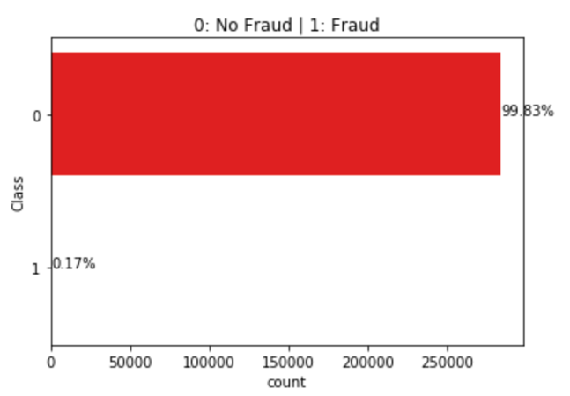
On the other hand, according to our research we found that in recently studies for credit card detection, data-driven approach started to be become more popular. For example, in [1] study applied two different data-driven approaches for credit card fraud detection which are one class support vector machines (OCSVM) and T2 control chart. However, there are some difficulties in achieving better results with this approach. For instance, it must has a very large labeled data set and it must be apply it’s algorithm over the data set over to many times. In addition to that, almost all data set about credit card fraud detection is imbalanced data set, which means that number of non-fraud transaction is, much more than number of fraud transaction.
Another issue regarding the detection & prevention of credit card fraud is the imbalanced data. Since the fraud data is hard to find, it makes the learning harder for the models. To overcome this problem, people use Autoencoders[4], Auto-Encoders supported with RBM and H2O[5].
Figure 1 - Data distrubition in the dataset
Another mentioned problems present in the field is the need of near real-time processing requirement despite the huge amounts of data that must be processed. To tackle this problem, [6] uses Big Data tools like Kafka, Spark and Cassandra to process the transactions as a stream of data, constantly flowing in and are able to provide near real-time results on the possibility of a transaction being fraudulent.
There are also ways of strengthening the system against fraudulent transactions. One such way that proposed by [7] is that since the amount of second form of authentication is not common enough due to causing hassle to the customers and potentially causing them to cancel their transaction completely, providing incentives can allow for a “win-win-win” scenario for everyone involved while reducing the success chance of fraudsters.
Since the features of a transaction is limited by nature and the immense amount of non-fraudulent transactions that simply span almost the entire range of feature-space of those features, [10] approach the problem from the perspective of features and apply methods of feature engineering to separate identifying features of fraudulent transactions to detect them.
Figure 2 - Description of all the data in dataset
While there are many approaches to detecting and preventing credit card frauds, [11] propose a solution to accurately prevent credit card frauds by encrypting and embedding user’s credentials into their biometric fingerprints, which is user’s fingerprints most of the time.

3 Dataset
In this project, we used the dataset that belongs to an online contest, which is about Credit Card Fraud Detection [14].

The dataset contains 284,807 transactions in total, which are collected from the transactions made in September 2013 by the credit card users. Out of these 284,807 transactions, 492 of them are fraud (near 0.172% of total dataset), which means we have to deal with heavily imbalanced dataset (check Figure 1).

In the description of the data, it is said that for the sake of privacy and security purposes most of the data has gone through PCA transformation process. There are 28 features which are obtained from PCA transformation (V1, V2, ..., V28). The only features which are not transformed are 'Time' and 'Amount'.
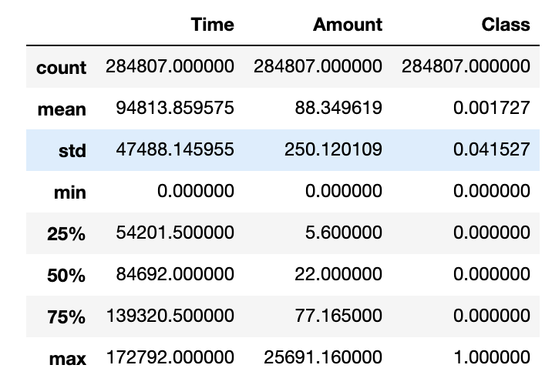
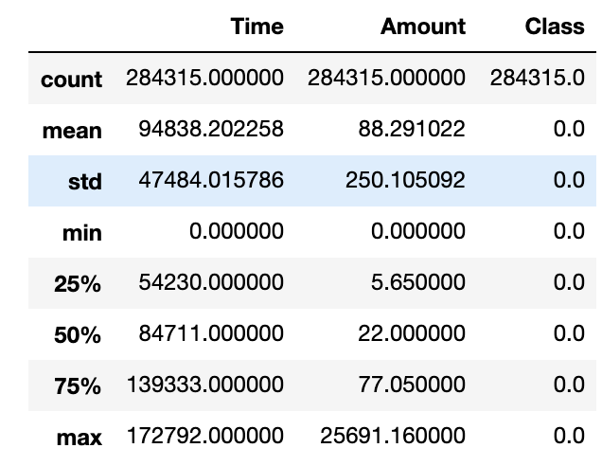
Figure 3 - Description of Non-Fraud data in dataset

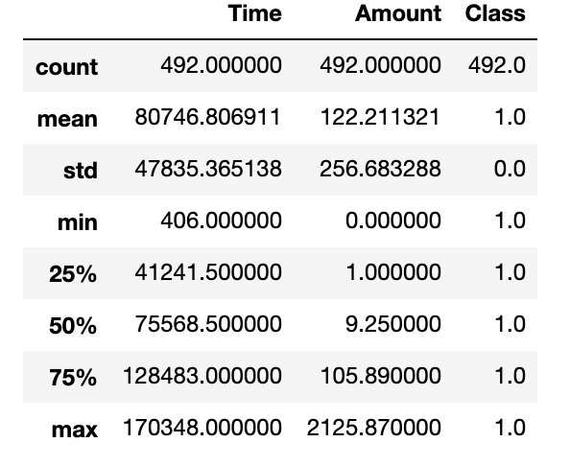
Figure 4 - Description of Fraud data in dataset
As it can be seen in the Figure 2, the transaction amount is nearly 88.34 USD, which is slightly higher than the mean of non-fraud transaction (88.29 USD) (can be seen in Figure 3). Mean of the total transaction amount is also much more smaller than the mean of fraud transaction, which is 122.21 USD (can be seen in Figure 4).
The dataset doesn’t include any “Null” value, so there is no need for preprocessing for the missing values.
We also checked the transformation data distribution over time to get more insight about the dataset.
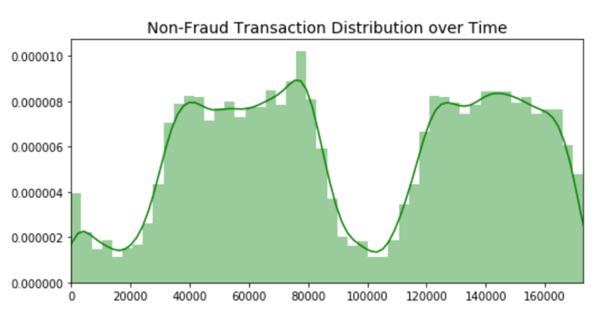
Figure 5 - Non-fraud transaction distribution over time
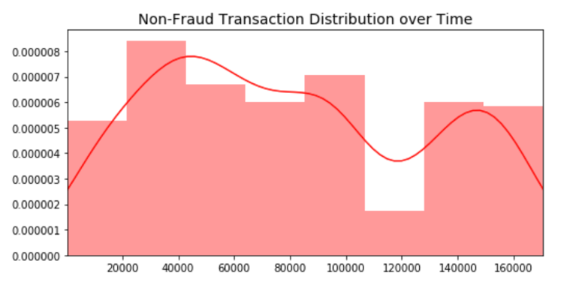
Figure 6 - Fraud transaction distribution over time

4 Detaıls of Proposed solutıon
Nowadays, a significant portion of credit card transactions happen online, i.e. without the required presence of the credit card itself. Since only the credit card number, expiration date and CVV information are required for the transaction, possibility of a fraudulent transaction is much higher on online transactions. In the online transaction processing workflow, after the user enters their credit card details, the merchant performs some preliminary checks on the entered data, such as Luhn check (or Modulus 10 check) to verify the validity of given credit card number and expiration check on the given date, to prevent invalid credit card data to be sent to the card issuer, thus preventing possible per-request payment costs. After the validity of the given information is verified, these data are sent to the card issuer for application of transaction. There happen additional checks, such as checking the transaction history of the initiating user for their purchase trends (amount paid, time of day that the purchase is made etc.), and completes transaction if it passes all checks. Since the card issuer is responsible for deducting the payment amount from the card-holder's account, it is in their best interest to prevent and detect possible fraud's. However, since the infrastructure of card issuers are often built upon outdated technologies and require more-than-usual consideration regarding the security of any data that are processed or transferred through the system, it becomes much harder to integrate newer technologies and systems into existing infrastructure and the costs of doing so are often-times undesirable. Therefore, we propose to integrate our solution with the merchant's infrastructure to cut down on the costs while possibly preventing the fraud before the transaction information reaches the card issuer. The obvious downside of this is that our solution can't consider any apparent trends in the card-holder's behavior to improve it's decision, but it is neutralized by significant reduction in integration costs as described above.
We propose to integrate the SENDES after merchant's checks to possibly request additional verification as soon as possible to both reduce the time card-holder waits and reduce the amount of possibly fraudulent transactions sent to the card issuer. Planned flow of transaction data can be seen in Figure 7. We propose to integrate SENDES right after the merchant performs the preliminary checks. If SENDES decides that the transaction has a significant probability of being fraudulent, the merchant is notified immediately, as this process is planned to take only a couple of seconds, and the merchant requests additional verification. If the additional verification is successful, the transaction details are forwarded to the card issuer. Otherwise the transaction is rejected and card issuer is notified for possible fraud, which in turn possibly notifies the owner of the said card about the denied possibly fraudulent transaction.

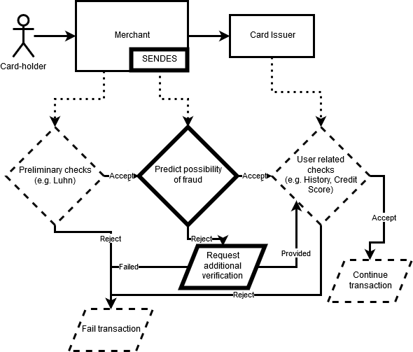
Figure 7 – Data-flow of transaction information and planned integration point of SENDES

Even though the authenticity of a transaction is binary (either fraud or legit), there is a trade-off between causing frustration to users due to strict and time consuming validations and protecting user, merchant and card issuer against monetary losses. Due to this trade-off, integrators of fraud detection systems must strike a careful balance between the user experience and prevention of asset loss. Considering these issues, it is near impossible to decide that a transaction is fraudulent before it finalizes. Therefore, instead of trying to completely decimate fraud, we propose to a solution as a first step to reduce the fraud by deciding on a possibility of a fraud and require additional verification, such as 3D Secure or Two-Factor Authentication, from the user if the possibility of fraud is greater than a certain threshold.
Since the occurrences of fraud are minuscule compared to the legit transactions in real-life scenarios, almost all of the transactions would be legit transactions in almost all cases, which creates an issue of imbalance. Supporting this, the data set at hand was hugely imbalanced; more than 99 percent of the data was consisting of non-fraud transactions. However, most of the machine learning algorithms work correct only when the data set is balanced, otherwise they tend to overfit for the majority class. There have been novel methods for learning from imbalanced data [15,18,20]. However, in order to prevent this problematic behavior, we have selected and applied SMOTE [8] algorithm to synthetically generate thousands of fraudulent data points by linearly interpolating between features of neighboring fraudulent data points.
Moreover, the features present in the data set were extracted using PCA, except for the time and amount values, respectively referring to the amount of seconds passed since the first transaction and the monetary amount. Considering that these two variables might have a relation to the possibility of a fraud, we haven't put any more weight on neither amount nor the time value: Frauds can happen in any hour of the day and isn't limited in any way regarding the monetary amount. However, since proper scaling can improve the speed of convergence [12], both amount and time values are scaled as a pre-processing step.
Another thing that should be wary of is that since most of the credit card transactions are the result of daily interactions, such as purchasing a meal or a grocery shopping, most of the data points have similar, respectively low values as amount feature. Or in other words, there would be many outliers, mostly skewed towards the higher monetary values. We have decided to eliminate the influence of these outliers and reduce the effect of disparity by using quantile normalization.
In accordance to the plan and problems outlined and explained above, we decided to approach the problem at hand as a regression problem instead of a classification problem and predict the possibility of a transaction being fraudulent or not. Some of the research show that applying the majority voting algorithm produces great results [16]. However, for this we have decided to use Random Forest Regression algorithm for training our model. The reason behind selection Random Forest algorithm instead of any other is that it being resistant to unscaled data, which is one of the main reasons behind the difficulty of consistently and successfully determining whether a transaction is fraudulent or not, and overfitting, which is another huge problem due to not having organic data for fraudulent transaction.
For fine-tuning the algorithm and ease the process of model training, we have constructed a pipeline on top of existing machine learning pipeline solutions to automate the pre-processing the input data, such as oversampling or undersampling the data, training the model with the processed data, saving the trained model for result analysis and rendering the analysed data for relevant graphics. Aside from that we have applied cross-validated grid-search over our defined reasonable parameters for Random Forest algorithm to find the best possible values for them. We mainly focused on number of estimators and maximum depth of the decision trees.
After training the model considering and using the methodologies defined above, it now can predict the possibility of fraud in a given credit card transaction. Depending on the predicted possibility, a second method of verification is requested from the user, such as 3D Secure or Two-Factor Authentication.
Since more than 70% of the fraudulent transactions happen when the credit card is not present [7,19], it is highly unlikely that the fraudster has access to the card-holder’s any second form of authentication methods. Therefore, if the transaction is indeed fraudulent, the fraudster would be unable to provide any second form of authentication and the transaction would be failed. However, if the transaction is legit, the card-holder would only interrupted for a insignificant amount. Even then, informing the card-holder that the system thinks that transaction might be fraudulent can incentivize the card-holder to protect their credit card details with increased attention. In the first case, where the transaction is fraudulent, the real card-holder must be informed as well about the situation. The card-holder might not even be aware that their credit card details are being used for fraud.

5 Analysis of Proposal Results
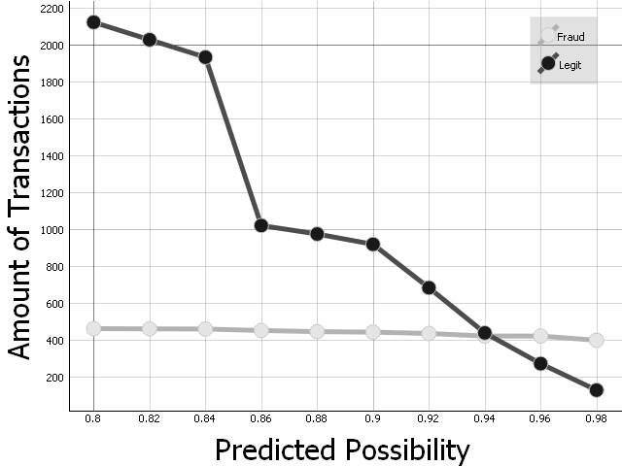
After implementing the proposed system and testing the original data-set against the trained model, first results show that while almost 95% of fraudulent transactions are marked as having a possibility of being fraudulent more than 80%, only 0.007% of the non-fraudulent transactions are marked with having the same amount of possibility to be fraudulent.
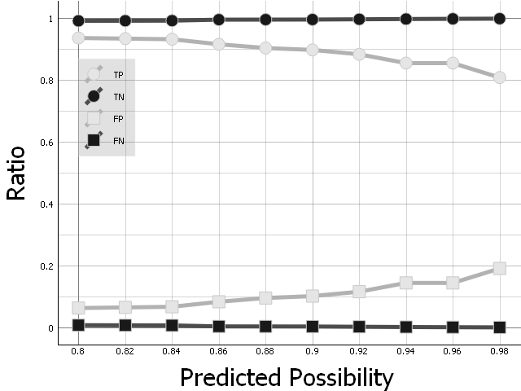
Figure 8 – Number of correctly predicted transactions for each threshold level above 80 percent
Figure 9 – Result of the prediction regarding the true positive (TP), true negatve (TN), false positive (FP) and false negative (FN) ratios.
Figure 8 shows that as the threshold for the possibility of being fraudulent increases, the amount of non-fraudulent transactions marked as high probability of being fraudulent (i.e. false-positives) drop to half around 86% while the amount of true-positives are barely affected. One cause of this might be that even though some non-fraudulent transactions have properties that cause them to be marked as having high probability of fraud, more than half of them still have significant differences to fraudulent transactions. However, increasing the threshold starts to affect the amount of true-positives after a certain amount. At the 95% mark, the amount of false-positives drop way below true-positives.
In the Figure 9 the effect on true-positives is much more prevalent. The amount of true-positives drop steadily as the threshold increases. Another interesting result is that even though both positives get lower and lower as the threshold increases, which is expected, almost 80% of the fraudulent transactions are marked as having a higher than 98% probability of being fraud while only a handful of non-fraudulent transactions, around 0.0005%, are marked as having the same probability of being fraud. These results show that a significant portion of fraudulent transactions might have identifying characteristics that separate them from non-fraudulent transactions.
According to these results, requesting for a second form of authentication, be it 3D Secure, Two-Factor Authentication or any other way that is more identifying than a password, can possibly prevent up to around 90% of frauds while disturbing the comfort of only one person out of every 200,000 people.

6 Conclusion and Future Work
The process of detecting and preventing fraud is a significantly hard task due to various reasons. There aren’t too much data available to begin with due to he sensitive nature of the credit card data. The available data has a great imbalance between fraudulent and non-fraudulent data due to the nature of all possible transactions: There are simply too many transactions happening every day and a great majority of them are genuine. Even then, the features available in the present data are anonymized and extracted using various methods, such as PCA, and therefore prevent some advanced forms of analysis where the trend of an account is analyzed, such as transaction history, average monetary amount of purchases made by a single customer or simply time of day when a customer usually finalizes a transaction.
Considering these limitations, there have been various attempts and solutions at both preventing and detecting credit card fraud. While some of the work we have researched approached problem as a binary classification problem, i.e. they try to arrive at a conclusion with a great certainity that a transaction happening or happened is fraud, while many others approach it as a regression problem and instead of certainities, they base their solutions on probabilities.
While there are many different machine learning algorithms in the literature, the extraordinary nature of the data removes most of them from the equation. Even though there have been various approaches, almost all of them go through the same steps of preparing the data. In order to prevent issues that may arise from the imbalance of the data, most of the works researched try to balance the data set using various techniques, such as oversampling, undersampling or random sampling.
Other than that, since some features of the transactions details are heavily imbalanced, such as the monetary amount or time of day the transaction is made, most of the researchers opt-in to normalize the data or transform it, e.g. convert time of day to partitions such as morning, evening or night.
Our approach to the problem at hand was similar. We took it as a problem of “prevention via probability prediction” and devised a strategy to increase the security of a transaction-processing system by first analyzing a transaction and arriving a probability value representing the probability of a transaction being fraudulent and requesting additional methods of verification if the probability exceeds a certain threshold.
As a preprocessing step, we have normalized time of the day of the input data and the monetary value, considering the imbalances in the aforementioned features and using a scaler that is robust against outliers.
Like other works on the topic, we have preprocessed the data to combat the issues caused by the imbalanced data and we have used SMOTE to synthetically generate fraudulent data points from the points we already had.
After preparing our data for learning, we have applied Random Forest Regression algorithm to train a model for predicting the probability of a fraudulent transaction, where a probability of one denoting an indisputable fraud and a probability of zero denoting a transaction that is completely genuine.
Testing the performance of our model, which is trained by using more than 500 thousand of data points, on the data set we have originally obtained, we have arrived at various conclusions.
One of these is that even a not-so-strong possibility of 80% was able to catch most of the fraudulent transactions while also capturing only a small subset of genuine transactions. However, increasing the threshold only by 5% reduced the amount of genuine transactions that got caught by half while missing only around 5% of the fraudulent transactions.
By choosing a threshold value strategically, it is possible to prevent most of the fraudulent transactions due to most of the fraudsters not having access to other devices of card-holders that can provide a second form of verification.
Even though the first results look promising to reduce the amount of credit card fraud, especially on transactions that a credit card is not present, there are many ways that this method can be improved and the results of the proposal here can be evaluated further.
Aside from that, more complex algorithms can be used for this problem. Recently, thanks to the advancements in high-speed computing, deep learning and neural networks became a performant and highly viable solution to this problem [17,21,22].
It is possible to use various other techniques to confirm the robustness of the solution proposed in this paper but one easy-to-test method, which is also effective on evaluating the robustness of the algorithm, is generating noisy data, as done in [13], to try to trick the algorithm and checking the performance of the solution against that data set.
One such way of improvement would be incorporating customer trends into the algorithm and weighing the predicted possibility with this trend to reduce the amount of falsely marked transactions.
Another possible improvement would be to provide better and easier methods of verification to card-holders. For example, sending an SMS for a Two-Factor Authentication might completely prevent the genuine customer to finalize transaction if it fails to arrive. One possible way of providing an easy and safe way of verification could be using multiple technologies together, such as combining NFC readers with biometrics to verify that the customer is making the transaction in a place he or she knows and the customer is actually the person he or she claims. The method of using biometrics also has a side-effect of improving the user’s trust on the system [9].
The problem at hand can be approached in many ways and each of them could try to solve different sub-problems, like the example given above regarding the ease-of-use.
References
- P. Tran, K. Tran, T. Huong, C. Heuchenne, P. HienTran and T. Le, "Real Time Data-Driven Approaches for Credit Card Fraud Detection", Proceedings of the 2018 International Conference on E-Business and Applications - ICEBA 2018, 2018. Available: 10.1145/3194188.3194196 [Accessed 13 November 2019].
- V. Jonnalagadda, P. Gupta and E. Sen " Credit card fraud de-tection using Random Forest Algorithm", International Journal of Advance Research, Ideas and Innovations in Technology, vol. 5, pp. 1797-1801, 2019.
- M. Zareapoor and P. Shamsolmoali, “Application of Credit Card Fraud Detection: Based on Bagging Ensemble Classifier,” Procedia Computer Science, vol. 48, pp. 679–685, 2015.
- M. Al-Shabi, "Credit Card Fraud Detection Using Autoencoder Model in Unbalanced Datasets", Journal of Advances in Mathematics and Computer Science, pp. 1-16, 2019. Available: 10.9734/jamcs/2019/v33i530192 [Accessed 13 November 2019].
- A. Pumsirirat and L. Yan, "Credit Card Fraud Detection using Deep Learning based on Auto-Encoder and Restricted Boltzmann Machine", International Journal of Advanced Computer Science and Applications, vol. 9, no. 1, pp. 18-25, 2018. Available: 10.14569/ijacsa.2018.090103.
- F. Carcillo, A. Dal Pozzolo, Y. Le Borgne, O. Caelen, Y. Mazzer and G. Bontempi, "SCARFF : A scalable framework for streaming credit card fraud detection with spark", Information Fusion, vol. 41, pp. 182-194, 2018. Available: 10.1016/j.inffus.2017.09.005 [Accessed 13 November 2019].
- D. Wang, B. Chen and J. Chen, "Credit card fraud detection strategies with consumer incentives", Omega, vol. 88, pp. 179-195, 2019. Available: 10.1016/j.omega.2018.07.001 [Accessed 13 November 2019].
- A. Fernandez, S. Garcia, F. Herrera and N. Chawla, "SMOTE for Learning from Imbalanced Data: Progress and Challenges, Marking the 15-year Anniversary", Journal of Artificial Intelligence Research, vol. 61, pp. 863-905, 2018. Available: 10.1613/jair.1.11192.
- O. Ogbanufe and D. Kim, "Comparing fingerprint-based biometrics authentication versus traditional authentication methods for e-payment", Decision Support Systems, vol. 106, pp. 1-14, 2018. Available: 10.1016/j.dss.2017.11.003 [Accessed 13 November 2019].
- J. Jurgovsky et al., "Sequence classification for credit-card fraud detection", Expert Systems with Applications, vol. 100, pp. 234-245, 2018. Available: 10.1016/j.eswa.2018.01.037 [Accessed 13 November 2019].
- J.S. Bridle, “Probabilistic Interpretation of Feedforward Classification Network Outputs, with Relationships to Statistical Pattern Recognition,” Neurocomputing—Algorithms, Architectures and Applications, F. Fogelman-Soulie and J. Herault, eds., NATO ASI Series F68, Berlin: Springer-Verlag, pp. 227-236, 1989. (Book style with paper title and editor)
- X. Wan, "Influence of feature scaling on convergence of gradient iterative algorithm", Journal of Physics: Conference Series, vol. 1213, p. 032021, 2019. Available: 10.1088/1742-6596/1213/3/032021 [Accessed 13 November 2019].
- K. Karthikeyan, K. Sangeeth Raj, S. Ramaganesh, P. Parthasarathi and N. Suguna, "Credit Card Fraud Detection Using Machine Learning", International Journal of Scientific Research in Science and Technology, vol. 6, no. 2, pp. 386-391, 2019. Available: 10.32628/IJSRST196271 [Accessed 13 November 2019].
- "Credit Card Fraud Detection", Kaggle.com, 2019. [Online]. Available: https://www.kaggle.com/mlg-ulb/creditcardfraud. [Accessed: 13- Nov- 2019].
- A. Estabrooks, T. Jo and N. Japkowicz, "A Multiple Resampling Method for Learning from Imbalanced Data Sets", Computational Intelligence, vol. 20, no. 1, pp. 18-36, 2004. Available: 10.1111/j.0824-7935.2004.t01-1-00228.x.
- K. Randhawa, C. Loo, M. Seera, C. Lim and A. Nandi, "Credit Card Fraud Detection Using AdaBoost and Majority Voting", IEEE Access, vol. 6, pp. 14277-14284, 2018. Available: 10.1109/access.2018.2806420 [Accessed 13 November 2019].
- A. Roy, J. Sun, R. Mahoney, L. Alonzi, S. Adams, and P. Beling, “Deep learning detecting fraud in credit card transactions,” 2018 Systems and Information Engineering Design Symposium (SIEDS), 2018.
- H. Naik and P. Kanikar, "Credit card Fraud Detection based on Machine Learning Algorithms", International Journal of Computer Applications, vol. 182, no. 44, pp. 8-12, 2019. Available: 10.5120/ijca2019918521.
- F. Akinbohun and S. Atanlogun, "Credit Card Fraud Detection System in Commercial Sites", European Journal of Engineering Research and Science, vol. 3, no. 11, pp. 1-5, 2018. Available: 10.24018/ejers.2018.3.11.920.
- D. Varmedja, M. Karanovic, S. Sladojevic, M. Arsenovic and A. Anderla, "Credit Card Fraud Detection - Machine Learning methods," 2019 18th International Symposium INFOTEH-JAHORINA (INFOTEH), East Sarajevo, Bosnia and Herzegovina, 2019, pp. 1-5.
- S. P. Maniraj, Aditya Saini, Shadab Ahmed and Swarna Deep Sarkar, "Credit Card Fraud Detection using Machine Learning and Data Science", International Journal of Engineering Research and, vol. 08, no. 09, 2019. Available: 10.17577/ijertv8is090031.
- C. Wang, Y. Wang, Z. Ye, L. Yan, W. Cai, and S. Pan, “Credit Card Fraud Detection Based on Whale Algorithm Optimized BP Neural Network,” 2018 13th International Conference on Computer Science & Education (ICCSE), 2018.

