Attack Detection in Connected Vehicles
Zeynep Gürler, Serra Uysal, and Ahmet Yemliha Öner
Abstract—This project focused on the usage of multiple machine learning techniques on credit card fraud detection. Credit card frauds are getting more and more common with the improvements in technology. In contrary, with the developments in the state-of-the-art techniques of machine learning, there are many countermeasures which can be available. In this work, we are going to use random forest regression to make predictions about the probability of transactions being fraud. Since the non-fraud data outnumbered the fraud data, we used undersampling and oversampling to deal with this imbalanced dataset. In this paper, we propose a solution to prevent possible fraudulent transactions by enhancing the security of the system.
Index Terms—Error analysis, machine learning, feature extraction, security, connected vehicles, dos attacks
——————————  ——————————
xxxx-xxxx/0x/$xx.00 © 200x IEEE Published by the IEEE Computer Society
————————————————
- Zeynep Gürler is an undergrad student in the Computer Engineering Department, Istanbul Technical University. E-mail: gurler17@itu.edu.tr.
- Serra Uysal is an undergrad student in the Computer Engineering Department, Istanbul Technical University. E-mail: uysals17@itu.edu.tr.
- Ahmet Yemliha Öner is an undergrad student in the Computer Engineering Department, Istanbul Technical University. E-mail: oner15@itu.edu.tr.

1 Introduction

IN In the last decade, people have witnessed a great deal of technological developments and improvements that have reflected in the most basic places of our daily life. Considering transportation constitutes a significant time in our lifestyle, it is inevitable to expect the least from this industry to keep up with the advantages that increasing technology brings with it. Connected vehicles come into the scene at this point. As mentioned in [1], connected vehicles comprise all the applications, services, and technologies that provide the capability to engage with outer devices, networks, applications, and services as well as communicate between other appliances found in the vehicle. Developments in connected vehicles have happened too rapidly that manufacturers could only focus on functionality rather than security. Latterly, this caused many security-related problems in the connected vehicles. When the subject is networks and technological services, the vulnerabilities that they will bring within should always be taken into consideration since these vulnerabilities often arise some crucial security problems in the system. Cyber-attacks are very crucial security threats to connected vehicles. [2] estimated that the cost of cybercrime, which was 3 trillion dollars in 2015, will increase to 6 trillion dollars by 2021 and they stated that these attacks began to directly target people and the tools they use in daily life such as cars, planes, etc. in a way that threatens their lives, instead of affecting computers, networks or smartphones. Therefore, even though technological developments ease our life, they generally come with the consequence of facing a series of security problems. To make a system secure, there are a few main methods; using cryptography, increasing network security, malware detection, or software vulnerability detection. In our paper, we focus on vulnerability detection in connected vehicles.
Since machine learning approaches constitute a consequential place as it is one of the most popular subjects in recent years, in this paper, we propose an attack detection framework that uses machine learning and data manipulation approaches for connected vehicles to detect cyber-attacks . Our data set where we test the framework includes a number of different attack types. Yet, one of them is mainly focused in this paper, which is called Denial of Service (DoS) attack. Before all the operations, the data set has to be arranged optimally. Feature extraction and normalization is prefered to achieve this. Then, we calculate the probability of an attack in the process between connected vehicles. As a result, we end up with a reliable attack detection software system. We propose this system to measure whether additional advanced security layers are needed for a specific process in a system or the process is safe to work with.
2 Attack Detection with Machine Learning
In this section, we examine the detection of cyber-attacks on connected vehicles without necessarily focusing on the type of the attacks and their properties. Then, we analyze the performance of the method that we suggest by testing it over a dataset and discuss the results. Before jumping into that part, first, we need to briefly explain the inspiration behind this work.
Our literature review about cyber-attacks on connected vehicles [3] showed that hackers had to have a physical admission in order to manipulate vulnerabilities of the system where the target of the attack could be only a single-vehicle. However, connectivity in the wireless network manner on vehicles abolished this restriction and gave power to hackers to perform malicious attacks via a distance. Some examples of these attacks can be specified as:
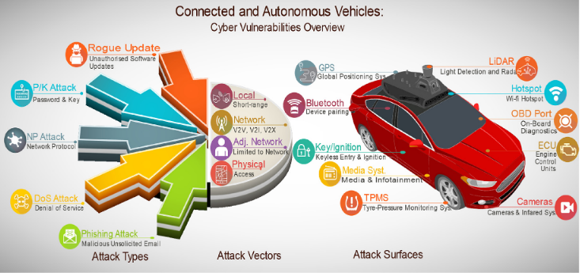
- Charlie Miller and Chris Valasek [4], showed that even though manufacturers rely on their implementation and argue for having “unhackable” connected vehicles, in 2015 they released the method that they used for finding IP addresses of the cars and after locating them sending arbitrary CAN messages which resulted with causing the cars to drive of-road and crash. They also included a list of vehicle models that they tested.
- Martyn Wiliams published a news article that points out how hackers mimicked the BMW servers that are managed by the BMW assistance line to help drivers who have been locked out of their cars. According to the news, in order to fix the issue, BMW published software patches to 2.2 million cars with the Connected Drive program[5].
- Jonathan Gitlin from Arstechnica wrote a news article that tells the story of security researchers that discovered how to use software-defined radio(SDR) to unlock and lock millions of Volkswagens. To do that, they only needed a $40 worth of Arduino and SDR[6].
- Keen Security Lab researchers find a way to control a Tesla car from out of the car, by 12 miles (19km). Hackers were able to open doors, switch lanes while the car was moving. Tesla published an update to fix the issue [7].
In the presence of these news, it can be seen that cyber-attacks are causing significant damage both financially and morally, by deaths and injuries caused by incidents, with intergrowth of connected vehicles in our lives and vulnerabilities it contains. That is why the importance of prevention of these attacks has increased. Fig 1. summarizes attack types that target vulnerabilities of attack surfaces on connected vehicles.

3 Dataset
In this section, we will concisely explain the dataset that is used for evaluation of our proposed DoS attack detection model. As mentioned earlier, we used the 10% KDD99 [12] intrusion detection benchmark dataset for the sake of simplicity. This dataset includes normal operations and 6 different types of DoS attacks; neptune, smurf, back, teardrop, pod and land. In addition to DoS attacks, there are a few other types of attacks which constitute less ratio in the dataset. Those attack types are u2r, r21 and probe attacks. The attacks buffer_overflow, loadmodule and pearl belong to u2r type; guess_passwd, ftp_write, imap, phf, mutihop, waresmaster, warezclient and spy belong to r21 type; and lastly portsweep, ipsweep, satan and nmap belong to probe attack type. In the sense that KDD99 consists of 41 features per entry, it possesses being one of the most prefered dataset for cyber-security related study projects by researchers.
The dataset contains 494021 operations in total where 488736 of these are representing the operations with one of the cyber-attack types that has been mentioned above. Table [1] shows the percentage of the operations in the dataset:

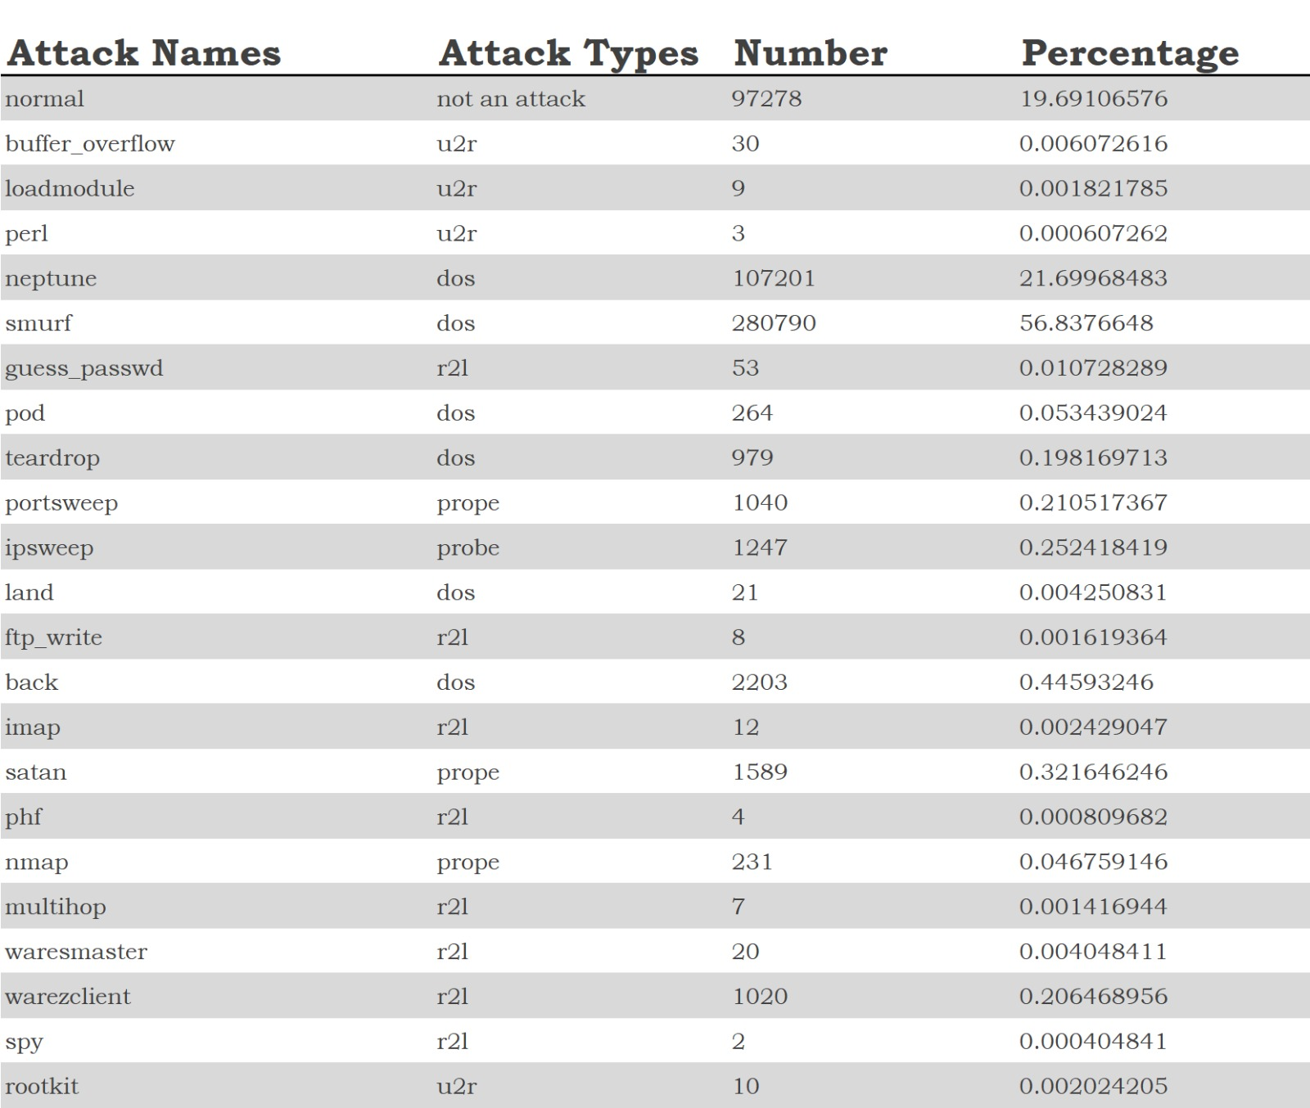
4 Attack Detectıon wıth Data Manıpulatıon and Machıne Learnıng for Connected Vehıcles
In this section, we introduce the key steps of our DoS attack detection framework for connected vehicles. We divided the framework into three elemental key steps as a basis. We will explain each of these three key steps of our detection framework as shown in Fig. 2.

near impossible to decide that a transaction is fraudulent before it finalizes. Therefore, instead of trying to completely decimate fraud, we propose to a solution as a first step to reduce the fraud by deciding on a possibility of a fraud and require additional verifica
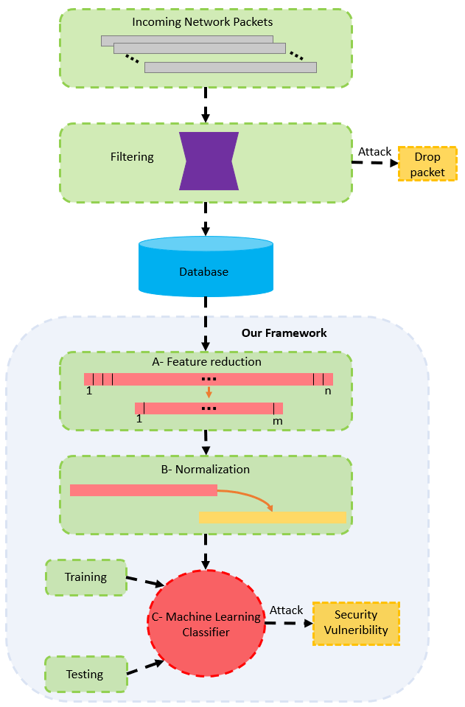

4.1 Feature reduction
Big data, which is generated with the increasing use of technology over time, provides us an opportunity to process and learn from the data. The first step in learning from data is to know your data. Knowing the data leads us to be able to make result-oriented manipulations on the data, and to get rid of unnecessary features. In high-dimensional data-based studies, as in our case, removing unnecessary and redundant features from the data leads to a more intelligible model [14]. Therefore, we apply feature reduction to our dataset by selecting the features that have slight standard deviations (STDs). We compute the STD of each feature and select the ones that have an STD greater than 0.5. Table 2 shows the STD of each feature.
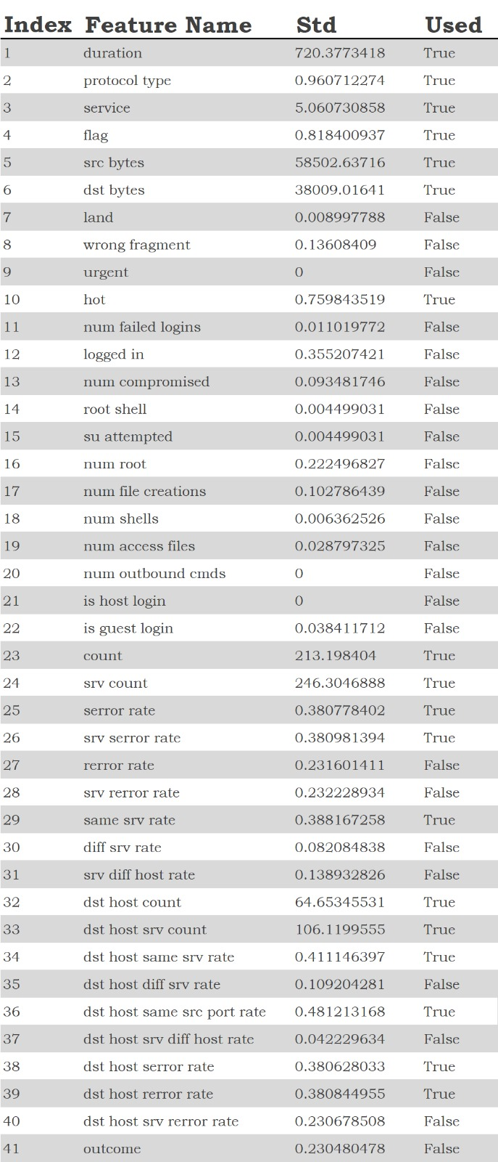
4.2 Normalization of reduced features
Data Normalization is one of the influential pre-processing steps for data analysis. By transforming the data into precise order with linear transformation, raw data is homogenized to create more suitable clusters and better the precision of algorithms [15]
model with the processed data, saving the trained model for result analysis and rendering the analysed data for relevant graphics. Aside from that we have applied cross-validated grid-search over our defined reasonable parameters for Random Forest algorithm to find the best possible values for them. We mainly focused on number of estimators and maximum depth of the decision trees.
After training the model considering and using the methodologies defined above, it now can predict the possibility of fraud in a given credit card transaction. Depending on the predicted possibility, a second method of verification is requested from the user, such as 3D Secure or Two-Factor Authentication.
Since more than 70% of the fraudulent transactions happen when the credit card is not present [7,19], it is highly unlikely that the fraudster has access to the card-holder’s any second form of authentication methods. Therefore, if the transaction is indeed fraudulent, the fraudster would be unable to provide any second form of authentication and the transaction would be failed. However, if the transaction is legit, the card-holder would only interrupted for a insignificant amount. Even then, informing the card-holder that the system thinks that transaction might be fraudulent can incentivize the card-holder to protect their credit card details with increased attention. In the first case, where the transaction is fraudulent, the real card-holder must be informed as well about the situation. The card-holder might not even be aware that their credit card details are being used for fraud.

5 Analysis of Proposal Results
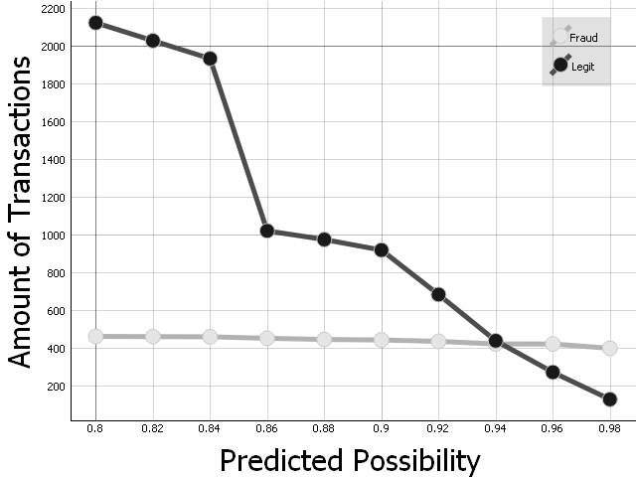
After implementing the proposed system and testing the original data-set against the trained model, first results show that while almost 95% of fraudulent transactions are marked as having a possibility of being fraudulent more than 80%, only 0.007% of the non-fraudulent transactions are marked with having the same amount of possibility to be fraudulent.
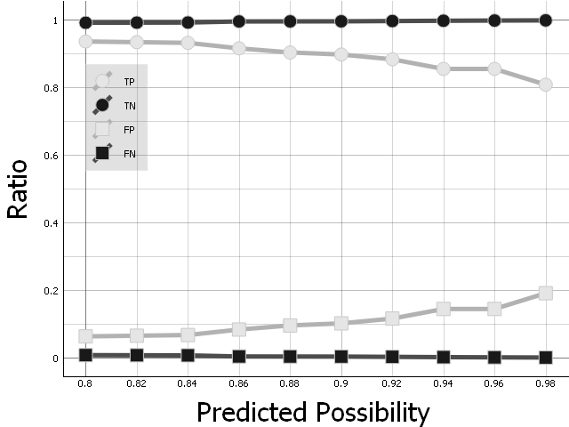
Figure 8 – Number of correctly predicted transactions for each threshold level above 80 percent
Figure 9 – Result of the prediction regarding the true positive (TP), true negatve (TN), false positive (FP) and false negative (FN) ratios.
Figure 8 shows that as the threshold for the possibility of being fraudulent increases, the amount of non-fraudulent transactions marked as high probability of being fraudulent (i.e. false-positives) drop to half around 86% while the amount of true-positives are barely affected. One cause of this might be that even though some non-fraudulent transactions have properties that cause them to be marked as having high probability of fraud, more than half of them still have significant differences to fraudulent transactions. However, increasing the threshold starts to affect the amount of true-positives after a certain amount. At the 95% mark, the amount of false-positives drop way below true-positives.
In the Figure 9 the effect on true-positives is much more prevalent. The amount of true-positives drop steadily as the threshold increases. Another interesting result is that even though both positives get lower and lower as the threshold increases, which is expected, almost 80% of the fraudulent transactions are marked as having a higher than 98% probability of being fraud while only a handful of non-fraudulent transactions, around 0.0005%, are marked as having the same probability of being fraud. These results show that a significant portion of fraudulent transactions might have identifying characteristics that separate them from non-fraudulent transactions.
According to these results, requesting for a second form of authentication, be it 3D Secure, Two-Factor Authentication or any other way that is more identifying than a password, can possibly prevent up to around 90% of frauds while disturbing the comfort of only one person out of every 200,000 people.

6 Conclusion and Future Work
The process of detecting and preventing fraud is a significantly hard task due to various reasons. There aren’t too much data available to begin with due to he sensitive nature of the credit card data. The available data has a great imbalance between fraudulent and non-fraudulent data due to the nature of all possible transactions: There are simply too many transactions happening every day and a great majority of them are genuine. Even then, the features available in the present data are anonymized and extracted using various methods, such as PCA, and therefore prevent some advanced forms of analysis where the trend of an account is analyzed, such as transaction history, average monetary amount of purchases made by a single customer or simply time of day when a customer usually finalizes a transaction.
Considering these limitations, there have been various attempts and solutions at both preventing and detecting credit card fraud. While some of the work we have researched approached problem as a binary classification problem, i.e. they try to arrive at a conclusion with a great certainity that a transaction happening or happened is fraud, while many others approach it as a regression problem and instead of certainities, they base their solutions on probabilities.
While there are many different machine learning algorithms in the literature, the extraordinary nature of the data removes most of them from the equation. Even though there have been various approaches, almost all of them go through the same steps of preparing the data. In order to prevent issues that may arise from the imbalance of the data, most of the works researched try to balance the data set using various techniques, such as oversampling, undersampling or random sampling.
Other than that, since some features of the transactions details are heavily imbalanced, such as the monetary amount or time of day the transaction is made, most of the researchers opt-in to normalize the data or transform it, e.g. convert time of day to partitions such as morning, evening or night.
Our approach to the problem at hand was similar. We took it as a problem of “prevention via probability prediction” and devised a strategy to increase the security of a transaction-processing system by first analyzing a transaction and arriving a probability value representing the probability of a transaction being fraudulent and requesting additional methods of verification if the probability exceeds a certain threshold.
As a preprocessing step, we have normalized time of the day of the input data and the monetary value, considering the imbalances in the aforementioned features and using a scaler that is robust against outliers.
Like other works on the topic, we have preprocessed the data to combat the issues caused by the imbalanced data and we have used SMOTE to synthetically generate fraudulent data points from the points we already had.
After preparing our data for learning, we have applied Random Forest Regression algorithm to train a model for predicting the probability of a fraudulent transaction, where a probability of one denoting an indisputable fraud and a probability of zero denoting a transaction that is completely genuine.
Testing the performance of our model, which is trained by using more than 500 thousand of data points, on the data set we have originally obtained, we have arrived at various conclusions.
One of these is that even a not-so-strong possibility of 80% was able to catch most of the fraudulent transactions while also capturing only a small subset of genuine transactions. However, increasing the threshold only by 5% reduced the amount of genuine transactions that got caught by half while missing only around 5% of the fraudulent transactions.
By choosing a threshold value strategically, it is possible to prevent most of the fraudulent transactions due to most of the fraudsters not having access to other devices of card-holders that can provide a second form of verification.
Even though the first results look promising to reduce the amount of credit card fraud, especially on transactions that a credit card is not present, there are many ways that this method can be improved and the results of the proposal here can be evaluated further.
Aside from that, more complex algorithms can be used for this problem. Recently, thanks to the advancements in high-speed computing, deep learning and neural networks became a performant and highly viable solution to this problem [17,21,22].
It is possible to use various other techniques to confirm the robustness of the solution proposed in this paper but one easy-to-test method, which is also effective on evaluating the robustness of the algorithm, is generating noisy data, as done in [13], to try to trick the algorithm and checking the performance of the solution against that data set.
One such way of improvement would be incorporating customer trends into the algorithm and weighing the predicted possibility with this trend to reduce the amount of falsely marked transactions.
Another possible improvement would be to provide better and easier methods of verification to card-holders. For example, sending an SMS for a Two-Factor Authentication might completely prevent the genuine customer to finalize transaction if it fails to arrive. One possible way of providing an easy and safe way of verification could be using multiple technologies together, such as combining NFC readers with biometrics to verify that the customer is making the transaction in a place he or she knows and the customer is actually the person he or she claims. The method of using biometrics also has a side-effect of improving the user’s trust on the system [9].
The problem at hand can be approached in many ways and each of them could try to solve different sub-problems, like the example given above regarding the ease-of-use.
References
- P. Tran, K. Tran, T. Huong, C. Heuchenne, P. HienTran and T. Le, "Real Time Data-Driven Approaches for Credit Card Fraud Detection", Proceedings of the 2018 International Conference on E-Business and Applications - ICEBA 2018, 2018. Available: 10.1145/3194188.3194196 [Accessed 13 November 2019].
- V. Jonnalagadda, P. Gupta and E. Sen " Credit card fraud de-tection using Random Forest Algorithm", International Journal of Advance Research, Ideas and Innovations in Technology, vol. 5, pp. 1797-1801, 2019.
- M. Zareapoor and P. Shamsolmoali, “Application of Credit Card Fraud Detection: Based on Bagging Ensemble Classifier,” Procedia Computer Science, vol. 48, pp. 679–685, 2015.
- M. Al-Shabi, "Credit Card Fraud Detection Using Autoencoder Model in Unbalanced Datasets", Journal of Advances in Mathematics and Computer Science, pp. 1-16, 2019. Available: 10.9734/jamcs/2019/v33i530192 [Accessed 13 November 2019].
- A. Pumsirirat and L. Yan, "Credit Card Fraud Detection using Deep Learning based on Auto-Encoder and Restricted Boltzmann Machine", International Journal of Advanced Computer Science and Applications, vol. 9, no. 1, pp. 18-25, 2018. Available: 10.14569/ijacsa.2018.090103.
- F. Carcillo, A. Dal Pozzolo, Y. Le Borgne, O. Caelen, Y. Mazzer and G. Bontempi, "SCARFF : A scalable framework for streaming credit card fraud detection with spark", Information Fusion, vol. 41, pp. 182-194, 2018. Available: 10.1016/j.inffus.2017.09.005 [Accessed 13 November 2019].
- D. Wang, B. Chen and J. Chen, "Credit card fraud detection strategies with consumer incentives", Omega, vol. 88, pp. 179-195, 2019. Available: 10.1016/j.omega.2018.07.001 [Accessed 13 November 2019].
- A. Fernandez, S. Garcia, F. Herrera and N. Chawla, "SMOTE for Learning from Imbalanced Data: Progress and Challenges, Marking the 15-year Anniversary", Journal of Artificial Intelligence Research, vol. 61, pp. 863-905, 2018. Available: 10.1613/jair.1.11192.
- O. Ogbanufe and D. Kim, "Comparing fingerprint-based biometrics authentication versus traditional authentication methods for e-payment", Decision Support Systems, vol. 106, pp. 1-14, 2018. Available: 10.1016/j.dss.2017.11.003 [Accessed 13 November 2019].
- J. Jurgovsky et al., "Sequence classification for credit-card fraud detection", Expert Systems with Applications, vol. 100, pp. 234-245, 2018. Available: 10.1016/j.eswa.2018.01.037 [Accessed 13 November 2019].
- J.S. Bridle, “Probabilistic Interpretation of Feedforward Classification Network Outputs, with Relationships to Statistical Pattern Recognition,” Neurocomputing—Algorithms, Architectures and Applications, F. Fogelman-Soulie and J. Herault, eds., NATO ASI Series F68, Berlin: Springer-Verlag, pp. 227-236, 1989. (Book style with paper title and editor)
- X. Wan, "Influence of feature scaling on convergence of gradient iterative algorithm", Journal of Physics: Conference Series, vol. 1213, p. 032021, 2019. Available: 10.1088/1742-6596/1213/3/032021 [Accessed 13 November 2019].
- K. Karthikeyan, K. Sangeeth Raj, S. Ramaganesh, P. Parthasarathi and N. Suguna, "Credit Card Fraud Detection Using Machine Learning", International Journal of Scientific Research in Science and Technology, vol. 6, no. 2, pp. 386-391, 2019. Available: 10.32628/IJSRST196271 [Accessed 13 November 2019].
- "Credit Card Fraud Detection", Kaggle.com, 2019. [Online]. Available: https://www.kaggle.com/mlg-ulb/creditcardfraud. [Accessed: 13- Nov- 2019].
- A. Estabrooks, T. Jo and N. Japkowicz, "A Multiple Resampling Method for Learning from Imbalanced Data Sets", Computational Intelligence, vol. 20, no. 1, pp. 18-36, 2004. Available: 10.1111/j.0824-7935.2004.t01-1-00228.x.
- K. Randhawa, C. Loo, M. Seera, C. Lim and A. Nandi, "Credit Card Fraud Detection Using AdaBoost and Majority Voting", IEEE Access, vol. 6, pp. 14277-14284, 2018. Available: 10.1109/access.2018.2806420 [Accessed 13 November 2019].
- A. Roy, J. Sun, R. Mahoney, L. Alonzi, S. Adams, and P. Beling, “Deep learning detecting fraud in credit card transactions,” 2018 Systems and Information Engineering Design Symposium (SIEDS), 2018.
- H. Naik and P. Kanikar, "Credit card Fraud Detection based on Machine Learning Algorithms", International Journal of Computer Applications, vol. 182, no. 44, pp. 8-12, 2019. Available: 10.5120/ijca2019918521.
- F. Akinbohun and S. Atanlogun, "Credit Card Fraud Detection System in Commercial Sites", European Journal of Engineering Research and Science, vol. 3, no. 11, pp. 1-5, 2018. Available: 10.24018/ejers.2018.3.11.920.
- D. Varmedja, M. Karanovic, S. Sladojevic, M. Arsenovic and A. Anderla, "Credit Card Fraud Detection - Machine Learning methods," 2019 18th International Symposium INFOTEH-JAHORINA (INFOTEH), East Sarajevo, Bosnia and Herzegovina, 2019, pp. 1-5.
- S. P. Maniraj, Aditya Saini, Shadab Ahmed and Swarna Deep Sarkar, "Credit Card Fraud Detection using Machine Learning and Data Science", International Journal of Engineering Research and, vol. 08, no. 09, 2019. Available: 10.17577/ijertv8is090031.
- C. Wang, Y. Wang, Z. Ye, L. Yan, W. Cai, and S. Pan, “Credit Card Fraud Detection Based on Whale Algorithm Optimized BP Neural Network,” 2018 13th International Conference on Computer Science & Education (ICCSE), 2018.

