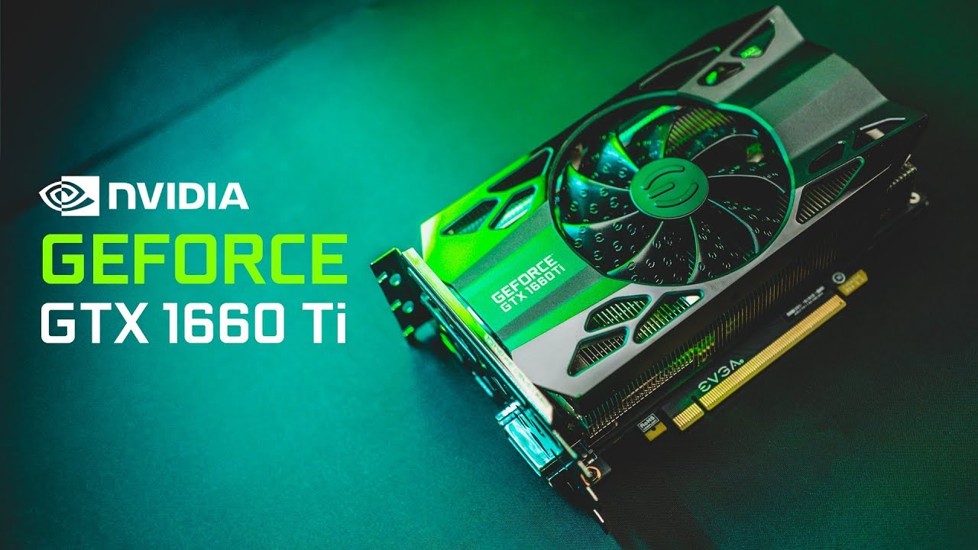

metin içeren bir resim

Açıklama otomatik olarak oluşturuldu

I started doing research about my computer's GPU. I got GPU information via DirectX Diagnostic Tool. My computer model is Monster Tulpar T5. I found out that my GPU is GeForce GTX 1660 Ti. I am very satisfied with my GPU quality. I think it's pretty good, especially for games. Technical specifications:

The GeForce GTX 1660 Ti stands out with 1,536 CUDA cores, 6GB of GDDR6 memory running at 12Gbps, and a core clock of 1.8GHz, which can be easily overclocked for more performance.

Featuring the 12th generation Turing GPU architecture, the GTX 1660 Ti leverages Turing's innovations in shader technology to deliver 2X the TOPS of the previous generation Pascal architecture. The GTX 1660 Ti supports simultaneous floating point and integer operations, unified cache architecture with 3xL1 cache, and adaptive shading technology.

The GeForce GTX 1660 Ti outperforms previous-generation GPUs, excelling in modern games with complex shaders. 1.5 times faster than the GeForce GTX 1060 6GB, the card offers a performance value of 120 frames per second in popular online games such as Fortnite, PUBG and Apex Legends.

**ZEYNEP NAZ CEYHAN / 210315003**