Course Name: Database Management Systems
Project Type: Term Project
Department: Software Engineering
University: Turkish Aeronautical Association University
LIBRARY MANAGEMENT SYSTEM

Student Name: Mithat Altay
Student Number: 210446017

Student Name: Zeynep Aydemir
Student Number: 210446019

Student Name: Alperen Çoban
Student Number: 210446020

Student Name: Mustafa Kutlu Şahin
Student Number: 210446036

LIBRARY MANAGEMENT SYSTEM PROJECT REPORT

1. Introduction
This project aims to design and implement a Library Management System that manages library members, books, and borrowing operations efficiently.
The system is developed using Entity Relationship (ER) modeling, transformed into a relational database schema, and implemented with a database-driven application and graphical user interface.

2. Project Scope
The scope of this project includes:
Managing library members
Managing books
Recording book borrowing and return transactions
Storing and managing data using a relational database

3. Technologies Used
Database: MySQL
Backend Language: C# / Java
User Interface: Graphical User Interface (GUI)
Modeling Tool: draw.io (diagrams.net)

4. Data Modeling Using Entity Relationship (ER) Model
The system is modeled using the Entity Relationship (ER) Model to represent entities, attributes, and relationships.

4.1 Entities and Attributes

Person
person_id (Primary Key)
full_name
birth_date
phone

Book
book_id (Primary Key)
title
subject
publisher
author

Loan
loan_id (Primary Key)
loan_date
return_date
The Loan entity is modeled as a transaction (associative) entity, as it represents the borrowing process and contains additional attributes.

4.2 Relationships
Person (1) — (N) Loan
A person can borrow multiple books.
Book (1) — (N) Loan
A book can be borrowed multiple times over time.

5. ER Diagram
The ER diagram illustrates the entities Person, Book, and Loan, along with their relationships and cardinalities.
Primary keys are defined for each entity, and all relationships are shown using 1:N cardinality.
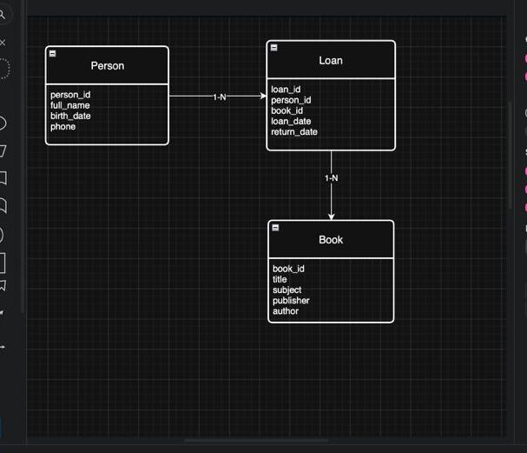

6. ER → Relational Mapping
After modeling the system using ER, the model is converted into a relational schema.

6.1 Mapping Rules
Each entity is mapped to a table.
Primary keys remain unchanged.
1:N relationships are implemented by adding foreign keys to the N-side.
Transaction entities are implemented as separate tables.

6.2 ER → Relational Mapping Table
ER Element | Relational Table | Primary Key | Foreign Key
Person | TBL_KISILER | person_id | —
Book | TBL_KITAPLAR | book_id | —
Loan | TBL_EMANETLER | loan_id | person_id → TBL_KISILER(person_id) book_id → TBL_KITAPLAR(book_id)

7. Database Schema Implementation

7.1 Person Table (TBL_KISILER)
Stores information about library members.

7.2 Book Table (TBL_KITAPLAR)
Stores information about books in the library.

7.3 Loan Table (TBL_EMANETLER)
Stores borrowing transactions linking persons and books.

8. SQL Queries

8.1 List All Loans
SELECT * FROM TBL_EMANETLER;

8.2 List Loans of a Specific Person
SELECT *
FROM TBL_EMANETLER
WHERE KISI_ID = ?;

8.3 List Books Borrowed by a Person
SELECT b.*
FROM TBL_KITAPLAR b
JOIN TBL_EMANETLER e ON b.ID = e.KITAP_ID
WHERE e.KISI_ID = ?;

9. Stored Procedure Implementation
At least one stored procedure is implemented as required.

9.1 Stored Procedure: Add Loan
CREATE PROCEDURE AddLoan (
IN p_person_id INT,
IN p_book_id INT,
IN p_loan_date DATE
)
BEGIN
INSERT INTO TBL_EMANETLER (KISI_ID, KITAP_ID, VERILIS_TARIH)
VALUES (p_person_id, p_book_id, p_loan_date);
END;
This procedure inserts a new borrowing record into the database.

10. Application Implementation
The application connects to the database and provides the following functionalities through a graphical user interface:
Add, update, and delete persons
Add, update, and delete books
Create loan records
Record book returns
The system does not use a console-based interface.

11. Conclusion
In this project, a Library Management System was successfully designed and implemented using ER modeling and relational database principles.
The system provides a simple and effective solution for managing library operations.

