**Bilkent University**

**Department of Computer Engineering**

**IE400 – Principles of Engineering Management**

**Spring 2021-2022**

**Principles of Engineering Project Report**

**İlke KAŞ - 21803184**

**Bora Fatih KAZANCI – 21801753**

**Zeynep Büşra ZİYAGİL - 21801646**

**IE400-01 – Instructor: Özlem KARSU**

**Part A:**

**Given Parameters:**

* *Si*: Satisfaction of product *i*, *i* = 1,2,..,45 (Product number)
* *Ci*: Price of product *i* , *i* = 1,2,..,45 (Product number)
* *Ai*: Amount of product *i* in one packet/unit, *i* = 1,2,..,45 (Product number)
* *B*: Allocated budget for the week’s shopping
* *T* : At most travel distance in meters
* *Dn*: The demand for need *n*, *n* = 1, 2, 3, 4 (Beverages, Carbodydrates, Cheese, Breakfast Foods)
* *dkl*: distance between *k* to *l, k,l* = 0, 1, 2, 3, 4 (House, A, B, C, D)

**New Parameters:**

* *Din*: Need type of the product *i* as type *n, i=1, 2,..45, n= 1, 2, 3, 4, Din* ∈ {0, 1}
* *Mik*: Availability of the product *i* in the market *k, i*=1,..,45 (Product number), *k*= 1, 2, 3, 4 (A, B, C, D), *Mik* ∈ {0, 1}

**Decision Variables:**

* *xi* : Amount of unit product taken from product *i*, *i* = 1, 2,..., 45 (Product number)
* *rkl*:*k,l* = 0, 1, 2, 3, 4 (House, A, B, C, D)
* *vk:* :, k = 0, 1, 2, 3, 4 (House, A, B, C, D)

**Model:**

**max $\sum_{i=1}^{45}{S_{i}x_{i} +(B-\sum_{i=1}^{45}{C_{i}x_{i}})}$**

**s.t.**

$\sum_{i=1}^{45}{C_{i}x_{i}} ≤ B$ (1)

$\sum_{i=1}^{45}{D_{in}x_{i}A_{i }≥D_{n} }, n= 1, 2, 3, 4$ (2)

$\sum_{k=1}^{4}{\sum_{l=1}^{4}{r_{kl}d_{kl}≤T}}$ (3)

$V_{k } ≤ z$ (4)

$\sum_{l=0}^{4}{r_{kl}}≥z$, *z* ∈ {0, 1} for every k = 1, 2, 3, 4

$\sum_{l=0}^{4}{r_{lk}}≤z$, *z* ∈ {0, 1} for every k = 1, 2, 3, 4

$\sum_{k=0}^{4}{r_{k0}}$ = 1 (5)

$\sum_{k=0}^{4}{r_{0k}}$ = 1

$\sum_{k=0}^{4}{V_{k }}≤3z +2$ (6)

$r_{k0} +r_{0k} -1 ≤ 4- 3z$, *z* ∈ {0, 1} for every k = 1, 2, 3, 4

$\sum_{i=1}^{45}{M_{ik}x_{i} ≤ 30z}$ (7)

$V_{k }≥30z-29$, *z* ∈ {0, 1} for every k = 1, 2, 3, 4

$V_{0 }=1$ (8)

rkk = 0, k = 1, 2, 3, 4 (9)

*xi,* ∀*i* = 1, . . . , 45, *xi= integer* (10)

*rkl* ∈ {0, 1} (11)

*vk* ∈ {0, 1}

**Explanation of New Parameters:** In addition to the given parameters, we define 2 new parameters combining the information given to make model more understandable. These two parameters are *Din* and *Mik*.

* ***Din*** is used to define the need type of each product in Ii. It is a binary parameter that shows if the product i’s need type is n, then *Din*= 1. If the product i’s need type is not n, then *Din*= 0. We encode need type as the following:
  + Beverage = 1
  + Carbodydatres = 2
  + Cheese = 3
  + Breakfast Foods = 4

For example, in the given data, since product 1 meet the beverage needs, *D11* =1, *D12* = 0, *D13* = 0, *D14* = 0

* ***Mik*** is used to define the availibility of the product i in the market k. It is a binary parameter that shows if the product i is in the market k, then *Mik*=1. If the product i is not in the market k, then *Mik*=0. We encode market type as the following:
  + Market A = 1
  + Market B = 2
  + Market C = 3
  + Market D = 4

For example in the given data, since product 1 in the market B, *M11* =0, *M12* = 1, *M13* = 0, *M14* = 0.

**Explanation of Decision Variables:**

* ***xi***  denotes the amount of unit product taken from unit product i. It is an integer variable which can be at least 0.
* ***rkl*** denotes the road from k place to l place. It is a binary variable that shows if the road from k place to l place is taken, *rkl* = 1. Otherwise, *rkl* = 0. We encoded places as the following here:
  + House = 0
  + Market A = 1
  + Market B = 2
  + Market C = 3
  + Market D = 4
* ***vk*** denotes whether the place k is visited or not. It is a binary variable that show if the place k is visited, *vk* = 1. Otherwise, *vk* = 0.

**Explanation of Objective Function:**

* In the objective function, the satisfaction amount is maximized. Firstly, the expression $\sum_{i=1}^{45}{S_{i}x_{i}}$ calculates the satisfaction amount of each product that is bought. If the unit product gives S amount of satisfaction and 2 unit product is taken, then satisfaction amount is considered as 2S.
* The second part of the objective function is $\sum_{i=1}^{45}{(B-\sum_{i=1}^{45}{C_{i}x_{i}})}$. Since each unit money from the spared money also gives per unit satisfaction, the spared money is calculated.

**Explanation of Constraints:**

* **(1) Budget Constraint:** Total cost of the products bought should not exceed the allocasted budget B. Therefore, total cost is calculated first and it is constrained to be smaller or equal to the allocated budget B. Budget B is 150 in the given data.
* **(2) Demand Constraint:** The needs must be met. Therefore, the total amount of the product i that are bought is calculated. Then, by multiplying the $D_{in}$, we learned the demand type of the product i which it meets. For each demand type n, we sum all products amount that meets the need n. This sum should be greate than or equal to the demands given in the data.

$\sum_{k=1}^{4}{\sum_{l=1}^{4}{r_{kl}d_{kl}≤T}}$

* **(3) Distance Constraint:** Throughout the shopping, the travelled distance should not exceed the T meters. $r_{kl}d_{kl}$ multiplication gives us the distance from place k to place l if the road is taken. The sum of this multiplication must be smaller than or equal to the T meters to not exceed it. The T value is 1600 meter in given data.
* **(4) Road Constraint:** If the place k is visited, then there is at least 1 road from place k to any other place l. We use “If.. then..” relation here.

1. If $V_{k } = 1$

Then $\sum_{l=0}^{4}{r_{kl}} ≥1$

1. If $V_{k } > 0$

Then $1- \sum_{l=0}^{4}{r_{kl}} ≤0$

$V_{k } ≤ 0$

or

$$1- \sum_{l=0}^{4}{r_{kl}} ≤0$$

$V_{k } ≤ Mz$

$$1- \sum_{l=0}^{4}{r_{kl}} ≤M(1-z)$$

Where M = 1

Second one is:

1. If $V_{k } = 1$

Then $\sum_{l=0}^{4}{r_{lk}} ≥1$

1. If $V_{k } > 0$

Then $1- \sum_{l=0}^{4}{r_{lk}} ≤0$

$V_{k } ≤ 0$

or

$$1- \sum_{l=0}^{4}{r_{lk}} ≤0$$

$V_{k } ≤ Mz$

$$1- \sum_{l=0}^{4}{r_{lk}} ≤M(1-z)$$

Where M = 1

For every k = 1, 2, 3, 4

* **(5) Home Constraints:** Since we have to leave the house and arrive the house at the end, we should have only one road from any of the k places to the house and we should only one road from house to any of the k places. Therefore sum of these two situation equals to one.
* **(6) Home -> node -> Home Constraint:** If the total visited places is greater than 2, then we must satisfy that our directed path should not be house -> market k -> house. Because we have other places to visit.

1. If ${\sum_{l=0}^{4}{V_{k}}}_{ } > 2$

Then $r_{0k} +r_{k0} ≤1$

1. If ${\sum_{l=0}^{4}{V_{k}}}_{ }- 2 > 0$

Then $r_{0k} +r_{k0 }-1 ≤0$

${\sum_{l=0}^{4}{V_{k}}}_{ }- 2 ≤ 0$

or

$$r_{0k} +r_{k0 }-1 ≤0$$

${\sum_{l=0}^{4}{V_{k}}}_{ }- 2 ≤ Mz$

$$r_{0k} +r_{k0 }-1 ≤M(1-z)$$

Where M = 3

For every k = 1, 2, 3, 4

**(7) Visiting Constraints:** If one is planning to buy product i, then s/he must visit the market place where the product i is in.

1. If ${\sum_{i=1}^{45}{M_{ik}}}_{ }X_{i} > 0$

Then $1-V_{k} ≤0$

${\sum_{i=1}^{45}{M_{ik}}}_{ }X_{i}≤ 0$

or

$$1-V_{k} ≤0$$

${\sum_{i=1}^{45}{M_{ik}}}_{ }X_{i} ≤ Mz$

$$1-V_{k} ≤M(1-z)$$

Where M = 30

For every k = 1, 2, 3, 4

**(8) Visiting House Constraint:** Since we have to leave the house and arrive the house at the end, we have to visit house. Therefore, $V_{0 }=1$ in every situation.

**(9) Self-Road Constraint:** The road from place k to place k should not be taken.

**(10) Sign Constraint:** The amount of unit product taken from product *i* must be greater than or equal to zero and an integer value.

**(11) Binary Constraints:** Since $r_{kl}$ indicates whether the road from place k to l is taken or not, it must be a binary variable and takes 0 or 1.

Since *vk*  indicates whether the place k is visited or not, it must be a binary variable and takes 0 or 1.

**Part B:**

The implementation has been done using Python with Gurobi Solver. Output is below.

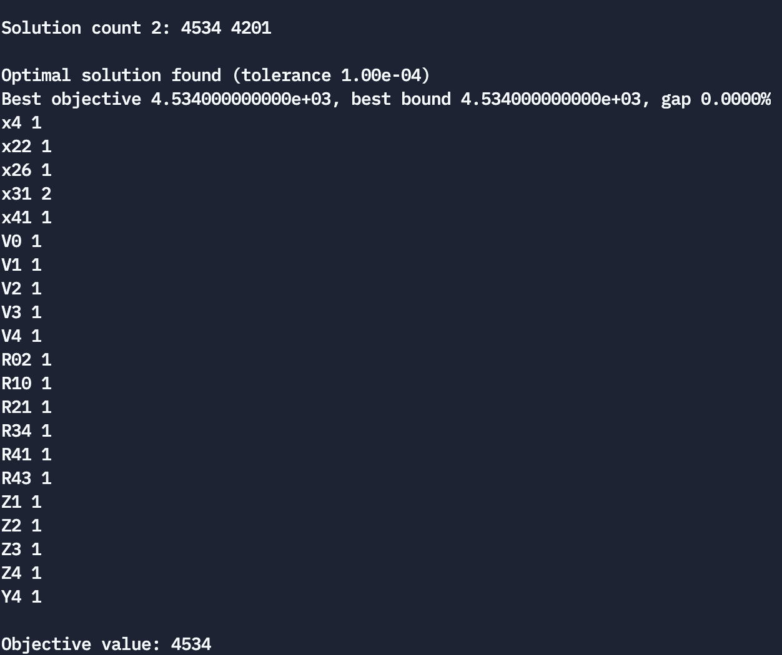

**Part C:**

**Given Parameters:**

* *Si*: Satisfaction of product *i*, *i* = 1,2,..,45 (Product number)
* *Ci*: Price of product *i* , *i* = 1,2,..,45 (Product number)
* *Ai*: Amount of product *i* in one packet/unit, *i* = 1,2,..,45 (Product number)
* *B*: Allocated budget for the week’s shopping
* *T* : At most travel distance in meters
* *Dn*: The demand for need *n*, *n* = 1, 2, 3, 4 (Beverages, Carbodydrates, Cheese, Breakfast Foods)
* *dkl*: distance between *k* to *l, k,l* = 0, 1, 2, 3, 4 (House, A, B, C, D)

**New Parameters:**

* *Din*: Need type of the product *i* as type *n, i=1, 2,..45, n= 1, 2, 3, 4, Din* ∈ {0, 1}
* *Mik*: Availability of the product *i* in the market *k, i*=1,..,45 (Product number), *k*= 1, 2, 3, 4 (A, B, C, D), *Mik* ∈ {0, 1}

**Decision Variables:**

* *xi* : Amount of unit product taken from product *i*, *i* = 1, 2,..., 45 (Product number)
* *rkl*:*k,l* = 0, 1, 2, 3, 4 (House, A, B, C, D)
* *vk:* :, k = 0, 1, 2, 3, 4 (House, A, B, C, D)

**Model:**

**max $\sum_{i=1}^{45}{S_{i}x_{i} +(B-\sum_{i=1}^{45}{C_{i}x_{i}})}$**

**s.t.**

$\sum_{i=1}^{45}{C_{i}x_{i}} ≤ B$ (1)

$\sum_{i=1}^{45}{D_{in}x_{i}A_{i }≥D_{n} }, n= 1, 2, 3, 4$ (2)

$\sum_{k=1}^{4}{\sum_{l=1}^{4}{r_{kl}d_{kl}≤T}}$ (3)

$V_{k } ≤ z$ (4)

$\sum_{l=0}^{4}{r_{kl}}≥z$, *z* ∈ {0, 1} for every k = 1, 2, 3, 4

$\sum_{l=0}^{4}{r_{lk}}≤z$, *z* ∈ {0, 1} for every k = 1, 2, 3, 4

$\sum_{k=0}^{4}{r_{k0}}$ = 1 (5)

$\sum_{k=0}^{4}{r_{0k}}$ = 1

$\sum_{k=0}^{4}{V_{k }}≤3z +2$ (6)

$r_{k0} +r_{0k} -1 ≤ 4- 3z$, *z* ∈ {0, 1} for every k = 1, 2, 3, 4

$\sum_{i=1}^{45}{M_{ik}x_{i} ≤ 30z}$ (7)

$V_{k }≥30z-29$, *z* ∈ {0, 1}

$x_{31}≤x_{25}$**(8)**

$V_{0 }=1$ (9)

rkk = 0, k = 1, 2, 3, 4 (10)

*xi,* ∀*i* = 1, . . . , 45, *xi= integer* (11)

*rkl* ∈ {0, 1} (12)

*vk* ∈ {0, 1}

**Explanation of New Parameters:** All of the new parameters are the same as explained in Part A.

**Explanation of Decision Variables:** All of the decision variables are the same as explained in Part A.

**Explanation of Objective Function:** The objective function does not change since the wanted constraint in this part can be handled by only **constraint (8).**

**Explanation of Constraints:** The constrains (1)-(7) is the same as the constraints (1)-(7) of Part A. The constrains (9)-(12) is the same as the constraints (8)-(11) of Part A. Only the constraint (8) is added.

* **(8) Bundled Product Constraint:** Since product 31 and product 25 is bundled, if product 31 is taken then the product 25 must be taken too.

**Output:**

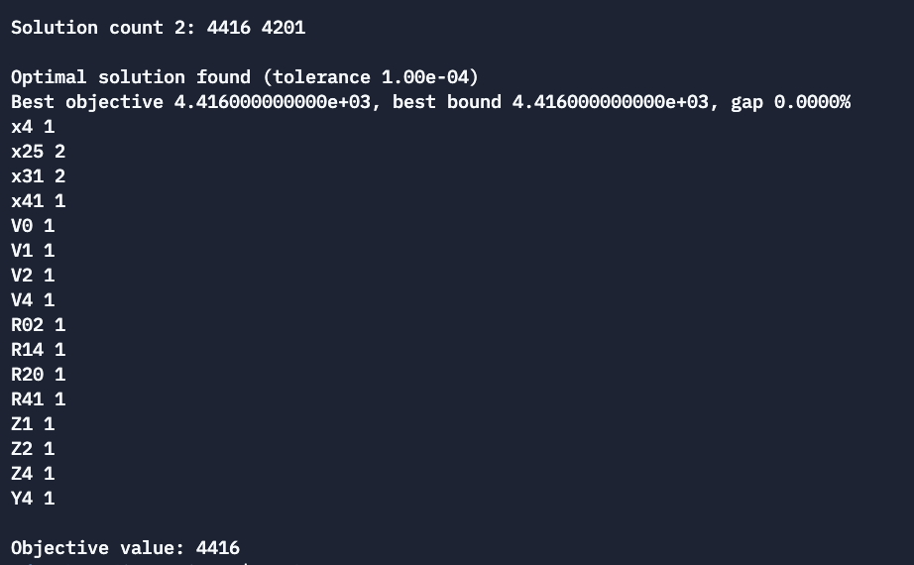

**Part D:**

**Given Parameters:**

* *Si*: Satisfaction of product *i*, *i* = 1,2,..,45 (Product number)
* *Ci*: Price of product *i* , *i* = 1,2,..,45 (Product number)
* *Ai*: Amount of product *i* in one packet/unit, *i* = 1,2,..,45 (Product number)
* *B*: Allocated budget for the week’s shopping
* *T* : At most travel distance in meters
* *Dn*: The demand for need *n*, *n* = 1, 2, 3, 4 (Beverages, Carbodydrates, Cheese, Breakfast Foods)
* *dkl*: distance between *k* to *l, k,l* = 0, 1, 2, 3, 4 (House, A, B, C, D)

**New Parameters:**

* *Din*: Need type of the product *i* as type *n, i=1, 2,..45, n= 1, 2, 3, 4, Din* ∈ {0, 1}
* *Mik*: Availability of the product *i* in the market *k, i*=1,..,45 (Product number), *k*= 1, 2, 3, 4 (A, B, C, D), *Mik* ∈ {0, 1}

**Decision Variables:**

* *xi* : Amount of unit product taken from product *i*, *i* = 1, 2,..., 45 (Product number)
* *rkl*:*k,l* = 0, 1, 2, 3, 4 (House, A, B, C, D)
* *vk:* :, *k* = 0, 1, 2, 3, 4 (House, A, B, C, D)
* *yi:* , *i =* 1,2,.....,45

**Model:**

**max $\sum_{i=1}^{45}{S_{i}x_{i} +(B-\sum_{i=1}^{45}{C_{i}x_{i}})}$**

**s.t.**

$\sum_{i=1}^{45}{C_{i}x_{i}} ≤ B$ (1)

$\sum_{i=1}^{45}{D_{in}x_{i}A_{i }≥D_{n} }, n= 1, 2, 3, 4$ (2)

$\sum_{k=1}^{4}{\sum_{l=1}^{4}{r_{kl}d_{kl}≤T}}$ (3)

$V_{k } ≤ z$ (4)

$\sum_{l=0}^{4}{r_{kl}}≥z$, *z* ∈ {0, 1} for every k = 1, 2, 3, 4

$\sum_{l=0}^{4}{r_{lk}}≤z$, *z* ∈ {0, 1} for every k = 1, 2, 3, 4

$\sum_{k=0}^{4}{r_{k0}}$ = 1 (5)

$\sum_{k=0}^{4}{r_{0k}}$ = 1

$\sum_{k=0}^{4}{V_{k }}≤3z +2$ (6)

$r_{k0} +r_{0k} -1 ≤ 4- 3z$, *z* ∈ {0, 1} for every k = 1, 2, 3, 4

$\sum_{i=1}^{45}{M_{ik}x_{i} ≤ 30z}$ (7)

$V_{k }≥30z-29$, *z* ∈ {0, 1} for every k = 1, 2, 3, 4

$x_{i} ≤ 30z$**(8)**

$y_{i} ≤ 30z-29$, *z* ∈ {0, 1} for every k = 1, 2, 3, 4

$y_{22} +y_{26}≤1$**(9)**

$V_{0 }=1$ (10)

rkk = 0, k = 1, 2, 3, 4 (11)

*xi,* ∀*i* = 1, . . . , 45, *xi= integer* (12)

*rkl* ∈ {0, 1} (13)

*vk* ∈ {0, 1}

**Explanation of New Parameters:** All of the new parameters are the same as explained in Part A.

**Explanation of Decision Variables:** All of the decision variables are the same as explained in Part A except *yi* variable.

* ***yi***denotes whether product i is taken or not. It is a binary variable that can take values 0 and 1. If the product i is taken, then *yi* = 1. Otherwise, *yi* = 0.

**Explanation of Objective Function:** The objective function does not change since the wanted constraint in this part can be handled by **constraint (8)** and **constraint(9).**

**Explanation of Constraints:** The constrains (1)-(7) is the same as the constraints (1)-(7) of Part A. The constrains (10)-(12) is the same as the constraints (8)-(11) of Part A. The constraints (8) and (9) are added.

* **(8) Bundled Product Constraint:** Since product 31 and product 25 is bundled, if product 31 is taken then the product 25 must be taken too.
* **(9) Disjoint Purchase Constraint:** the product 22 and the product 26 cannot be taken together. So, their *yi* values cannot be both 1. Therefore, sum of *y22* and *y26* must be equal or smaller than 1.

**Output:**

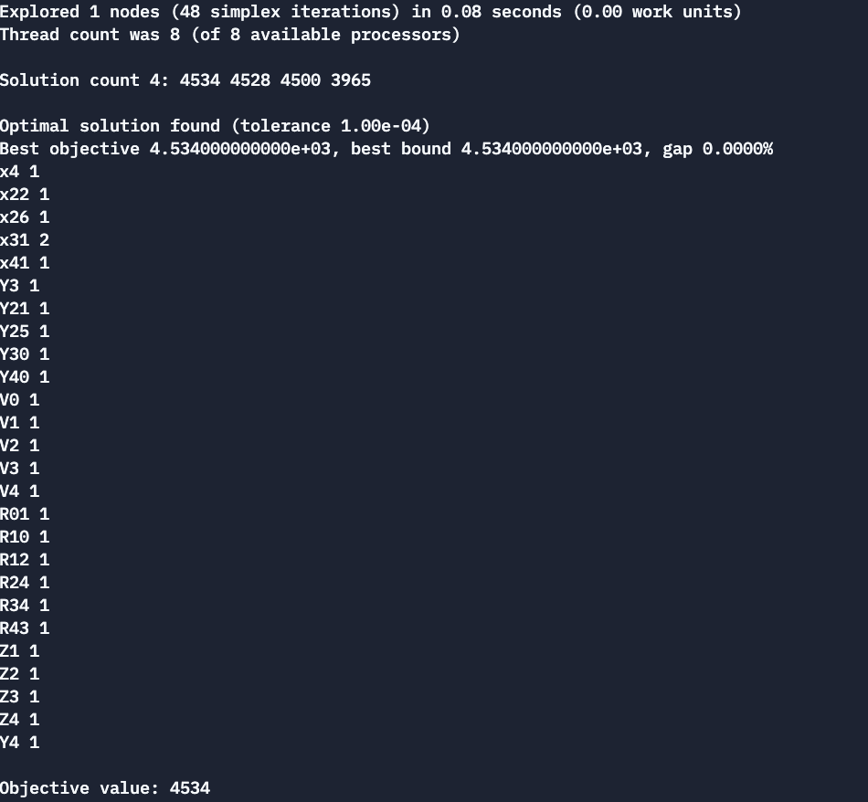

**PART E:**

**Given Parameters:**

* *Si*: Satisfaction of product *i*, *i* = 1,2,..,45 (Product number)
* *Ci*: Price of product *i* , *i* = 1,2,..,45 (Product number)
* *Ai*: Amount of product *i* in one packet/unit, *i* = 1,2,..,45 (Product number)
* *B*: Allocated budget for the week’s shopping
* *T* : At most travel distance in meters
* *Dn*: The demand for need *n*, *n* = 1, 2, 3, 4 (Beverages, Carbodydrates, Cheese, Breakfast Foods)
* *dkl*: distance between *k* to *l, k,l* = 0, 1, 2, 3, 4 (House, A, B, C, D)
* *Tk: Time spent in market k, k = 1, 2, 3, 4*
* *Td: Maximum time spent*

**New Parameters:**

* *Din*: Need type of the product *i* as type *n, i=1, 2,..45, n= 1, 2, 3, 4, Din* ∈ {0, 1}
* *Mik*: Availability of the product *i* in the market *k, i*=1,..,45 (Product number), *k*= 1, 2, 3, 4 (A, B, C, D), *Mik* ∈ {0, 1}

**Decision Variables:**

* *xi* : Amount of unit product taken from product *i*, *i* = 1, 2,..., 45 (Product number)
* *rkl*:*k,l* = 0, 1, 2, 3, 4 (House, A, B, C, D)
* *vk:* :, k = 0, 1, 2, 3, 4 (House, A, B, C, D)

**Model:**

**max $\sum_{i=1}^{45}{S_{i}x_{i} +(B-\sum_{i=1}^{45}{C_{i}x_{i}})}$**

**s.t.**

$\sum_{i=1}^{45}{C_{i}x_{i}} ≤ B$ (1)

$\sum_{i=1}^{45}{D_{in}x_{i}A_{i }≥D_{n} }, n= 1, 2, 3, 4$ (2)

$\sum_{k=1}^{4}{\sum_{l=1}^{4}{r_{kl}d_{kl}≤T}}$ (3)

$V_{k } ≤ z$ (4)

$\sum_{l=0}^{4}{r_{kl}}≥z$, *z* ∈ {0, 1} for every k = 1, 2, 3, 4

$\sum_{l=0}^{4}{r_{lk}}≤z$, *z* ∈ {0, 1} for every k = 1, 2, 3, 4

$\sum_{k=0}^{4}{r_{k0}}$ = 1 (5)

$\sum_{k=0}^{4}{r_{0k}}$ = 1

$\sum_{k=0}^{4}{V_{k }}≤3z +2$ (6)

$r_{k0} +r_{0k} -1 ≤ 4- 3z$, *z* ∈ {0, 1} for every k = 1, 2, 3, 4

$\sum_{i=1}^{45}{M_{ik}x_{i} ≤ 30z}$ (7)

$V_{k }≥30z-29$, *z* ∈ {0, 1} for every k = 1, 2, 3, 4

$\sum_{k=1}^{4}{v_{k}T_{k} + \sum_{l=0}^{4}{\sum_{k=0}^{4}{\frac{d_{kl}r_{kl}}{5} ≤}}}$ Td **(8)**

$V_{0 }=1$ (9)

rkk = 0, k = 1, 2, 3, 4 (10)

*xi,* ∀*i* = 1, . . . , 45, *xi= integer* (11)

*rkl* ∈ {0, 1} (12)

*vk* ∈ {0, 1}

**Explanation of Parameters:** Td as added as maximum time spent in throught the shopping. Tn shows the time spent in each market.

**Explanation of New Parameters:** All of the new parameters are the same as explained in Part A.

**Explanation of Decision Variables:** All of the decision variables are the same as explained in Part A.

**Explanation of Objective Function:** The objective function does not change since the wanted constraint in this part can be handled by only **constraint (8).**

**Explanation of Constraints:** The constrains (1)-(7) is the same as the constraints (1)-(7) of Part A. The constrains (9)-(12) is the same as the constraints (8)-(11) of Part A. Only the constraint (8) is added.

* **(8) Time Constraint: $\sum_{k=1}^{4}{v_{k}T_{k} }$**  part of this constraint calculates the time spent in markets if they are visited. $\sum_{l=0}^{4}{\sum_{k=0}^{4}{\frac{d_{kl}r_{kl}}{5} }}$ part of this constraint calculates the time spent in the roads.

**Output:**

