BEX6510 Notes
Table of Contents

Matrix Algebra

Linear Models
Notation
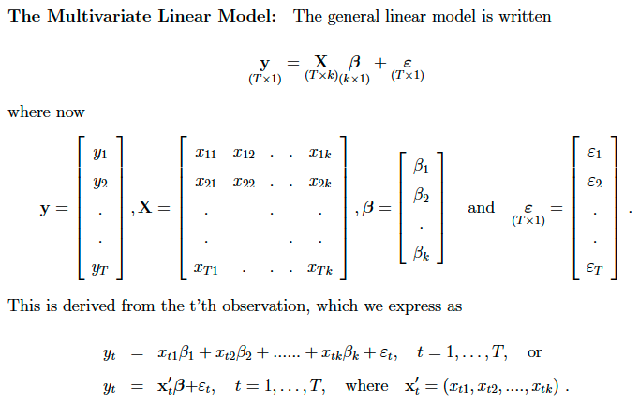
Assumptions/regularity conditions
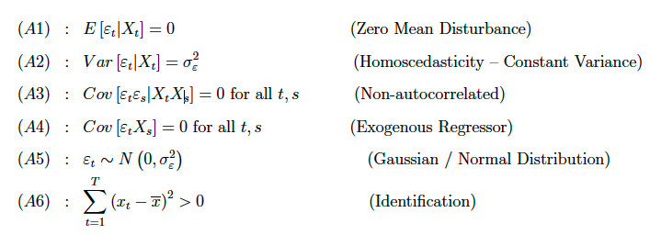
Useful matrix algebra identity
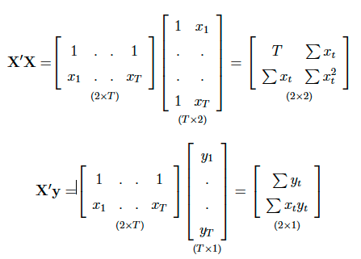

FWL Theorem
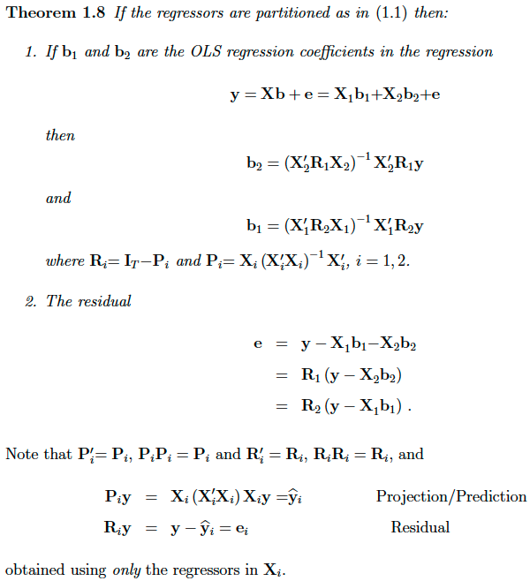

Statistical Properties of OLS
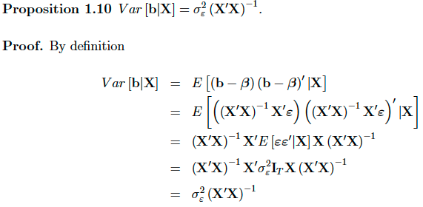
Proof of variance of residuals
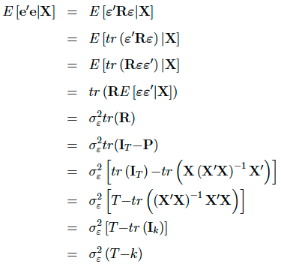

Inference
The very basic case
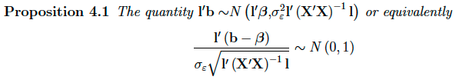
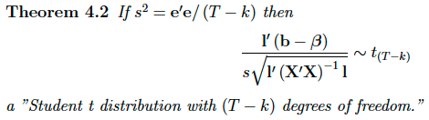
More generally
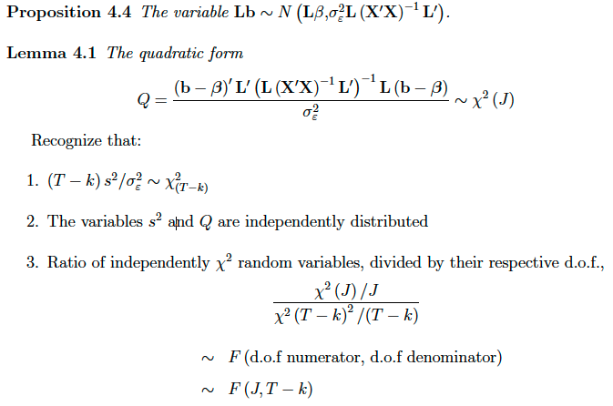
Restricted Least Squares (Lagrange Approach)
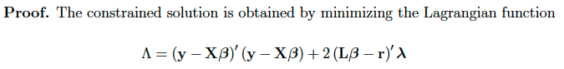
Note the choice of choosing the lagrange multiplier to has a constant in front to simplify things!
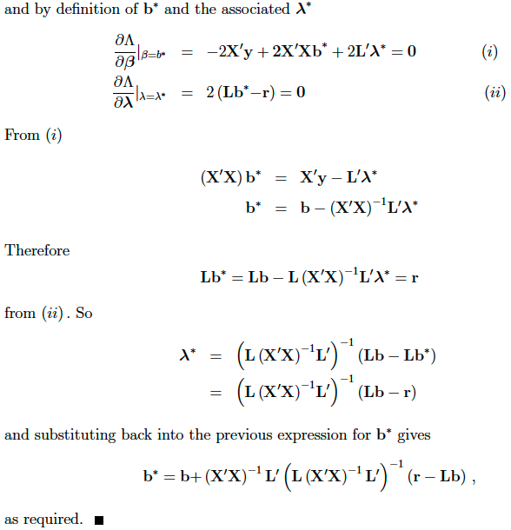

Chow test
Normal derivation
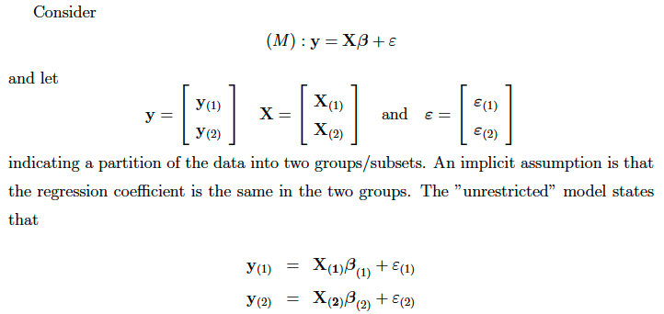
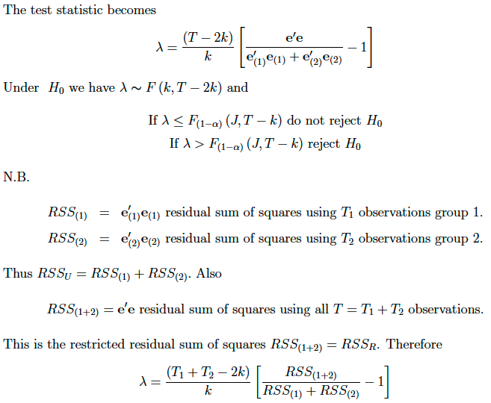
Alternative derivation when one of the sub samples has less observations than regressors:
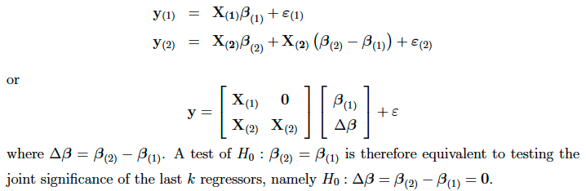
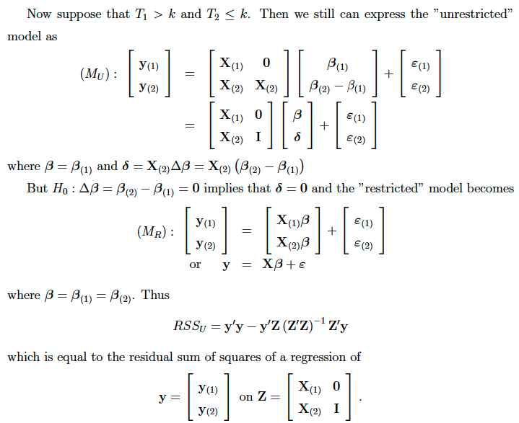
This is an F test with (T - T2 - k) = (T1 - k) dof and T2 indicator variables (restrictions).
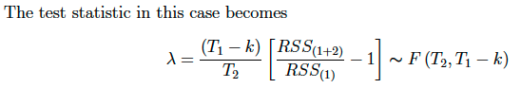

Likelihood
KL divergence. Note that the relative orders of the thetas are reversed in the fraction.
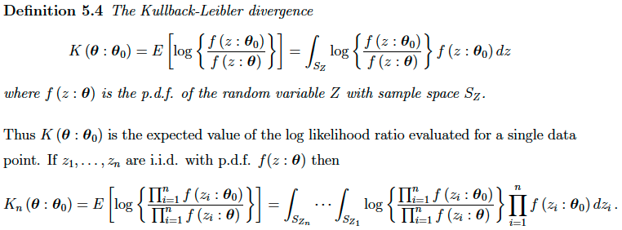
This proof is straightforward, but tedious. Focus on a case of n = 2. Just expand out the multiplication, etc.
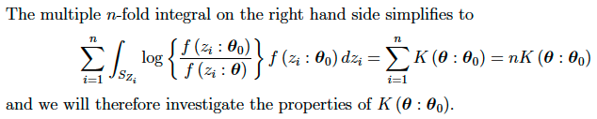
Remember that log(x) is concave, and -log(x) is convex.

Notation
The support function is the loglikelihood
The score is the 1st derivative of the loglikelihood
The hessian is the 2nd derivative of the loglikelihood
The fisher information is the expected value of the outer product of the score
Under certain conditions, the fisher information is also negative expected value of the hessian

Conditions
MLE estimator itself exists.
In practical terms, need to check that:
- loglik is continuous and differentiable wrt theta
- loglik is bounded (finite)
- limits of loglik, and check that this crosses over 0 (implies a turning point, and hence existence)
Alternatively, use the second derivative directly:
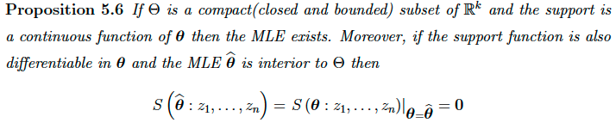
If the parameter space is convex, and loglik is concave (negative 2nd derivative), then the MLE exists and is unique (note that uniqueness impliex existence).

Statistical Properties of MLE
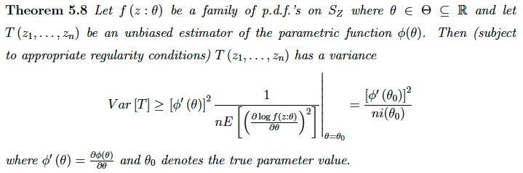
Easy way to check that some unbiased estimator reaches the CRLB.
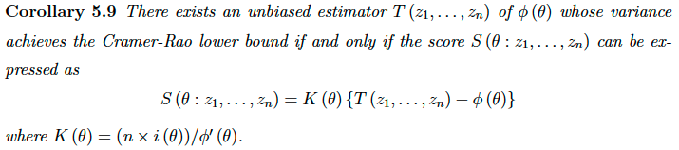
Practically, in the case of MLE, K(theta) can actually be any arbitrary function of theta, as noted by Casella and Berger, pg 364.
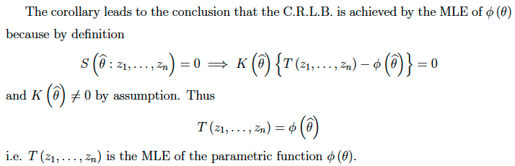

OLS MLE
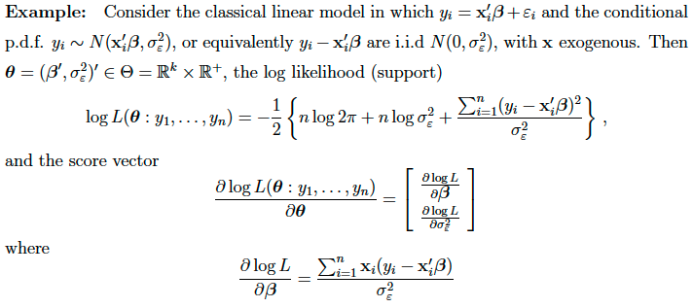
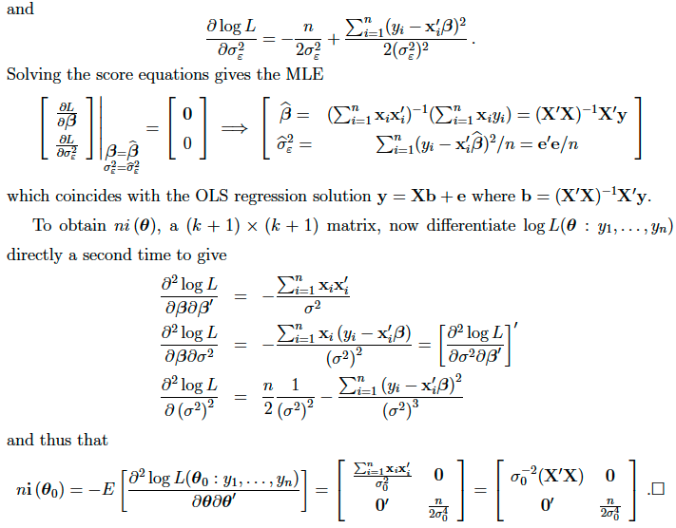

Asymptotic Properties
General distribution of MLE:
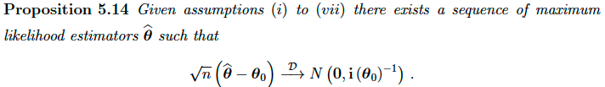
Note that the information matrix relies on true theta0, so instead use i(theta hat) as a consistent estimator for it.

Inference
Restrictions are denoted
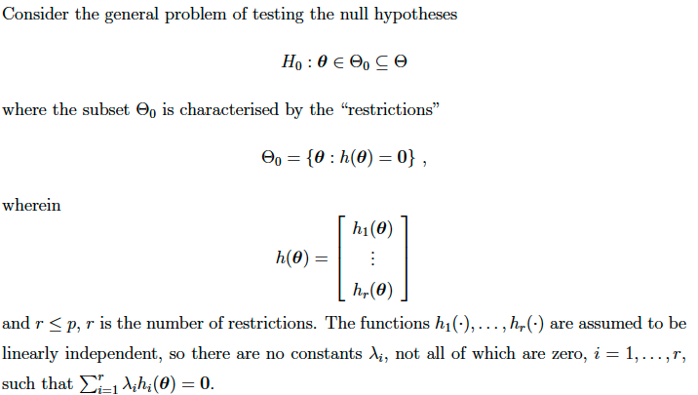

Wald Test
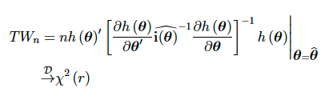
Proof: 1st order Taylor Expand h(theta hat) about true theta 0

LM/Gradient Test
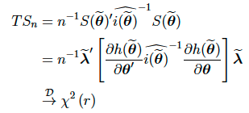
The proof in the notes has typos.

Likelihood Ratio (criterion differnce) test
The easiest one!
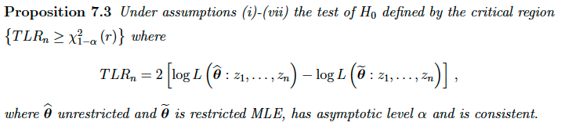
Proof is harder, requires 2nd order Taylor Series expansion.

Stochastic Order

Generalised Method of Moments
Note that Method of Moments is too easy and skipped (not too exciting).
There are p parameters, and k moment conditions
The true moment conditions are denoted by h, s.t. E(h) = 0
The sample moment conditions are denoted by m, whose sample (empirical) means correspond to E(h)
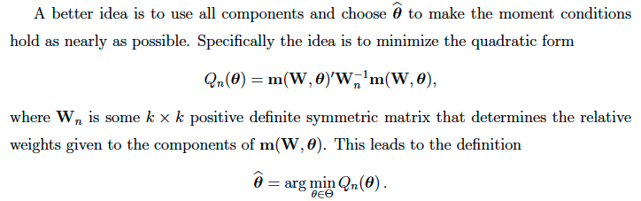
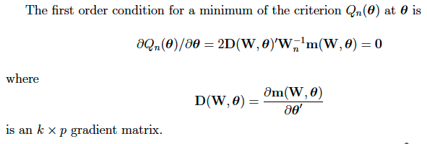
GMM is identified if:
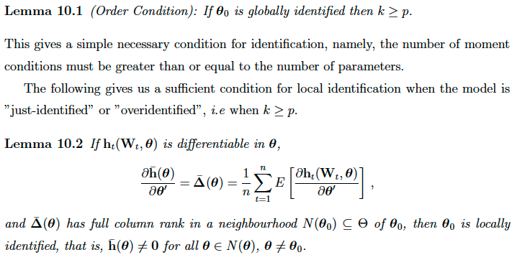

Asymptotics
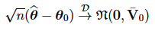
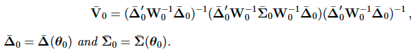
The proof is a straightforward, by tedious Taylor Series expansion about m(theta hat)
Relative Efficiency
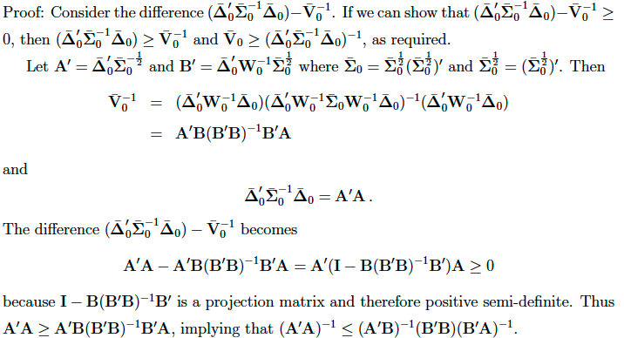

Weighting matrix
A an efficient weighting matrix needs to chosen up to a proportionality:
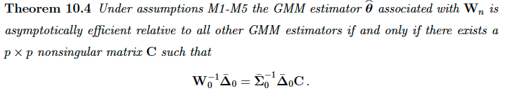
In practice, is it easier to directly work out the variance of the moment conditions and get the standard efficient weighting matrix.
However, the previous result is useful, as this allows us to be sloppy with constants (e.g. missing Ts).

OLS
Worked example
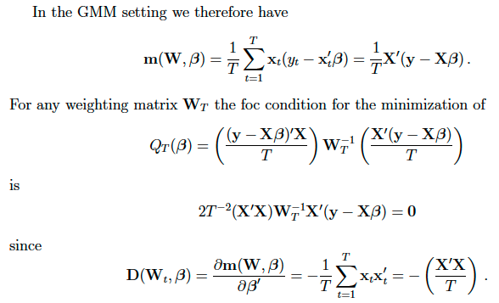

IV Regression
Worked Example. Note that sometimes Don is sloppy and specifies different T proportionalities.
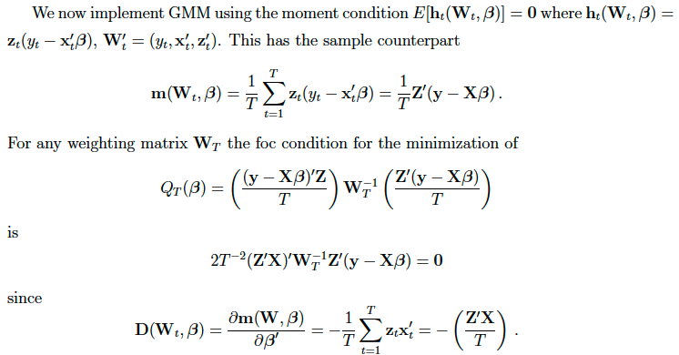
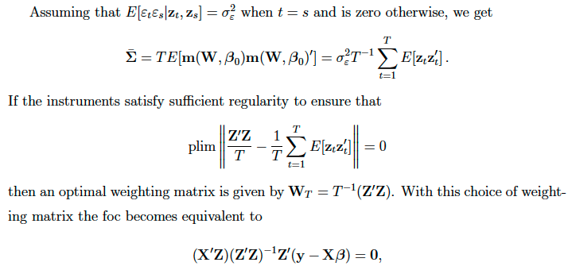

MLE
Worked Example

Inference

Wald Test

LM/Gradient Test

Criterion Difference Test

Notation

Inference

Extremum Estimators

Censoring and Truncation

Truncated
A truncated distribution is where any observations exceeding some threshold are not observed at all.

Censored
A censored distribution is where any observations exceeding some threshold are simply recorded as that threshold, but its actual value is unknown (censored).

Generalised Linear Models (GLMs)

