Part1
- Gini of data is 0.4628099173553719, Entropy of data is 0.9456603046006401
- (1) 0.9230769230769231, 0.9230769230769231 (2) 0.9230769230769231, 0.9090909090909091
- 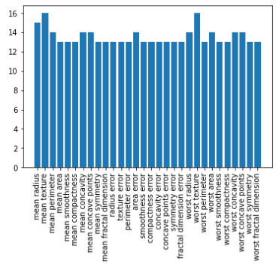
- (1) 0.9090909090909091, 0.9300699300699301 (2) 0.9440559440559441, 0.951048951048951
Part2