Part. 1
2. Learning curve
Objective Function MSE
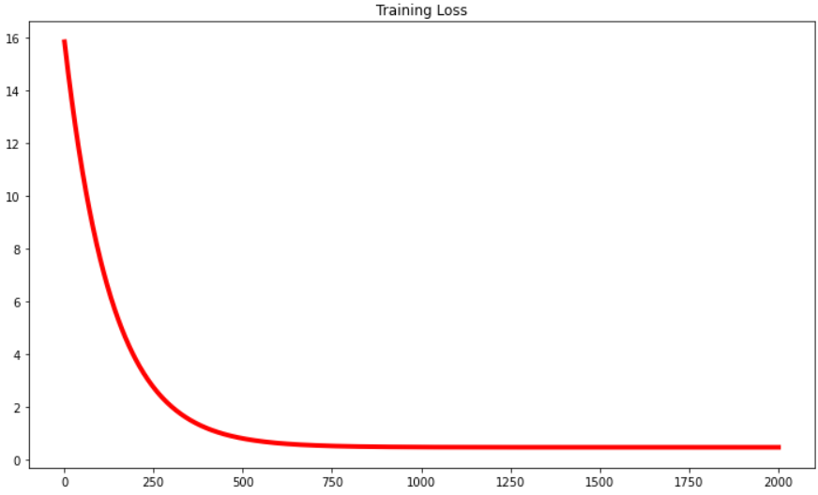
Objective Function MAE
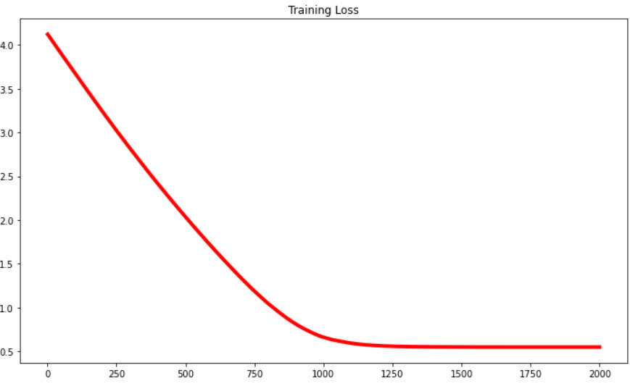

3. (mean square error, mean absolute error)
Objective Function MSE: (0.4933055707242924, 0.5625219139338563)
Objective Function MAE: (0.4943236609451898, 0.5640064991580637)

4. (weights, intercepts)
Objective Function MSE: (0.4527677032784589, -0.04147920939334472)
Objective Function MAE: (0.4338474404673587, -0.03764348286956803)

5. gradient descent每更新一次weights, intercepts就要跑完所有的訓練資料；mini-batch gradient descent把所有訓練資料分成很多份，每次更新weights, intercepts就只要跑完其中一份；stochastic gradient descent跟mini-batch gradient descent一樣是分小份的，但是每次的樣本是隨機抽取
Part. 2
