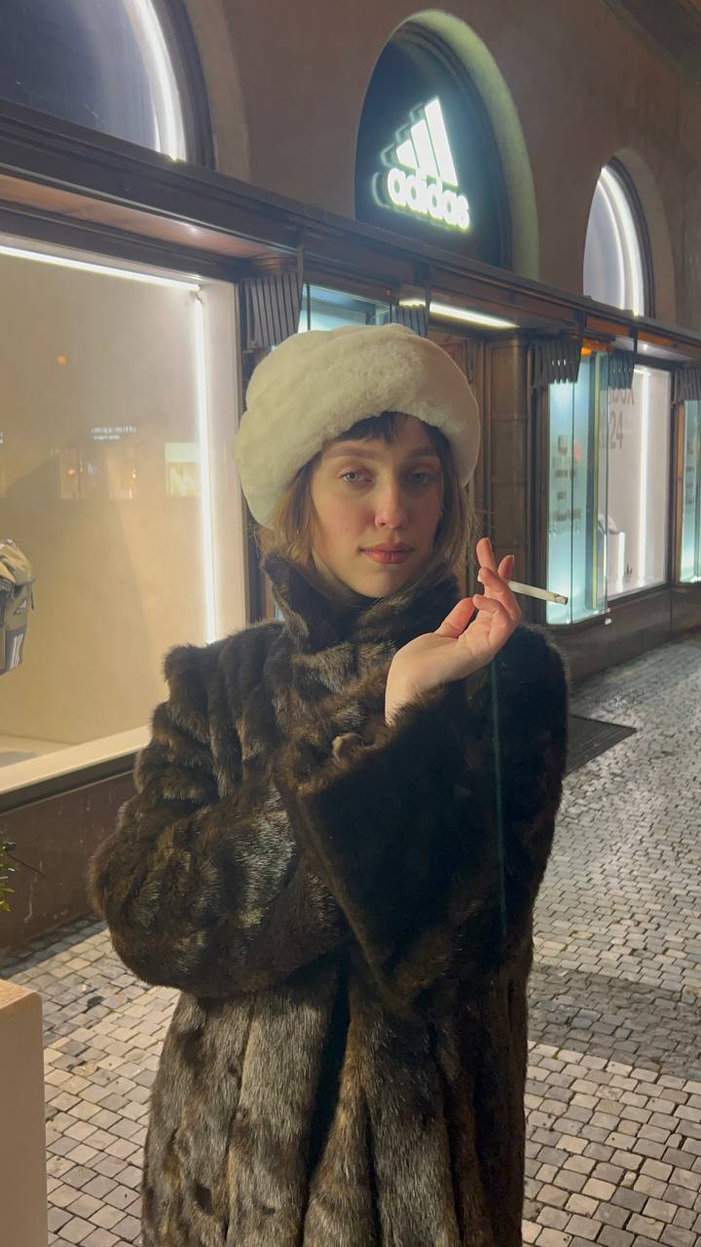 Hi! This is me, Liza. And I would like you to get to know me better through this presentation, where I will tell you about my creative projects, workflow and hobbies.

Long story short:   
I am 21 years old and I started my creative journey back in 2013, when I was enrolled at the Art school in Dnipro. After graduating, I met a painter, who became my graphic teacher for the next 4 years. In 2020 I moved to Prague to study animation and visual effects and this is what I still do.

**Storyboard projects:**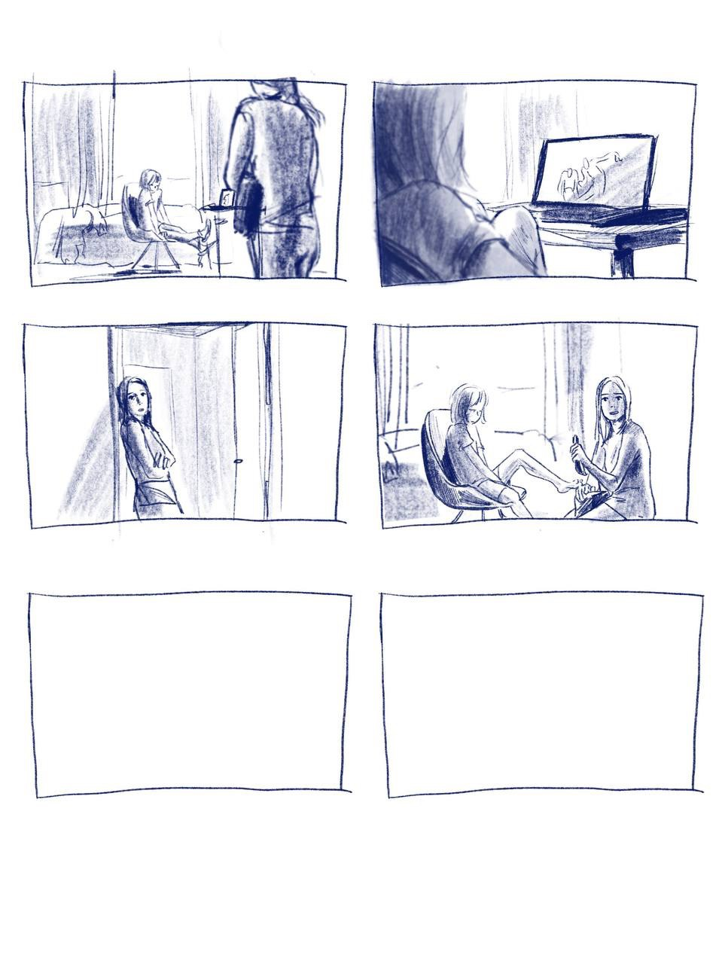

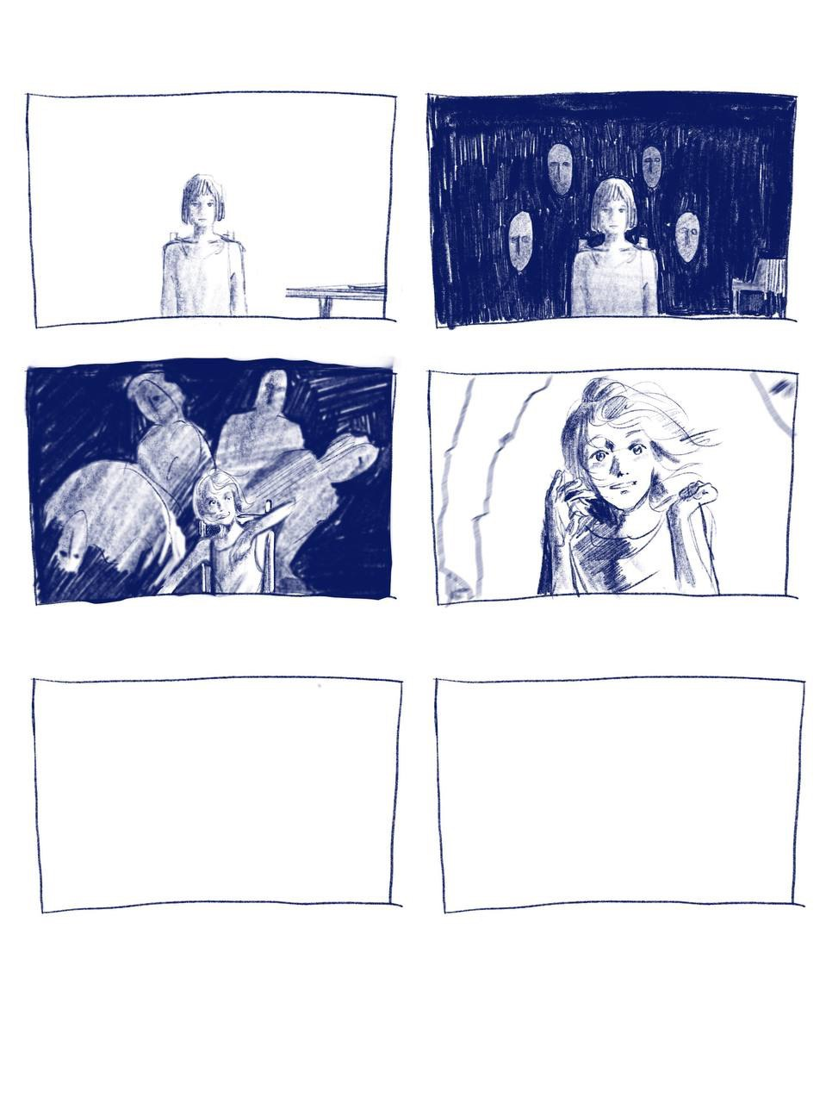

The storyboard project above was a commercial project for the advertisement of Prague ballet. The story begins with the girl sitting in the room waiting for her older sister who is (occasionally) a ballerina preparing for the show repetition. Meanwhile mystic heads appear and immediately the performance begins. The little girl is whirling in the dance, but unfortunately the show stops as the older sister comes to the room and says that she was ready and they had to go. The whole plot is based on the little sister, who accompanies the older one on her way to the show and the ballet, which a girl notices everywhere in the city.

The story and characters were already written by the director, so my role was to find visual solutions such as camera angle, place for the action, movement and to express the video's mood.

In general that was not that complicated, because we see a lot of scenes of casual life in advertisements, movies, series etc. However, more rare are shoots in specific fields such as dance. It's not a pretty common activity, so for that reason it's got less references.

For one scene I was using an angle from the Black swan by Darren Aranofski. Also I was inspired by an impressionist painter Edgar Degas, who was famous for his voyeuristic pictures of ballerinas.

**Comics.**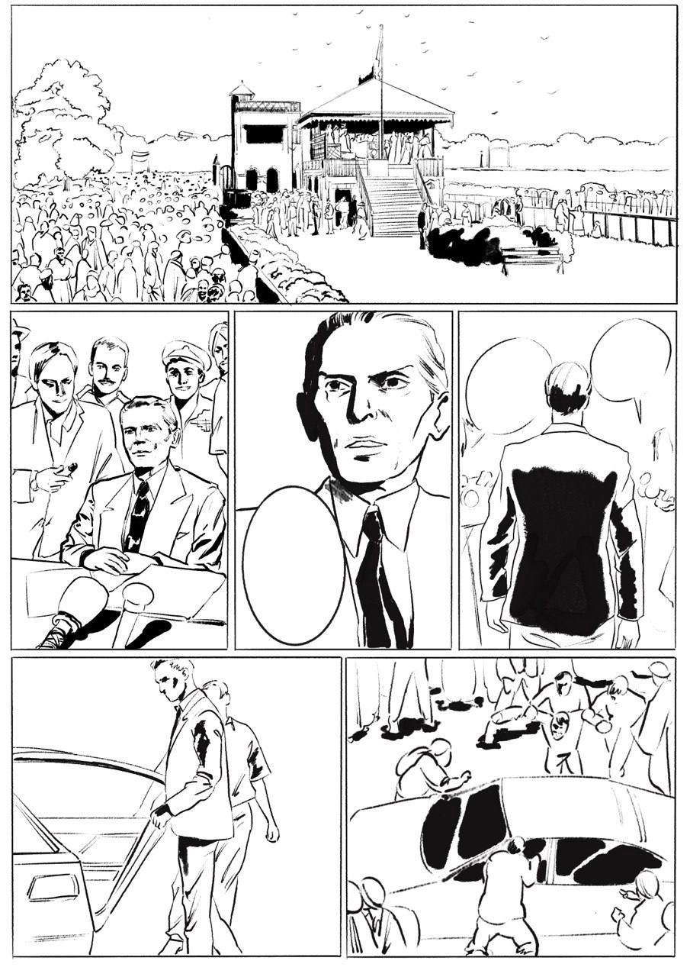

Once upon a time I was illustrating comics about the leader of the independence revolution in Pakistan Muhammad Ali-Jinah. That was an interesting project because I had the possibility to learn more about liberal movements and to train my skill of expressing the story through the picture.

Sometimes it takes time to make each picture good looking and also keep the composition of the whole page harmonic.

The part which I did not really like was that I was the only one illustrator, so that means that I was supposed to draw main characters, backgrounds, minor characters, looking for ethnic clothes of Pakistan for a more precise and truthworth environment, color it all, texturise and text writing. Though It was not a well-paid job, It taught me to value my time and work.

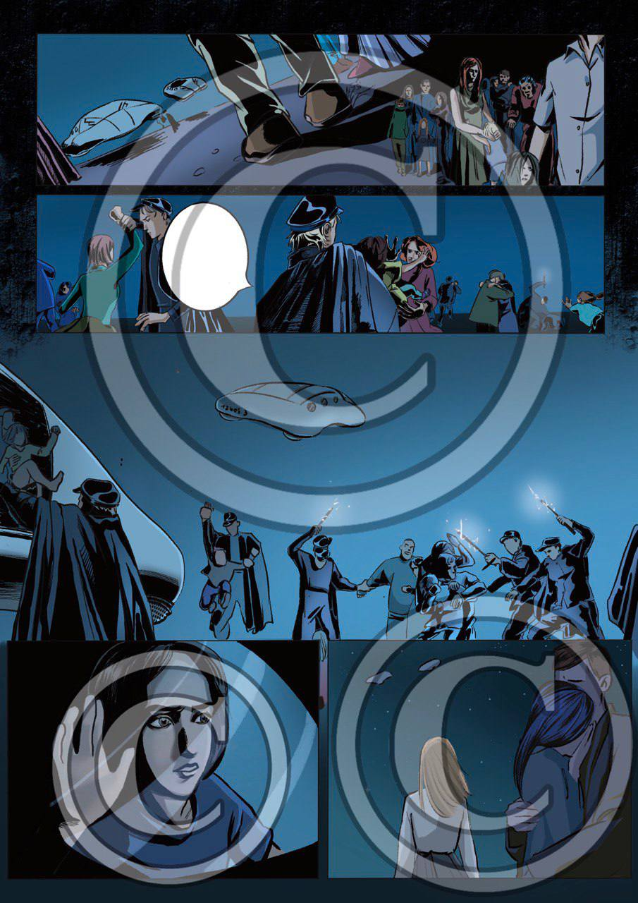

Another thing that I learnt during this project is to communicate. By communication I mean concretising more, talking about details and the most important thing - make a client formulate a good prompt from the very beginning, because as it appears they have a tendency to change their mind every few minutes which is basically a loss of yours and theirs time. But life is short and bad communication can make it even shorter. So in that case my honest advice is to be more strict and direct about what we need, what kind of result we want to get and how we can provide this more effectively.

**Character game design - references, references, references…**

Developing a character is creating a story filled with the wind of history and storm of emotions.

That was a part of my friend’s bachelor work. In a nutshell, usually games about history represent slavic people as doomed, tired people in gray cloth holding hammer and sickle. And there is no difference whether the character is from Ukraine or Czech, they are still damn COMMUNISTS, with a tattoo of grandad Lenin on the chest. So he asked me to make a character in a national slovakian costume with elements of fantasy, of course. I would like to show you below the references I was using.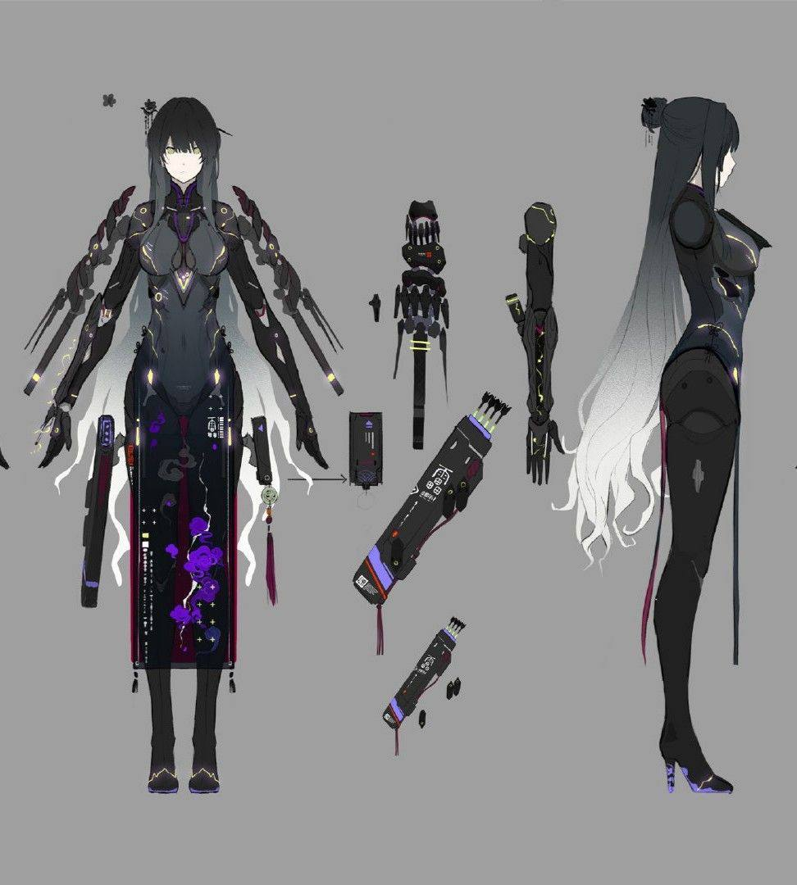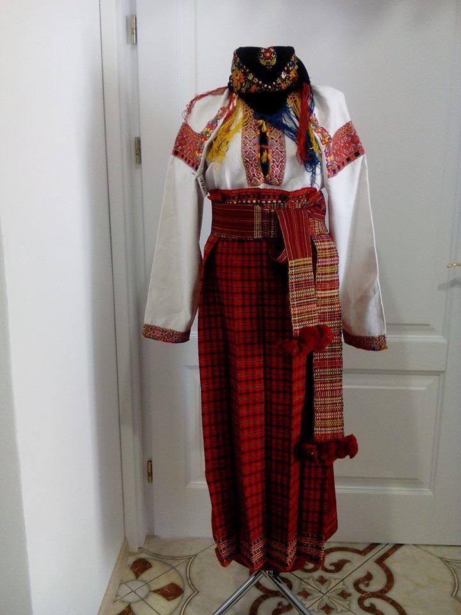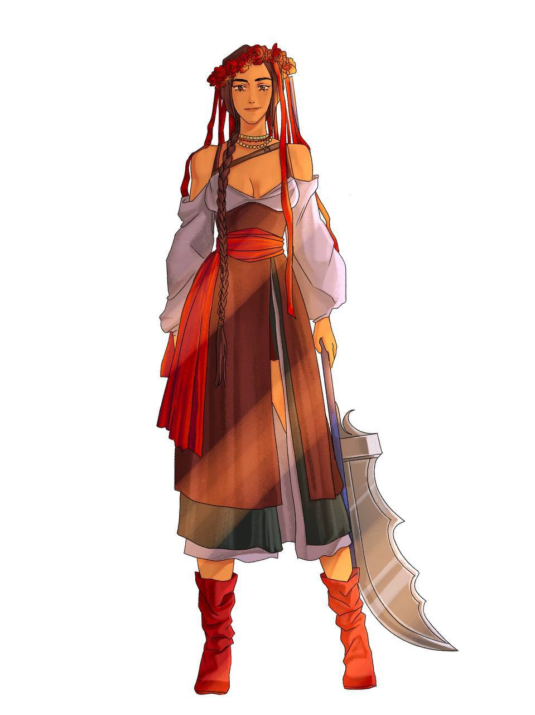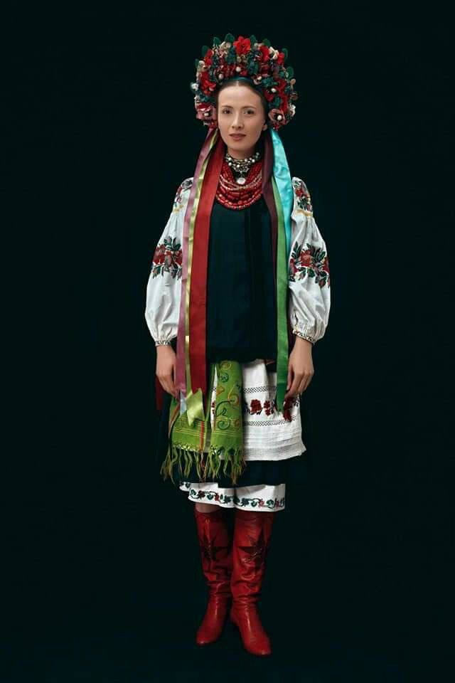

**My own projects**

This is what I love, yeah. Other people's projects are also cool, but what can be as good as being dead inside and being able to express it through art?

Well, I joke. I don't express it through art, but it is true that I try to picture feelings and moods in my animations and Illustrations.

One of them was that feeling of you laying next to your buddy at night talking about life, about things which bothers you, discussing deep topics in general. I used for this gif my friend’s photo (Ivan Raudin, genius photographer) and implemented its color palette. I attached the link below the photo.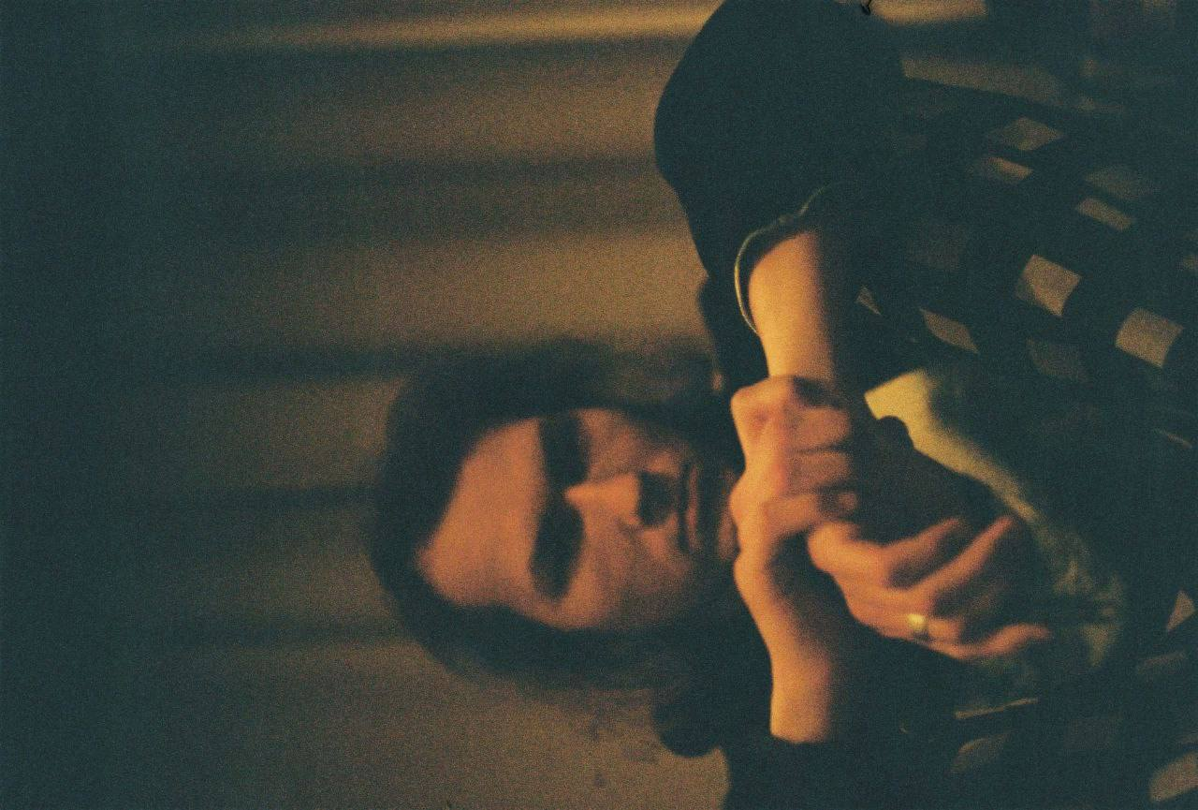

[Night talking scene](https://youtu.be/GjyObKzqyr0)

**Morty, A Great Dreamer in A Small Pants**

The comics series about the eccentric professor was my longest and the most favorite personal project. Professor Morty is a depressive university educator, who always questions himself, makes fun out of everything and dreams of better things. Sometimes he imagines himself as a bird or crossing over the bridge in one step. He is fragile and emotive, but tends to show up as a cold-hearted person, almost cynic.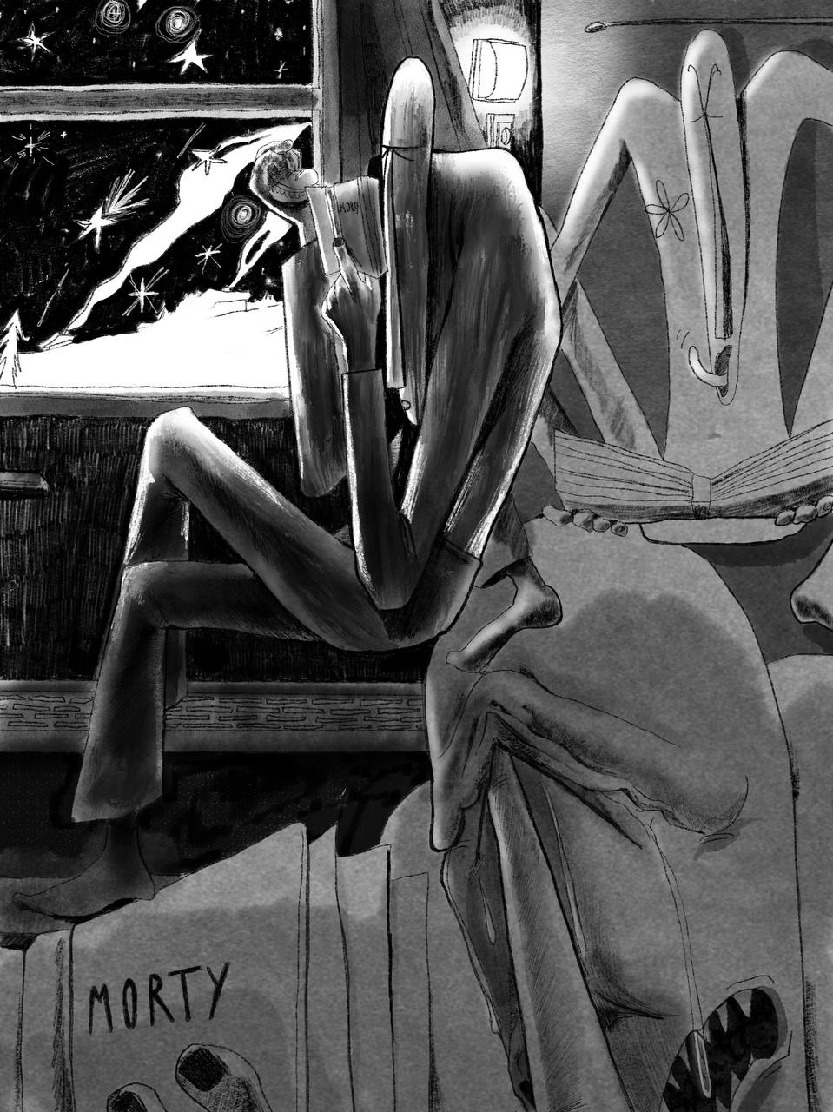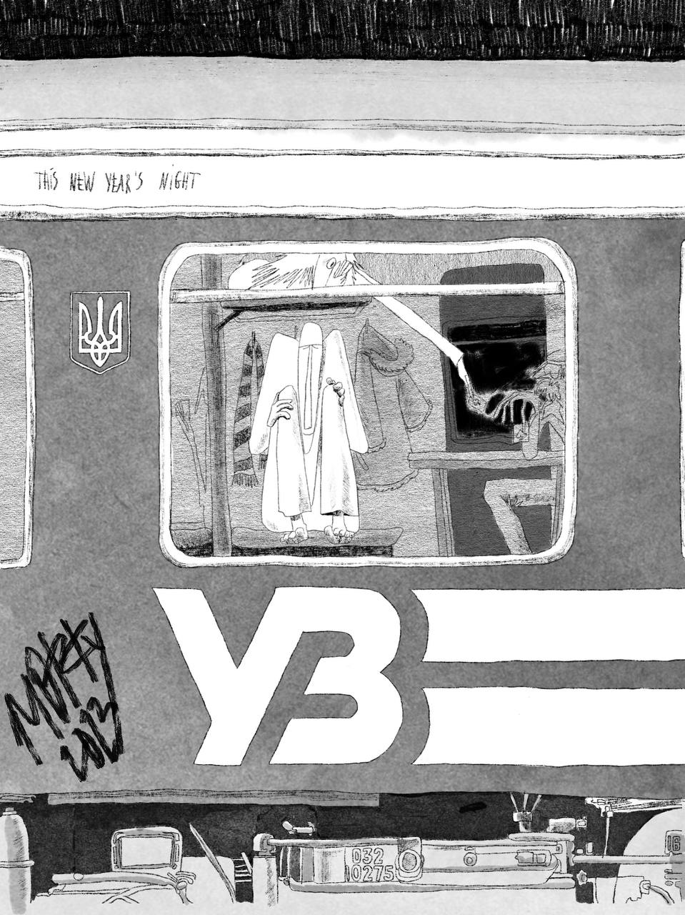

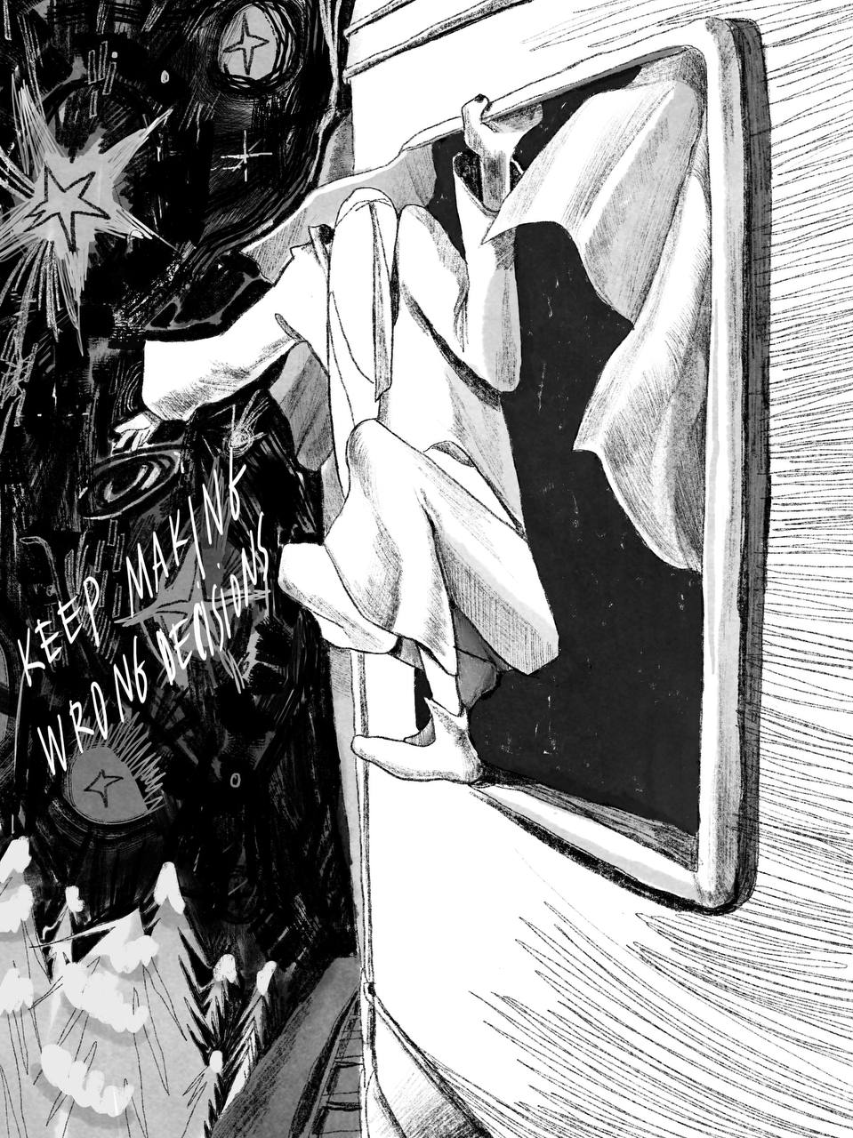

I have also got an animation series with him, where he continues to surprise us with him being brave and at the same time socially awkward.

For now I am done with this project, because I feel no more related to this story, but maybe in the future, who knows…

**Handpoke**

Tattooing is my hobby. In one period of life, I was even considering it as my full-time job, but It's more like a pleasure for me. Handpoke is a monotonous process, where you try to leave a picture on the body with small dots, which usually are 0,7 mm. The session takes up to 3 hours. I like this, because I feel free of thoughts for this time, I am concentrated only on pocking. It's a meditation. Also I am really interested to meet those people who come for a tattoo. The pain frees them and they can tell a lot about their personal life ( what I honestly don't expect), so it sometimes reminds me of psychotherapy sessions. But as long as they are comfortable and calm, I don't mind).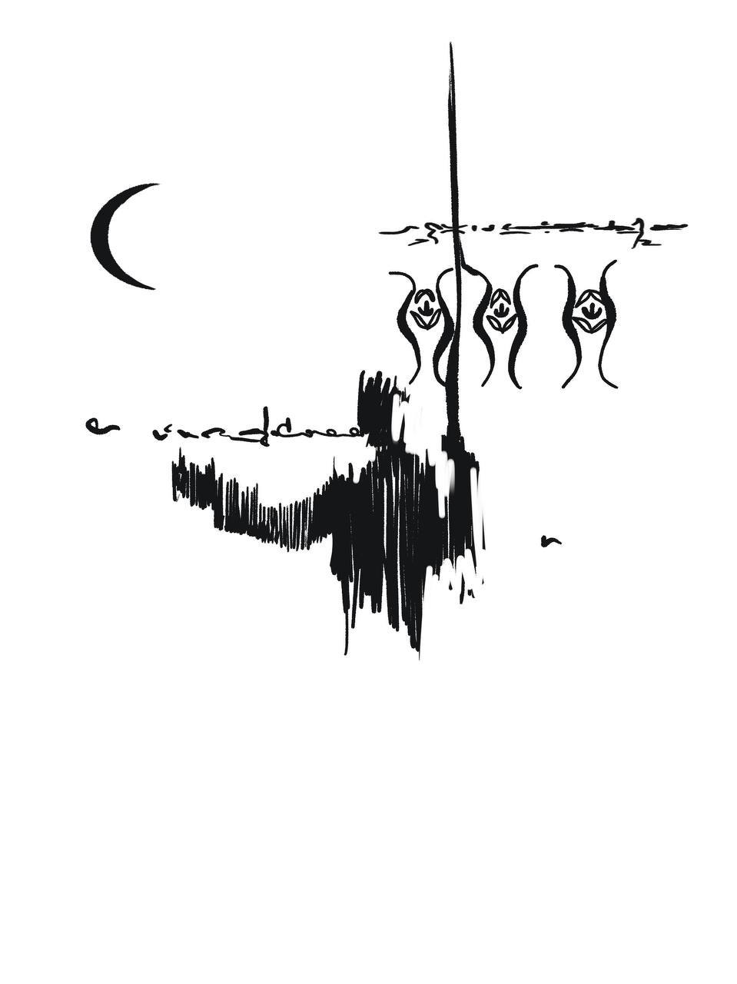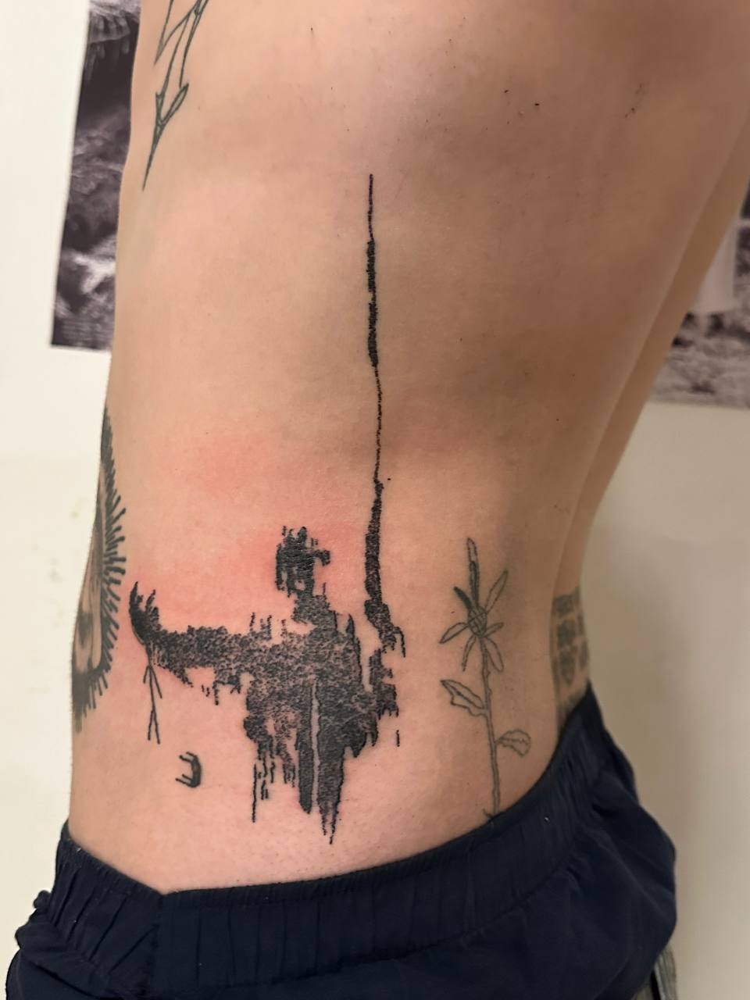

The left picture is the original design and the right one is a moderated final version.

**Many thanks**

I would like to thank you for reading this presentation and for trying to understand me better as a person and as an artist.

You can find me on instagram, where I post more art stuff and life-style.

<https://www.instagram.com/samosabotage/>

Thanks for your time and see ya later!