Taxpayer manager improved
OVerall Report
Final Version

ARGYRIOS ZEZOS 4588, FOTIOS PAPPAS 4773

Table of Contents
Introduction 3
Refactored Design 3
Use Cases 3
Architecture 11
Detailed Design 11
Classes Responcibilities and Collaborations (CRC CARDS) 16

Introduction
The objectives of this phase of the project are to reengineer a legacy application that serves as a management system for minnesota taxpayers. After capturing it’s design to get a grasp of it’s functionality and architecture, tests needs to be created to identify what works before it is modified. Afterward, the actual refactoring takes place constantly being tested. Finally the gui needs to be improved.

Refactored Design

Use Cases
The use cases identified from requirements are the following.
1.Load Taxpayer
2.Select Τaxpayer
3.Add Receipt
4.Remove Receipt
5.Create Report
6.Save Log File
7.Remove taxpayer
All of them were implemented as methods inside class TaxpayerManager,
except from uc’s 2,5 which don’t correspond to particular methods inside
package gui. A detailed description follows.

Load Τaxpayer

Use case ID | 1
Actors | The accountant-administrator.
Pre conditions | The data file must be available and of the right format (txt or xml).
Main flow of events | 1. The uc starts when the admin selects the desired input file.  2. The system loads it's data in a suitable memory structure.
Alternative flow 1 | At any time the admin can cancel the operation or exit the application.
Post conditions | The file contents must be stored appropriately in memory.

Select Τaxpayer

Use case ID | 2
Actors | The accountant-administrator.
Pre conditions | The input file must have been loaded.
Main flow of events | 1. The admin selects a taxpayer.  2. The system displays selected taxpayer's information.
Alternative flow 1 | At any time the admin can cancel the operation or exit the application.
Post conditions | None.

Add Receipt

Use case ID | 3
Actors | The accountant-administrator.
Pre conditions | The admin must have selected a taxpayer.
Main flow of events | 1. The admin selects add receipt option.  2. The system diplays a form, using data collected from form  3. The system stores the receipt and updates the data file.
Alternative flow 1 | At any time the admin can cancel the operation or exit the application.
Post conditions | The additional receipts must have been loaded in memory and the data file must have been updated.

Remove Receipt

Use case ID | 4
Actors | The accountant-administrator.
Pre conditions | The admin must have selected a taxpayer.
Main flow of events | 1. The admin selects receipt to be deleted.  2. The system deletes the receipt from memory and updates data file.
Alternative flow 1 | At any time the admin can cancel the operation or exit the application.
Post conditions | The selected receipts must have been deleted and the data file updated.

Create Report

Use case ID | 5
Actors | The accountant-administrator.
Pre conditions | The admin must have selected a taxpayer.
Main flow of events | 1. The admin selects create report option.  2. The system performs the necessary calculations.  3. The system displays a bar chart with the due tax, the basic tax and it's fluctuation due to receipts. Also a pie chart showcasing the areas on which money was spent.
Alternative flow 1 | At any time the admin can cancel the operation or exit the application.
Post conditions | None.

Save Log File

Use case ID | 6
Actors | The accountant-administrator.
Pre conditions | The admin must have selected a taxpayer.
Main flow of events | 1. The admin selects the option to create a log and it's format.  2. The system creates a log file of the desired format.
Alternative flow 1 | At any time the admin can cancel the operation or exit the application.
Post conditions | A log file must have been created.

Remove taxpayer

Use case ID | 7
Actors | The accountant-administrator.
Pre conditions | The taxpayer input file must have been loaded.
Main flow of events | 1. The admin selects a taxpayer to be deleted.  2. The system deletes the selected taxpayer from memory.
Alternative flow 1 | At any time the admin can cancel the operation or exit the application.
Post conditions | The selected taxpayer must have been deleted from memory.

Architecture
Overall UML package diagram that shows the architecture of
the refactored application.
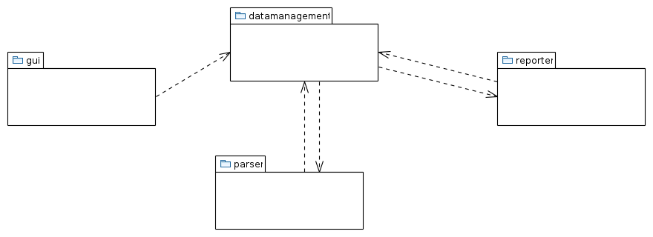

Detailed Design
Here is how the different problems of the old design were addressed.
Requirements clearly demand 4 packages.
datamanagement.io was split to parser and reporter.
Each exception was moved to the package that uses it.
As requested, factories were constructed to hide object creation details.
What follows are the UML class diagrams for the classes of each package of the
refactored application.

Package gui

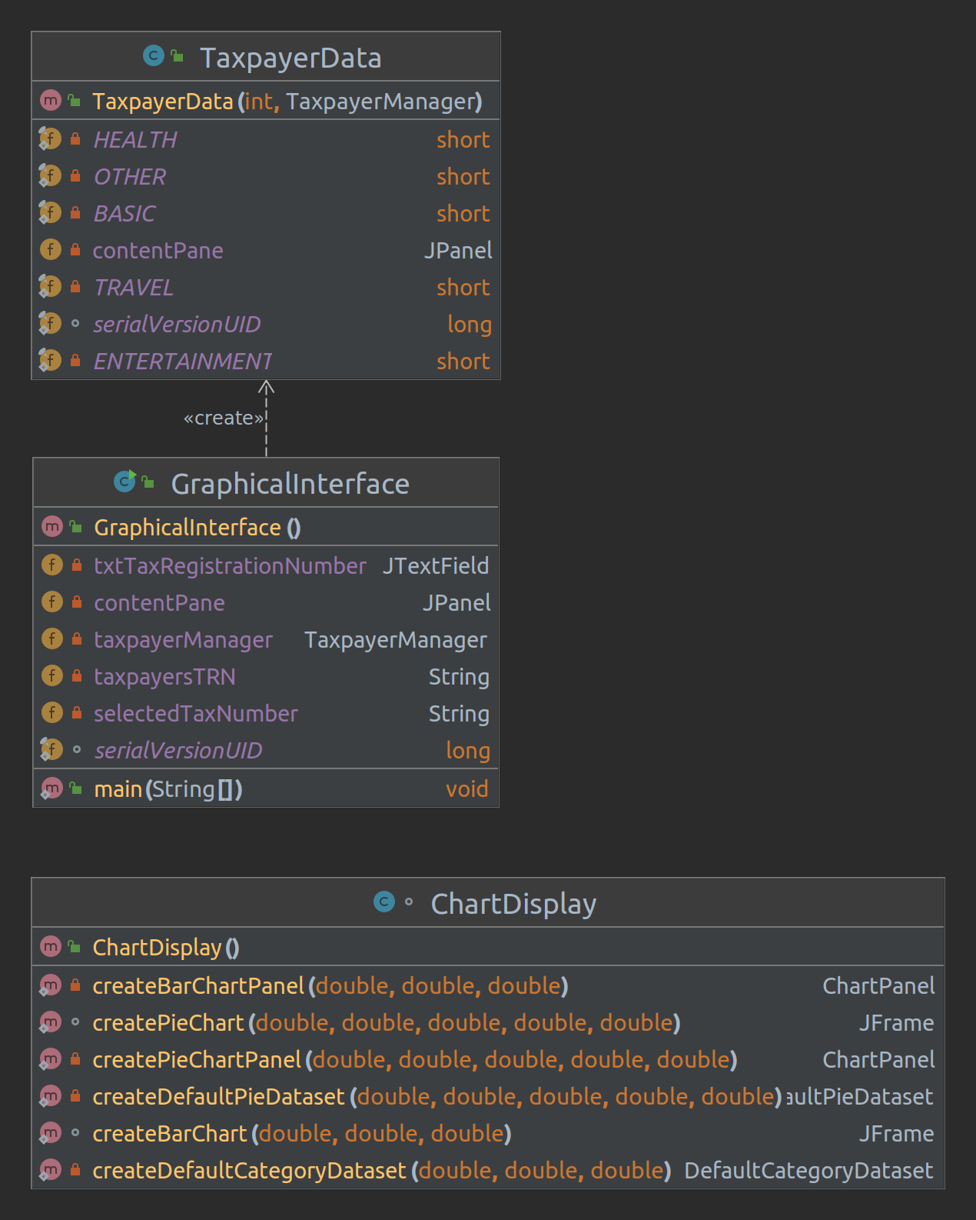

Package datamanagement
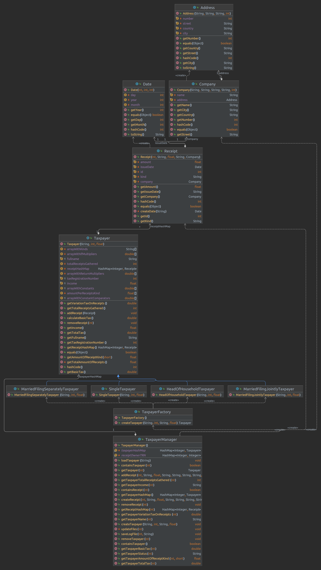

Package parser

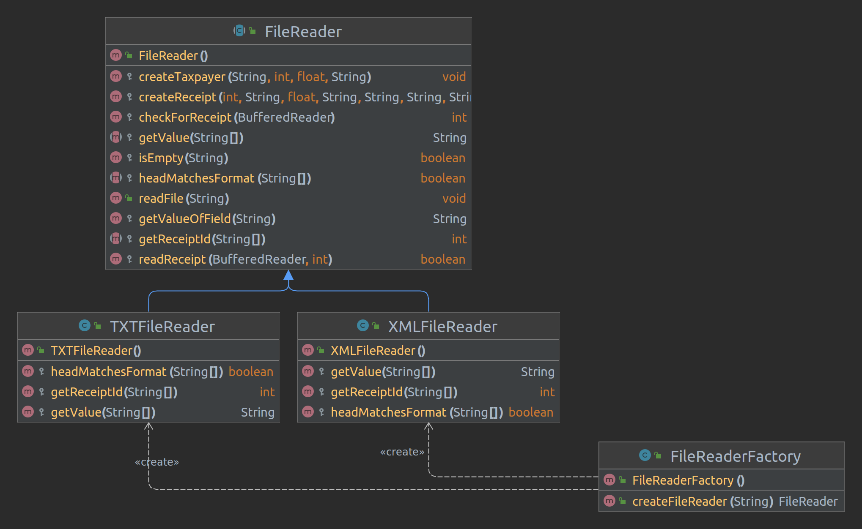

Package reporter

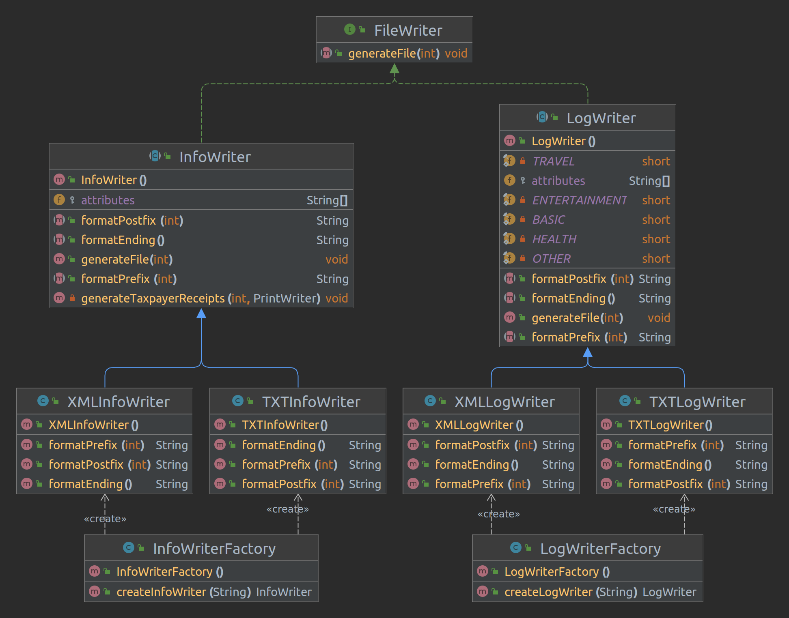

Classes Responsibilities and Collaborations (CRC CARDS)

Here is a brief description in terms of a CRC card for each class

Class Name: TaxpayerData
Responsibilities | Collaborations
Provides a graphical view of the taxpayer’s data.  Enables actor to activate certain use cases through buttons such as: add/delete receipt, view report, save data. | Uses Receipt.  Uses TaxpayerManager.

Class Name: GraphicalInterface
Responsibilities | Collaborations
Hosts the main method.  Acts as the graphical home screen.  Enables actor to activate certain use cases through buttons such as: load taxpayer, select taxpayer, delete taxpayer. | Has a TaxpayerManager.

Class Name: ChartDisplay
Responsibilities | Collaborations
Responsible for creating the pie and bar charts using taxpayer’s data. | -

Class Name: Address
Responsibilities | Collaborations
Store company’s address data. | Composite of Company.

Class Name: Company
Responsibilities | Collaborations
Stores information regarding a particular company. | Composed of Address.

Class Name: Date
Responsibilities | Collaborations
Stores information about the creation date of a particular receipt. | Composite of Address.

Class Name: Receipt
Responsibilities | Collaborations
Holds the information about a Taxpayer’s Receipt. | Composite of Taxpayer.  Composed of Date, Company.

Class Name: Taxpayer
Responsibilities | Collaborations
Holds data of a taxpayer on wich performs calculations. Provides helper methods for some use cases. | Composite of Taxpayer Manager  Composed of Receipt

Class Name: TaxpayerFactory
Responsibilities | Collaborations
Responsible for creating the different types of taxpayers. | Used by TaxpayerManager

Class Name: TaxpayerManager
Responsibilities | Collaborations
Bussiness logic class that implements 5 of 7 use cases. Performs the core funtionality of the application. | Uses Parser  Uses Reporter  Has many Taxpayers

Class Name: HeadOfHouseholdTaxpayer
Responsibilities | Collaborations
Specific type of taxpayer wich extends. | Is a taxpayer

Class Name: MarriedFilingJointlyTaxpayer
Responsibilities | Collaborations
Specific type of taxpayer wich extends. | Is a taxpayer

Class Name: SingleTaxpayer
Responsibilities | Collaborations
Specific type of taxpayer wich extends. | Is a taxpayer

Class Name: MarriedFilingSeparatelyTaxpayer
Responsibilities | Collaborations
Specific type of taxpayer wich extends. | Is a taxpayer

Class Name: FileReader
Responsibilities | Collaborations
Abstract class that is responsible for parsing taxpayer and receipt data from a text or xml format file. | Uses TaxpayerManager

Class Name: FileReaderFactory
Responsibilities | Collaborations
Creates the different types of FileReaders | Uses FileReader

Class Name: TXTFileReader
Responsibilities | Collaborations
Specific type of FileReader wich extends. Parses text fromatted files. | Is a FileReader

Class Name: XMLFileReader
Responsibilities | Collaborations
Specific type of FileReader wich extends. Parses xml formatted files. | Is a FileReader

Class Name: FileWriter
Responsibilities | Collaborations
Interface with a single method for generating a file. | -

Class Name: InfoWriter
Responsibilities | Collaborations
Abstract class implementing FileWriter. Responsible for updating INFO files. | Uses TaxpayerManager  Uses Receipt

Class Name: LogWriter
Responsibilities | Collaborations
Abstract class implementing FileWriter. Responsible for updating LOG files. | Uses TaxpayerManager

Class Name: InfoWriterFactory
Responsibilities | Collaborations
Creates the different types of InfoWriters. | Uses InfoWriter.

Class Name: LogWriterFactory
Responsibilities | Collaborations
Creates the different types of LogWriters. | Uses LogWriter.

Class Name: XMLInfoWriter
Responsibilities | Collaborations
Specific type of InfoWriter wich extends. Updates xml formatted INFO files. | Is an InfoWriter

Class Name: TXTInfoWriter
Responsibilities | Collaborations
Specific type of InfoWriter wich extends. Updates txt formatted INFO files. | Is an InfoWriter

Class Name: XMLLogWriter
Responsibilities | Collaborations
Specific type of LogWriter wich extends. Creates xml formatted LOG files. | Is a LogWriter

Class Name: TXTLogWriter
Responsibilities | Collaborations
Specific type of LogWriter wich extends. Creates txt formatted LOG files. | Is a LogWriter

Report ends here, thank you for reading.

