ENGI 9874 Group 37 Project
Library Management System

Group Members
- Fang, Zhou
- Patel, Vivek Thakorbhai
- Patel, Kevin Harshadkumar

Problem Statement
The objective is to design and implement a Library Management System that facilitates the management of books and members within a library. This system should support various functionalities such as adding books, borrowing and returning books, adding members, and searching for books. Additionally, the system should integrate third-party book data and allow for the addition of accessories to books when borrowed. The design should employ multiple software design patterns to ensure scalability, flexibility, and maintainability.

Overall Class Diagram

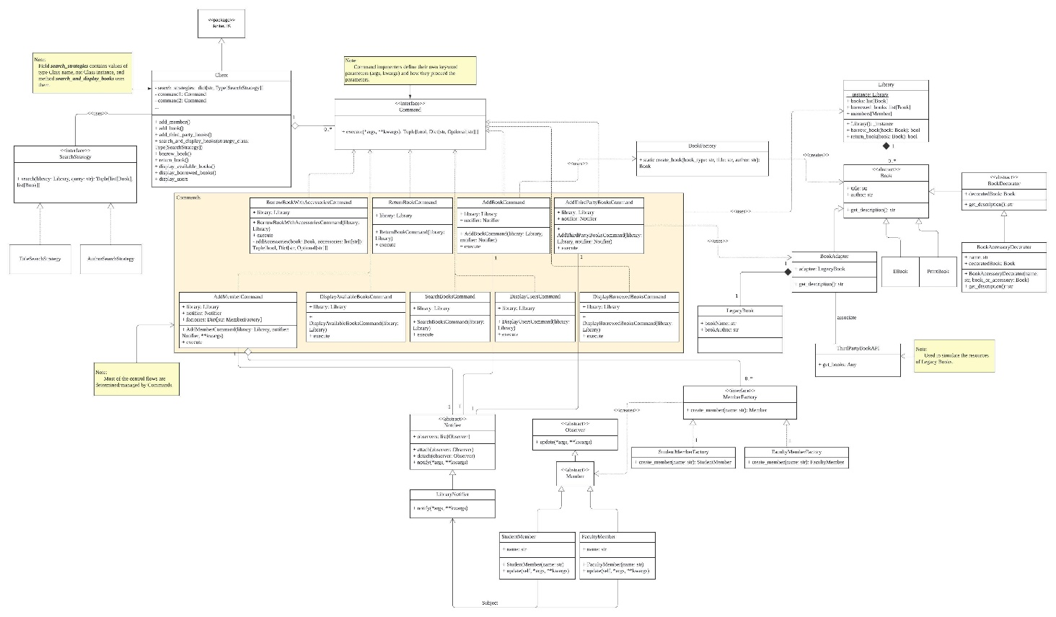
Class Diagram And Design Rational For Each Pattern

Factory Pattern / Factory Method Pattern
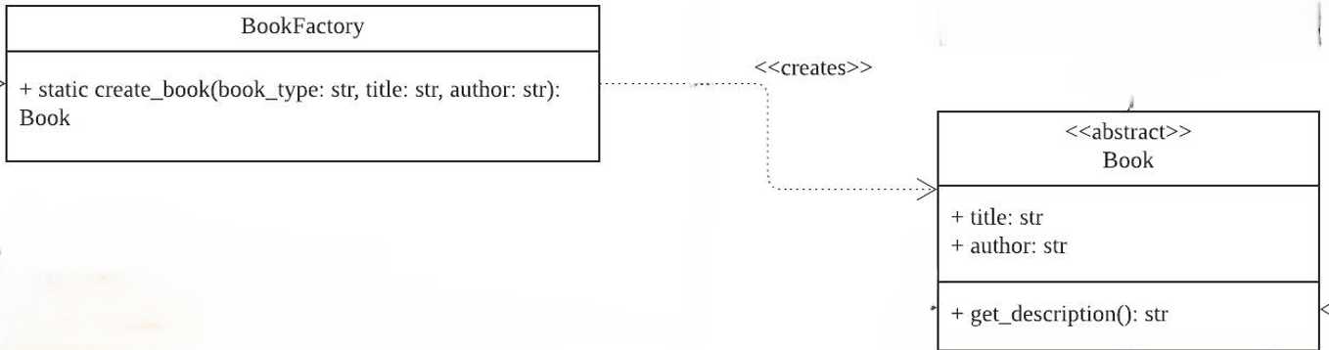

  - Class: BookFactory
  - Purpose: Abstract the creation of different types of books (e.g., EBook, PrintBook) to avoid tight coupling between the client code and specific book classes.
  - Implementation: The BookFactory class has a static method create_book that instantiates books based on the specified type.

Abstract Factory Pattern
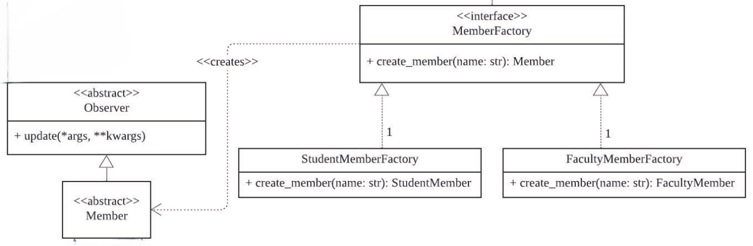

  - Classes: MemberFactory, StudentMemberFactory, FacultyMemberFactory
  - Purpose: Provide an interface for creating families of related or dependent objects without specifying their concrete classes.
  - Implementation: The MemberFactory abstract class defines a method create_member, which is implemented by StudentMemberFactory and FacultyMemberFactory to create StudentMember and FacultyMember objects, respectively.

Adapter Pattern
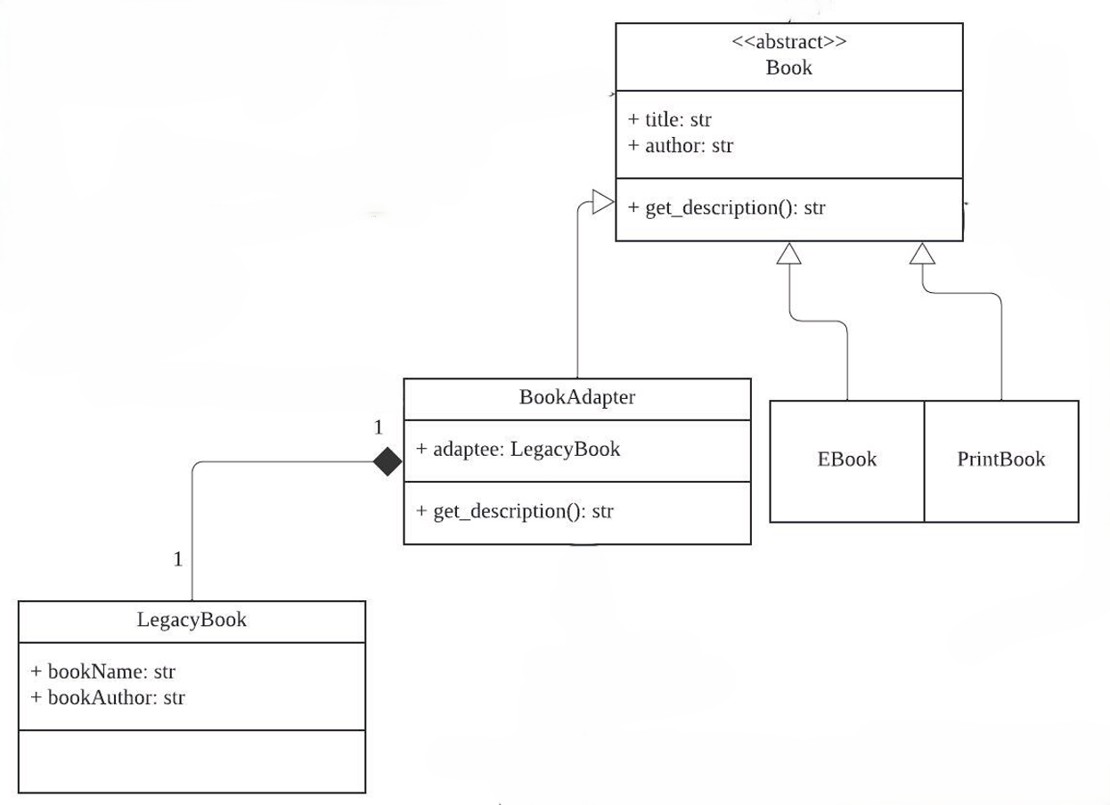

  - Classes: ThirdPartyBookAPI, LegacyBook, BookAdapter
  - Purpose: Allow the interface of an existing class to be used as another interface. It is often used to make existing classes work with others without modifying their source code.
  - Implementation: The BookAdapter class adapts the interface of ThirdPartyBookAPI to be compatible with the Book class used in the library, allowing third-party books to be integrated seamlessly into the system.

Command Pattern
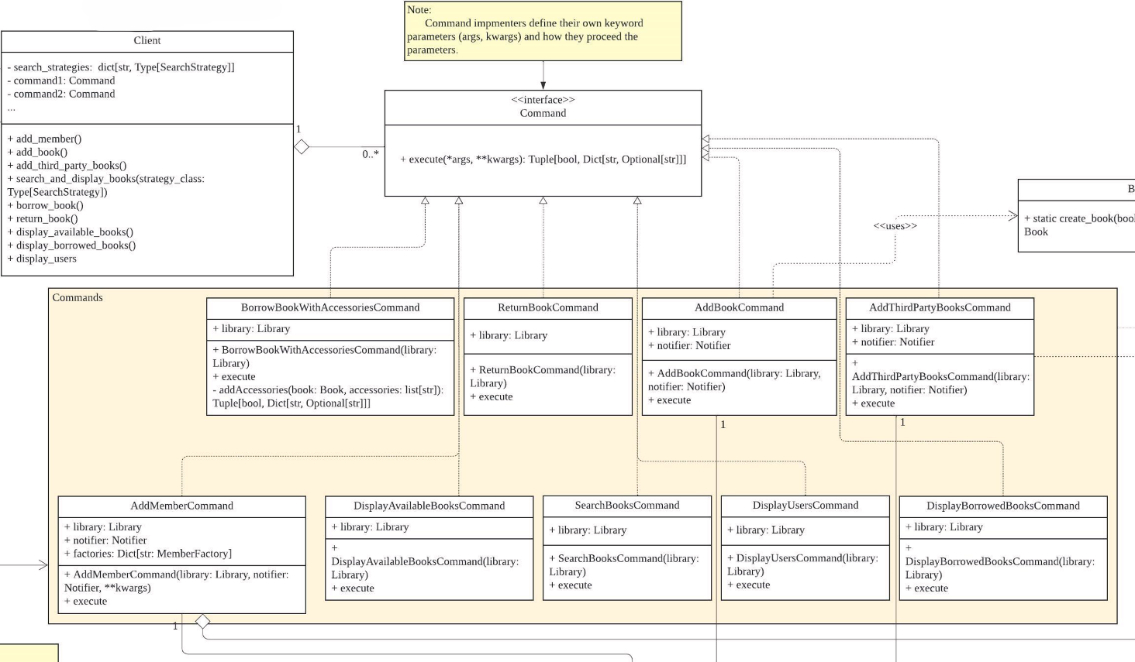

  - Classes: Command, BorrowBookWithAccessoriesCommand, ReturnBookCommand, AddBookCommand, AddMemberCommand, SearchBooksCommand, DisplayBorrowedBooksCommand, AddThirdPartyBooksCommand, DisplayAvailableBooksCommand, DisplayUsersCommand
  - Purpose: Encapsulate a request as an object, thereby allowing users to parameterize clients with queues, requests, and operations, as well as decoupling the Client/UI from detailed implementation.
  - Implementation: The Command abstract class defines the execute method, which is implemented by various command classes to perform operations like borrowing books, returning books, adding members, and displaying information.

Decorator Pattern
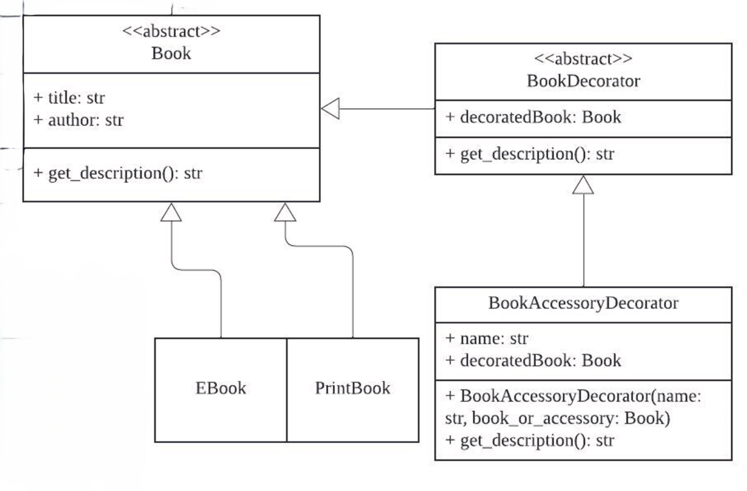

  - Classes: Book, BookDecorator, BookAccessoryDecorator
  - Purpose: Allow behavior to be added to individual objects dynamically and locally, without affecting the behavior of other objects of same class.
    - Eg. BookAccessoryDecorator has no effect to the Ebook/PrintBook, and every time get_description() is called, it stacks its value together with the value of get_description() generated from its child decoratedBook.
  - Implementation: The BookAccessoryDecorator class extends the BookDecorator class and adds additional functionality (e.g., accessories) to the book objects.

Observer Pattern
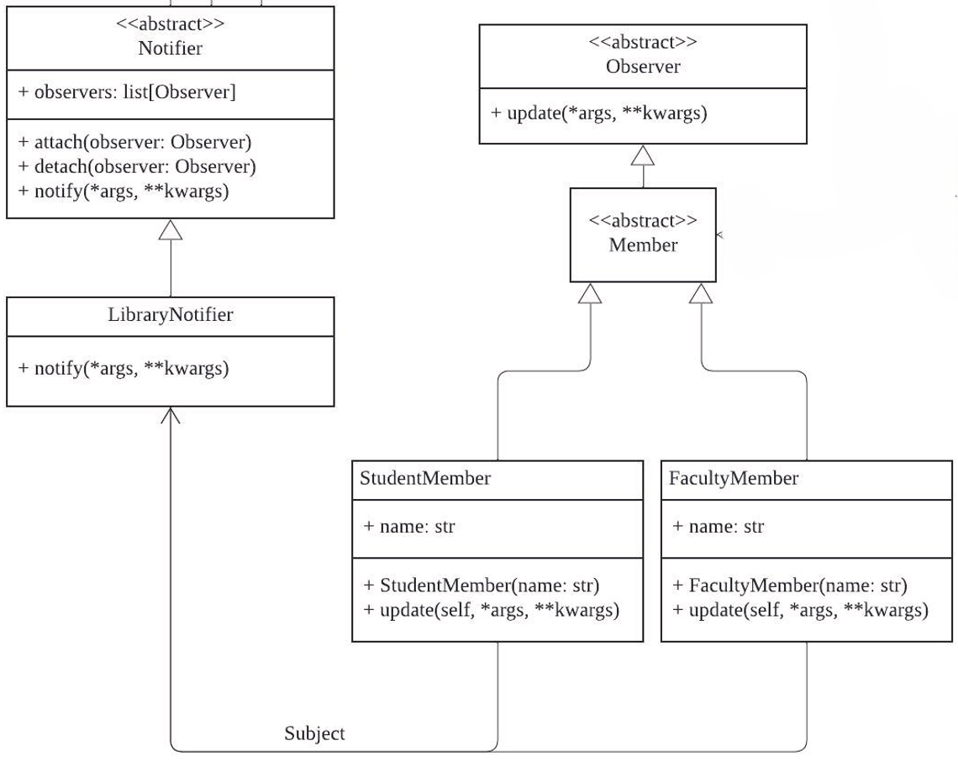

  - Classes: Notifier, LibraryNotifier, Member, StudentMember, FacultyMember
  - Purpose: Establish a one-to-many dependency between objects so that when one object changes state, all its dependents are notified and updated automatically.
  - Implementation: The Notifier class maintains a list of observers (e.g., Member objects) and notifies them when a new book is added. LibraryNotifier extends Notifier and provides specific notification functionality.

Singleton pattern
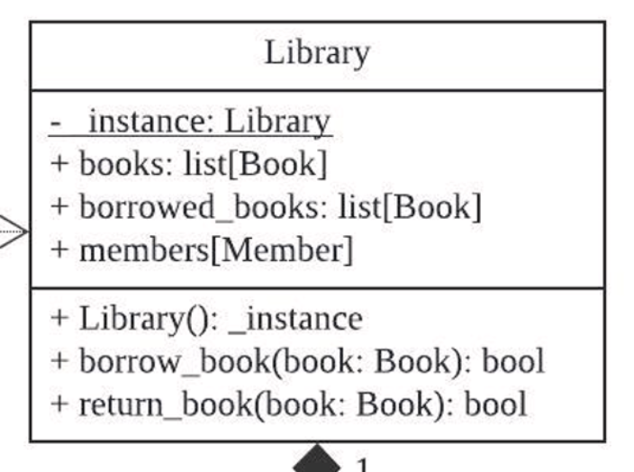

  - Class: Library, LibraryNotifier, MemberFactory
  - Purpose: Ensure that there is only one instance of these classes throughout the application to manage books, members, and notifications consistently.
  - Implementation:
    - Each of these classes have a private static instance and a __new__ method that ensures only one instance is created.

Strategy Pattern
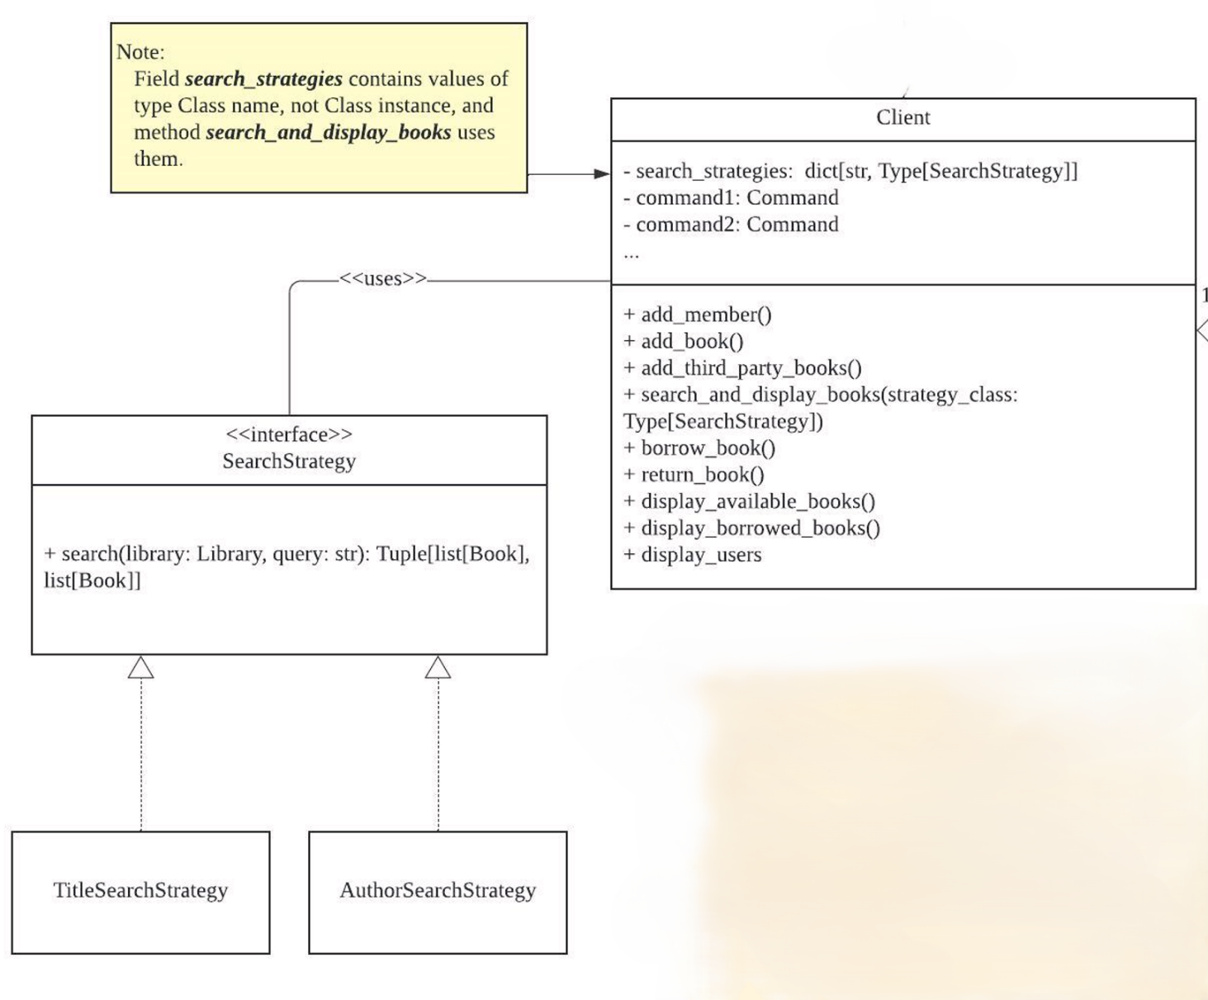

  - Classes: SearchStrategy, TitleSearchStrategy, AuthorSearchStrategy
  - Purpose: Define a family of algorithms, encapsulate each one, and make them interchangeable. The strategy pattern allows the algorithm to vary independently from clients that use it.
  - Implementation: The SearchStrategy abstract class defines the abstract search method, which is implemented by TitleSearchStrategy and AuthorSearchStrategy to provide different search criteria.

