Problem 5.1 – Thevenin Equivalents in RF Systems (0.5h)

In rf circuits, it is very important to “match” the resistance of loads (the things that receive rf power) with signal sources. When we speak of the “resistance” of the signal source, we mean its Thevenin equivalent resistance. Let’s examine an rf “power splitter” which has one signal source $v_{in}$ with output resistance $R_{0}$ and it sends a signals to two loads, each a resistor of value $R_{0}$. A power splitting circuit composed of three resistors of value $R_{1}$ may be included. The three ports labeled are understood to be from the labeled point to ground.

- Explain why the splitting circuit is necessary. In other words, imagine the two loads simply connected in parallel to Port 1. What equivalent resistance would the source see, i.e. what is the equivalent resistance to the right of “Port 1”? Does it match the source’s output resistance?
- Now analyze the full circuit. In particular, find the Thevenin Equivalent resistance from the perspective of each of the three ports. For Port 1, this includes everything but the signal source and its output impedance. For Port 2, this includes everything except Load 2. For Port 3, this includes everything except Load 3. Show that if $R_{1}=R_{0}/3$, then the source and each load “sees” a matched Thevenin resistance looking into the rest of the circuit.

(if you take ECE 363M Microwave and Radio Frequency Engineering, you’ll learn more about why this matching is so important)

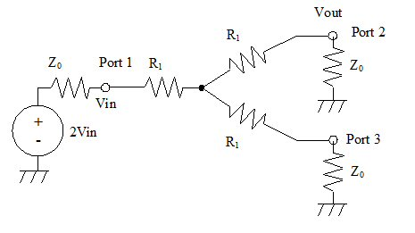
$$R_{0}$$
$$R_{0}$$

$$v_{in}$$
$$R_{0}$$

Problem 5.2 – Op Amps and MOSFETs (1h)

The circuit for this problem is similar to what you will use in Lab 7 to study Op Amp gain and also FETs. The circuit consists of a function generator with an output impedance of 50 ohms (the source plus RFNG) feeding an amplifier based on an op-amp. In the amplifier, one of the resistors (1k) has a MOSFET in parallel with it. Rfng, Rfet, and the 1000 ohm resistor (R1) collectively have a value of Rs. We will learn in a couple of weeks that a MOSFET, in certain operating conditions, can be modeled as a variable resistor RFET. The amplifier supplies a load whose equivalent resistance is 5k ohm. The Op Amp supply voltage is 5V.

- Calculate the value of the equivalent resistance R_{s} (which is a combination of RFNG, RFET and 1000 Ohms, as shown in the figure) and the output voltage of the Op Amp v₀ for R_{f} = 200 and R₁ = 1 k. Assume R_{FNG} = 50 Ohms and take R_{FET} to be 60 Ohms.
- Repeat with R_{FET} = 2k and all other resistors and v_{s} being the same.
- For R_{FET} = 60 Ohms, the input voltage (which is initially at -0.2 V) is increased in magnitude. What is the maximum input voltage magnitude for which the Op Amp still operates in the linear region?
Problem 5.3 – A Negative-Resistance Circuit (1h)

A negative resistor is an object whose current is proportional to its voltage $i=-v/R$ where the constant of proportionality $-R$ is a negative number.

- Calculate the power in a negative resistor of value $-R$ (where $R$ itself is positive, such that $-R$ is negative) as a function of the voltage applied to it and use it to show that a negative resistor always supplies power.
- It is impossible for a passive component to supply net power, so true negative resistors do not exist in real life. However, it is possible to synthesize circuits that behave as negative resistors. Consider the circuit in the Figure. Calculate its input current $I_{S}$ as a function of its input voltage $V_{S}$ and show that the circuit emulates a negative resistor of value $-R$. Calculate the value of $R$ assuming an ideal op amp.
- Suppose that this circuit (the op amp and the three resistors) were placed in series with a real resistor of value $+R$ – what would the net resistance of the series combination be? How about if they were placed in parallel?
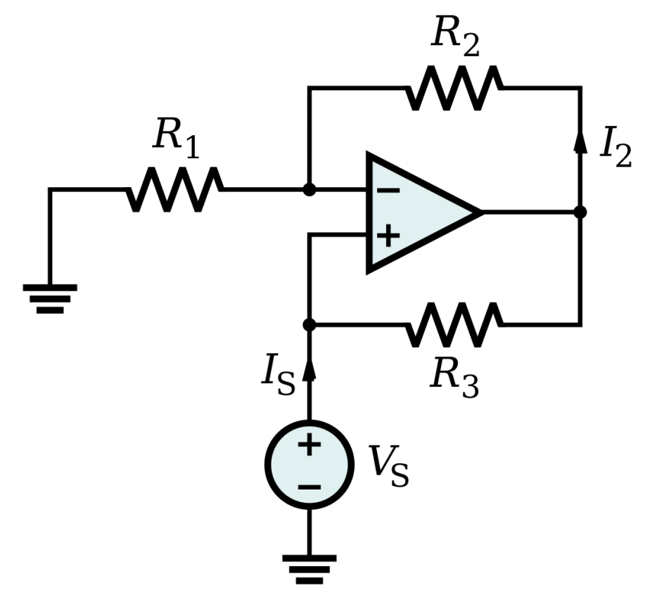

Problem 5.4 – A transconductance amplifier (0.5h)

Feedback can be used to create a circuit that behaves as a current source. This is known as a transconductance amplifier, i.e. one that converts a voltage in one place into a current (“conductance”) in another place (“trans”). Consider the circuit below with an op-amp arranged in feedback with a MOSFET. Assume that the drain (top) of the MOSFET is connected to some circuit (not open-circuited), but that we don’t know what that circuit is. The output current of the circuit $i_{o}$ is the drain-source current of the MOSFET, indicated by an arrow near the top of the diagram.
- Assume that the MOSFET behaves such that the higher the voltage applied to its gate (on the left), the higher the current that will flow from its drain (top) to its source (bottom). Does the configuration below qualify as negative feedback? Explain.
- If the amplifier gain is infinite, what will the voltage $v_{1}$ be? Other than the assumption above, do you need to know the IV characteristics of the MOSFET or of the load circuit (not shown) in order to solve for $v_{1}$?
- What is $i_{o}$? Other than the assumption above, do you need to know the IV characteristics of the MOSFET or of the load circuit not shown in order to solve for $i_{o}$?
- What accounts for the circuit’s remarkable lack of dependence on the details of its components or the load connected to it? In other words, explain how the circuit can maintain constant $i_{o}$ even if you replaced the MOSFET with a different MOSFET with a different IV characteristic?
- What are the input resistance and the Thevenin equivalent output resistance of the circuit?

$$i_{0}$$
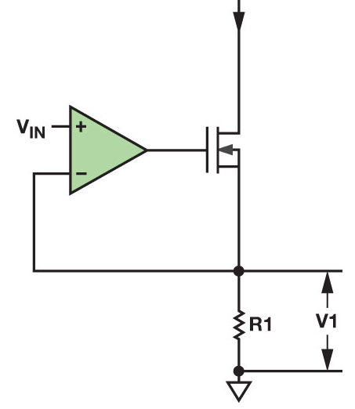

Problem 5.5 – A transimpedance amplifier (0.5h)

A transimpedance (or transresistance) amplifier is shown in the Figure. The name comes from “resistance,” which turns a current into a voltage, and “trans,” which means that the current in one place gets converted into a voltage in another place.
- Calculate the transimpedance of the circuit, $r=V_{o}/I_{in}$, assuming that the op-amp gain is $A$. Then let $A→∞$. Use the $A→∞$ result for the rest of the problem.
- Often $I_{in}$ is provided by a relatively poor current source. When learning about Thevenin and Norton equivalents, we learned that a good current source has near-infinite output resistance, while a poor current source has an output resistance that is large but not negligibly so. We also learned that an object acts most like a good current source when it the load resistance is much lower than the circuit’s output resistance. What is the equivalent input resistance of the op amp circuit, i.e. everything to the right of $I_{in}$? Is this a good circuit to load an imperfect current source?
- This circuit might appear to be overkill. One might wonder why not just run $I_{in}$ into a grounded resistor of value $r$ to get the same current-to-voltage conversion factor. Explain why this would not be as good of an idea.

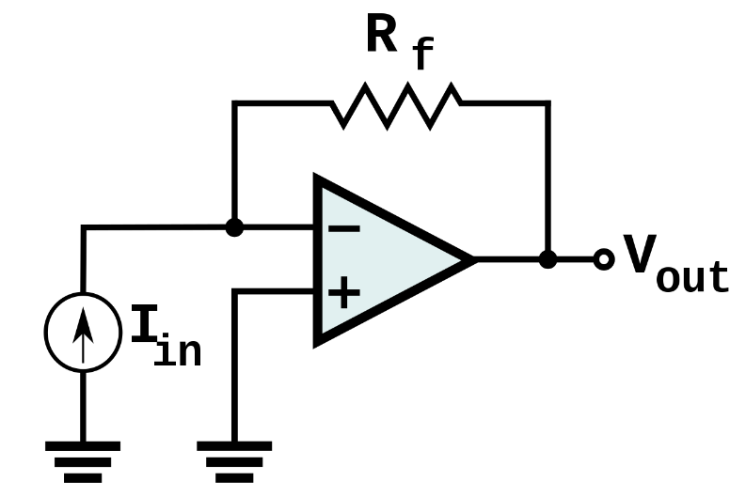

Problem 5.6 – Duality (1h)

- An op amp is a 3-terminal object: two input terminals (+) and (-) and one output terminal. Consider the following statements about op amps: An op amp measures the voltage across the two input terminals $v_{d}$ and produces an output voltage that is proportional to the input, $v_{o}=Av_{d}$. Real op amps are modeled as having some input resistance $R_{i}$ (between $+$ and $-$) and some output resistance $R_{o}$ (in series with the output voltage $Av_{d}$). Ideal op amps have $R_{i}→∞$, $R_{o}→0$, and $A→∞$. Based on this description, what would the dual of an op amp be? Copy these statements, replacing words as needed to exchange the role of voltage and current. Draw a circuit model to represent the op amp’s dual (both non-ideal and ideal).
- What is the dual of an open switch? What is the dual of a closed switch? Suppose a switch is turned on and off at a frequency $f$ (period $T$). Further suppose that the switch spends a fraction of the period $DT (D<1)$ in the on position and the other fraction $\left(1-D\right)T$ in the off position. (The on-fraction $D$ is called the “duty cycle”). If you took the dual of this switch, what would the dual’s duty cycle $D'$ be?
- A poor man’s Digital to Analog converter is shown in the figure, in which two switches are alternately turned on such that only one switch is closed at a time. The top switch is closed with a duty cycle of $D$ and the lower switch is closed whenever the top switch is open (i.e., a duty cycle of $(1-D)$). This circuit involves a component we have not yet studied (but that we mentioned in lecture) called a capacitor, which has a value of $C$, units of $Farads=\frac{C}{V}=\frac{A×s}{V}$, and a component law $i_{c}=C\frac{dv_{c}}{dt}$. You’re not prepared to derive this circuit’s operation yet, but the circuit’s function is to cause $v_{c}$ to be equal to $DV_{in}$. By adjusting the duty cycle of the top switch (and the corresponding duty cycle of the lower switch), the output voltage can be made to be any voltage less than $V_{in}$. There’s a good chance you will implement this circuit in ECE 319K.

What would the component law be for the dual of a capacitor? Research what kind of component has that law. What would the dual of this circuit be? What would the dual’s function be? What units would all of the components have, and what would the duty cycles of the switches be?

