MIS301H -- Spring 20XX
Introduction to MIS
Final Exam

This exam is worth 50 points. You have exactly 70 minutes to complete the exam. There are two parts to this exam: multiple choice (36 points – 30 -40 minutes) and Short Answers (14points – 25-30 minutes). Manage your time wisely. This is a closed book/notes exam.

Circle the Section:

9:30 – 10:45am 11am – 12:15pm 12:30pm – 1:45 pm

Name:_______________________________________

Multiple Choice (36 points)

- Blockchain is most relevant in these situations:
  - When any asset requires authentication and immutability
  - When privacy is not important
  - When a single entity requires control of all of the data
  - When third-party intermediaries settle transactions
  - Both (A) and (D)
  - All of the above

- If you have a product with low margin and long product lifecycle, you will likely benefit from:
  - A responsive supply chain
  - An efficient supply chain
  - Economies of scale
  - (A) and (C)
  - (B) and (C)
  - None of the above

- Cemex has no bullwhip effect because
  - It is a pull system
  - It is vertically integrated
  - Processes are designed to avoid bullwhip effect
  - Customers order what they want
  - All of the above
  - None of the above

- Benefits of RFID include
  - Lower shrink rates
  - Higher stock out situations
  - Higher risk of technology failure
  - Only (A) and (B)
  - (A), (B), and (C)
  - None of the above

- Cluster analysis can be used for the following:
- Association
- Market basket analysis
- Customer segmentation based on various characteristics
- (A) and (B)
- (B) and (C)
- (A), (B), and (C)

- Closeness centrality measures
  - Number of other nodes associated with a node in the network
  - Total distance of a node from other nodes in the network
  - Total number of nodes in a network
  - (B) and (C)
  - None of the above

- Long tail phenomenon does NOT imply
  - Blockbuster products have the highest sales
  - Products at the tail have the lowest sales
  - Total sales for products in the head may exceed the total sales for tail products
  - (A) and (B)
  - (A), (B) and (C)
  - None of the above

- These are the benefits of social media:
  - Co-creation
  - Customer targeting
  - Social affiliation
  - A & B
  - A, B & C

- A Lift Ratio closer to one may suggest:
- Products may be substitutes
- Products are complements
- Products are bought together
- Products are independent
- (B) or (C)
- (A) or (D)

- In using K-Means clustering algorithm, we do the following first:
  - Select the number of clusters, identify the variable to predict, identify relevant attributes, normalize data, and then run K-means clustering algorithm
  - Select the number of clusters, identify relevant attributes and their importance, normalize data, and then run K-means clustering algorithm
  - Identify the relevant attributes and their importance, normalize data, and then run K-means clustering algorithm
  - Select the number of clusters, use all available attributes, identify the importance of each attribute, normalize data and then run K-means clustering algorithm
  - Select the K dependent variables, identify relevant attributes and their importance, normalize data, and then run K-means clustering algorithm
  - None of the above

- Following is true when it comes to differentiation:

A) None of the above
B) Lack of differentiation can lead to a monopoly outcome for a regular product
C) Differentiation can lead to winner-take-all outcome for a regular product
D) Lack of differentiation can lead to a monopoly outcome for a platform
E) Differentiation can lead to winner-take-all outcome for a platform

12. An AI system generates reports but cannot take any action beyond responding to prompts. Why is it NOT considered agentic?
A. It lacks data inputs
B. It lacks reasoning ability
C. It does not take autonomous actions toward goals
D. It cannot store outputs
E. It lacks visualization capability

13. A consulting firm uses GenAI to generate client reports. Some reports contain subtle inaccuracies that go unnoticed.
Which risks are illustrated?
A. Errors in AI outputs
B. Misinformation risk
C. Improved accuracy
D. A & B
E. B & C

14. After AI adoption, some employees significantly outperform others despite similar tools.
Which explanations are valid?
A. Differences in skill levels
B. Differences in AI usage capability
C. AI ensures equal outcomes
D. A & B
E. B & C

15. Following is not true for same-sided network effects
A. Network effects lead to economies of scale
B. Network effects lead to economies of demand
C. Brand with large network effects is very popular
D. Strength of network effects can vary
E. Network effects lead to high switching costs.

Part II: Short Answers (14 points)

- You are given a sample set of random transactions from a retail store. Assume there are X transactions in this sample set. This retail store sells products M, N and O. There were 800 transactions that had both M and O. The number of transactions that had N is 1200 and the likelihood that someone would buy N is 0.30. Now, you are interested in knowing more about the following association rule: (4 points)

Rule A: IF a person buys M then he/she is likely to buy N

After running a data mining software you found the following information:
Rule A: Lift Ratio 1.5

Now, compute the following – show steps

  - What is the confidence level of Rule A and the # of transactions (X) in the database? (4 points)
P(N) = 1200/X = 0.3

X= # of Transactions = 1200/0.3 = 4000

LR = P(N/M) / P(N)

Confidence level of Rule A = P(N/M) = 1.5 * P(N) = 1.5* 0.3 = 0.45

- (A) The following questions are based on Excel snapshot below.
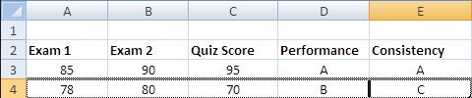

Rule 1: Write a formula that assigns an “A” if a student gets at least 95 in both exams (i.e., Exam I and II), or at least 90 in all three (Exams I and II, and quiz score). If the student doesn’t satisfy criteria for “A” but has any two scores >= 90 s/he will receive a “B,” if not a “C.” You should NOT use all combination of scores to find at least 95 or >=90. You must use appropriate functions than enumerating all possible combinations. (3 point)

Hint: Use min & large functions

(B) Calculate Total Revenue in the East Region(3 points)

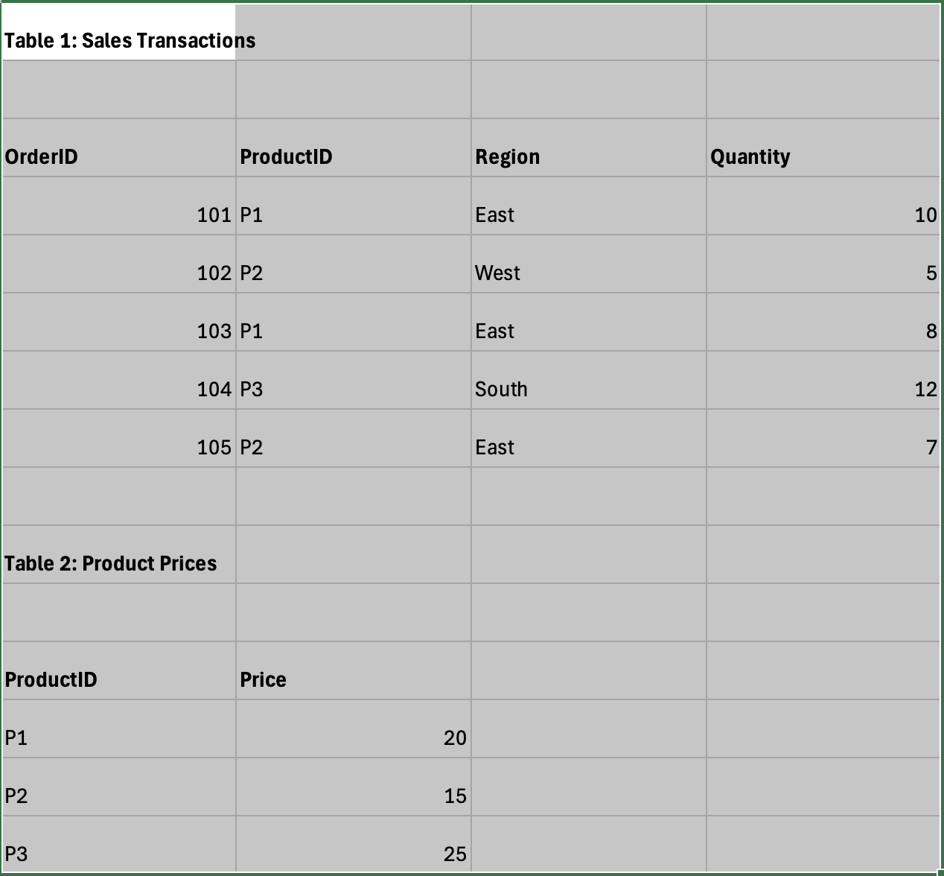

Hint: Use XLookup and SumProduct

(C) Consider the following case and answer related questions (4 points):

A large e-commerce company, ShopEase, has recently deployed an AI-powered customer service agent that can autonomously handle customer inquiries, process refunds, recommend products, and resolve complaints. The system uses past customer data, company policies, and real-time interactions to make decisions and take actions without human intervention in most cases. While the system has significantly improved response times and reduced operational costs, several issues have emerged. Some customers have received incorrect refunds, and in a few cases, the AI denied legitimate claims due to biased or incomplete data. Additionally, concerns have been raised about how customer data is being used and whether the AI’s decisions are transparent and accountable. Senior management is now debating whether to scale the system further or introduce stricter governance and human oversight.

Based on the case, what characteristics make the system an example of Agentic AI, and how does it differ from a purely generative AI system?

What are the key governance and risk challenges the company is facing, and what controls or mechanisms would you recommend to address them?

