1. Get all cras

This API is used for retrieving all users from the database.
- URL
cars/all
- Method:
GET
- URL Params
Not required
- Data Params
Not required
- Success Response:
code:200
Example:
[
{
"id": 1,
"carName": "Audi",
"deletable": true,
"editable": true
},
{
"id": 2,
"carName": "Mercedes",
"deletable": true,
"editable": false
},
{
"id": 3,
"carName": "BMW",
"deletable": false,
"editable": false
}]
- Error Response:
{
"timestamp": "2019-04-04T08:23:32.112+0000",
"status": 404,
"error": "Not Found",
"message": "No message available",
"path": "/cars/alll"
}
Notes:
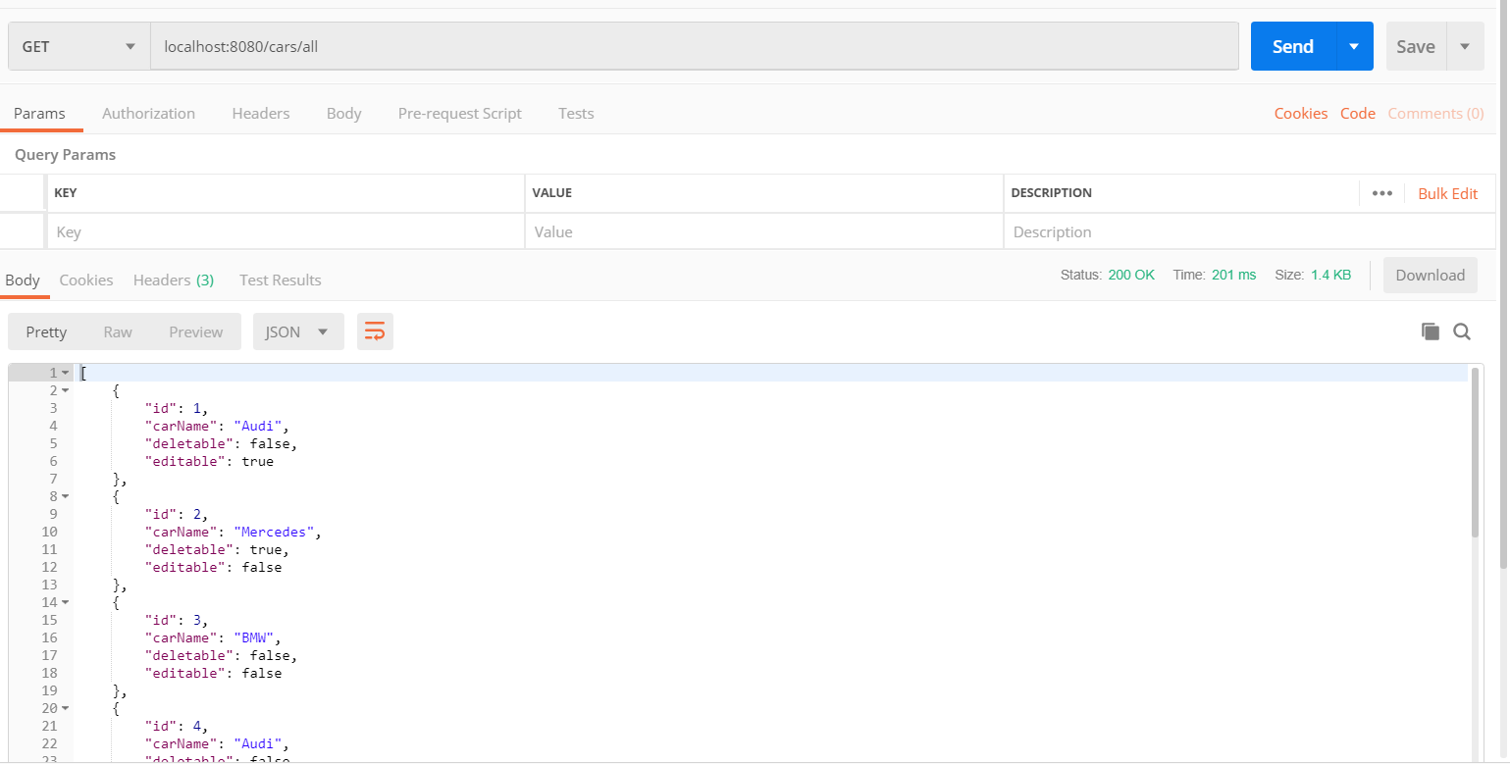
Picture 1. Get All Cars

Get car by id
Retrieve the car with specific ID
- URL
/cars/id
- Method:
GET
- URL Params
Required:
id=[int]
- Data Params
Not required
- Success Response:
- Code: 200
Content: {
"id": 3,
"carName": "BMW",
"deletable": false,
"editable": false
}
- Error Response:
{
"timestamp": "2019-04-04T08:29:32.531+0000",
"status": 400,
"error": "Bad Request",
"message": "Failed to convert value of type 'java.lang.String' to required type 'int'; nested exception is java.lang.NumberFormatException: For input string: \"a\"",
"path": "/cars/car/a"
}
- Notes
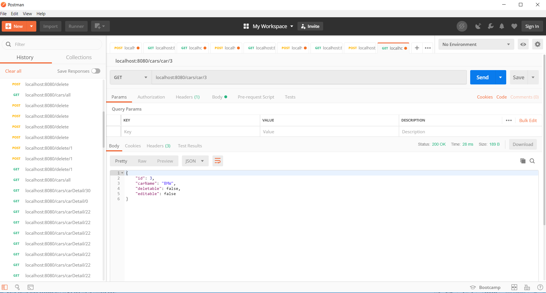

Add new car
Create new car
- URL
cars/addCar
- Method:
POST
- URL Params

- Data Params
{
"carName": "Golf",
"editable": true,
"deletable": false
}
- Success Response:
- Code: 200
Content:
{
"id": 32,
"carName": "Golf",
"deletable": false,
"editable": true
}
- Error Response:
- {
"timestamp": "2019-04-04T08:34:37.725+0000",
"status": 404,
"error": "Not Found",
"message": "No message available",
"path": "//addCar"
}
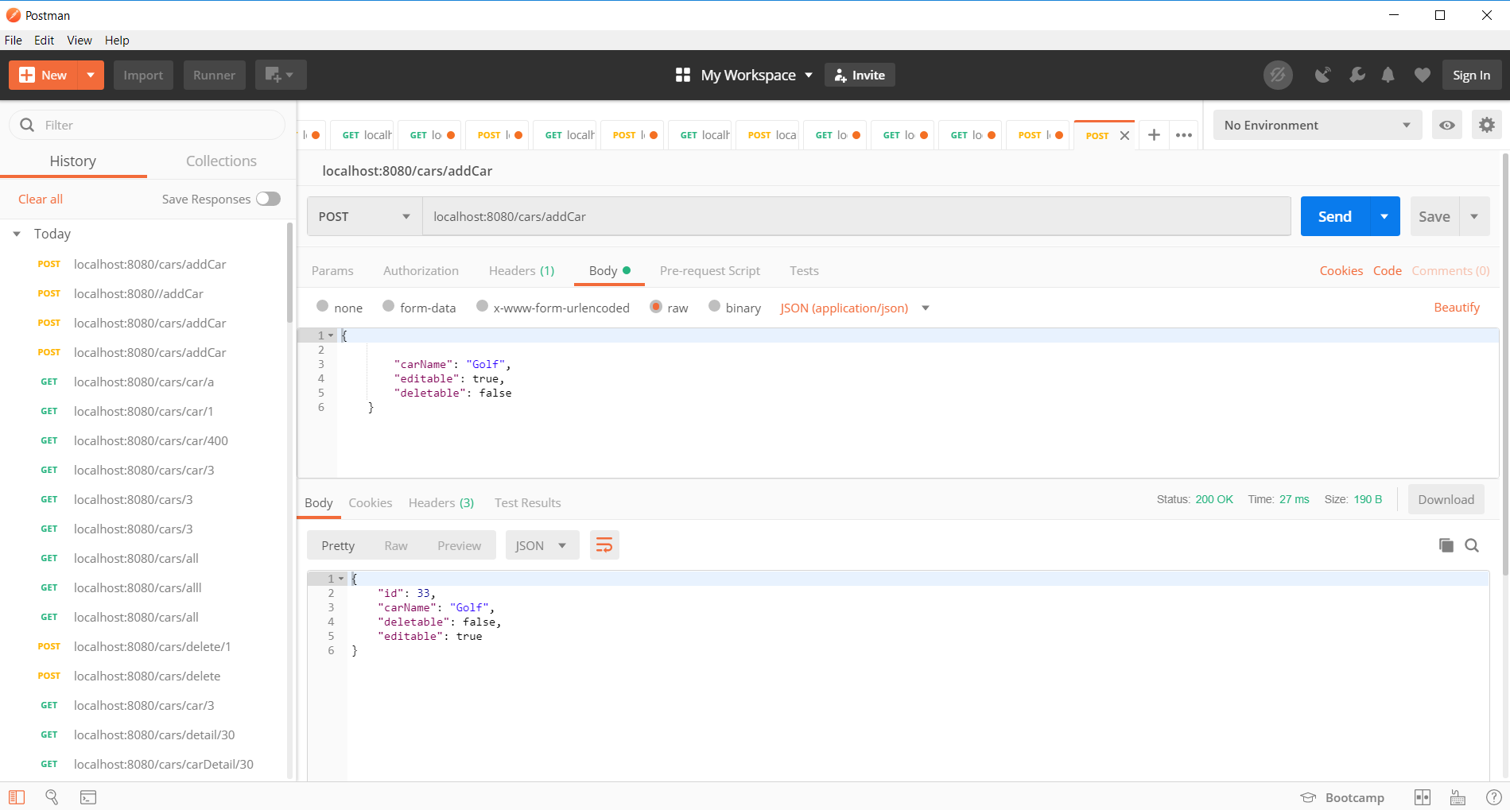
Notes

UPDATE car
Create new car
- URL
cars/delete/id
- Method:
UPDATE
- URL Params
id=[int]
- Data Params
- Success Response:
- Code: 200
Content:
{
"id": 3,
"carName": "BMW",
"deletable": true,
"editable": false
}
- Error Response:
{
"timestamp": "2019-04-04T08:37:39.050+0000",
"status": 500,
"error": "Internal Server Error",
"message": "No message available",
"path": "/cars/delete/0"
}
Notes
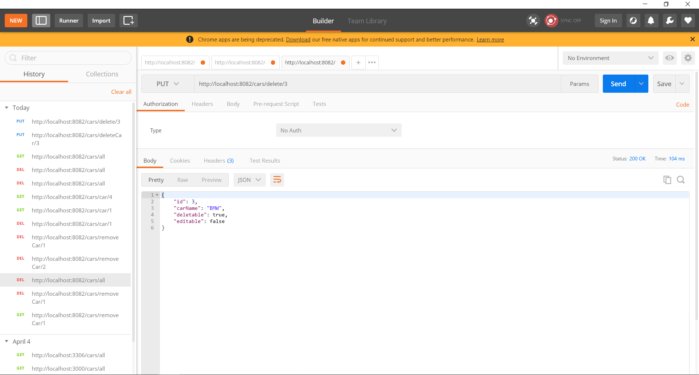

DELETE car
Create new car
- URL
cars/removeCar/id
- Method:
DELETE
- URL Params
id=[int]
- Data Params
- Success Response:
- Code: 200
Content:
Car with id: 2 was deleted!
- Error Response:
{
"timestamp": "2019-04-11T07:25:47.343+0000",
"status": 500,
"error": "Internal Server Error",
"message": "No class com.cars.model.Cars entity with id 1 exists!",
"path": "/cars/removeCar/1"
}
Notes
