Get car details by id
Retrieve the car with specific ID
- URL
/detail/id
- Method:
GET
- URL Params
Required:
id=[int]
- Data Params
Not required
- Success Response:
- Code: 200
Content: {
"id": 30,
"carName": "Golf",
"carType": "typeee",
"yearModel": 2015,
"police": "osigurano",
"numberOfSeats": 5,
"carId": 0,
"available": false
}
- Error Response:
{
"timestamp": "2019-04-11T07:43:13.141+0000",
"status": 400,
"error": "Bad Request",
"message": "Failed to convert value of type 'java.lang.String' to required type 'int'; nested exception is java.lang.NumberFormatException: For input string: \"a\"",
"path": "/details/detail/a"
}
- Notes
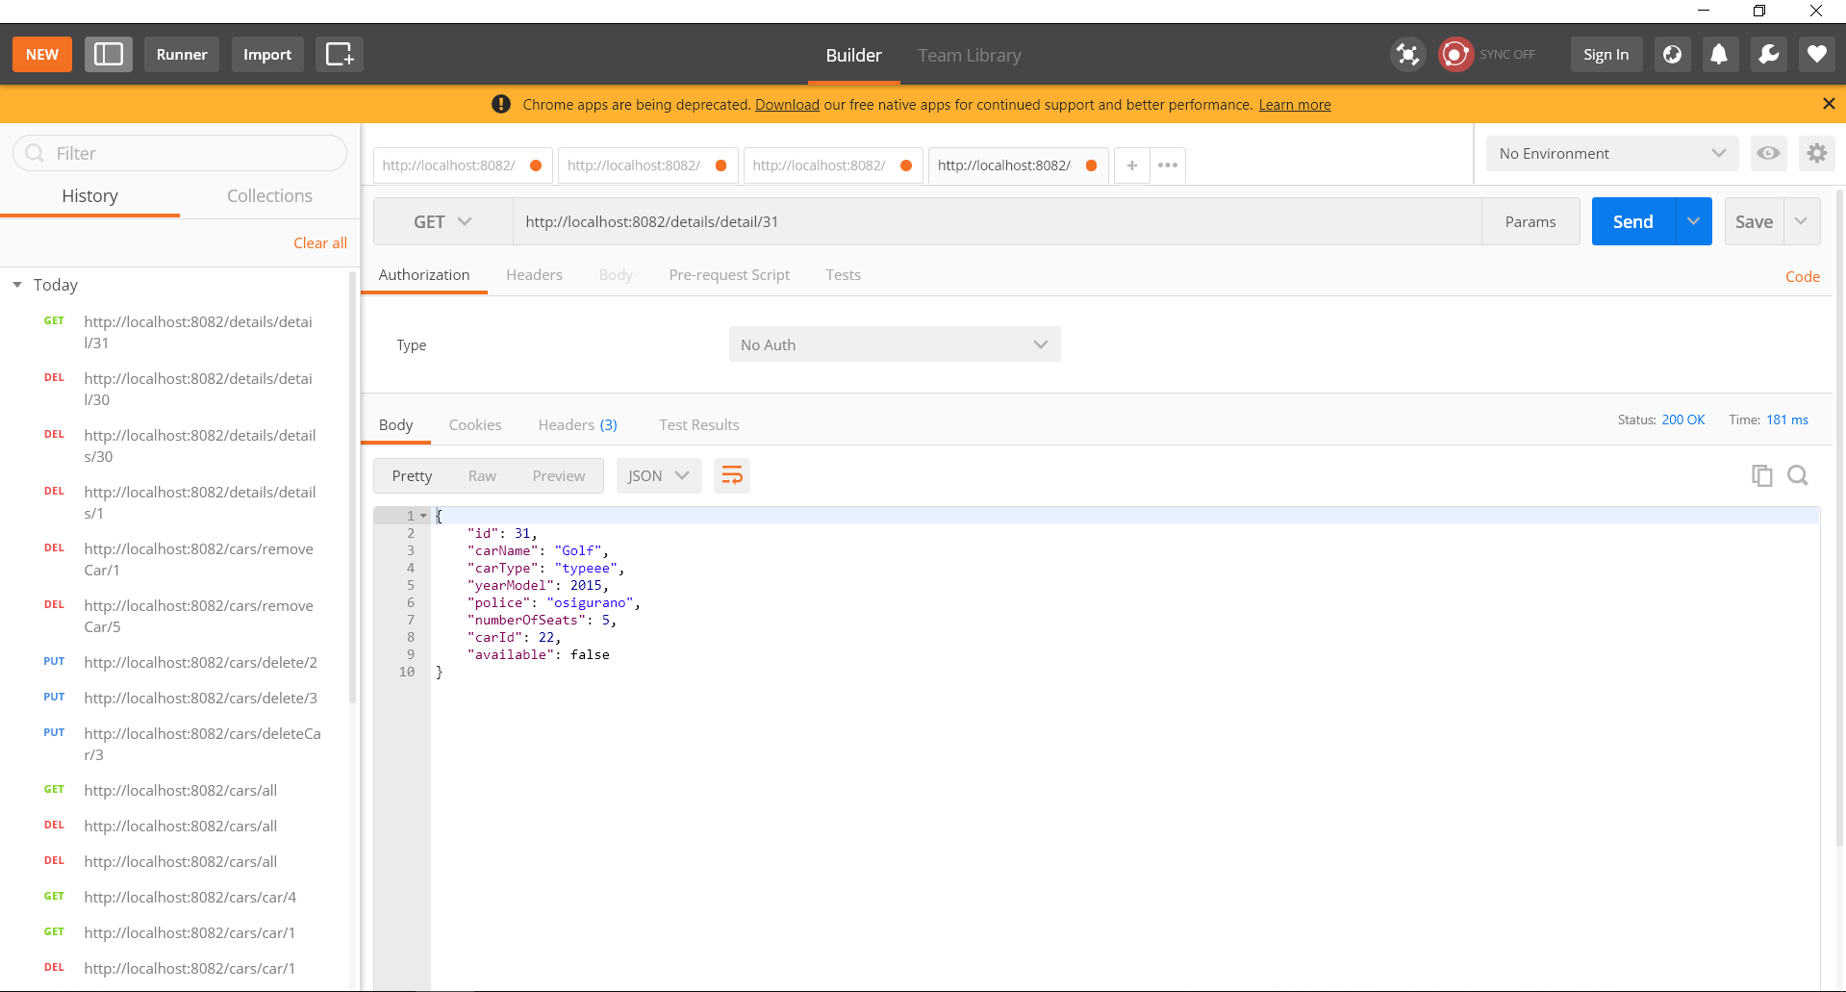

Add new car details
Create new car details
- URL
details/addDetail
- Method:
POST
- URL Params

- Data Params
{
"carName": "Opel Astra",
"carType": "typeee",
"yearModel": 2012,
"police": "osigurano",
"numberOfSeats": 5,
"carId": 5,
"available": false
}
- Success Response:
- Code: 200
Content:
{ "id": 34,
"carName": "Opel Astra",
"carType": "typeee",
"yearModel": 2012,
"police": "osigurano",
"numberOfSeats": 5,
"carId": 5,
"available": false
}
- Error Response:
- {
"timestamp": "2019-04-11T07:47:38.343+0000",
"status": 500,
"error": "Internal Server Error",
"message": "Could not commit JPA transaction; nested exception is javax.persistence.RollbackException: Error while committing the transaction",
"path": "/details/addDetail"
}
Notes
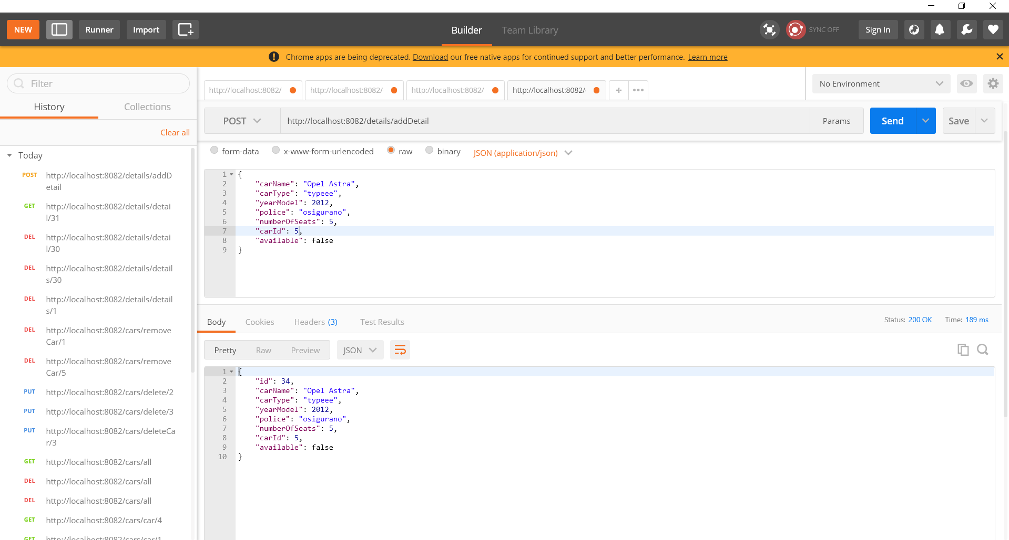

UPDATE car details

- URL
cars/available/id
- Method:
UPDATE
- URL Params
id=[int]
- Data Params
- Success Response:
- Code: 200
Content:
{
"id": 34,
"carName": "Opel Astra",
"carType": "typeee",
"yearModel": 2012,
"police": "osigurano",
"numberOfSeats": 5,
"carId": 5,
"available": false
}
- Error Response
{
"timestamp": "2019-04-11T07:49:51.636+0000",
"status": 500,
"error": "Internal Server Error",
"message": "No message available",
"path": "/details/available/3"
}
Notes
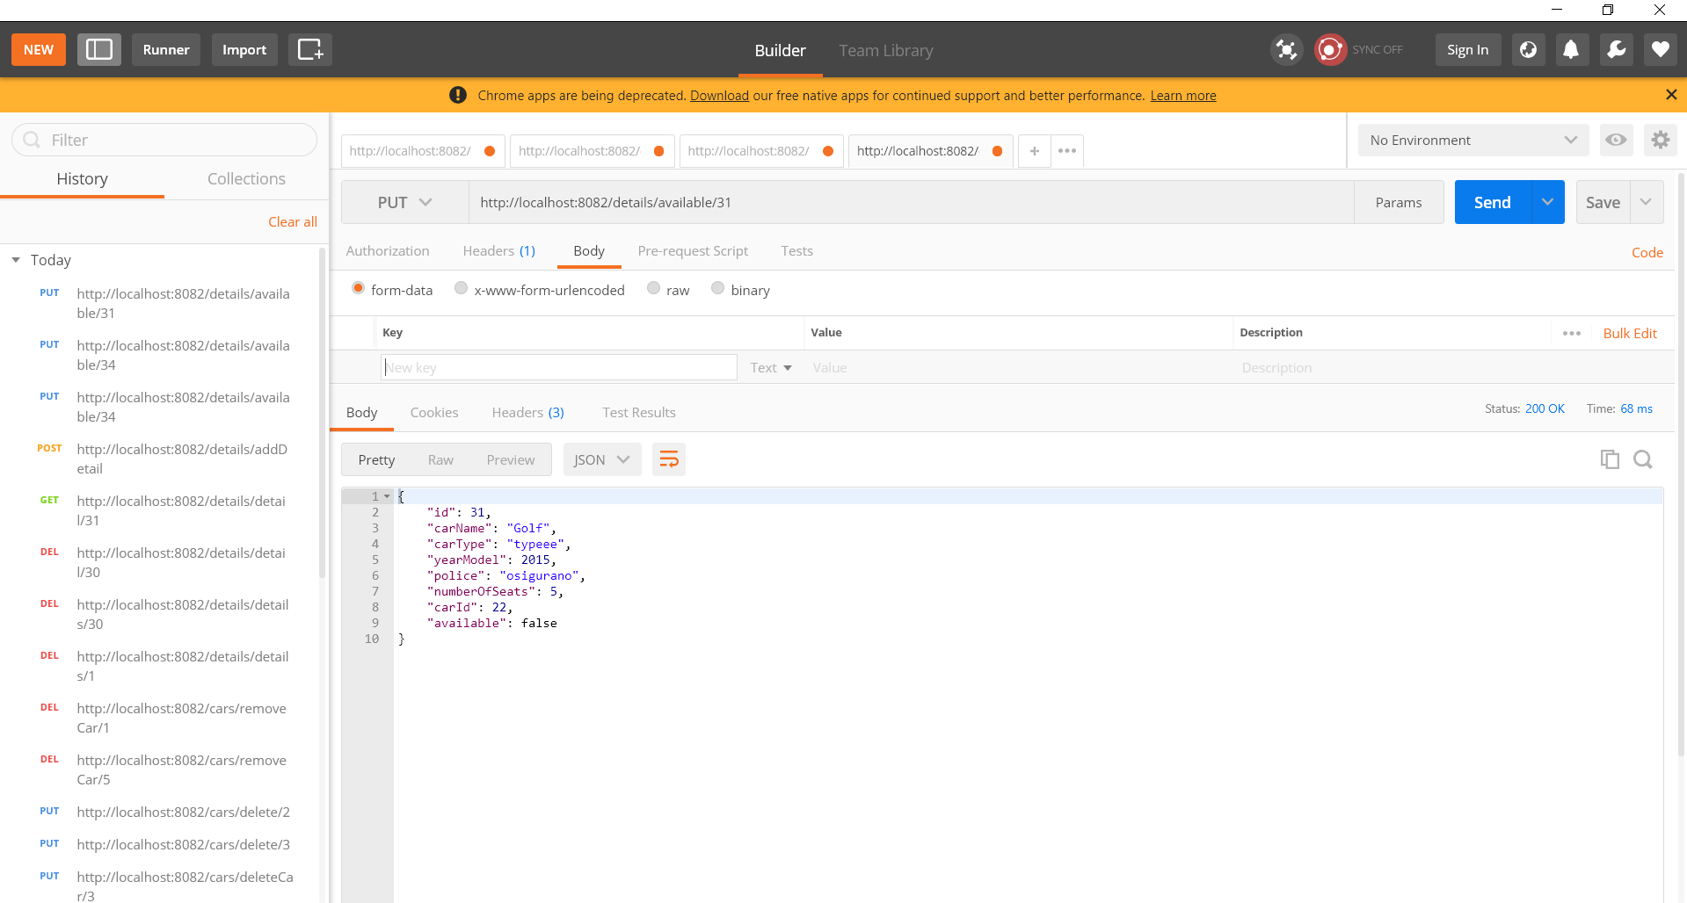

DELETE car
Create new car
- URL
details/removeDetails/id
- Method:
DELETE
- URL Params
id=[int]
- Data Params
- Success Response:
- Code: 200
Content:
Car details with id: 31 was deleted!
- Error Response:
{
"timestamp": "2019-04-11T07:52:09.132+0000",
"status": 500,
"error": "Internal Server Error",
"message": "No class com.cars.model.CarDetails entity with id 5 exists!",
"path": "/details/removeCarDetails/5"
}
Notes
