# Step 1.

First, I followed Fumihiko’s instructions for installing both of his programs. Then I opened the builtin Keyboard System Preference and set the Caps Lock Key to No Action.

[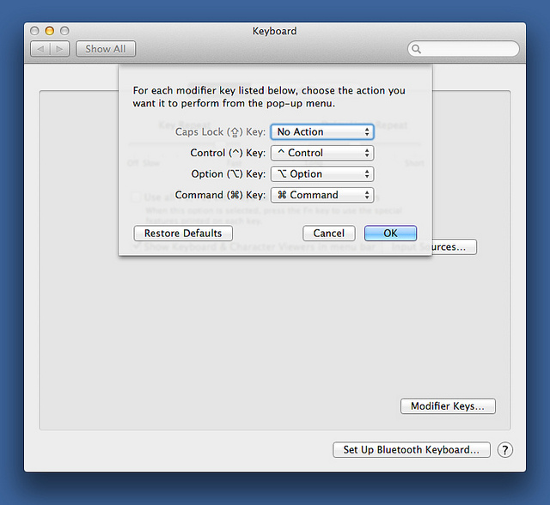](http://www.flickr.com/photos/drdrang/8213170570/)

# Step 2.

Then I opened the PCKeyboardHack Setting pane and remapped the Caps Lock key to keycode 80, which corresponds to F19 on keyboards that have an F19. Function keys on my MacBook Air max out at F12, so mapping Caps Lock to F19 causes no conflict.

[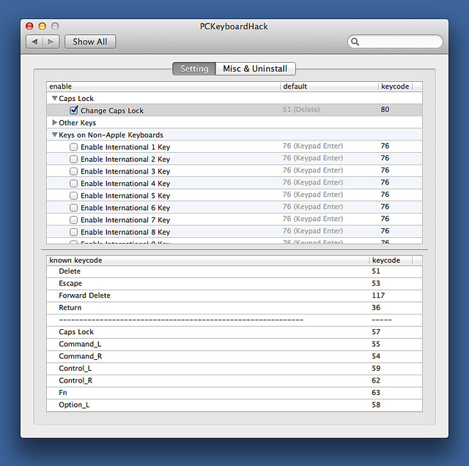](http://www.flickr.com/photos/drdrang/8209466391/)

# Step 3.

Next I opened KeyRemap4MacBook (which, despite its name, isn’t restricted to MacBooks) and opened its private.xml document from the Misc & Uninstall pane.

[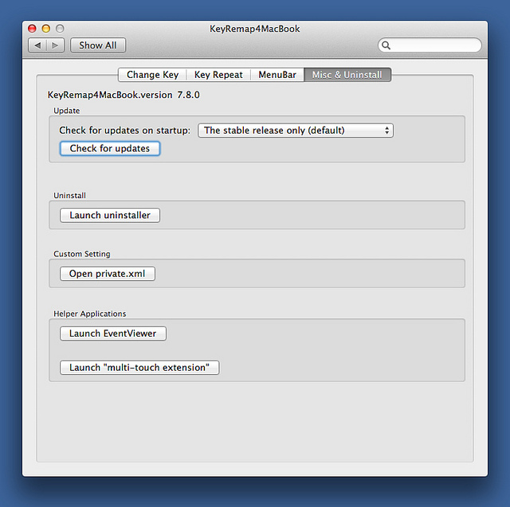](http://www.flickr.com/photos/drdrang/8209463833/)

I set the contents of my private.xml to this,

xml:

1: <?xml version="1.0"?>

2: <root>

3: <item>

4: <name>Remap Caps Lock to Hyper</name>

5: <appendix>OS X doesn't have a Hyper. This maps Left Control to Control + Shift + Option + Command.</appendix>

6:

7: <identifier>caps_lock_to_hyper</identifier>

8:

9: <autogen>

10: --KeyToKey--

11: KeyCode::F19,

12:

13: KeyCode::COMMAND_L,

14: ModifierFlag::OPTION_L | ModifierFlag::SHIFT_L | ModifierFlag::CONTROL_L

15: </autogen>

16: </item>

17: </root>

which is a minor rewrite of Losh’s private.xml. After saving and closing this file, I switched to KeyRemap4MacBook’s Change Key pane and activated the new entry.

[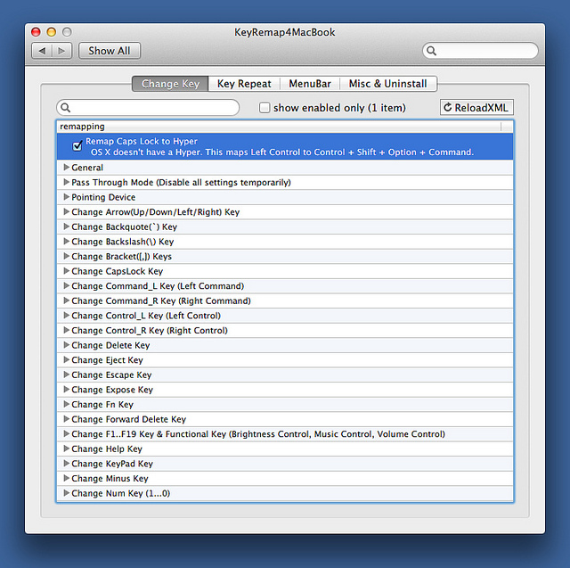](http://www.flickr.com/photos/drdrang/8209464599/)

It’s true that this remapping loses me the Caps Lock function, but I see that as a small price to pay for an entire alphabet’s worth of new keyboard shortcuts.