Migration Design Notes
This document describes the legacy migration plan and references critical risks
The rollout uses staged validation and change windows.
Phase | Owner
Execution + Verification | Platform Team
 | Docs Team
See image below for the current architecture.
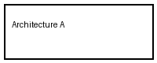
A highlighted notice appears in section 2.

