Q2.

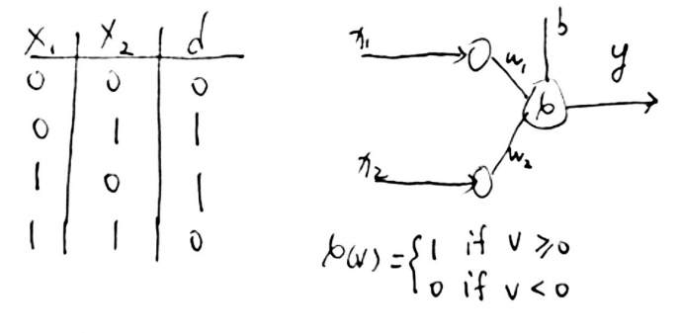

Let’s define the decision boundary equation: w1 x1 + w2 x2 + b = 0,

1, when x1 =0, x2 = 0, having y = d = 0, which requires b < 0

2, when x1 =1, x2 = 0, having y = d = 1, which requires w1 + b > 0

3, when x1 =0, x2 = 1, having y = d = 1, which requires w2 + b > 0

4, when x1 =1, x2 = 1, having y = d = 0, which requires -w1 -w2 - b > 0

5,Adding equation (2) and (3) having w1 + w2 +2b >0

Adding (4) and (5): b>0, this is in contradict with the condition required in equation (1),

Therefore, the XOR problem is not linear separable.