Hive源码

第1章 HQL是如何转换为MR任务的

1.1 Hive的核心组成介绍
1）用户接口：Client
CLI（command-line interface）、JDBC/ODBC(jdbc访问hive)、WEBUI（浏览器访问hive）
2）元数据：Metastore
元数据包括：表名、表所属的数据库（默认是default）、表的拥有者、列/分区字段、表的类型（是否是外部表）、表的数据所在目录等；
默认存储在自带的derby数据库中，推荐使用MySQL存储Metastore
3）Hadoop
使用HDFS进行存储，使用MapReduce进行计算。
4）驱动器：Driver
5）解析器（SQL Parser）
将SQL字符串转换成抽象语法树AST，这一步一般都用第三方工具库完成，比如antlr；对AST进行语法分析，比如表是否存在、字段是否存在、SQL语义是否有误。
6）编译器（Physical Plan）
将AST编译生成逻辑执行计划。
7）优化器（Query Optimizer）
对逻辑执行计划进行优化。
8）执行器（Execution）
把逻辑执行计划转换成可以运行的物理计划。对于Hive来说，就是MR/Spark。

1.2 HQL转换为MR任务流程说明

第2章 HQL转换为MR源码详细解读

2.1 HQL转换为MR源码整体流程介绍

2.2 程序入口 — CliDriver
众所周知，我们执行一个HQL语句通常有以下几种方式：
1）$HIVE_HOME/bin/hive进入客户端，然后执行HQL；
2）$HIVE_HOME/bin/hive -e “hql”；
3）$HIVE_HOME/bin/hive -f hive.sql；
4）先开启hivesever2服务端，然后通过JDBC方式连接远程提交HQL。
可以知道我们执行HQL主要依赖于$HIVE_HOME/bin/hive和$HIVE_HOME/bin/ hivesever2两种脚本来实现提交HQL，而在这两个脚本中，最终启动的JAVA程序的主类为“org.apache.hadoop.hive.cli.CliDriver”，所以其实Hive程序的入口就是“CliDriver”这个类。

2.3 HQL的读取与参数解析

2.3.1 找到“CliDriver”这个类的“main”方法
public static void main(String[] args) throws Exception {
int ret = new CliDriver().run(args);
System.exit(ret);
}

2.3.2 主类的run方法
public int run(String[] args) throws Exception {

OptionsProcessor oproc = new OptionsProcessor();

//解析系统参数
if (!oproc.process_stage1(args)) {
return 1;
}

... ...

CliSessionState ss = new CliSessionState(new HiveConf(SessionState.class));

//标准输入输出以及错误输出流的定义,后续需要输入HQL以及打印控制台信息
ss.in = System.in;
try {
ss.out = new PrintStream(System.out, true, "UTF-8");
ss.info = new PrintStream(System.err, true, "UTF-8");
ss.err = new CachingPrintStream(System.err, true, "UTF-8");
} catch (UnsupportedEncodingException e) {
return 3;
}

//解析用户参数,包含"-e -f -v -database"等等
if (!oproc.process_stage2(ss)) {
return 2;
}

... ...

// execute cli driver work
try {
return executeDriver(ss, conf, oproc);
} finally {
ss.resetThreadName();
ss.close();
}
}

2.3.3 executeDriver方法
private int executeDriver(CliSessionState ss, HiveConf conf, OptionsProcessor oproc)
throws Exception {

CliDriver cli = new CliDriver();
cli.setHiveVariables(oproc.getHiveVariables());

// use the specified database if specified
cli.processSelectDatabase(ss);

// Execute -i init files (always in silent mode)
cli.processInitFiles(ss);

if (ss.execString != null) {
int cmdProcessStatus = cli.processLine(ss.execString);
return cmdProcessStatus;
}

... ...

setupConsoleReader();

String line;
int ret = 0;
String prefix = "";
String curDB = getFormattedDb(conf, ss);
String curPrompt = prompt + curDB;
String dbSpaces = spacesForString(curDB);

//读取客户端的输入HQL
while ((line = reader.readLine(curPrompt + "> ")) != null) {
if (!prefix.equals("")) {
prefix += '\n';
}
if (line.trim().startsWith("--")) {
continue;
}
//以按照“;”分割的方式解析
if (line.trim().endsWith(";") && !line.trim().endsWith("\\;")) {
line = prefix + line;
ret = cli.processLine(line, true);
prefix = "";
curDB = getFormattedDb(conf, ss);
curPrompt = prompt + curDB;
dbSpaces = dbSpaces.length() == curDB.length() ? dbSpaces : spacesForString(curDB);
} else {
prefix = prefix + line;
curPrompt = prompt2 + dbSpaces;
continue;
}
}

return ret;
}

2.3.4 processLine方法
public int processLine(String line, boolean allowInterrupting) {
SignalHandler oldSignal = null;
Signal interruptSignal = null;

... ...

try {
int lastRet = 0, ret = 0;

// we can not use "split" function directly as ";" may be quoted
List<String> commands = splitSemiColon(line);

String command = "";
for (String oneCmd : commands) {

if (StringUtils.endsWith(oneCmd, "\\")) {
command += StringUtils.chop(oneCmd) + ";";
continue;
} else {
command += oneCmd;
}
if (StringUtils.isBlank(command)) {
continue;
}

//解析单行HQL
ret = processCmd(command);
command = "";
lastRet = ret;
boolean ignoreErrors = HiveConf.getBoolVar(conf, HiveConf.ConfVars.CLIIGNOREERRORS);
if (ret != 0 && !ignoreErrors) {
return ret;
}
}
return lastRet;
} finally {
// Once we are done processing the line, restore the old handler
if (oldSignal != null && interruptSignal != null) {
Signal.handle(interruptSignal, oldSignal);
}
}
}

2.3.5 processCmd方法
public int processCmd(String cmd) {
CliSessionState ss = (CliSessionState) SessionState.get();

... ...

//1.如果命令为"quit"或者"exit",则退出
if (cmd_trimmed.toLowerCase().equals("quit") || cmd_trimmed.toLowerCase().equals("exit")) {

// if we have come this far - either the previous commands
// are all successful or this is command line. in either case
// this counts as a successful run
ss.close();
System.exit(0);

//2.如果命令为"source"开头,则表示执行HQL文件,继续读取文件并解析
} else if (tokens[0].equalsIgnoreCase("source")) {
String cmd_1 = getFirstCmd(cmd_trimmed, tokens[0].length());
cmd_1 = new VariableSubstitution(new HiveVariableSource() {
@Override
public Map<String, String> getHiveVariable() {
return SessionState.get().getHiveVariables();
}
}).substitute(ss.getConf(), cmd_1);

File sourceFile = new File(cmd_1);
if (! sourceFile.isFile()){
console.printError("File: "+ cmd_1 + " is not a file.");
ret = 1;
} else {
try {
ret = processFile(cmd_1);
} catch (IOException e) {
console.printError("Failed processing file "+ cmd_1 +" "+ e.getLocalizedMessage(),
stringifyException(e));
ret = 1;
}
}

//3.如果命令以"!"开头,则表示用户需要执行Linux命令
} else if (cmd_trimmed.startsWith("!")) {
// for shell commands, use unstripped command
String shell_cmd = cmd.trim().substring(1);
shell_cmd = new VariableSubstitution(new HiveVariableSource() {
@Override
public Map<String, String> getHiveVariable() {
return SessionState.get().getHiveVariables();
}
}).substitute(ss.getConf(), shell_cmd);

// shell_cmd = "/bin/bash -c \'" + shell_cmd + "\'";
try {
ShellCmdExecutor executor = new ShellCmdExecutor(shell_cmd, ss.out, ss.err);
ret = executor.execute();
if (ret != 0) {
console.printError("Command failed with exit code = " + ret);
}
} catch (Exception e) {
console.printError("Exception raised from Shell command " + e.getLocalizedMessage(),
stringifyException(e));
ret = 1;
}

//4.以上三者都不是,则认为用户输入的为"select ..."正常的增删改查HQL语句,则进行HQL解析
} else {
try {

try (CommandProcessor proc = CommandProcessorFactory.get(tokens, (HiveConf) conf)) {
if (proc instanceof IDriver) {
// Let Driver strip comments using sql parser
ret = processLocalCmd(cmd, proc, ss);
} else {
ret = processLocalCmd(cmd_trimmed, proc, ss);
}
}
} catch (SQLException e) {
console.printError("Failed processing command " + tokens[0] + " " + e.getLocalizedMessage(),
org.apache.hadoop.util.StringUtils.stringifyException(e));
ret = 1;
}
catch (Exception e) {
throw new RuntimeException(e);
}
}

ss.resetThreadName();
return ret;
}

2.3.6 processLocalCmd方法
int processLocalCmd(String cmd, CommandProcessor proc, CliSessionState ss) {
boolean escapeCRLF = HiveConf.getBoolVar(conf, HiveConf.ConfVars.HIVE_CLI_PRINT_ESCAPE_CRLF);
int ret = 0;

if (proc != null) {
if (proc instanceof IDriver) {
IDriver qp = (IDriver) proc;
PrintStream out = ss.out;

//获取系统时间作为开始时间,以便后续计算HQL执行时长
long start = System.currentTimeMillis();
if (ss.getIsVerbose()) {
out.println(cmd);
}

//HQL执行的核心方法
ret = qp.run(cmd).getResponseCode();
if (ret != 0) {
qp.close();
return ret;
}

// query has run capture the time
//获取系统时间作为结束时间,以便后续计算HQL执行时长
long end = System.currentTimeMillis();
double timeTaken = (end - start) / 1000.0;

ArrayList<String> res = new ArrayList<String>();

//打印头信息
printHeader(qp, out);

// print the results,包含结果集并获取抓取到数据的条数
int counter = 0;
try {
if (out instanceof FetchConverter) {
((FetchConverter) out).fetchStarted();
}
while (qp.getResults(res)) {
for (String r : res) {
if (escapeCRLF) {
r = EscapeCRLFHelper.escapeCRLF(r);
}
out.println(r);
}
counter += res.size();
res.clear();
if (out.checkError()) {
break;
}
}
} catch (IOException e) {
console.printError("Failed with exception " + e.getClass().getName() + ":" + e.getMessage(),
"\n" + org.apache.hadoop.util.StringUtils.stringifyException(e));
ret = 1;
}

qp.close();

if (out instanceof FetchConverter) {
((FetchConverter) out).fetchFinished();
}

//打印HQL执行时间以及抓取数据的条数（经常使用Hive的同学是否觉得这句很熟悉呢，其实就是执行完一个HQL最后打印的那句话）
console.printInfo(
"Time taken: " + timeTaken + " seconds" + (counter == 0 ? "" : ", Fetched: " + counter + " row(s)"));
} else {
String firstToken = tokenizeCmd(cmd.trim())[0];
String cmd_1 = getFirstCmd(cmd.trim(), firstToken.length());

if (ss.getIsVerbose()) {
ss.out.println(firstToken + " " + cmd_1);
}
CommandProcessorResponse res = proc.run(cmd_1);
if (res.getResponseCode() != 0) {
ss.out
.println("Query returned non-zero code: " + res.getResponseCode() + ", cause: " + res.getErrorMessage());
}
if (res.getConsoleMessages() != null) {
for (String consoleMsg : res.getConsoleMessages()) {
console.printInfo(consoleMsg);
}
}
ret = res.getResponseCode();
}
}

return ret;
}

2.3.7 qp.run(cmd)方法
点击进入“run”方法，该方法为IDriver接口的抽象方法，此处实际调用的是“org.apache.hadoop.hive.ql.Driver”类中的“run”方法，找到“Driver”类中的“run”方法。
public CommandProcessorResponse run(String command) {
return run(command, false);
}

public CommandProcessorResponse run(String command, boolean alreadyCompiled) {

try {
runInternal(command, alreadyCompiled);
return createProcessorResponse(0);
} catch (CommandProcessorResponse cpr) {
... ...
}

}

2.3.8 runInternal方法
private void runInternal(String command, boolean alreadyCompiled) throws CommandProcessorResponse {
errorMessage = null;
SQLState = null;
downstreamError = null;
LockedDriverState.setLockedDriverState(lDrvState);

lDrvState.stateLock.lock();

... ...

PerfLogger perfLogger = null;

if (!alreadyCompiled) {
// compile internal will automatically reset the perf logger

//1.编译HQL语句
compileInternal(command, true);
// then we continue to use this perf logger
perfLogger = SessionState.getPerfLogger();
}

... ...

try {

//2.执行
execute();
} catch (CommandProcessorResponse cpr) {
rollback(cpr);
throw cpr;
}

isFinishedWithError = false;
}
}

2.4 HQL生成AST（抽象语法树）

2.4.1 compileInternal方法
private void compileInternal(String command, boolean deferClose) throws CommandProcessorResponse {
Metrics metrics = MetricsFactory.getInstance();
if (metrics != null) {
metrics.incrementCounter(MetricsConstant.WAITING_COMPILE_OPS, 1);
}

… …

if (compileLock == null) {
throw createProcessorResponse(ErrorMsg.COMPILE_LOCK_TIMED_OUT.getErrorCode());
}

try {
compile(command, true, deferClose);
} catch (CommandProcessorResponse cpr) {
try {
releaseLocksAndCommitOrRollback(false);
} catch (LockException e) {
LOG.warn("Exception in releasing locks. " + org.apache.hadoop.util.StringUtils.stringifyException(e));
}
throw cpr;
}
}

2.4.2 compile方法
private void compile(String command, boolean resetTaskIds, boolean deferClose) throws CommandProcessorResponse {
PerfLogger perfLogger = SessionState.getPerfLogger(true);
perfLogger.PerfLogBegin(CLASS_NAME, PerfLogger.DRIVER_RUN);
perfLogger.PerfLogBegin(CLASS_NAME, PerfLogger.COMPILE);
lDrvState.stateLock.lock();

... ...

//HQL生成AST
ASTNode tree;
try {
tree = ParseUtils.parse(command, ctx);
} catch (ParseException e) {
parseError = true;
throw e;
} finally {
hookRunner.runAfterParseHook(command, parseError);
}
}

2.4.3 parse方法
/** Parses the Hive query. */
public static ASTNode parse(String command, Context ctx) throws ParseException {
return parse(command, ctx, null);
}

public static ASTNode parse(
String command, Context ctx, String viewFullyQualifiedName) throws ParseException {
ParseDriver pd = new ParseDriver();
ASTNode tree = pd.parse(command, ctx, viewFullyQualifiedName);
tree = findRootNonNullToken(tree);
handleSetColRefs(tree);
return tree;
}

public ASTNode parse(String command, Context ctx, String viewFullyQualifiedName)
throws ParseException {
if (LOG.isDebugEnabled()) {
LOG.debug("Parsing command: " + command);
}

//1.构建词法解析器
HiveLexerX lexer = new HiveLexerX(new ANTLRNoCaseStringStream(command));

//2.将HQL中的关键词替换为Token
TokenRewriteStream tokens = new TokenRewriteStream(lexer);
if (ctx != null) {
if (viewFullyQualifiedName == null) {
// Top level query
ctx.setTokenRewriteStream(tokens);
} else {
// It is a view
ctx.addViewTokenRewriteStream(viewFullyQualifiedName, tokens);
}
lexer.setHiveConf(ctx.getConf());
}
说明：Antlr框架。Hive使用Antlr实现SQL的词法和语法解析。Antlr是一种语言识别的工具，可以用来构造领域语言。 这里不详细介绍Antlr，只需要了解使用Antlr构造特定的语言只需要编写一个语法文件，定义词法和语法替换规则即可，Antlr完成了词法分析、语法分析、语义分析、中间代码生成的过程。
Hive中语法规则的定义文件在0.10版本以前是Hive.g一个文件，随着语法规则越来越复杂，由语法规则生成的Java解析类可能超过Java类文件的最大上限，0.11版本将Hive.g拆成了5个文件，词法规则HiveLexer.g和语法规则的4个文件SelectClauseParser.g，FromClauseParser.g，IdentifiersParser.g，HiveParser.g。
HiveParser parser = new HiveParser(tokens);
if (ctx != null) {
parser.setHiveConf(ctx.getConf());
}
parser.setTreeAdaptor(adaptor);
HiveParser.statement_return r = null;
try {
//3.进行语法解析，生成最终的AST
r = parser.statement();
} catch (RecognitionException e) {
e.printStackTrace();
throw new ParseException(parser.errors);
}

if (lexer.getErrors().size() == 0 && parser.errors.size() == 0) {
LOG.debug("Parse Completed");
} else if (lexer.getErrors().size() != 0) {
throw new ParseException(lexer.getErrors());
} else {
throw new ParseException(parser.errors);
}

ASTNode tree = (ASTNode) r.getTree();
tree.setUnknownTokenBoundaries();
return tree;
}
说明：例如HQL语句为：
FROM
(
SELECT
p.datekey datekey,
p.userid userid,
c.clienttype
FROM
detail.usersequence_client c
JOIN fact.orderpayment p ON p.orderid = c.orderid
JOIN default.user du ON du.userid = p.userid
WHERE p.datekey = 20131118
) base
INSERT OVERWRITE TABLE `test`.`customer_kpi`
SELECT
base.datekey,
base.clienttype,
count(distinct base.userid) buyer_count
GROUP BY base.datekey, base.clienttype
生成对应的AST（抽象语法树）为：
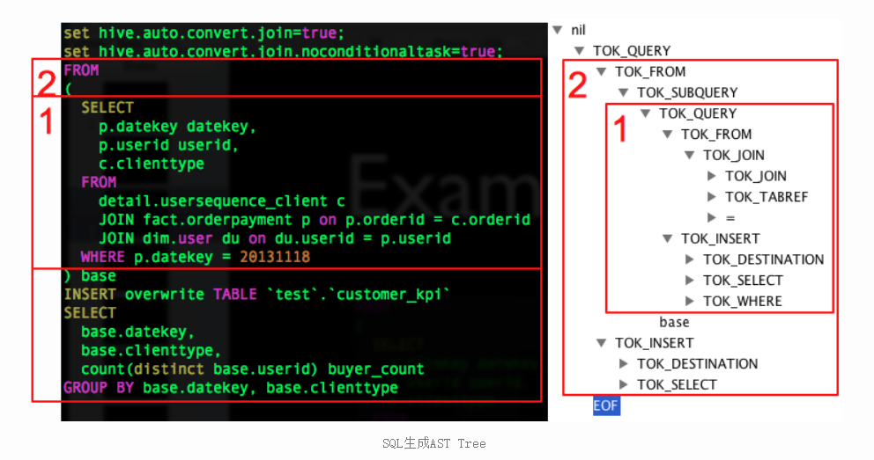

2.5 对AST进一步解析
接下来的步骤包括：
1）将AST转换为QueryBlock进一步转换为OperatorTree；
2）对OperatorTree进行逻辑优化（LogicalOptimizer）；
3）将OperatorTree转换为TaskTree（任务树）；
4）对TaskTree进行物理优化（PhysicalOptimizer）。
之所以将这4个步骤写在一起，是因为这几个步骤在源码中存在于一个方法中。

2.5.1 compile方法（接2.4.2节compile方法继续往下）
private void compile(String command, boolean resetTaskIds, boolean deferClose) throws CommandProcessorResponse {
PerfLogger perfLogger = SessionState.getPerfLogger(true);
perfLogger.PerfLogBegin(CLASS_NAME, PerfLogger.DRIVER_RUN);
perfLogger.PerfLogBegin(CLASS_NAME, PerfLogger.COMPILE);
lDrvState.stateLock.lock();

... ...

//HQL生成AST
ASTNode tree;
try {
tree = ParseUtils.parse(command, ctx);
} catch (ParseException e) {
parseError = true;
throw e;
} finally {
hookRunner.runAfterParseHook(command, parseError);
}

// Do semantic analysis and plan generation
BaseSemanticAnalyzer sem = SemanticAnalyzerFactory.get(queryState, tree);

if (!retrial) {
openTransaction();
generateValidTxnList();
}

//进一步解析抽象语法树
sem.analyze(tree, ctx);
}

2.5.2 analyze方法
public void analyze(ASTNode ast, Context ctx) throws SemanticException {
initCtx(ctx);
init(true);
analyzeInternal(ast);
}

2.5.3 analyzeInternal方法
public abstract void analyzeInternal(ASTNode ast) throws SemanticException;
此方法为“org.apache.hadoop.hive.ql.parse.BaseSemanticAnalyzer”抽象类的抽象方法，我们进入实现类“org.apache.hadoop.hive.ql.parse.SemanticAnalyzer”的analyzeInternal方法。
public void analyzeInternal(ASTNode ast) throws SemanticException {
analyzeInternal(ast, new PlannerContextFactory() {
@Override
public PlannerContext create() {
return new PlannerContext();
}
});
}

2.5.4 继续调用重载的analyzeInternal方法
注意：该段源码中出现的“1,2,3,4…11”均为源码所定义步骤，该方法代码虽然很长，但是由于存在官方提供的步骤注释，其实读懂并不难。
void analyzeInternal(ASTNode ast, PlannerContextFactory pcf) throws SemanticException {
LOG.info("Starting Semantic Analysis");
// 1. Generate Resolved Parse tree from syntax tree
boolean needsTransform = needsTransform();
//change the location of position alias process here
processPositionAlias(ast);
PlannerContext plannerCtx = pcf.create();
//处理AST，转换为QueryBlock
if (!genResolvedParseTree(ast, plannerCtx)) {
return;
}

... ...

// 2. Gen OP Tree from resolved Parse Tree
Operator sinkOp = genOPTree(ast, plannerCtx);

// 3. Deduce Resultset Schema:定义输出数据的Schema
… …

// 4. Generate Parse Context for Optimizer & Physical compiler
copyInfoToQueryProperties(queryProperties);
ParseContext pCtx = new ParseContext(queryState, opToPartPruner, opToPartList, topOps,
new HashSet<JoinOperator>(joinContext.keySet()),
new HashSet<SMBMapJoinOperator>(smbMapJoinContext.keySet()),
loadTableWork, loadFileWork, columnStatsAutoGatherContexts, ctx, idToTableNameMap, destTableId, uCtx,
listMapJoinOpsNoReducer, prunedPartitions, tabNameToTabObject, opToSamplePruner,
globalLimitCtx, nameToSplitSample, inputs, rootTasks, opToPartToSkewedPruner,
viewAliasToInput, reduceSinkOperatorsAddedByEnforceBucketingSorting,
analyzeRewrite, tableDesc, createVwDesc, materializedViewUpdateDesc,
queryProperties, viewProjectToTableSchema, acidFileSinks);

... ...

// 5. Take care of view creation：处理视图相关

… …

// 6. Generate table access stats if required
if (HiveConf.getBoolVar(this.conf, HiveConf.ConfVars.HIVE_STATS_COLLECT_TABLEKEYS)) {
TableAccessAnalyzer tableAccessAnalyzer = new TableAccessAnalyzer(pCtx);
setTableAccessInfo(tableAccessAnalyzer.analyzeTableAccess());
}

// 7. Perform Logical optimization：对操作树执行逻辑优化
if (LOG.isDebugEnabled()) {
LOG.debug("Before logical optimization\n" + Operator.toString(pCtx.getTopOps().values()));
}

//创建优化器
Optimizer optm = new Optimizer();
optm.setPctx(pCtx);
optm.initialize(conf);
//执行优化
pCtx = optm.optimize();
if (pCtx.getColumnAccessInfo() != null) {
// set ColumnAccessInfo for view column authorization
setColumnAccessInfo(pCtx.getColumnAccessInfo());
}
if (LOG.isDebugEnabled()) {
LOG.debug("After logical optimization\n" + Operator.toString(pCtx.getTopOps().values()));
}

// 8. Generate column access stats if required - wait until column pruning
// takes place during optimization
boolean isColumnInfoNeedForAuth = SessionState.get().isAuthorizationModeV2()
&& HiveConf.getBoolVar(conf, HiveConf.ConfVars.HIVE_AUTHORIZATION_ENABLED);
if (isColumnInfoNeedForAuth
|| HiveConf.getBoolVar(this.conf, HiveConf.ConfVars.HIVE_STATS_COLLECT_SCANCOLS)) {
ColumnAccessAnalyzer columnAccessAnalyzer = new ColumnAccessAnalyzer(pCtx);
// view column access info is carried by this.getColumnAccessInfo().
setColumnAccessInfo(columnAccessAnalyzer.analyzeColumnAccess(this.getColumnAccessInfo()));
}

// 9. Optimize Physical op tree & Translate to target execution engine (MR,
// TEZ..)：执行物理优化
if (!ctx.getExplainLogical()) {
TaskCompiler compiler = TaskCompilerFactory.getCompiler(conf, pCtx);
compiler.init(queryState, console, db);
//compile为抽象方法，对应的实现类分别为MapReduceCompiler、TezCompiler和SparkCompiler
compiler.compile(pCtx, rootTasks, inputs, outputs);
fetchTask = pCtx.getFetchTask();
}
//find all Acid FileSinkOperatorS
QueryPlanPostProcessor qp = new QueryPlanPostProcessor(rootTasks, acidFileSinks, ctx.getExecutionId());

// 10. Attach CTAS/Insert-Commit-hooks for Storage Handlers

... ...

LOG.info("Completed plan generation");

// 11. put accessed columns to readEntity
if (HiveConf.getBoolVar(this.conf, HiveConf.ConfVars.HIVE_STATS_COLLECT_SCANCOLS)) {
putAccessedColumnsToReadEntity(inputs, columnAccessInfo);
}

if (isCacheEnabled && lookupInfo != null) {
if (queryCanBeCached()) {
QueryResultsCache.QueryInfo queryInfo = createCacheQueryInfoForQuery(lookupInfo);

// Specify that the results of this query can be cached.
setCacheUsage(new CacheUsage(
CacheUsage.CacheStatus.CAN_CACHE_QUERY_RESULTS, queryInfo));
}
}
}

2.5.5 提交任务并执行（接2.3.8节runInternal方法继续往下）
此处接2.3.8节中的第二步：
//2.执行
execute();

2.5.6 execute方法
private void execute() throws CommandProcessorResponse {
PerfLogger perfLogger = SessionState.getPerfLogger();
perfLogger.PerfLogBegin(CLASS_NAME, PerfLogger.DRIVER_EXECUTE);

... ...

//1.构建任务：根据任务树构建MrJob
setQueryDisplays(plan.getRootTasks());
int mrJobs = Utilities.getMRTasks(plan.getRootTasks()).size();
int jobs = mrJobs + Utilities.getTezTasks(plan.getRootTasks()).size()
+ Utilities.getSparkTasks(plan.getRootTasks()).size();
if (jobs > 0) {
logMrWarning(mrJobs);
console.printInfo("Query ID = " + queryId);
console.printInfo("Total jobs = " + jobs);
}

perfLogger.PerfLogBegin(CLASS_NAME, PerfLogger.RUN_TASKS);
// Loop while you either have tasks running, or tasks queued up
while (driverCxt.isRunning()) {
// Launch upto maxthreads tasks
Task<? extends Serializable> task;
while ((task = driverCxt.getRunnable(maxthreads)) != null) {

//2.启动任务
TaskRunner runner = launchTask(task, queryId, noName, jobname, jobs, driverCxt);
if (!runner.isRunning()) {
break;
}
}

... ...

//打印结果中最后的OK
if (console != null) {
console.printInfo("OK");
}
}

2.5.7 launchTask方法
private TaskRunner launchTask(Task<? extends Serializable> tsk, String queryId, boolean noName,
String jobname, int jobs, DriverContext cxt) throws HiveException {
if (SessionState.get() != null) {
SessionState.get().getHiveHistory().startTask(queryId, tsk, tsk.getClass().getName());
}
if (tsk.isMapRedTask() && !(tsk instanceof ConditionalTask)) {
if (noName) {
conf.set(MRJobConfig.JOB_NAME, jobname + " (" + tsk.getId() + ")");
}
conf.set(DagUtils.MAPREDUCE_WORKFLOW_NODE_NAME, tsk.getId());
Utilities.setWorkflowAdjacencies(conf, plan);
cxt.incCurJobNo(1);
console.printInfo("Launching Job " + cxt.getCurJobNo() + " out of " + jobs);
}
tsk.initialize(queryState, plan, cxt, ctx.getOpContext());
TaskRunner tskRun = new TaskRunner(tsk);

//添加启动任务
cxt.launching(tskRun);

// Launch Task：根据是否可以并行来决定是否并行启动Task
if (HiveConf.getBoolVar(conf, HiveConf.ConfVars.EXECPARALLEL) && tsk.canExecuteInParallel()) {
// Launch it in the parallel mode, as a separate thread only for MR tasks
if (LOG.isInfoEnabled()){
LOG.info("Starting task [" + tsk + "] in parallel");
}
//可并行任务启动,实际上还是执行tskRun.runSequential();
tskRun.start();
} else {
if (LOG.isInfoEnabled()){
LOG.info("Starting task [" + tsk + "] in serial mode");
}
//不可并行任务,则按照序列顺序执行任务
tskRun.runSequential();
}
return tskRun;
}

2.5.8 runSequential方法
public void runSequential() {
int exitVal = -101;
try {
exitVal = tsk.executeTask(ss == null ? null : ss.getHiveHistory());
} catch (Throwable t) {
if (tsk.getException() == null) {
tsk.setException(t);
}
LOG.error("Error in executeTask", t);
}
result.setExitVal(exitVal);
if (tsk.getException() != null) {
result.setTaskError(tsk.getException());
}
}

2.5.9 executeTask方法
public int executeTask(HiveHistory hiveHistory) {
try {
this.setStarted();
if (hiveHistory != null) {
hiveHistory.logPlanProgress(queryPlan);
}
int retval = execute(driverContext);
this.setDone();
if (hiveHistory != null) {
hiveHistory.logPlanProgress(queryPlan);
}
return retval;
} catch (IOException e) {
throw new RuntimeException("Unexpected error: " + e.getMessage(), e);
}
}

2.5.10 execute方法
protected abstract int execute(DriverContext driverContext);
此时我们进入了一个抽象“org.apache.hadoop.hive.ql.exec.Task”的“execute”方法，我们则需要找到一个实现类的“execute”方法，此处我选择“org.apache.hadoop.hive.ql.exec.mr.MapRedTask”这个类。
public int execute(DriverContext driverContext) {

Context ctx = driverContext.getCtx();
boolean ctxCreated = false;

try {

... ...

if (!runningViaChild) {
// since we are running the mapred task in the same jvm, we should update the job conf
// in ExecDriver as well to have proper local properties.
if (this.isLocalMode()) {
// save the original job tracker
ctx.setOriginalTracker(ShimLoader.getHadoopShims().getJobLauncherRpcAddress(job));
// change it to local
ShimLoader.getHadoopShims().setJobLauncherRpcAddress(job, "local");
}
// we are not running this mapred task via child jvm
// so directly invoke ExecDriver

//设置MR任务的InputFormat、OutputFormat等等这些MRJob的执行类
int ret = super.execute(driverContext);

// restore the previous properties for framework name, RM address etc.
if (this.isLocalMode()) {
// restore the local job tracker back to original
ctx.restoreOriginalTracker();
}
return ret;
}

... ...

//构建执行MR任务的命令
String isSilent = "true".equalsIgnoreCase(System
.getProperty("test.silent")) ? "-nolog" : "";

String jarCmd = hiveJar + " " + ExecDriver.class.getName() + libJarsOption;

String cmdLine = hadoopExec + " jar " + jarCmd + " -plan "
+ planPath.toString() + " " + isSilent + " " + hiveConfArgs;

... ...

// Run ExecDriver in another JVM
executor = Runtime.getRuntime().exec(cmdLine, env, new File(workDir));
}

第3章 Hive源码Debug介绍

3.1 Debug环境准备

3.1.1 下载源码包
下载Hive源码包，自行编译一下，建议在Linux环境下编译，然后将整个编译好的包全部拷贝到IDEA工作目录中并使用IDEA打开。该文档是以Hive3.1.2版本作为讲解的。在资料包中提供了已经编译好的Hive源码包。

3.1.2 打开项目配置项
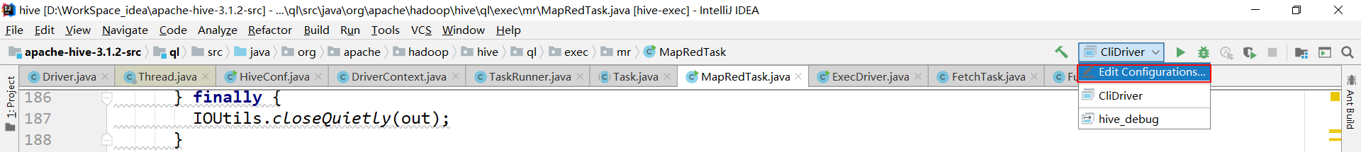

3.1.3 添加远程连接配置组
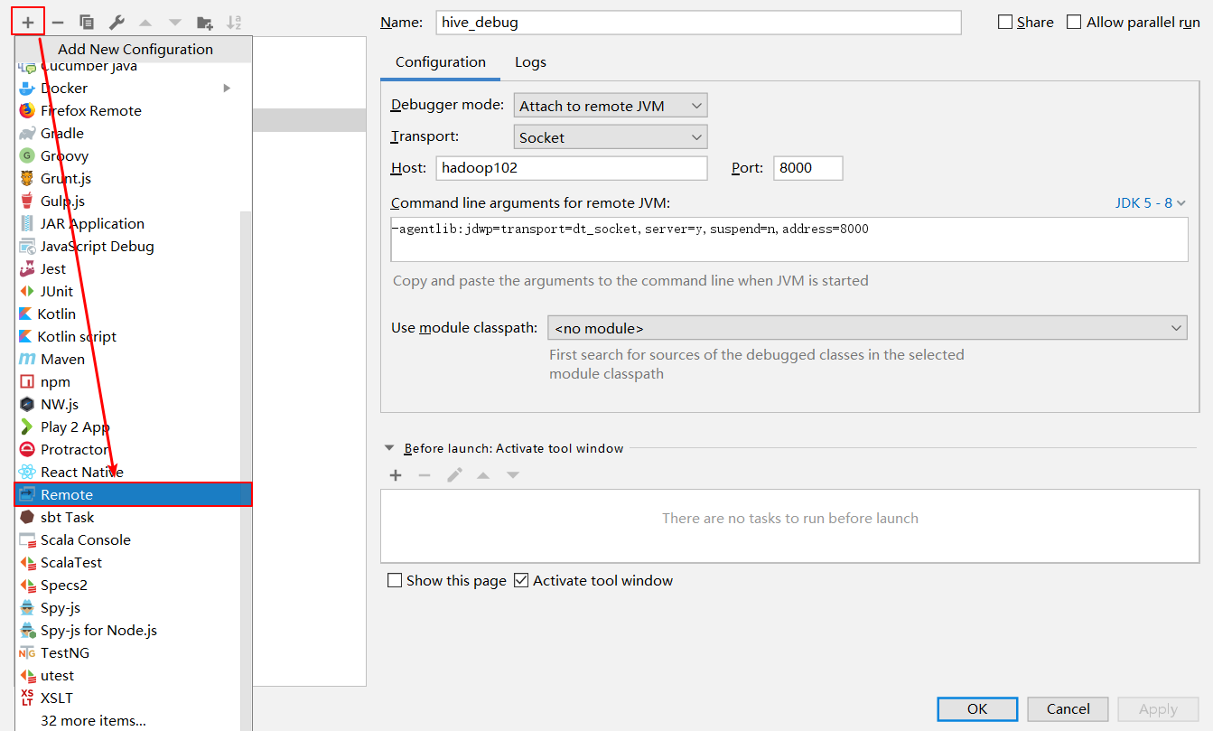

3.1.4 添加配置信息
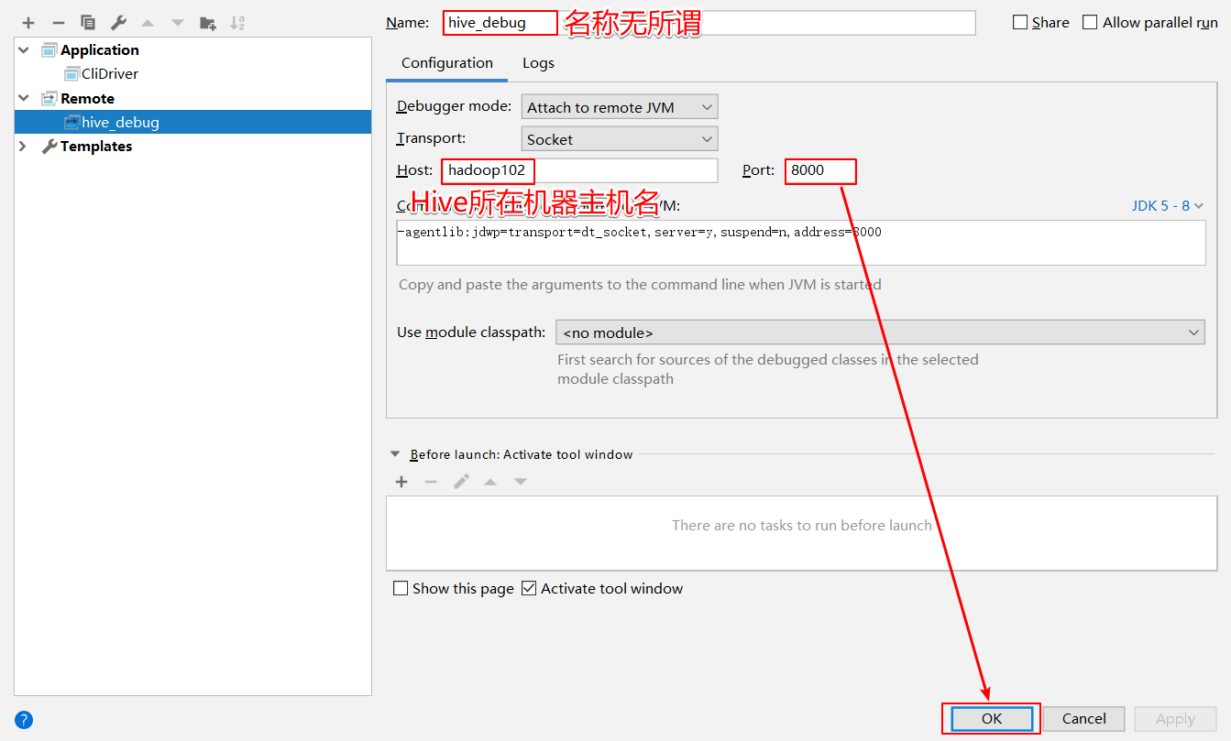

3.2 测试

3.2.1 在CliDriver类的run方法中随意打上断点
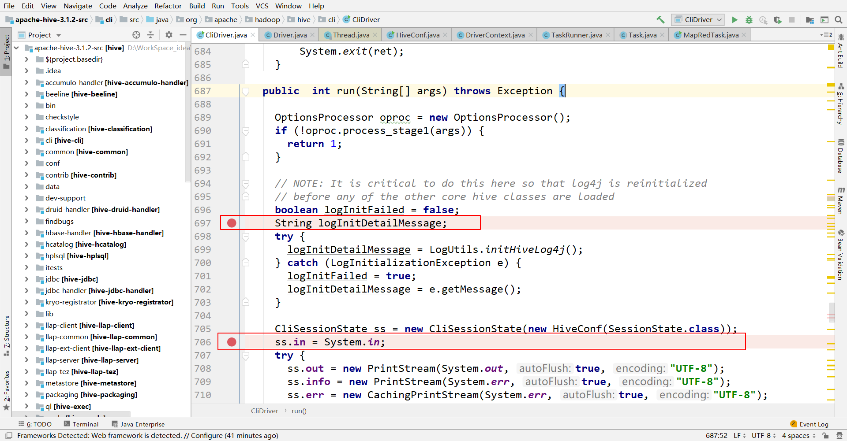

3.2.2 开启Hive客户端Debug模式
$HIVE_HOME/bin/hive –debug

3.2.3 使用debug模式启动本地项目
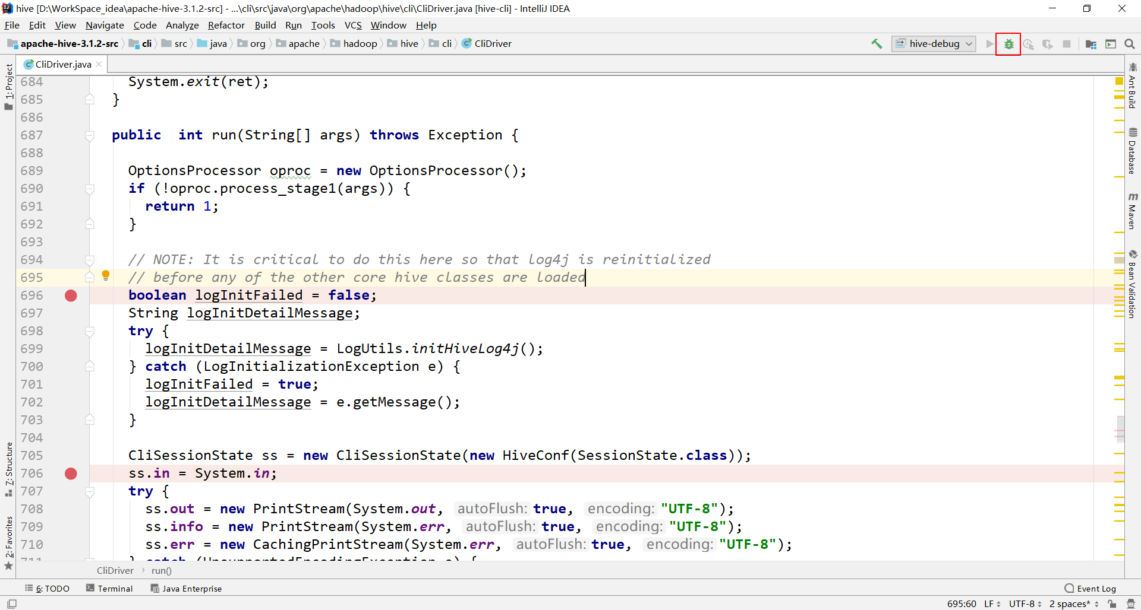

3.2.4 在Hive客户端中执行HQL，切换到IDEA中查看
1）在IDEA中查看断点
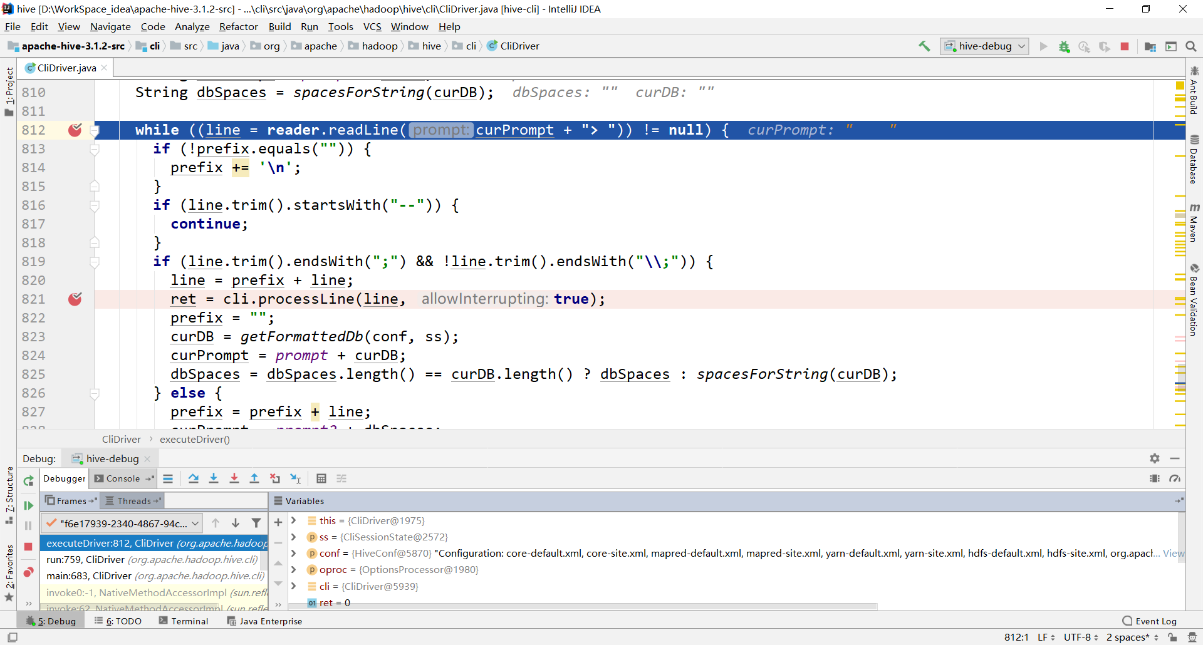
2）在Hive Debug模式客户端查看
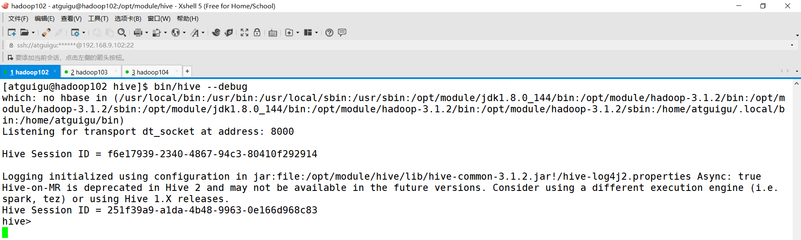
说明：此文档部分图片来自于美团帖子
链接：https://tech.meituan.com/2014/02/12/hive-sql-to-mapreduce.html

