Short-window motor-imagery EEG decoding with training-time privileged information and validation-controlled routing
MBEC-oriented manuscript draft | Authors and affiliations to be inserted
Abstract
Motor-imagery EEG (MI-EEG) decoders often use several seconds of post-cue data, which improves evidence accumulation but delays a decision. We investigated whether a student decoder restricted to the first 2 s can benefit from information available only during training. Across nine participants and five random seeds, validation-controlled routing on BCI Competition IV-2a achieved 59.31% accuracy versus 56.72% for fixed 2-s cross-entropy training (paired t-test p=0.0055; Wilcoxon p=0.0078). On BCI Competition IV-2b, adaptive Riemannian knowledge distillation with spatial supervision achieved 77.12%, compared with 76.34% for fixed 2-s cross-entropy. Teachers were removed at inference. These findings support training-time privileged information for earlier MI-EEG decisions, while showing that gains depend on task complexity and spatial information.
Keywords: motor imagery; electroencephalography; brain-computer interface; short-window decoding; knowledge distillation; Riemannian geometry; EEGNet
1 Introduction
Longer MI-EEG windows accumulate more evidence but delay a BCI decision. We address the engineering question of how much decoding performance can be retained when the deployed classifier is restricted to the first 2 s after the cue. The proposed framework uses 4-s information only during training and removes teachers from inference.
The central hypothesis is bounded: training-time long-window information and validation-controlled strategy selection can improve a latency-matched 2-s student for difficult participant-dependent MI decoding, but need not replace complete-window decoding.
2 Materials and methods
2.1 Datasets and protocol
Signals were retrieved through MOABB. The training session was split into stratified training and validation subsets (80/20); the evaluation session was held out as the only test set. Filtering used 8-32 Hz, and all 0-4 s signals were sampled at 250 Hz. Five seeds controlled the internal split and optimization.
Table 1 | Datasets and cross-session evaluation protocol.
Dataset | Classes | Channels | Rate | Protocol
BCI IV-2a | 4 | 22 | 250 Hz | Train session -> train/validation; eval session -> test
BCI IV-2b | 2 | 3 | 250 Hz | Train session -> train/validation; eval session -> test

2.2 Training-time privileged information and routing
The deployed student was Compact EEGNet with a 2-s input. In IV-2a, frozen 4-s Compact EEGNet and Riemannian teachers supplied soft labels. In IV-2b, a 4-s Riemannian teacher supplied soft labels and a covariance-derived spatial target regularized the pre-depthwise student representation. Candidate routes were selected only from validation performance; the evaluation session was not used to fit teachers, select checkpoints, or select a route.
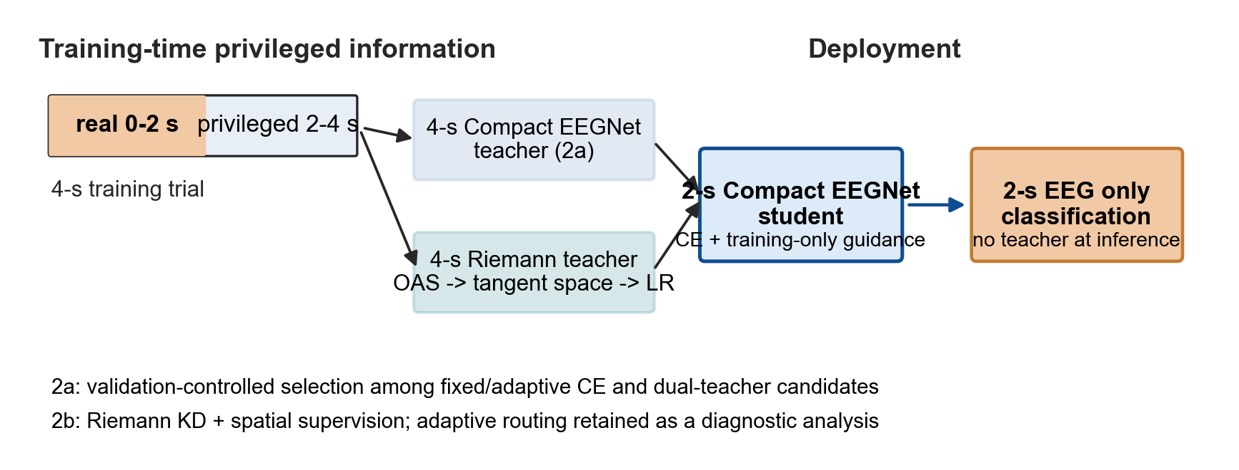
Figure 1 | Training-time privileged information and deployment-time short-window inference. The 4-s teachers and covariance targets are available only during training. Deployment uses the 2-s student and, for an adaptive candidate, an optional detector.
3 Results
3.1 Routing improved short-window decoding on IV-2a
Validation-controlled routing achieved 59.31% accuracy on IV-2a, compared with 56.72% for fixed 2-s CE (+2.59 percentage points). The gain was observed in eight of nine participants after seed averaging and was significant (paired t-test p=0.0055; Wilcoxon p=0.0078). The routing-versus-fixed-dual difference was not significant, indicating that the main advantage is participant-specific selection among candidates rather than universal dominance of one route.
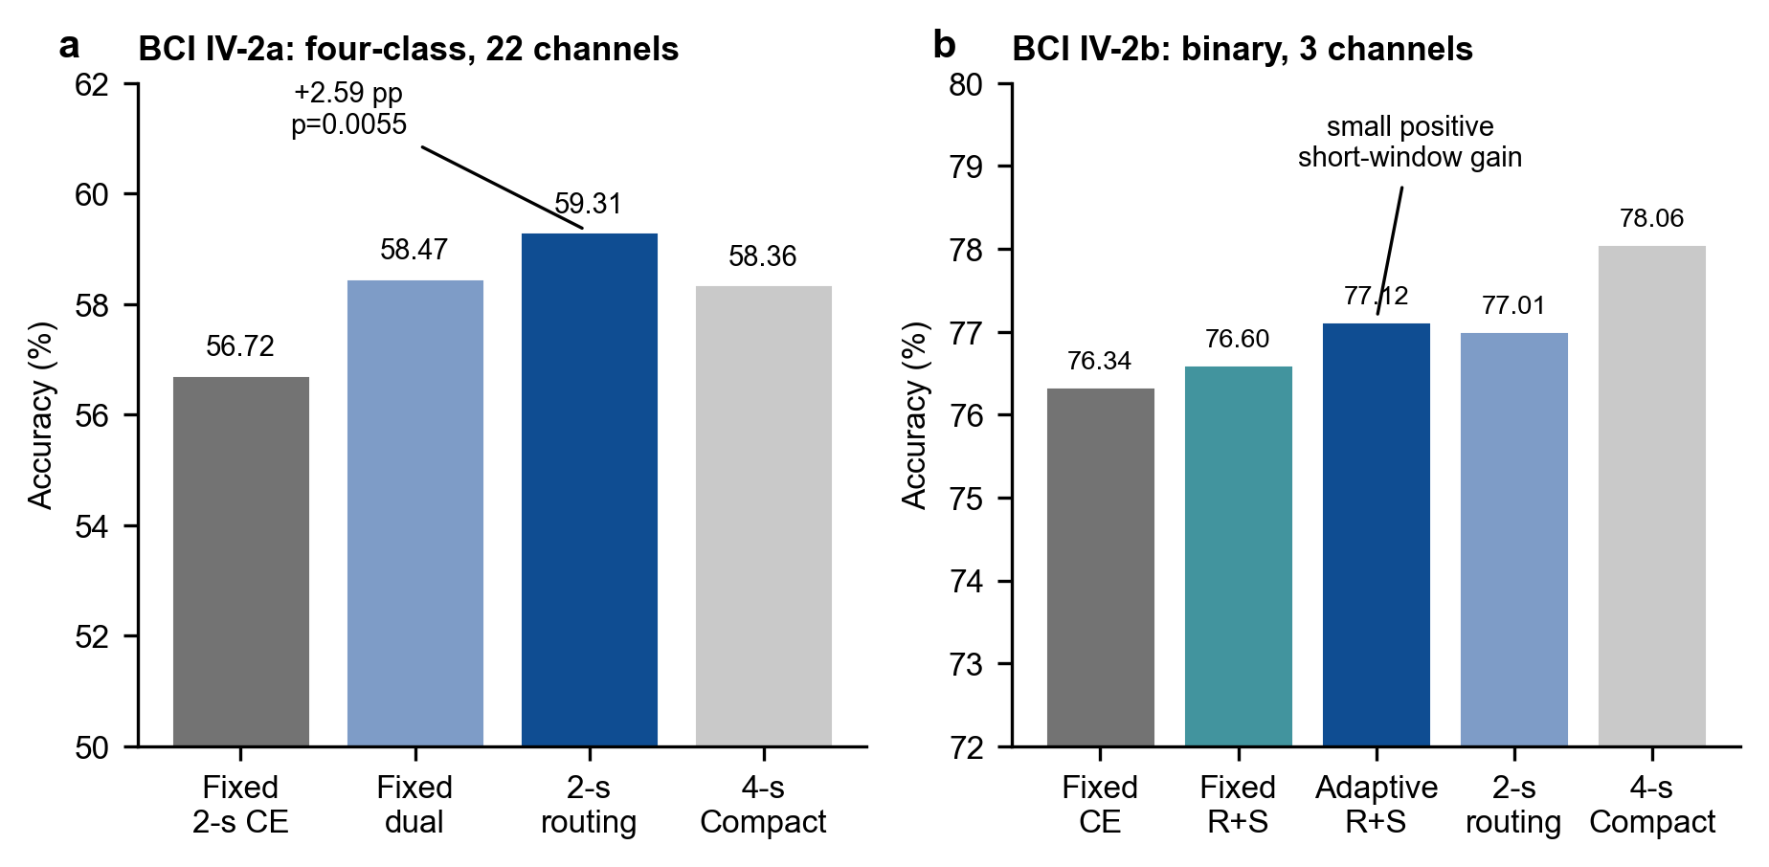
Figure 2 | Main short-window evidence. (a) IV-2a routing significantly improved 2-s accuracy over fixed CE. (b) IV-2b showed smaller gains and retained a complete-window advantage. Values are five-seed means across nine participants; the figure does not compare seed standard deviations across different statistical summaries.
Table 2 | Main short-window results.
Dataset | Method | Input | Accuracy | Macro-F1 | Kappa
2a | Fixed 2-s CE | 2 s | 0.5672 +/- 0.0093 | 0.5550 | 0.4229
2a | Fixed 2-s dual teacher | 2 s | 0.5847 +/- 0.0125 | 0.5724 | 0.4463
2a | Validation-controlled routing | 2 s | 0.5931 +/- 0.0114 | 0.5842 | 0.4575
2a | Compact EEGNet CE | 4 s | 0.5836 | 0.5749 | 0.4448
2b | Fixed 2-s CE | 2 s | 0.7634 +/- 0.0120 | 0.7567 | 0.5268
2b | Fixed Riemann KD + spatial | 2 s | 0.7660 +/- 0.0142 | 0.7627 | 0.5319
2b | Adaptive CE | 2 s | 0.7675 +/- 0.0031 | 0.7637 | 0.5349
2b | Adaptive Riemann KD + spatial | 2 s | 0.7712 +/- 0.0152 | 0.7681 | 0.5424
2b | Validation-controlled routing | 2 s | 0.7701 +/- 0.0103 | 0.7665 | 0.5402
2b | Compact EEGNet CE | 4 s | 0.7806 | 0.7763 | 0.5612

3.2 Cross-dataset boundary and Riemannian spatial ablation
On IV-2b, adaptive Riemannian KD plus spatial supervision achieved 77.12%, while global routing reached 77.01% and fixed CE reached 76.34%. The gain was smaller than on IV-2a, consistent with the lower channel count and binary task. A matched auxiliary-loss ablation showed the highest mean at moderate joint weighting (0.10+0.10), but this ablation is descriptive because paired tests against CE have not yet been recomputed for the final spatial-supervision matrix.
3.3 Reproduced 2-s baseline comparison
The proposed 2-s strategies were compared with reproduced shallow, deep, classical, Riemannian, and EEGNetV4 baselines. On IV-2a, routing exceeded the reproduced ShallowConvNet and DeepConvNet baselines. On IV-2b, adaptive Riemann KD plus spatial supervision was close to EEGNetV4 and exceeded the shallow/deep 2-s baselines. These neural baseline comparisons are descriptive pending paired statistical tests.
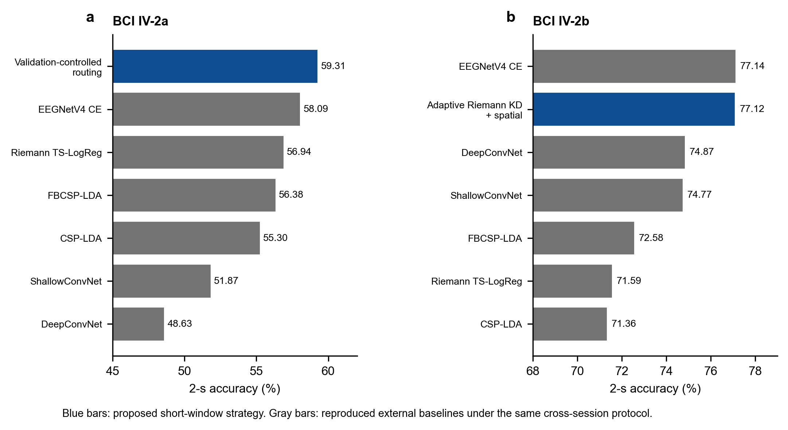
Figure 3 | Reproduced latency-matched 2-s baselines. Blue bars indicate the proposed short-window strategy for each dataset; gray bars are external baselines under the same cross-session setting.
Table 3 | Reproduced 2-s external baselines.
Dataset | 2-s comparator | Accuracy | Macro-F1 | Kappa
2a | ShallowConvNet | 0.5187 +/- 0.0026 | 0.5113 | 0.3582
2a | DeepConvNet | 0.4863 +/- 0.0131 | 0.4553 | 0.3151
2a | CSP-LDA | 0.5530 | -- | --
2a | FBCSP-LDA | 0.5638 | 0.5517 | 0.4184
2a | Riemann TS-LogReg | 0.5694 | -- | --
2a | EEGNetV4 CE | 0.5809 | -- | --
2a | Validation-controlled routing | 0.5931 +/- 0.0114 | 0.5842 | 0.4575
2b | ShallowConvNet | 0.7477 +/- 0.0073 | 0.7443 | 0.4954
2b | DeepConvNet | 0.7487 +/- 0.0118 | 0.7429 | 0.4973
2b | CSP-LDA | 0.7136 | 0.7076 | 0.4272
2b | FBCSP-LDA | 0.7258 | 0.7227 | 0.4515
2b | Riemann TS-LogReg | 0.7159 | 0.7080 | 0.4317
2b | EEGNetV4 CE | 0.7714 | 0.7676 | 0.5427
2b | Adaptive Riemann KD + spatial | 0.7712 +/- 0.0152 | 0.7681 | 0.5424

3.4 Complete-window context
Four-second models remained strong references. The short-window contribution should therefore be read as preserving useful decoding performance under an earlier-decision constraint, rather than as surpassing all complete-window methods.
Table 4 | Four-second reference context.
Dataset | 4-s reference | Accuracy | Macro-F1 | Kappa
2a | ShallowConvNet | 0.5038 | 0.4923 | 0.3384
2a | DeepConvNet | 0.4710 | 0.4372 | 0.2947
2a | Compact EEGNet CE | 0.5836 | 0.5749 | 0.4448
2a | EEGNetV4 CE | 0.6025 | 0.5894 | 0.4700
2a | Riemann TS-LogReg | 0.6525 | 0.6420 | 0.5367
2a | CSP-LDA | 0.6029 | 0.5726 | 0.4705
2a | FBCSP-LDA | 0.6296 | 0.6154 | 0.5061
2b | ShallowConvNet | 0.7666 | 0.7619 | 0.5332
2b | DeepConvNet | 0.7741 | 0.7639 | 0.5482
2b | Compact EEGNet CE | 0.7806 | 0.7763 | 0.5612
2b | EEGNetV4 CE | 0.7895 | 0.7852 | 0.5790
2b | Riemann TS-LogReg | 0.7297 | 0.7189 | 0.4593
2b | CSP-LDA | 0.7303 | 0.7197 | 0.4606
2b | FBCSP-LDA | 0.7587 | 0.7540 | 0.5173

3.5 Riemannian soft-label and spatial supervision were complementary
The IV-2b auxiliary-loss ablation is descriptive: moderate joint weighting (0.10+0.10) reached the highest participant-level mean. These values summarize participants after five-seed averaging, so their standard deviations quantify participant heterogeneity and are not directly comparable with the seed-level standard deviations in Table 2. A paired comparison against CE remains necessary before drawing a confirmatory ablation claim.
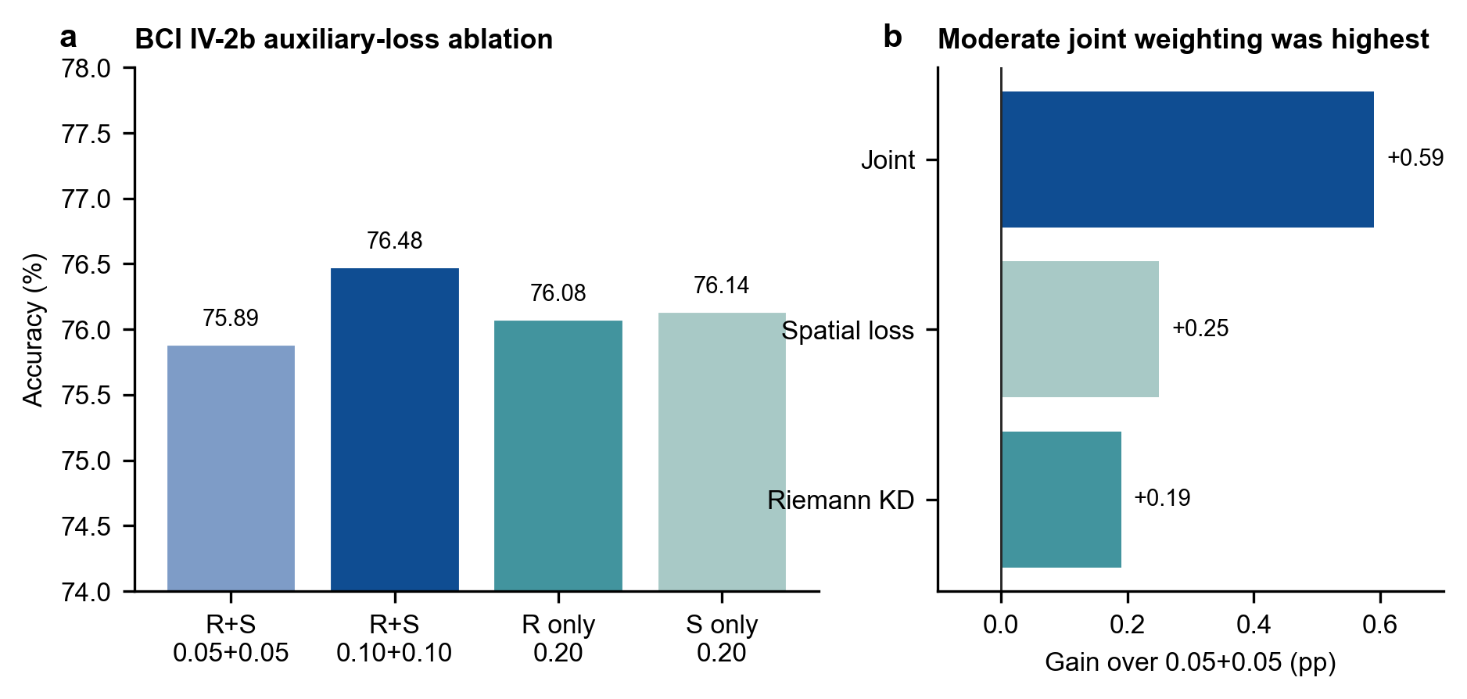
Figure 4 | IV-2b Riemannian KD and spatial-supervision ablation. Values are participant-level means after five-seed averaging; error values are reported in Table 5.
Table 5 | IV-2b Riemannian KD and spatial-loss ablation at 8-32 Hz.
Configuration | Total weight | Accuracy | Macro-F1 | Kappa
Riemann KD + spatial (0.05 + 0.05) | 0.10 | 0.7589 +/- 0.1420 | 0.7525 +/- 0.1494 | 0.5177 +/- 0.2840
Riemann KD + spatial (0.10 + 0.10) | 0.20 | 0.7648 +/- 0.1354 | 0.7617 +/- 0.1373 | 0.5296 +/- 0.2709
Riemann KD only (0.20 + 0.00) | 0.20 | 0.7608 +/- 0.1373 | 0.7543 +/- 0.1458 | 0.5216 +/- 0.2745
Spatial only (0.00 + 0.20) | 0.20 | 0.7614 +/- 0.1421 | 0.7551 +/- 0.1499 | 0.5229 +/- 0.2841

4 Discussion
The main result is a significant improvement in IV-2a short-window decoding without carrying the 4-s teachers into inference. The IV-2a/IV-2b contrast suggests that the utility of privileged long-window information is task-dependent: it is more useful when class structure and spatial covariance are richer. The study does not claim that 2 s replaces 4 s. It instead establishes a controlled route toward earlier decisions when the available evidence is restricted.
The principal limitation is route-selection stability. Although the evaluation session was isolated, routing used one internal validation partition per seed. A future out-of-fold or inner K-fold routing analysis should test whether the selected route remains stable across partitions. The work is also participant-dependent and does not establish cross-participant transfer or asynchronous online performance.
5 Conclusion
Training-time privileged information and validation-controlled strategy selection improved 2-s MI-EEG decoding on the four-class IV-2a dataset, while Riemannian spatial supervision produced a smaller positive effect on IV-2b. The results support short-window decoding as an earlier-decision engineering strategy with explicit dataset-dependent limits.
Declarations
Data availability: BCI Competition IV-2a and IV-2b are available through MOABB as BNCI2014_001 and BNCI2014_004. Code availability: the release should include environment versions, result CSV files, source-data tables, and all commands used for the reported matrices. Competing interests: none declared.
References
参考文献保留原始英文书目信息。
1. Altaheri H, Muhammad G, Alsulaiman M et al (2023) Deep learning techniques for classification of electroencephalogram (EEG) motor imagery (MI) signals: a review. Neural Comput Appl 35:14681-14722. https://doi.org/10.1007/s00521-023-08542-7
2. Ang KK, Guan C (2018) EEG-based strategies for stroke rehabilitation. In: Nam CS, Nijholt A, Lotte F (eds) Brain-computer interfaces handbook. CRC Press, pp 553-574
3. Barachant A, Bonnet S, Congedo M, Jutten C (2012) Multiclass brain-computer interface classification by Riemannian geometry. IEEE Trans Biomed Eng 59:920-928. https://doi.org/10.1109/TBME.2011.2172210
4. Barachant A, Bonnet S, Congedo M, Jutten C (2013) Classification of covariance matrices using a Riemannian-based kernel for BCI applications. Neurocomputing 112:172-178. https://doi.org/10.1016/j.neucom.2012.12.039
5. Blankertz B, Tomioka R, Lemm S, Kawanabe M, Muller KR (2008) Optimizing spatial filters for robust EEG single-trial analysis. IEEE Signal Process Mag 25:41-56. https://doi.org/10.1109/MSP.2008.4408441
6. Brunner C, Leeb R, Muller-Putz G, Schlogl A, Pfurtscheller G (2010) BCI Competition 2008: Graz data set A. Institute for Knowledge Discovery, Graz University of Technology
7. Chen Y, Wiesel A, Eldar YC, Hero AO (2010) Shrinkage algorithms for MMSE covariance estimation. IEEE Trans Signal Process 58:5016-5029. https://doi.org/10.1109/TSP.2010.2053029
8. Congedo M, Barachant A, Bhatia R (2017) Riemannian geometry for EEG-based brain-computer interfaces; a primer and a review. BCI 4:1-39. https://doi.org/10.1080/2326263X.2017.1297192
9. Cui J, Lan Z, Liu Y et al (2022) A compact and interpretable convolutional neural network for cross-subject driver drowsiness recognition from single-channel EEG. IEEE Trans Neural Syst Rehabil Eng 30:286-296. https://doi.org/10.1109/TNSRE.2022.3147419
10. Ding Y, Robinson N, Zeng Q et al (2022) TSception: a deep learning framework for emotion detection using EEG. In: Proc Int Joint Conf Neural Networks (IJCNN), pp 1-8. https://doi.org/10.1109/IJCNN55064.2022.9967692
11. Hinton G, Vinyals O, Dean J (2015) Distilling the knowledge in a neural network. arXiv:1503.02531. https://doi.org/10.48550/arXiv.1503.02531
12. Jayaram V, Barachant A (2018) MOABB: trustworthy algorithm benchmarking for BCIs. J Neural Eng 15:066011. https://doi.org/10.1088/1741-2552/aadea0
13. Kalunga EK, Chevallier S, Barre Q, Djouani K, Monacelli E, Hamam Y (2016) Online SSVEP-based BCI using Riemannian geometry. Neurocomputing 191:55-68. https://doi.org/10.1016/j.neucom.2016.01.007
14. Lawhern VJ, Solon AJ, Waytowich NR, Gordon SM, Hung CP, Lance BJ (2018) EEGNet: a compact convolutional neural network for EEG-based brain-computer interfaces. J Neural Eng 15:056013. https://doi.org/10.1088/1741-2552/aace8c
15. Lotte F, Bougrain L, Cichocki A et al (2018) A review of classification algorithms for EEG-based brain-computer interfaces: a 10 year update. J Neural Eng 15:031005. https://doi.org/10.1088/1741-2552/aab2f2
16. Lotte F, Jeunet C (2015) Towards improved BCI spellers using a co-adaptive calibration of the P300 speller with RSVP and visual feedback. J Neural Eng 12:066007
17. Mane R, Chew E, Chua K et al (2021) FBCNet: a multi-view convolutional neural network for brain-computer interface. arXiv:2104.01233
18. Meisheri H, Ramrao N, Mitra S, Saha S (2022) Common spatial pattern for EEG based brain-computer interface: an implementation review. In: Proc Int Conf Comput Intell, pp 1-6
19. Pfurtscheller G, Neuper C (2001) Motor imagery and direct brain-computer communication. Proc IEEE 89:1123-1134. https://doi.org/10.1109/5.939829
20. Roy Y, Banville H, Albuquerque I, Gramfort A, Falk TH, Faubert J (2019) Deep learning-based electroencephalography analysis: a systematic review. J Neural Eng 16:051001. https://doi.org/10.1088/1741-2552/ab260c
21. Schirrmeister RT, Springenberg JT, Fiederer LDJ et al (2017) Deep learning with convolutional neural networks for EEG decoding and visualization. Hum Brain Mapp 38:5391-5420. https://doi.org/10.1002/hbm.23730
22. Song Y, Zheng Q, Liu B, Gao X (2023) EEG conformer: convolutional transformer for EEG decoding and visualization. IEEE Trans Neural Syst Rehabil Eng 31:710-719. https://doi.org/10.1109/TNSRE.2022.3230250
23. Tangermann M, Muller KR, Aertsen A et al (2012) Review of the BCI Competition IV. Front Neurosci 6:55. https://doi.org/10.3389/fnins.2012.00055
24. Tang J, Liu C, Li Q (2020) EEG feature distillation for motor imagery classification. In: Proc IEEE Int Conf Bioinformatics and Biomedicine (BIBM), pp 1680-1683
25. Wang J, Li S, Li R, Shi Y (2022) EEG motor imagery classification with multi-view convolutional neural network. Biomed Signal Process Control 77:103778
26. Wei Q, Wang Y, Gao X, Gao S (2022) Amplitude and phase coupling in steady-state motion visual evoked potentials for BCI. J Neural Eng 19:026002
27. Yger F, Berar M, Lotte F (2016) Riemannian approaches in brain-computer interfaces: a review. IEEE Trans Neural Syst Rehabil Eng 25:1753-1762. https://doi.org/10.1109/TNSRE.2016.2627016
28. Zhang L, Wang J, Chen B et al (2023) Temporal convolutional network for motor imagery EEG decoding with attention mechanism. Biomed Signal Process Control 81:104432
29. Zhang X, Yao L, Wang X, Monaghan J, McAlpine D (2022) A survey on deep learning-based non-invasive brain signals: recent advances and new frontiers. J Neural Eng 18:031002
30. Zuo C, Jin J, Yin Y et al (2023) Novel hybrid deep learning model for motor imagery EEG classification based on capsule network. Cogn Neurodyn 17:107-121

