Candidate-pool expansion, validation-ranking distortion and model-selection loss in molecular property prediction: a retrospective nested audit

Abstract
Background: Molecular property-prediction studies increasingly compare large and correlated registries of representations, learning algorithms and tuning variants. Such expansion may introduce useful chemical information, but it also increases the opportunity to repeatedly rank noisy candidate estimates using finite validation data.
Methods: We conducted a retrospective nested audit across nine public endpoints and a prespecified six-endpoint composition intervention. Three locked registries were evaluated at K = 4, 8, 16 and 32 with repeated 3×3 nested scaffold folds. Component ablations, equal-downstream-budget truncation, three predefined anchors, three normalizations, selection-stability measures and a three-endpoint Tanimoto-component loop were added.
Results: Across 18 endpoint–pool cells, CAHit@3 decreased from K = 4 to 32 in 14 cells and the cross-fitted gap increased in 10. At K = 32, modern augmentation increased validation-selected gain relative to the homogeneous registry in 6 of six endpoints. Component, budget, anchor and split-regime analyses showed that useful complementarity, selection stability and downstream exposure—not nominal K alone—governed realised benefit.
Conclusions: Candidate-pool expansion raises both finite audited opportunity and selection pressure. Effective diversity is informative but not causal; net value depends on whether finite validation can identify complementary candidates at an acceptable downstream budget.
Scientific Contribution: This study provides an auditable molecular-model-selection decomposition that jointly intervenes on candidate count and composition, evaluates component and compute controls, quantifies selection stability, tests predefined anchors and normalizations, and transports composition effects across two split mechanisms. It does not claim a new universal statistical law or a fully optimized architecture leaderboard.
Keywords: molecular property prediction; candidate-pool expansion; registry composition; model selection; nested cross-validation; utility-pattern diversity; ranking fidelity; audit gap

1 Introduction
Modern molecular property prediction operates over a candidate space that extends far beyond a few fixed fingerprints and regressors. Contemporary studies may compare circular and substructure fingerprints, physicochemical descriptor panels, graph models, directed message-passing models, chemical-language models, pretrained representations, automated machine-learning systems, ensembles and post-hoc calibration strategies within the same benchmark [1,2,5–10,16–24,34,35]. Each component can encode a different inductive bias: fingerprints emphasize local motifs, descriptors summarize global molecular properties, graph networks learn neighbourhood interactions, and language models transfer regularities from large molecular corpora. The final reported performance therefore depends not only on the predictive capacity of individual candidates but also on which candidates entered the search, how extensively they were tuned, how their utilities were compared and how a winner was chosen. These choices can materially change the apparent benchmark conclusion. As registries grow, model search becomes part of the estimand rather than a neutral preliminary step, yet benchmark reports often describe the selected predictor more completely than the selection process that produced it.
Candidate expansion has two distinct effects: genuine representational opportunity arises when an additional representation or learner captures chemical information that the existing registry cannot express; repeated validation-selection opportunity arises because every eligible candidate contributes another noisy utility estimate that can be ranked using the same finite validation information. The first mechanism can improve generalization through complementary chemical signal; the second can favour a candidate whose apparent advantage is specific to the available validation scaffolds. Correlation among candidates moderates but does not remove this tension, because near-duplicate pipelines may share most errors while still exchange ranks under finite sampling. Direct test leakage is not required: repeated comparisons among representations, learners, tuning variants, calibration rules and ensemble choices can consume validation information even when the final audit fold remains hidden during fitting [3,4]. A larger registry may therefore create useful opportunity and additional selection pressure at the same time.
Nested cross-validation is the principal design for separating these stages. Inner folds support candidate ranking, hyperparameter selection and any fitted preprocessing, whereas an outer fold evaluates the frozen decision produced by that inner procedure. This separation prevents the tuning score itself from being reported as final predictive performance and permits alternative selectors to be compared on shared outer folds. Repeated seeded scaffold partitions further expose sensitivity to chemically coherent test groups and allow paired candidate comparisons under identical audit conditions. For molecular data, where random splits can place closely related compounds on both sides of the evaluation boundary, nested scaffold designs offer an important safeguard. They preserve a clear distinction between inner selection and outer evaluation and provide an auditable record of how a registered selector behaves across repeated chemical partitions.
Nested evaluation nevertheless leaves several properties of the search unresolved. It does not quantify candidate dependence or establish that nominal candidate count equals effective diversity. It does not equalize compute exposure when larger registries require more fits, nor does it automatically account for unavailable or failed candidates. An outer score is valid for evaluating a frozen selector, but the maximum taken across many outer candidate scores can still exhibit outer-maximum optimism when examined after the fact. Effective-rank estimates also depend on matrix construction: raw utilities retain common audit-unit difficulty, row-centred utilities remove level shifts, fixed-reference contrasts depend on the chosen reference, and rank matrices discard utility spacing. These distinctions become acute when the number of candidates exceeds the number of audit units and an empirical candidate-correlation matrix is rank deficient. Finally, reuse of public outer folds for retrospective decomposition remains different from evaluation on an independent external cohort, even when inner fitting is leakage free.
Model-selection behaviour must also be interpreted at chemical-support boundaries. Molecular similarity and scaffold novelty alter prediction difficulty, while activity cliffs show that close structural neighbours can have sharply different properties [9–14,29,30,33]. Rare positive classes create a separate risk: ROC-AUC can appear favourable even when precision, minority recall or false-negative behaviour is unsuitable for screening. Applicability-domain diagnostics, support-stratified performance, error overlap, uncertainty and conditional coverage therefore delimit what a selected model result means. Such analyses do not form an independent confirmation of the candidate-expansion finding, and they should not be averaged into a single performance score. They provide boundary evidence showing where apparently strong aggregate selection results may weaken for dissimilar molecules, novel scaffolds, activity-cliff pairs or scarce toxicity labels.
Under a retrospectively locked repeated nested scaffold evaluation, how did candidate-pool expansion relate to matrix-dependent utility-pattern diversity, chance-adjusted ranking fidelity, cross-fitted selection gaps and representation-composition effects; did the principal audit directions persist under a stricter structure-separated split; and, at fixed K, did homogeneous, classical multiview and modern-augmented registries create different opportunity, realised gain and computational exposure? We address this limited question through calibration controls, split transfer and a matched-budget registry-composition intervention.

2 Methods

2.1 Study design and evidence hierarchy
The study was a retrospective audit of completed molecular-property experiments. The nine primary endpoints, candidate order, K values, model seeds, split logic, selection rules, outcomes and exclusions were held fixed for the analyses reported here. Because the audit specification was reconstructed after the original outer outcomes existed, the design was not prospectively preregistered. Frozen denotes unchanged eligibility and analysis rules during this audit; it does not imply an untouched prospective cohort. (Figure 1).
Evidence was organized into four levels. The primary analysis evaluated registered prefixes of a 32-candidate near-duplicate conventional-model pool across nine endpoints. Candidate-composition resampling and a known-truth simulation examined mechanisms that could generate the observed trend. A 12-candidate multiview experiment assessed whether heterogeneous representations could produce realizable gains under the same public endpoints and nested splits. A four-candidate representation panel, conformal analyses and chemical-boundary stratifications were limited stress tests. They were not merged into a single leaderboard because they involved different candidate budgets, endpoint sets and evidential purposes.
Outer folds served as audit sets for frozen inner-selection decisions. Outer labels did not influence candidate eligibility, hyperparameters, fold-specific preprocessing or tie breaking within a completed unit. The same outer results were subsequently used to quantify the largest observed candidate utility, ranking agreement and selection loss; the resulting maximum is therefore an observed finite-audit best rather than a population bound. The multiview and representation panels reused public endpoint definitions and are not independent external validations.
The candidate-pool audit was the primary inferential line. TDC, automated machine learning, conformal prediction, activity-cliff, beyond-rule-of-five and duplicate-sensitivity analyses were retained as supplementary reliability or boundary evidence and were not presented as independent confirmation.

2.2 Datasets and molecular standardization
The primary panel comprised ESOL, FreeSolv, Lipophilicity, blood–brain barrier penetration (BBBP), beta-secretase 1 inhibition (BACE), ClinTox, Caco2 Wang, human intestinal absorption (HIA Hou) and P-glycoprotein inhibition (P-gp Broccatelli) [1,2]. ESOL, FreeSolv, Lipophilicity and Caco2 were regression endpoints evaluated by root mean squared error (RMSE). The remaining endpoints were binary classifications evaluated primarily by receiver operating characteristic area under the curve (ROC-AUC). Precision–recall area under the curve (PR-AUC), Brier score, expected calibration error and minority recall were retained for reliability analyses but did not replace the registered classification utility used for candidate selection.
Molecules were parsed and standardized with RDKit. The largest valid molecular fragment was retained, charge normalization was applied where chemically valid and canonical SMILES preserved stereochemical information. These operations preceded feature calculation but were governed by fixed endpoint-level rules rather than by outer performance. Within modelling pipelines, imputation, scaling and any fitted transformation were estimated only from the corresponding training fold. For classification endpoints, duplicate structures were merged only when their labels agreed; groups with conflicting labels were removed. For regression endpoints, replicate labels were averaged and the replicate count was retained for the cleaning audit.
Cleaning affected endpoints differently. BBBP was reduced from 2,050 records to 1,955 standardized structures after 62 consistent duplicate merges, 22 conflicting rows and 11 invalid SMILES were addressed. ClinTox was reduced from 1,484 to 1,376 structures, including exclusion of 98 conflicting rows and four invalid SMILES. Only 58 ClinTox structures were positive after cleaning, corresponding to 4.2% of the analysis population. This scarcity is reported whenever thresholded toxicity or minority coverage is interpreted. Regression target ranges and units were retained so that raw RMSE effects would not be silently combined across incompatible scales. Dataset-level summaries are provided in Table 1.
Table 1. Primary datasets and endpoint metrics.
Endpoint | n | Class balance / target range | Metric
ESOL | 1117 | -11.60 to 1.58 | RMSE
FreeSolv | 642 | -25.47 to 3.43 | RMSE
Lipophilicity | 4200 | -1.50 to 4.50 | RMSE
BBBP | 1955 | 1494 positive (76.4%) | ROC-AUC
BACE | 1512 | 690 positive (45.6%) | ROC-AUC
ClinTox | 1376 | 58 positive (4.2%) | ROC-AUC
Caco2 Wang | 904 | -7.76 to -3.51 | RMSE
HIA Hou | 578 | 500 positive (86.5%) | ROC-AUC
P-gp Broccatelli | 1212 | 647 positive (53.4%) | ROC-AUC
Target units: ESOL, log mol/L; FreeSolv, kcal/mol; Lipophilicity, logD; Caco2 Wang, dataset-provided permeability scale. Classification rows report positive-class n (%).

2.3 Candidate registry and computational exposure
The controlled expansion registry contained 32 candidates using a common Morgan-512 representation. Classification positions 1–4 were logistic-regression variants. Positions 5–12 contained random-forest and extremely randomized-tree variants, positions 13–16 histogram or gradient-boosting variants, positions 17–24 LightGBM variants, positions 25–28 XGBoost variants and positions 29–32 CatBoost variants. The regression registry replaced the first four candidates with ridge and elastic-net models and retained the same tree-family structure. K = 4, 8, 16 and 32 were deterministic prefixes of this order.
Registry order was chosen to add model-family complexity in stages: regularized linear candidates entered first, bagging candidates second and boosting families thereafter. It was not reordered using outer-audit performance. Prefix expansion therefore changed both nominal K and family composition, which motivated the separate random-order, random-subset and family-balanced controls. Because the registry contains many candidates that share a fingerprint and closely related learners, it was designed as a controlled repeated-selection stress rather than as a representative sample of all graph and foundation models.
Per-candidate opportunity was held constant across K: the same preprocessing rules, candidate configuration, inner folds and refit logic applied whenever a candidate was eligible. Total search exposure was not held constant. The controlled audit recorded 17,280 candidate fits and 4,437.95 candidate fit-seconds. Calibration and composition controls reused stored results and required no additional model fitting. The equal-size registry intervention recorded 270 outer audit units with downstream time at the unit level; a total fit count was not reconstructed. Exposure measures are analysis specific and are summarized in Table 2, with complete configurations in Tables S2-S3 and S28-S30.
Table 2. Audit components and recorded exposure.
Audit component | Registry | Evaluation design | Recorded exposure
Controlled prefix audit | 32 Morgan candidates | 5 seeds; 3 outer × 3 inner | 17,280 candidate fits
Calibration and resampling controls | Stored 32-candidate results | 5,000 permutations; 100 resamples per mode/K/seed | No additional model fitting
Matched multiview audit | 12 multiview candidates | 5 seeds; all C(12,3) subsets | 6,480 candidate fits
Split-regime transfer audit | 32 Morgan candidates | 3 endpoints; scaffold vs Tanimoto components | 5,760 candidate fits
Equal-size registry intervention | Three equal-size registries | 3 endpoints; 3 registries; K = 16 and 32 | 270 outer audit units; time recorded
Exposure units are analysis specific and are not directly comparable. Downstream cost excludes encoder pretraining and cached embedding extraction.

2.4 Repeated nested scaffold evaluation
Five seeded scaffold partitions were generated independently for both classification and regression endpoints using seeds 11, 23, 37, 53 and 71. Each partition contained three outer scaffold folds and three inner scaffold folds within every outer-training partition. Bemis–Murcko scaffold groups were kept intact; group allocation used seed-dependent random tie breaking while balancing sample counts, and no model performance informed allocation. The split manifest records sample and scaffold counts, target mean, standard deviation and range, split hashes and the absence of cross-fold scaffold overlap.
The validation-best selector ranked candidates by mean inner utility, where utility was ROC-AUC for classification and negative RMSE for regression. Ties were resolved deterministically by registry order. The chosen candidate was refitted on the complete outer training partition and evaluated once on the outer fold. Fixed-single, one-standard-error and risk-adjusted selectors were retained as sensitivity analyses, but validation-best defined the primary selection-loss contrast. Candidate failures remained in the audit trail and did not trigger outer-informed replacement.
Outer folds share training observations and are paired audit units rather than independent biological replications. For every endpoint, fold effects were first averaged within each of five distinct split seeds before split-seed resampling. The five seeds define repeated scaffold partitions; the three folds within a seed do not constitute three independent replications.

2.5 Audit-gap and ranking estimands
All utilities were oriented so that larger values were better. Let C_K denote the registered prefix of size K, V_uj the mean inner-validation utility for candidate j in outer unit u and A_uj its outer-audit utility. The selected candidate was s_u = argmax_j V_uj, and the observed outer best was b_u = argmax_j A_uj. Raw selection loss was L_u(K) = A_u,b_u − A_u,s_u. It is an ROC-AUC difference for classification and an RMSE increase for regression because regression utility equals negative RMSE.
Raw-scale loss was the primary outcome because it preserves the quantity used in each endpoint. Range-normalized loss divided L_u(K) by the observed candidate-utility range within the same outer unit and pool. That transformation supported sensitivity summaries across endpoints but depended on the worst and best candidates in the finite pool. We therefore did not interpret a cross-endpoint mean normalized gain as a universal chemical effect, and we did not combine raw RMSE changes from ESOL, FreeSolv, Lipophilicity and Caco2 as if they shared one physical unit.
The rank of the observed outer-best candidate within the validation ordering generated several fidelity estimands. Top-3 recovery was chance adjusted as CAHit@3 = (Hit@3 − 3/K)/(1 − 3/K), and MRR was normalized against its random-order expectation H_K/K. A 5,000-replicate permutation control drew random candidate ranks within each locked outer unit and repeated the same fold-to-seed-to-endpoint aggregation as the empirical analysis. A graded positive control used the 4,320 locked outer-candidate utilities from 135 audit units and injected validation–audit signal levels of 0, 0.10, 0.25, 0.50, 0.75 and 1.0; each non-perfect cell used 500 simulations. These controls calibrated metric zero points and signal recovery and were not used to alter empirical candidate selections.
Mean reciprocal rank (MRR) was also adjusted for K. Under a random ordering, E(MRR_random) = H_K/K, where H_K is the Kth harmonic number. Normalized MRR gain was (MRR_observed − MRR_random)/(1 − MRR_random). Additional outcomes were the percentile rank of the outer-best candidate in the validation list, normalized discounted cumulative gain (NDCG), Spearman correlation and Kendall correlation between complete validation and outer candidate orderings. These metrics have different sensitivities to the top of the ranking and prevent the interpretation from depending on one K-sensitive hit rate.
For each outer unit, observed audit-best gain was the largest eligible outer utility minus the fixed candidate utility; selected-model gain was the validation-selected utility minus the same fixed utility. Their difference defined the incremental observed audit gap. The realization ratio divided selected-model gain by observed audit-best gain when the denominator was positive. Classification and regression were summarized separately because ROC-AUC loss and RMSE loss are not exchangeable units.

2.6 Effective-diversity estimation
For each endpoint and K, we formed a 15 x K matrix whose rows were seed-by-outer-fold units and whose columns were candidate utilities. Four matrices were analysed: raw utilities; row-centred utilities after subtracting each unit mean; utilities relative to candidate 1, with the zero reference column removed; and within-unit candidate ranks. Row centring targets common audit-unit difficulty, whereas the fixed-reference and rank matrices ask whether candidate contrasts persist after removing level shifts. We use utility-pattern diversity because aggregate fold utilities do not fully represent prediction-level or mechanistic diversity.
Effective diversity was estimated from candidate-utility matrices rather than from candidate labels or model-family counts. For each endpoint and K, the outer matrix contained 15 rows, indexed by five seeds and three outer folds, and K columns, indexed by registered candidates. The corresponding inner matrix contained 45 rows, indexed by seed, outer fold and inner fold, and K columns. The main diversity analysis used the outer-utility matrix because it characterizes behavioural similarity on held-out scaffold groups. Inner-utility estimates were retained to assess whether redundancy was already visible during selection.
A direct empirical K × K correlation matrix is singular when K exceeds the number of rows and can yield unstable eigenvalues even below that boundary. We therefore reported both the original empirical correlation spectrum and a Ledoit–Wolf shrinkage covariance estimate after column standardization. The shrinkage covariance was converted to a correlation matrix R by dividing each element by the product of its marginal standard deviations. This estimator pulls noisy covariance directions toward a structured target and produces a full-rank matrix when K > 15, but it does not create new independent information.
Let λ_1,…,λ_K be the non-negative eigenvalues of R and p_i = λ_i/Σ_j λ_j. Spectral-entropy effective rank was r_entropy = exp(−Σ_i p_i log p_i). Participation-ratio effective rank was r_PR = (Σ_i λ_i)^2/Σ_i λ_i^2, equivalently 1/Σ_i p_i^2. Both equal one for a perfectly redundant rank-one spectrum and K when all eigenvalues are equal. Spectral entropy is more sensitive to small eigenvalue mass, whereas the participation ratio places greater weight on dominant directions. Median off-diagonal correlation was reported as a directly interpretable complement.
Uncertainty in endpoint-specific effective diversity was estimated with 5,000 hierarchical bootstrap replicates using fixed seed 20260713. Split-seed blocks were sampled with replacement and, within each sampled block, three outer-fold rows were sampled with replacement; the shrinkage correlation and effective ranks were recomputed. Across-endpoint summaries are medians, IQRs and ranges, without a population-level confidence interval because the nine endpoints were not treated as a random sample from a molecular-task population. Sensitivity analyses omitted each seed and fold and repeated fixed-reference-relative estimates with predefined references; no reference was chosen from outer performance.

2.7 Candidate-composition controls
Prefix composition could confound a K effect because each increase added specific model families. Three frozen controls addressed this issue. Random-order controls permuted registry order before taking prefixes. Random-subset controls sampled K candidates from the complete registry without requiring a prefix. Family-balanced controls sampled candidates to maintain representation of available learner families. Every mode used 100 predetermined seeds for each endpoint and K.
The subset or order seed was a resampling device, not an independent endpoint. Results were first summarized within endpoint, and endpoint remained the cross-task inferential unit. At K = 32 all three modes necessarily equal the complete pool; convergence at that point is therefore a design property rather than independent corroboration. The controls test whether increasing normalized selection loss was peculiar to one early registry composition, not whether all conceivable candidate distributions would show the same trend.

2.8 Cross-fitted audit reference
To reduce the same-unit advantage of defining the reference with the evaluated outer scores, we used leave-one-seed-out cross-fitting. For each endpoint, K and held-out seed, candidate mean outer utility was computed over the other four seeds. The highest mean candidate, with registry order used for ties, was fixed as the reference and evaluated on all three folds of the held-out seed. The cross-fitted gap was reference utility minus validation-selected utility; the same-unit gap used the maximum candidate utility in that held-out fold. Their difference quantifies the additional optimism induced by the same-unit maximum.
This reference is less circular than a same-unit maximum but is not a new cohort or prospective experiment. It reuses the same endpoint population and split generator. Its purpose is to test whether the K = 32 minus K = 4 direction persists when reference selection and evaluation are separated at the seed level.

2.9 Finite-audit winner-optimism simulation
A known-truth simulation isolated the mechanical effect of maximizing noisy audit estimates. In the equal-truth scenario, all candidates had identical true standardized utility. Audit errors followed a multivariate Gaussian distribution with pairwise correlations of 0, 0.5 or 0.9. Effective audit sample sizes were 25, 50, 100 or 200, candidate counts were K = 4, 8, 16 or 32 and 30,000 Monte Carlo replicates were generated for every configuration. A weak-gradient scenario was retained as a secondary sensitivity analysis.
Winner optimism was the maximum observed audit utility minus the true utility of the selected maximum, expressed in simulation standard-deviation units. Because candidate truth was equal in the primary simulation, any positive maximum was produced entirely by finite estimation noise. The simulation was not used to subtract a bias correction from empirical endpoints. Its purpose was to demonstrate that an outer maximum can be optimistic even when the outer data were not used for inner selection and even when candidate estimates are strongly correlated.

2.10 Matched-size multiview stress test
The multiview registry crossed four representations (Morgan-512, MACCS, RDKit2D and their concatenation) with three learners. The matched-size analysis exhaustively enumerated all C(12,3) = 220 three-candidate subsets without retraining, using stored candidate-level inner and outer utilities. These overlapping subsets are composition-sensitivity contrasts within one registry, not independent experiments; the endpoint remained the interpretation unit and no subset-level P values were calculated. Subsets were assigned to mutually exclusive classes: Morgan-only reference, single-representation only, single-learner only, representation-balanced without concatenation, representation-balanced with concatenation, or mixed unbalanced. We report medians, IQRs, distribution ranges and the within-endpoint proportion outperforming Morgan-only.
Within-learner analyses selected among four representations for one learner and compared the result with that learner's Morgan candidate. The full K = 12 versus Morgan K = 3 contrast is termed the multiview-pool gain because it combines representation breadth and additional candidates. Only comparisons at the same K are termed representation-composition effects.
For every paired unit we retained the endpoint, split seed, outer fold, registered candidates, selected candidate and paired inner and outer utilities. Deterministic split hashes and SHA-256 source hashes were recorded in the machine-readable supplement. Prediction-level quantities were calculated only for registries with traceable candidate-level prediction exports.

2.11 Limited representation-baseline analysis
A separate six-endpoint panel included RDKit random forest (RDKit-RF), a graph convolutional network (GCN), a ChemBERTa frozen-embedding probe and a MoLFormer frozen-embedding probe. RDKit-RF used Morgan fingerprints and 120 trees. The GCN contained two 32-unit graph-convolution layers, global mean pooling and five fixed training epochs. ChemBERTa and MoLFormer encoders were frozen and followed by logistic or ridge probes. These configurations provide representation diversity but are not exhaustive or equivalently tuned modern baselines.
Search budgets differed across candidates: RDKit-RF used a fixed tree configuration, the GCN used a short fixed training schedule and the language models did not receive end-to-end fine tuning. The panel was therefore restricted to selector behaviour and error correlation under shared splits. It was not used to claim that conventional fingerprints outperform adequately tuned graph or foundation models. Chemprop/D-MPNN and TabPFN were not included because a complete shared-split audit was unavailable.
Per-molecule outer predictions were available for the rerun 32-candidate regression audit and for the completed four-model representation panel. Prediction correlations, high-error Jaccard overlap, Ledoit–Wolf entropy rank and participation-ratio rank were calculated only where the requisite candidate-level predictions were traceable. Prediction-level diversity is therefore reported as a boundary analysis and is not treated as equivalent to utility-pattern diversity.

2.12 Reliability and chemical-boundary analyses
Classification uncertainty was evaluated with split conformal, label-conditional conformal and Mondrian label-and-similarity conformal prediction at 80%, 90% and 95% nominal coverage. Minority-class coverage and prediction-set size were primary reliability outputs because overall marginal coverage can conceal undercoverage of rare positives. Regression intervals used conformalized quantile regression (CQR). Coverage and interval width were reported separately by endpoint because interval widths inherit endpoint units [26–28,33,36].
Ensemble uncertainty was assessed by its association with absolute error, risk-coverage behaviour and high-error enrichment. Test molecules were stratified by maximum training-set Morgan Tanimoto similarity into low (<0.5), intermediate (0.5 to <0.7) and high (at least 0.7) support. We compared selected and cross-fitted-reference performance, candidate error overlap, model disagreement, uncertainty-error association and false-negative enrichment within each stratum. Exact held-out Murcko scaffolds were unseen by construction; related versus novel scaffolds were therefore defined by a prespecified maximum scaffold-fingerprint similarity threshold of 0.5. This derived relatedness definition is reported explicitly.
ClinTox was treated as a prespecified negative reliability example because only 58 positive standardized structures were available. ROC-AUC, PR-AUC, minority recall, false-negative rate, label-conditional conformal coverage and mean prediction-set size were reported as distinct quantities. Coverage addresses prediction-set validity, whereas recall and false-negative rate address screening safety; none establishes deployment-level toxicology performance.
These analyses were retained in the main text only as boundaries on interpretation. Complete TDC, conformal, MoleculeACE, bRo5, deduplication and failure-case results are provided in Additional files 1-3.

2.13 Split-regime transfer audit
ClinTox, BACE and ESOL represented rare-class classification, regular classification and regression, respectively. The locked 32-candidate Morgan-512 registry, candidate order, K = 4, 8, 16 and 32 prefixes, seeds 11, 23, 37, 53 and 71, and three outer by three inner folds were retained. Scaffold results reused the locked source-of-record outputs. For the new structure-separated rerun, molecular pairs with Morgan-512 Tanimoto similarity at least 0.70 were connected, and each connected component was kept intact during outer and inner allocation. The threshold and allocation rule were fixed before formal model fitting after splitter feasibility checks; model performance did not inform grouping.
A seeded greedy allocator balanced sample counts and, for classification, both class counts across intact components. Every formal inner and outer split was required to retain both classes where applicable, keep components disjoint and have maximum cross-fold Tanimoto below 0.70; random fallback was prohibited. The transfer audit added 5,760 candidate fits. Direction transport was assessed for CAHit@3 change from K = 4 to K = 32, leave-one-seed-out cross-fitted K = 32 minus K = 4 selection gaps and Ledoit–Wolf effective ranks under the four prespecified matrix transformations. This was a robustness analysis on three selected endpoints, not a new confirmatory population sample.

2.14 Expanded equal-size registry-composition intervention
Six endpoints were fixed from task coverage before expanded outcomes were read: ClinTox, BACE and BBBP for classification, and ESOL, Lipophilicity and Caco2_Wang for regression. Three exact-prefix registries—homogeneous Morgan, classical multiview and modern-augmented—were evaluated at K = 4, 8, 16 and 32 with seeds 11, 23, 37, 53 and 71 and identical three-outer by three-inner folds. The shared Morgan linear candidate occupied the first locked position. Candidate configuration and order did not change across eligible prefixes.
Fixed-K component ablations compared classical multiview, classical plus ChemBERTa, classical plus MoLFormer, classical plus D-MPNN and the full modern-augmented registry at K = 16 and 32. Each addition replaced a prespecified classical candidate so that K remained exact. Equal-downstream-budget analyses truncated each locked registry prefix at the endpoint- and K-specific median downstream time of the classical multiview registry; outer performance never determined retention. Observed downstream time includes inner and outer fit/predict time but excludes encoder pretraining, model acquisition and cached embedding extraction.
Anchor sensitivity used the shared Morgan linear model, a fixed Morgan random forest and the predefined registry-median candidate. Raw gains, endpoint-MAD normalization and paired homogeneous-audit-best normalization were reported. Selection stability comprised candidate, representation and learner-family frequencies, selection entropy, modal proportion, leave-one-seed-out agreement and adjacent-fold switches. ClinTox, BACE and ESOL additionally completed the full three-composition loop under seeded scaffold and Tanimoto-component splits while holding registries, seeds, folds, rules and metrics fixed.

2.15 Mathematical estimands and matrix-relative diversity
Let u = (s, f) index an outer audit unit formed by repeat seed s and outer fold f; V(u,j) is the mean inner-validation utility and A(u,j) is outer-audit utility for candidate j. The eligible registry prefix C(p,K), candidate order, anchor a and reference j0 were fixed before outer outcomes were inspected. All unit-level quantities were averaged over folds within seed before five-seed block aggregation.

Selection and ranking estimands
Here r_u is the inner-validation rank of the outer finite-audit best candidate, q is a rank cutoff (q = 3), I is the indicator function and H_K is the Kth harmonic number.
${\hat{j}}_{u\left(K\right)}=\arg{\max_{j∈C_{K}}{V_{u,j}}}$, (1)
$j_{best_{u\left(K\right)}}=\arg{\max_{j∈C_{K}}{A_{u,j}}}$, (2)
$L_{u\left(K\right)}=A_{u,j_{best_{u\left(K\right)}}}-A_{u,{\hat{j}}_{u\left(K\right)}}$, (3)
${\tilde{L}}_{u\left(K\right)}=\frac{L_{u\left(K\right)}}{\max_{j}{A_{u,j}}-\min_{j}{A_{u,j}}+ε}$, (4)
$CAHit_{q,u}=\frac{I\left(r_{u}≤q\right)-\frac{q}{K}}{1-\frac{q}{K}}, q=3$, (5)
$MRR_{u}=\frac{1}{r_{u}}$, (6)
$E_{0\left(MRR\right)}=\frac{H_{K}}{K}$, (7)
$MR{\tilde{R}}_{u}=\frac{MRR_{u}-\frac{H_{K}}{K}}{1-\frac{H_{K}}{K}}$. (8)

Cross-fitted reference
U_(-s) contains all outer units from seeds other than held-out seed s; S = 5 and F = 3 are the numbers of repeat seeds and outer folds.
$j_{ref_{\left(-s\right)\left(K\right)}}=\arg{\max_{j}\left[\left(\frac{1}{\left|U_{-s}\right|}\right)\sum_{u∈U_{-s}}{A_{u,j}}\right]}$, (9)
$L_{\left(CF,s\right)\left(K\right)}=\left(\frac{1}{F}\right)\sum_{f=1}^{F}{\left[A_{\left(s,f\right),j_{ref_{\left(-s\right)\left(K\right)}}}-A_{\left(s,f\right),{\hat{j}}_{\left(\left(s,f\right)\right)\left(K\right)}}\right]}$, (10)
$Δ_{CF,e}=\left(\frac{1}{S}\right)\sum_{s=1}^{S}{\left[L_{\left(CF,e,s\right)\left(32\right)}-L_{\left(CF,e,s\right)\left(4\right)}\right]}$. (11)

Matrix transformations and effective rank
X is the outer-utility matrix; S in Equation 16 is the sample covariance (not the seed count), T is the scaled-identity target, lambda_i are non-negative eigenvalues of the shrinkage correlation matrix and p_i are their unit-sum proportions.
$X_{raw,u,j}=A_{u,j}$, (12)
$X_{ctr,u,j}=A_{u,j}-\left(\frac{1}{K}\right)\sum_{l}{A_{u,l}}$, (13)
$X_{ref,u,j}=A_{u,j}-A_{u,j_{0}}$, (14)
$X_{rank,u,j}=rank_{j\left(A_{u,j}\right)}$, (15)
${\hat{Σ}}_{LW}=\left(1-α\right)S+αT$, (16)
$p_{i}=\frac{λ_{i}}{\sum_{l}{λ_{l}}}$, (17)
$r_{ent}=\exp\left[-\sum_{i}{p_{i}\ln\left(p_{i}\right)}\right]$, (18)
$r_{PR}=\frac{{\left(\sum_{i}{λ_{i}}\right)}^{2}}{\sum_{i}{λ_{i}^{2}}}=\frac{1}{\sum_{i}{p_{i}^{2}}}$. (19)

Composition, normalization and downstream cost
The label hom denotes the homogeneous Morgan pool, and T_down is measured inner-plus-outer downstream fit/predict wall time.
$G_{best,u,p,K}=\max_{j∈C_{p,K}}{A_{u,j}}-A_{u,a}$, (20)
$G_{sel,u,p,K}=A_{u,{\hat{j}}_{u,p,K}}-A_{u,a}$, (21)
$${\tilde{G}}_{sel,e,p,K}=\frac{1}{SF}\sum_{s,f}{\frac{G_{sel,\left(s,f\right),p,K}}{G_{best,\left(s,f\right),hom,K}}}$$ | (22)

$d_{rel,e,p,K}=\frac{r_{ent\left(X_{e,p,K}\right)}}{K}$, (23)
$${\tilde{L}}_{CF,e,p,K}=\frac{1}{SF}\sum_{s,f}{\frac{\left[A_{\left(s,f\right),j_{ref_{-s}}}-A_{\left(s,f\right),{\hat{j}}_{\left(s,f\right)}}\right]}{G_{best,\left(s,f\right),hom,K}}}$$ | (24)

$η_{down,u,p,K}=\frac{G_{sel,u,p,K}}{T_{down,u,p,K}}$. (25)

Selection stability
Here q_j is the proportion of repeated outer audit units in which candidate j is selected; it is distinct from the rank cutoff q in Equation 5.
$H_{sel}=-\sum_{j}{q_{j}\ln\left(q_{j}\right)}$, (26)
$H_{sel,norm}=\frac{H_{sel}}{\ln\left(K\right)}$. (27)
We used epsilon = 1e-12. Ledoit–Wolf shrinkage used the scaled-identity target and the analytic coefficient implemented in scikit-learn. The shrinkage covariance was rescaled to a correlation matrix R before eigenanalysis. Correlation eigenvalues below zero only because of floating-point error were clipped to zero, and 0 log 0 was defined as zero. Equations 22 and 24 divide within paired outer units before fold-to-seed-to-endpoint aggregation; units with an absolute denominator at or below epsilon were reported as missing.

2.16 Statistical inference
For endpoint-specific K = 32 minus K = 4 contrasts, fold differences were averaged within each of five distinct split seeds and resampled 10,000 times. Classification cross-fitted ROC-AUC loss and regression cross-fitted RMSE loss were prespecified task-stratified co-primary strata. Their units were not combined, no cross-task average effect was calculated, and endpoint effects with 95% intervals were interpreted by direction and heterogeneity. Ranking measures, same-unit gaps, effective diversity and matched-size effects were key complementary evidence. No endpoint-aggregation P values or multiplicity-adjusted confirmatory family was used.
Matched-size subset results are distributional summaries over all 220 registered subsets, not 220 independent experiments. Medians, interquartile ranges, 95% distribution ranges and endpoint-level composition frequencies are reported. Prediction-level support and scaffold analyses use fold-level medians and retain classification and regression on separate numerical axes.
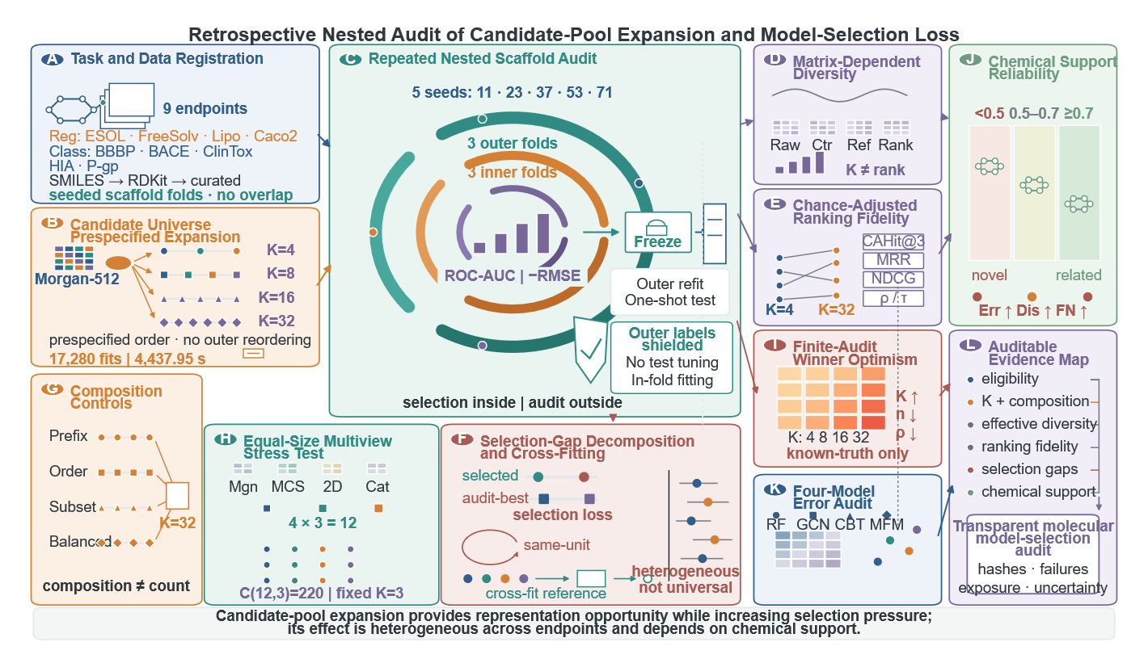
Figure 1. Retrospective nested audit of candidate-pool expansion and model-selection loss. The central module separates candidate ranking in three inner scaffold folds from one-shot auditing in three outer folds across five seeded partitions, with no outer-label feedback. Registered endpoints and prespecified candidate prefixes enter from the left. Surrounding branches summarize utility-pattern diversity, chance-adjusted ranking, same-unit and cross-fitted selection gaps, split-regime transfer, equal-size registry composition, finite-audit winner optimism, chemical-support boundaries and four-model prediction/error reliability. These streams converge on an auditable evidence map rather than a model leaderboard.

3 Results

3.1 Effective diversity depended on matrix construction
Effective diversity depended strongly on utility-matrix construction. At K = 32, endpoint-specific Ledoit–Wolf entropy-rank point estimates summarized across the nine endpoints were raw 2.98 (IQR 2.79–3.65; range 2.42–10.66); row-centred 24.23 (IQR 14.89–25.08; range 6.17–27.98); fixed-reference-relative 5.86 (IQR 2.72–9.88; range 1.87–13.20); within-unit-rank 27.14 (IQR 16.92–28.78; range 11.71–29.76). Raw utilities retained common audit-unit difficulty; row centring removed common level shifts; fixed-reference estimates depended on the reference; and within-unit ranks preserved order while discarding utility spacing. The corresponding participation-ratio ranks and correlations are reported in Additional file 2: Table S6. No transformation is treated as a unique true candidate count.
Estimator choice changed magnitude but not the central contrast. At K = 32, raw participation-ratio rank was 1.80 and the reference-relative value was 2.89; row-centred and rank-based point estimates were higher. The raw median candidate correlation was 0.814, the reference-relative value was 0.688 and row centring reduced the median to 0.039. These changes demonstrate why unadjusted utility correlation cannot by itself be described as complete utility-pattern diversity.
Leave-one-seed, leave-one-fold and predefined-reference analyses retained a substantial nominal-effective gap but changed endpoint magnitudes. Monte Carlo checkpoints through 5,000 replicates showed that central estimates were more stable than some tail limits. Effective diversity is therefore reported as an estimator- and matrix-dependent audit quantity rather than a single intrinsic candidate count (Additional file 2: Tables S6-S7). (Figure 2; Additional file 2: Tables S6-S7).
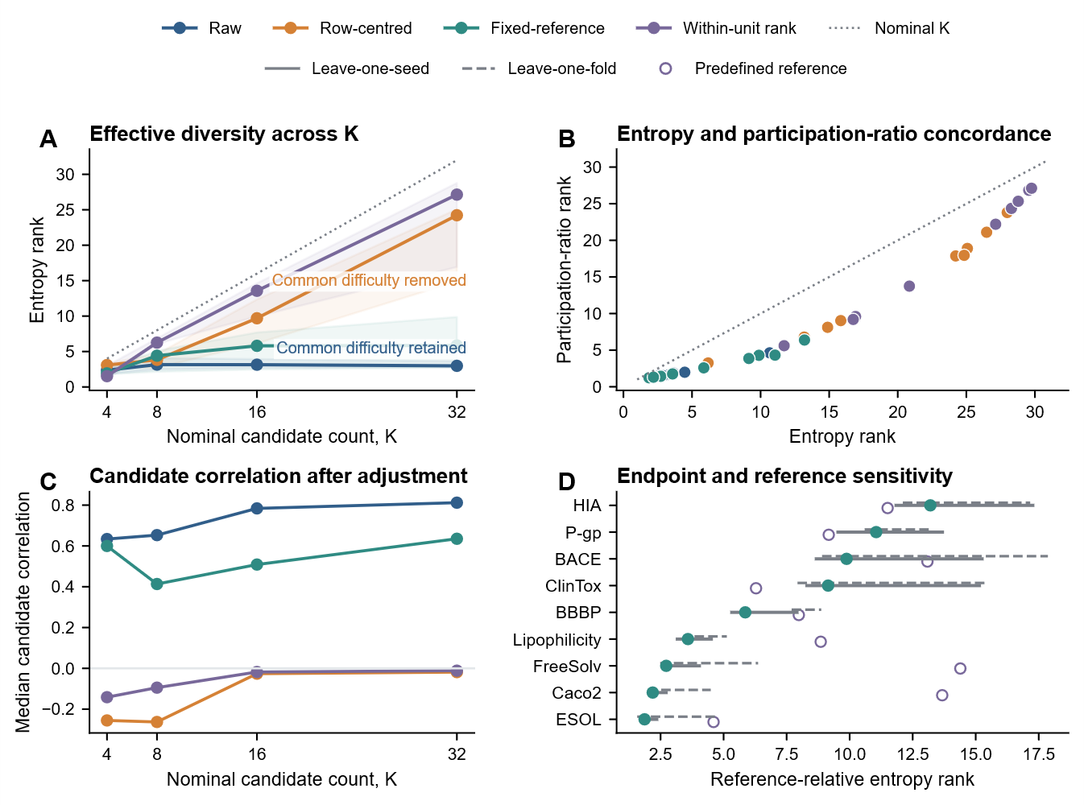
Figure 2. Matrix-dependent candidate diversity. (A) Ledoit–Wolf entropy rank across raw, row-centred, fixed-reference-relative and within-unit-rank matrices; solid lines are endpoint medians, ribbons are endpoint IQRs and the grey dotted line is nominal K. Raw utilities retain common audit-unit difficulty, whereas row centring removes common level shifts. (B) Entropy and participation-ratio concordance at K = 32 with a 45° reference. (C) Median candidate correlation after adjustment. (D) Fixed-reference-relative endpoint estimates at K = 32; solid and dashed lines are leave-one-seed and leave-one-fold ranges, respectively, and hollow points show predefined references.

3.2 Chance-adjusted ranking fidelity declined with K
This analysis asked whether the validation ordering recovered the outer-best candidate beyond the opportunity expected from K alone. Under the predefined fold-to-seed-to-endpoint aggregation, endpoint-median CAHit@3 was 1.000 (IQR 1.000–1.000) at K = 4, 0.680 (0.467–0.893) at K = 8, 0.179 (0.015–0.344) at K = 16 and 0.264 (0.117–0.338) at K = 32. The overall loss of top-rank fidelity was nonmonotonic between K = 16 and K = 32 and cannot be attributed solely to the changing 3/K random baseline.
Endpoint-median normalized MRR gain, using H_K/K as the random-order expectation, was 0.861 (IQR 0.200–1.000) at K = 4, 0.322 (0.246–0.344) at K = 8, 0.118 (0.064–0.271) at K = 16 and 0.157 (0.101–0.197) at K = 32. From K = 4 to K = 32, endpoint-median NDCG changed from 0.962 to 0.564, Spearman correlation from 0.827 to 0.658, Kendall correlation from 0.733 to 0.509 and rank percentile from 0.956 to 0.809.
Raw Top-1 recovery and MRR become mechanically harder as K grows. Under the predefined fold-to-seed-to-endpoint aggregation, endpoint-median CAHit@3 changed from 1.000 to 0.264, while endpoint-median normalized MRR gain changed from 0.861 to 0.157. Normalized MRR used the random-order expectation H_K/K. NDCG, Spearman, Kendall and rank percentile provide complementary views of global ordering, so the interpretation rests on their joint pattern rather than one cut-off.
The permutation control was centred near the adjusted zero, and observed endpoint-median CAHit@3 exceeded its 95% permutation envelope at all four K values (maximum one-sided permutation P = 0.0002). Across K = 4, 8, 16 and 32, increasing injected validation–audit signal monotonically increased median CAHit@3 and normalized MRR gain and monotonically reduced fixed-range selection loss. The maximum absolute zero-signal CAHit@3 was 0.010, and perfect signal reduced median selection loss to 0.000 at every K. Thus the adjusted measures retained information above chance while exhibiting the intended null and recovery behaviour (Figure 3A–B).

3.3 Expansion increased observed opportunity more than selected gain
At K = 32, the classification mean observed audit-best gain over the fixed candidate was 0.0311 ROC-AUC, whereas selected-model gain was 0.0173 and the incremental observed audit gap was 0.0138. At K = 4, the corresponding values were 0.0028, -0.0014 and 0.0042. For regression, the K = 32 means were 0.8078 RMSE units of observed audit-best gain, 0.7378 selected-model gain and a 0.0700 gap, compared with 0.7619, 0.7442 and 0.0178 at K = 4. The scales are reported separately and are not pooled.
The decomposition shows that expansion can raise both the opportunity represented by the largest observed utility and the amount captured by the selected model. Selection loss increases when the former rises faster than the latter. Realization ratios were unstable when the audit-best gain was near zero and are therefore secondary, machine-readable quantities rather than a headline result (Figure 4A-B; Additional file 2: Table S8).
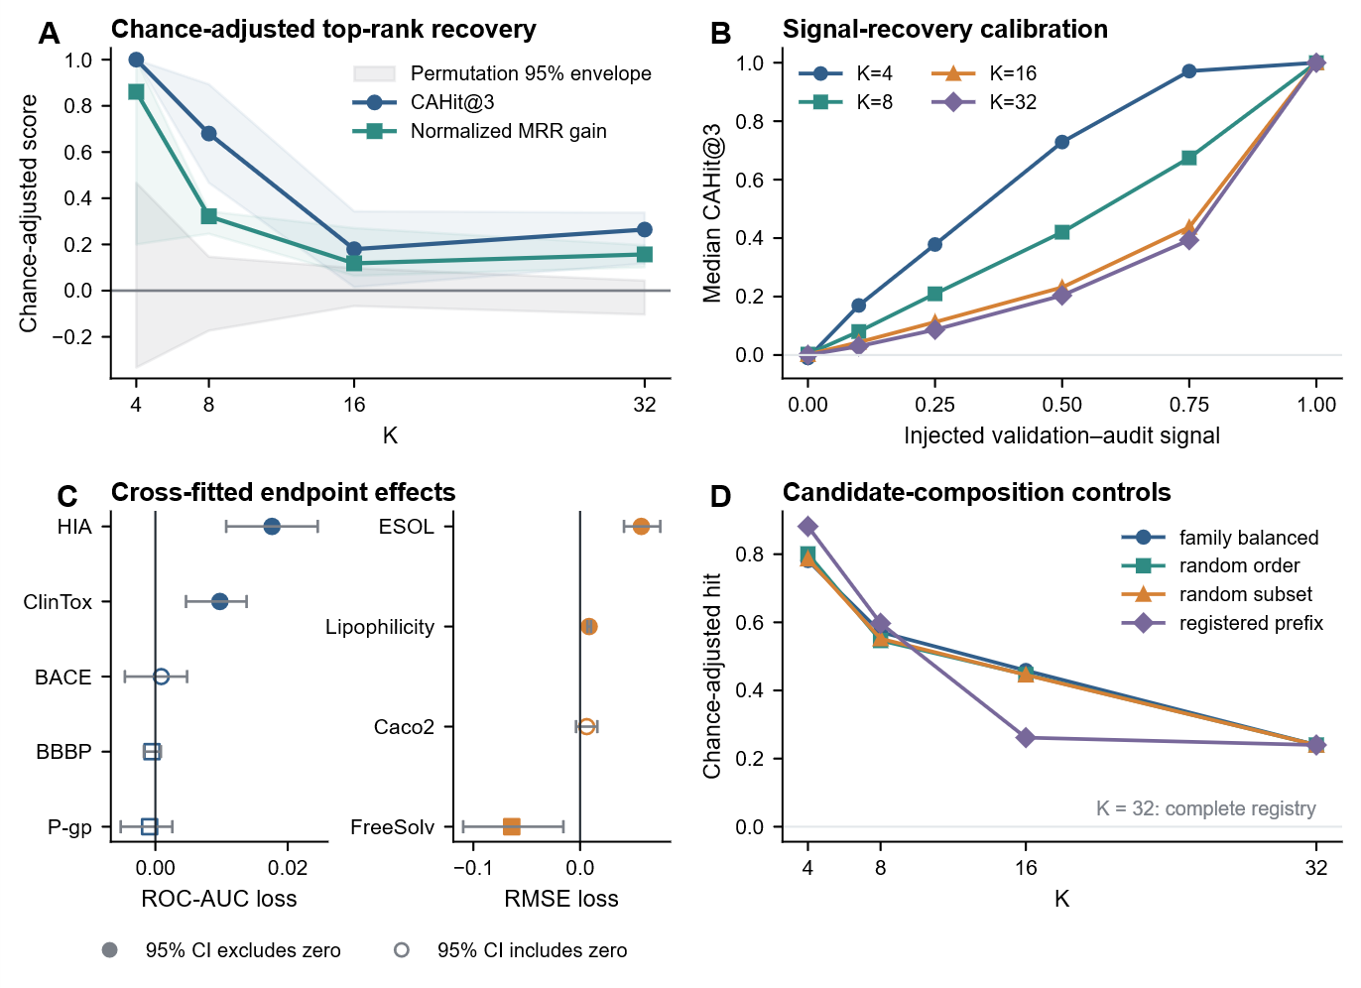
Figure 3. Chance-adjusted ranking calibration and cross-fitted gaps. (A) Endpoint-median CAHit@3 and normalized MRR gain with endpoint IQRs; the grey band is the joint 95% envelope from 5,000 random-rank permutations under the same aggregation. (B) Positive-control recovery of endpoint-median CAHit@3 across six injected validation–audit signal levels and four candidate counts. (C) Task-stratified cross-fitted classification ROC-AUC loss and regression RMSE loss with split-seed bootstrap 95% intervals; filled markers exclude zero, hollow markers include zero, and colour denotes task type rather than significance. (D) Registered-prefix, random-order, random-subset and family-balanced controls; all modes equal the complete registry at K = 32 by design.

3.4 Cross-fitted effects were heterogeneous across endpoints
Separating reference selection from held-out-seed evaluation attenuated same-unit maxima. Cross-fitted K = 32 minus K = 4 effects were positive in six of nine endpoints and negative in three. Split-seed intervals excluded zero for ClinTox and HIA in the classification ROC-AUC-loss stratum and for ESOL, FreeSolv and Lipophilicity in the regression RMSE-loss stratum; FreeSolv was negative. Table 3 combines each estimate and 95% interval in one cell and labels direction as greater loss, lower loss or uncertain without pooling the task scales (Figure 3C; Figure 4C; Table S8).
The same-unit effect was positive for BACE, BBBP, ClinTox, ESOL, Lipophilicity, Caco2, HIA and negative for FreeSolv, P-gp. It exceeded the cross-fitted effect in most endpoints, consistent with additional optimism when the reference is the maximum from the evaluated unit. Endpoint exceptions are retained and prevent a deterministic or universal interpretation.
Because the cross-fitted reference still uses the same public endpoint and split generator, it does not transform the audit into an external validation. It does, however, support use of model-selection loss in the title as an endpoint-qualified empirical result rather than a claim based only on same-unit maxima.
Table 3. Cross-fitted effects of candidate-pool expansion.
Endpoint | Effect (95% CI) | Direction
Classification: ROC-AUC loss
BACE | 0.0009 (-0.0046, 0.0048) | Uncertain
BBBP | -0.0005 (-0.0017, 0.0008) | Uncertain
ClinTox | 0.0098 (0.0046, 0.0138) | Greater loss
HIA | 0.0176 (0.0107, 0.0245) | Greater loss
P-gp | -0.0009 (-0.0052, 0.0026) | Uncertain
Regression: RMSE loss
ESOL | 0.0573 (0.0411, 0.0751) | Greater loss
FreeSolv | -0.0641 (-0.1095, -0.0157) | Lower loss
Lipophilicity | 0.0085 (0.0069, 0.0102) | Greater loss
Caco2 | 0.0062 (-0.0038, 0.0162) | Uncertain
Effects are K = 32 minus K = 4 contrasts. Positive effects indicate greater model-selection loss at K = 32. Classification and regression effects use different units and are not pooled.

3.5 Finite-audit maxima contained winner optimism
This simulation asked whether maximizing finite outer estimates produces optimism even when candidates are equally good. With pairwise candidate correlation 0.9 and effective audit size 50, mean winner optimism increased from 0.046 standard-deviation units at K = 4 to 0.092 at K = 32. At effective size 25, K = 32 optimism was 0.132; at effective size 200 it was 0.047. Lower correlation produced larger maxima because candidates supplied more independent noise directions.
The simulation demonstrates a mechanical property of finite maxima, not an empirical bias correction. Real candidates differ in truth, and their endpoint-specific correlation structures are more complex than equicorrelation. Nevertheless, the equal-truth result shows why observed outer-best performance must be distinguished from a true upper bound. An outer fold can be untouched by inner selection and still yield an optimistic maximum when the analyst compares many outer candidate estimates after the fact.
At candidate correlation 0.9, winner optimism increased as effective audit size decreased and as K increased. This simulation does not estimate a correction for the empirical endpoints; it demonstrates that a positive same-unit maximum can arise mechanically even when candidate population utilities are equal. (Figure 4C-D).
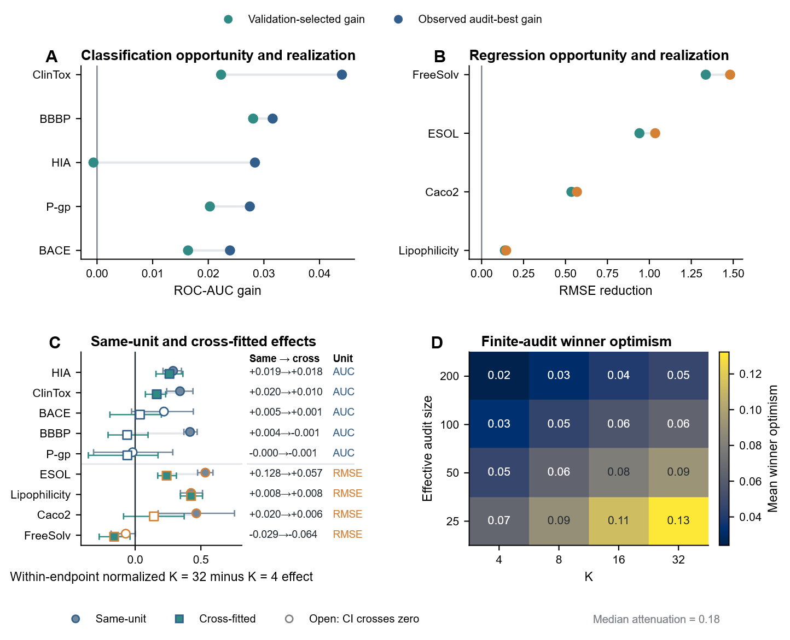
Figure 4. Selection-gap decomposition and winner optimism. Panels A and B compare observed audit-best and validation-selected gains for classification and regression. Panel C presents all endpoints in one task-stratified forest plot using within-endpoint normalized effects; raw ROC-AUC and RMSE effects are listed separately. Panel D shows finite-audit winner optimism under equal candidate truth.

3.6 Matched-size representation effects were endpoint dependent
Exhaustive enumeration of all 220 K = 3 subsets refined the multiview interpretation. The endpoint median of subset-level selected-model gains versus Morgan K = 3 was positive for BBBP, ClinTox, ESOL, FreeSolv, Lipophilicity, Caco2, HIA, P-gp and negative for BACE. The within-endpoint proportion of subsets with positive mean gain ranged from 0.318 to 0.995. These proportions describe the registered composition space and do not turn 220 overlapping subsets into independent replications.
The K = 3, 6, 9 and 12 ladder retained endpoint heterogeneity, with negative endpoint-level composition medians preserved for BACE. Because classification ROC-AUC gains and regression RMSE reductions have different units, they are shown on separate axes and are not combined into a continuous cross-task effect.
The full multiview-pool and K = 3, 6, 9 and 12 ladder analyses retained endpoint heterogeneity under five distinct scaffold partitions for classification and regression. Composition-class summaries are mutually exclusive, while the full set of 220 subset identities and their overlapping candidate memberships remains machine readable. Complete subset and ladder results are in Additional file 2: Tables S9-S10. (Figure 5; Additional file 2: Tables S9-S10).
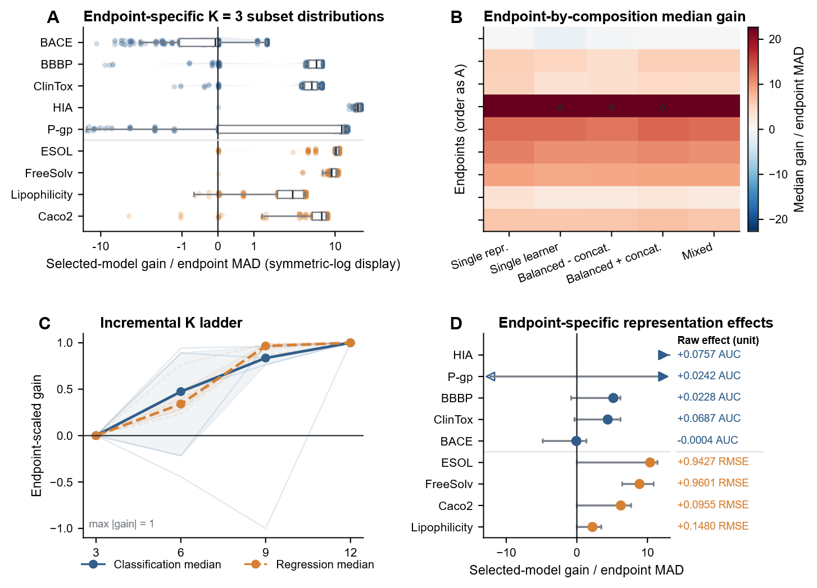
Figure 5. Matched-size representation-composition effects. Panel A shows endpoint-specific distributions across all 220 registered K = 3 subsets. Panel B summarizes mutually exclusive composition classes. Panel C shows the K = 3, 6, 9 and 12 ladder. Panel D presents all endpoints in one integrated forest plot using endpoint-MAD-normalized effects, with raw ROC-AUC gains and RMSE reductions listed separately.

3.7 Prediction errors were correlated but partially complementary
The limited four-model panel provided 90 endpoint-seed-fold prediction sets across six endpoints. Prediction correlations and error overlaps were substantial but incomplete; mean Ledoit-Wolf prediction entropy rank was below the nominal four models. These quantities characterize the completed fixed configurations and cannot rank fully optimized modern architectures.
Across chemical-support strata, pairwise high-error Jaccard overlap was non-zero and model disagreement increased at weaker support in several endpoints. Prediction-level complementarity therefore existed, but it was not equivalent to independent candidate opportunity. Unequal model-training budgets further restrict any architecture-level comparison.
The panel cannot support a performance hierarchy among adequately tuned modern methods. The GCN received only five fixed epochs, and both language-model representations used frozen linear probes rather than end-to-end fine tuning. RDKit-RF consequently had a different optimization budget and inductive bias. The completed outputs are informative for selector behaviour and error correlation under the evaluated configurations, but they should not be generalized to all graph networks, ChemBERTa variants or MoLFormer training strategies.
The support-stratified audit retained one traceable selected-candidate result per split-seed outer fold and avoided plotting duplicate selected and reference points. Candidate performance, error overlap and disagreement were summarized within prespecified support strata; no support stratum was used to choose a candidate. (Figure 6A-B).

3.8 Reliability weakened at chemical-support boundaries
This analysis asked whether predictive reliability remained stable in sparse or discontinuous chemical regions. At 90% nominal coverage, mean minority-class coverage across classification endpoints was 0.788 for split conformal, 0.887 for label-conditional conformal and 0.891 for Mondrian label-and-similarity conformal prediction. Conditional methods substantially reduced minority undercoverage but remained slightly below the target on average. Prediction sets also became larger, so improved coverage did not constitute a free increase in information.
CQR coverage was endpoint dependent: 0.836 for ESOL, 0.893 for FreeSolv and 0.917 for Lipophilicity at the 90% target. The cross-endpoint mean was 0.882. Raw interval widths were not pooled for interpretation because the targets use different units and dynamic ranges. Ensemble uncertainty had mean uncertainty–error Spearman correlation 0.321 and enriched the 10% highest-error samples by 1.54-fold, indicating useful but incomplete error ranking.
Chemical-support stratification showed a boundary signal. Median classification ROC-AUC across audit units was 0.842 below Tanimoto 0.5, 0.914 from 0.5 to <0.7 and 0.925 at or above 0.7. Median regression RMSE was 1.337, 1.097 and 0.767 across the same strata. Novel-scaffold relative changes in error overlap, disagreement and high-error enrichment were reported against seen-or-related scaffolds as reference = 1.
ClinTox remained the strongest negative result in the traceable four-model panel. Discrimination, minority recall, false-negative rate, label-conditional conformal coverage and mean prediction-set size are shown as distinct quantities rather than collapsed into one ranking. The observed minority-safety limitation prevents interpreting a favourable ROC-AUC as deployment readiness. (Figure 6C-D).

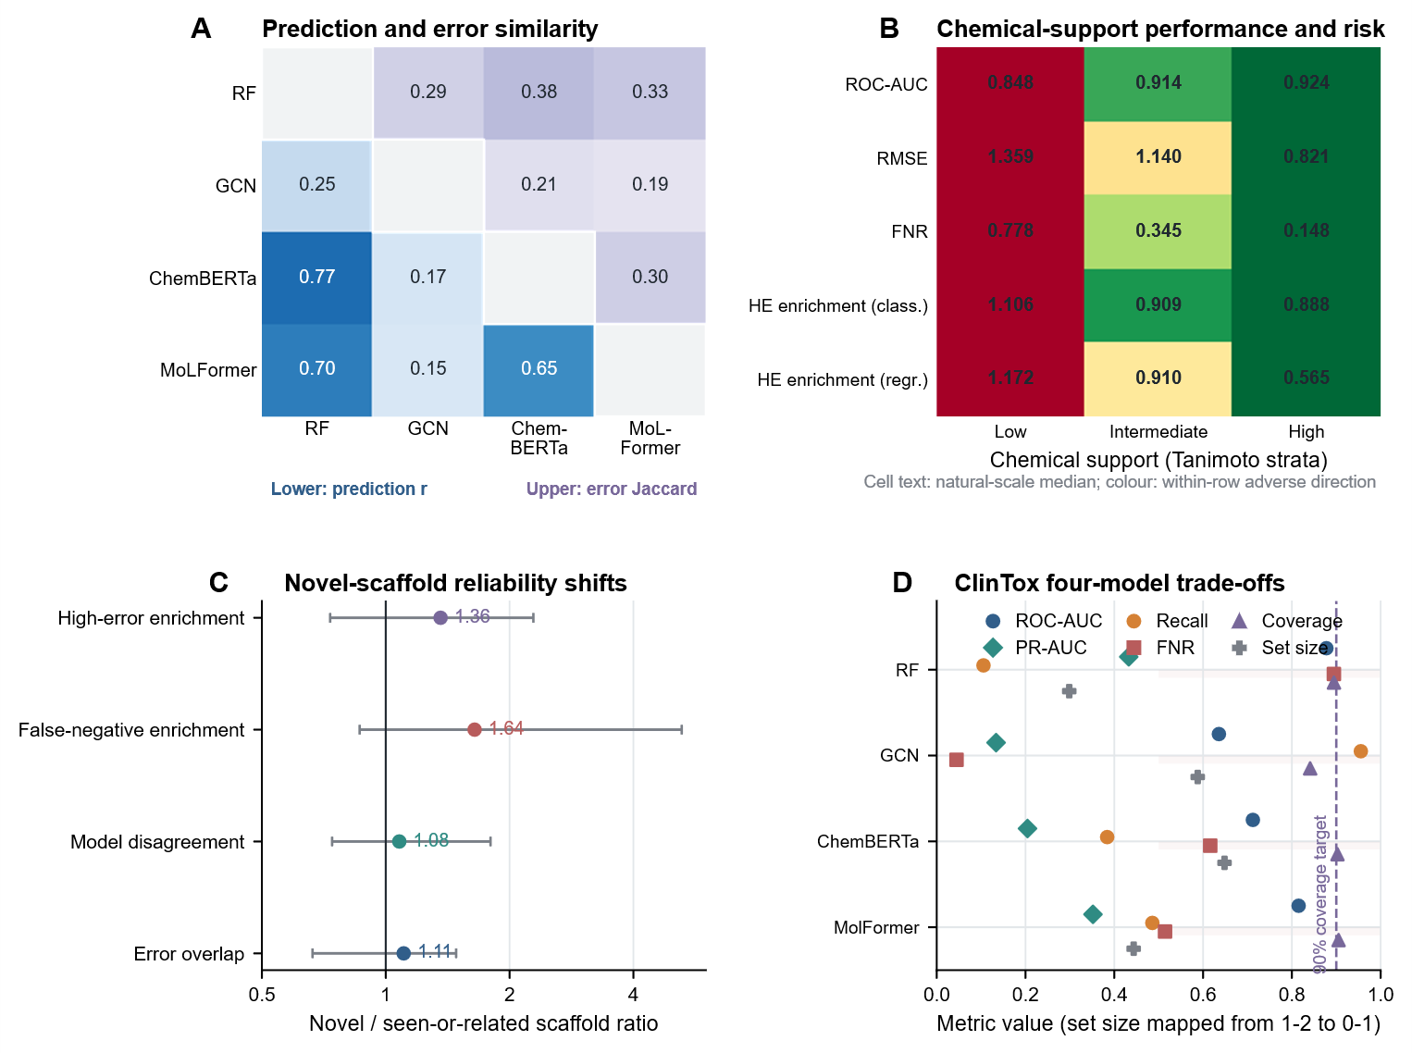
Figure 6. Prediction reliability across chemical-support boundaries. Panel A combines prediction correlations and high-error Jaccard overlaps in a symmetric four-model matrix with separate colour scales. Panel B consolidates classification ROC-AUC, regression RMSE, classification false-negative rate and classification/regression high-error enrichment into one Tanimoto-support risk matrix; cell text gives natural-scale medians and colour encodes only the within-row adverse direction. Panel C reports novel-scaffold relative changes in error overlap, model disagreement, high-error enrichment and false-negative enrichment on a log-ratio axis. Panel D separates discrimination and minority-safety measures for the four fixed-configuration models; prediction-set size is mapped from its 1-2 scale only for display.

3.9 Audit directions transferred but effect magnitudes changed under structure separation
The formal similarity-cluster rerun completed all 1,440 outer and 4,320 inner candidate-utility evaluations without random-split fallback. Each endpoint had 15 unique outer-fold assignments, all inner and outer component sets were disjoint, test-fold sizes ranged from 376 to 505 molecules, and the largest observed cross-fold Tanimoto was 0.699. The corresponding 5,760 candidate fits are recorded as a distinct audit component in Table 2 (Additional file 2: Table S26).
CAHit@3 changes from K = 4 to K = 32 were negative under scaffold and similarity-cluster splits for BACE (-0.662 and -0.009), ClinTox (-0.956 and -0.690) and ESOL (-0.883 and -0.515). Thus the direction persisted in all three endpoints, but the BACE similarity-cluster change was close to zero and normalized MRR did not decline uniformly. The result supports transport of the prespecified CAHit@3 direction, not universal degradation of every ranking metric (Additional file 3: Figure S18A).
Cross-fitted K = 32 minus K = 4 gaps were positive in both regimes for all three endpoints. The scaffold and similarity-cluster effects were 0.0009 (-0.0046 to 0.0048) and 0.0178 (0.0124 to 0.0243) for BACE, 0.0098 (0.0046 to 0.0138) and 0.0049 (-0.0089 to 0.0215) for ClinTox, and 0.0573 (0.0411 to 0.0751) and 0.0017 (-0.0072 to 0.0107) for ESOL. Classification ROC-AUC loss and regression RMSE loss remained on separate scales. Effective-rank estimates across endpoint, K and transformation combinations had Spearman correlation 0.832 between regimes, while absolute values still changed materially (Figure S18B-D; Tables S24-S25).

3.10 Expanded composition, stability and compute controls
The expanded intervention completed six endpoints, three candidate-pool compositions and four locked K values. From K = 4 to K = 32, CAHit@3 decreased in 14 of 18 endpoint–pool cells, whereas the cross-fitted gap increased in 10 cells. At K = 32, classical multiview and modern augmentation increased validation-selected gain relative to the homogeneous registry in 6 and 6 of six endpoints, respectively. These counts describe direction across prespecified endpoints; classification ROC-AUC utility and regression negative-RMSE utility were not pooled on their raw scales.
At fixed K = 16 and 32, selected gain exceeded the corresponding classical multiview value in 6, 4, 1 and 6 of 12 endpoint–K cells for the ChemBERTa, MoLFormer, D-MPNN and full-modern registries. The component results therefore separated architecture identity from the effect of merely enlarging K (Figure S17; Table S33).
Under the locked classical-time budget, equal-budget selected gain was at least the equal-K value in 17 of 36 endpoint–pool–K cells. Because D-MPNN occupied the second modern position and dominated downstream time, the modern registry retained a mean of 1.00 candidates under this strict prefix rule. This result is a downstream-compute sensitivity, not an end-to-end efficiency comparison (Figure S21; Tables S33 and S36).
At K = 32, median normalized selection entropy was 0.256, 0.384 and 0.215 for homogeneous, classical multiview and modern-augmented registries; corresponding median leave-one-seed-out agreement was 0.600, 0.467 and 0.667. Paired homogeneous normalization had 0 near-zero denominators among 90 endpoint outer units at K = 32; valid denominators were no smaller than 0.05201. Across the nine predefined anchor–normalization combinations, selected-gain direction concordance with the primary raw-scale reference ranged from 0.611 to 1.000; 6 undefined summary cells were retained as missing. Raw, endpoint-MAD and alternative-anchor results are reported in Figure S18 and Table S34.
Across ClinTox, BACE and ESOL, 54 of 72 prespecified composition-by-K metric contrasts had the same direction under scaffold and Tanimoto-component splits. Magnitudes and several individual contrasts changed, so this analysis supports composition-effect transport across two evaluated split regimes rather than external validation or universal robustness (Figure S19; Table S35).

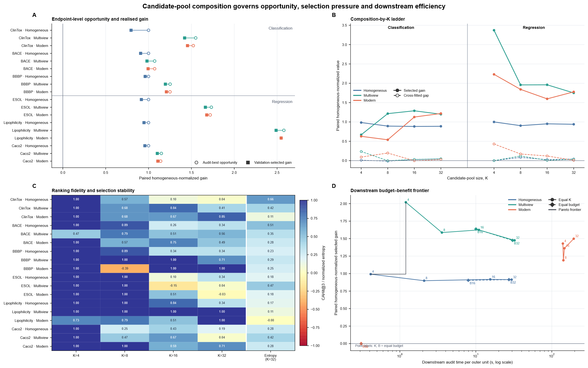Figure 7. Expanded equal-size candidate-pool composition intervention. (A) At K = 32, horizontal segments connect paired homogeneous-normalized validation-selected gain (filled squares) and observed finite-audit opportunity (open circles) for six prespecified endpoints and three pool compositions; classification and regression occupy separate row blocks. (B) The K = 4, 8, 16 and 32 ladders show mean paired homogeneous-normalized selected gain (solid) and cross-fitted gap (dashed), with classification and regression displayed in separate x-axis bands. (C) CAHit@3 is shown for every endpoint–pool–K cell; the right strip reports normalized selection entropy at K = 32. Negative CAHit@3 values are retained. (D) Equal-K and equal-downstream-budget trajectories relate measured downstream audit time per outer unit to paired homogeneous-normalized selected gain; the step line marks the empirical Pareto frontier. Uncertainty used five seed blocks after averaging the three outer folds within seed. Downstream time excludes pretrained-encoder acquisition, pretraining and cached embedding extraction.

4 Discussion

4.1 Nominal K did not define candidate diversity
Candidate count, family count, representation count, compute exposure and effective diversity describe different aspects of a model search. Nominal K records how many candidates were eligible, whereas family and representation counts describe registry composition and compute exposure records how much fitting opportunity was consumed. None of these quantities establishes how independently candidates behaved across audit units.
The registered prefixes increased candidate and compute exposure mechanically, but their candidates shared representations and closely related learners. Effective diversity instead summarized variation in observed utility patterns and remained conditional on the evaluated endpoints and splits. Molecular benchmark reports should therefore distinguish search size, registry composition, computational exposure and matrix-dependent effective diversity rather than treating any one quantity as a substitute for the others.

4.2 Matrix construction changed effective-rank interpretation
Raw utility, row-centred utility, fixed-reference utility and within-unit rank matrices answer different questions. Raw utilities retain common audit-unit difficulty; row-centred utilities remove common level shifts while imposing a row-sum constraint; fixed-reference contrasts depend on the prespecified reference; and within-unit ranks preserve ordering while discarding utility spacing. Their effective ranks should not be interpreted as competing estimates of one intrinsic candidate count.
At the largest registry each endpoint supplied only 15 outer rows, so the empirical candidate-correlation matrix was rank deficient. Ledoit–Wolf shrinkage stabilized noisy covariance directions but did not create independent audit information. Spectral entropy and participation-ratio rank weight the eigenvalue spectrum differently, and omission and reference-sensitivity analyses changed endpoint magnitudes. Reporting these estimators together makes the matrix dependence visible and prevents selective use of whichever rank best supports a preferred narrative.

4.3 Chance-adjusted ranking degradation accompanied selection gaps
Raw winner recovery becomes mechanically harder as K grows, so the interpretation relies on opportunity-adjusted and graded ranking measures. CAHit@3 asks whether the eventual outer best entered a short validation list, normalized MRR credits its position relative to the random-order expectation, NDCG emphasizes the ordered utility profile, and Spearman, Kendall and rank percentile capture broader reordering.
The permutation negative control placed both adjusted metrics around their random-order zero, whereas every observed CAHit@3 endpoint median exceeded its 95% null envelope. In the graded positive control, increasing injected validation–audit signal monotonically increased CAHit@3 and normalized MRR gain and reduced fixed-range selection loss at every K, reaching zero loss at perfect signal. These controls show that the metrics have the intended null and recovery behaviour. The empirical degradation still accompanied heterogeneous endpoint gaps without proving that one ranking statistic caused every loss.

4.4 Cross-fitting attenuated same-unit maxima
A same-unit maximum reuses the evaluated outer scores to define the reference and can therefore overstate the opportunity available to the selector. The leave-one-seed-out cross-fitted reference separated reference selection from held-out-seed evaluation and attenuated same-unit effects in most endpoints while retaining positive and negative cases.
Cross-fitting did not remove finite-maximum optimism, model-registry conditioning or public endpoint reuse. The known-truth simulation illustrated finite-maximum optimism when noisy candidate estimates were maximized, but it was not used as a bias correction. Because the cross-fitted reference still uses the same public endpoint population and split generator, it is sensitivity evidence rather than external validation. Same-unit and cross-fitted estimates should be shown together so that dependence on the evaluated-unit maximum remains visible.

4.5 Matched-size analyses refined the multiview interpretation
Exhaustive enumeration of 220 overlapping matched-size subsets held candidate count fixed while changing representation and learner composition. These subsets map sensitivity within one registry and are not independent experiments. Mutually exclusive composition classes prevent balance, concatenation, representation and learner labels from being interpreted as independent factors.
Endpoint-specific distributions retained heterogeneous and negative results, including the BACE negative median, while avoiding a pooled scale for ROC-AUC gains and RMSE reductions. Learner interaction and representation breadth remained intertwined in the larger K ladder, and matched size did not equalize every tuning or training budget. The analysis therefore supports endpoint-dependent composition effects rather than a general claim that multiview expansion is beneficial.

4.6 Reliability remained conditional on chemical support
Tanimoto support and novel-scaffold analyses showed that selection results remained conditional on chemical neighbourhood. Evidence from activity cliffs further demonstrates that close structural similarity does not guarantee similar properties, so applicability cannot be summarized by one average scaffold score. Error overlap, disagreement and support-stratified performance provide complementary boundary evidence.
ClinTox illustrates why discrimination, conformal coverage and screening safety must remain separate. ROC-AUC can coexist with weak rare-class behaviour, and nominal coverage does not guarantee acceptable minority recall or false-negative risk. Conditional methods may improve coverage by enlarging prediction sets, but they do not establish deployment readiness. These reliability analyses delimit the model-selection audit rather than independently confirm it.

4.7 Split-regime transfer reduced, but did not remove, design dependence
Preserving the CAHit@3 change direction and the cross-fitted gap direction under a split that prohibited cross-fold Tanimoto of 0.70 or greater weakens the explanation that the primary finding arose only from ordinary scaffold allocation. The rank correlation of matrix-dependent diversity estimates also shows that broad registry structure was partly preserved when the split mechanism changed.
The transfer was conditional rather than invariant. BACE showed almost no CAHit@3 change under the similarity-cluster split, normalized MRR was not uniformly lower, and interval exclusion shifted across endpoints. Split mechanism therefore changed both difficulty and the estimated magnitude of selection pressure. The appropriate claim is direction transport in three representative endpoints, not a universal law across targets, temporal splits, model registries or deployment populations.

4.8 Registry composition, selection stability and bounded compute
The six-endpoint intervention changes the interpretation from a three-dataset boundary check to a prespecified composition experiment spanning rare-class, regular classification, small regression, large regression and permeability settings. Expansion raised finite audited opportunity in many cells, but the realised gain depended on whether inner validation could rank the added candidates consistently. Effective diversity, ranking fidelity and selected utility therefore describe different parts of the audit.
The component ablations show why the modern panel should not be treated as one indivisible category. Frozen chemical-language-model embeddings and the one-epoch D-MPNN changed opportunity, selection stability and downstream time differently across endpoints. The strict equal-budget prefix analysis further shows that a computationally expensive candidate can consume the budget before later complementary candidates become eligible. This is a property of the prespecified order and bounded downstream accounting, not evidence that any architecture is intrinsically inefficient.
Anchor and normalization sensitivity constrains the strongest claim. Paired homogeneous normalization is interpretable only when its finite-audit opportunity denominator is away from zero; near-zero units were not regularized into large ratios. The raw and endpoint-MAD results, together with the fixed Morgan-RF and registry-median anchors, distinguish directional conclusions from scale-specific presentation.

4.9 Limitations
The primary nine-endpoint audit and the expanded six-endpoint composition intervention remain retrospective evaluations of public data. Effective rank at each endpoint used 15 outer units, so shrinkage stabilizes but does not create independent information. The split-regime composition loop covered only ClinTox, BACE and ESOL and one Morgan-derived Tanimoto threshold; it was not temporal, target-aware or prospective external validation.
The modern candidates were frozen ChemBERTa and MoLFormer representations with lightweight nested heads plus a locked one-epoch D-MPNN. They do not form an exhaustive or compute-optimized modern molecular-learning benchmark. Equal-budget results depend on measured hardware-specific downstream time and the prespecified prefix order, while encoder pretraining and acquisition cost were excluded. Paired homogeneous normalization was undefined when the homogeneous finite-audit opportunity was at most 1e-12; all such units are disclosed rather than imputed.
Finally, component-ablation and endpoint–pool–K cells reuse endpoints and folds and are not independent experiments. Inference therefore retained seed blocks and endpoint-specific reporting; cell counts and descriptive associations were not promoted to confirmatory population-level tests.

5 Conclusions
Across six prespecified molecular-property endpoints, candidate-pool expansion simultaneously changed finite audited opportunity, validation-realised gain, ranking fidelity, selection stability and downstream cost. Effective diversity rather than nominal K better described independent utility movement, but diversity alone did not determine selection loss.
The strengthened audit supports a bounded practical conclusion: registry expansion is useful when added candidates contribute complementary chemical information that finite inner validation can identify at an acceptable downstream budget. Robust reporting should therefore combine locked composition and K ladders, chance-adjusted ranking, cross-fitted gaps, matrix-relative diversity, selection frequencies, anchor/normalization sensitivity, compute-matched analysis and split-mechanism sensitivity.

Supplementary Information
Additional file 1. Supplementary Methods and Results, including split-regime and equal-size composition audits.
Additional file 2. Machine-readable Supplementary Tables (Tables S1-S31; XLSX).
Additional file 3. Supplementary Figures (Figures S1-S18; PDF).

List of abbreviations
BACE, beta-secretase 1; BBBP, blood–brain barrier penetration; bRo5, beyond the rule of five; CAHit@3, chance-adjusted Top-3 hit; CQR, conformalized quantile regression; ECE, expected calibration error; GCN, graph convolutional network; HIA, human intestinal absorption; MACCS, Molecular ACCess System; MRR, mean reciprocal rank; NDCG, normalized discounted cumulative gain; P-gp, P-glycoprotein; PR-AUC, precision–recall area under the curve; RDKit-RF, RDKit Morgan-fingerprint random forest; RMSE, root mean squared error; ROC-AUC, receiver operating characteristic area under the curve.

Declarations

Ethics approval and consent to participate
Not applicable. This study used publicly available molecular datasets and involved no human participants, human data or animal experiments.

Consent for publication
Not applicable.

Availability of data and materials
Public dataset provenance is listed in Additional file 2: Table S1. The submission package supplies frozen registries, fold-level inner and outer utilities, split manifests, source hashes, Figure 7 and Figures S16–S21 as editable SVG/PDF and 600-dpi PNG, Tables S32–S36, timing records, native equation-to-code mappings and all analysis scripts required to reproduce the expanded intervention.

Competing interests

Funding

Authors' contributions

Acknowledgements

References
1. Wu Z, Ramsundar B, Feinberg EN, et al. MoleculeNet: a benchmark for molecular machine learning. Chem Sci. 2018;9:513–530. doi:10.1039/C7SC02664A.
2. Huang K, Fu T, Gao W, et al. Therapeutics Data Commons: machine learning datasets and tasks for drug discovery and development. NeurIPS Datasets and Benchmarks Track. 2021. arXiv:2102.09548.
3. Cawley GC, Talbot NLC. On over-fitting in model selection and subsequent selection bias in performance evaluation. J Mach Learn Res. 2010;11:2079–2107.
4. Varma S, Simon R. Bias in error estimation when using cross-validation for model selection. BMC Bioinformatics. 2006;7:91. doi:10.1186/1471-2105-7-91.
5. Zhao D, Zhu Y, Wu Z, et al. Revisiting ADMET prediction reliability under real-world challenges in the foundation model era. J Cheminform. 2026. doi:10.1186/s13321-026-01217-2.
6. Zhang L, Zeng Y, Qi Y, et al. DCPM-ADMET: fusion of dual-component pre-trained model and molecular fingerprints to enhance drug ADMET properties prediction. J Cheminform. 2026. doi:10.1186/s13321-026-01244-z.
7. Jang Y, Lee J, Jeong K, Kim J. Multimodal graph fusion with statistically guided parsimonious descriptor selection for molecular property prediction. J Cheminform. 2026;18:18. doi:10.1186/s13321-025-01140-y.
8. Zhang Y, Liu W, Zhao H, et al. MolGramTreeNet: a multimodal molecular property prediction model via grammar tree-constrained molecular representation. iScience. 2026;29:114928. doi:10.1016/j.isci.2026.114928.
9. Wen X, Liu H, Long W, Wei S, Zhu R. Consistent semantic representation learning for out-of-distribution molecular property prediction. Brief Bioinform. 2025;26:bbaf147. doi:10.1093/bib/bbaf147.
10. Yin T, Gao P, Panapitiya G, Saldanha EG. Out-of-distribution evaluation of active learning pipelines for molecular property prediction. RSC Adv. 2026;16:5281–5295. doi:10.1039/D5RA08055J.
11. Uchibori Y, Kaneko H. Generation of molecules near the applicability domain boundaries of property prediction models. J Chem Inf Model. 2026;66:6866–6879. doi:10.1021/acs.jcim.5c03220.
12. Kim JY, Vlachos DG. Distance-aware molecular property prediction in nonlinear structure–property space. J Chem Inf Model. 2025;65:6744–6756. doi:10.1021/acs.jcim.5c01037.
13. Tang H, Yue T, Li Y. Assessing uncertainty in machine learning for polymer property prediction: a benchmark study. J Chem Inf Model. 2025;65:6585–6598. doi:10.1021/acs.jcim.5c00550.
14. Fralish Z, Reker D. Pairwise learning for molecular property prediction and optimization. Front Drug Discov. 2026;6:1859068. doi:10.3389/fddsv.2026.1859068.
15. Landrum G. RDKit: open-source cheminformatics software. Version 2026.3.1. https://www.rdkit.org/. Accessed 12 July 2026.
16. Rogers D, Hahn M. Extended-connectivity fingerprints. J Chem Inf Model. 2010;50:742–754. doi:10.1021/ci100050t.
17. Breiman L. Random forests. Mach Learn. 2001;45:5–32. doi:10.1023/A:1010933404324.
18. Ke G, Meng Q, Finley T, et al. LightGBM: a highly efficient gradient boosting decision tree. Adv Neural Inf Process Syst. 2017;30.
19. Chen T, Guestrin C. XGBoost: a scalable tree boosting system. Proc ACM SIGKDD. 2016:785–794. doi:10.1145/2939672.2939785.
20. Prokhorenkova L, Gusev G, Vorobev A, Dorogush AV, Gulin A. CatBoost: unbiased boosting with categorical features. Adv Neural Inf Process Syst. 2018;31:6638–6648.
21. Yang K, Swanson K, Jin W, et al. Analyzing learned molecular representations for property prediction. J Chem Inf Model. 2019;59:3370–3388. doi:10.1021/acs.jcim.9b00237.
22. Chithrananda S, Grand G, Ramsundar B. ChemBERTa: large-scale self-supervised pretraining for molecular property prediction. arXiv:2010.09885. 2020.
23. Ross J, Belgodere B, Chenthamarakshan V, et al. Large-scale chemical language representations capture molecular structure and properties. Nat Mach Intell. 2022;4:1256–1264. doi:10.1038/s42256-022-00580-7.
24. Erickson N, Mueller J, Shirkov A, et al. AutoGluon-Tabular: robust and accurate AutoML for structured data. arXiv:2003.06505. 2020.
25. Tropsha A. Best practices for QSAR model development, validation, and exploitation. Mol Inform. 2010;29:476–488. doi:10.1002/minf.201000061.
26. Vovk V, Gammerman A, Shafer G. Algorithmic Learning in a Random World. New York: Springer; 2005.
27. Shafer G, Vovk V. A tutorial on conformal prediction. J Mach Learn Res. 2008;9:371–421.
28. Guo C, Pleiss G, Sun Y, Weinberger KQ. On calibration of modern neural networks. Proc ICML. 2017;70:1321–1330.
29. van Tilborg D, Alenicheva A, Grisoni F. Exposing the limitations of molecular machine learning with activity cliffs. J Chem Inf Model. 2022;62:5938–5951. doi:10.1021/acs.jcim.2c01073.
30. Sheridan RP. Time-split cross-validation as a method for estimating the goodness of prospective prediction. J Chem Inf Model. 2013;53:783–790. doi:10.1021/ci400084k.
31. Demšar J. Statistical comparisons of classifiers over multiple data sets. J Mach Learn Res. 2006;7:1–30.
32. Hoyt CT, Zdrazil B, Guha R, et al. Improving reproducibility and reusability in the Journal of Cheminformatics. J Cheminform. 2023;15:62. doi:10.1186/s13321-023-00730-y.
33. Parrondo-Pizarro R, Lanini J, Rodríguez-Pérez R. Uncertainty quantification in molecular machine learning for property predictions under data shifts. J Chem Inf Model. 2026;66:923–935. doi:10.1021/acs.jcim.5c02381.
34. Deng J, Yang Z, Wang H, Ojima I, Samaras D, Wang F. A systematic study of key elements underlying molecular property prediction. Nat Commun. 2023;14:6395. doi:10.1038/s41467-023-41948-6.
35. Li Z, Chen X, Wen H, et al. A systematic survey and benchmark of deep learning for molecular property prediction in the foundation model era. arXiv:2604.16586. 2026.
36. Romano Y, Patterson E, Candès EJ. Conformalized quantile regression. Adv Neural Inf Process Syst. 2019;32.

