Candidate-pool opportunity and selection stability under finite validation in molecular property prediction: a repeated nested audit
Furong Zheng¹; Yu Gao²; Yuancheng Zeng²; Weiwei Zeng³; Junxiong Guo¹; Yejin Huang¹; Yongxia Yang^{1,4*}; Luonan Qiu^{1,4*}
¹ College of Medical Information Engineering, Guangdong Pharmaceutical University, No. 280 Waihuan East Road, Guangzhou Higher Education Mega Center, Panyu District, Guangzhou, Guangdong, 510006, China.
² College of Basic Medicine, Guangdong Pharmaceutical University, No. 280 Waihuan East Road, Guangzhou Higher Education Mega Center, Panyu District, Guangzhou, Guangdong, 510006, China.
³ Department of Pharmacy, Shenzhen Longgang Second People’s Hospital, Shenzhen, Guangdong, 518112, China.
⁴ The First Affiliated Hospital of Guangdong Pharmaceutical University, No. 19 Nonglinxia Road, Yuexiu District, Guangzhou, Guangdong, 510080, China.
*Corresponding authors: Yongxia Yang (primary corresponding author) and Luonan Qiu (co-corresponding author). Emails: yangyongxia@gdpu.edu.cn; 532039615@qq.com.
ORCID: Furong Zheng, https://orcid.org/0009-0002-5036-4761

Abstract
Background: Molecular property-prediction studies increasingly compare large, correlated candidate registries. Expansion can add useful candidates, but finite validation may fail to realize that opportunity reliably. We audited these effects without treating a larger registry as evidence of better predictive performance.
Methods: We retrospectively audited nine public endpoints with a fixed 32-candidate registry, K = 4, 8, 16, and 32 prefixes, three inner and three outer scaffold folds, and ten split seeds. The full-registry completion-gap contrast (Δinv) was decomposed exactly into candidate-availability (Δavail) and within-prefix selection (Δdep) components. Secondary analyses examined candidate order, model seed, structure-separated thresholds, practical tolerance, chemical support, simulations, and a forward-temporal cyclic-peptide source.
Results: The K = 32 minus K = 4 Δinv contrast was negative in eight of nine endpoints. Candidate availability dominated seven endpoints, and Δavail and Δdep moved in opposite directions in each of those seven; a smaller full-registry gap therefore did not imply more stable within-prefix selection. Candidate-order, model-seed, component-threshold, and forward-temporal analyses exposed material design dependence. Practical-equivalence results were reported separately for classification and regression and were treated as descriptive tolerance analyses rather than formal equivalence tests. The external-source temporal analysis did not validate the nine primary endpoint-specific effects.
Conclusions: Candidate availability and selection realization must be separated. Endpoint-specific directions and mechanisms cannot be replaced by a pooled average, and stronger independent-source, prospective, and task-diverse validation remains necessary.
Scientific Contribution: We introduce an exact completion-gap decomposition that distinguishes newly available candidate opportunity from within-prefix selection realization. The framework prevents a smaller full-registry gap from being misread as improved selection stability and combines repeated nested auditing, descriptive practical tolerance, and chemical-support diagnostics.
Keywords: molecular property prediction; candidate-pool expansion; nested cross-validation; cross-fitted reference; practical equivalence; PR-AUC; selection stability; chemical support

1 Introduction
Molecular property prediction now searches far more than a few fixed fingerprints and regressors. A single benchmark may compare circular and substructure fingerprints, physicochemical descriptors, graph models, directed message-passing neural networks (D-MPNNs), chemical-language models, pretrained representations, automated machine-learning systems, ensembles, and post hoc calibration strategies [1,2,5–10,16–24,34,35]. These candidates encode different inductive biases. Fingerprints emphasize local motifs, descriptors summarize global molecular properties, graph networks learn neighborhood interactions, and language models transfer regularities from large molecular corpora. Reported performance therefore depends not only on the predictive capacity of each candidate, but also on registry membership, tuning exposure, utility comparisons, and the winner-selection rule. Those design choices can materially alter benchmark conclusions. As registries grow, model search becomes part of the estimand rather than a neutral preliminary step. Yet benchmark reports often describe the selected predictor more fully than the selection process that produced it.
Expanding a candidate pool creates two distinct opportunities. First, a new representation or learner may capture chemical information that the existing registry cannot express. Second, every eligible candidate contributes another noisy utility estimate that the same finite validation data must rank. The first mechanism can improve generalization by adding complementary chemical signal. The second can favor a candidate whose apparent advantage is specific to the available validation scaffolds. Correlation among candidates moderates but does not remove this tension: near-duplicate pipelines may share most errors while still exchanging ranks under finite sampling. Crucially, this selection pressure does not require direct test leakage. Repeated comparisons among representations, learners, tuning variants, calibration rules, and ensemble choices can consume validation information even when the final audit fold remains hidden during fitting [3,4]. A larger registry may therefore create useful opportunity and additional selection pressure at the same time.
Nested cross-validation is the principal design for separating selection from evaluation. Inner folds rank candidates, select hyperparameters, and fit any data-dependent preprocessing. An outer fold then evaluates the frozen decision produced by that inner procedure. This design prevents the tuning score from becoming the final performance estimate. It also permits alternative selectors to be compared on shared outer folds. Repeated seeded scaffold partitions expose sensitivity to chemically coherent test groups and support paired candidate comparisons under identical audit conditions. This safeguard matters for molecular data because random splits can place closely related compounds on both sides of the evaluation boundary. Together, nested scaffold evaluation and repeated partitions preserve the distinction between inner selection and outer evaluation and document how a registered selector behaves across chemical partitions [25].
Nested evaluation does not resolve every property of a model search. It neither quantifies candidate dependence nor ensures that nominal candidate count reflects effective diversity. Larger registries may also require more fits, creating unequal compute exposure, and some candidates may fail or be unavailable. Each outer score validly evaluates a frozen selector. However, inspecting the maximum across many outer candidate scores after the fact can still produce outer-maximum optimism. Effective-rank estimates also depend on matrix construction. Raw utilities retain common audit-unit difficulty; row-centered utilities remove level shifts; fixed-reference contrasts depend on the chosen reference; and rank matrices discard utility spacing. These issues become especially important when the number of candidates exceeds the number of audit units and the empirical candidate-correlation matrix is rank deficient. Finally, retrospective reuse of public outer folds remains distinct from evaluation on an independent external cohort, even when inner fitting is leakage free.
Chemical-support boundaries further constrain the interpretation of model-selection results. Molecular similarity and scaffold novelty alter prediction difficulty, while activity cliffs show that close structural neighbors can have sharply different properties [9–14,29,30,33]. Rare positive classes pose another risk: ROC-AUC can appear favorable even when precision, minority recall, or false-negative behavior is unsuitable for screening. Applicability-domain diagnostics, support-stratified performance, error overlap, uncertainty, and conditional coverage therefore define where a selected-model result remains credible. These analyses do not independently confirm the candidate-expansion finding and should not be averaged into a single performance score. Instead, they show where strong aggregate results may weaken—for dissimilar molecules, novel scaffolds, activity-cliff pairs, or scarce toxicity labels.
We therefore designed a retrospectively specified and subsequently locked, task-stratified audit rather than a model leaderboard. We asked whether finite validation could reproducibly realize the opportunities created by candidate-pool expansion. The primary analysis used a 32-candidate registry and ten scaffold partitions generated with the locked current split implementation. We retained historical unseeded GroupKFold outputs only for data provenance and the split-transition audit. We classified the six-endpoint registry-composition intervention and all other analyses without complete ten-split-seed outputs as five-split-seed secondary analyses. The primary estimand used a K-invariant K = 32 leave-one-split-seed-out reference. K-dependent cross-fitting and the same-fold maximum served as sensitivity and descriptive opportunity quantities, respectively.

2 Methods

2.1 Study design
We defined the ten-split-seed, nine-endpoint Morgan-32 audit as the primary retrospective analysis. Analyses based on five split seeds, alternative registries, restricted endpoint panels, historical outputs, or heterogeneous compute budgets were labelled secondary or contextual before the present summaries were generated. They assess mechanisms, transport, reliability, or boundary conditions and are not independent confirmation of the primary estimand. Candidate eligibility, prefix order, estimands, aggregation units, and exclusions were frozen for this audit, but the study was not prospectively preregistered because some rules were reconstructed after the original outer outcomes had been generated. The evidence hierarchy and chronology are archived in Additional files 1, 2, and 4.

2.2 Datasets and molecular standardization
The primary panel included ESOL, FreeSolv, Lipophilicity, BBBP, BACE, ClinTox, Caco2 Wang, HIA Hou, and P-gp Broccatelli. ESOL, FreeSolv, Lipophilicity, and Caco2 were evaluated by root mean squared error (RMSE); the five classification endpoints were evaluated by the area under the receiver operating characteristic curve (ROC-AUC). These task types retained independent numerical scales. RDKit Cleanup [15] was followed by largest-fragment selection, uncharging when possible, and canonical isomeric SMILES generation. This preserved stereochemical notation; no separate tautomer collapse or isotope-removal rule was applied. Invalid or missing structures and non-numeric labels were excluded before splitting.
Duplicate handling was endpoint specific and applied after canonicalization. Classification structures with concordant labels were retained once, whereas all rows for a structure with conflicting labels were excluded. Regression replicates were replaced by their arithmetic-mean target and the replicate count was retained. Every fold-dependent imputation, scaling, target transformation, class weight, and threshold was estimated within the relevant training partition. Table 1 and Table S1 report raw and cleaned counts, exclusions, label semantics, units, and frozen target ranges.
Table 1. Primary datasets and endpoint metrics.
Endpoint | n | Class balance / target range | Metric
ESOL | 1 117 | −11.60 to 1.58 | RMSE
FreeSolv | 642 | −25.47 to 3.43 | RMSE
Lipophilicity | 4 200 | −1.50 to 4.50 | RMSE
BBBP | 1 955 | 1 494 positive (76.4%) | ROC-AUC
BACE | 1 512 | 690 positive (45.6%) | ROC-AUC
ClinTox | 1 376 | 58 positive (4.2%) | ROC-AUC
Caco2 Wang | 904 | −7.76 to −3.51 | RMSE
HIA Hou | 578 | 500 positive (86.5%) | ROC-AUC
P-gp Broccatelli | 1 212 | 647 positive (53.4%) | ROC-AUC
Note: For classification endpoints, positive denotes label = 1 in the frozen data table; endpoint-specific label semantics are reported in Table S1. Regression units, label transformations and original definitions are reported in Table S1. Ranges are label ranges after frozen cleaning.
The complete registered workflow is summarized in Figure 1.
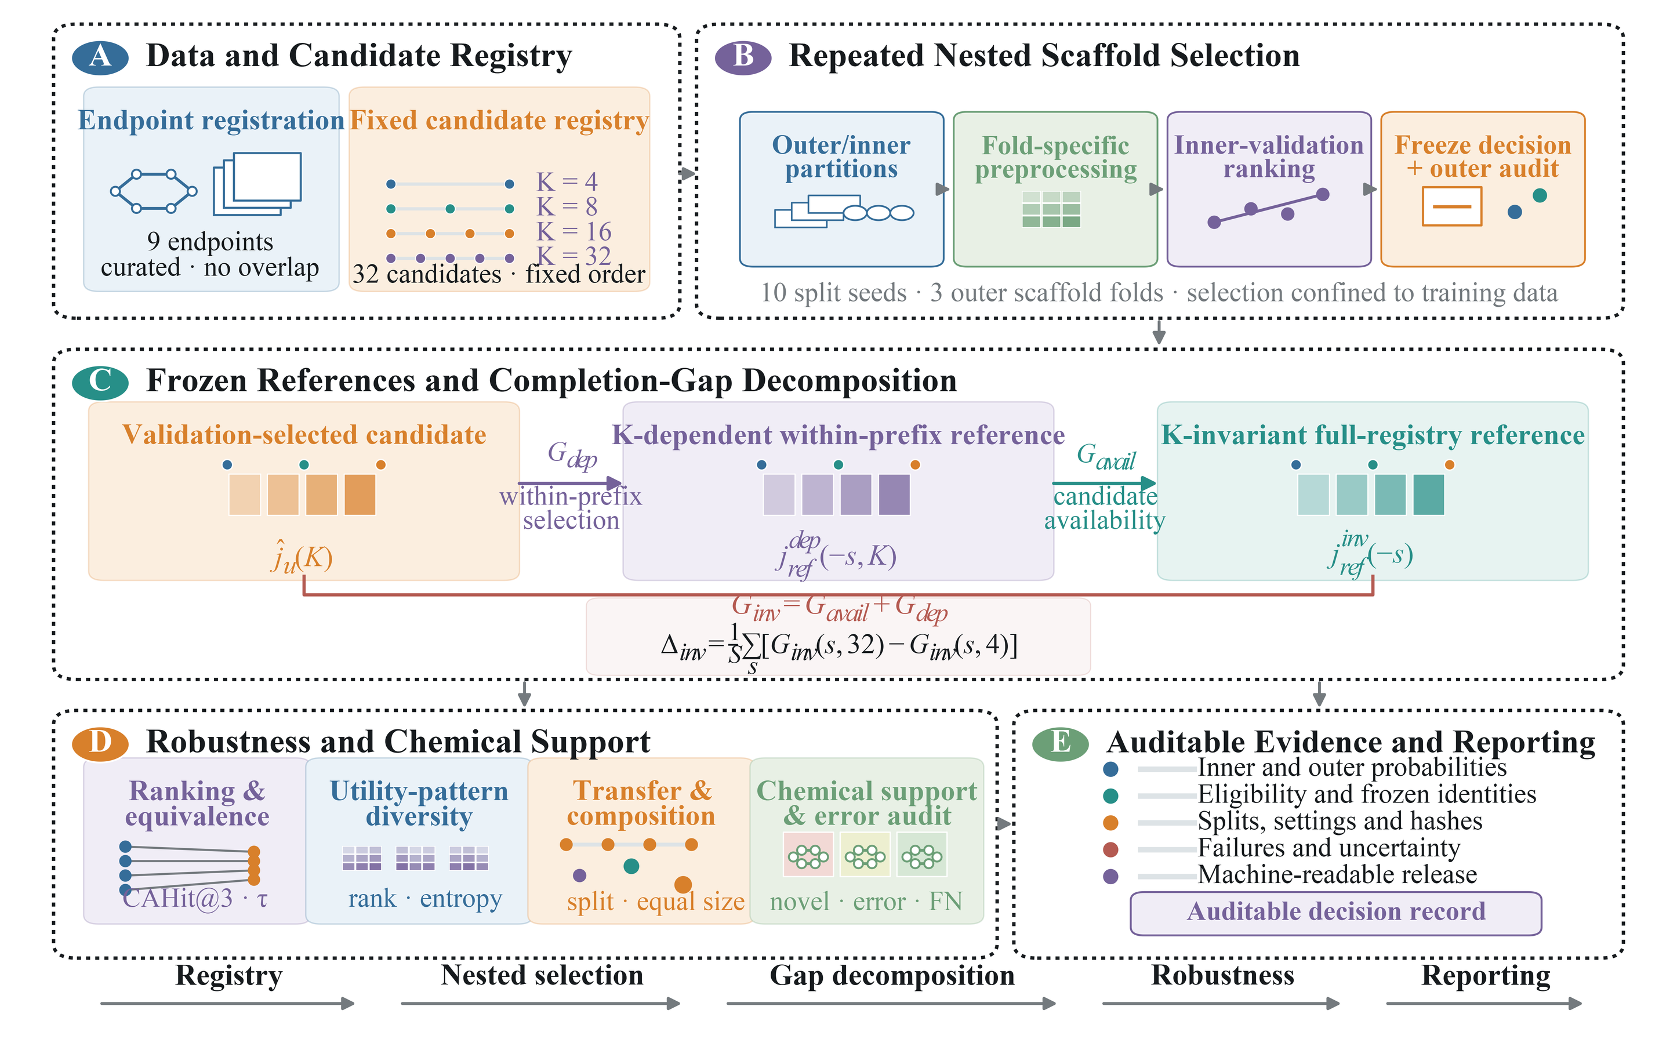
Figure 1. Core workflow for candidate-pool expansion and selection-stability auditing. Module A registers nine curated endpoints and the fixed 32-candidate registry with deterministic K = 4, 8, 16, and 32 prefixes. Module B shows the repeated nested scaffold workflow, including outer and inner partitioning, fold-specific preprocessing, inner-validation ranking, decision freezing, and outer-fold evaluation. Module C distinguishes the validation-selected candidate, the K-dependent within-prefix reference, and the K-invariant full-registry reference; the two component gaps and their exact decomposition are displayed in a dedicated, unobstructed formula band. Module D groups ranking, practical-equivalence, diversity, transfer, composition, chemical-support, and error diagnostics. Module E records probabilities, frozen identities, split assignments, settings, hashes, failures, uncertainty, and machine-readable release artifacts. Classification ROC-AUC and regression RMSE remain on independent scales.

2.3 Candidate registry and computational exposure
The controlled registry comprised 32 lightweight Morgan-512 pipelines spanning linear, kernel, tree, and ensemble learners with locked hyperparameter variants. Candidate provenance, family, exact parameters, eligibility, and position are listed in Tables S2–S3. The available records did not permit verification that the candidate order preceded all inspection of outer outcomes. Candidate-order conclusions were therefore treated as retrospective and accompanied by random-order sensitivity analysis; the chronology and provenance audit are supplied with the source data.
The complete ten-split-seed matrix comprised 34,560 candidate fits and 8,130.16 s of recorded current-run candidate fitting time. Every primary fit cell was finite and complete, so no fallback split, candidate substitution, or silent deletion entered the primary estimates. A secondary variance audit crossed three independent model seeds (101, 202, and 303) with three frozen split seeds (11, 83, and 149) for all nine endpoints. It covered all 28 stochastic candidates in orders 5–32 and retained model-seed identities and outer predictions. Budget truncation, 220-subset enumeration, and all historical failures remain in Additional file 1.
Table 2. Audit components and recorded computational exposure.
Audit component | Registry | Evaluation design | Recorded exposure
Controlled prefix audit | 32 Morgan candidates | 9 endpoints; K = 4, 8, 16, 32; 10 seeds; 3 outer × 3 inner folds | 34 560 candidate fits; candidate-fitting time 8 130.16 s
Calibration and resampling controls | Stored 32-candidate results | Full permutation and resampling schedule in Additional file 1 | No additional model fitting
Matched multiview audit (secondary) | 12 multiview candidates | 9 endpoints; 5 seeds; all C(12,3) registered subsets | 6 480 candidate fits
Split-regime transfer audit (secondary) | 32 Morgan candidates | 3 endpoints; seeded scaffold and Tanimoto-component splits | 5 760 candidate fits
Registry-composition intervention (secondary) | Three locked candidate registries | 6 endpoints; K = 4, 8, 16, 32; composition and stability controls | 1 080 outer units; downstream fitting/prediction time 64 616.35 s
Note: The analysis rows use different exposure units and therefore must not be summed. Recorded time excludes data download, encoder pretraining, and cached embedding extraction; the full permutation and mode-specific resampling schedule is reported in Additional file 1.

2.4 Repeated nested evaluation
For each endpoint and split seed, canonical molecules were grouped by Bemis–Murcko scaffold with scaffold chirality disabled. Classification used intact scaffold groups with stratified group allocation; regression used seeded sample-count balancing of intact scaffold groups. The registered primary folds had no scaffold overlap. Classification feasibility required both labels in each assessment fold. All registered primary partitions met the feasibility rules, so the current matrix required no random-split fallback; complete split types, counts, hashes, and feasibility flags are reported in Table S4.
Each outer training partition was split again into three inner folds using the same task-appropriate scaffold rule. All preprocessing and hyperparameter-specific fitting occurred inside the corresponding inner-training fold. We averaged the three inner-validation utilities, selected the eligible candidate with the highest mean utility, resolved exact ties by registered order, refit that frozen candidate on the complete outer-training partition, and evaluated it once on the untouched outer fold. Outer scores never determined eligibility, preprocessing, thresholds, candidate identity, or tie breaking. The primary audit used ten split seeds, three outer folds, and three inner folds; split and prediction hashes permit unit-level reconstruction.

2.5 Primary references and gap decomposition
For an outer audit unit u = (s, f) and eligible prefix C_K, the validation-selected candidate is the member of C_K with the highest mean inner-validation utility V. The K-invariant full-registry reference is selected from C_32 by averaging outer-audit utility A over all units whose split seed is not s. The K-dependent within-prefix reference applies the same leave-one-split-seed-out construction within C_K. Thus the first reference keeps the comparator identity independent of K, whereas the second isolates selection within the available prefix.
Leave-one-split-seed-out reference selection separates reference construction from evaluation within the held-out split seed. Because all split seeds reuse the same endpoint population, it does not provide dataset-level independence and must not be interpreted as external validation or an oracle estimate of population-best performance.
${\hat{j}}_{u}(K) = \underset{j ∈ C_{K}}{arg max}V(u,j)$
jrefinv(−s) = arg maxj ∈ C32u′: s(u′) ≠ sA(u′,j)|{u′: s(u′) ≠ s}|
jrefdep(−s,K) = arg maxj ∈ CKu′: s(u′) ≠ sA(u′,j)|{u′: s(u′) ≠ s}|
$G_{inv}(u,K) = A(u,j_{ref}^{inv}(−s)) − A(u,{\hat{j}}_{u}(K))$
$G_{dep}(u,K) = A(u,j_{ref}^{dep}(−s,K)) − A(u,{\hat{j}}_{u}(K))$
$G_{avail}(u,K) = A(u,j_{ref}^{inv}(−s)) − A(u,j_{ref}^{dep}(−s,K))$
$G_{inv}(u,K) = G_{avail}(u,K) + G_{dep}(u,K)$
${\bar{G}}_{q,e,s}(K) = \frac{\sum_{f=1}^{F_{e,s}}{G_{q}((s,f),K)}}{F_{e,s}}, q ∈ \{inv, avail, dep\}$
$Δ_{q}(e) = \frac{\sum_{s=1}^{S_{e}}{\left[{\bar{G}}_{q,e,s}(32) − {\bar{G}}_{q,e,s}(4)\right]}}{S_{e}}$
For example, if the full-registry reference, within-prefix reference, and selected candidate have utilities 0.90, 0.88, and 0.86, respectively, then G_inv = 0.04, G_avail = 0.02, and G_dep = 0.02. This illustration is scale neutral and is not an empirical endpoint result.
Table 3. Core notation required to interpret the primary audit estimands.
Symbol | Definition
u = (s, f) | outer audit unit indexed by split seed s and outer fold f
C_{K} | eligible retrospectively locked candidate prefix at size K
V(u, j) | inner-validation utility
A(u, j) | outer-audit utility (negative RMSE direction for regression)
ĵ_{u}(K) | validation-selected candidate at size K
j_{ref}^{inv}(−s) | K-invariant full-registry reference selected without split seed s
j_{ref}^{dep}(−s, K) | K-dependent within-prefix reference selected without split seed s
G_{inv}(u, K) | K-invariant full-registry completion gap
G_{dep}(u, K) | K-dependent within-prefix selection gap
G_{avail}(u, K) | candidate-availability component
Δ_{inv}(e) | endpoint-level K = 32 minus K = 4 contrast averaged over split-seed blocks
Note: The main table retains 11 core symbols. S_main, S_secondary, G_same and other secondary notation are reported in Supplementary notation Table S47 in Additional file 2.

2.6 Effective diversity
We quantified effective diversity from raw, rank-transformed, robustly standardized, and shrinkage-correlation versions of the outer-utility matrix. For each version, we calculated entropy and participation-ratio effective ranks. We reported candidate count, unique prediction vectors, and matrix-effective rank as distinct quantities. Additional file 1 provides the complete anchor, normalization, and numerical-stability definitions.

2.7 Practical equivalence and metric-matched selection
Before generating the present summaries, we retrospectively locked a task-scale tolerance grid of 0.005, 0.010, and 0.020 ROC-AUC for classification and 0.025, 0.050, and 0.100 RMSE for regression. We report the full grid rather than selecting a favourable threshold; the middle values are descriptive operating tolerances, not clinical, pharmacological, or industrial minimum important differences. PR-AUC and ROC-AUC selectors were compared on identical outer partitions. The archived recall-constrained implementation redefined the frequency-minority class within each inner training fold. A valid analysis would fix the target class once from the complete outer-training partition and retain it across all inner folds and outer evaluation. Because inner-validation probabilities were not retained, that selector could not be refitted and its candidate-switch and outer-performance effects were excluded; only the definition error and identity audit remain.

2.8 Chemical-support and reliability analyses
Reliability analyses separately reported discrimination, calibration, minority safety, conformal coverage, prediction-set size, chemical similarity, scaffold novelty, and activity-cliff behavior [26–28,36]. Classification and regression results, coverage and recall, and endpoint-specific units were not collapsed into a single score. Full conditioning and transfer algorithms are provided in Additional file 1. Because scaffold-separated, component-separated, and forward-temporal evaluation can violate exchangeability between calibration and audit samples, the reported coverage values are empirical coverage estimates under the observed distribution shift rather than finite-sample distribution-free guarantees. The value 0.90 is a nominal target, and coverage is not interpreted as deployment readiness.

2.9 Statistical summaries and limitations of inference
Outer folds were averaged within each split seed before endpoint-level summarisation. The resulting intervals quantify sensitivity to the ten registered split seeds; they are not confidence intervals based on independent datasets. We report complete seed-level paired values and avoid confirmatory significance claims. Endpoints are the interpretation units, whereas folds, seeds, candidates, and overlapping subsets are dependent technical units. We performed no multiplicity-adjusted confirmatory testing [31] and make no causal, external-validation, or deployment claim.

2.10 Secondary robustness analyses and chronology
We initially repeated the Tanimoto-component analysis at thresholds 0.60, 0.70, and 0.80 for BACE, ClinTox, and ESOL, using split seeds 11, 23, 37, 53, and 71 and the frozen registry. Before inspecting extension outputs, we locked BBBP, FreeSolv, and Lipophilicity as one additional classification and two additional regression endpoints. Component formation, fold feasibility, candidate selection, and decomposition were rerun without altering the primary outer results. Infeasible thresholds were to be retained as failures rather than modified to obtain favourable results. The complete supplementary figure set is supplied as Additional file 3, and executable code, locked configurations, and integrity manifests are supplied as Additional file 4.
Independent model-seed variation crossed model seeds 101, 202, and 303 with split seeds 11, 83, and 149 for all nine endpoints. The apparent decline in candidate-identity agreement beyond K = 4 is partly structural because the K = 4 prefix contains only deterministic candidates, whereas stochastic learners enter from position 5 onward. The model-seed analysis therefore characterizes sensitivity of the expanded registered prefixes but does not isolate a causal candidate-count effect. Original, family-balanced, and stochastic-proportion-balanced registries were reconstructed from retained inner and outer scores; a deterministic-balanced registry was reported as infeasible where the four available deterministic candidates could not meet the target without duplication. Because the three split seeds were not documented as prospectively selected, this remains an exploratory secondary analysis.
For a forward-temporal transport stress test on an additional cyclic-peptide source, we used 7,334 cleaned CycPeptMPDB/CycPeptMP records [38]. The three windows used train/validation/test years of ≤2017/2018–2019/2020, ≤2019/2020/2021, and ≤2020/2021/2022. They were overlapping sequential stress tests rather than independent external cohorts, because earlier records contributed to later training or validation sets. We audited exact canonical-SMILES and InChIKey overlap, scaffold overlap, maximum train–test Tanimoto similarity, target shift, and unavailable source-family fields. The source was contextual transfer evidence, not validation of the nine primary endpoint-specific effects.

2.11 Use of large language models
OpenAI Codex was used for code review, language editing, formatting assistance, and consistency checks. It did not determine the study design, candidate registry, model selection, statistical analysis, or reported results. All generated or modified content was reviewed and verified by the authors, who retain full responsibility for the manuscript.

3 Results

3.1 Primary full-registry completion-gap decomposition
The K = 32 minus K = 4 full-registry completion-gap contrast, Δinv, was negative in eight of nine endpoints and positive only for ESOL. The decomposition identity Δinv = Δavail + Δdep held at unrounded machine precision in every endpoint. Candidate availability dominated BACE, BBBP, ClinTox, HIA, P-gp, Lipophilicity, and Caco2, and the two components moved in opposite directions in all seven. These seven contrasts therefore cannot be interpreted as improved within-prefix selection stability. ESOL had Δavail = 0, so its positive Δinv came entirely from Δdep; FreeSolv was the only endpoint for which both components were negative and moved in the same direction.
Classification ROC-AUC and regression RMSE remain on independent scales. The descriptive registered-seed range crossed zero for HIA and Caco2, and all interval language refers to split-seed sensitivity rather than independent-dataset inference. Table 4 supplies the point estimates, and Figure 2 shows all ten fold-averaged seed contrasts, endpoint means, medians, interquartile ranges, same-sign counts, and registered-seed ranges.
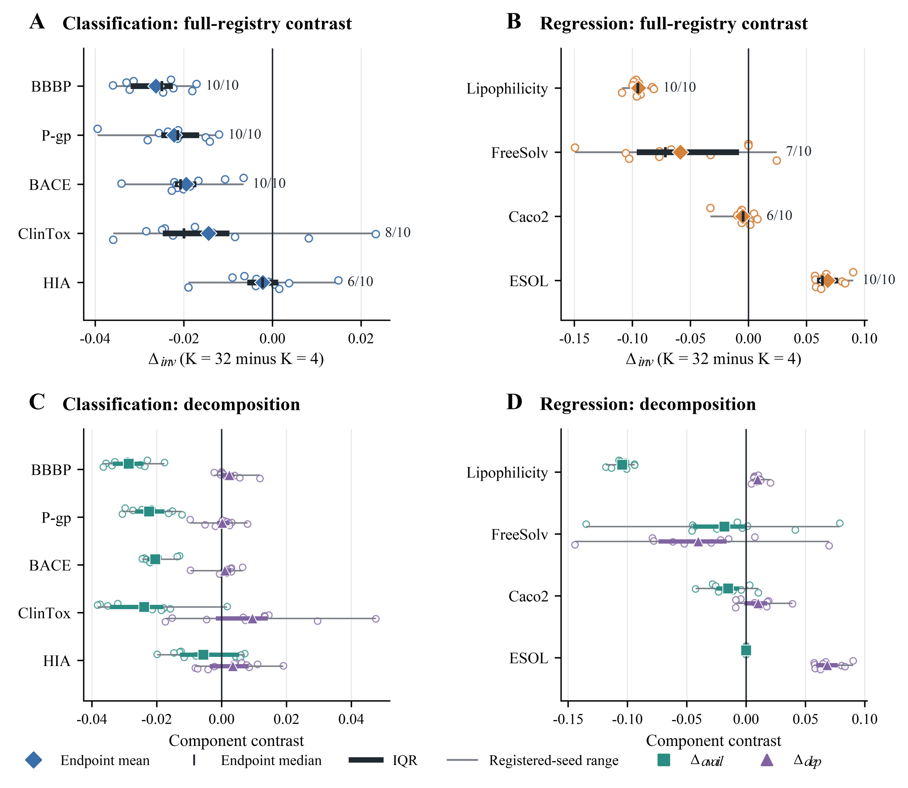
Figure 2. Split-seed decomposition of the full-registry contrast. Panels A and B show the ten fold-averaged Δinv contrasts for classification and regression on independent natural-metric axes. Open points denote split seeds, diamonds denote endpoint means, vertical ticks denote medians, and thick and thin horizontal segments denote interquartile and full registered-seed ranges, respectively. The right-side fractions report the number of split seeds sharing the endpoint-mean direction. Panels C and D show Δavail and Δdep using the same seed-level summaries. The identity Δinv = Δavail + Δdep holds at unrounded machine precision. These ranges summarize split-seed sensitivity and are not confidence intervals based on independent datasets.
Table 4. Full-registry completion-gap decomposition by endpoint.
Endpoint | Δinv (95% split-seed sensitivity interval) | Δavail | Δdep | Dominant mechanism
BACE | −0.0195 (−0.0238, −0.0152) | −0.0205 | +0.0010 | candidate availability; opposite directions
BBBP | −0.0263 (−0.0301, −0.0225) | −0.0287 | +0.0024 | candidate availability; opposite directions
ClinTox | −0.0144 (−0.0241, −0.0031) | −0.0239 | +0.0095 | candidate availability; opposite directions
HIA | −0.0022 (−0.0075, +0.0031) | −0.0056 | +0.0035 | candidate availability; opposite directions
P-gp | −0.0222 (−0.0271, −0.0178) | −0.0224 | +0.0002 | candidate availability; opposite directions
ESOL | +0.0683 (+0.0618, +0.0757) | +0.0000 | +0.0683 | within-prefix selection; same direction
FreeSolv | −0.0586 (−0.0912, −0.0263) | −0.0183 | −0.0403 | within-prefix selection; same direction
Lipophilicity | −0.0947 (−0.0992, −0.0899) | −0.1044 | +0.0098 | candidate availability; opposite directions
Caco2 | −0.0049 (−0.0121, +0.0008) | −0.0152 | +0.0102 | candidate availability; opposite directions
Note: Δinv = Δavail + Δdep holds exactly at unrounded machine precision. The columns are rounded independently to four decimals, so displayed values may differ by 0.0001. The 95% ranges are descriptive registered-split-seed sensitivity intervals, not confidence intervals from independent datasets. The dominant component is the component with the larger absolute point estimate; it is not an inferential claim. ‘Opposite directions’ means that Δavail and Δdep have different signs. Negative values indicate a smaller corresponding gap at K = 32 than at K = 4.

3.2 Split-seed heterogeneity and reference stability
The ten seed-level summaries showed endpoint-specific dispersion. Same-direction counts were 10/10 for BACE, BBBP, P-gp, ESOL, and Lipophilicity; 9/10 for FreeSolv; 8/10 for ClinTox; and 6/10 for HIA and Caco2. Medians and IQRs are reported with every endpoint rather than replaced by a pooled seed statistic.
Leave-one-split-seed reference identities, reference frequencies, entropy, and Top-1/Top-3 stability were audited separately. These summaries quantify sensitivity to the registered split generator; they do not turn repeated uses of the same molecular population into independent datasets.

3.3 Candidate-order sensitivity
The historical prefix order could not be verified as outcome independent. We therefore compared it with 100 random candidate orders per endpoint and with cost-first, family-balanced, random, cross-fitted best-first, and worst-first boundary orders. Registered-order percentile, direction retention, and reference-identity changes varied by endpoint, showing that prefix order is part of the estimand rather than a neutral presentation choice.
The random-order analysis used stored utilities and did not refit models. Best-first and worst-first arrangements are sensitivity bounds, not plausible prospective policies, and no ordering analysis was interpreted as an independent confirmation of the primary decomposition.

3.4 Effective candidate diversity
At K = 32, median Ledoit–Wolf entropy rank across endpoints was 2.36 for raw utilities, 19.25 after row centering, 5.56 for fixed-reference-relative utilities, and 24.33 for within-unit ranks. Entropy rank, participation-ratio rank, and candidate correlation changed with matrix construction and with leave-one-seed or leave-one-fold omission. See Figure 3.
Nominal K therefore did not determine effective diversity. Raw utility, centered utility, reference-relative utility, and ranks answer different questions and were not collapsed into one preferred measure.
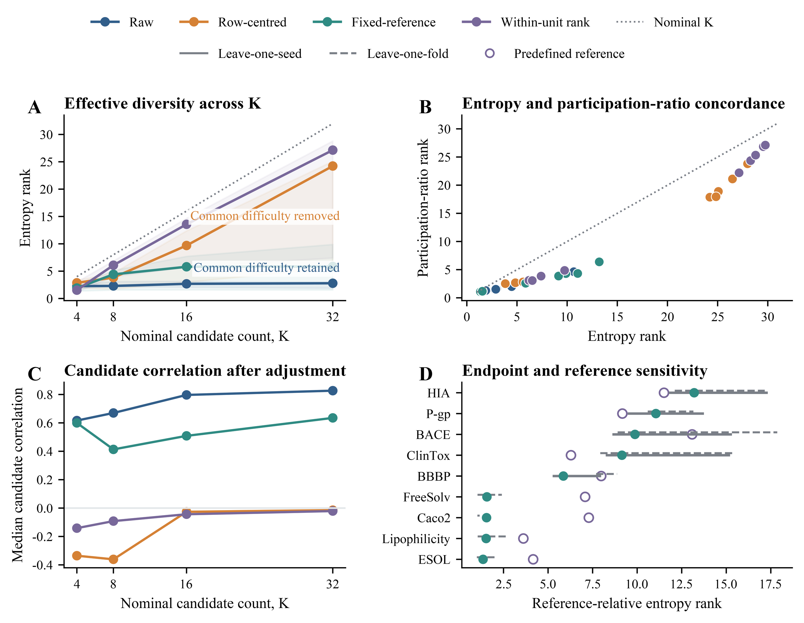
Figure 3. Matrix-dependent candidate diversity in the ten-split-seed audit. Panel A compares Ledoit–Wolf entropy rank across raw, row-centered, fixed-reference-relative, and within-unit-rank outer-utility matrices as candidate count K increases; lines show endpoint medians, shaded bands show endpoint interquartile ranges, and the dotted diagonal denotes nominal K. Panel B compares entropy and participation-ratio ranks at K = 32 against the identity line. Panel C reports median candidate correlation after each matrix adjustment. Panel D reports endpoint-level fixed-reference-relative entropy ranks at K = 32; solid and dashed ranges show leave-one-split-seed and leave-one-outer-fold sensitivity, filled points show complete estimates, and open circles show the predefined-reference analysis. Matrix construction changes the estimand and should not be interpreted as a model-performance comparison.

3.5 Ranking calibration and simulation controls
The chance-adjusted permutation control was centered near its random-order baseline. With stronger injected validation–audit signal, CAHit@3 and normalized MRR increased and fixed-range selection loss decreased. These controls calibrate the ranking statistics; they do not validate any empirical endpoint effect.
Across the retained empirical-correlation heteroskedastic simulations, mean Top-1 recovery was 0.509, with endpoint means ranging from 0.377 for HIA to 0.723 for Lipophilicity; 44 of 108 endpoint–K–noise settings placed the observed same-fold gap within the simulated 95% envelope. Candidate-rank-level outputs needed for Top-3 recovery and decomposition-direction recovery were not retained, so those quantities were not fabricated. Finite-validation noise is therefore a plausible contributor but not a sufficient generative explanation for all observed patterns.

3.6 Observed opportunity and selected gain
For classification, mean observed audit-best gain increased from 0.0028 to 0.0311 ROC-AUC between K = 4 and K = 32, whereas selected-model gain increased from −0.0014 to 0.0173. For regression, observed audit-best gain increased from 0.7619 to 0.8078 RMSE units, whereas selected-model gain changed from 0.6542 to 0.6924. Expansion increased observed opportunity faster than realized gain. See Figure 4.
Finite-audit maxima also contained winner optimism. With candidate correlation 0.9 and effective audit size 50, mean simulated optimism rose from 0.046 at K = 4 to 0.092 at K = 32. The simulation is a mechanism control, not a bias correction.
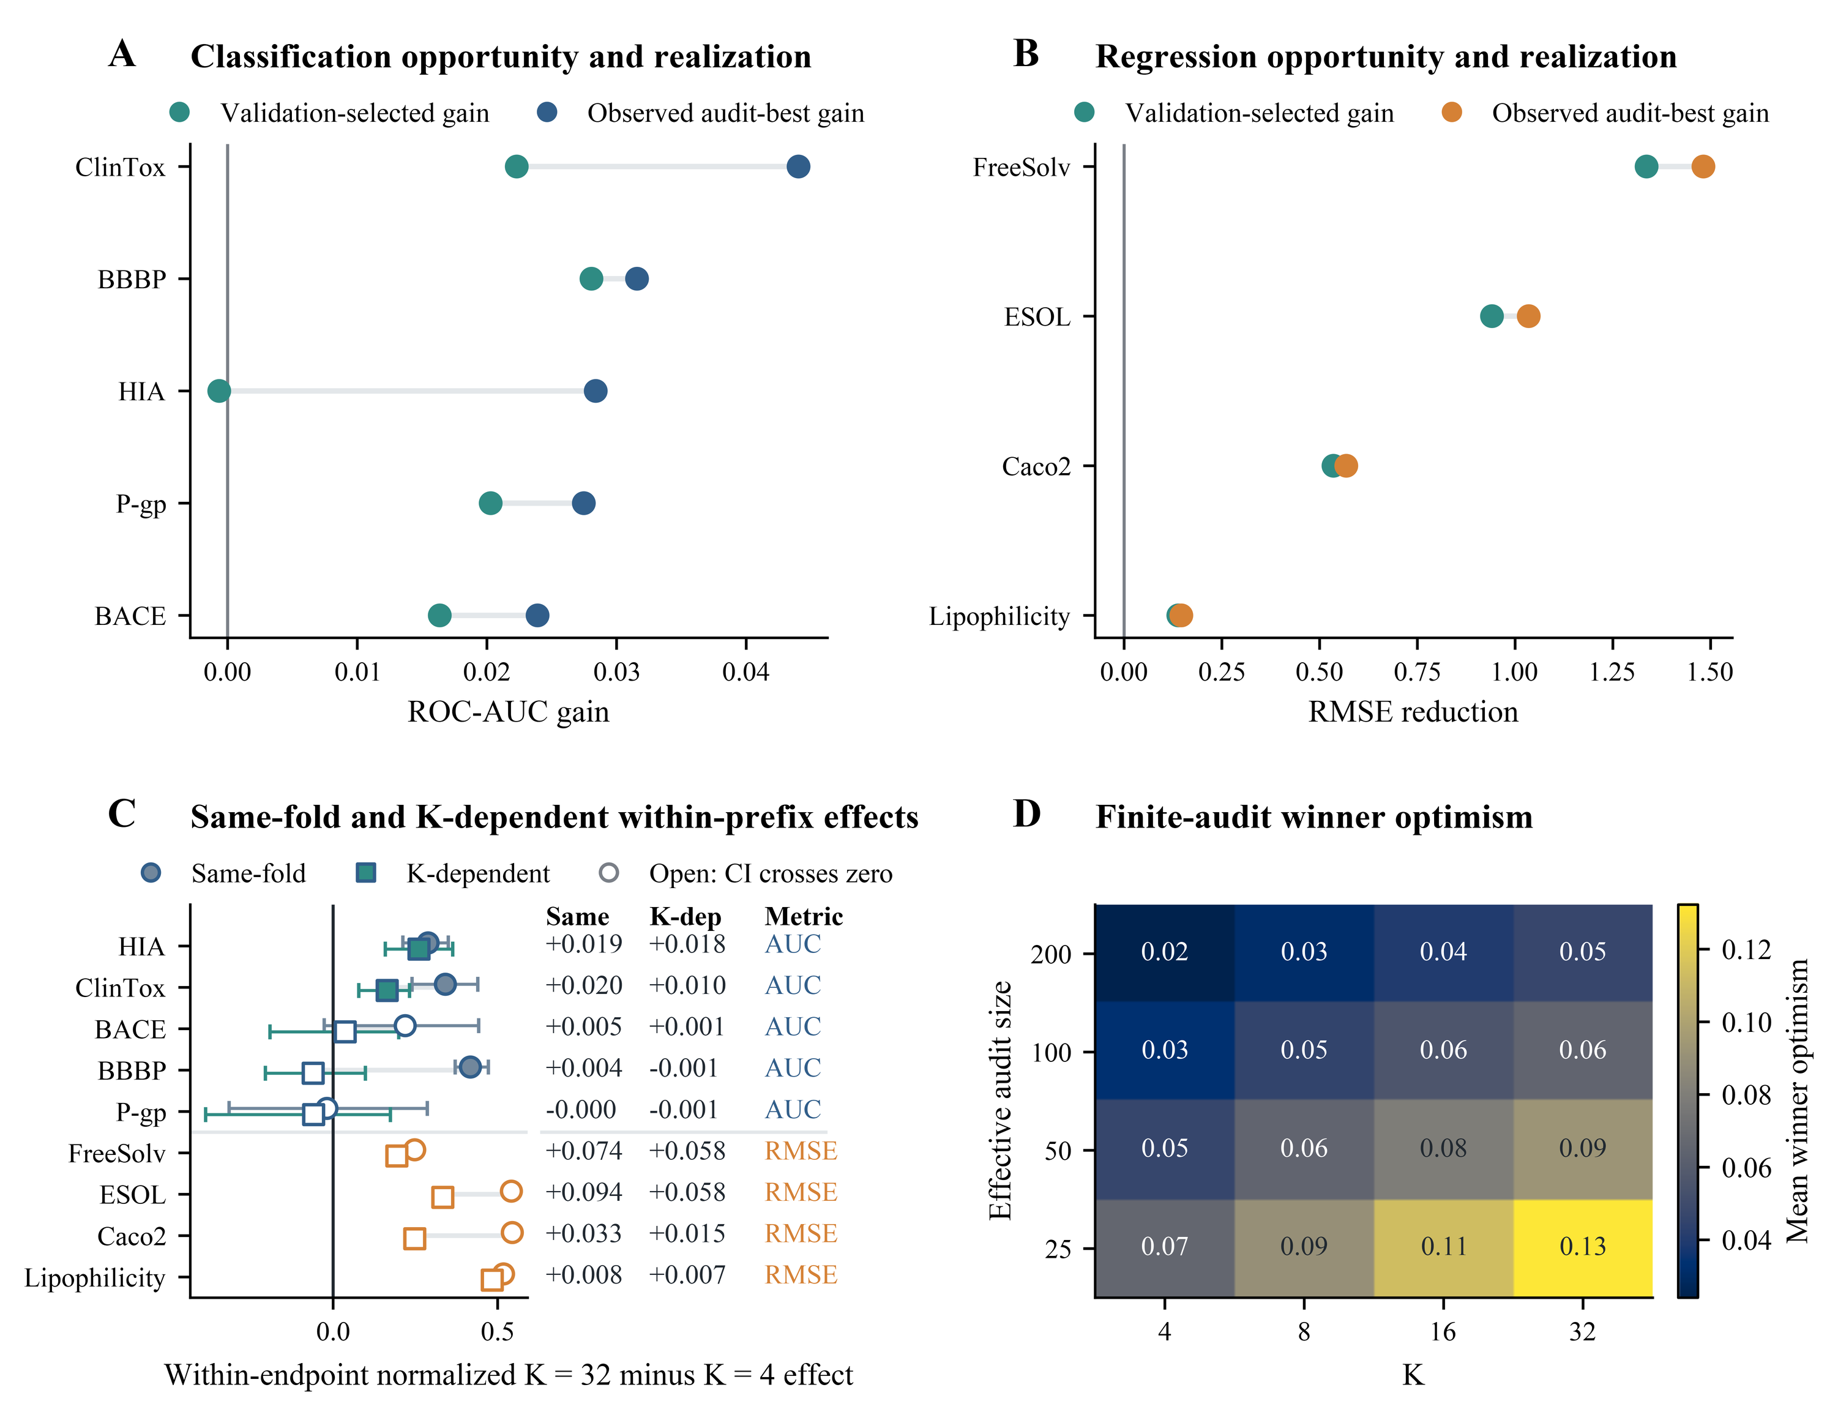
Figure 4. Opportunity, realized gain, within-prefix effects, and finite-audit winner optimism. Panel A pairs validation-selected and observed audit-best ROC-AUC gains for the classification endpoints. Panel B shows the corresponding RMSE reductions for the regression endpoints on an independent scale. Panel C compares same-fold and K-dependent within-prefix K = 32 minus K = 4 effects after within-endpoint normalization; interval bars show split-seed sensitivity, and open symbols identify intervals that cross zero. Panel D shows simulated mean winner optimism across candidate count K and effective audit size. The simulation is a calibrated diagnostic and is not used to correct the observed endpoint estimates.

3.7 Matched-size registry composition
The 220 overlapping K = 3 subsets retained positive, weak, and negative representation-composition effects. Increasing K along the registered ladder did not remove endpoint heterogeneity. These subsets share candidates and are sensitivity units, not independent experiments. See Figure 5 and Figure 6.
In the exploratory model-seed composition audit, family-balanced and stochastic-proportion-balanced registries changed Top-1 agreement, Top-3 Jaccard agreement, switch rates, selected-utility variance, and reference identities in some endpoint–fold units. A deterministic-balanced comparison was structurally infeasible for larger K because only four deterministic candidates existed. This result reinforces the confounding between candidate count and registry composition.
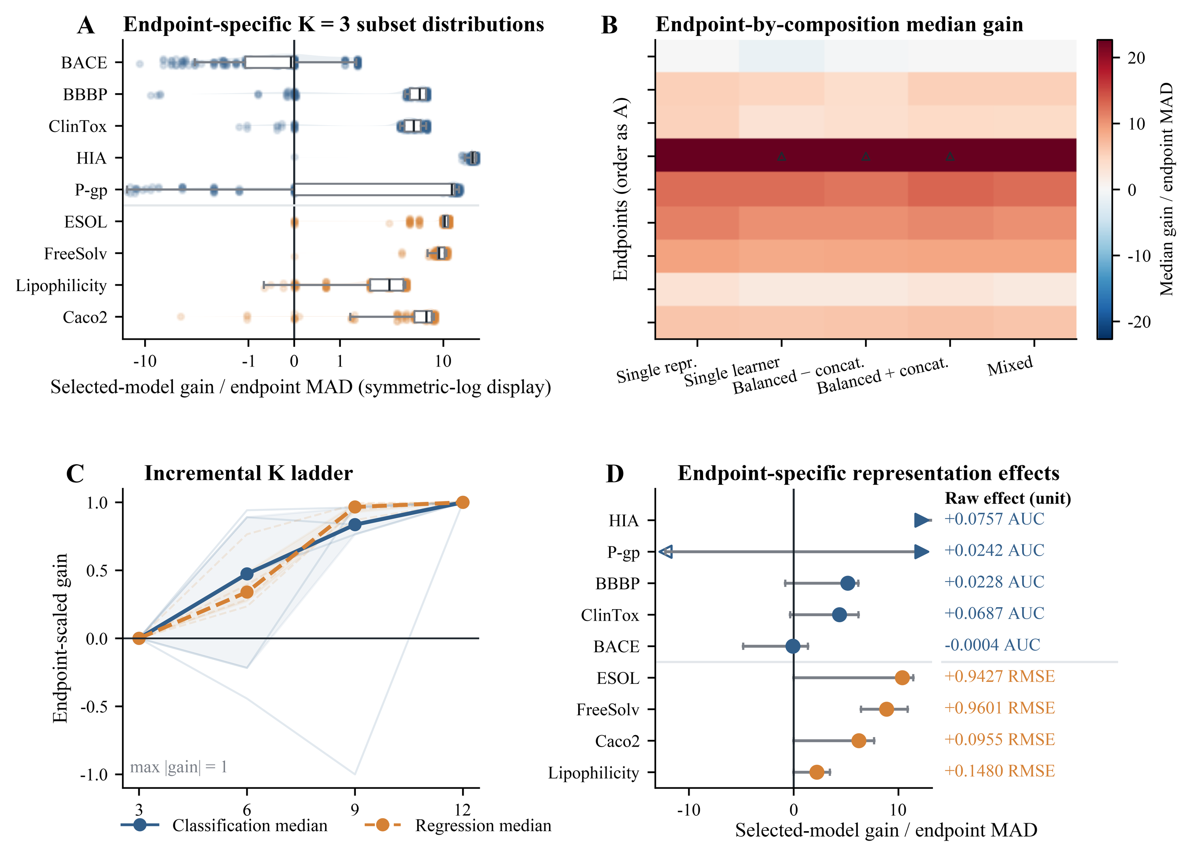
Figure 5. Matched-size representation-composition effects. Panel A shows endpoint-specific K = 3 subset distributions of selected-model gain scaled by endpoint median absolute deviation on a symmetric-log display; classification and regression retain separate colors. Panel B summarizes median gain for the prespecified, mutually exclusive composition classes across endpoints. Panel C traces endpoint-scaled gain along the incremental K ladder, with endpoint trajectories in light lines and task-level medians in bold. Panel D reports endpoint-specific representation effects with sensitivity ranges and the corresponding raw ROC-AUC or RMSE estimate printed at right. The matched-size subsets are overlapping candidate subsets and must not be treated as independent experiments.
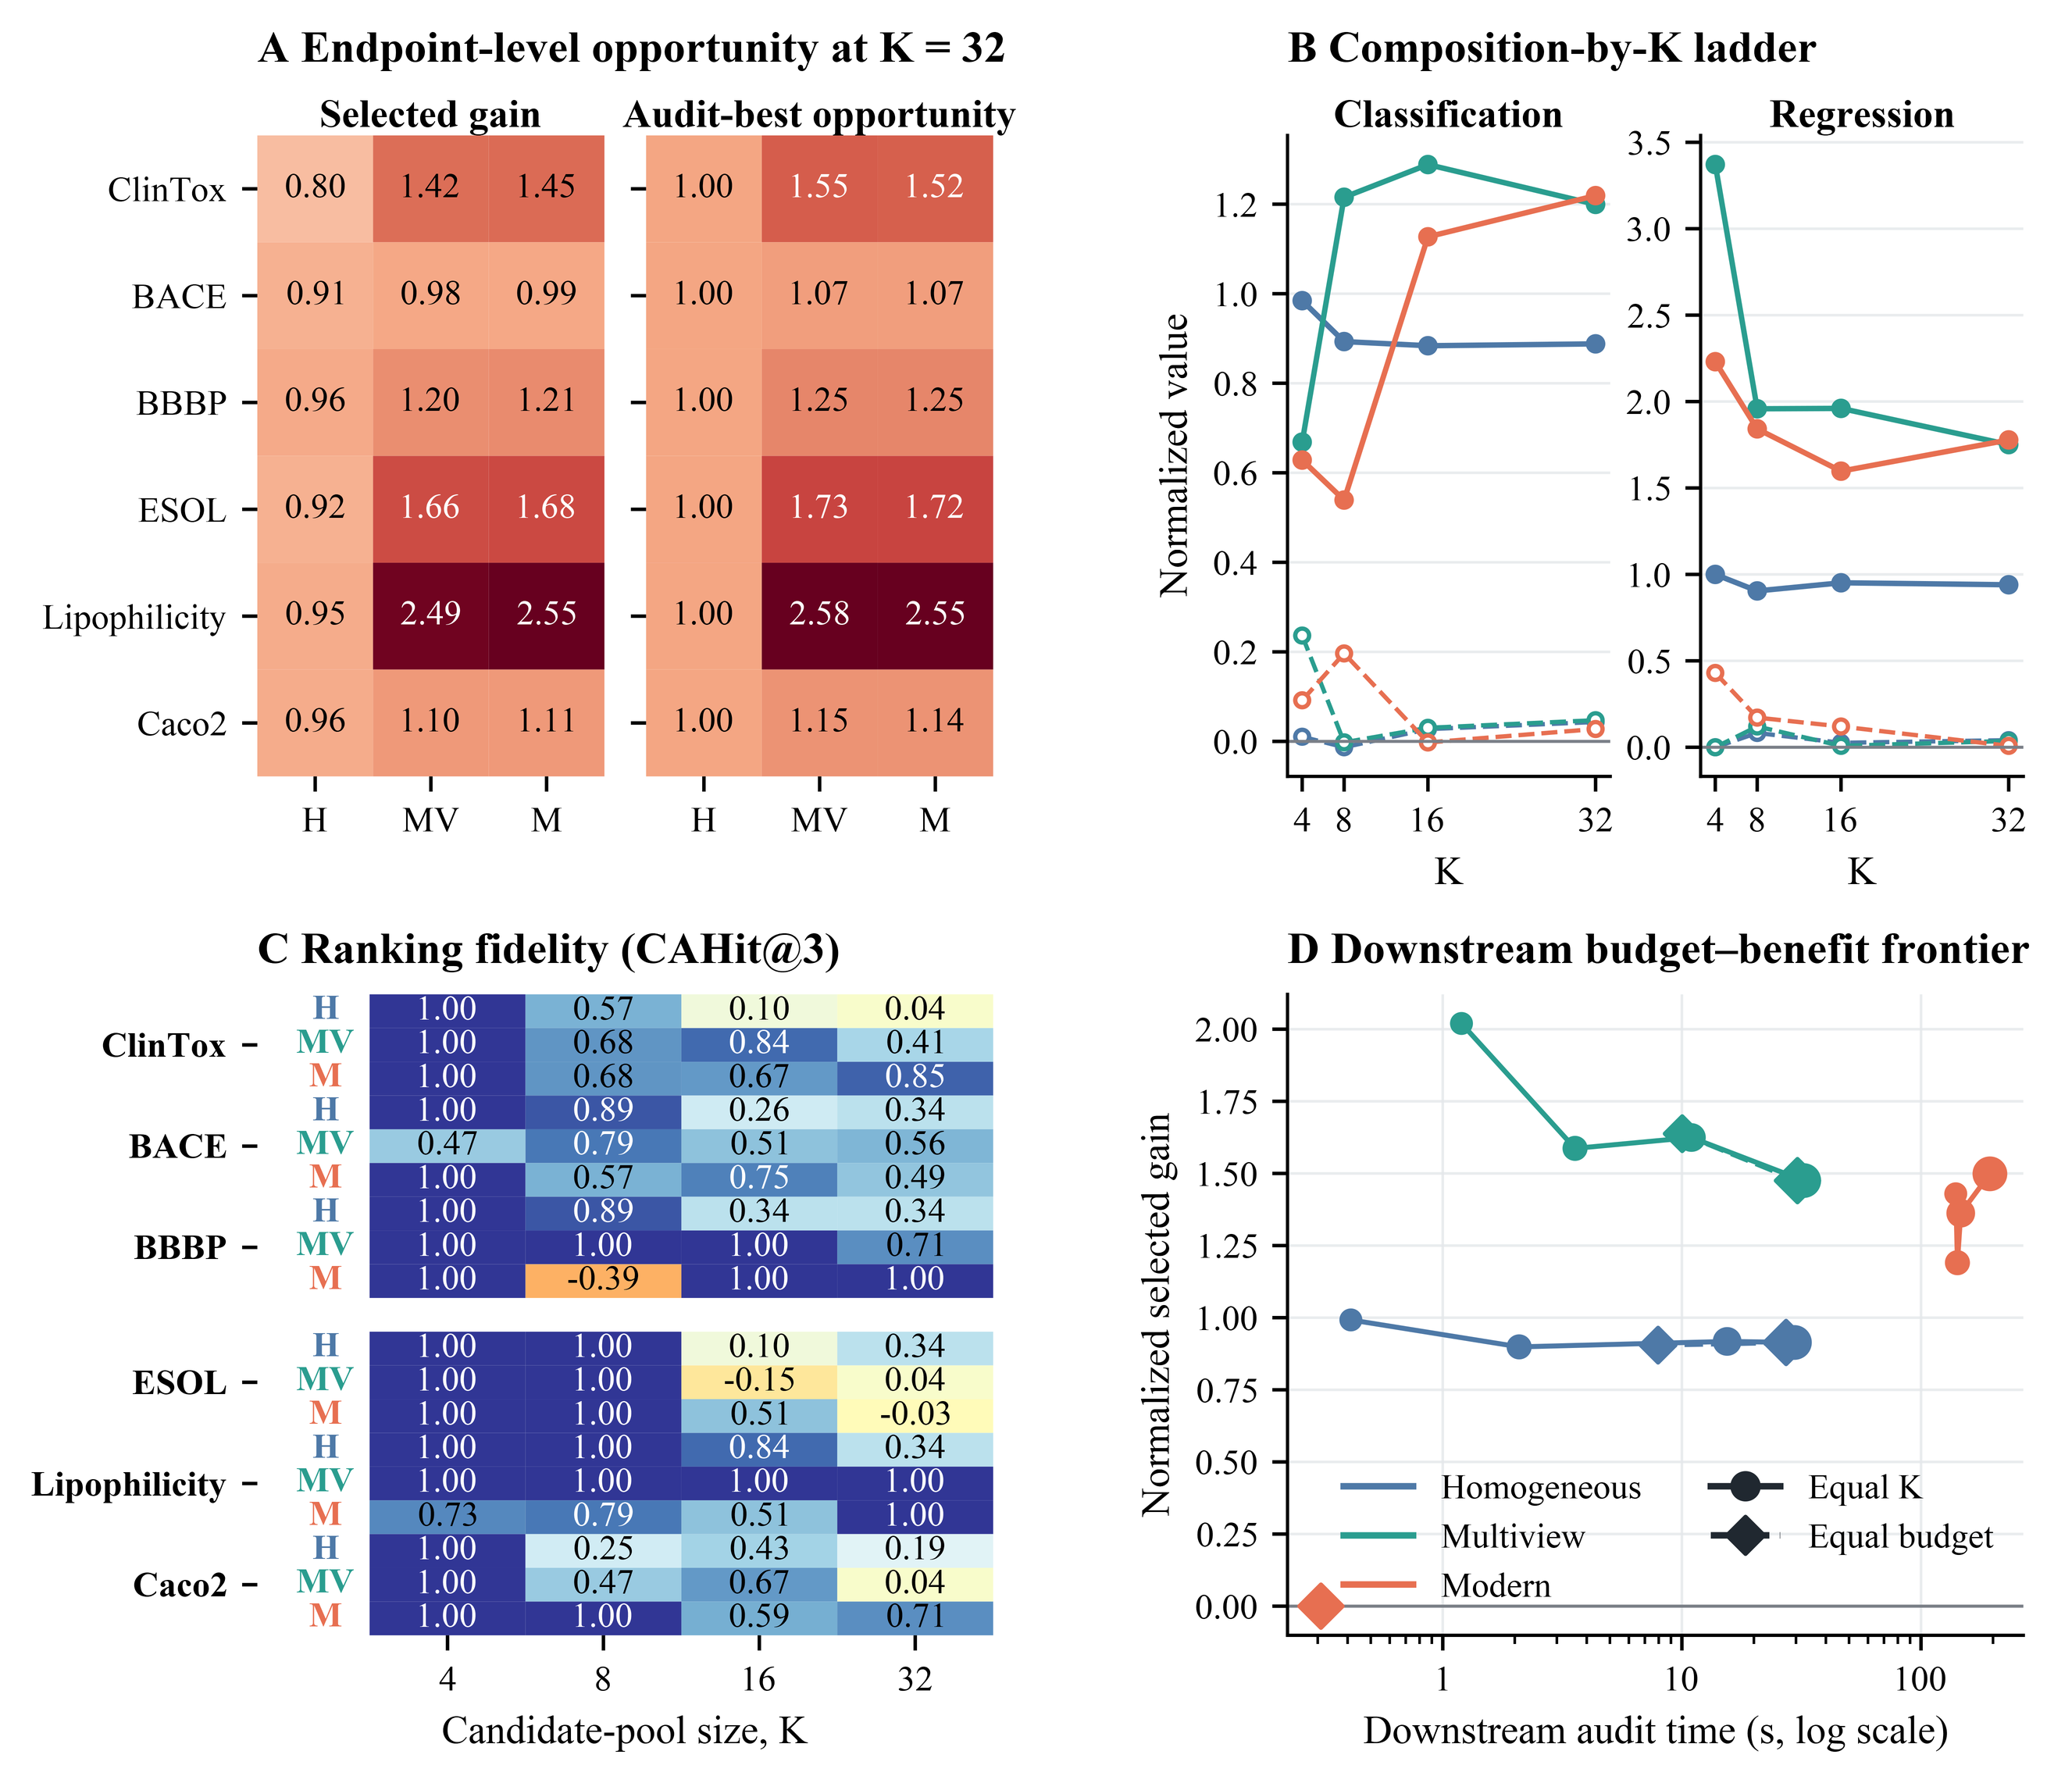
Figure 6. Five-split-seed secondary candidate-pool composition analysis. Panel A shows normalized validation-selected gain and finite-audit-best opportunity at K = 32 for six prespecified endpoints and three pool compositions. Panel B traces the composition-by-K ladder separately for classification and regression, preserving their natural metric scales. Panel C reports chance-adjusted top-three recovery (CAHit@3) for every endpoint, composition, and K combination; negative values are retained. Panel D compares normalized selected gain with downstream audit time, using circles for equal-K comparisons and diamonds for equal-budget comparisons. H denotes homogeneous Morgan, MV denotes classical multiview, and M denotes modern-augmented. These five-split-seed results are labeled secondary and are not pooled with the primary ten-split-seed estimand.

3.8 Practical tolerance analysis
At the retrospectively locked middle reporting tolerances, practical-equivalence success was 80.0% for classification endpoints and 79.2% for regression endpoints. These task-specific rates were not pooled or interpreted on a common numerical scale. The tolerances are descriptive reporting thresholds rather than formal equivalence margins. See Figure 7.
PR-AUC selection changed candidate identity for some classification units and produced endpoint-specific outer PR-AUC changes. Recall-constrained outer effects were excluded because the target-class identity was not frozen consistently through all inner folds.
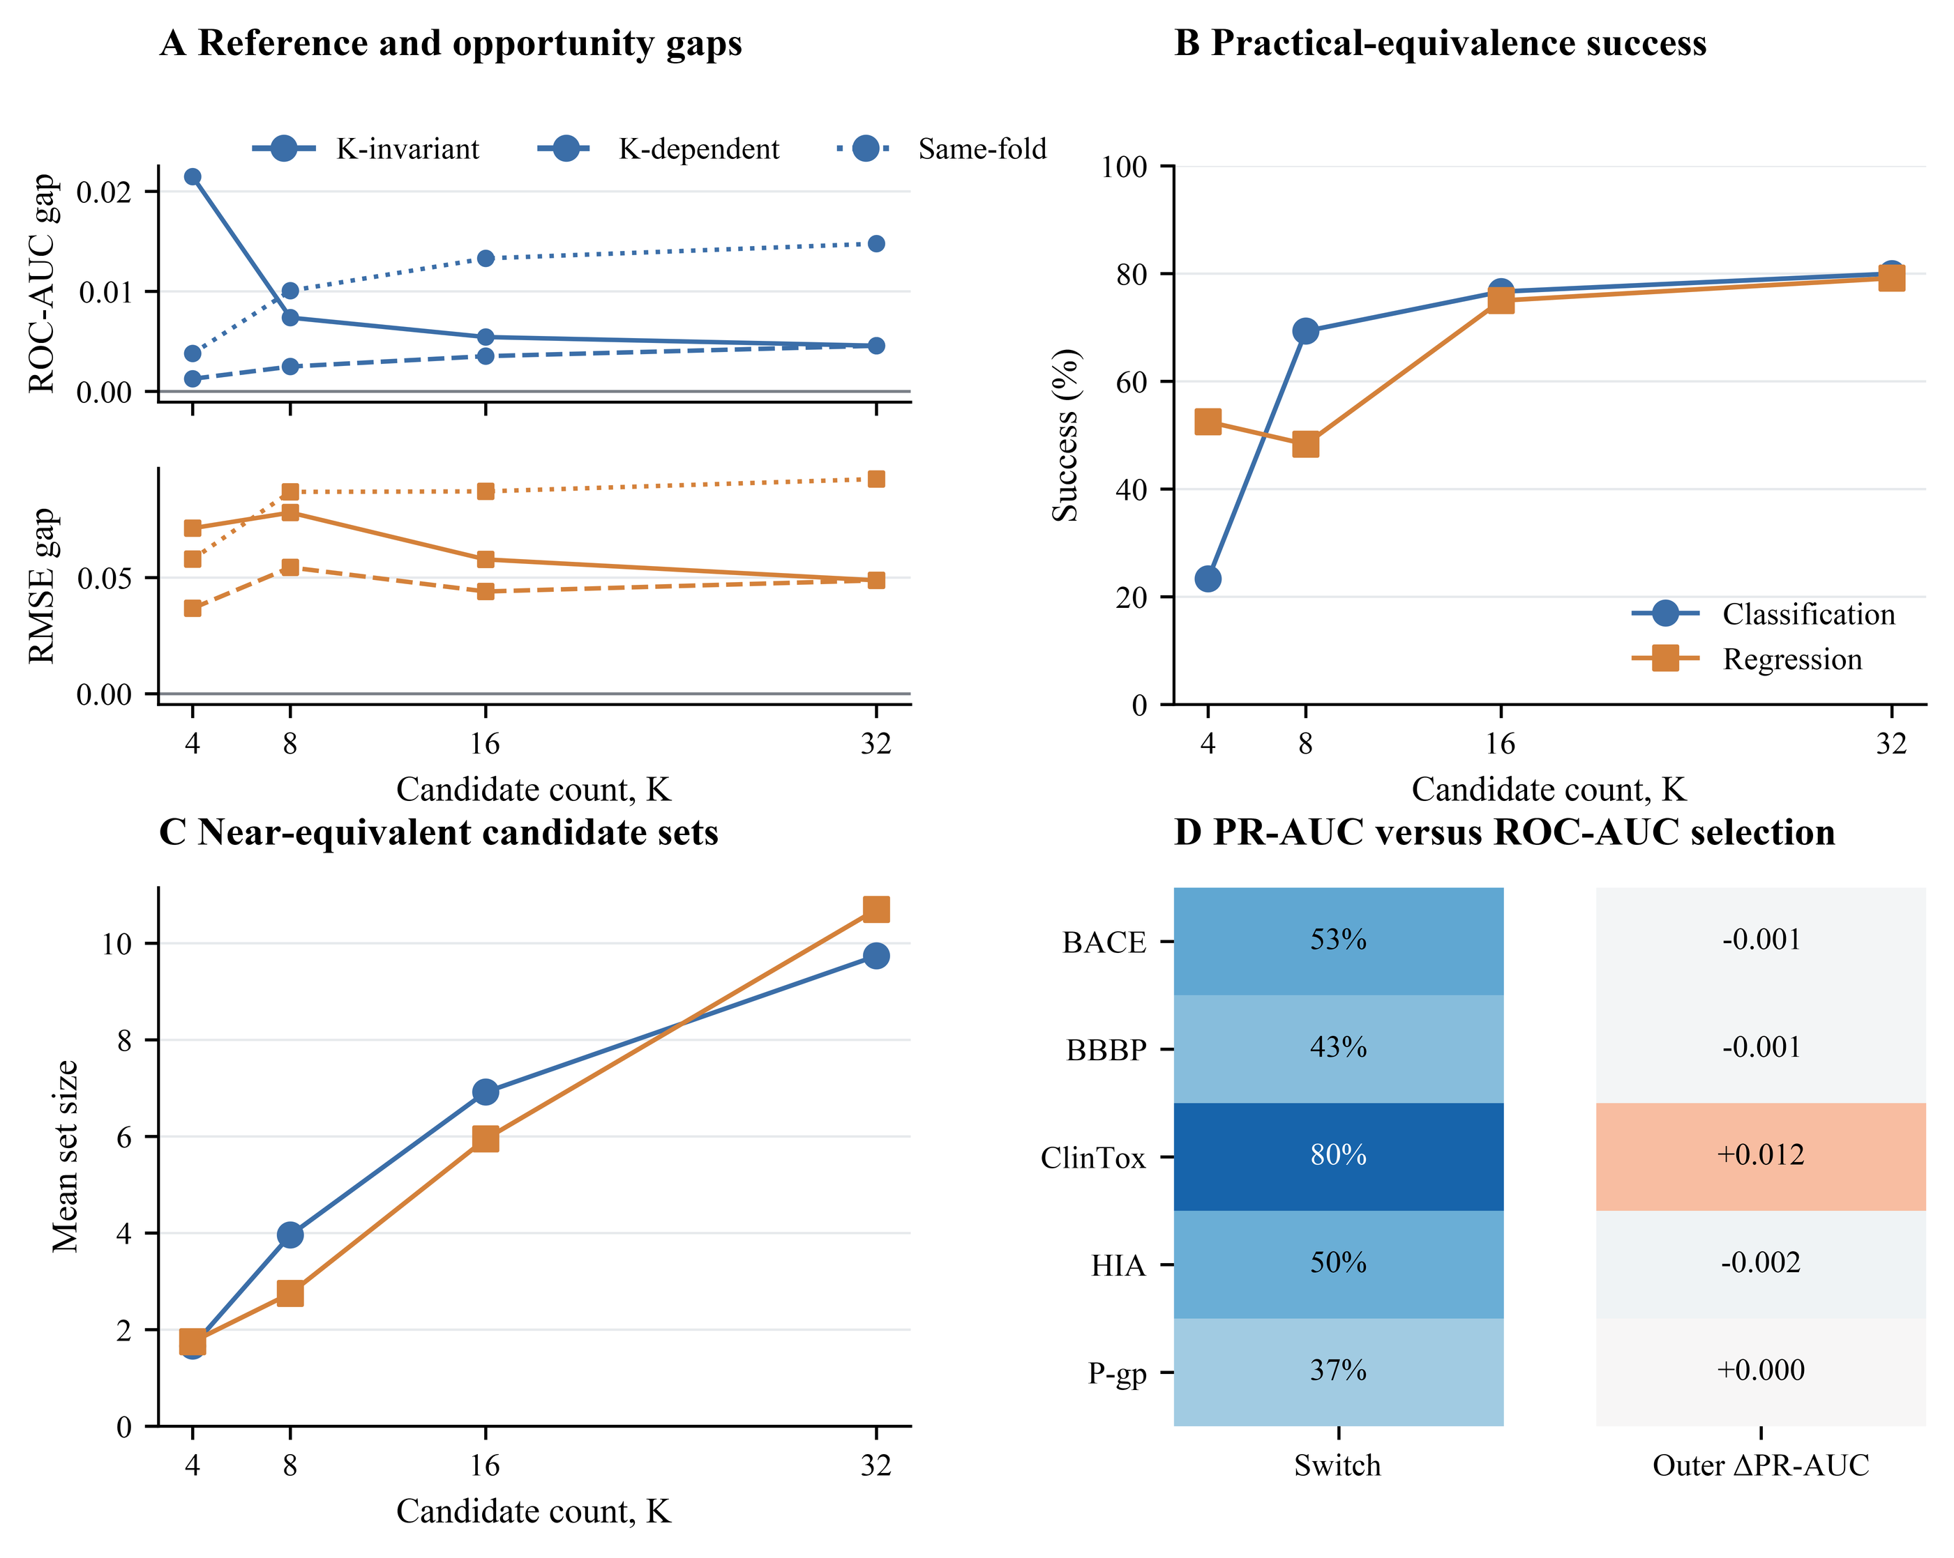
Figure 7. Practical tolerance and metric-matched selection. Panel A reports K-invariant, K-dependent, and same-fold opportunity gaps across candidate count K, with classification ROC-AUC and regression RMSE shown on independent stacked axes. Panel B shows descriptive practical-equivalence success at the retrospectively locked task-specific tolerances. Panel C reports the corresponding mean near-equivalent candidate-set size. Panel D jointly reports endpoint-level switching when PR-AUC replaces ROC-AUC for selection and the resulting outer PR-AUC change at K = 32; the two columns use independent numerical and color scales. Recall-constrained effects are excluded because the frozen minority-class rule was not formally rerun.

3.9 Reliability and chemical support
Prediction and error similarity were nonzero across the four-model panel, but errors were not identical. Chemical-support strata showed poorer discrimination and larger errors under low support: median classification ROC-AUC was 0.842, 0.914, and 0.925, whereas median regression RMSE was 1.337, 1.097, and 0.767 across low, intermediate, and high Tanimoto strata. See Figure 8.
At nominal 0.90 coverage, minority-class and regression empirical coverage varied by method and endpoint. Because scaffold and support shifts can violate exchangeability, these are observed coverage estimates rather than distribution-free guarantees. ClinTox retained the negative trade-off between discrimination and minority safety.
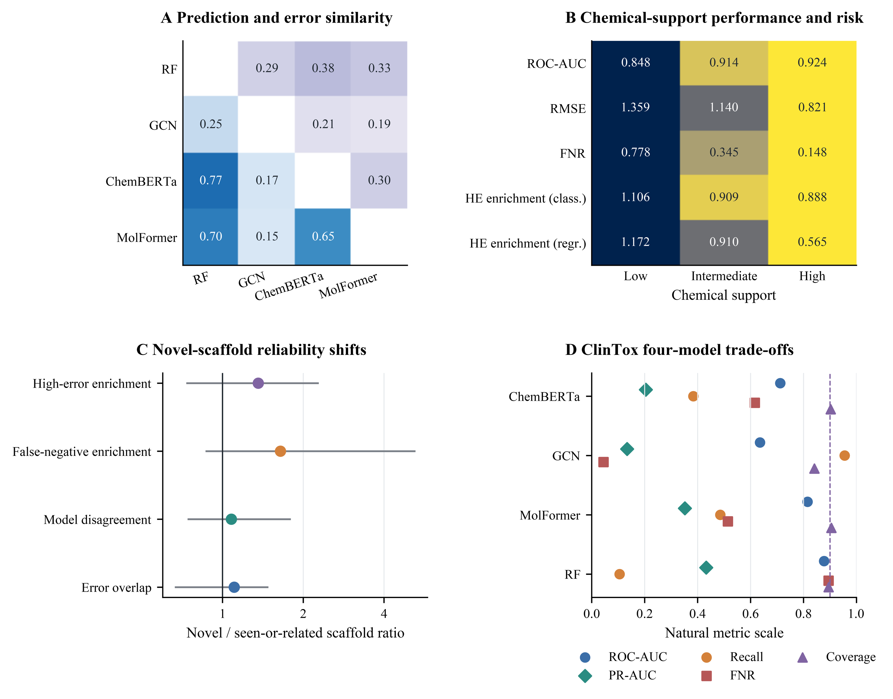
Figure 8. Prediction reliability across chemical-support boundaries. Panel A combines four-model prediction correlations in the lower triangle and high-error Jaccard overlaps in the upper triangle; the two triangular encodings are interpreted separately. Panel B prints natural-scale medians for classification ROC-AUC, regression RMSE, false-negative rate (FNR), and high-error (HE) enrichment across low, intermediate, and high chemical-support strata; color encodes favorability within each row only and must not be compared numerically across metrics. Panel C shows median novel-to-seen-or-related scaffold ratios with empirical interval ranges on a log2 axis, where 1 denotes no shift. Panel D compares ROC-AUC, PR-AUC, recall, FNR, and empirical coverage for four fixed ClinTox configurations; the dashed vertical line denotes the 0.90 coverage target.

3.10 Structure-separated sensitivity
The original component analysis at thresholds 0.60, 0.70, and 0.80 showed non-monotone and endpoint-dependent results for BACE, ClinTox, and ESOL. The K = 32 minus K = 4 cross-fitted gap was 0.0379, 0.0178, and −0.0012 for BACE; −0.0062, 0.0049, and −0.0024 for ClinTox; and 0.0224, 0.0017, and 0.0039 for ESOL. BACE and ClinTox changed direction across thresholds; ESOL retained its direction.
The locked extension passed all component-feasibility and cross-fold-similarity checks. The K = 32 minus K = 4 cross-fitted gap was 0.0033, −0.0007, and 0.0034 for BBBP; −0.0392, 0.0285, and 0.0123 for FreeSolv; and 0.0081, 0.0060, and 0.0063 for Lipophilicity at thresholds 0.60, 0.70, and 0.80, respectively. BBBP and FreeSolv changed direction, whereas Lipophilicity retained a positive direction. Across all six audited endpoints, only ESOL and Lipophilicity retained the same direction at every threshold. The extension therefore reinforced the negative robustness finding: component-threshold conclusions were endpoint dependent and were not treated as independent confirmation of the primary scaffold analysis (Table S50; Figure S27).

3.11 Model-seed sensitivity
Across 2,268 stochastic candidate–fold units in split seeds 11, 83, and 149, the median, 95th percentile, and maximum model-seed SD of outer utility were 0.0033, 0.0277, and 0.1457. Candidate identity was identical across three model seeds in all K = 4 units but in 51.9% of K = 32 units. Unit-level classification probabilities and regression predictions for split seeds 11, 83, and 149 are supplied as Additional files 5–7, respectively.
That contrast is partly structural: K = 4 contains only deterministic candidates, while stochastic learners enter from position 5. The analysis characterizes expanded registered prefixes and does not identify a causal effect of candidate count. Because only three split seeds were evaluated and their prospective selection was not documented, all model-seed and matched-composition results are exploratory secondary evidence.

3.12 External-source forward-temporal stress test
The three CycPept-PAMPA windows contained 1,814/468/3,206, 2,282/3,206/1,613, and 5,488/1,613/233 train/validation/test records. Exact canonical-SMILES and InChIKey train–test overlap was zero in every window, but test-scaffold overlap fractions were 0.160, 0.006, and 0.129, and median maximum train–test Tanimoto similarities were 0.754, 0.525, and 0.690. Publication-source and peptide-family overlap could not be audited because those fields were absent from the supplied source schema. The unit-level temporal regression prediction archive is supplied as Additional file 8.
Mean K = 32 test RMSE across model seeds was 0.758, 0.615, and 0.895 in the three windows. The windows were not independent: 5,488 records overlapped between windows 1 and 2, 5,488 between windows 1 and 3, and 7,101 between windows 2 and 3. This analysis is therefore a contextual forward-temporal transport stress test, not three independent cohorts and not external validation of the nine primary effects.

3.13 Failure cases and limits of generality
Negative and incomplete results were retained. Recall-constrained outer effects were removed after the minority-class identity audit; the empirical-noise simulation did not recover all candidate-ranking structure; component-threshold directions changed; model-seed effects were composition confounded; and the temporal source covered one regression property.
No external classification dataset satisfying the prespecified requirements for source independence, InChIKey de-duplication, assay or temporal separation, and one-time frozen evaluation was identified. We therefore provide the dataset-selection plan, download checklist, and overlap-audit script and do not claim independent external classification validation. ChemBERTa and MolFormer are interpreted as fixed pretrained-representation configurations because molecule-, scaffold-, and near-neighbour overlap with their pretraining corpora could not be fully audited.

4 Discussion

4.1 Candidate opportunity is not selection realization
A larger candidate pool creates more opportunities to find a useful representation or learner, but finite inner validation does not necessarily identify those opportunities more reliably. The exact decomposition resolves the central ambiguity: a smaller full-registry completion gap can be driven by newly available candidates even when the within-prefix selection component moves in the opposite direction. Seven endpoints showed precisely this pattern. Consequently, negative Δinv cannot be summarized as a general improvement in selection stability or as evidence that larger pools yield better molecular-property prediction.
Endpoint-specific mechanisms matter. ESOL changed entirely through the within-prefix component, FreeSolv had two same-direction negative components, and HIA and Caco2 showed weak seed-level directional consistency. Reporting Δinv, Δavail, and Δdep separately prevents these distinct mechanisms from disappearing inside a pooled mean.

4.2 Candidate dependence, ordering, and chemical support
Nominal K is an exposure count, not an information count. Effective rank depended on the utility representation, while candidate-order permutations and matched registries showed that prefix composition and order changed opportunity, selected identity, and computational exposure. The historical order could not be verified as outcome independent, so order-specific conclusions remain retrospective.
Chemical-support analyses add a second boundary. Prediction correlations, error overlaps, scaffold novelty, and similarity strata showed that apparent reliability depends on molecular support. Empirical conformal coverage under scaffold, component, or temporal shift cannot be promoted to a finite-sample distribution-free guarantee, and coverage alone does not establish screening safety or deployment readiness.

4.3 Secondary stress tests constrain generality
The model-seed analysis did not isolate candidate count from deterministic/stochastic composition. K = 4 comprised deterministic candidates, whereas later prefixes introduced stochastic learners. The observed decline in candidate-identity agreement beyond K = 4 therefore characterizes the registered expansion path, not a causal K effect. Its restriction to three retrospectively selected split seeds further limits inference.
Component-threshold results were non-monotone, and the cyclic-peptide windows were overlapping sequential stress tests. These analyses probe robustness and transfer, but neither independently confirms the primary estimand. Independent external classification validation was outside the completed evidence base because no source satisfying the prespecified independence and single-use requirements was identified.

4.4 Simulation interpretation
The empirical-noise simulation recovered only part of the endpoint-level candidate-ranking structure. This indicates that finite-validation noise is a plausible contributor but not a sufficient generative explanation for all observed completion-gap patterns. Label noise, chemical heterogeneity, non-exchangeable scaffold distributions, candidate misspecification, calibration mismatch, molecular-support shift, unequal model flexibility, and endpoint-specific assay variation remain plausible contributors. The simulations neither prove an unbiased decomposition nor support a bias correction.

4.5 Limitations
This study was retrospective and was not prospectively preregistered. The outcome-independent timing of the candidate order cannot be established from retained records. The same endpoint molecular populations were reused across split seeds, which are sensitivity blocks rather than independent datasets. Candidate families, hyperparameter variants, and computational budgets were unequal, and modern models were evaluated as fixed limited configurations.
The model-seed audit covered only three split seeds and was structurally confounded by deterministic/stochastic registry composition. The original structure-separated audit covered three endpoints, and any extension remains secondary. The temporal windows overlapped, external classification validation was not completed, and the external test involved one source and one regression property. Publication-source and peptide-family overlap were not available for the temporal data.
Scaffold-, component-, and time-separated evaluation can violate conformal exchangeability. The nominal 0.90 target is not a deployment guarantee. We could not fully audit molecule-, scaffold-, or near-neighbour overlap between public benchmark endpoints and the ChemBERTa and MolFormer pretraining corpora. Prediction-level primary archives were not retained for all ten split seeds, and the empirical simulation did not retain Top-3 or component-direction recovery outputs. Prospective, independent-source, task-diverse, and deployment-oriented validation is still required.

5 Conclusions
Candidate availability and selection realization must be decomposed rather than inferred from a single completion gap. Endpoint-specific directions and mechanisms cannot be replaced by a pooled result. Independent-source, prospective, and task-diverse validation remains necessary.

List of abbreviations
ROC-AUC, area under the receiver operating characteristic curve; PR-AUC, area under the precision–recall curve; RMSE, root mean squared error; MRR, mean reciprocal rank; NDCG, normalized discounted cumulative gain; IQR, interquartile range; MAD, median absolute deviation; CAHit@3, chance-adjusted top-3 hit; CQR, conformalized quantile regression; GCN, graph convolutional network; D-MPNN, directed message-passing neural network; TDC, Therapeutics Data Commons; RDKit, open-source cheminformatics toolkit.

Supplementary Information
Additional file 1 (.docx): File name: Additional_file_1_supplementary_methods.docx. Title: Supplementary Methods and Results. Description: Contains detailed algorithms, sensitivity analyses, complete secondary notation, and the completed threshold, model-seed, and temporal methods.
Additional file 2 (.xlsx): File name: Additional_file_2_supplementary_tables.xlsx. Title: Machine-readable Supplementary Tables S1–S52. Description: Contains frozen endpoint definitions, analysis-unit outputs, audit results, threshold sensitivity, model-seed summaries, and temporal selection results.
Additional file 3 (.pdf): File name: Additional_file_3_supplementary_figures.pdf. Title: Supplementary Figures S1–S29. Description: Contains the complete supplementary figure set, including threshold sensitivity (S27), model-seed variation (S28), and the external-source forward-temporal contextual stress test (S29).
Additional file 4 (.zip): File name: Additional_file_4_code_and_reproducibility_archive.zip. Title: FZYC-Mol code and reproducibility package. Description: Contains source code, locked configurations, source-data indexes, tests, integrity manifests, and rerun instructions for attached archive version paper-release-2026-08-r12.9, based on the public R12.6 release.
Additional file 5 (.parquet): File name: Additional_file_5_model_seed_predictions_split_11.parquet. Title: Model-seed outer predictions, split seed 11. Description: Contains classification probabilities and regression predictions sufficient for unit-level metric recomputation, with canonical identifiers, selected/reference flags, provenance fields, and source hashes.
Additional file 6 (.parquet): File name: Additional_file_6_model_seed_predictions_split_83.parquet. Title: Model-seed outer predictions, split seed 83. Description: Contains classification probabilities and regression predictions sufficient for unit-level metric recomputation, with canonical identifiers, selected/reference flags, provenance fields, and source hashes.
Additional file 7 (.parquet): File name: Additional_file_7_model_seed_predictions_split_149.parquet. Title: Model-seed outer predictions, split seed 149. Description: Contains classification probabilities and regression predictions sufficient for unit-level metric recomputation, with canonical identifiers, selected/reference flags, provenance fields, and source hashes.
Additional file 8 (.parquet): File name: Additional_file_8_temporal_outer_predictions.parquet. Title: CycPeptMPDB/CycPeptMP forward-temporal outer predictions. Description: Contains regression predictions for three overlapping forward windows, three model seeds, and all 32 candidates, with canonical identifiers, selected/reference flags, provenance fields, and source hashes; it is sufficient for unit-level RMSE recomputation.

Declarations

Ethics approval and consent to participate
Not applicable. This study used publicly available molecular datasets and involved no human participants, human data or animal experiments.

Consent for publication
Not applicable.

Availability of data and materials
The datasets supporting this article are public; source details are listed in Additional file 2, Table S1. Processed audit tables and reproducibility materials are included in Additional files 1–8.
The archived public software release is available at https://github.com/zfr0857/FZYC-Mol/releases/tag/paper-release-2026-08-r12.9 [37].
Immutable commit: 0640c159fbb741fda0b8dcb5bd7121fd5d92153b.
Additional file 4 is the paper-release-2026-08-r12.9 submission archive based on the public R12.6 release; its SHA-256 is 10B4385D65337D0919AA5B11344519441CF77DC1C9BB4F56051DADF826501A71. It adds the completed six-endpoint threshold, model-seed, matched-registry, and temporal audits without changing recorded primary outer-performance results. Metric-recomputable probability partitions are supplied as Additional files 5–8.
No separate archival DOI was available at the time of manuscript preparation.
Software record. Project name: FZYC-Mol candidate-pool audit. Project homepage: https://github.com/zfr0857/FZYC-Mol. Archived release/tag: paper-release-2026-08-r12.9. Immutable commit: 0640c159fbb741fda0b8dcb5bd7121fd5d92153b. Operating systems: Windows, Linux and macOS where the locked environment is supported. Programming language: Python 3.13.7. Software requirements: requirements-lock.txt and environment.yml. License: MIT. Restrictions on non-academic use: none under the MIT license, subject to original public-dataset licenses and access conditions.

Competing interests
The authors declare that they have no competing interests.

Funding
This work was supported by the Shenzhen Science and Technology Foundation (Grant No. JCYJ20250604191201002) and the National Undergraduate Training Program for Innovation and Entrepreneurship & Student Research Training Program (No. 202510573012). The funders had no role in the study design, data collection, data analysis, interpretation of the results, preparation of the manuscript, or the decision to submit the manuscript for publication.

Authors' contributions
FZ conceived the study, developed the methodology, implemented the computational workflow, performed the formal analyses, curated the data, prepared the visualizations, and drafted the manuscript. YG contributed to data curation, validation, statistical checking, and revision of the manuscript. YZ contributed to methodology development, software verification, reproducibility testing, and revision of the manuscript. WZ contributed to data curation, validation, and preparation of the supplementary materials. JG contributed to software testing, visualization, and verification of the results. YH contributed to the investigation, validation, and critical revision of the manuscript. YY contributed to the study design, supervised the research, administered the project, and critically revised the manuscript. LQ contributed to the methodology and interpretation of the results, co-supervised the research, administered the project, and critically revised the manuscript. All authors read and approved the final manuscript and agreed to be accountable for all aspects of the work.

Acknowledgements
Not applicable.

References
1. Wu Z, Ramsundar B, Feinberg EN et al (2018) MoleculeNet: a benchmark for molecular machine learning. Chem Sci 9:513–530. https://doi.org/10.1039/C7SC02664A
2. Huang K, Fu T, Gao W et al (2021) Therapeutics Data Commons: machine learning datasets and tasks for drug discovery and development. NeurIPS Datasets and Benchmarks Track. arXiv:2102.09548 [Preprint]. https://doi.org/10.48550/arXiv.2102.09548
3. Cawley GC, Talbot NLC (2010) On over-fitting in model selection and subsequent selection bias in performance evaluation. J Mach Learn Res 11:2079–2107.
4. Varma S, Simon R (2006) Bias in error estimation when using cross-validation for model selection. BMC Bioinformatics 7:91. https://doi.org/10.1186/1471-2105-7-91
5. Zhao D, Zhu Y, Wu Z et al (2026) Revisiting ADMET prediction reliability under real-world challenges in the foundation model era. J Cheminform 18:95. https://doi.org/10.1186/s13321-026-01217-2
6. Zhang L, Zeng Y, Qi Y et al (2026) DCPM-ADMET: fusion of dual-component pre-trained model and molecular fingerprints to enhance drug ADMET properties prediction. J Cheminform. https://doi.org/10.1186/s13321-026-01244-z
7. Jang Y, Lee J, Jeong K, Kim J (2026) Multimodal graph fusion with statistically guided parsimonious descriptor selection for molecular property prediction. J Cheminform 18:18. https://doi.org/10.1186/s13321-025-01140-y
8. Zhang Y, Liu W, Zhao H et al (2026) MolGramTreeNet: a multimodal molecular property prediction model via grammar tree-constrained molecular representation. iScience 29:114928. https://doi.org/10.1016/j.isci.2026.114928
9. Wen X, Liu H, Long W, Wei S, Zhu R (2025) Consistent semantic representation learning for out-of-distribution molecular property prediction. Brief Bioinform 26:bbaf147. https://doi.org/10.1093/bib/bbaf147
10. Yin T, Gao P, Panapitiya G, Saldanha EG (2026) Out-of-distribution evaluation of active learning pipelines for molecular property prediction. RSC Adv 16:5281–5295. https://doi.org/10.1039/D5RA08055J
11. Uchibori Y, Kaneko H (2026) Generation of molecules near the applicability domain boundaries of property prediction models. J Chem Inf Model 66:6866–6879. https://doi.org/10.1021/acs.jcim.5c03220
12. Kim JY, Vlachos DG (2025) Distance-aware molecular property prediction in nonlinear structure–property space. J Chem Inf Model 65:6744–6756. https://doi.org/10.1021/acs.jcim.5c01037
13. Tang H, Yue T, Li Y (2025) Assessing uncertainty in machine learning for polymer property prediction: a benchmark study. J Chem Inf Model 65:6585–6598. https://doi.org/10.1021/acs.jcim.5c00550
14. Fralish Z, Reker D (2026) Pairwise learning for molecular property prediction and optimization. Front Drug Discov 6:1859068. https://doi.org/10.3389/fddsv.2026.1859068
15. Landrum G (2026) RDKit: open-source cheminformatics software. Version 2026.3.1. https://www.rdkit.org/. Accessed 12 Jul 2026
16. Rogers D, Hahn M (2010) Extended-connectivity fingerprints. J Chem Inf Model 50:742–754. https://doi.org/10.1021/ci100050t
17. Breiman L (2001) Random forests. Mach Learn 45:5–32. https://doi.org/10.1023/A:1010933404324
18. Ke G, Meng Q, Finley T et al (2017) LightGBM: a highly efficient gradient boosting decision tree. Adv Neural Inf Process Syst 30.
19. Chen T, Guestrin C (2016) XGBoost: a scalable tree boosting system. In: Proceedings of the 22nd ACM SIGKDD International Conference on Knowledge Discovery and Data Mining, pp 785–794. https://doi.org/10.1145/2939672.2939785
20. Prokhorenkova L, Gusev G, Vorobev A, Dorogush AV, Gulin A (2018) CatBoost: unbiased boosting with categorical features. Adv Neural Inf Process Syst 31:6638–6648.
21. Yang K, Swanson K, Jin W et al (2019) Analyzing learned molecular representations for property prediction. J Chem Inf Model 59:3370–3388. https://doi.org/10.1021/acs.jcim.9b00237
22. Chithrananda S, Grand G, Ramsundar B (2020) ChemBERTa: large-scale self-supervised pretraining for molecular property prediction. arXiv:2010.09885 [Preprint]. https://doi.org/10.48550/arXiv.2010.09885
23. Ross J, Belgodere B, Chenthamarakshan V et al (2022) Large-scale chemical language representations capture molecular structure and properties. Nat Mach Intell 4:1256–1264. https://doi.org/10.1038/s42256-022-00580-7
24. Erickson N, Mueller J, Shirkov A et al (2020) AutoGluon-Tabular: robust and accurate AutoML for structured data. arXiv:2003.06505 [Preprint]. https://doi.org/10.48550/arXiv.2003.06505
25. Tropsha A (2010) Best practices for QSAR model development, validation, and exploitation. Mol Inform 29:476–488. https://doi.org/10.1002/minf.201000061
26. Vovk V, Gammerman A, Shafer G (2005) Algorithmic learning in a random world. Springer, New York. https://doi.org/10.1007/b106715
27. Shafer G, Vovk V (2008) A tutorial on conformal prediction. J Mach Learn Res 9:371–421.
28. Guo C, Pleiss G, Sun Y, Weinberger KQ (2017) On calibration of modern neural networks. Proc Mach Learn Res 70:1321–1330.
29. van Tilborg D, Alenicheva A, Grisoni F (2022) Exposing the limitations of molecular machine learning with activity cliffs. J Chem Inf Model 62:5938–5951. https://doi.org/10.1021/acs.jcim.2c01073
30. Sheridan RP (2013) Time-split cross-validation as a method for estimating the goodness of prospective prediction. J Chem Inf Model 53:783–790. https://doi.org/10.1021/ci400084k
31. Demšar J (2006) Statistical comparisons of classifiers over multiple data sets. J Mach Learn Res 7:1–30.
32. Hoyt CT, Zdrazil B, Guha R et al (2023) Improving reproducibility and reusability in the Journal of Cheminformatics. J Cheminform 15:62. https://doi.org/10.1186/s13321-023-00730-y
33. Parrondo-Pizarro R, Lanini J, Rodríguez-Pérez R (2026) Uncertainty quantification in molecular machine learning for property predictions under data shifts. J Chem Inf Model 66:923–935. https://doi.org/10.1021/acs.jcim.5c02381
34. Deng J, Yang Z, Wang H, Ojima I, Samaras D, Wang F (2023) A systematic study of key elements underlying molecular property prediction. Nat Commun 14:6395. https://doi.org/10.1038/s41467-023-41948-6
35. Li Z, Chen X, Wen H et al (2026) A systematic survey and benchmark of deep learning for molecular property prediction in the foundation model era. arXiv:2604.16586 [Preprint]. https://doi.org/10.48550/arXiv.2604.16586
36. Romano Y, Patterson E, Candès EJ (2019) Conformalized quantile regression. Adv Neural Inf Process Syst 32.
37. FZYC-Mol Authors (2026) FZYC-Mol: candidate-pool expansion audit code and reproducibility package. Version paper-release-2026-08-r12.9, commit 0640c159fbb741fda0b8dcb5bd7121fd5d92153b. GitHub. https://github.com/zfr0857/FZYC-Mol/releases/tag/paper-release-2026-08-r12.9. Accessed 15 Aug 2026
38. Li J, Yanagisawa K, Sugita M et al (2023) CycPeptMPDB: a comprehensive database of membrane permeability of cyclic peptides. J Chem Inf Model 63:2240–2250. https://doi.org/10.1021/acs.jcim.2c01573

