**Polito**

**A Sprite Editor**

by Alex Steele, Dalton Nell, Zachary Frye, Bernie Cosgriff, and Christian Felt

November, 2016

**User Manual**

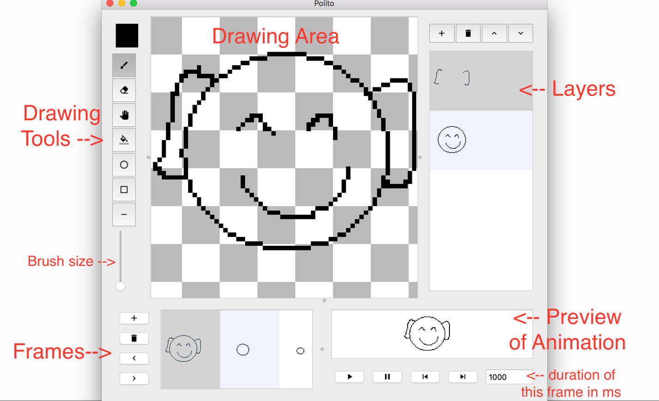

**Drawing:**

The pen tool icons/brush.png is selected by default. The icons/erase.png tool erases, and the icons/fill.png tool fills an area with the selected color. To change drawing color, click on the colored box in the top left corner and you will be presented with a color wheel. Make your selection and click OK. Draw an ellipse, rectangle, or line using the icons/circle.png,icons/square.png, oricons/line.png icons.

**Edit Menu:**

Most of Polito’s tools can also be accessed by name through the “Edit” menu bar item. The “Change Sprite Size” option allows you to change the size of the canvas in pixels (dimensions are always square), and specify filtering options. The filtering options are “bilinear” and “none.” The default keyboard shortcuts for each tool are also listed here, and you can change them with the “Set Key Bindings” option. The **default key bindings** are:

Brush tool: B

Pan tool: M

Fill tool: F

Eraser tool: E

Color Picker: E

Circle tool: R

Square tool: S

Line tool: I ( i )

Add frame: ctrl T

add layer: ctrl A

move frame right: ctrl n

move frame left: ctrl g

move layer up: ctrl h

move layer down: ctrl d

delete frame: ctrl j

delete layer: ctrl k

**Undo/Redo:**

To undo an action, press ctrl-Z. To redo, press ctrl-R. Polito supports global undos and redos, meaning you can undo or redo almost any action you perform.

**Animation:**

To add a new frame, click + in the Frame menu in the bottom left. Frames can be rearranged using the < and > buttons. Delete a frame using icons/delete.png. The **preview area** is displayed to the right of the frame menu. Play, pause, or step through the frames in the animation using icons/play.png, icons/pause.png, icons/next.png , andicons/previous.png . The number of milliseconds per frame is listed in the box in the bottom right-hand corner. Each frame can have a custom duration in milliseconds.

**Saving:**

Saving options are located under “File” in the menu bar. Polito files can be saved as sprite sheets (all the frames placed one after another in a single image) or in the special Polito save format, which preserves information about layers and custom frame durations. To save in the special Polito format, chose “Save Project (extended format)”. Sprites can also be exported as animated gifs.

**Options:**

Using the “Options” item in the menu bar, you can clear the current frame and set custom key bindings. The **default key bindings** are:

Brush tool: B

Pan tool: M

Fill tool: F

Eraser tool: E

Color Picker: E

Circle tool: R

Square tool: S

Line tool: I ( i )

Add frame: ctrl T

add layer: crtl A

move frame right: ctrl n

move frame left: ctrl g

move layer up: ctrl h

move layer down: ctrl d

delete frame: ctrl j

delete layer: ctrl k

**Layers:**

Polito allows you to add multiple layers to each frame. Press + in the layer menu at the top right of the screen to add a new layer at the top of the current frame. The currently selected layer is called the active layer and is highlighted dark blue. Only the active layer can be modified. To change the active layer, simply click on the desired layer. Move layers up and down using icons/up.png and icons/down.png and delete them with icons/delete.png .

**Social Media Sharing:**

To share your sprite as a GIF on Twitter, under “File” select “Upload GIF to Twitter,” enter your pin where prompted and press OK.

