**VISVESVARAYA TECHNOLOGICAL UNIVERSITY**

Jnana Sangama, Belagavi-560018, Karnataka, India

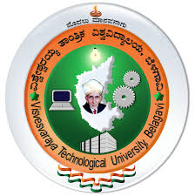

**An Internship report**

**“BIO COMPOSITES AGRICULTURAL WASTE”**

Submitted in partial fulfillment for the award of the degree in

**BACHELOR OF ENGINEERING**

**in**

**MECHANICAL ENGINEERING**

*Submitted by*

**CHETHAN M**

**(1VE18ME008)**

***Internship Carried out***

***at***

**HITZE EQUIPMENTS (India) PVT. LTD.,**

**45-B, 2nd Phase, Peenya Industrial Area, Bengaluru, Karnataka-560058**

**Internal Guide External Guide**

**Mr. Mohan V Dr. Narendra Reddy**

**Assistant Prof., MED, Director**

**SVCE, Bengaluru Agringenium Innovations**



**DEPARTMENT OF MECHANICAL ENGINEERING**

**SRI VENKATESHWARA COLLEGE OF ENGINEERING**

**Vidyanagar, Bengaluru-562157**

**2020-2021**

**VISVESVARAYA TECHNOLOGICAL UNIVERSITY**

Jnana Sangama, Belagavi-560018, Karnataka, India



**Internship report on**

**“BIO COMPOSITES AGRICULTURAL WASTE”**

Submitted in partial fulfillment of the requirements for the award of the degree in

**BACHELOR OF ENGINEERING**

**in**

**MECHANICAL ENGINEERING**

*Submitted by*

**CHETHAN M**

**(1VE18ME008)**

**Under The Guidance of**

**Mr. Mohan V**

**Assistant Professor,**

**Department of Mechanical Engineering**

** **

**DEPARTMENT OF MECHANICAL ENGINEERING**

**SRI VENKATESHWARA COLLEGE OF ENGINEERING**

**Vidyanagar, Bengaluru-562157**

**2020-2021**



**SRI VENKATESHWARA COLLEGE OF ENGINEERING**

**Vidyanagar, Bengaluru-562157**

**Department of Mechanical Engineering**

**CERTIFICATE**

Certified that the Internship report entitled **“BIO COMPOSITES AGRICULTURAL WASTE”** carried out by **CHETHAN M (1VE18ME008)** bonafide of the **VISVESVARAYA TECHNOLOGICAL UNIVERSITY, BELAGAVI** during the year **2020-2021**. It is certified that all the corrections, suggestions indicated for the internal assessment have been incorporated in the report deposited in the department library. The Internship / Professional Practice report (18ME185) has been approved as it satisfies the academic requirements in respect of the Internship Report prescribed for the said Degree. Students of **SRI VENKATESHWARA COLLEGE OF ENGINEERING** in partial fulfillment for the award of **Bachelor of Engineering in Mechanical Engineering.**

**___________________ __________________________ ______________________ Mr. Mohan V Dr. Sunil S Dr. Nageswara Guptha M**

Assistant Professor**,** Professor and Head Principal

Department of ME, Department of ME, SVCE, Bengaluru

SVCE, Bengaluru SVCE, Bengaluru

**(GUIDE)**

**Name of the Examiners Signature with Date**

**1.**

**2.**

**ORGANIZATION / INDUSTRY CERTIFICATE** 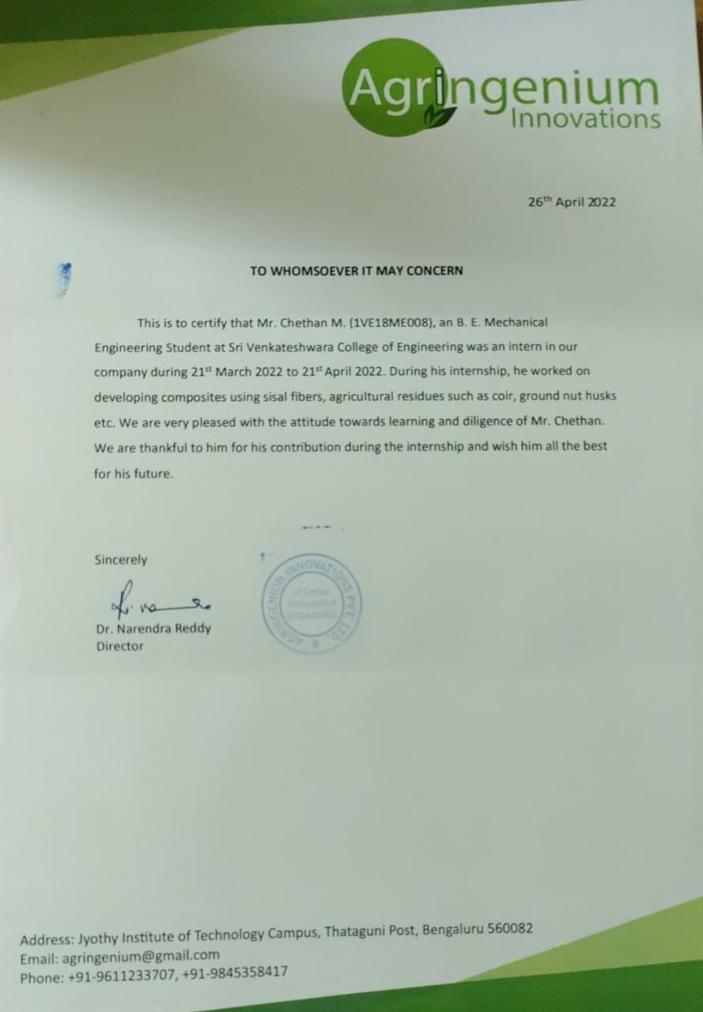



**SRI VENKATESHWARA COLLEGE OF ENGINEERING**

**Vidyanagar, Bengaluru-562157**

**Department of Mechanical Engineering**

**DECLARATION**

I hereby declare that the internship report entitled **“INTERSHIP TRAINEE”** Practice report (18MEP78) submitted in the partial fulfillment of the requirements for the award of the degree of **BACHELOR OF ENGINEERING** in **MECHANICAL ENGINEERING** of the **VISVESVARAYA TECHNOLOGICAL UNIVERSITY, BELAGAVI** is an authentic record of my work carried out during 2020-2021.

The report embodied in this Internship report has not been submitted to any other University or Institute for the award of any Degree or Diploma.

**Place: Bengaluru**

**Date:**

**CHETHAN M**

**(1VE18ME008)**

**ACKNOWLEDGEMENT**

An Endeavour over a long period can be successful only with blessings of the almighty God and guidance of well-wishers. I take this opportunity to express my deep sense of gratitude and heartfelt thanks to several key personalities whose constant support and encouragement have helped me to transfer my effort into the completion of this Internship Report.

I consider it as our privilege to express my gratitude and respect to all those who guided me in the completion of this Internship Report. I would like to express my gratitude to **Sri Venkateshwara College of Engineering (SVCE**), for their kind cooperation and encouragement which help me in completing this Internship Report.

I sincerely thanks to my guide **Dr. Sunil S, Professor and HOD, Department of Mechanical Engineering, SVCE,** for his valuable guidance in the completion of the Internship Report.

I sincerely thank my guide **Mr. Mohan V Assistant Professor, Department of Mechanical Engineering, SVCE,** for his valuable guidance in the completion of the Internship Report and would like to express my gratitude for providing unrelenting support and constant encouragement.

I would like to express my gratitude to **Dr. Nageshwara Guptha M, Principal, SVCE, Bengaluru** who has always been a great source of inspiration.

I would also like to mention my special thanks to all other **Teaching and Non-Teaching** staff of the Department of Mechanical Engineering, SVCE who helped with the completion of the Internship Report successfully.

I also thank my beloved parents for their continuous support in the completion of this Internship Report.

**(CHETHAN M)**

**EXECUTIVE SUMMARY**

Sisal plants grow as weeds but are also cultivated for their fibers and other biological components. Sisal fibers are lignocellulosic and have properties similar or better than other fibers from biomass sources. Since sisal grows without the need for major natural resources, the fibers can be obtained without much need for natural resources and hence the fibers can be considered to be renewable and sustainable. In this work, Sisal fiber (SF), which is extracted by a process called decertification where leaves are crushed, beaten and brushed away by a rotating wheel set with blunt knives, so that only fibers remain. This extracted fiber is used for milk covers. Composites have been developed with only one density composition developed in a simple compression molding approach. The composites were tested to study on the mechanical properties. The composites possessed a tensile and flexural strength of 38.9 MPa and 48.79 MPa, respectively at the optimum condition (SF: MC). The results suggest that SF/MC composite can be a promising low-cost, eco-friendly substitute for conventional building materials for roofing and sound proofing applications. It can be further tested to study it’s thermal, acoustic, flame resistance, morphology etc.. properties based on the requirements.

**Keywords:** Bio-composites, Sisal fiber (SF), Milk cover (MC), Agricultural Waste



**CONTENTS**

|  |  |  |
| --- | --- | --- |
| **Sl. No.** | **TOPIC** | **PAGE No.** |
| **1** | **VISION and MISSION OF THE DEPARTMENT** | i |
| **2** | **CERTIFICATE** | ii |
| **3** | **DECLARATION** | iii |
| **4** | **AKNOWLEDGEMENT** | iv |
| **5** | **ABSTRACT** | v |
| **6** | **LIST OF TABLES** | vi |
| **7** | **LIST OF FIGURES** | vii |
| **8** | **ABBREVIATIONS** | viii |
| **Chapter-1**  **COMPANY PROFILE**  **INTRODUCTION**  1.1 Introduction to Bio composites.  1.2 Classification of bio-composites.  1.3. Need for Bio-composites.  1.4. Method of processing Bio-composites.  1.4.1. Compression Molding. | | 1-7 |
| **Chapter-2**  MATERIALS AND THEIR PROPERTIES.  2.1. Materials used to develop bio-composites.  2.1.1. Reinforcement.  2.1.2. Matrix.  2.3. Disadvantage of bio-composites. | | 8-9 |
| **Chapter-3**  OBJECTIVES AND METHODOLOGY  3.1. Objectives.  3.2. Carding process.  3.3. Weight distribution and stacking of materials.  3.4. Developing a material. | | 10-12 |
| **Chapter-4**  TESTING OF COMPOSITE MATERIALS.  4.1. Flexural Test.  4.2. Tensile test. | | 13 |
| **Chapter 5**  RESULTS AND DISCUSSION  5.1. Tensile test.  5.2. Flexural test. | | 14-15 |
| **Chapter 6**  OUTCOME OF INTERNSHIP PROGRAM.  CONCLUSIONS  REFERENCES | | 17-19 |





**LIST OF FIGURES**

|  |  |  |
| --- | --- | --- |
| **FIG No.** | **TITLE** | **PAGE No.** |
| 1.2 | Classification of bio-composites. |  |
| 3.1 | Schematic diagram of Compression molding |  |
| 2.1.1 | Sisal fiber |  |
| 2.1.2 | Milk cover. |  |
| 3.1.1 | Carding machine |  |
| 3.4.1 | Process of material development. |  |
| 3.4.2 | Standard marking of material. |  |
| 4.1.1 | Composite during testing and after testing. |  |
| 4.2.1 | Composite cut for tensile test as per ASTM standard. |  |

|  |  |  |
| --- | --- | --- |
| LIST OF TABLES | | |
| 15.1 | TENSILE TEST. |  |
| 25.2 | FLEXURL TEST. |  |
| 36.1 | COMPARISON. |  |

**CENTRE PROFILE**

##### About

The **“Centre for Incubation, Innovation, Research and Consultancy” (CIIRC®)**, is a joint initiative between Sri Sringeri Sharada Peetham, Sringeri and Jyothy Institute of Technology (JIT), Bengaluru. CIIRC® has emerged with a promise of ushering a new philosophy by bringing for the first time on the same platform the diverse components of science, engineering, business orientation and skill development with emphasis on innovation, incubation and research leading to successful entrepreneurship. The understanding of all these three aspects thus forms the core of academic &research erudition at CIIRC, JIT and market research alongside business planning forms the basis of the enterprise component. The essential outcome of any academic pursuit apart from imparting knowledge should be to enable the students to become readily employable or create their own industry, firms or enterprises. Hence an IEDC centre has been established to nurture and hone the skills of the budding entrepreneurs. CIIRC being a multidisciplinary research centre aims to bring together complementary streams of activities for the benefit of society.

##### Director’s Message

From times immemorial teaching and research have been an indispensable activity and today is becoming increasingly multidisciplinary in nature. Technological advances in every stream the world over, cultures are increasingly starting to interact with one another. Also significant social and political changes are currently under way and there is tremendous potential for global teaching and research, free of ideologies, to engage in peaceful activity for the benefit of mankind. Globalization of media has shown mankind the potential possibilities available with modern society and has made them desire improvements in their quality of life. Such desires and needs can only be met on a global scale when a new class of academicians and professionals come prepared with multitude of skills, insight, more perspective, better analytical, creative skills and willingness to adapt to new and changing conditions. Such competencies are critical, as we have transcended into the new millennium.

Academicians, students and professionals with cross cultural sensitivity, skills and a broad base of knowledge would be in significant demand in the coming decade, the need would be to empower them with such skills (required for teaching and active research) so that they would be able to effectively contribute to the growth of new economies. The Centre for Incubation, Innovation, Research & Consultancy addresses the same by promoting new and advanced technologies by establishing centers’ of excellence jointly with support from various agencies in diverse domains of science and technology.

##### Our research domains

The domains envisaged at CIIRC are Water, Health, Energy, Environment, Agriculture, Food, and Homeland Security addressing societal and environmental needs. Towards this, a platonic relationship is being built up with a number of companies and institutions within the country and outside India.

##### Our labs

* Sophisticated Instrumentation Facility
* Ancient Indian Science and Technology
* Affordable Medical Devices & Sensors
* Autonomous Systems
* Biopolymers and Bio-composites
* Cell and Molecular Biology
* Construction Technology
* Computational Engineering
* Energy
* Environment
* Food Technology
* Nano Bio-technology
* Nano sciences and Engineering
* Plant and Microbial Technology
* Remote Sensing
* Surfaces & Interfaces
* Tribology & Thermal Engineering
* Water
* Innovation and Entrepreneurship Development Centre

The Centre is equipped with sophisticated instruments such as SEM, XRD, HPLC, DSC, TGA, FT-IR, Lyophiliser, GC, Electrochemical Workstations, PCR, BSC–L2, ELISA and others.

A qualified group of 70 faculty-researchers consisting of 35 doctorates and 25 Master’s from premier institutes has been set up to support the centre considering that the coming decade shall be driven by knowledge based economies. Research at CIIRC is wide ranging with a blend of scientists and engineers contributing towards the development of novel technologies that are efficient, innovative and sustainable for civil, military and societal applications. Faculty-Researchers at CIIRC have the experience of successfully executing several funded projects in the past espoused by leading agencies like DST, MNRE, DOS, DAE, AR & DB, NRB, DRDO, PSU, KSCST, Vision Group on Science and Technology (VGST)-GOK and others supported by numerous patent filings.

Currently there are ongoing projects funded by DST, DRDO, DOS, UGC-DAE, DBT, DIC and BIRAC and a few more in the pipeline are being positively considered for funding. The Faculty-Researchers have collaborations and ties with Institutions and Organizations at the Individual and Institutional level both within and outside the country. Identifying the capability of CIIRC, ISRO has set up the IRNSS Satellite Receiving Station at the campus. The members at the centre have been globally recognized with several laurels such as Commonwealth, Hungarian, DBT, Ramalinga Swamy Fellowship, Honeywell Silver Plaque, Most Innovative Enterprise, etc. Having said these aspects, it is clearly evident that the centre is reaching a tall order in R&D and aims to capture the attention of the community through its strategically innovative and technically sound products that have wide relevance to the humankind. CIIRC faculty have 500 plus Scopus/Thomson Reuters indexed publications to their credit with an average impact factor of 2, citation index of close to 5000, average h-index of 5, numerous books and book chapters by major publishing houses alongside a multitude of products to their credit.

#### 

#### RESEARCH DOMAIN

##### Bio-polymers and Bio-composites

Research in the bio-polymers and bio-composites group is directed towards addressing the social and economic issues related to agriculture, food, health and environment and to develop green technologies and bio-based solutions for various industrial applications. The group has a product-driven approach to research and has developed prototypes of various products. Examples include biodegradable and inexpensive packaging materials for food and non-food products, biodegradable printed circuit boards and low-cost fiber based sapling pots and trays, light-weight highly insulating false ceilings etc. All products are developed using agricultural residues such as rice straw, wheat straw, sugarcane bagasse, coir fibers, banana fibers and co-products such as oil meals, chitosan and alginate. These efforts contribute towards a bio-based economy where exploitation of natural resources is minimized and the concept of **“Waste to Wealth”** is practiced. Bio- products developed need simple technology and are highly cost-effective which facilitates easy adoption by industries in rural areas.

##### Project Undertaken

Work towards developing bio-composites for green building materials, using sisal fiber as reinforcement. In recent years, there is considerable interest in the development and use of bio-based composites. Agricultural residues are preferred as reinforcements in these composites due to their abundant availability and need to find alternatives to inefficient disposal of same by burning or burying which is one of the major causes of pollution. However, previous attempts on converting agricultural residues into bio- composites either subject the residues to extensive physical and/or chemical modifications or use complicated processing which makes the process and products economically unviable compared to similar plastic-based productions.

Common applications of composites are in an automobile sector, aerospace, furniture, and many more commodities but most of them are completely made using synthetic polymers such as nylon, epoxy

and other petroleum-based polymers, developing of these creates a hazardous working environment and disposal is also challenging. A long period of exposure to formaldehyde-based board manufacturing and burning can cause throat spasms, accumulation of fluid in the lungs and even death in extreme cases.

and other petroleum-based polymers, developing of these creates a hazardous working environment and disposal is also challenging. A long period of exposure to formaldehyde-based board manufacturing and burning can cause throat spasms, accumulation of fluid in the lungs and even death in extreme cases.

In this work, extracted sisal fiber used as reinforcement and MC used as matrix for composites. Using the residues provides an opportunity to add substantial value addition and avoid burning or burying of the residues. Simultaneously, a possible substitute for non-biodegradable products can be developed which can be utilized and disposed of without any harm to the environment.

**Chapter-1.**

# INTRODUCTION

## **1.1 Introduction to Bio composites.**

A bio-composite is a material formed by matrix and a reinforcement of natural fibers.

Environmental concern and cost of synthetic fibers have led the foundation of using natural fiber as reinforcement in polymeric composites. The matrix phase is formed by polymers derived from renewable and non-renewable resources. Advocates of bio-composites state that use of these materials improve health and safety in production, are light in weight, have a visual appeal similar to that of wood and are environmentally superior.

## **1.2 Classification of bio-composites.**

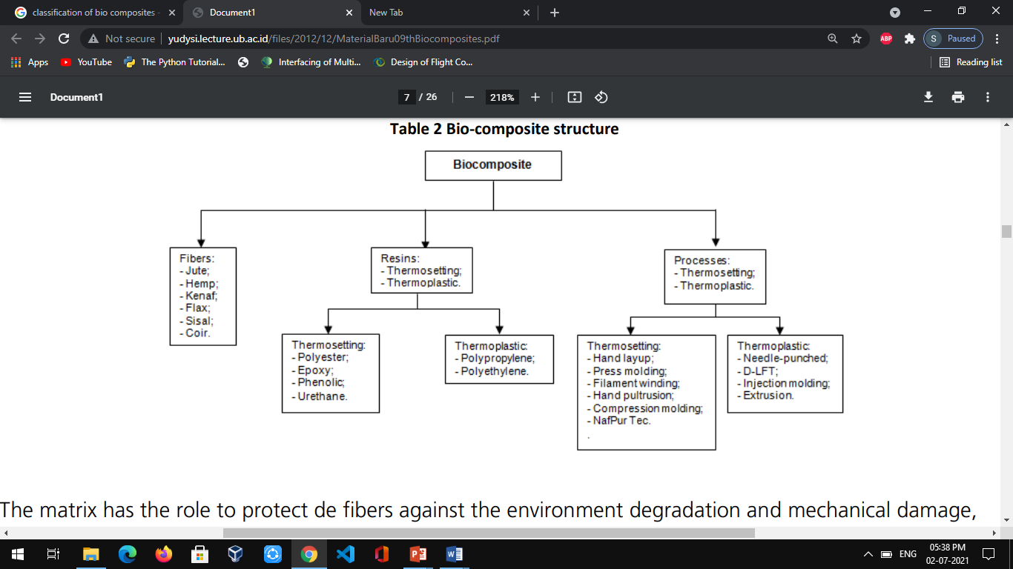

Figure 1.2.1. Classification of bio-composites and their manufacturing process.

**1.2.1**. Based on Reinforcement :

**1. Non wood fibers** **:** The non-wood fibers are also natural fibers which have good mechanical

and physical properties. Also, these fibers are long fibers, and these also have high cellulose

content, which gives high tensile strength. The most widely used non wood fibers are

extracted from hemp, kenaf, jute and reeds.

**2. Wood fibers :** Wood fibers are those which are derived from tree. Fibers are extracted

from wood using chemical and/or physical process. Wood fibers are relatively shorter and

also do not have the high tensile properties seen in natural fibers.

Some examples for natural reinforcements **:** Coir**,** Sisal, Bagasse, Jute, Sheep wool, Chicken

feathers etc….

Some examples for the matrix **:** Polypropylene, Polyethene, Epoxy resin, Polyvinyl

chloride, Polyethylene etc…

## **1.3. Need for Bio-composites.**

Knowing the need to combat wood scarcity, substitute materials are continuously being looked for. One of the possible solutions is to promote the development and utilization of composite material based on agro-material.

The interest in bio-composites is rapidly growing in terms of industrial applications (automobiles, railway coach, aerospace, military applications, construction & packaging) and fundamental research, due to several benefits (renewable, cheap, recyclable, and biodegradable). In addition, the perceived shortage and pressure to decrease the dependence on wood and plastic (non-renewable) materials, has led to additional interests on other renewable materials. Bio-composites can be used alone, or as a complement to standard materials, such as carbon fiber.

Advocates of bio-composites state that use of these materials improves health and safety in their production, are lighter in weight, have a visual appeal similar to that of wood, and are environmentally superior. One advantage of natural fibers is their low density, which results in a higher tensile strength and stiffness than glass fibers, besides of its lower manufacturing costs. By varying process parameters and binding agents, a wide variety of composite could be made from agro- based raw materials and can substitute solid wood.

## **1.4. Method of processing Bio-composites.**

The production of bio-composites uses techniques that are used to manufacture plastics or composites materials. These techniques include:

* Machine press;
* Filament winding;
* Extrusion;
* Injection molding;
* Compression molding;
* Resin transfer molding;
* Sheet molding compound.

Here below are some of such methods used explained in details.

## **1.4.1. Compression Molding.**

Figure1.4.1: Schematic diagram of Compression molding

Compressed molding in this method molding material is generally pre-heated, and is first placed in an open, heated mold cavity. The mold is closed with a top force or plug member, pressure is applied to force the material into contact with all mold areas, while heat and pressure are maintained until the molding material has cured. The process employs thermosetting resins in a partially cured stage, either in the form of granules, putty like masses.

Example: Bowls, Cups, Handles, Switches, etc.

**Chapter-2.**

# MATERIALS AND THEIR PROPERTIES.

## **2.1. Materials used to develop bio-composites.**

###### 2.1.1. Reinforcement.

**Sisal Fiber:**

Sisal fibres show high strength and are obtained from the leaves of the sisal plant (*Agave sisalana*). The leaves reach a length of 2 m. The plant originates from central America and is now cultivated in East Africa and East Asia.

Sisal fibre will play a key role to fabricate a varied range of structural and non-structural industrial products with different polymer matrix. This review article deals the mechanical properties of sisal fibre and the several factors influencing the mechanical properties of its polymer composites, such as fibre loadings, fibre length, fibre architecture, chemical treatments and hybridization by incorporating different natural/synthetic fibre/fillers or additive, according to the application and strength requirements. Attempt also been made to investigate the effect of water absorption, chemical concentration, exposure time, filler weight% and individual fibre loading % in the hybrid configuration on the mechanical properties.

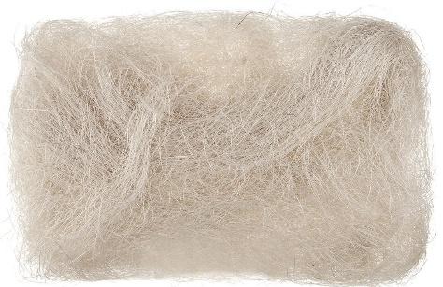

Figure 2.1.1. Sisal fiber

Sisal was widely used in ropes, general cordage and twines, but product varieties gradually increased, as companies started using sisal to manufacture paper, buffing cloth, dartboards, handicrafts, Macram, carpets, geotextiles, wire rope cores and mattresses. Other sisal-inclusive products now range from steel cable yarn to twisted thread, and general yarn to knitted art crafts.

The main feature of sisal fibre is its strength, which gives it a rough and rigid appearance. Properties like strength, durability, ability to stretch and resistance to deteriorate in saltwater, are some of the reasons that sisal is used in making ropes and similar stuff.

**Chemical composition of sisal fiber**.

* Cellulose 55-65

**Properties of sisal fiber**

Density - 1.33-1.5 g/cm3.

Tensile strength - 400-700MPa

Young’s modulus - 9-38GPa

* Hemi-cellulose 10-15
* Pectin 2-4
* Lignin 10-20
* Water soluble materials 1-4
* Fat and wax 0.15-0.3
* Ash 0.7-1.5

###### 2.1.2. Matrix.

**Milk Cover:**

Waste milk covers are generated in enormous quantities in different places of our country. It is made of low density polyethylene and linear low density polyethylene. Only a small fraction of waste milk cover is collected and converted into low grade plastic products. LDPE is widely used for manufacturing various containers, dispensing bottles, wash bottles, tubing, plastic parts for computer components, and various [molded](https://en.wikipedia.org/wiki/Molding_(process)) laboratory equipment. Its most common use is in [plastic bags](https://en.wikipedia.org/wiki/Plastic_bags).

. It has the density between 0.91 and 0.93 g/cm3 and has young’s modulus between 130 and 300 N/mm2.The commercial LDPE melts between the range of 120o and 135o C.

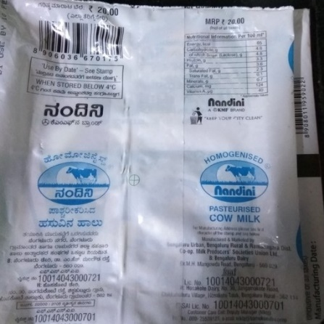

Figure 2.1.2. Milk cover.

**2.2. Advantages of Bio-composite over conventional composite materials.**

1. They are biodegradable.
2. They cause less pollution in the environment compared to conventional type.
3. They are renewable source, which means the availability of material is more.
4. Cost effective, and in some cases they are completely recyclable.
5. Natural fibers have low density which results in higher specific tensile strength and

Stiffness compared to glass fibers.

Etc…

## **2.3. Disadvantage of bio-composites.**

Apart from the many common disadvantages of composites, some are common with bio-composites, many of the natural fibers tend to absorb moisture after a certain amount of time making the composite weaker.

**CHAPTER 3**

# OBJECTIVES AND METHODOLOGY

## **3.1. Objectives.**

Major objective of this work is to fabricate sustainable bio-composites using sisal fiber at the expense of minimum resources as a solution to in efficient disposal of valuable biopolymers.

* + To reduce plastic disposal and reduce environmental pollution.
  + To decrease pollution due to mass burning of agricultural residues/wastes
  + To understand the feasibility of developing composites using agricultural wastes.
  + To develop Light weight components with acceptable physical and mechanical properties.

## **3.2. Carding process.**

Using carding machine, we make cards of sisal fiber to get straight web of fibers. This is done by passing the sisal fiber between the counter moving objects in the carding

machine.

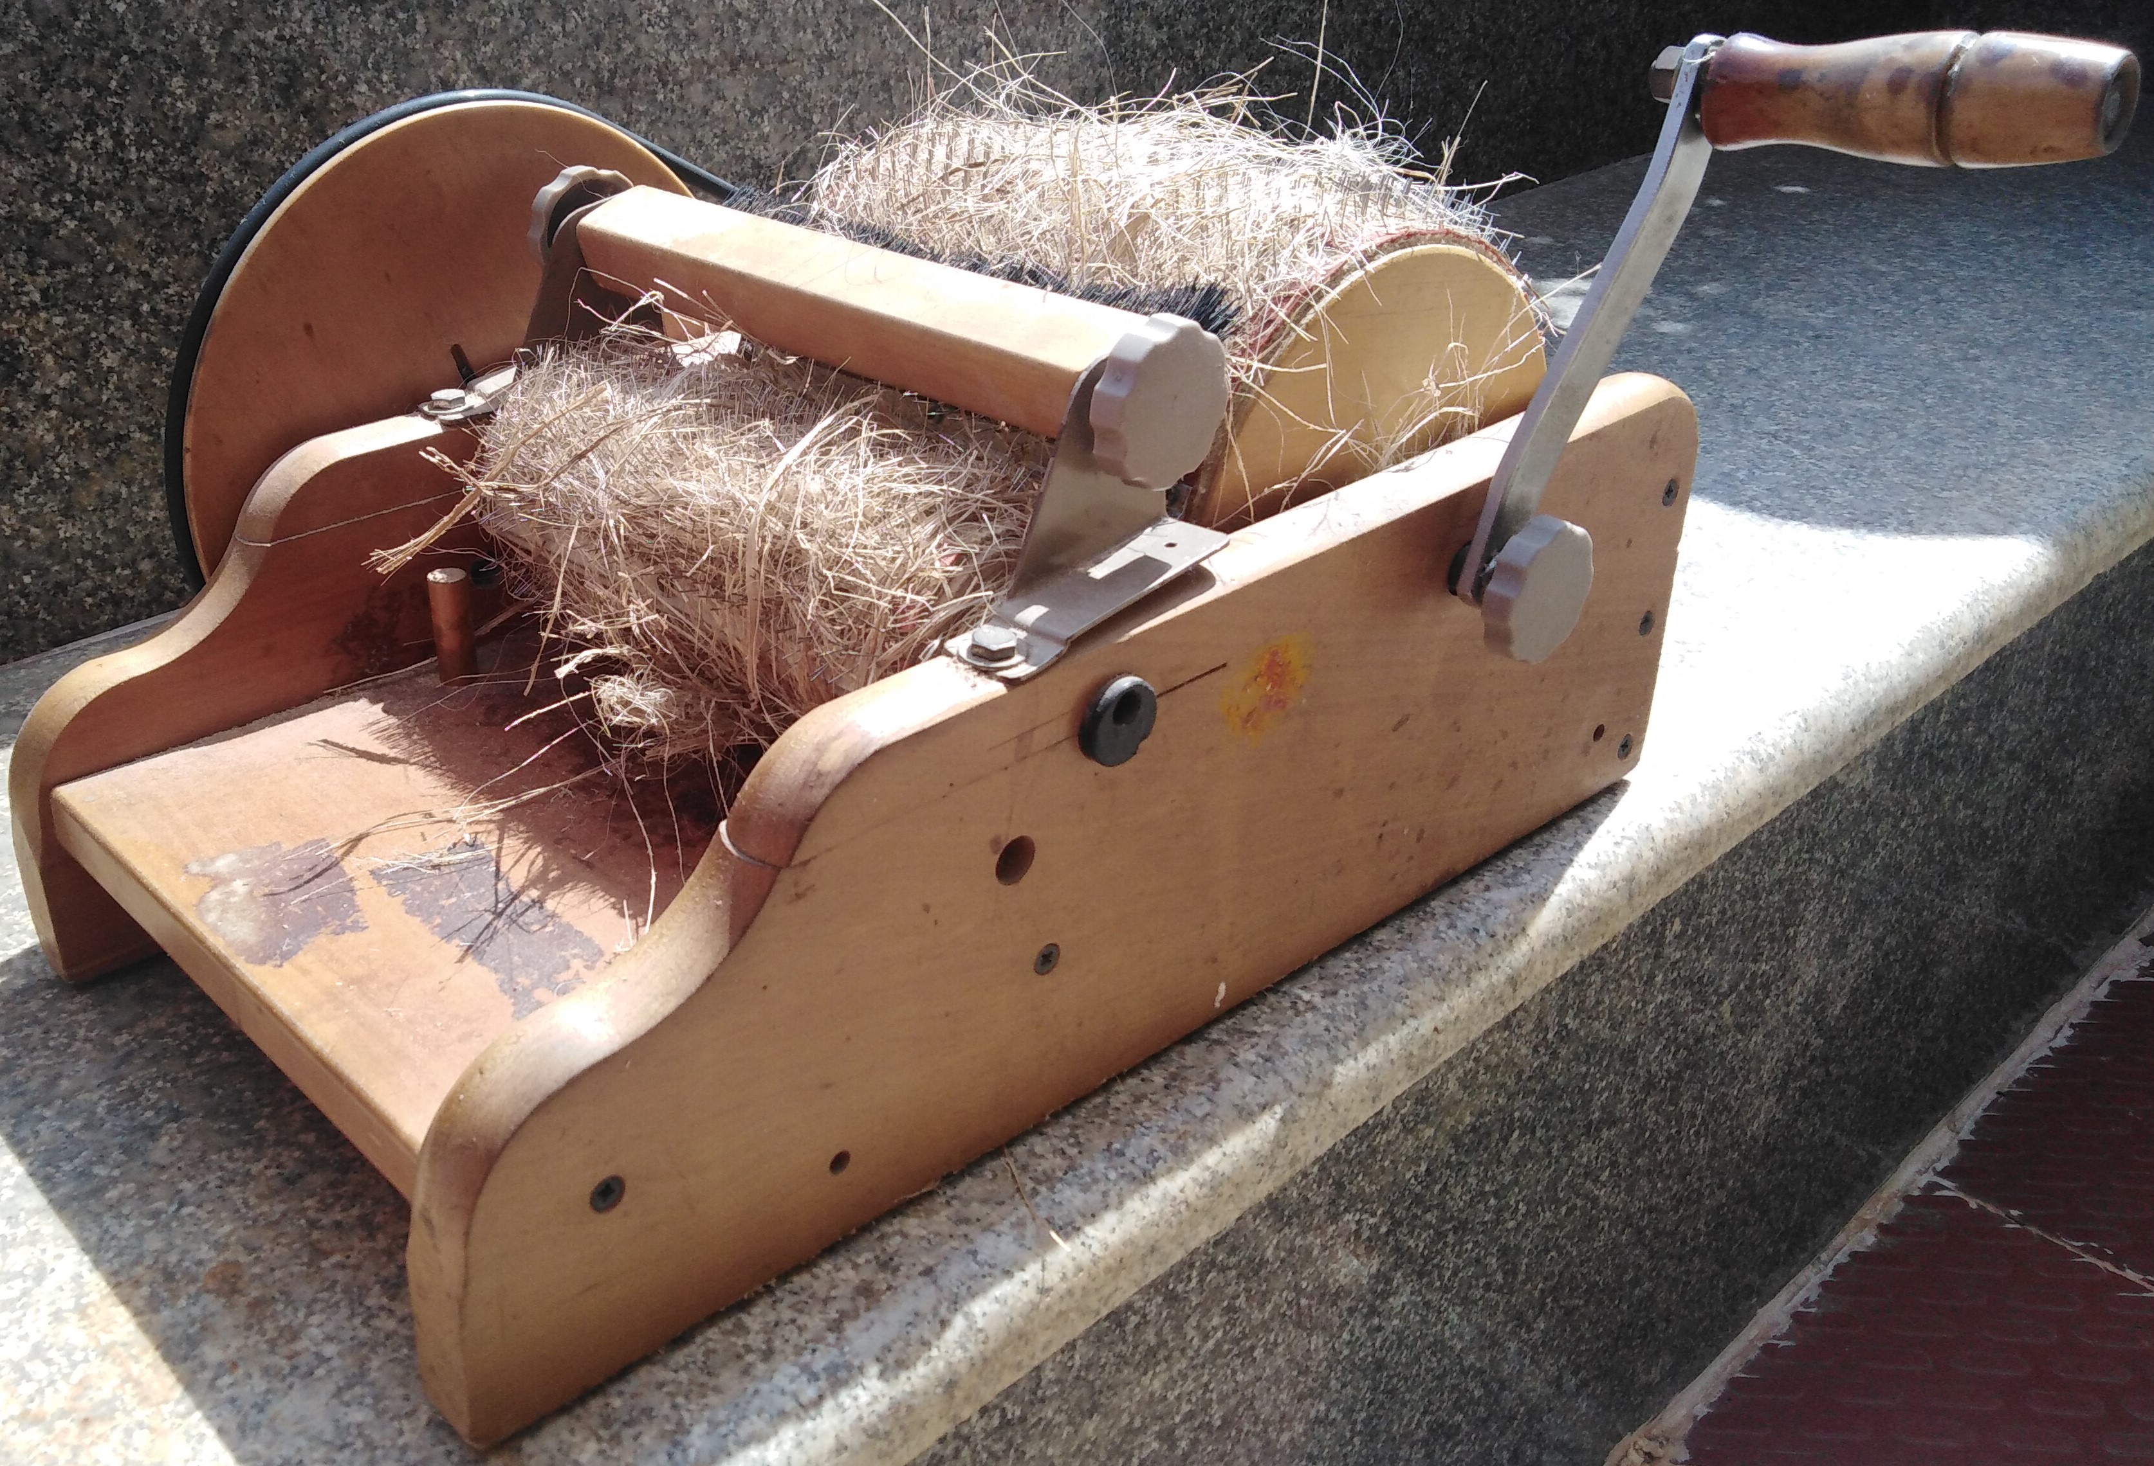

Figure 3.1.1.Carding machine.

## **3.3. Weight distribution and stacking of materials.**

[1] The mechanical properties of composite material is always high comparatively when 60% of fibre content is used. Also the mechanical property property of composite material is max 50/50 compostion a review by Quazy[2]. In order to increase the bio-degradable content we increased fibre content in this project to compare the results with maximum PP content. Hence the composition variation is given below.

In the 100% of total weight, four different composition is selected for testing.

1. 50% of sisal fiber and 50% of milk cover.

2.60% of sisal fiber and 40% of milk cover.

3. 70% of sisal fiber and 30% of milk cover.

4. 80% of sisal fiber and 20% of milk cover.

Then these materials are layered in a definite manner starting from milk cover and alternate layers of Sisal fiber and milk cover is kept after and ending it by milk cover making it a single layered composite material. But they are distributed equally among them [by weight]. The prepared Pre-pegs were placed in between aluminum foils to avoid sticking to the platens of the compression mold.

## **3.4. Developing a material.**

Here we are using compression molding technique for our internship.

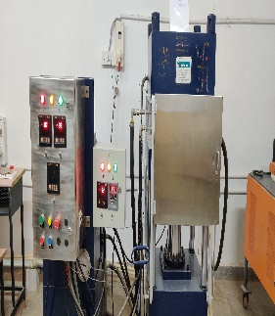 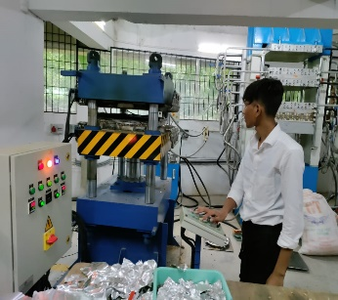 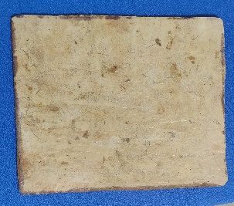

**Figure 3.4.1. Process of composite development.**

At first the compression machine is heated up to 165°c.Then the sample is placed inside the machine. Then the sample is compressed under pressure of 1000lb/m2 for 6 minutes. Cold water is later run through the press immediately after compression until the temperature reduced to about 700C. Composite formed was removed, cut to standard sizes and stored for testing and analysis.

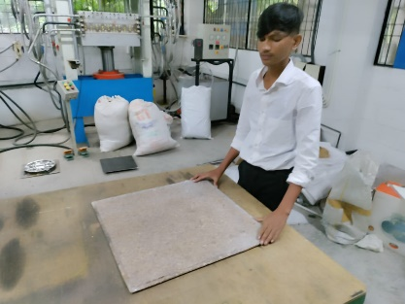

**Figure 3.4.2. Standard marking of material.**

**Chapter-4.**

# TESTING OF COMPOSITE MATERIALS

## **4.1. Flexural Test.**

Flexural properties of the composite are tested on a universal flexural tester equipped with a 1000N load cell. Flexural strength and modulus were also determined from specimens prepared according to ASTM standard D790-15. Samples with length of 210 mm and width 80 mm were used for the flexural studies. Crosshead speed for flexural tests was 10mm/min. about 15 samples were tested for each condition. Average (Flexural Strength(MPa) & Flexural Modulus (MPa)) and standard deviation and mean of the values were reported.

u

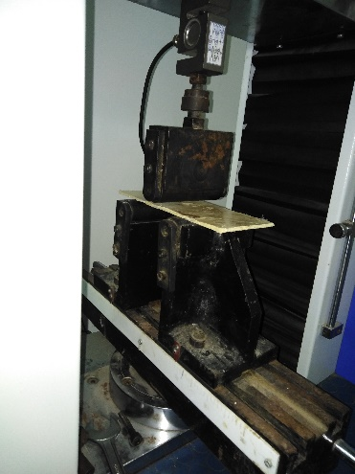 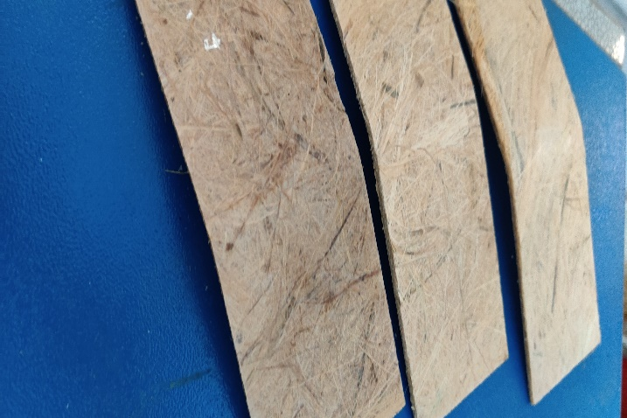

**Figure 4.1.1 Composite samples during testing and after testing.**

## **4.2. Tensile test.**

Tensile properties of the composites are tested on a universal tensile tester equipped with a 1000N load cell. Test samples are prepared according to ASTM standard D 638-14 with samples having dimensions of 165 mm length and 19 mm width at the widest section. Crosshead speed for tensile tests was 50 mm/min. About 15 samples were tested for each condition. Average (Tensile Strength (MPa) & Tensile Modulus (MPa) and standard deviation of the values is reported.

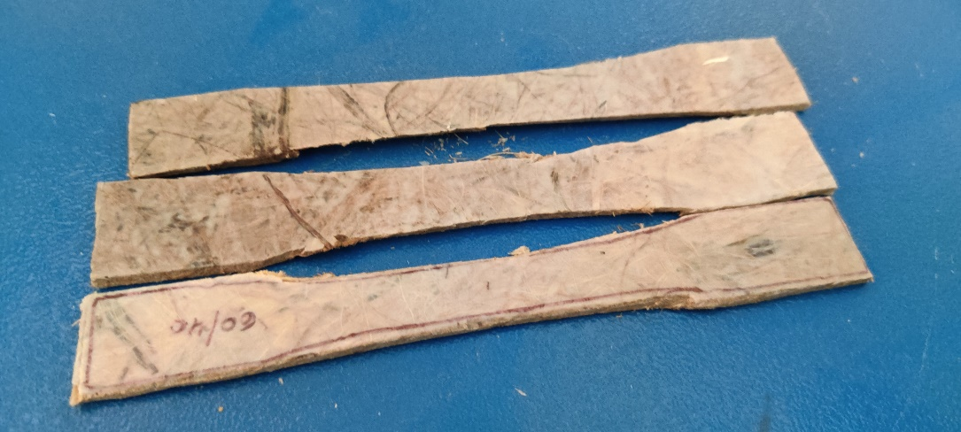

**Figure 4.2.1. Composite samples cut**

**Chapter-5**

# RESULTS AND DISCUSSION

## **5.1. Tensile test.**

Table 5.1 TENSILE TEST.

|  |  |  |
| --- | --- | --- |
| **Percentage variation(W%)**  **SF/MC** | **Young’s modulus of SF/MC in N/mm2(avg.)** | **Tensile strength of SF/MC in N/mm2(avg.)** |
| **50/50** | 434.83 | 18.96 |
| **60/40** | 259.51 | 19 |
| **70/30** | 468.29 | 15.29 |
| **80/20** | 542.55 | 16.72 |

**Fig.5.1.1. Young’s modulus for SF/MC. Fig.5.1.2. Tensile strength for SF/MC**

The tensile properties of the SF/PP and SF/MC can be seen from **fig.5.1.1.** and **fig.5.1.2.**

Surprisingly for SF/MC composition, the maximum young’s modulus was obtained at 80/20 with 542.55 N/mm2 and the minimum being 259.51 N/mm2 at 60/40 W% composition. The increment observed was 109.06% from the minimum shockingly. By decreasing the SF% from 70% to 60% the minimum value of tensile strength being 15.29 N/mm2 is increased to maximum value of 19 N/mm2 with 24.46% increment. The tensile properties of SF/MC can be seen above. The tensile strength and modulus with different composition is decreased significantly, this is due to interfacial compatibility between SF and MC is poor.

## **5.2. Flexural test.**

Table 5.2. FLEXURL TEST RESULT.

|  |  |  |
| --- | --- | --- |
| **Percentage variation(W%)**  **SF/MC** | **Flexural modulus of SF/MC in N/mm2(avg.)** | **Flexural strength of SF/MC in N/mm2(avg.)** |
| **50/50** | 544.69 | 18.72 |
| **60/40** | 908.67 | 31.34 |
| **70/30** | 1049.99 | 32.31 |
| **80/20** | 763.10 | 22.78 |

**Fig.5.2.1. Flexural modulus for SF/MC. Fig.5.2.2. Flexural strength for SF/MC.**

The figures fig.5.2.1. and fig.5.2.2. shows the variation of flexural properties of composite material.

For flexural test of SF/MC, both modulus and strength have seen to be similar to each other with maximum is observed at 70/30 W% and minimum is seen at 50/50 W% for both. The maximum modulus is 1049.99 N/mm2 and minimum is 544.69 N/mm2. The increment of modulus is 92.76% from the minimum value. Similarly the maximum strength observed was 32.31 N/mm2 and minimum is 18.72 N/mm2. The percentage increment observed was 72.59%.

From the above given figures it can be seen that the flexural properties tend to decrease from the maximum value from 70/30 for SF/MC. So we can conclude that the increase in fiber content increases the flexural property but only up to a certain extent.

**Chapter-6.**

# OUTCOME OF INTERNSHIP PROGRAM

##### Comparison with other bio-composites

**Table 6.1**shows a comparison of SF composites with other material composites. This comparison is only an indication of the properties since the fabrication, testing conditions and densities between the different composites are not the same. However, it is apparent that properties of SF composites such as tensile property and flexural properties are better than most of the composites reported. Gypsum based ceiling tiles showed a lower flexural strength value compared to the highest flexural strength value of the SF/MC composite.

Table 6.1. COMPARISON of S-MC composites with other biocomposites and gypsum tiles used for false ceiling applications

|  |  |  |  |
| --- | --- | --- | --- |
| Sample | Flexural Strength (MPa) | Tensile strength (MPa) | Reference |
| Flax/PP | 45-50 | 20.47-30.65 | [12] |
| Cork- Gypsum Composite | 1.82 – 8.12 | - | [13] |
| Commercial  Gypsum Board | 7.16 | - | [14] |
| SF/MC | 18.72-32.17 | 15.29-19 | **This**  **Project** |

In addition, this developed material can be further tested to study it’s other properties like thermal, acoustic, flame resistance, moisture absorption, etc… to further develop it’s application based on the results obtained. On the whole, SF/MC composites possess a right blend of properties that could feasibly be used in construction, interior and building applications. Improved acoustic, flammability and mechanical properties required for different operating environment can be obtained by appropriate surface treatment or other modification techniques. However, the real life scenario has to be taken in to account before proceeding with such modifications because high pretreatment cost decreases the value added to the agricultural residues.

Developed SF/MC composite is a promising economic and eco-friendly substitute for mineral fiber based building materials for roofing and sound proofing in places like schools, hospitals and theatres.

**Chapter-7.**

# CONCLUSIONS

Sisal fiber is a low-cost resource available in abundance across the world. Utilizing sisal fiber in its extracted form without any chemical treatment is an inexpensive and viable approach to increase the value of sisal fiber. Furthermore, the approach used in this study also enables us to retain the inherent structure and properties of sisal fiber. Upon fabricating into composites with polypropylene as a matrix, the composites exhibited excellent properties in terms of mechanical properties. Furthermore, the use of milk cover reduces the environment pollution by utilizing discarded milk cover which is one of the causes for the environment pollution, particularly in urban areas. The properties of sisal fiber composites were comparable to many of the agro-based polypropylene composites available in the literature as well as conventional materials.

# 

# REFERENCES

1. Mueller, D. H., & Krobjilowski, A. (2003). New Discovery in the Properties of Composites Reinforced with Natural Fibers. Journal of Industrial Textiles, 33(2), 111–130. doi:10.1177/152808303039248.
2. Mechanical properties of polypropylene composites: A review Quazi T. H. Shubhra, A. K. M. M. Alam and M. A. Quaiyyum Journal of Thermoplastic Composite Materials published online 12 December 2011 DOI: 10.1177/0892705711428659.
3. Ratna Prasad A V, Mohana Rao K. Mechanical properties of natural fibre reinforced polyester composites: Jowar, sisal and bamboo. Materials & Design, 2011, 32(8): 4658-4663
4. George J, Sreekala M S, Thomas S. A review on interface modification and characterization of natural fiber reinforced plastic composites. Polymer Engineering & Science, 2001, 41(9): 1471-1485.
5. Shalwan A, Yousif B F. In state of art: mechanical and tribological behaviour of polymeric composites based on natural fibres. Materials & Design, 2013, 48: 14-24.
6. Faruk O, Bledzki A K, Fink H P, et al. Biocomposites reinforced with natural fibers: 2000–2010. Progress in Polymer Science, 2012, 37(11): 1552-1596.
7. Lu S R, Ling R H, Luo C X, et al. Sisal fibre/polypropylene composites modified with carboxyl terminated hyperbranched polymer. Plastics, Rubber and Composites, 2013, 42(9): 361-366.
8. Lu S R, Ling R H, Luo C X, et al. Sisal fibre/polypropylene composites modified with carboxyl terminated hyperbranched polymer. Plastics, Rubber and Composites, 2013, 42(9): 361-366.
9. Kaewkuk S, Sutapun W, Jarukumjorn K. Effects of interfacial modification and fiber content on physical properties of sisal fiber/polypropylene composites. Composites Part B: Engineering, 2013, 45(1): 544-549.
10. Han S, Ren K, Geng C, et al. Enhanced interfacial adhesion via interfacial crystallization between sisal fiber and isotactic polypropylene: direct evidence from single – fiber fragmentation testing. Polymer International, 2014, 63(4):646-651.
11. Rodriguz E, Petrucci R, Puglia D, Jose MK and Vazauez A. Characterization of composites
12. based on natural and glass fibers obtained by vacuum infusion. J Compos Mater 2005;
13. 39(3): 265–282.

3. Rodriguz E, Petrucci R, Puglia D, Jose MK and Vazauez A. Characterization of composites

based on natural and glass fibers obtained by vacuum infusion. J Compos Mater 2005;

39(3): 265–282.

Rodriguz E, Petrucci R, Puglia D, Jose MK and Vazauez A. Characterization of composites

based on natural and glass fibers obtained by vacuum infusion. J Compos Mater 2005;

39(3): 265–282.

Rodriguz E, Petrucci R, Puglia D, Jose MK and Vazauez A. Characterization of composites

based on natural and glass fibers obtained by vacuum infusion. J Compos Mater 2005;

39(3): 265–282.

3. Rodriguz E, Petrucci R, Puglia D, Jose MK and Vazauez A. Characterization of composites

based on natural and glass fibers obtained by vacuum infusion. J Compos Mater 2005;

39(3): 265–282

Rodriguz E, Petrucci R, Puglia D, Jose MK and Vazauez A. Characterization of composites

based on natural and glass fibers obtained by vacuum infusion. J Compos Mater 2005;

39(3): 265–282

Rodriguz E, Petrucci R, Puglia D, Jose MK and Vazauez A. Characterization of composites

based on natural and glass fibers obtained by vacuum infusion. J Compos Mater 2005;

39(3): 265–282

Rodriguz E, Petrucci R, Puglia D, Jose MK and Vazauez A. Characterization of composites

based on natural and glass fibers obtained by vacuum infusion. J Compos Mater 2005;

39(3): 265–282

Rodriguz E, Petrucci R, Puglia D, Jose MK and Vazauez A. Characterization of composites

based on natural and glass fibers obtained by vacuum infusion. J Compos Mater 2005;

39(3): 265–282

Han SO, Lee SM, Park WH and Cho D. Mechanical and thermal properties of waste silk fiber

reinforced poly(butylenes succinate) bio composites. J Appl Polym Sci 2006; 100(6):

4972–4980

Han SO, Lee SM, Park WH and Cho D. Mechanical and thermal properties of waste silk fiber

reinforced poly(butylenes succinate) bio composites. J Appl Polym Sci 2006; 100(6):

4972–4980

Han SO, Lee SM, Park WH and Cho D. Mechanical and thermal properties of waste silk fiber

reinforced poly(butylenes succinate) bio composites. J Appl Polym Sci 2006; 100(6):

4972–4980

3. Han SO, Lee SM, Park WH and Cho D. Mechanical and thermal properties of waste silk fiber

reinforced poly(butylenes succinate) bio composites. J Appl Polym Sci 2006; 100(6):

4972–4980

Rodriguz E, Petrucci R, Puglia D, Jose MK and Vazauez A. Characterization of composites

based on natural and glass fibers obtained by vacuum infusion. J Compos Mater 2005;

39(3): 265–282

Rodriguz E, Petrucci R, Puglia D, Jose MK and Vazauez A. Characterization of composites

based on natural and glass fibers obtained by vacuum infusion. J Compos Mater 2005;

39(3): 265–282

Rodriguz E, Petrucci R, Puglia D, Jose MK and Vazauez A. Characterization of composites

based on natural and glass fibers obtained by vacuum infusion. J Compos Mater 2005;

39(3): 265–282

11. Rongyuan chen, Zen huang,etc. Preparation of Polypropylene/Sisal fiber composites

and study on the fiber orientation. Advanced material research vols989-994(2014)

pp 581-586.

12. M. Soleimani, L. Tabil, S. Panigrahi, A. Opoku, The Effect of Fiber

Pretreatment and Compatibilizer on Mechanical and Physical Properties of

Flax Fiber-Polypropylene Composites, J. Polym. Environ. 16 (2008) 74–82.

doi:10.1007/s10924-008-0102-y.

13. F. Hernández-Olivares, M.R. Bollati, M. Del Rio, B. Parga-Landa, Development

of cork- gypsum composites for building applications, Constr. Build. Mater.

(1999). doi:10.1016/S0950-0618(99)00021-5.

14. N. Benmansour, B. Agoudjil, A. Gherabli, A. Kareche, A. Boudenne, Thermal

and mechanical performance of natural mortar reinforced with date palm fibers

for use as insulating materials in building, Energy Build. (2014).

doi:10.1016/j.enbuild.2014.05.032.