0: CHU 1: Public

2: Private For Profit 3: Private non profit

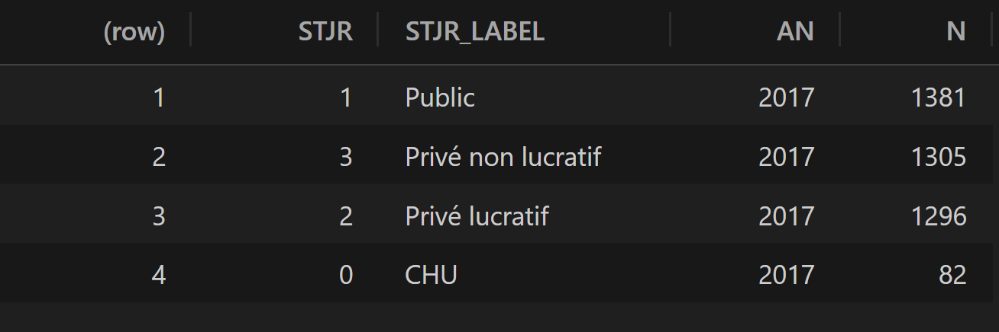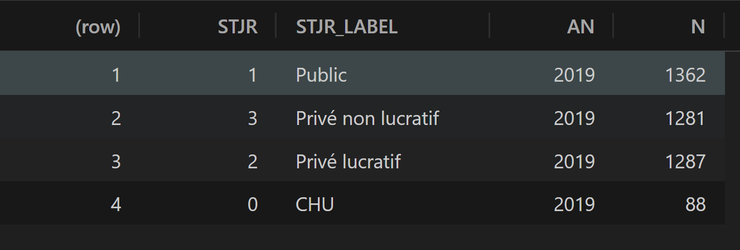

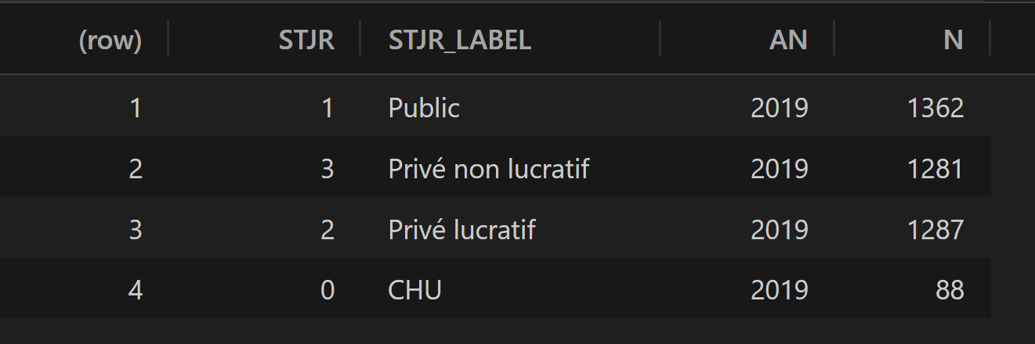

Input: labor (2019)

MD (physicians and surgeons) IF(nurses) AS(assistant nurses) NM(non-medical personnel)

sum of labors:

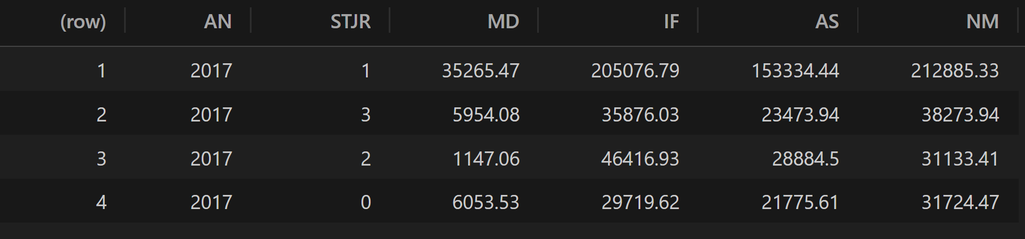

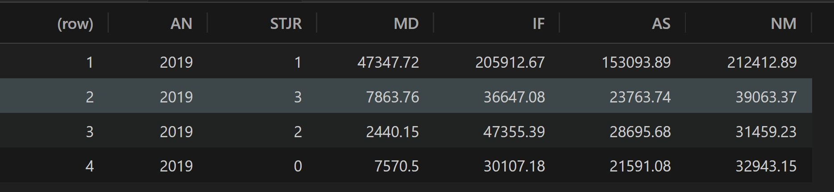

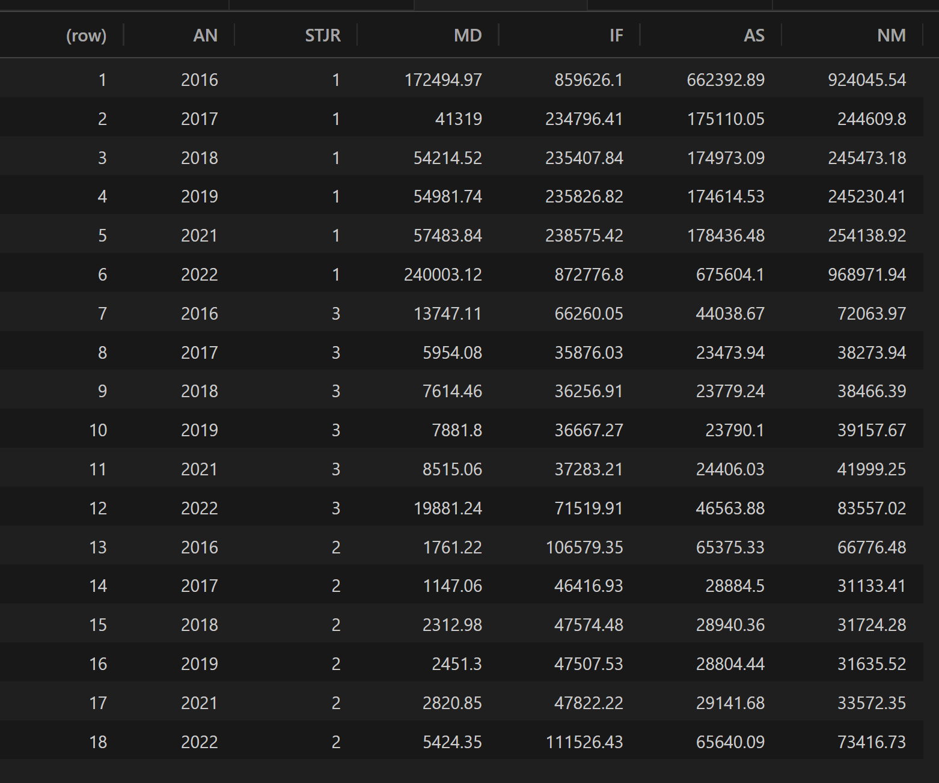

Mean of labor input:

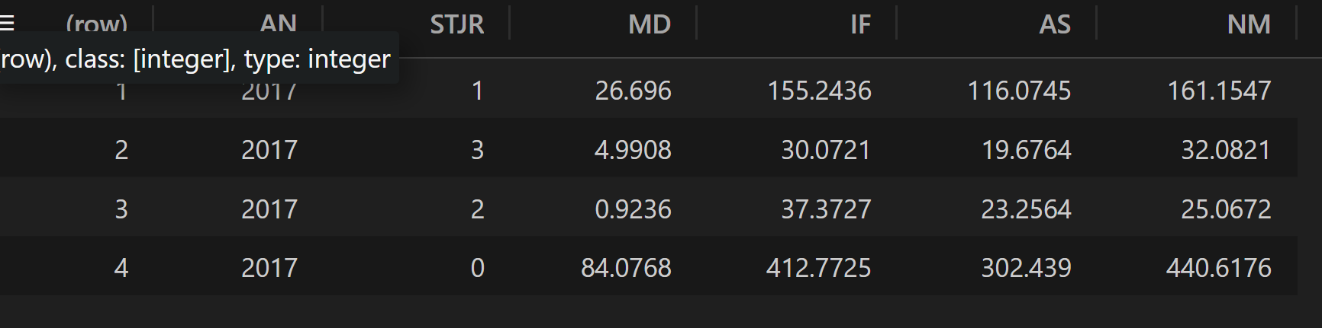

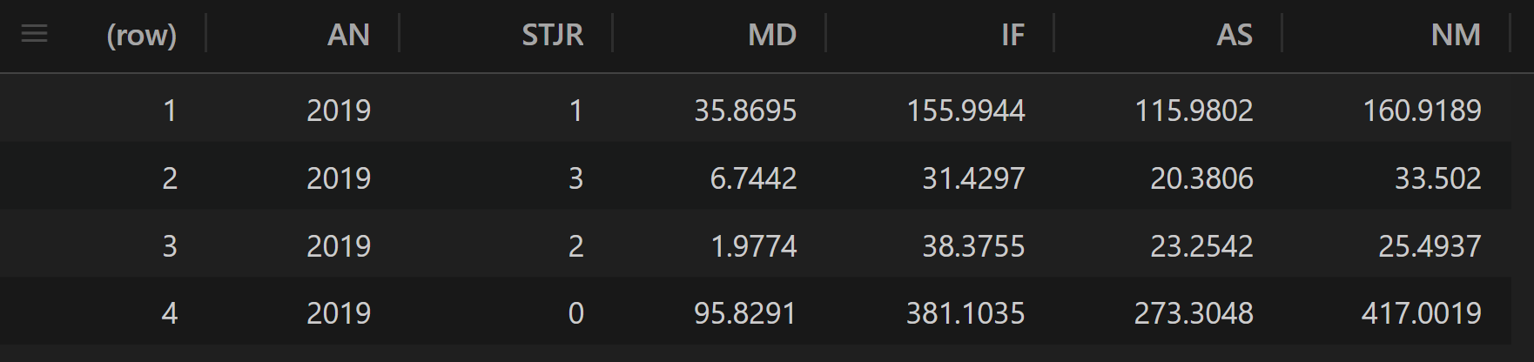

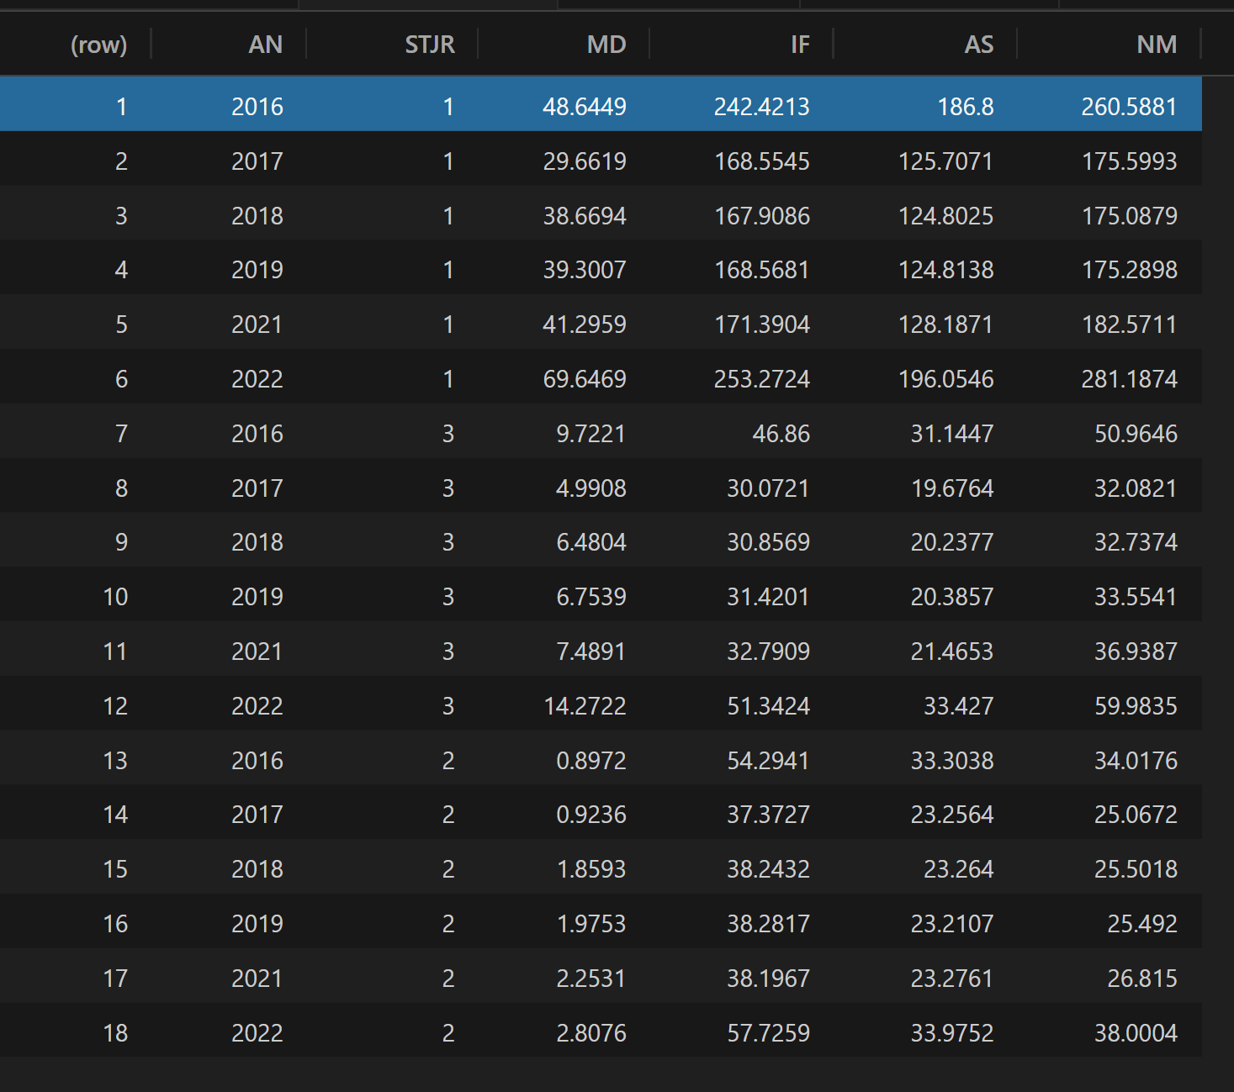

Output:

**Short term acute care STAC inpatient**

**STAC outpatient**

**Sessions**

**Emergency stays**

Rehab

Lont term care unit/LTAC

Home hospitalization

Psychiatry department stays

Outpatient Consultations

Research

Training

These figures indicate a relative specialization of hospital categories: the nonprofits are strong on sessions, the clinics are strong on STAC and public hospitals run important EDs. The sum of the three most important categories, i.e., STAC, ED stays and sessions, always represents more than 80% of the total number of stays in a given institution. To these we should in principle add two other outputs: research and training (i.e., higher education).

Controls:

%cancer

Casemix: which measures the average severity of the cases treated by the hospital in a given year

Slots*Casemix

Descriptive statistics:

Average productivity of personnels:

For each entity: # (STAC) stays / # personnels

MD:

Nurses:

Aide soigants:

Share of Outpatient Surgery and Medicine:

For each entity: STAC outpatient stay/(STAC outpatient + STAC inpatient)

Average length of stays:

Issues with patient selection:

Beds and (slots) measure the size/capacity of the entity:

*This index is precisely the official A9 indicator published yearly for each hospital in the Hospidiag base that we exploited. We will see that this index is significant and that average severity matters.*

The smaller the size of entity, the larger the severity. But how to explain the phenomenon?