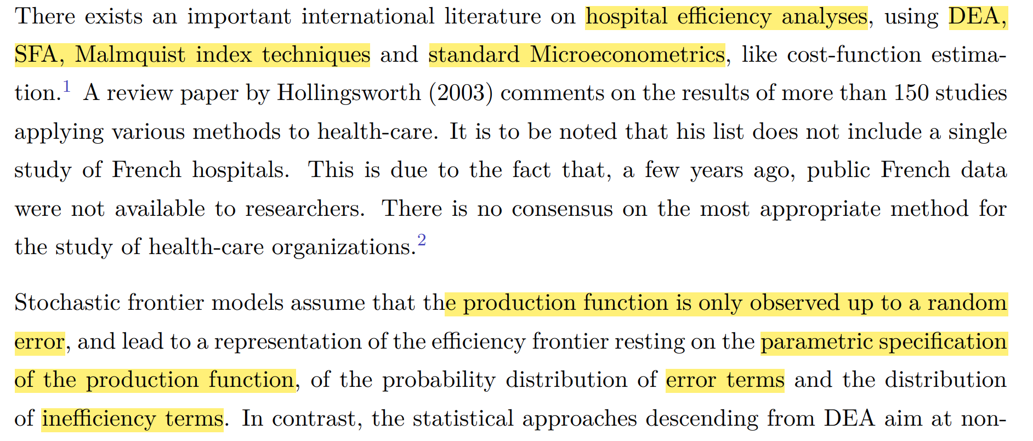

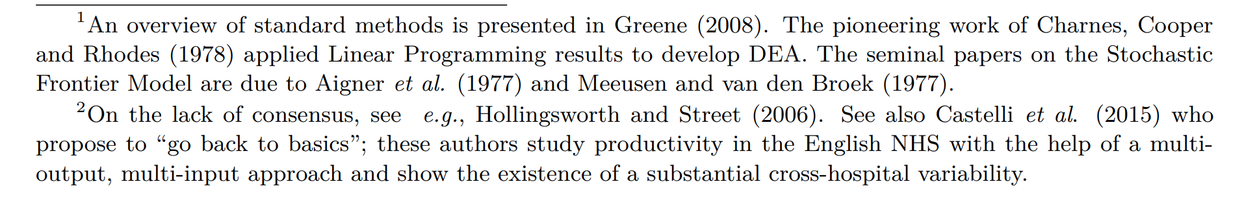

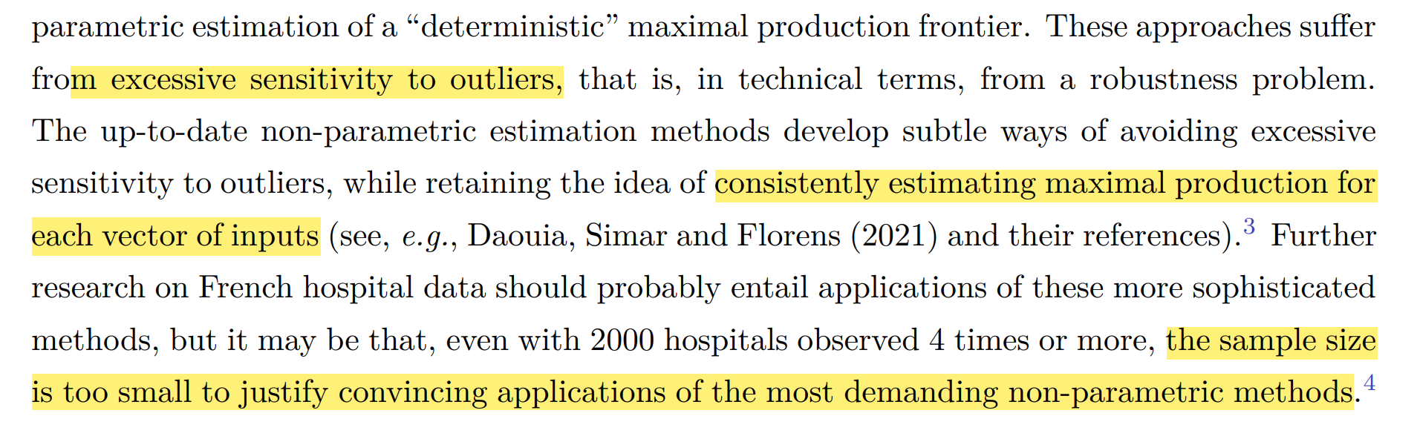

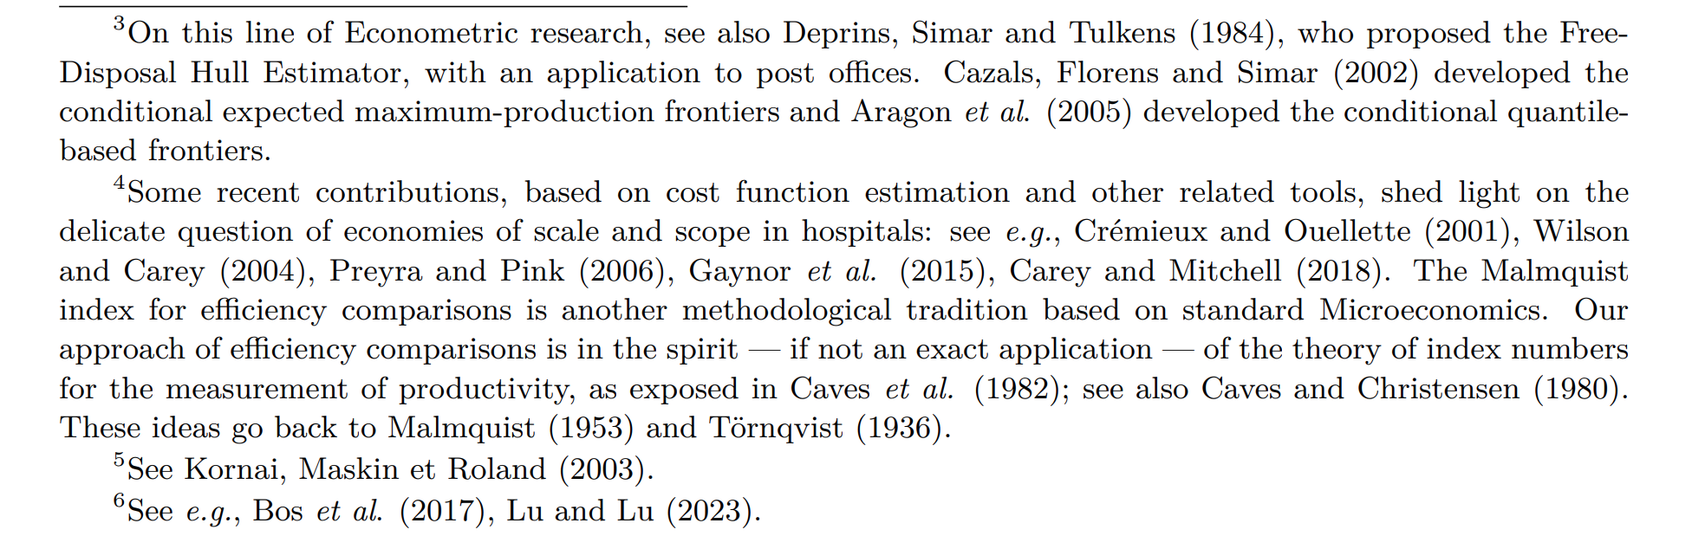

1. Two stage.